# Base features and Syntax

## The Build Workflow

## Using Create React App

## Understanding the Folder structure

## Component basics

react is all about creating components, basically custom html elements you could say, which you can then use to construct your application.

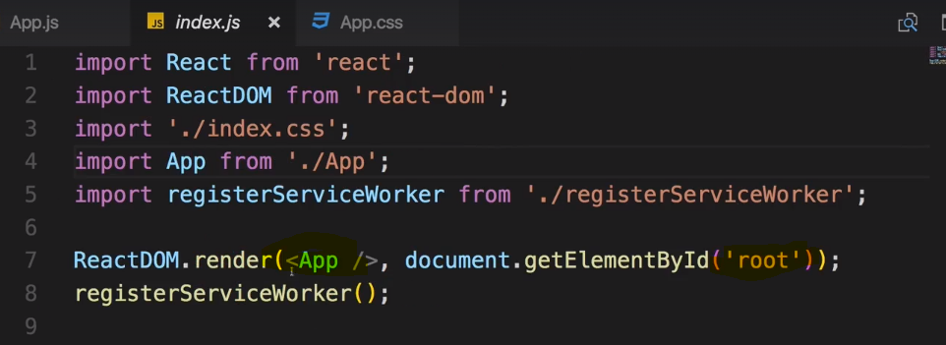

This app component actually gets used in the index.js file where you render it into the place of this root element.



we could render a normal html element here to test for example, this would work,

this is now no react component. we're rendering a normal html element but we're not rendering our own react component.

Now you could of course use multiple react on renders and render all the html code you want to use in your app, that's not really how you create your react apps though.

**Typically, you render one root component, the app component but you can name it whatever you want. One root component, in our case it is the app component named app, and in there you would nest all the other components your application might need and of course these components can then also be nested into each other but all the way up to the top, you only have one root component.**

You could reach out to multiple nodes in your html file and mount different root components for different react apps all in the same project, that would be possible but it's not what we do here.

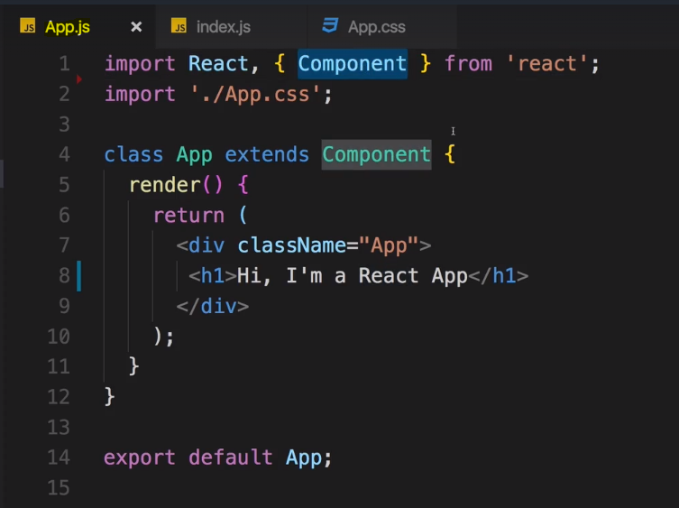

We have this app component which is defined in the app.js file, here we see one way, one of two ways of defining a react component. We create a javascript class with the class keyword and then we use the extends keyword to inherit from this component object or class to be precise which is imported up here from the react library.

**Actually we import two things, react which is responsible or required for rendering anything, anything to the dom, we always need to import that in a file where we define a component, and of course the component class itself.** I will soon show you a different way of creating components though.

**this class has one method, the render method. It needs to have that because react will call this method to render something to the screen. There is one important job every react component has to do, it has to return or render some html code which can be rendered to the dom to the screen. You can do other things in there too, reach out to the internet, do some calculations, listen to events, whatever you need in your application**

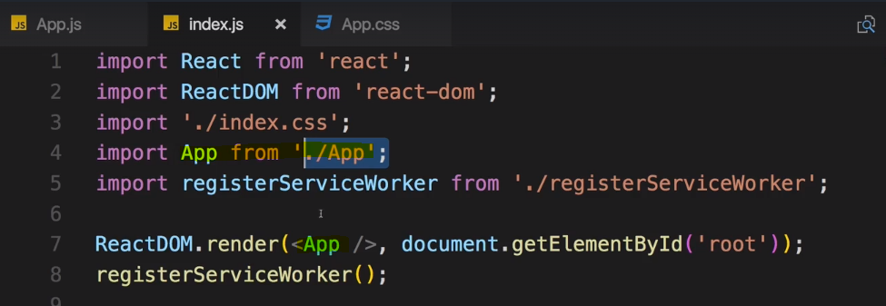

We then export this app class as the default export of this file, this is an ES6 feature and simply means if you import this whole file, you'll simply import this class because it's the default export.

We do use this in the index.js file where we import app from the app file omitting this .js extension because it's added by our build workflow automatically for javascript files. This app name here by the way is chosen arbitrarily but typically you use the name of the component

you might also see these components with .jsx as a file extension instead of js, the reason for this is code here. I referred to it as html which is returned.

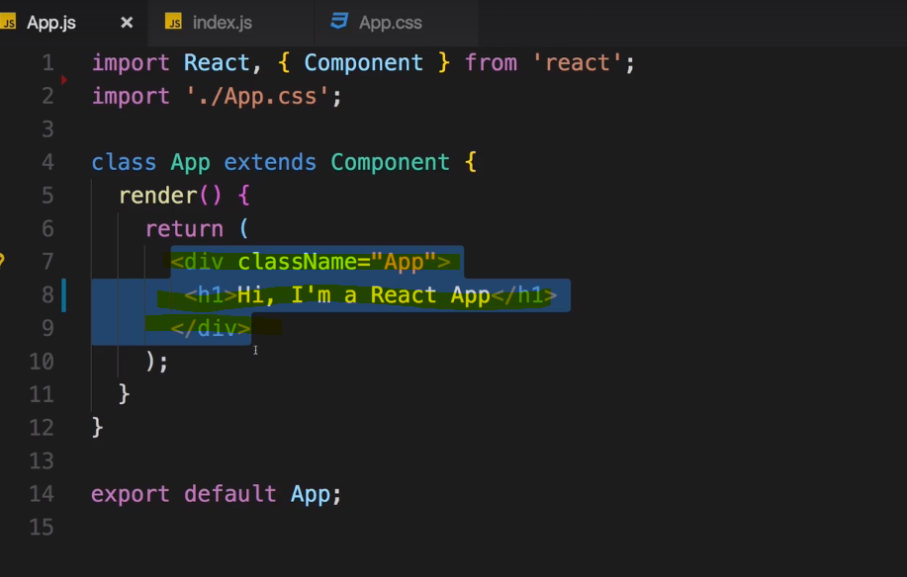

**But in the end, this is not html, it looks like it but it is jsx so it is javascript looking a bit different, and this can be confusing at first when you are learning react, this might be one of the most confusing things actually. Important to know is this is just some syntactical sugar, it was basically invented by the react team and we can write it in our javascript files because of the build workflow we're using here,**

**it will basically automatically transpile it to valid javascript in the end. It's not connected to the file extension you're using, it works in .js and .jsx files and the convention nowadays is pretty much to always use .js files which is why we do it here too.**

## Understanding JSX

createElement, is a method on react module which is also the reason why we have to import react

because this code here

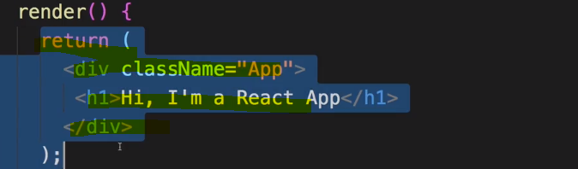

is going to converted/compiled to what we're writing here





Create element is a method and it takes three arguments, actually it takes

an infinite amount of arguments but at least three. The first one is the element we want to render to

the dom,

this could be a div, this can be a normal html element like a div,

It could also be your own component

Not complete……….

## JSX restrictions

## Creating a functional Component

## Working with component and re-using them

## Outputting Dynamic Content

## Props

## Props children property

## State : Understanding and Using Component State

## Handling Events with methods

## To which Event you can listen

To Which Events Can You Listen?

Section 3, Lecture 40

In the last lecture, we saw that you can react to the onClick event - but to which other events can you listen? You can find a list of supported events here: <https://reactjs.org/docs/events.html#supported-events>

#### **Clipboard Events**

Event names:

1. onCopy onCut onPaste

Properties:

1. DOMDataTransfer clipboardData

Composition Events

Event names:

1. onCompositionEnd onCompositionStart onCompositionUpdate

Properties:

1. string data

Keyboard Events

Event names:

1. onKeyDown onKeyPress onKeyUp

Properties:

1. boolean altKey
2. number charCode
3. boolean ctrlKey
4. boolean getModifierState(key)
5. string key
6. number keyCode
7. string locale
8. number location
9. boolean metaKey
10. boolean repeat
11. boolean shiftKey
12. number which

Focus Events

Event names:

1. onFocus onBlur

These focus events work on all elements in the React DOM, not just form elements.

Properties:

1. DOMEventTarget relatedTarget

Form Events

Event names:

1. onChange onInput onInvalid onSubmit

For more information about the onChange event, see [Forms](https://reactjs.org/docs/forms.html).

Mouse Events

Event names:

1. onClick onContextMenu onDoubleClick onDrag onDragEnd onDragEnter onDragExit
2. onDragLeave onDragOver onDragStart onDrop onMouseDown onMouseEnter onMouseLeave
3. onMouseMove onMouseOut onMouseOver onMouseUp

The onMouseEnter and onMouseLeave events propagate from the element being left to the one being entered instead of ordinary bubbling and do not have a capture phase.

Properties:

1. boolean altKey
2. number button
3. number buttons
4. number clientX
5. number clientY
6. boolean ctrlKey
7. boolean getModifierState(key)
8. boolean metaKey
9. number pageX
10. number pageY
11. DOMEventTarget relatedTarget
12. number screenX
13. number screenY
14. boolean shiftKey

Selection Events

Event names:

1. onSelect

Touch Events

Event names:

1. onTouchCancel onTouchEnd onTouchMove onTouchStart

Properties:

1. boolean altKey
2. DOMTouchList changedTouches
3. boolean ctrlKey
4. boolean getModifierState(key)
5. boolean metaKey
6. boolean shiftKey
7. DOMTouchList targetTouches
8. DOMTouchList touches

UI Events

Event names:

1. onScroll

Properties:

1. number detail
2. DOMAbstractView view

Wheel Events

Event names:

1. onWheel

Properties:

1. number deltaMode
2. number deltaX
3. number deltaY
4. number deltaZ

Media Events

Event names:

1. onAbort onCanPlay onCanPlayThrough onDurationChange onEmptied onEncrypted
2. onEnded onError onLoadedData onLoadedMetadata onLoadStart onPause onPlay
3. onPlaying onProgress onRateChange onSeeked onSeeking onStalled onSuspend
4. onTimeUpdate onVolumeChange onWaiting

Image Events

Event names:

1. onLoad onError

Animation Events

Event names:

1. onAnimationStart onAnimationEnd onAnimationIteration

Properties:

1. string animationName
2. string pseudoElement
3. float elapsedTime

Transition Events

Event names:

1. onTransitionEnd

Properties:

1. string propertyName
2. string pseudoElement
3. float elapsedTime

Other Events

Event names:

1. onToggle

## Manipulating the state

## useState() Hook : Using the useState() hook for state manipulation

## Stateless vs Statefull component

## Passing method references between Components

## Adding Two way binding

## Adding Styling with stylesheet

### Adding Styling with Inline Styles

# Working with Lists and Conditionals

## Rendering Content Conditionally

## Handling Dynamic content : the javascript way

## Outputting Lists

## List and updating State

### Updating State immutably

## List and Keys

 A “key” is a special string attribute you need to include when creating lists of elements.

Let’s assign a key to our list items inside numbers.map() and fix the missing key issue.

function NumberList(props) {

const numbers = props.numbers;

const listItems = numbers.map((number) =>

<li key={number.toString()}>

{number}

</li>

);

return (

<ul>{listItems}</ul>

);

}

const numbers = [1, 2, 3, 4, 5];

ReactDOM.render(

<NumberList numbers={numbers} />,

document.getElementById('root')

);

[**Try it on CodePen**](https://codepen.io/gaearon/pen/jrXYRR?editors=0011)

## Keys

Keys help React identify which items have changed, are added, or are removed. Keys should be given to the elements inside the array to give the elements a stable identity:

const numbers = [1, 2, 3, 4, 5];

const listItems = numbers.map((number) =>

<li key={number.toString()}>

{number}

</li>

);

The best way to pick a key is to use a string that uniquely identifies a list item among its siblings. Most often you would use IDs from your data as keys:

const todoItems = todos.map((todo) =>

<li key={todo.id}>

{todo.text}

</li>

);

When you don’t have stable IDs for rendered items, you may use the item index as a key as a last resort:

const todoItems = todos.map((todo, index) =>

// Only do this if items have no stable IDs

<li key={index}>

{todo.text}

</li>

);

We don’t recommend using indexes for keys if the order of items may change. This can negatively impact performance and may cause issues with component state. Check out Robin Pokorny’s article for an [in-depth explanation on the negative impacts of using an index as a key](https://medium.com/@robinpokorny/index-as-a-key-is-an-anti-pattern-e0349aece318). If you choose not to assign an explicit key to list items then React will default to using indexes as keys.

## Flexible Lists

# Styling React Components and Elements

## Setting Styles dynamically

let's dynamically adjust the button style depending on

whether we're about to show persons or not.

Now as always everything here is javascript

so if we assign a style to the button here, this part between the curly braces can be any javascript

expression.

and we could adjust this style variable dynamically

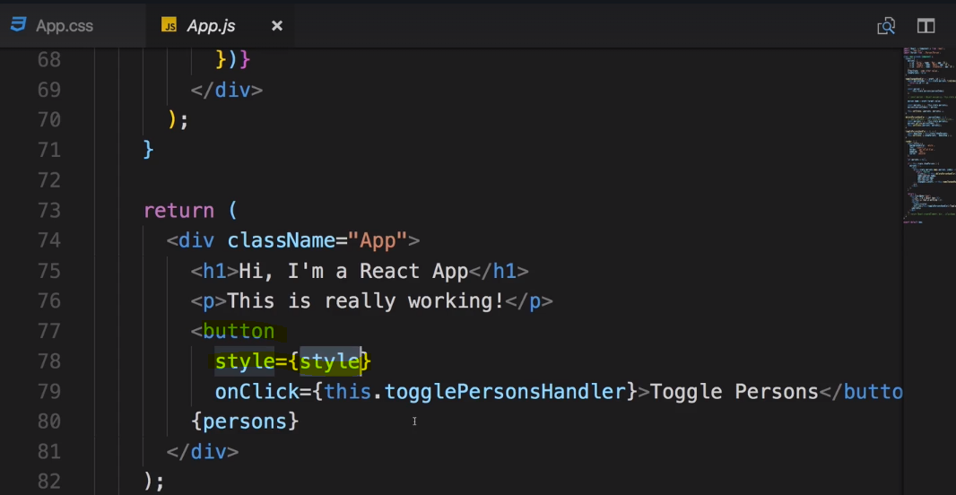

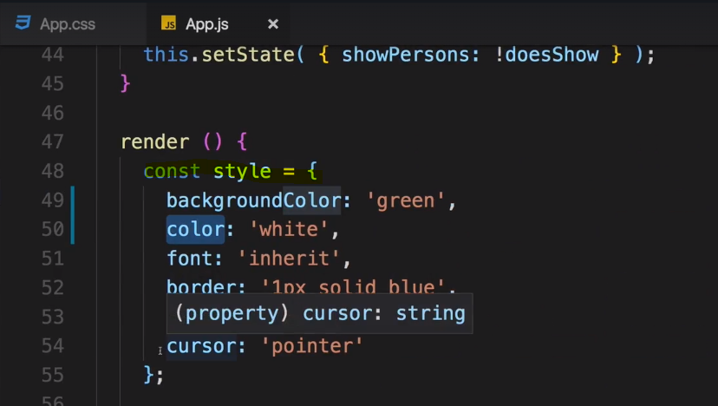

So what we can do is in our if statement which we already have where we set a person's variable, we can

of course do more besides setting this person's variable here. After doing that,

I can also reach out to style and set the background color property which the style object clearly has,

we set it up here to red of course, simply like that.

So we simply get into this style object,

we don't assign a new value so it's still a constant

but we assign a new value to one of its properties, to the background color

and with this tiny change in place, we already got dynamic styling.

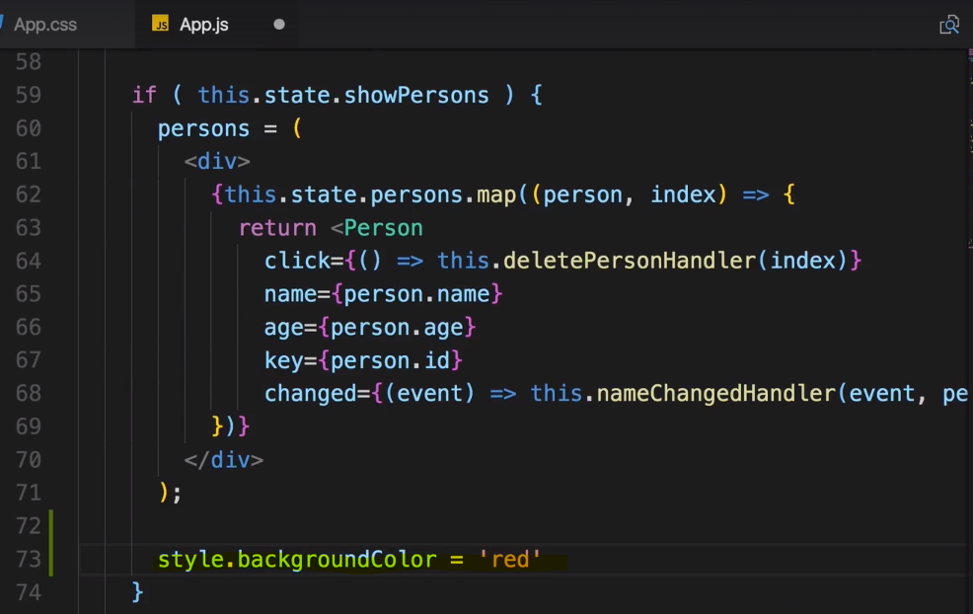

So this shows one crucial thing which you really have to wrap your head around if you haven't already,

everything is javascript,

I guess I said this before. We change the style dynamically just as we change this variable persons dynamically

just as we change anything dynamically, we're talking about javascript here.

You can manipulate the style object with any javascript code you want and in the end when you then bind

it here, it will simply apply this no matter how you edited it.

This is a crucial take away and this shows you how you can dynamically assign cells

## Setting Class Names dynamically

everything is just javascript.

So you work with your array of classes here as you do with a normal array because it is a normal array

in normal javascript and all you do in the end here is you have to make sure that you actually assign

a string as we do here with the join method.

And of course you could have whatever logic you need to construct an array of classes or get a string

with css classes by other means without joining an array, whatever you have.

Maybe take some user input which is a string by default,

you can assign anything which is a valid string to class name and it will then be handled as a list

of css classes which hopefully meet the classes you set up in your css file.

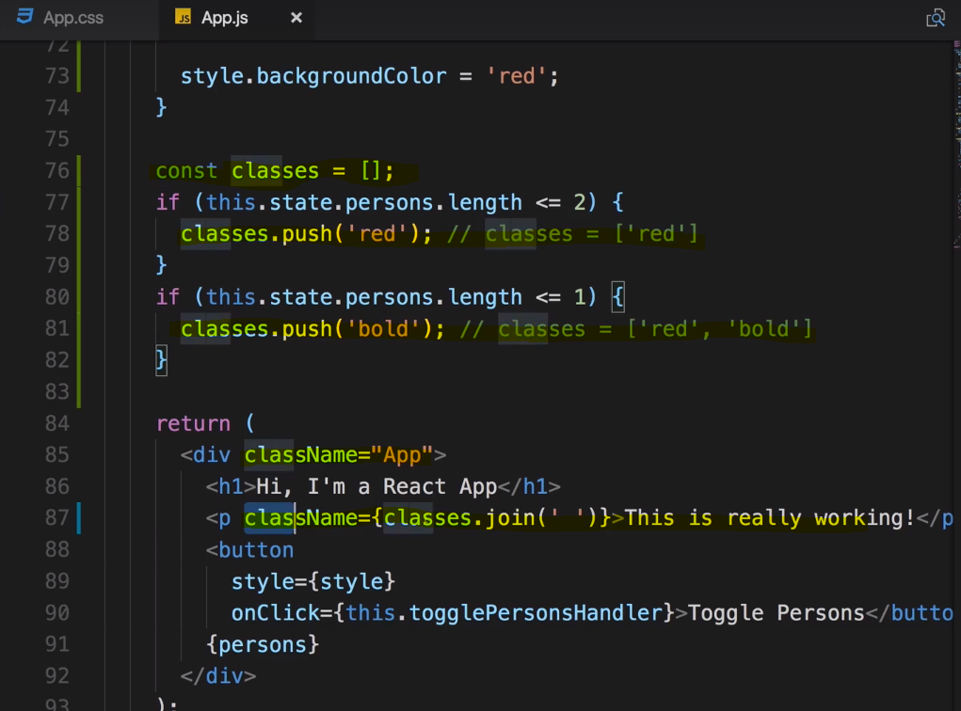

Css class style -

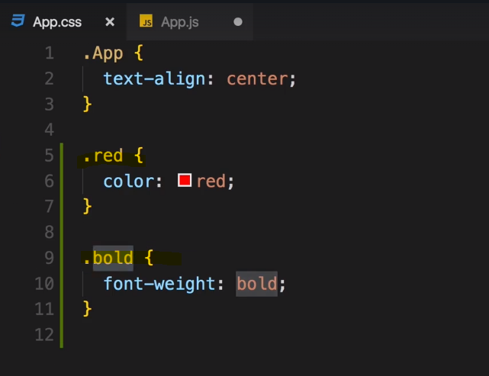

We have used join here and join them with an empty space,

this will turn this array of strings into one string which is in the end just “red bold”,

this is what we'll get in the end.

This is a valid css class list we can assign to class names.



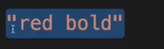

## Adding and Using Radium : for Psuedo selector

fact that we can't assign a hover style for our button. Hover which in css you would simply

create with :hover is a pseudo selector which means it's a selector based on some other selector

indicated by that colon.

Hover is not a css property.

So we could fix this of course by styling the button in the css file but I already mentioned that this style

would then not be scoped to this component only and all the buttons in our application would get the

styling.

Yes, we could work around this with some unique css IDs or classes but having the possibility of using

these inline styles here can also be pretty cool because as we already do, you can edit them in your

code because everything is javascript. So it would be nice if we could actually use pseudo selectors

and media

queries in our normal javascript inline styles,

and by default that's of course not possible, but we can add a third party package which is pretty popular

to add this functionality to our application,

the package is called radium.



Radium is a popular package for react which allows us to use inline styles with pseudo selectors and

media queries.

we first of all have to import it in the file we want to use it

and this could be any of your files

Let's work in the app.js file though because there is a button where I want to add a hover state. To be

able to do this,

I first of all need to import radium.

So add import statement here, position doesn't matter but it should be at the top of the file,

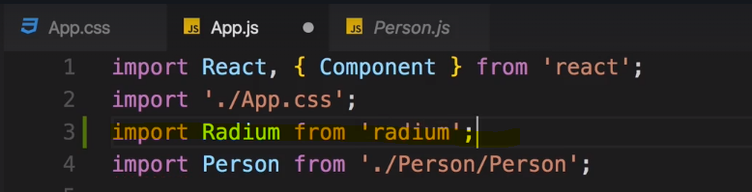

Now with that imported, you can scroll all the way down where you export your app and there you can call

radium as a function and wrap your app with it.

Now this is called a higher order component

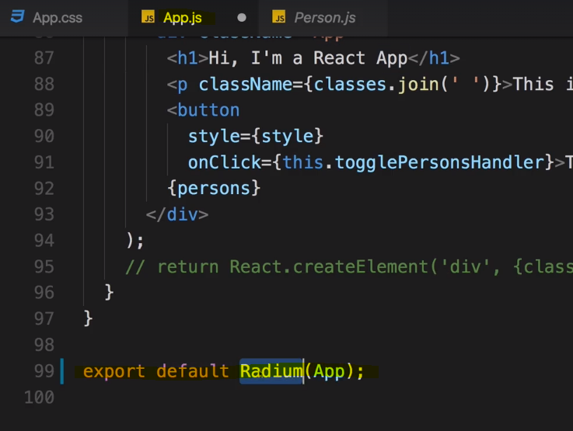

It might look super fancy but in the end it's just a component wrapping your component adding kind of

injecting some extra functionality,

in this case some extra syntax which will parse your styles and understand some extra features you can

now start using.

You can use this on any components created with class and extends component as well as functional components,

Now with that added, we can start adding or using some new features and we of course do this in our style

because radium is all about styles.

I want to add a hover style and with radium added and wrapping your export, you can simply add a new

property ":hover" or any other pseudo selector.

All pseudo selectors are supported,

you need to wrap them in quotation marks though because since they start with a colon, they are not

valid javascript property names, as strings as they are though. As you know, you can create javascript

properties as strings or if you don't have an invalid character in them

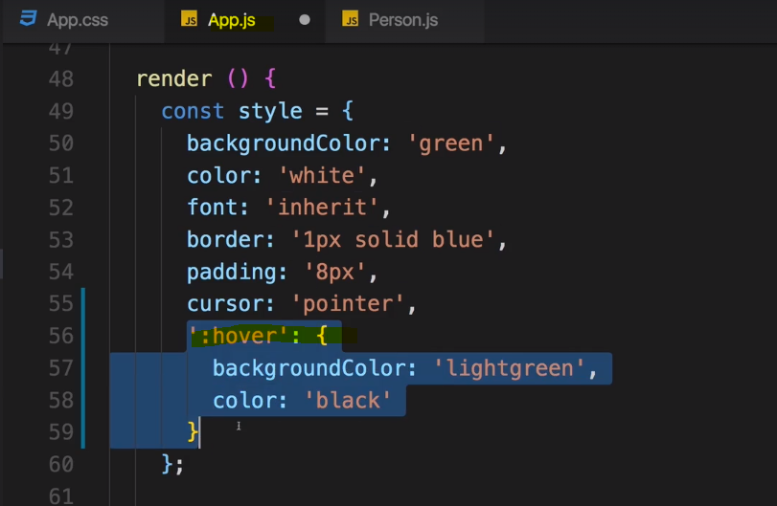

And I will also of course overwrite hover down there where I overwrite my background color, there

I will simply set style and now not dot hover because it's a string,

we need to use square brackets.

So here we then assign a new value

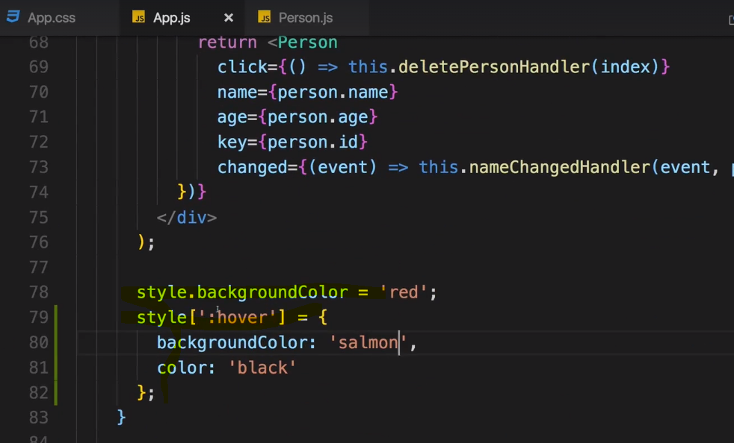

So this is pretty cool because now you have the best of both worlds,

you have the normal css pseudo selectors you can add and you still have scoped styles which you can

easily edit from within your javascript code, as you can see here.

Now radium doesn't limit you to using pseudo selectors as we did,

you can also add media queries.

### Using Radium for media queries

we could of course easily add a media

query here

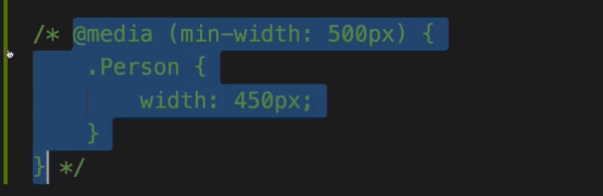

 but I don't want to use my css class,

I want to show you how to do it with radium which you might need in some occasions

if you want to scope it to a component or if you want to change it dynamically.

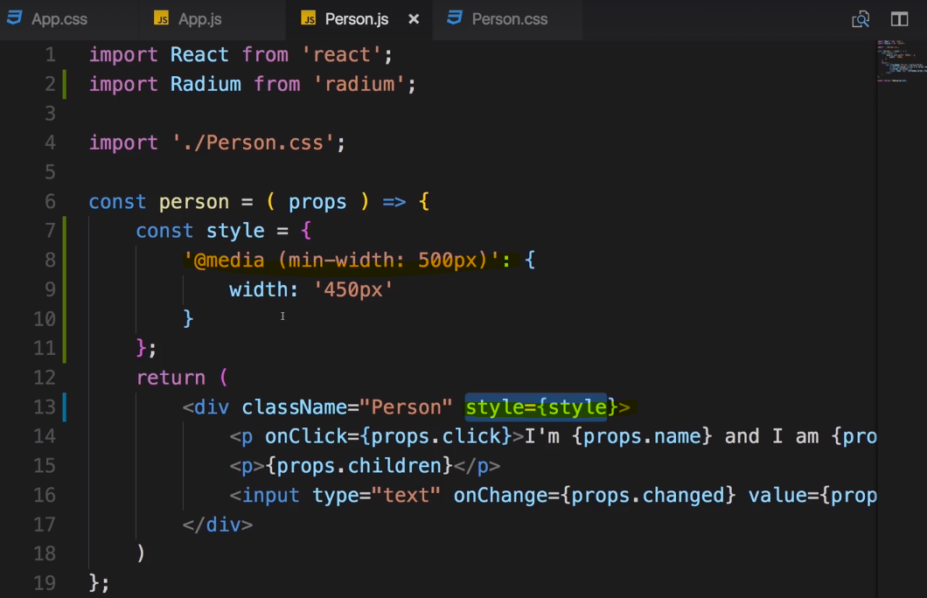

I know this looks super weird

but since it's a string, it's a valid name and radium will parse it

and of course understand it because it's a media query and among pseudo selectors, it is something

radium understands.

now I want to assign this to my component here, I want to assign the style and I do have my class added

but I also have my style which will overwrite my class setting, by default css rules not because of

radium.

And now we should see the following if I reload the application or toggle the persons,

now as you can see we now get an error that plugin requiring addCSS for example when using keyframes

or for us important media queries,

we need to wrap our application in a style root component.

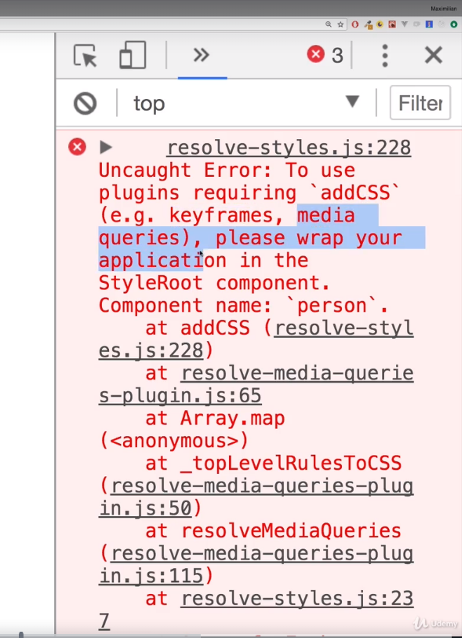

This is a component made available by Radium and whilst wrapping the export with radium is enough

for its pseudo selectors, for basically transforming selectors like media queries or other animations

with keyframes,

we need to wrap the entire application in a special component provided by Radium.



**There, we can simply import style root from radium with this first radium import here, we're importing**

**the default export of that file and then we import a named export style root**

So what we can do is we can simply go here , the return statement and simply wrap

everything, the whole div with the class name app into style root like this.

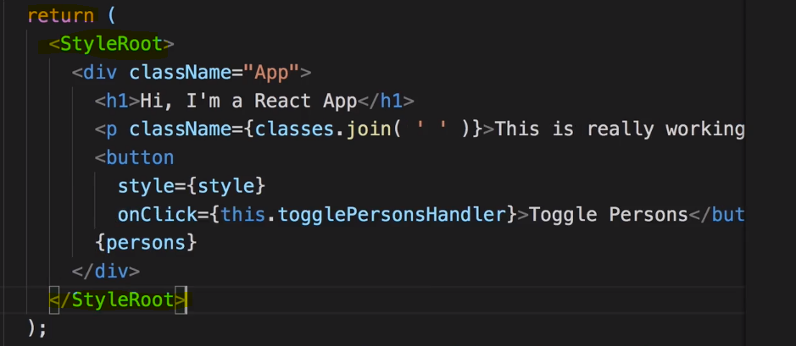

Important,

wrap your entire application in the root component only there with the style root component provided

by radium, so that you can safely access advanced features to call it like this, like media queries. For

pseudo selector alone, you don't need to do that whichever feature you use,

you have to wrap a component where you plan on using radium features like media queries, like pseudo

selectors,

you have to wrap the export with the radium function basically which you import from the radium package.

## CSS Modules : Enabling and Using

Over the last lectures you learn about radium, one third-party package which is very popular which allows

you to use inline styles with features like media queries.

Now that's one way of scoping your styles, being able to easily edit them and still use features like

media queries,

it's not the only way though.

Wouldn't it be great if a css file like the person.css could be scoped to

the person.js component file, so that whichever styles we define in here could be imported and

assigned to elements in this component and wouldn't overwrite styles in other components or other parts

of the app

even if we were to share the names of the css classes. This is actually possible and it's actually

possible in the setup we use here.

We can use a feature named css modules

Now I want to handle everything through scoped css files and to do that, we actually need to tweak the built

configuration of our project.

we're using these react scripts, that this is a package which

exposes the whole build workflow to us and we can't really add it to the configuration.

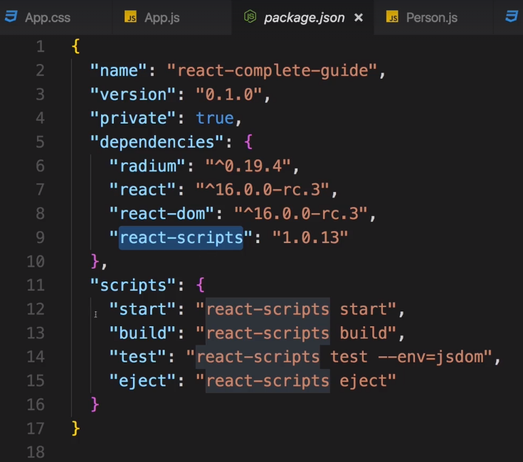We could dig into the

node modules folder, search for this package and edit it there,

but this is something you should never do, because every time you rerun npm install, your changes will be

overwritten.

Thankfully, there is a command which gives us access to the configuration though, eject.

**npm run eject** - to basically convert your

everything is managed

for me project into everything is managed for me but I can edit the configuration project.

Now

there won't be a way back but it shouldn't break, it will still work in the same way it did before

but you can then edit the configuration.

Of course, this should be done with care because you don't want a break to set up.

**Note** - One important note if you're using git to track your changes, make sure you add and commit all changes

before you run the eject command,

it will not work otherwise.

Lets run eject command -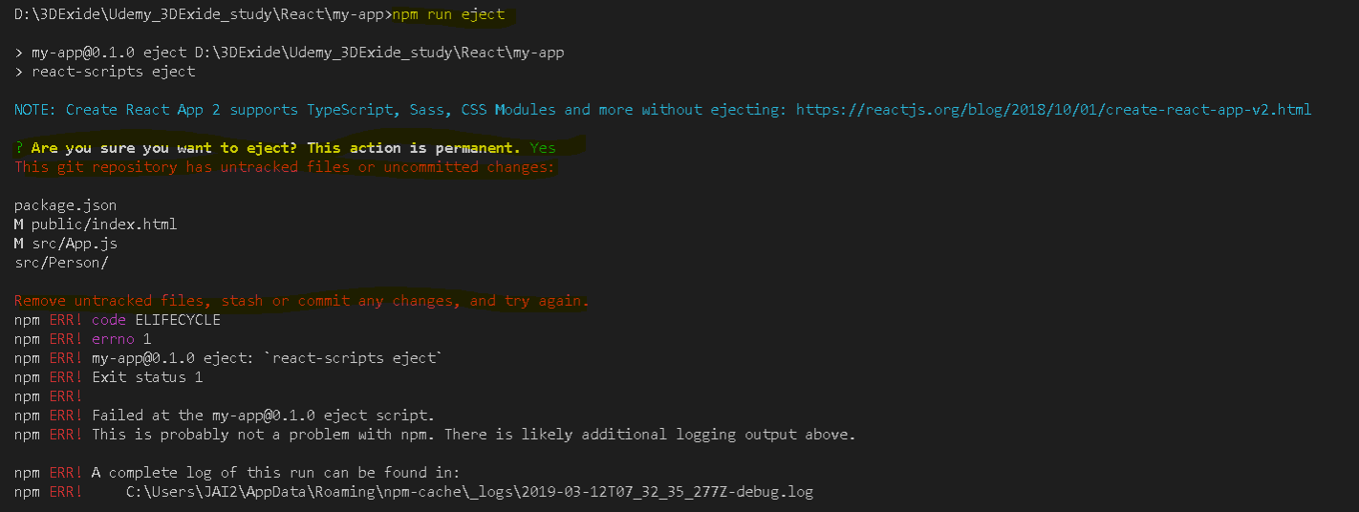

Solution –

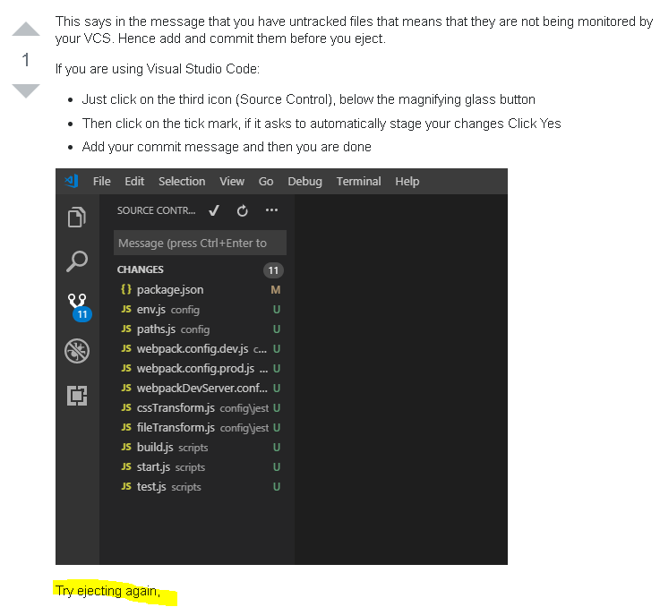

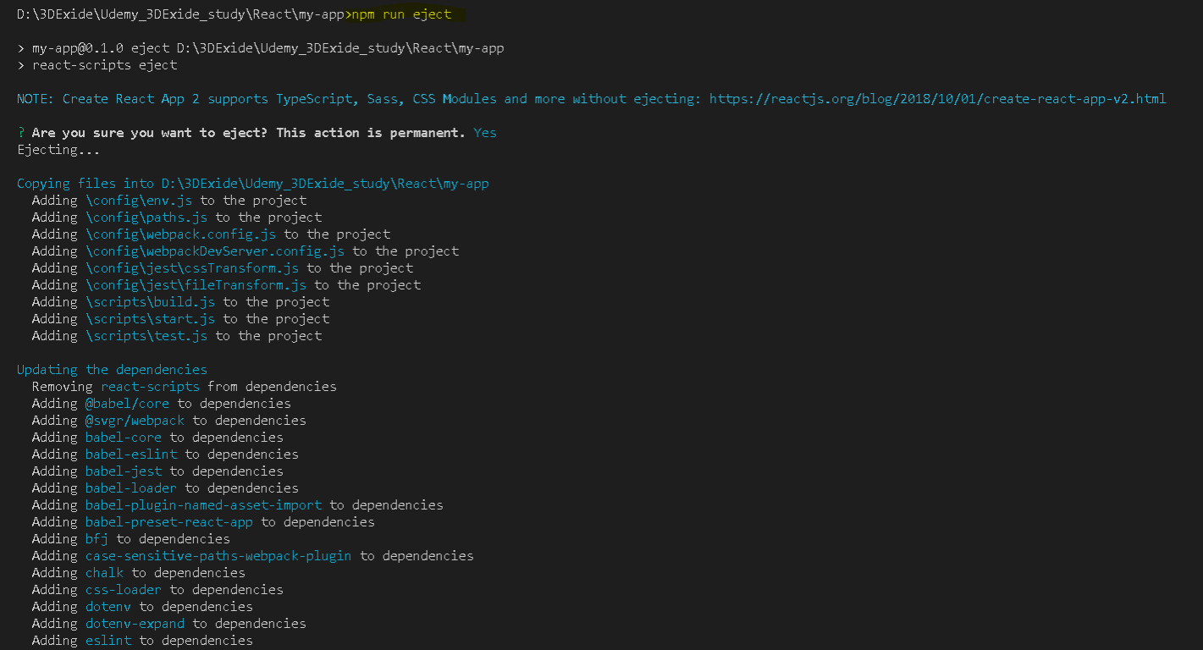

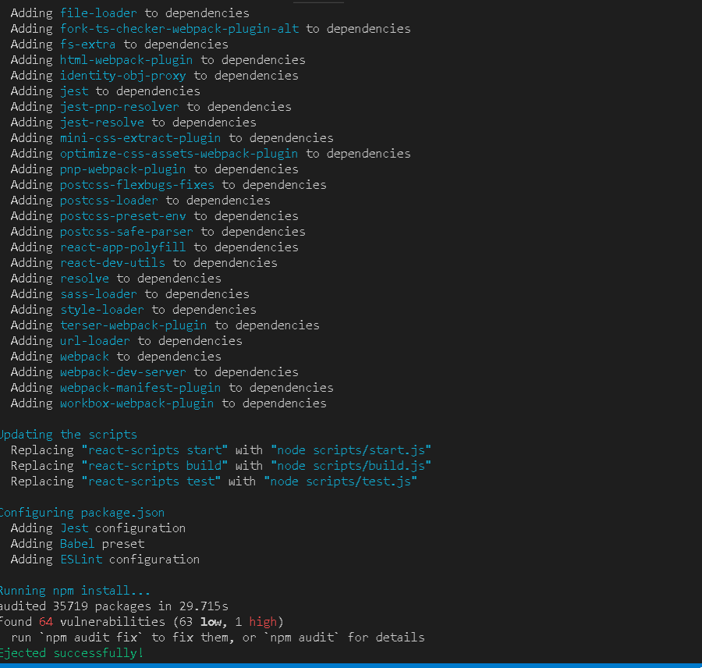

When we're done.

And now, all of a sudden we see new folders, the scripts folder and the config folder.

Now the scripts folder has one script for each command we had in the package.js file, you

also see that our list of dependencies grew by quite a lot because now we see all these

development dependencies which are used under the hood,

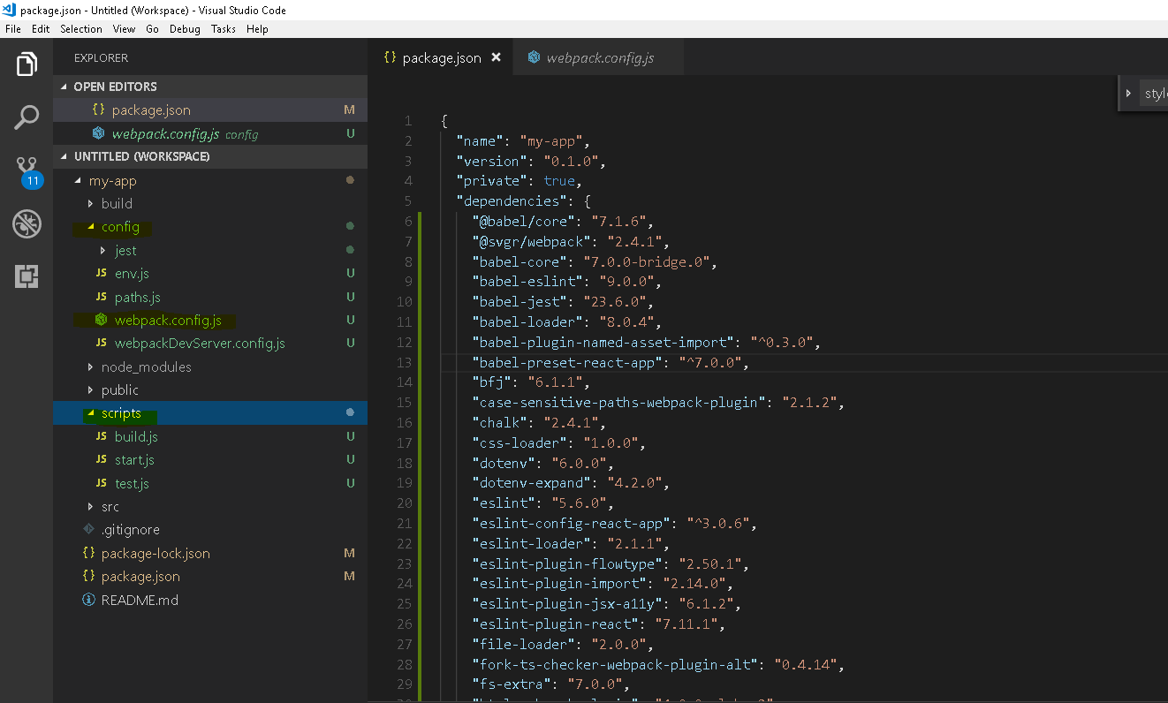

Babel for example is responsible for compiling

ES6 to ES5.

Now no worries, we won't dive deeply into that configuration,

we won't tweak it,

it will still work.

However for us interesting in the config folder is the webpack.config.dev and webpack.config.prod

file. Webpack is basically the build, the bundling tool which gets used, which applies

all kinds of transformations and optimizations on our files and bundles them together and as part of

this process, it also takes care about our css files.

Remember that I said that it's webpack which is able to parse this css import in our javascript file. Well

since webpack is the one responsible for this, webpack is the place where we can now also adjust the way

we handle css files and where we can unlock this extra feature

For that and the webpack.config.dev

file, we should scroll down to module and then down to the module where you can spot the css extension

here where you test for css files.

There we then use these css loader and we don't need to edit that and we shouldn't edit this but we will

tweak the options here for the css loader.

There, I will set modules to true, css loader is a tool which simply parses and converts

our css, extracts it and store is it and it supports css modules,

a feature I will show you how to use in a second.

This is one part, setting modules to true

you also need to add a localIdentName with a capital I and capital N

and now you should add the following string here which might look cryptic but which in the end is important

for your styles,

your css classes getting unique names per component so that that don't overwrite

each other application wide.

Here you should use square brackets,

name, this will basically be your css class name. __local,

this will allow a css loader to assign it to a local component, to scope it basically and then

__[hash:base64:5], this will basically give it a unique hash to make

sure you don't overwrite your styles across your application

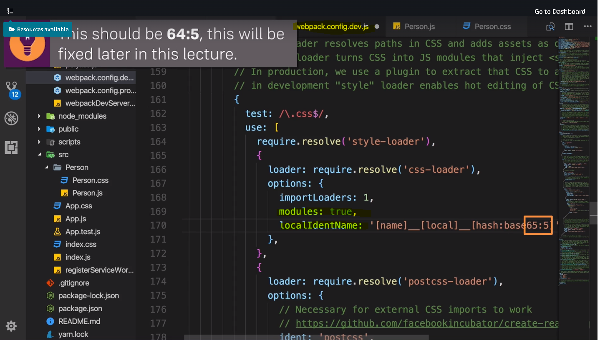

Do that for prod also - 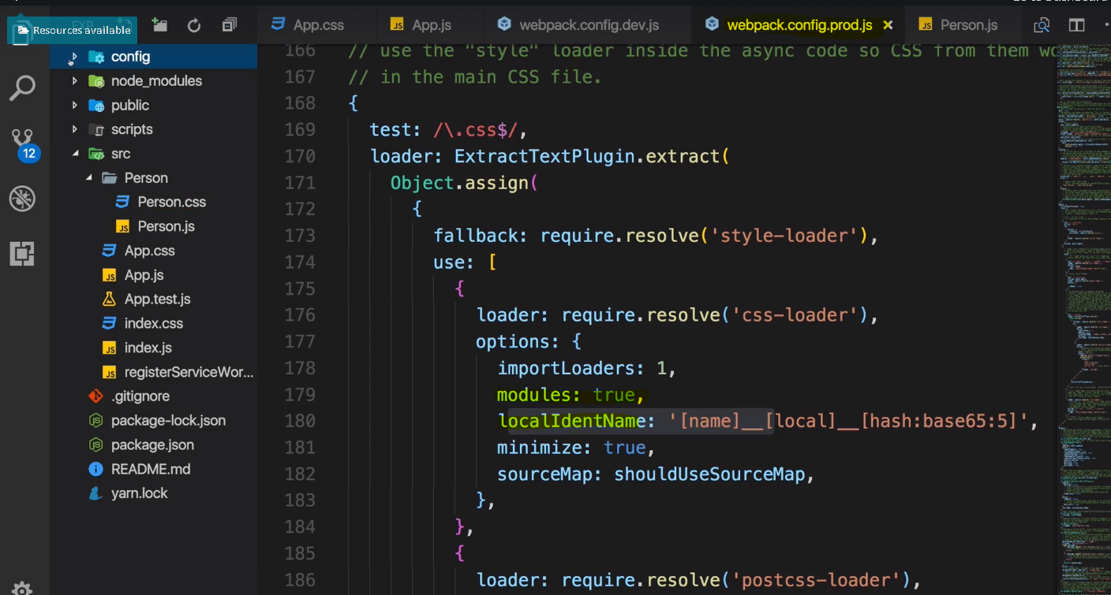

With that one important thing changed when we import app.css, It will now actually scope the css classes

in this css file to this component where we import it, to app.js in this example.

So here if we have the classes app, red and bold, we can now import them from our css file,

we also need to tweak that import statement there for all import classes from app.css, this name is up to

you,

you could name it styles, whatever you want.

I'll pick classes because it will be object, a javascript object containing these css classes as properties,



it is magic done by the css loader which allows us or which basically transforms

the css code in our css file to an object we can use in the javascript file.

this allows us to now go down to the place where we use a class like here class name and no longer assign

a string here

but reach out to the classes object we are importing and there app for example,

simply a property named app,

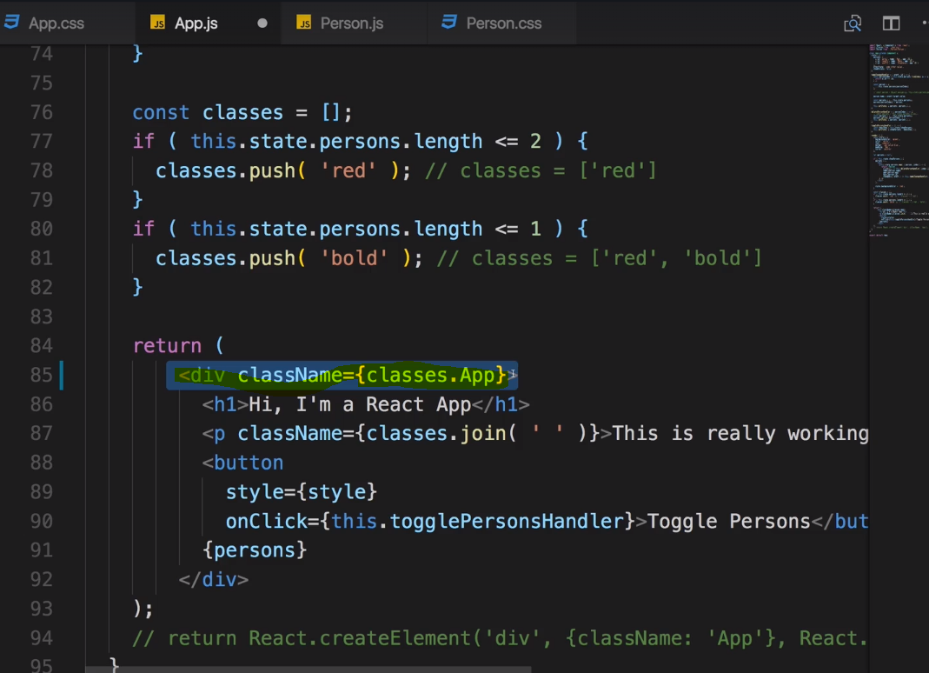

**This will refer to this class and apply it and its styles to this div.** 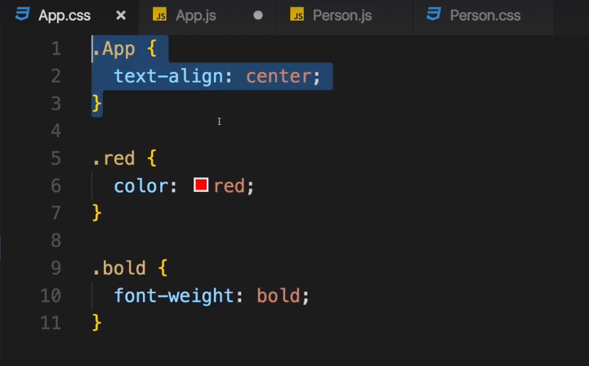

Now the css loader of course doesn't do any real magic here,

instead what's happening here is that the css loader transforms the css class name

we set up in the css file into a unique one using this localIdentName pattern we set up in the webpack

config file where it essentially takes the class name we defined, the file name of the javascript file

where you import a class and some random hash to generate a unique css

class name and then it simply stores all these unique class names it generated in this javascript

object you import, and it stores them in the properties where the property names are

your original css class names. So the values of these properties like here for a classes app are

simply the unique class names generated by css loader,

this is how this works behind the scenes.

**we never restarted our development server when we change something in our react application but if we changed the configuration**

**as we did, we have to do that.**

**this should work but now it will take these new configuration into account and reload this page once.**

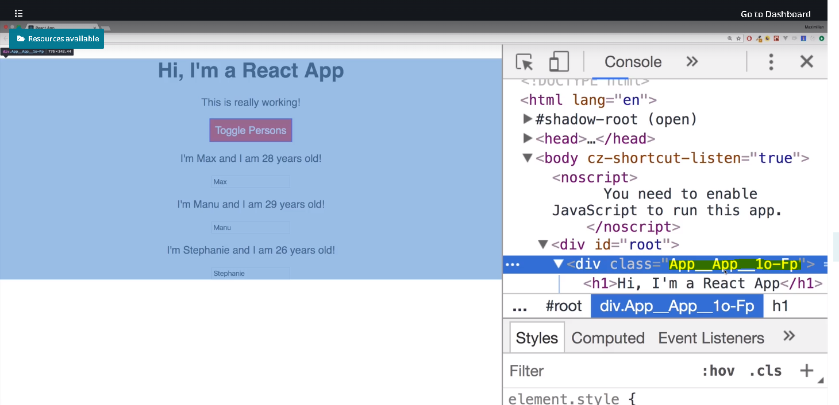

you see that strange name? That basically is a unique name because it's still css running

in the browser

but by having these automatically generated unique name, only this div has this class and even if you

were to reuse this app.css class anywhere else in the app, we wouldn't get the same styling because

it's scoped to the component where we import it.

If we want to make this CSS file work for another component also then

We need to import classes from person there to or any other name you like and now assign it as such,

so not person as a string but they're simply classes.person using the css that

you have here as the name of the property.

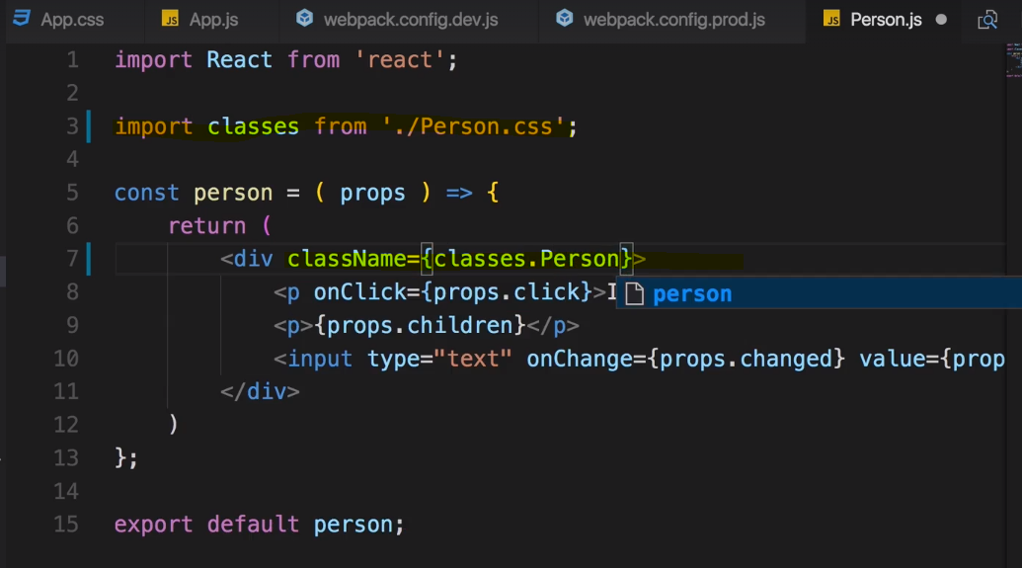

### Important points

**CSS Modules** are a relatively new concept (you can dive super-deep into them here: <https://github.com/css-modules/css-modules>). With CSS modules, you can write normal CSS code and make sure, that it only applies to a given component.

It's not using magic for that, instead it'll simply **automatically generate unique CSS class names** for you. And by importing a JS object and assigning classes from there, you use these dynamically generated, unique names. So the imported JS object simply exposes some properties which hold the generated CSS class names as values.

**Example:**

**In Post.css File**

1. .Post {
2. color: red;
3. }

**In Post Component File**

1. import classes from './Post.css';
3. const post = () => (
4. <div className={classes.Post}>...</div>
5. );

Here, classes.Post  refers to an automatically generated Post  property on the imported classes  object. That property will in the end simply hold a value like Post__Post__ah5_1 .

So your .Post  class was automatically transformed to a different class (Post__Post__ah5_1 ) which is unique across the application. You also can't use it accidentally in other components because you don't know the generated string! You can only access it through the classes  object. And if you import the CSS file (in the same way) in another component, the classes  object there will hold a Post  property which yields a **different** (!) CSS class name. Hence it's scoped to a given component.

By the way, if you somehow also want to define a global (i.e. un-transformed) CSS class in such a .css  file, you can prefix the selector with :global .

**Example:**

:global .Post { ... }

Now you can use className="Post"  anywhere in your app and receive that styling.

### Psuedo Selectors

Pseudo selectors are important here in the app.js file where we assign a button style,

we could now create a button

css class which we then assigned to the button or we simply create a normal css rule for

every button nested inside our app class,

we can now assign the styles we want.

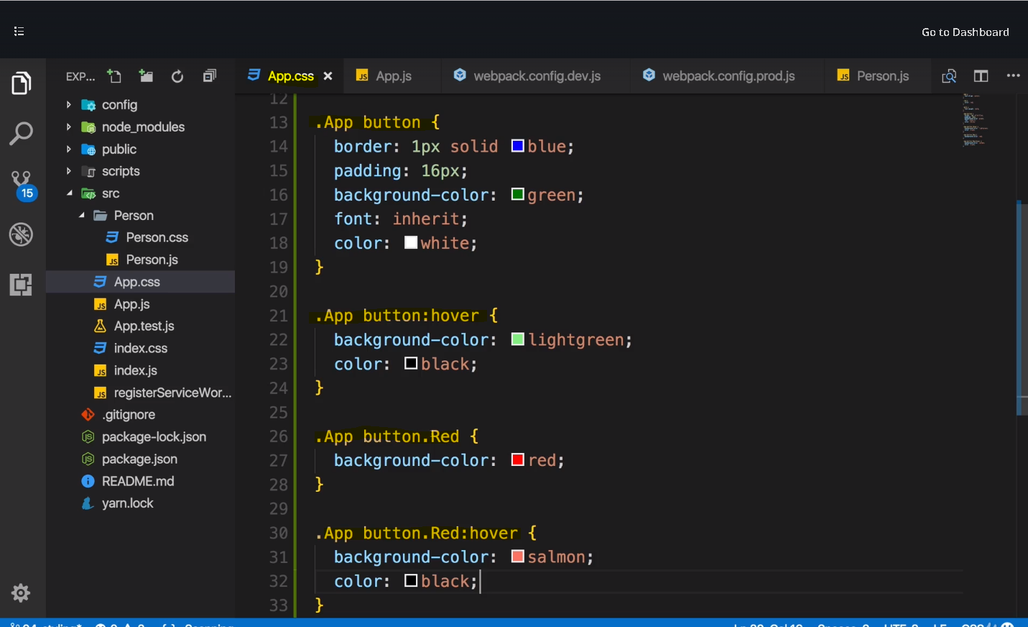

Now all we need to do is conditionally add the red class to this button if we need it,

so back in app.js, we simply need to bind the class name of the button.

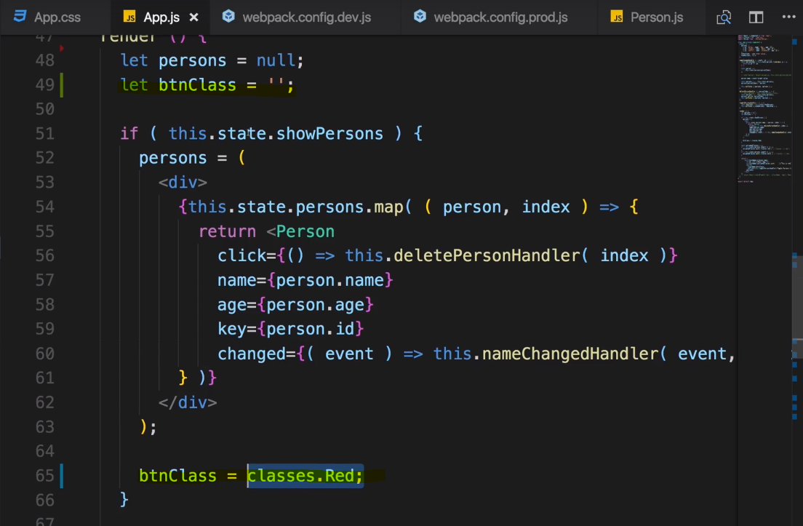

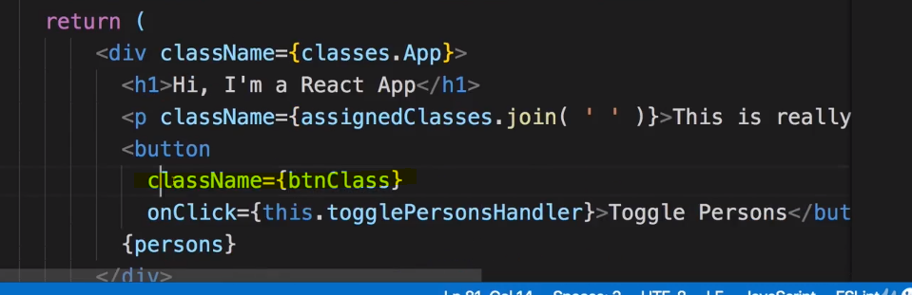

**Now one important note,**

**button class always needs to be a string if we assign it to class name and classes red in the end is**

**just a string created by the css loader which gives us still access to the class like this but in the end returns**

**a string with the valid css, or it is an empty string**

**if we're outside of this if condition.**

So any css class we define in css file

we import with that css modules enabled, any classes defined in here even if they only apply to a

special sub-selector are available on the classes object

we're importing from that css file.

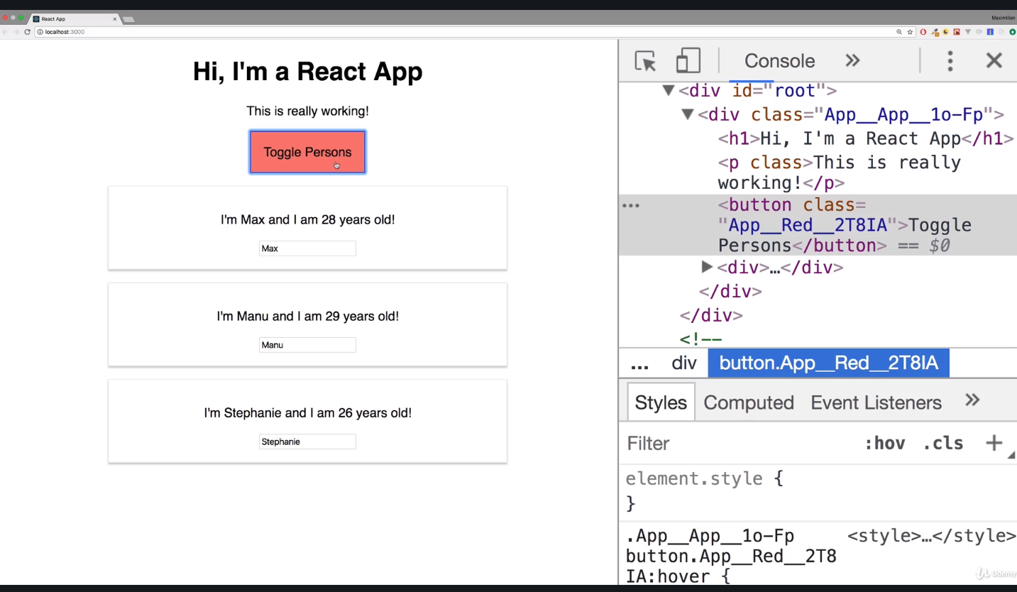

### Media Queries

I assign the person css class to the outer div and I actually already added the code earlier.

I will simply comment it in, some normal css media query adjusting our Person class with this

width if we have a viewport being broader than 500px.

it will still import this person class

fine on this classes object here,

even if it's wrapped inside a media query.

**So it will work directly no need for change**

So that was super simple and what can be kind of challenging to wrap your head around css module,

simply think about this classes object here as a javascript object which gives you access to a string

version of your css styles, of your css class but of a css class which was adjusted to be unique.

So it will simply just translate your person class to something like.

Person_

some unique cache, so that you can be safe and sure that when you use that class in a given

component, that's the only place where the css styles apply.

No where else in your application can these styles have any effect,

that's the idea behind css modules.

# Debugging React apps

## Understanding Error Messages

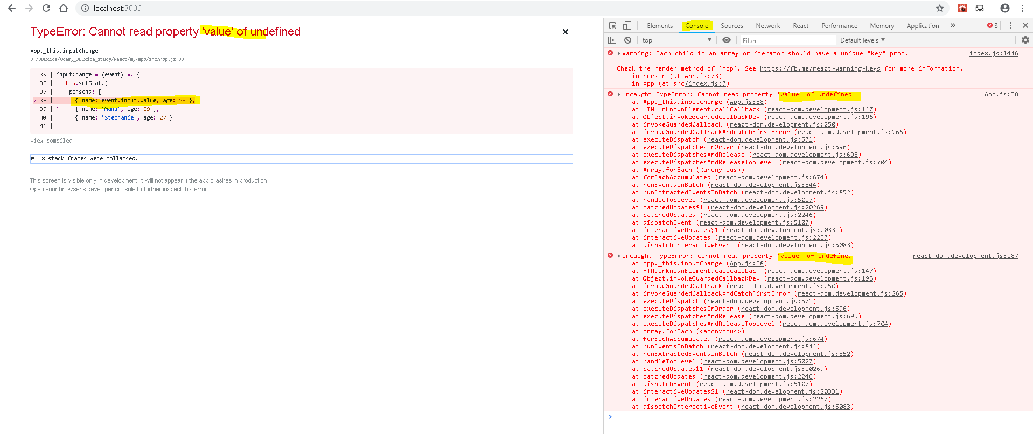

so this part here, is undefined which is the case because there is no input property on event.

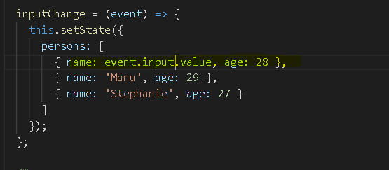

Now you still need to figure out the **target** is correct on your own

for example by looking into the event documentation that's the you can look into the normal html

input event documentation

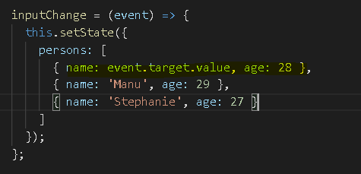

but you get a clear clue about what went wrong and where.

Now sometimes error messages are less helpful than this one is, even if the error message itself is cryptic.

Most of the time you should get a helpful line number which allows you to go back into your code and

try to find out what's wrong about this line,

this should be helpful and should allow you to fix the value.

This is how you react on react error messages.

## Finding Logical Errors by Using DEV tools and Sourcemaps

In the last lecture, we had a look at error messages, certainly important but oftentimes you have logical

errors which are even harder to spot.

You don't get the error message but somehow it's not working.

this is incorrect, a person has no user id property.

It will not throw an error though because user ID is undefined but you can compare undefined to something

you probably just won't find a fitting person.

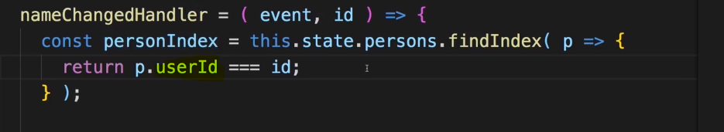

so if I save this code and we go back to the application, if we now start typing, we don't get an error

but I can type as much as I want,

it won't update,

I don't even see my updated value here because I broke the two way binding because I'm not correctly

updating the name of this person.

Now what can we do in such a case?

We can walk through our code step by step,

for that I recommend using the chrome developer tools.

There you can go to the sources tab, in the sources tab you will find your code structure shown under localhost,

there you will find a source folder and you actually find your code here.

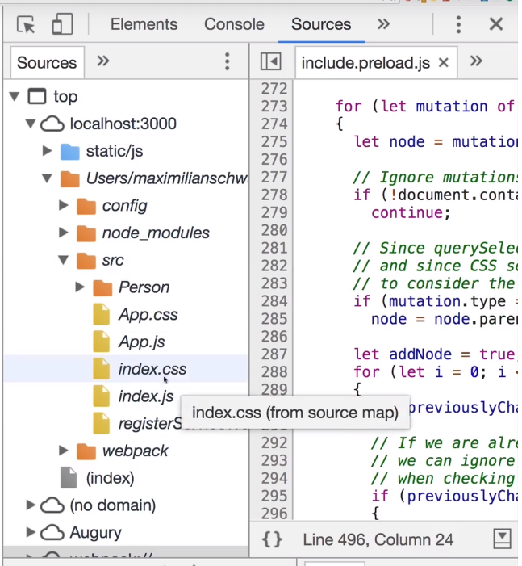

Now this is possible due to source maps which are generated.

**Basically you could say translation files allowing the browser developer tools to go into your code as you wrote it and allow you to debug that code even though the code which is shipped to the browser will be a different one, an optimized and bundled one.**

This is pretty cool because you can debug the code you wrote even though it's not the code running in the browser.

So in there, we know something's not working when I type here

and as we wrote the code, we know that the nameChangedHandler is getting fired when we type.

So let's place a breakpoint by clicking on a new line number here

and let's start typing again.

I typed one character and that's now pausing this

and now we can use the normal chrome debugger tools here to walk through our code.



So now inside there, we can have a look at the data

we have available there like the p object.

Now we see this is for Max, this is the object it's currently looking at with find

index and we have an idea of asfa1.

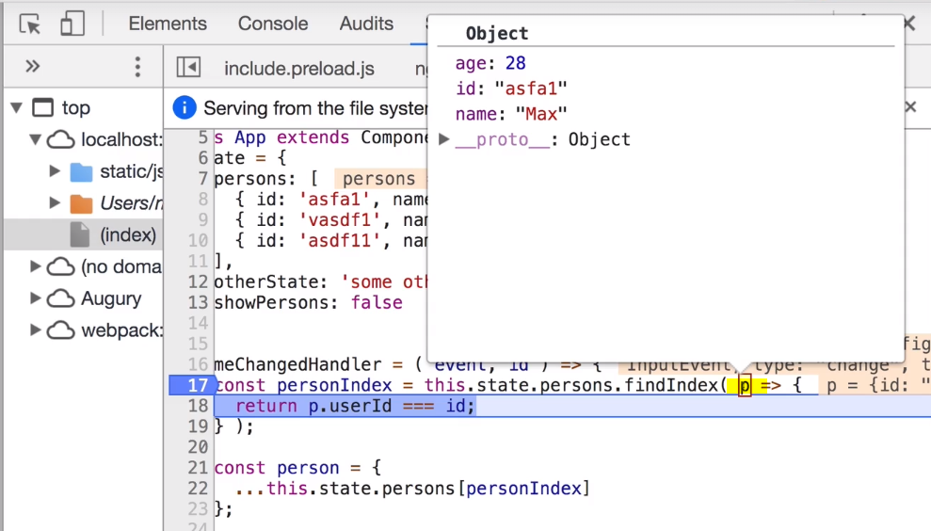

We also see that this expression here is undefined though and we compared this to an id of asfa1

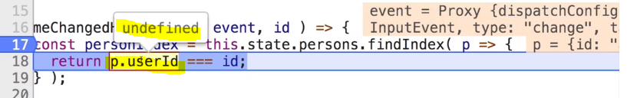

we can clearly see that user ID is not a valid ID because if we hover over the person again, we see

there only is ID object, no user id object. With that information,

we can now exit this process go back to our code and fix our logical error.

**So using the chrome debugger tools with source maps which are generated for you automatically is a powerful**

**feature for detecting logical errors.**

**You can walk your code as you wrote it, even though that's not the code running in the browser.**

## React Developer Tools

Sometimes you want know the current state of your react component or props passed to component

and while you might be able to figure that out with the developer tools, it can be inconvenient.

Thankfully there is a cool extension you can add to Chrome, the react developer tools,

You can simply google for react developer tools and you will find the github repository where you can learn

more about them, how to use them and can even contribute to the project or you head right to the Chrome

web store.

Once you added them, you probably need to restart Chrome and thereafter in the chrome developer tools,

you can choose react, this new tab should be available

now. Very cool thing is you now see your react app as you created it,

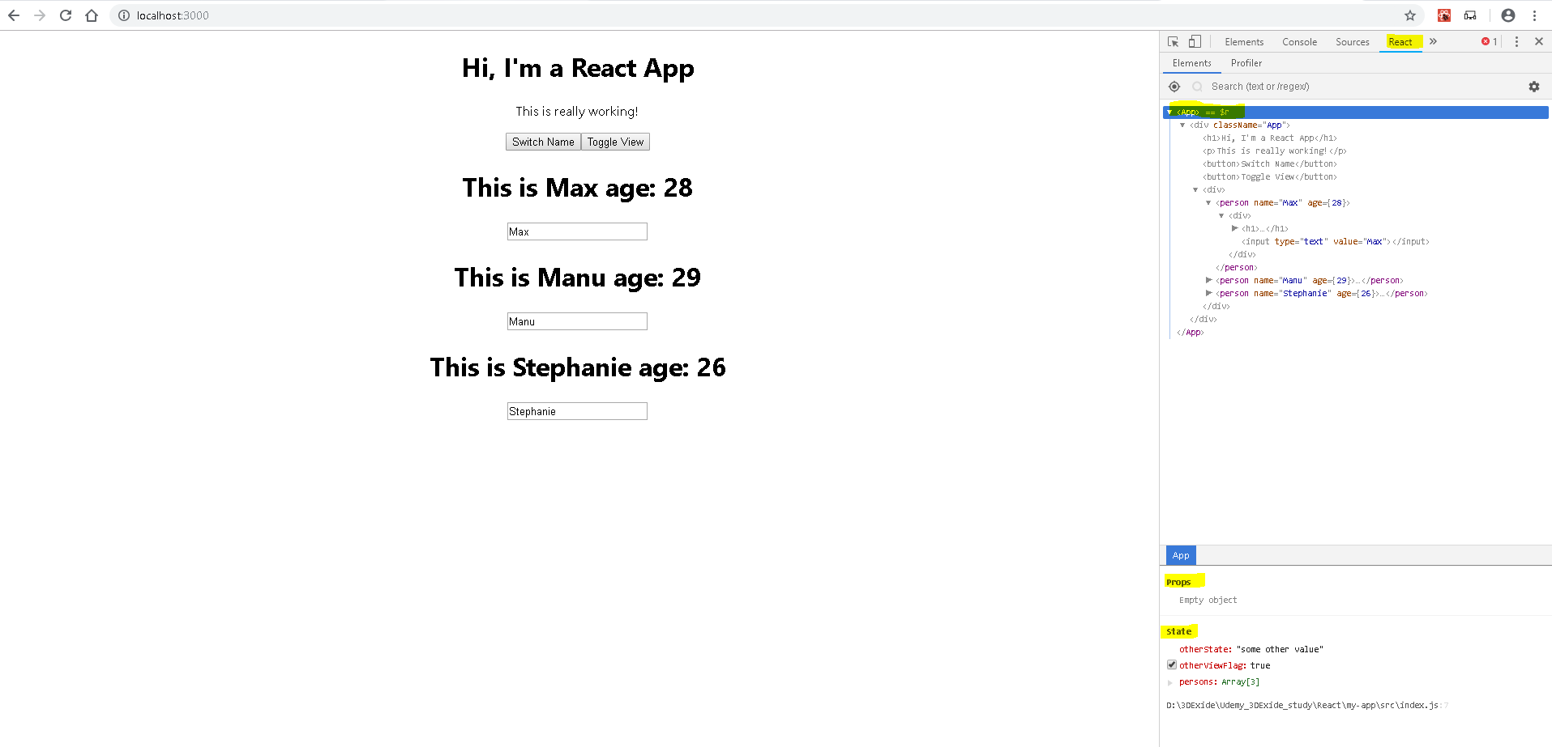

You don't just see the dom elements but you see your components too like the person component here or the

app component.

And down there at the button, you also see props and state of that component,

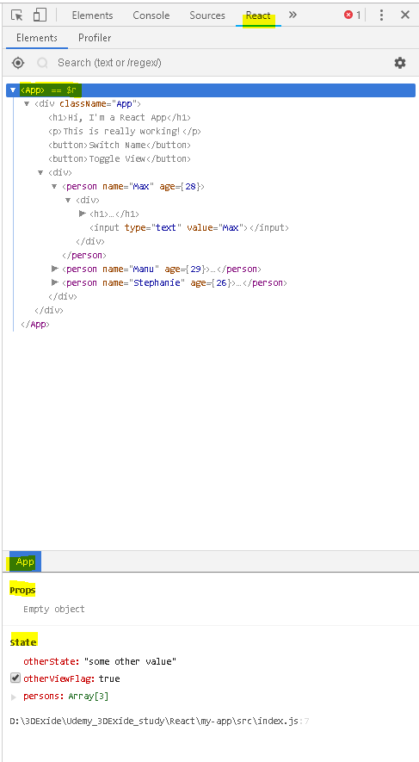

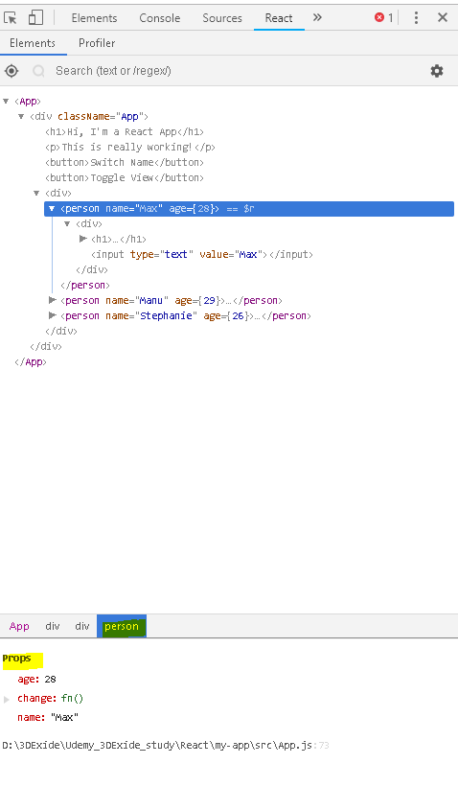

You can also highlight updates

so that you see highlighted here

what changed in your code, like the addition of this class name for example,

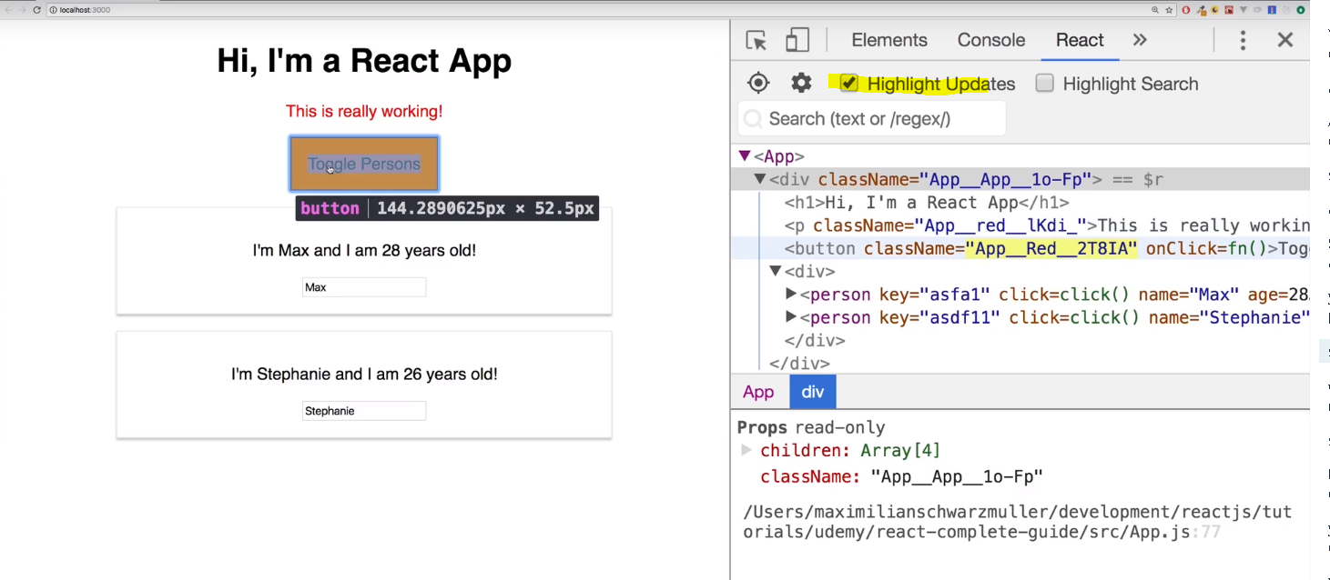

So React Developer tool allows you to quickly understand the state of your components of your app and manipulate it and give

you some insights you can't easily get with the normal developer tools because it goes beyond showing

what was rendered,

it shows you what's behind the scenes, what's under the hood.

## Error Boundaries (react 16+)

 sometimes, you have code which might fail at runtime and you know that but you can't guarantee that

it always works.

In this case you probably want to show a nice screen or at least a custom error message to the user.

A JavaScript error in a part of the UI shouldn’t break the whole app. To solve this problem for React users, React 16 introduces a new concept of an “error boundary”.

<https://reactjs.org/docs/error-boundaries.html>

Error boundaries are React components that **catch JavaScript errors anywhere in their child component tree, log those errors, and display a fallback UI** instead of the component tree that crashed. Error boundaries catch errors during rendering, in lifecycle methods, and in constructors of the whole tree below them.

**Note**

Error boundaries do **not** catch errors for:

* Event handlers ([learn more](https://reactjs.org/docs/error-boundaries.html#how-about-event-handlers))
* Asynchronous code (e.g. setTimeout or requestAnimationFrame callbacks)
* Server side rendering
* Errors thrown in the error boundary itself (rather than its children)

A class component becomes an error boundary if it defines either (or both) of the lifecycle methods [static getDerivedStateFromError()](https://reactjs.org/docs/react-component.html#static-getderivedstatefromerror) or [componentDidCatch()](https://reactjs.org/docs/react-component.html#componentdidcatch). Use static getDerivedStateFromError() to render a fallback UI after an error has been thrown. Use componentDidCatch() to log error information.

**componentDidCatch**, this is a method which receives potential error and some additional information passed

into it automatically by react and componentDidCatch will be executed whenever a component

we wrap with the error boundary throws an error,

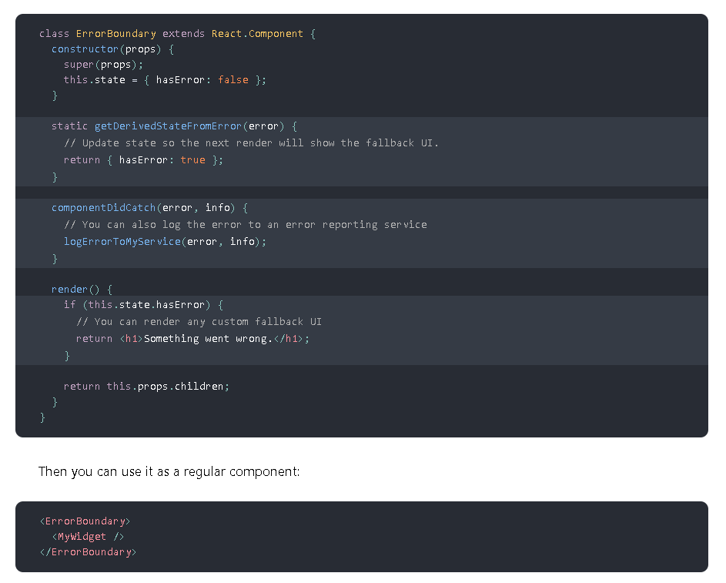

Error boundaries work like a JavaScript catch {} block, but for components. Only class components can be error boundaries. In practice, most of the time you’ll want to declare an error boundary component once and use it throughout your application.

Note that **error boundaries only catch errors in the components below them in the tree**. An error boundary can’t catch an error within itself. If an error boundary fails trying to render the error message, the error will propagate to the closest error boundary above it. This, too, is similar to how catch {} block works in JavaScript.

let's say that when we render a person class, we actually have a chance of getting an error.

in a real application, you might indeed have some code which run some operation, reaches out to some

web server which can definitely fail and you can't guarantee that it does not. It would

be nice to then at least catch this error and handle it graciously.

**Example –**

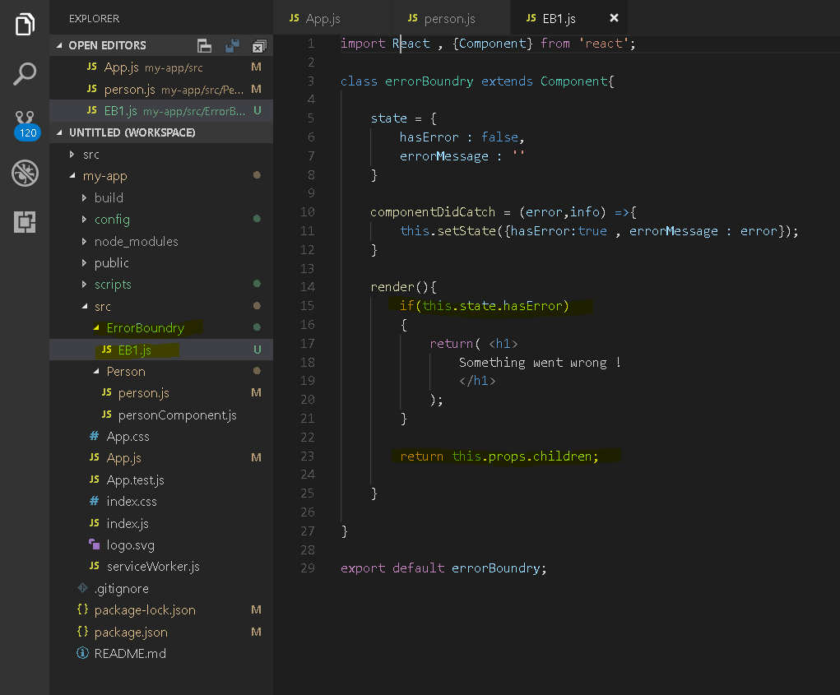

this.props.children is whatever we wrap inside of error boundary,

this should be our default case but if we get an error thrown by something we wrap inside error boundary,

this method here will fire and hasError will be set True and hence we can return this.

**componentDidCatch**, this is a method which receives potential error and some additional information passed

into it automatically by react and componentDidCatch will be executed whenever a component

we wrap with the error boundary throws an error.

import ErrorBoundry from './ErrorBoundry/EB1'

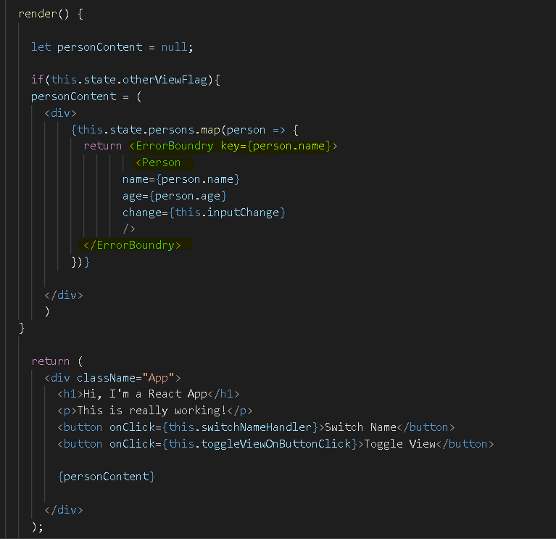

**error boundary** is a so-called higher order component,

it's a component which simply wraps a component with the goal of handling any errors that component

might throw.

Now for Faking error - 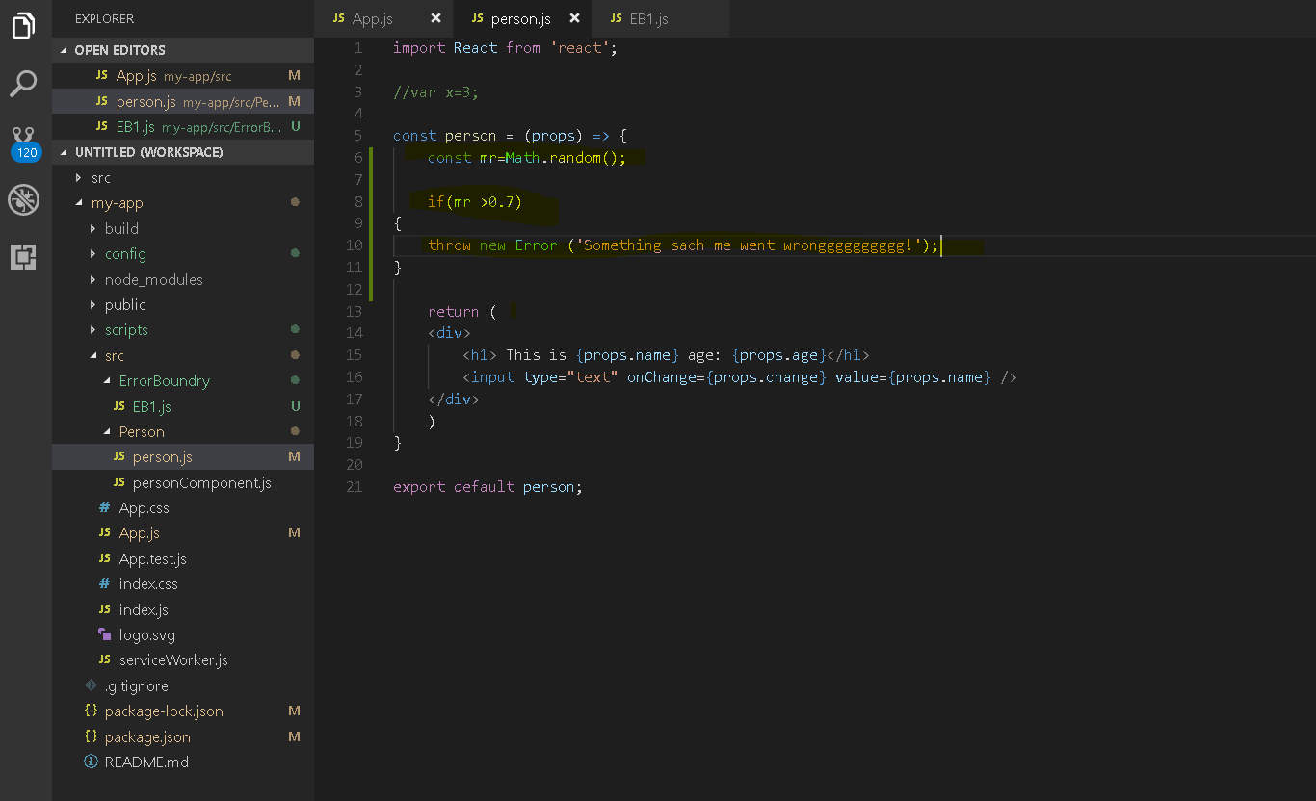

Now if you toggle persons until you get an error, you'll still see that error in the middle here unfortunately.

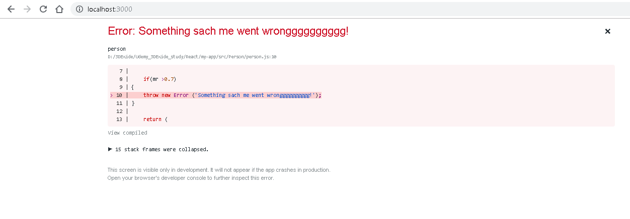

Now that only happens during development mode,

once you've built this for production and ship it to a real server, it will not overwrite your page like this.

Instead what you will then see is you will see whatever you render inside your error boundary like the

error message or any other default message you have.

This does not mean that you should cluster your whole application with error boundaries, only use them when it makes sense.

So basically only use them if you have some code you know that it may fail,

don't wrap any other code because if normal code fails, you as a developer probably made a mistake during development,

only use error boundaries for cases where you know that it might fail and you can't control that.

Then this might be a nice tool for production to show a custom error message and not have the whole

application fail, because the react application will then actually still work fine and only the problematic

component will be replaced with your custom error message.

So error boundary is a nice tool to know, not a tool to use anywhere in your application .

In this module we had a look at how we can read react error messages, that they can be quite

helpful, that we shouldn't get shocked if we see them and that we should always check the line numbers

we see in the error messages.

You also learned how to debug logical errors with the help of source maps and the chrome developer

tools where you can place breakpoints and go through your code.

You also learned how to use the react

dev tools to get insights into the state of your application and you learned how to use the error boundary

here to wrap code which might fail at runtime which you can prevent and then show a custom error message

or some fallback page or content. Don't over use them

but with all these tools, you should have a rich tool set to create hardened and safe and well working

react applications.

# Component – Deep Dive

## A better Project Structure

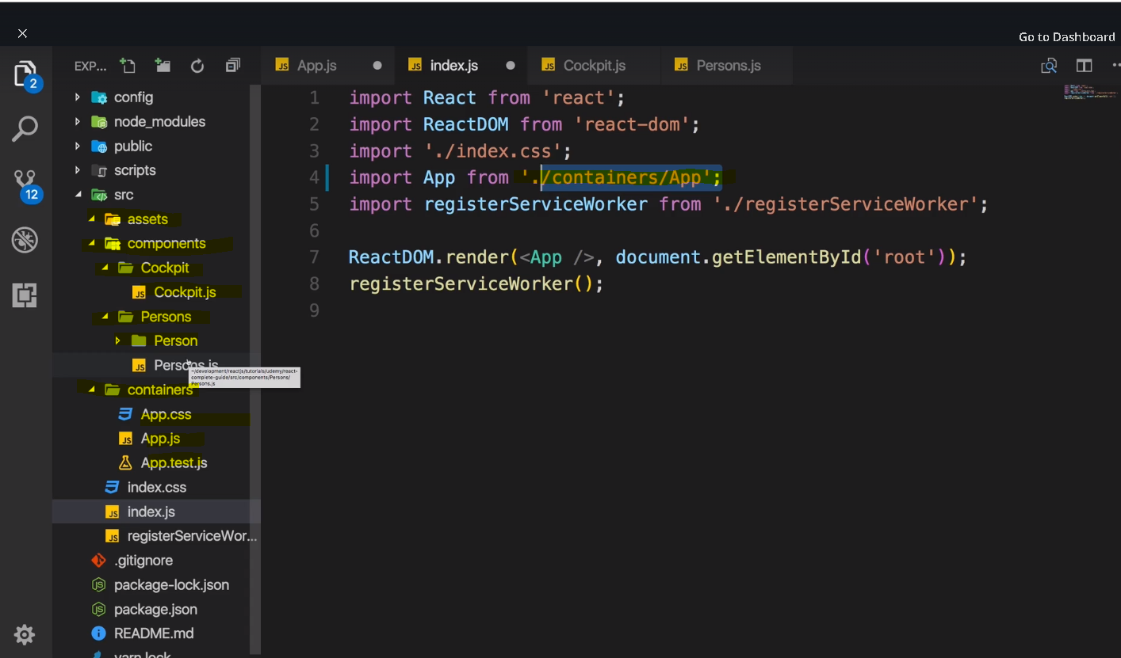

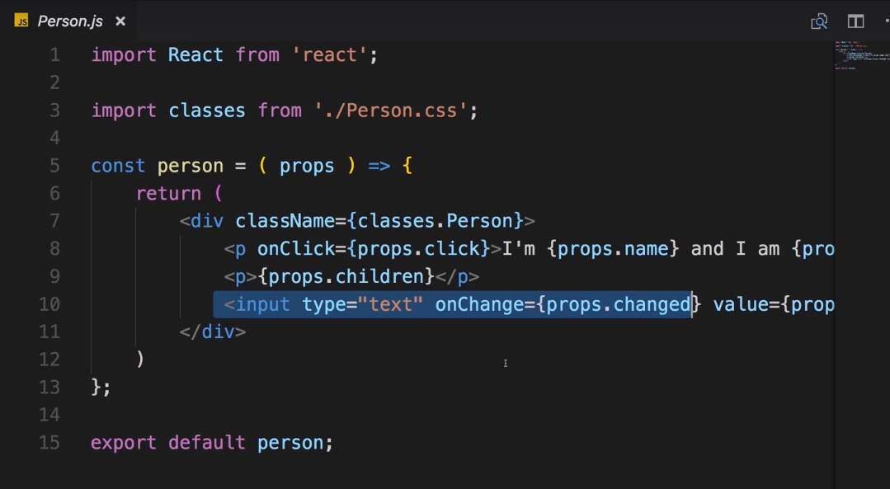

So this component doesn't need any more splitting up, what would you put into its own component?

You could outsource the input into its own component,

that might make sense if you want to create a generic input component across your application where

you really only change the styling.

But if that's not the goal, putting input into its own component doesn't make much sense.

So for us we can definitely leave it here.

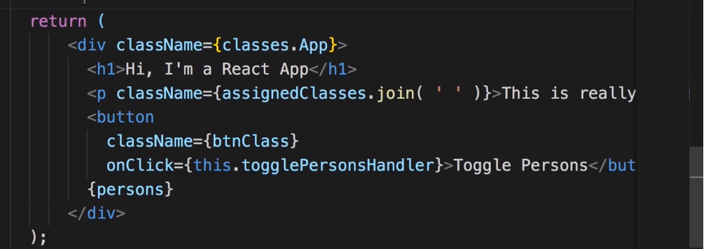

we see that we rendered a list of persons here but then we also of course do have this toggle button.

Now typically container components like the app.js component, so components which also manage state

shouldn't be involved with the UI rendering too much.

Put in other words, the render method should be rather lean and contain not too much jsx.

So whilst it's not necessarily the worst practice to have this kind of app component especially for

a small app like this one is, we might still split this up into more components.

## Splitting an app into Components

if we only want to return something in that function body due to our

project set up and all the ES6 features we can use or the next-gen features in general we can use, we

can shorten this to just return parentheses.

Now this is simply due to the way arrow functions work,

if you write them in one line and this by the way does not mean that you can't split the part inside

the parentheses across multiple lines but you start with that in the same line,

if you only have that one line and not multiple lines as a function body, you can simply start with the

return statement

and if you return parentheses, this is what we got here

since you omit you return statement in this one line notation.

So that's the default ES6 error function notation,

if it's in one line, this automatically gets returned and you can hence omit the return statement.

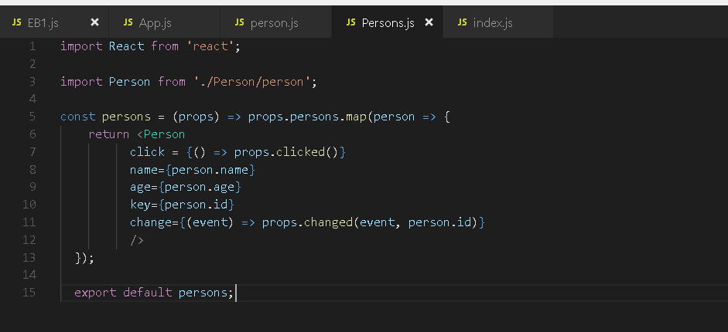

Now we split the app 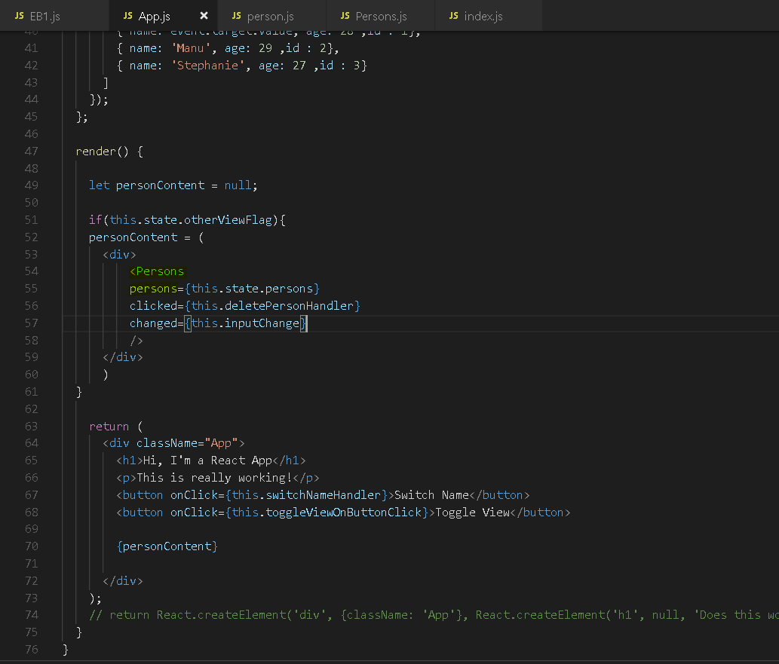

**Note :** Now as you see, this of course throws an error because here we return multiple elements without a root Node and this is not supported here.

Error : jsx expression mast have one parent element.

Now we will dive into ways of supporting this in the next lectures, for now. 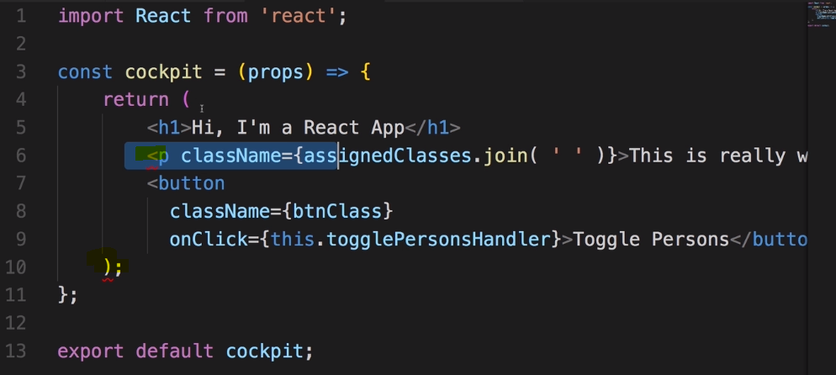

Some alternative

 here we return a list and of course this means

that we have multiple person objects sitting next to each other,

there is no wrapping div but this is okay for React 16, this is a feature which is supported, if you

return a list, that is OK, you just may not hardcode elements next to each other.

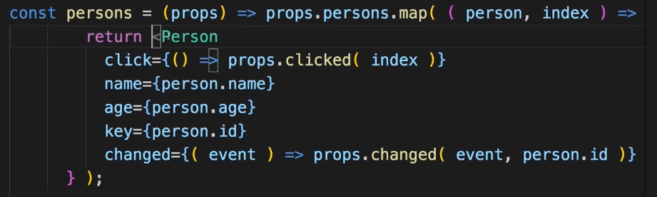

So we split our application with more components , see below-

**App.js**

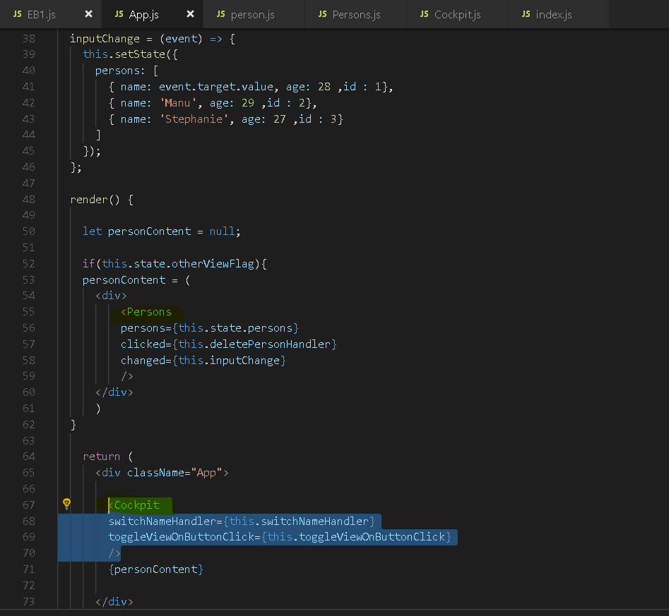

**Persons.js** 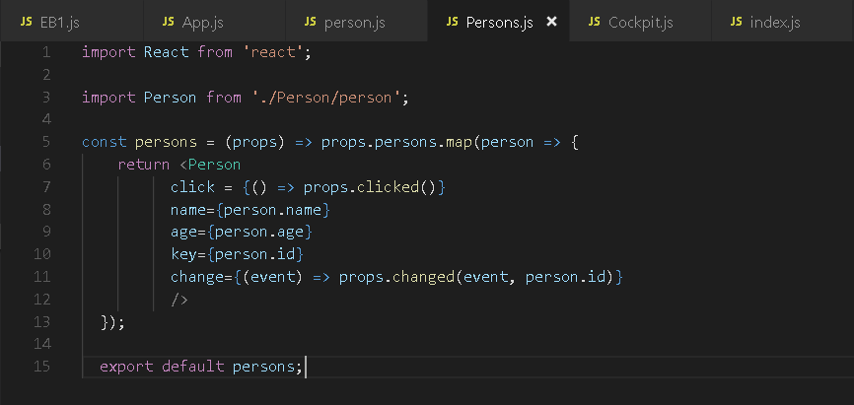

Cockpit.js 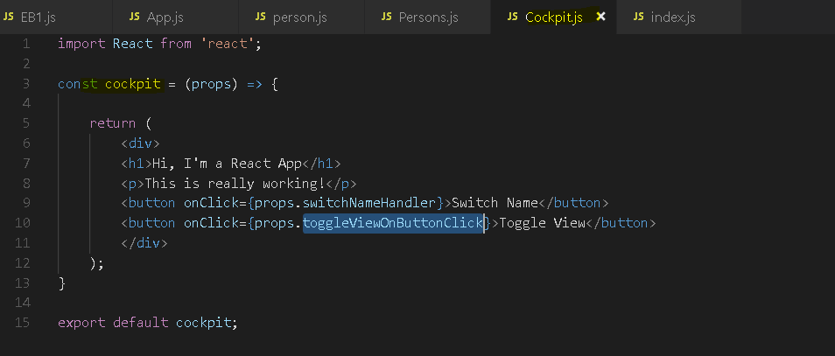

now we get a much better structure

with clearly focused components and this is actually how you should compose and create your React application.

You should have clear responsibilities of your components, have them narrowly focused, create granular

components,

use as many functional components as possible and have your containers be as lean as possible

when it comes to JSX and styling, some containers might not even have a style file because they only

import other components which then do the styling.

So this is a very lean setup here which allows us to have a flexible and maintainable application.

## Stateful and Stateless Component

we're referring to stateful components when we're managing state in them, like we're doing in

the app.js. We got state here and we're calling set state to change that state.

Now a functional component that manages its own state with the useState would of course also be a

stateful component, so stateful does not automatically mean class-based component,

though historically this has been the case because React hooks like useState are a really new feature

and therefore, you will still find plenty of applications where state is only managed in class-based

components.

Still since React 16.8, stateful is not automatically a class-based component. It is a component

that manages state, he that with state in a class or with the useState hook.

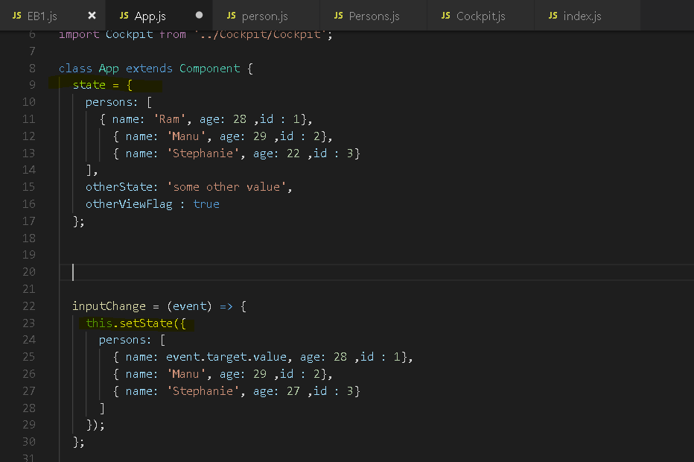

Presentational, also called dumb or stateless components historically have always been functional components because prior to React 16.8, these functional components could not manage state. Since React 16.8, functional components can also manage state with the useState hook

but still, you want to have many presentational components in your app and now what is a presentational component? It is a functional component that does not manage state. Even though you could with useState, it is still a good practice to restrict yourself to a couple of components that are involved in the state management.

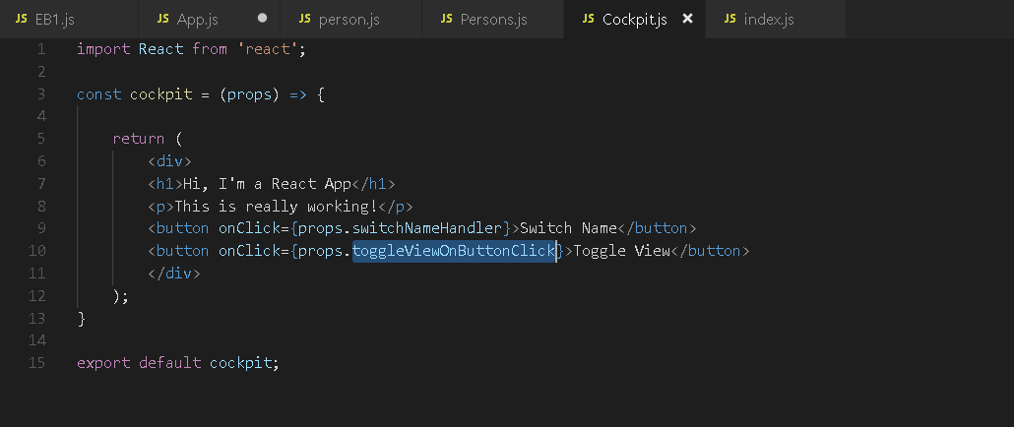

the question of course is why and the answer is by splitting your app into container components which

is another term for these components that manage the state in your app and the dumb presentational components,

by making that split, you keep your app manageable because you have a predictable flow of data, you know

where your state changes, that will be in a couple of components and the other components are only there

to render a nice user interface and they only define on external inputs, on props and that simply ensures

that these components are highly predictable, that you can throw them anywhere into your application

and they work if you pass the right inputs in and as your application grows, you therefore have an easier

time maintaining it.

## Class-based vs Functional Components

With class-based and functional components, it's important to understand which kind of component can

do what, what their history is and what their future is. So class-based components,

with that I simply mean components that extend that component object

we can import from the React package and functional components are simply these functions that take

props and return some

JSX code.

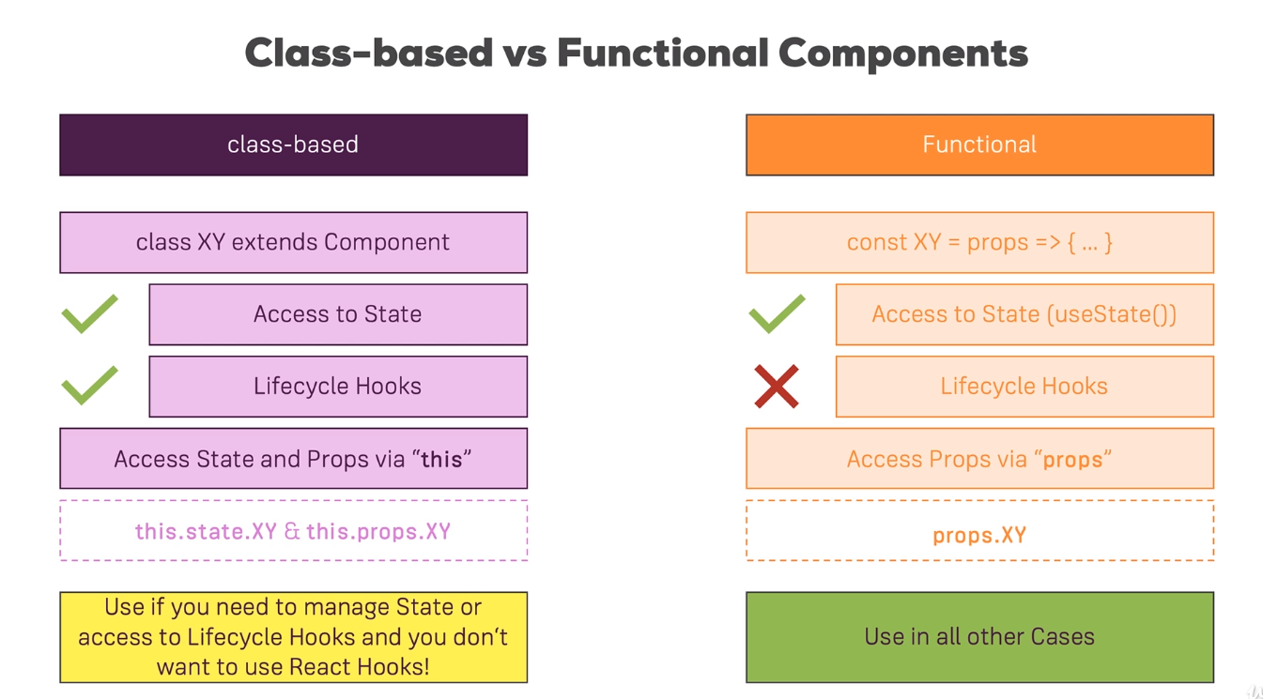

 Functional components,

there it's a bit tricky. In the past before React

hooks were introduced, they couldn't manage state but since React hooks were introduced, they can with

the useState hook.

So access to state is actually possible but lifecycle hooks are still not supported.

What's important to note though that not every React project you might be working on will use the latest

version of React and therefore, it's still important to be aware of the fact that historically, state

management could only be done in class-based components and therefore you had to transform your

components to class-based components if you wanted to access state.

**Now regarding the way we access state and also props, it's important to know that in class-based components,**

**you need the this keyword because state and props are properties of the component class and we haven't**

**used this props yet, we'll do so in this video still but just keep that in mind, you need the this keyword**

**there.**

**In functional components, you get props as an argument and therefore you can just use it like this, like**

**a normal variable in your function.**

**Example –**

**Lets try to use props in class-based component and use it by this.props**

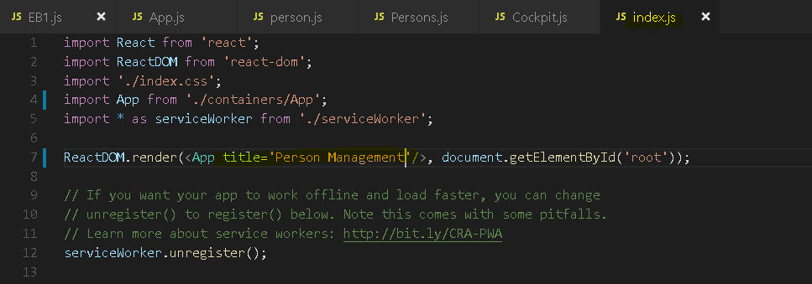

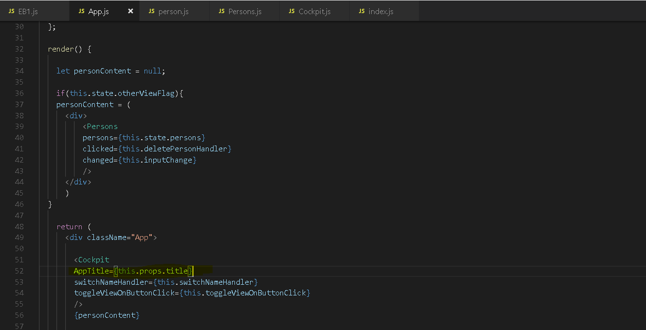

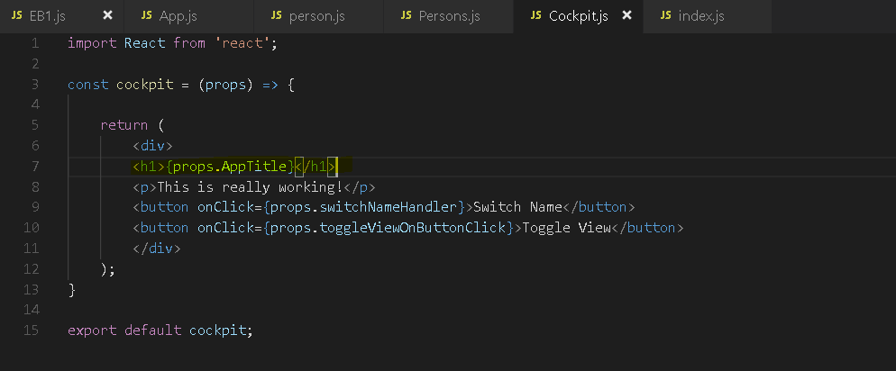

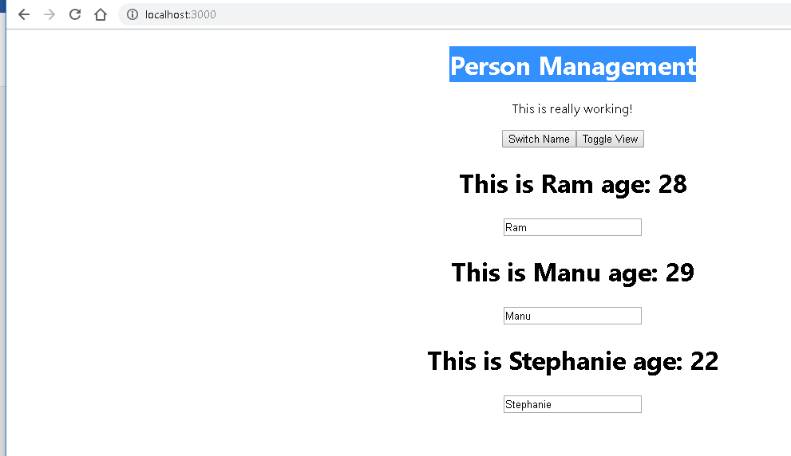

## Component Lifecycle hooks/methods(only available in Class-based components)

**it's only available in class-based components.**

**You will actually learn that functional components when using React hooks have an equivalent you could say but generally, it's only available in class-based components,** that lifecycle and I will

show you both of course, the lifecycle and the functional component equivalent.

We've got these methods which we can add to any class-based component and React will execute them for us and they will run at different points of time and we can do different things with them.

for example

fetch data from the web or to do some cleanup work before a component is removed from the DOM

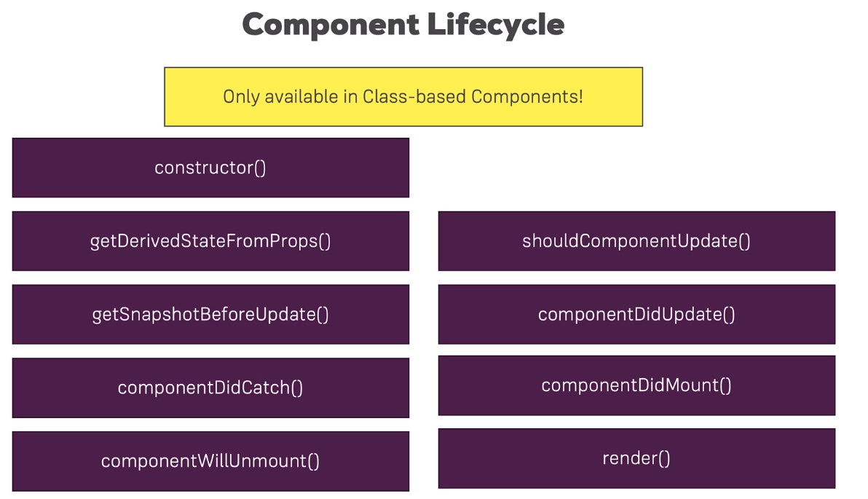



Let's start with the component lifecycle

during the component creation

because we actually have to differentiate between lifecycle hooks that run whenever something changes

in our component, some props for example and the lifecycle that runs when a component is rendered for

the first time because it's rendered as part of a list

or because we only conditionally show it.

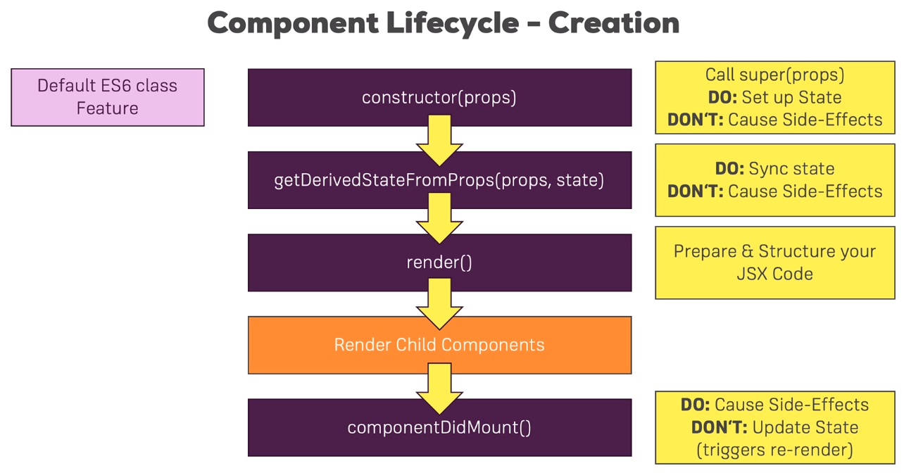

So when a component is created, then first of all the constructor executes.



Now this is actually not a React lifecycle hook,

instead it's a default

ES6 class feature,

the important thing there is this constructor will receive the props of this component and you have

to call super props in the constructor. Only if you add it, so you don't have to add it just to make that

call,

it's done for you if you don't add it but if you add your own constructor where you will want to execute

your own logic, you need to call super props in there

You can do it for basic initialization work, for example for setting an initial state.

What you shouldn't do here is cause side effects.

Now the word side effect is relatively abstract,

in the end it means things like sending a HTTP request or storing something in your local storage of the

browser or sending some analytics to Google analytics.

You don't really want to do things like that in the constructor because that can impact performance and

cause unnecessary re-render cycles which of course are pretty bad and you want to avoid.

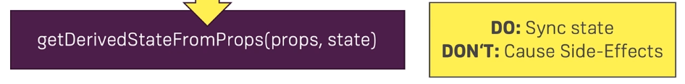

After the constructor,

getDerivedStateFromProps runs. That is a lifecycle hook that was added With React 16.3 and

in the end, the idea here is that whenever your props change for your class-based component, you can sink

your state to them and that will actually be very rare niche cases,

let me be very honest, you'll not use that lifecycle hook a lot but if you have some scenario where props

of your component can change and then you want to update some internal state of that component, then

this is the hook to use and I will show you how that hook works as well.

Now what you shouldn't do in there still is causing side effects,

don't send HTTP requests in that hook,

there are better places for that.

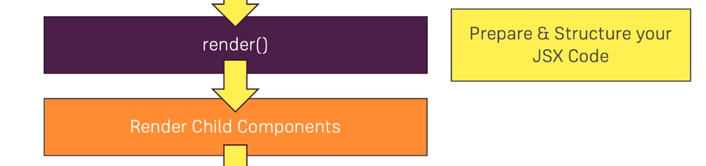

Now after these two hooks, the render method executes.

We already know that, that is the method that returns JSX and that is really its job.

You should use it only to prepare the data as you need it to lay out your JSX code and to render the

HTML code so to say. What you still shouldn't do in there is send HTTP requests or set any timeouts,

so nothing which can block this rendering process. Now when render runs and you do render any other React

components in this class-based component,

then these child components will now be rendered.

So every child component you included in your rendered component here will then be rendered as well

and only once all child components were rendered and that their lifecycle looks finished, your lifecycle

hook here will finish for the creation



componentDidMount gets called. componentDidMount is a very important lifecycle hook which you'll use a lot when you're working with class-based components because here, you can cause side effects.

That is a typical hook you would use for making an HTTP request to get new data from the web.

What you shouldn't do in here is update the state,

so don't call set state in here unless it's in, let's say the then block of a promise after you sent

an HTTP request but don't call set state in here synchronously. So you can definitely set up some code

that executes in the future which then updates the state,

for example when the response from the server is back but don't do it right away when componentDidMount

runs that you immediately call set state because that will trigger a re-render cycle and that is

bad for performance.

### Example : Component Creation Lifecycle in Action

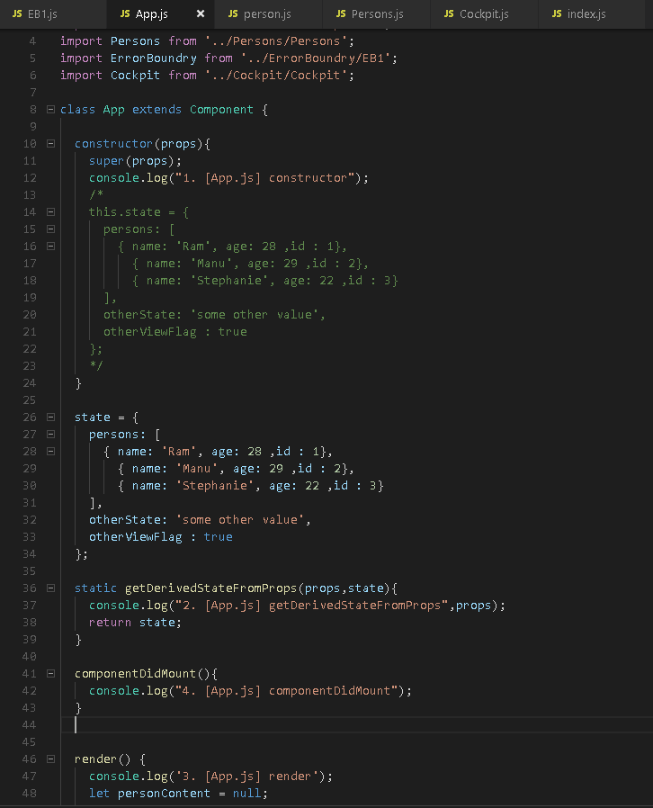

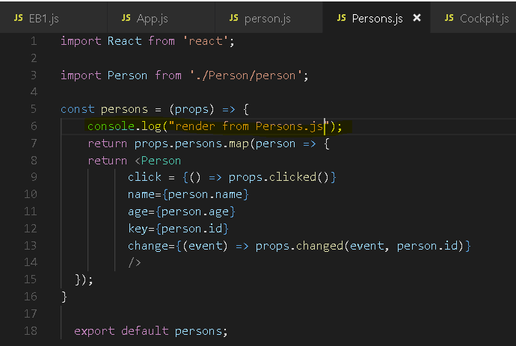

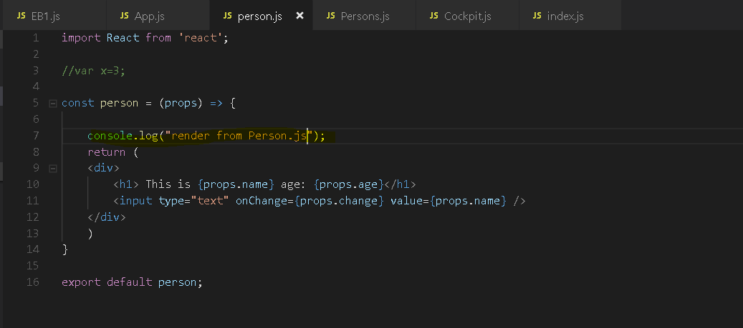

Output - 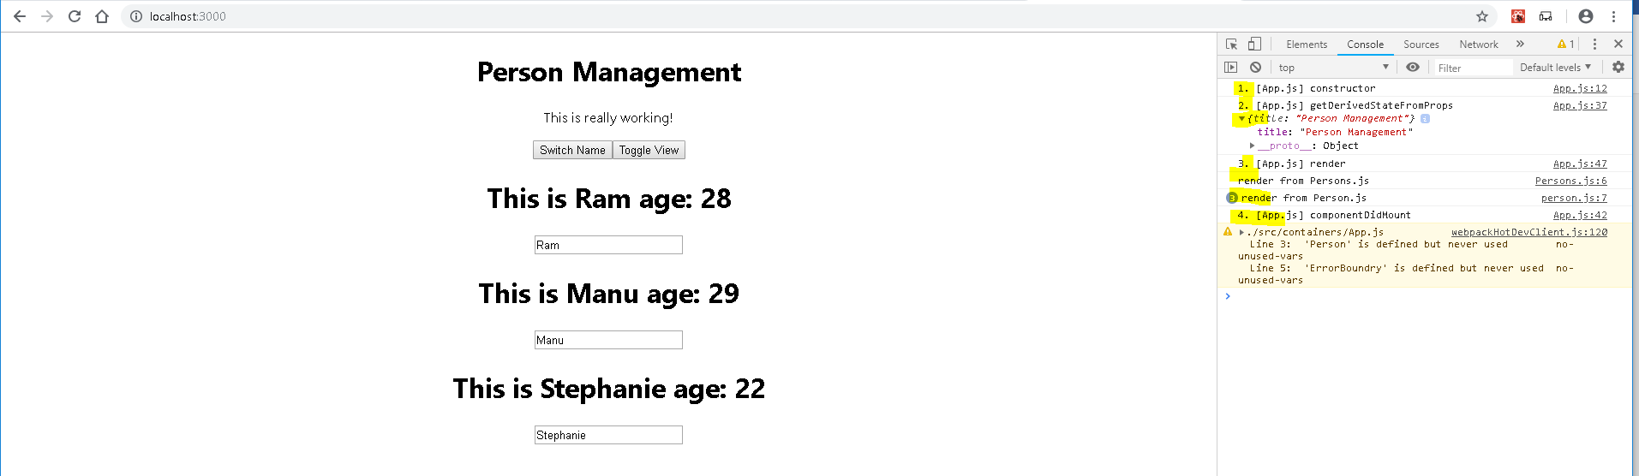

you can set state here in constructor.Important just

since you initialize the state, you should set the state like this and not with this set state because

there will be no state to merge this state with.

after the constructor,

we learned that getDerivedStateFromProps runs. For that,

I'll add getDerivedStateFromProps and this actually is a so-called static method,

so you have to add the static keyword in front of it.

This is just important for React so that React can execute this correctly. You will get your props

and your state in here and you should return your updated state and here I'll just return the old state

after getDerivedStateFromProps,

the render method executes

and as I mentioned, then all the child components will be rendered. and if that were class-based components, we could add the lifecycle there too and see it run for all.

When the component gets rendered, even though it is a functional one, of course that code here gets executed,

So that is how the lifecycle hook works here,

this is how we can go through the different lifecycle hooks when a component is created.

It's also worth highlighting that historically, there were other hooks as well and these are still

supported and I'll actually use one of them later in the course still.

Now one of them was componentWillMount and I'm saying was even though it still exists because whilst

you can use it,

it's not insecure and nothing like that,

these hooks were very rarely used and could be used incorrectly and therefore they will be removed in

the future.

omponentWillMount executed right before the componentWouldMount

and indeed it would be hard to explain what kind of work you do in here,

generally it would be something like preparing your state correctly and that is something you would

now do in the getDerivedStateFromProps and both were actually relatively seldom to be used and therefore

this will be removed

**Now accessing the render method by the way does not mean that the real DOM gets re-rendered,**

**it simply means that React will now re-render its internal virtual DOM and then check if the real DOM**

**needs to be changed**

### Component Update Lifecycle hooks (for props changes)

Just as we have a lifecycle for the component creation, we also have one for updating components.

So when props or state change which are the two triggers you have for a component to be re-evaluated

by React, then we go through a different lifecycle.

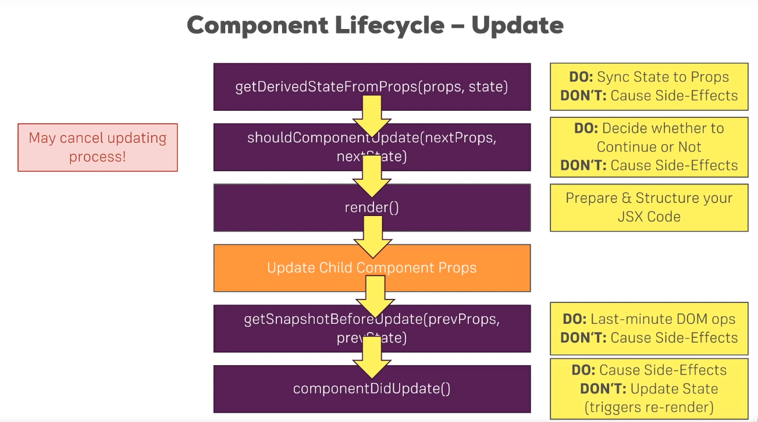

This lifecycle then starts with getDerivedStateFromProps being called, a lifecycle method which

you'll not use too often,

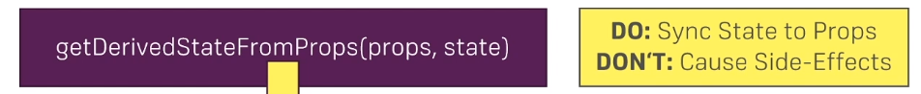you would use it to initialize the state of a component that updates based

on props you're getting, so updated props you're getting most likely and that could be for example some

form control which gets external properties and then you internally want to handle user input but initialize

your state or update your state based on outside changes

and as you will see throughout this course, we'll not use that lifecycle hook because actually, you very

very rarely need that and often there is a more elegant way of updating your state or of managing your

components based on external properties.  it's there for you to sync your local state inside of the component to

your props you're getting, you should not cause side effects in here so don't send any HTTP requests

or anything like that.



this lifecycle method or hook here is interesting because it allows you to cancel the updating process.

So here you can decide whether or not React should continue evaluating and re-rendering the component.

Now why would you do that? For performance optimization as you will learn over the next lectures.

This should be used carefully because obviously, you can break your components if you block an update

from happening incorrectly but it is very powerful since it allows you to also prevent unnecessary update

cycles.

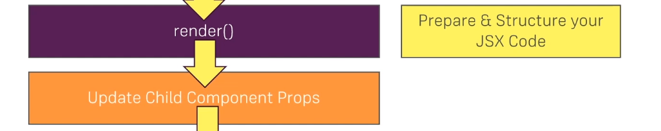

Now after that, the render method is called and React then goes through the JSX code, evaluates that and basically constructs its virtual DOM into which I'll also dive later in this module for you and sees if it needs to update the real DOM.

Now there as always you prepare and structure your JSX code

therefore. Now React then goes ahead and updates all child components of this component, so it evaluates all the child components you have in your JSX code of this main component and of course every child component then also goes through that lifecycle if it receives new props or state.

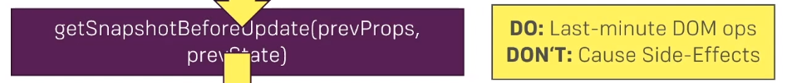

This is a lifecycle hook that takes the previous props and the previous state as input and that actually

returns a snapshot object which you can freely configure and this also is a niche lifecycle hook which

we'll not use too much

So imagine that your upcoming update of your component will re-render the DOM and will add new elements

on the DOM and you therefore want to restore the scrolling position of the user wants the update is done.

Well then getSnapshotBeforeUpdate can give you that snapshot of the user state,

so of the scrolling position right before the update happens and then you can consume and use that

snapshot once the update is done to scroll the user back to where he was or anything like that.

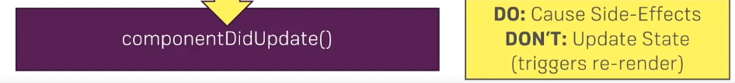

once we're done with the update, componentDidUpdate is called. A lifecycle hook that signals that you are now done with the updating, that the render method has been executed

and here you can now cause side effects, so here you could now make an HTTP request, though you'll have to watch out to not enter an infinite loop here

if you make an HTTP request and you get back a response and you then update your component and then this cycle starts again and that is also something we'll have a look at later in this course

once we dive into HTTP requests because there,

this is a typical problem you'll be facing. Now what you shouldn't do here outside of the,

let's say then block of a promise of an HTTP request is updating the state with set state.

It's fine to do it as a result of some async task you're kicking off here but you should not call it synchronously in componentDidUpdate because that will simply lead to an unnecessary re-render cycle.

### Example – Component Update lifecycle methods/hooks in action

getDerivedStateFromProps also part of the creation lifecycle so it will run for both at time of creation and for update also.

If we return define **getDerivedStateFromProps** lifecycle hooks without initializing **state** then -

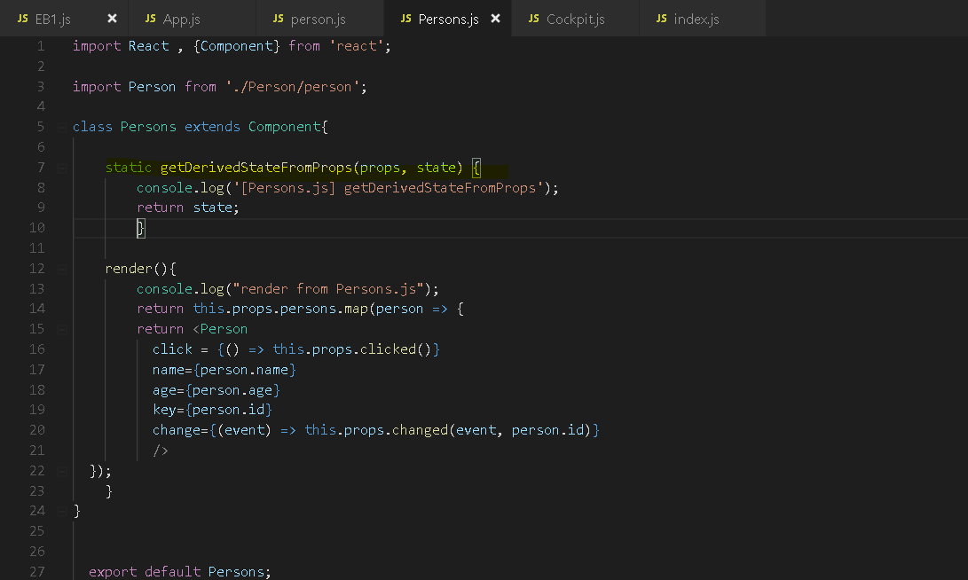

We get an error

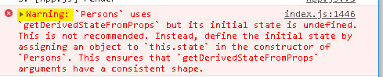

**Note –**

**For shouldComponentUpdate lifecycle hook , it will gets called when we change something (props or state)**

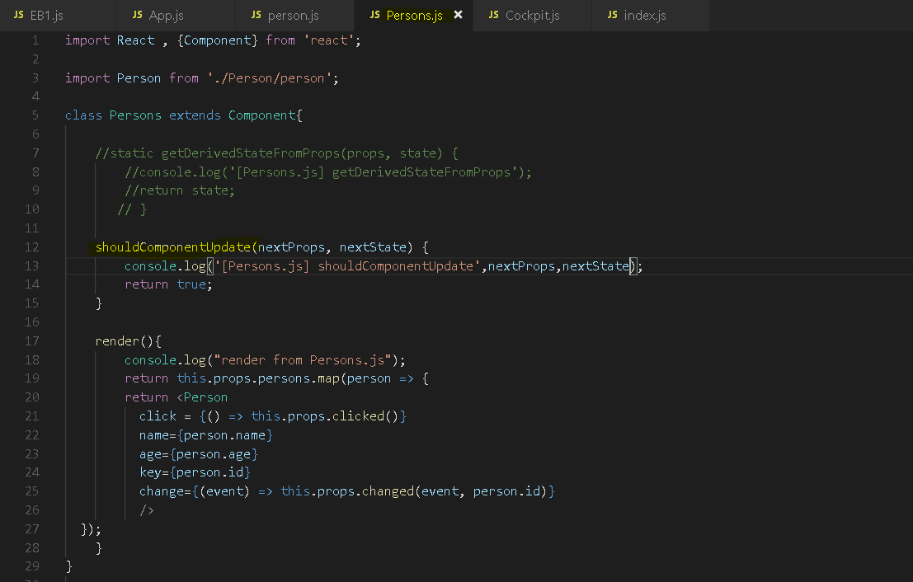

**Output -** 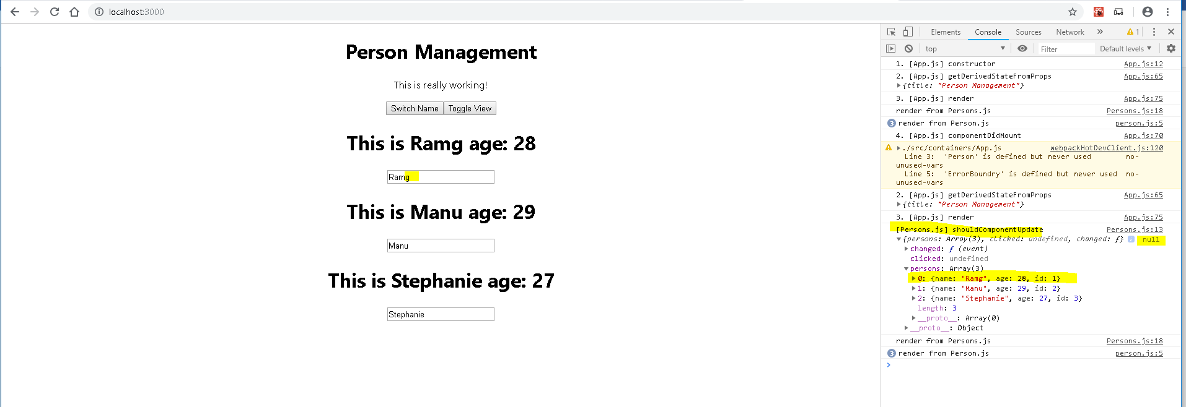

**getSnapshotBeforeUpdate**

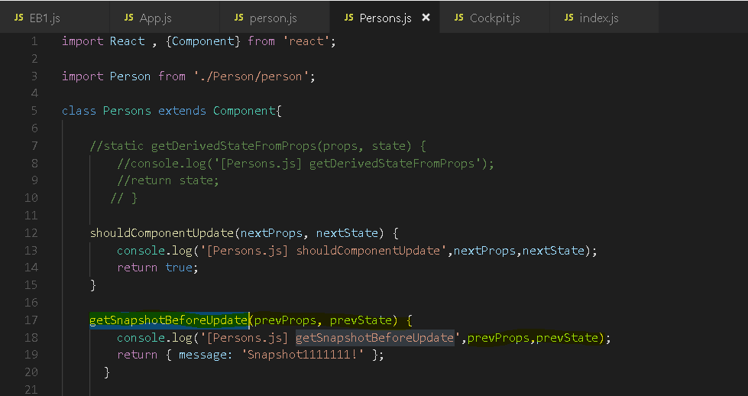

**Output – we get previous props and state before update happened** 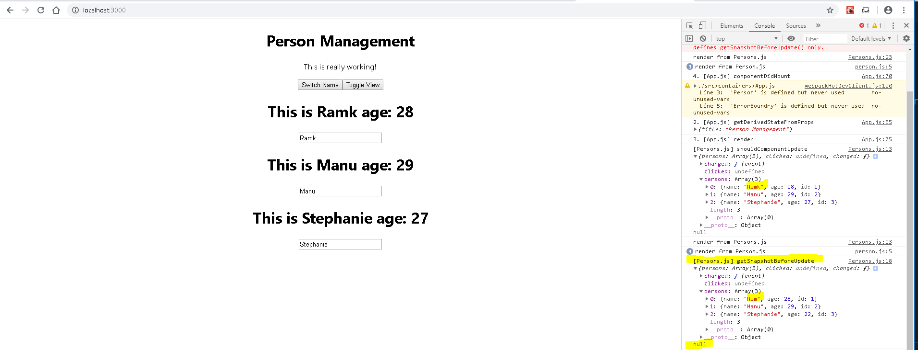

**componentDidUpdate**

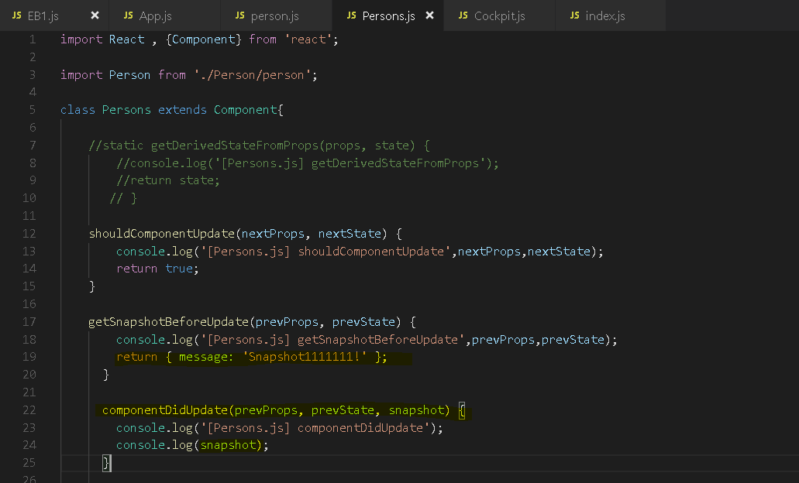

**Output -** 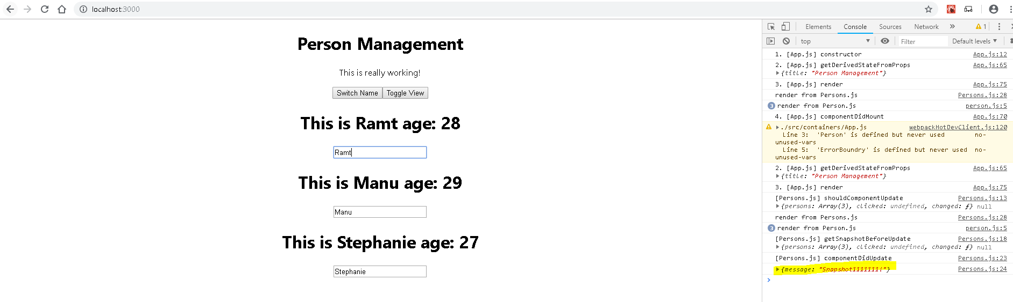

**So whats happening inside , when we type/change something in input text box**

for example, type something here because then, we'll actually trigger, if you have a look

at your input in person component, we'll trigger this onChange handler which triggers this props changed.

This props changed in person.js here is forwarded to the changed prop of the persons component which

is forwarded to our app.js file and in there if we have a look, changed calls the name changed handler

and this updates our persons which we pass back in as a property to the persons component and

therefore in this component,

now the updating lifecycle will begin because we forwarded that event from a child to the parent component

to the app component,

there we updated its state and then we got new data as a prop into this persons component and therefore

this persons component lifecycle triggers as soon as we type.

**Note –**

Now I mentioned earlier that there are some lifecycle hooks which we had in the past which aren't really

supported anymore and which you should not use if possible,

that was componentWillMount, now for updating, we have two other hooks.

**1)** 

**2)** 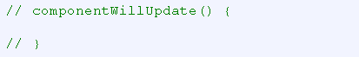

In the past, you had componentWillUpdate here and that ran right before componentDidUpdate

and again, it was kind of hard to justify using this hook, it was often used incorrectly and therefore

this is now also removed but if you are seeing this in older projects, it was a hook that existed historically,

that technically still could be used but that shouldn't be used anymore because you never really needed

it. If you needed it, you were probably using React incorrectly and that's why it's not available anymore.

### Component Update Lifecycle hooks (for state changes)

componentDidMount, componentDidUpdate and also for performance improvements, shouldComponentUpdate

are the most important hooks because in componentDidMount and componentDidUpdate, you will

typically do things like fetching new data from a server, shouldComponentUpdate,

well we'll dive into that again in this module, can be used for performance improvements.

Example –

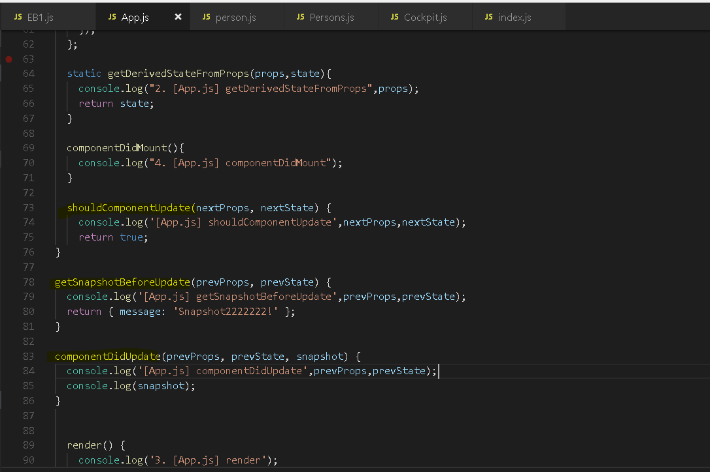

**Output – after clicking on switchName button -** 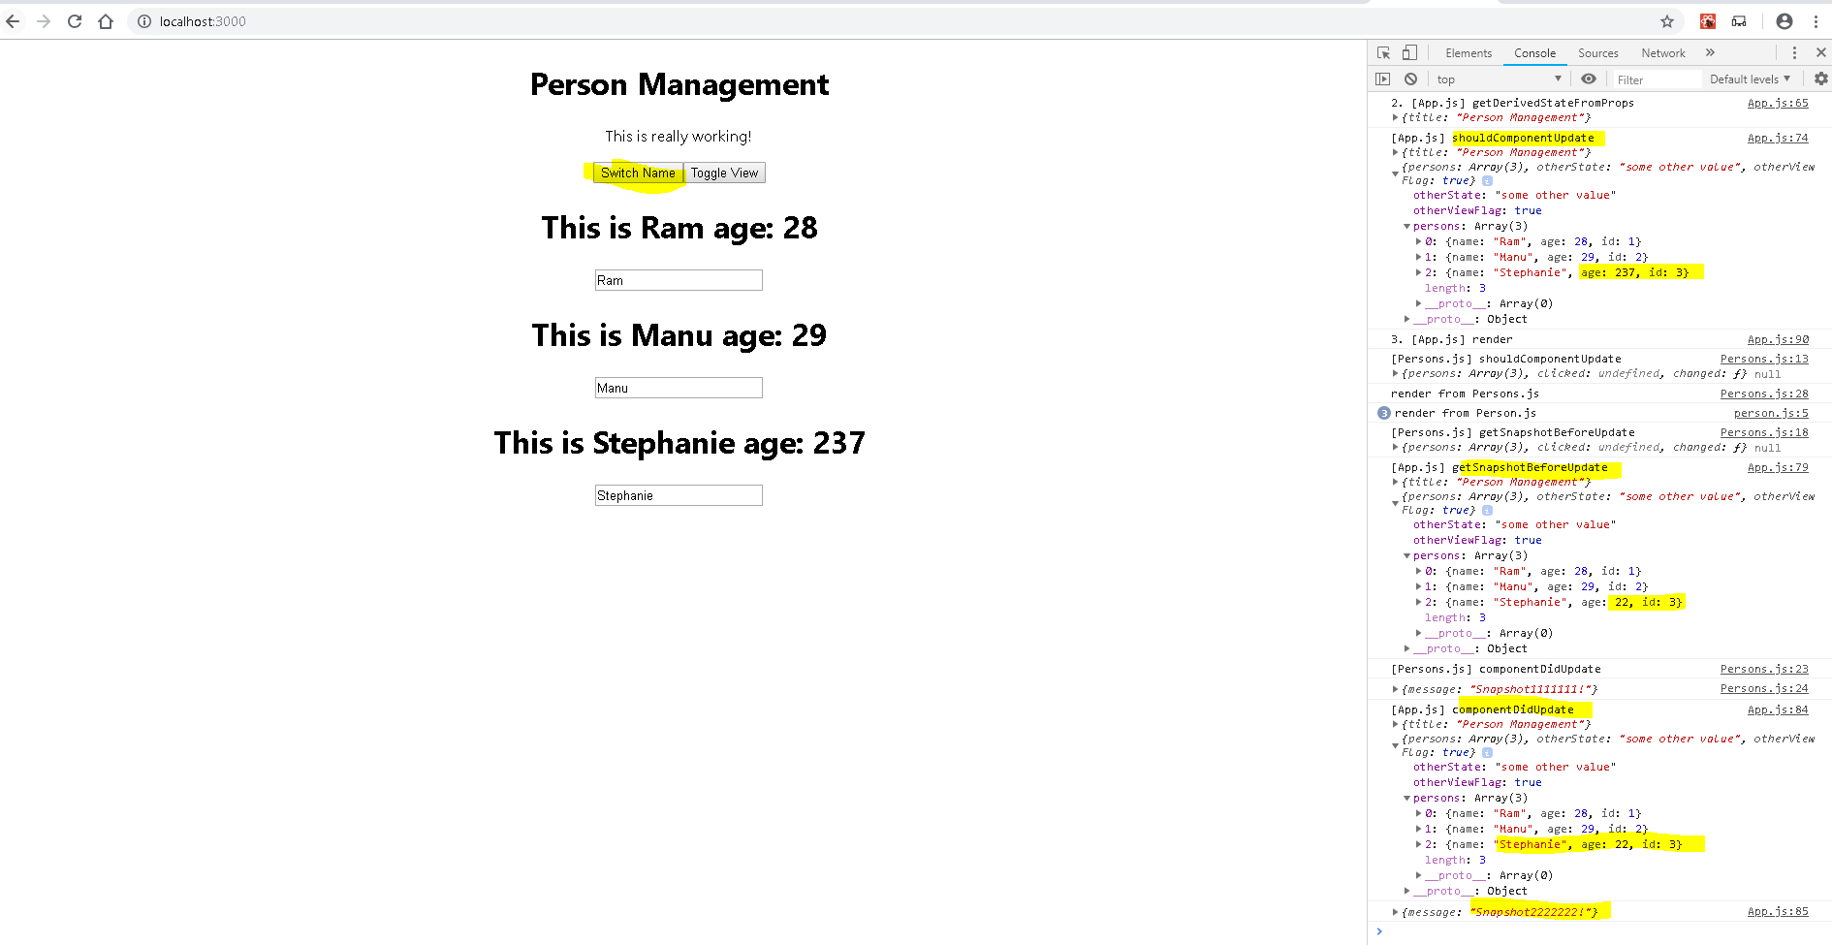

## useEffect for functional component(for handling component lifecycle for Functional Component

But what about functional components?

I mentioned that the lifecycle is only available for class-based components and prior to the introduction of React hooks, functional components had nothing that would compare to that which was fine because we

only use them for presentational purposes.

But now with React hooks, you can actually build your entire React app with functional components only

because you can manage the state in there. So you should also have a tool for running some code whenever the component updates or when it is created and therefore what is the equivalent to these lifecycle

hooks for functional components? **useEffect**

if we're using the right React version that actually supports React hooks of course.

**Now in functional Component, we can't add componentDidMount or anything like that but we can of course manage state with useState, though that doesn't help us**

**but what we can use is another hook. We have to import it from React and it's called useEffect.**

useEffect is the second most important React hook you can use next to useState because useEffect basically combines the functionality or the use cases you can cover

of all these class-based lifecycle hooks in one React hook- useEffect

here both is called hook, it's actually not related. This is not a lifecycle hook,

this is a React hook so basically a function you can add into one of your functional components.

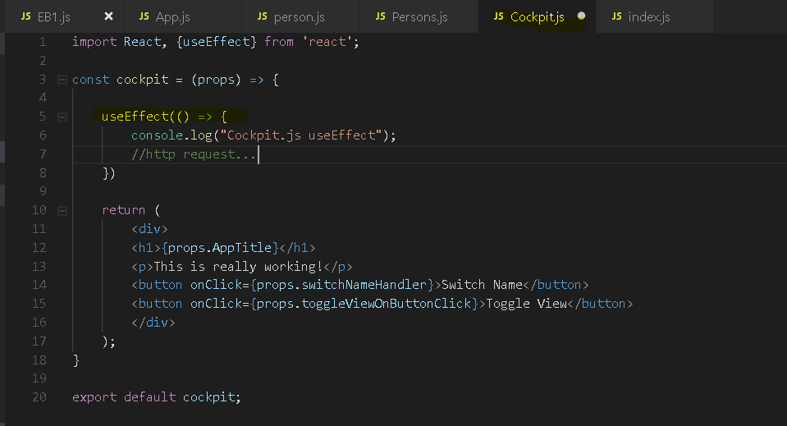

You can add it anywhere here in your functional component body and useEffect as a default takes a function

that will run for every render cycle.

you pass in a function here which doesn't

take any arguments but it has to be a function, you pass a function to useEffect and this will execute

for every render cycle of the cockpit. If I now click here, we see it again because we changed something

here and that re-rendered that cockpit. If I now type something here, we see useEffect again.

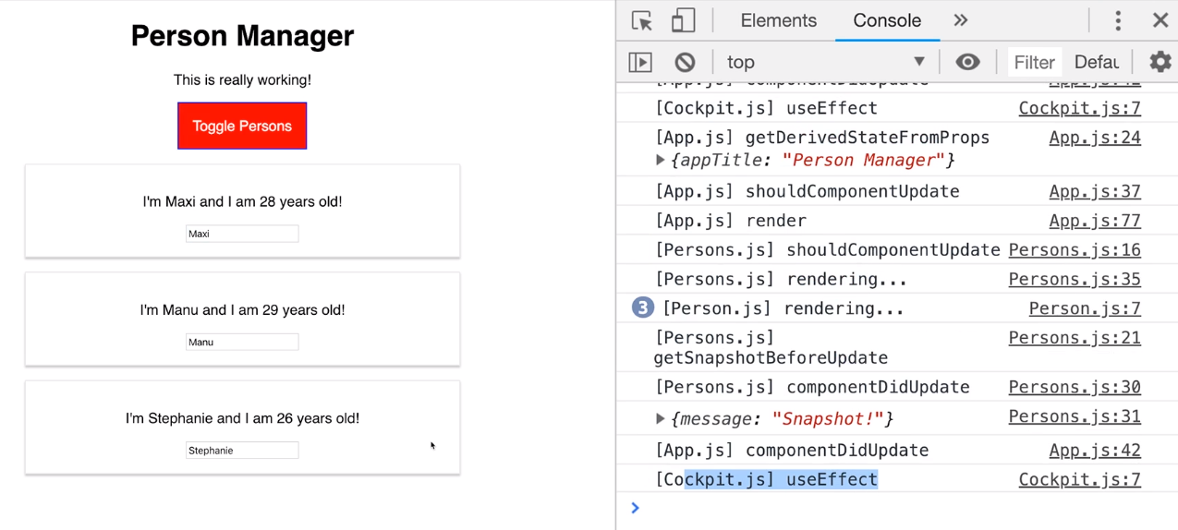

**Of course nothing changed in the cockpit if I type here but because we haven't added any performance optimizations**

**thus far, React will basically re-render app.js when we type because in app.js, we manage the state**

**of the persons and that state changes when we type and therefore it calls the render method of app.js**

**and in there, we of course include our cockpit and so the cockpit gets re-rendered too.** As always when

I say re-rendered, I don't mean in the real DOM as you will learn but in that virtual DOM, React will

check if it needs to touch the real DOM.

useEffect runs for every update and this means we can already use it for

all the things we would have done in componentDidUupdate and indeed that is OK. If you need to send

an HTTP request or anything like that in here, you can do that. It also obviously runs when the

component is created ,it executed because it executes for every render cycle and that includes the first one. So it is componentDidMount and componentDidUpdate combined in one effect.

Now some hooks like getDerivedStateFromProps is not included in here but you also don't really need it because if you have props here and you want to base your state on that, well then you can **useState** and pass some data from your props as an initial state into this.

useEffect is for the other, more important and useful lifecycle hooks.

### Controlling the **useEffect** behavior

useEffect can be tricky to use though because right now, it runs all the time,

it combines componentDidMount and componentDidUpdate.

Now what if we were to send an HTTP request here but we only want to do that when the component is rendered

for the first time or only when some specific props changes not for every re-render cycle,

what would we do then?

let's add a set timeout call here and maybe add a timeout of one second and after one second, this function will

execute and I'm just doing this to kind of fake an HTTP request here.

This is of course no HTTP request but it takes some time to finish and then does something and what it

does here is it should throw an alert, saved data to cloud.

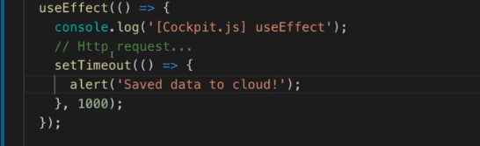

now I click here and yes, I get this again, thank you. And I click here and I want to delete something and I get this again. Now this might not be what I want,

how can I control when this actually executes?

**For example let's say this should only execute because it is saving data to the cloud**

**when our persons changed but not on any other condition.**

for that, you can add a second argument here to useEffect, that second argument is an array where you simply point at all the variables or all the data that actually are used in your effect.

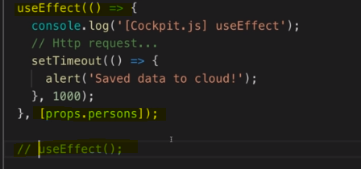

Now by the way if you have different effects that depend on different data, you can use useEffect more than once, that is absolutely fine, you can have as many useEffect setups here or functions as you want.

now this effect should only execute when our persons changed

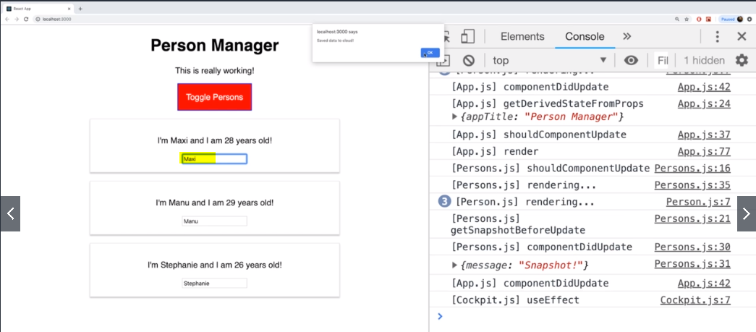

If I type an I, we will get alert because that changes my persons.

So that is already an improvement, it allows us to control when this executes which is very useful.

What if we now only want to execute this when the component renders the first time?

Well for this, there is a little shortcut so to say, you can pass an empty array,

you have to pass an array, that's important but it's empty.

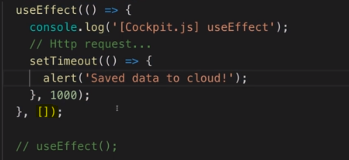

This tells React this effect has no dependencies and it should rerun whenever one of the dependencies changes.

**Now if you have no dependencies, they can never change and therefore this can never rerun.**

**it will run for the first time, that is the default but it will never run again.**

**So if you just need componentDidMount, you would use useEffect with an empty array passed as a second argument to the useEffect function.**

**If you have a dependency on a certain field, you pass that field in here and of course, you can have multiple fields you will depend on.**

## Cleaning up with lifecycle hooks and useEffect

The persons.js component is a component which will actually get removed from the DOM when we click toggle person.

Now let's say in that case you want to do some cleanup work,

let's say in that scenario you want to cleanup some event listeners you set up somewhere, anything like that, any cleanup work you want to do.

We got no such cleanup work here but in an app where you do have a live connection to some server or something like that, it's a very realistic scenario that you do have to cleanup some stuff.

you can add componentWillUnmount here

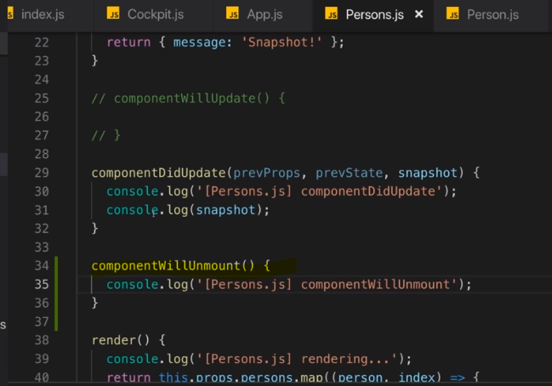

 if I toggle again, here we see componentWillUnmount from persons.js.

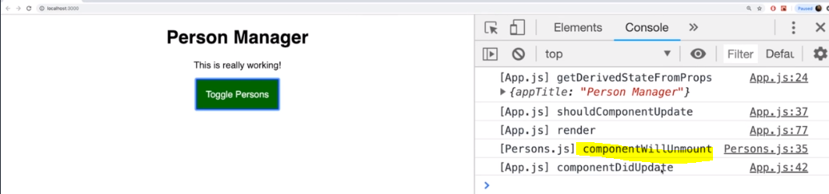

Now in here, you could have any code that needs to run right before the component is removed,

 If you're using hooks like we're doing in the cockpit.js file, then

you also can use useEffect for this cleanup work.

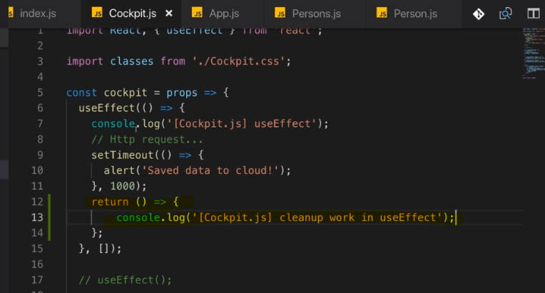

so in this anonymous arrow function here in my case, you can return either nothing, so you don't have to

have a return statement

but if you add one, you can return a function here,

so here I'm using yet another anonymous function that will actually run after every render cycle.

**Note -**

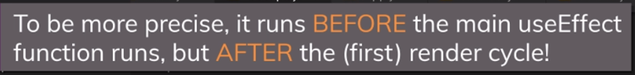

We added a button to remove cockpit component 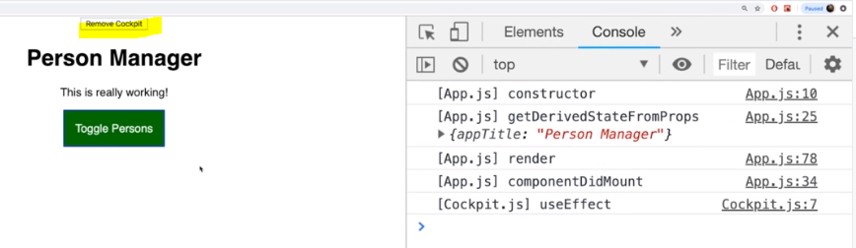

if I click this, you actually see cleanup work in useEffect. That is coming from our React hook here

of course because that runs right when useEffect runs for the last time so to say

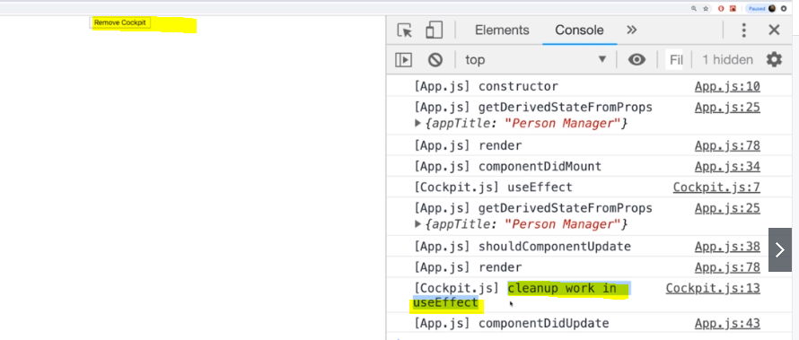

The case depends on this second argument you passed to useEffect. If you passed an empty array, useEffect will basically execute this function only, this function here, only when that component rendered and when it is unmounted.

Now let me add another useEffect call here 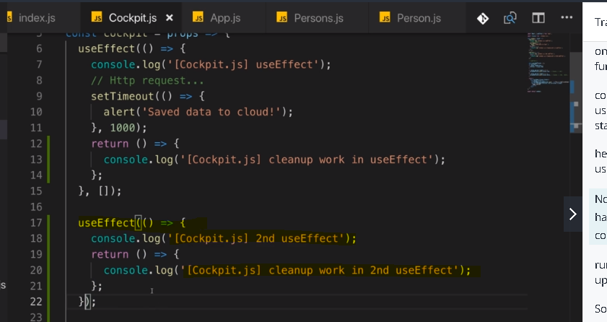

Now please note that the second useEffect has no second argument, so I'm not controlling when this should

run and therefore it will run for every update cycle.

So now what we see is, here we have the second useEffect and already now when I just toggle persons, 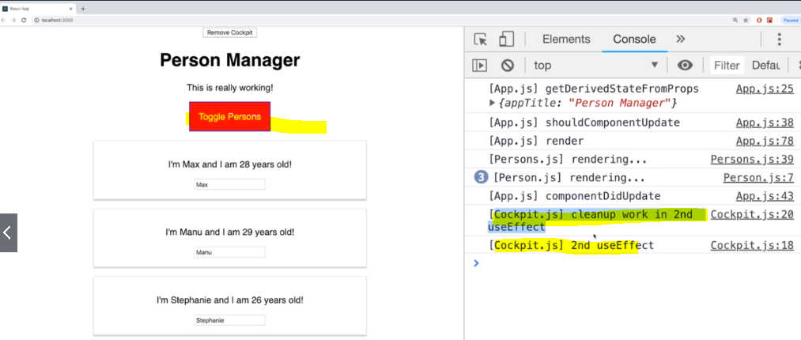

so I'm not doing anything with the cockpit, if I toggle persons, we got cockpit second useEffect

but before that, we had the cleanup work in the second useEffect.

Now this can also be useful in case you have some operation which actually should be canceled whenever

the component re-renders,

so after it updated so to say.

So this is an extra bit of flexibility, that you have this cleanup function here and you can either let

this run when the component gets destroyed by passing an empty array as a second argument or it runs

on every update cycle with no argument or you pass a second argument which is an array that lists all the data.

## Using shouldComponentUpdate for Optimization

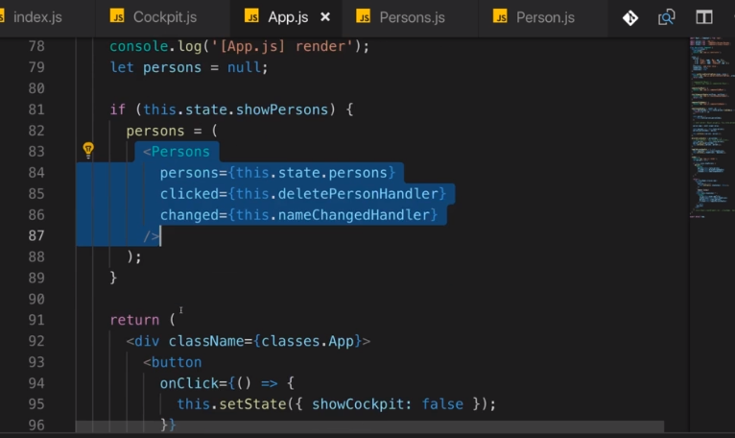

 In persons.js

I have shouldComponentUpdate and I return true which means by default whenever something changes here

on this component, whenever it gets re-rendered, then we update. Now persons.js already gets re-rendered

when in app.js, something changes because persons is in the end a child component of app.js

So whenever we change something in app.js, even if that only affects the cockpit or anything else

in app.js but not persons, the persons child still gets re-rendered because that render function

here gets called and therefore this whole function executes and React will go through that entire

component tree, that is how it works and that is how it makes sense logically because this is a function,

it gets executed from top to bottom. So persons gets re-rendered when something changes

a good example

is here in our application when this reloads,

when I toggle my persons and I then remove the cockpit which only affects the cockpit but not the persons.

Still here, we see persons shouldComponentUpdate, persons rendering, every single person renders,

getSnapshotBeforeUpdate, persons componentDidUpdate,

so all our persons updating hooks ran even though in persons, nothing changed. 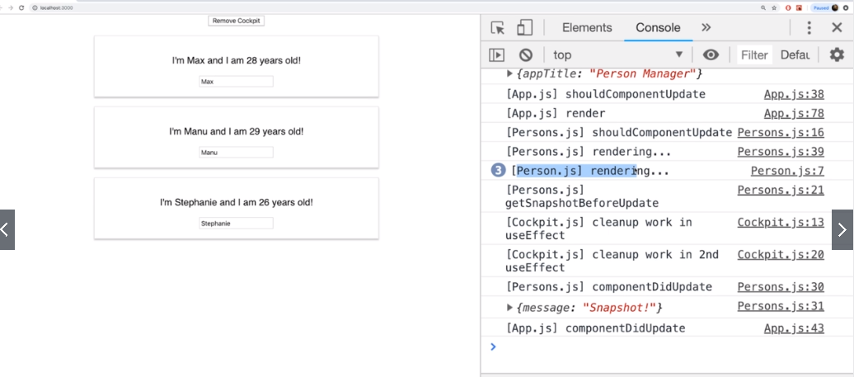

It would be good if we can prevent this, wouldn't it?

Now we can prevent this by simply checking what changed in shouldComponentUpdate here in persons.js

So here I can check if next props persons is actually different to this props persons which is our current set. If that is the case, then I want to return else I will return false.

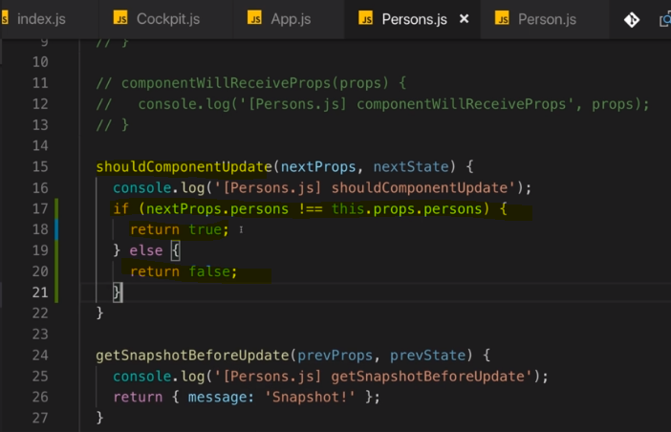

Now let's save that and let's try that again. The app restarts,

I toggle my persons and now I remove the cockpit and now we see persons.js shouldComponentUpdate

still gets executed but nothing else.

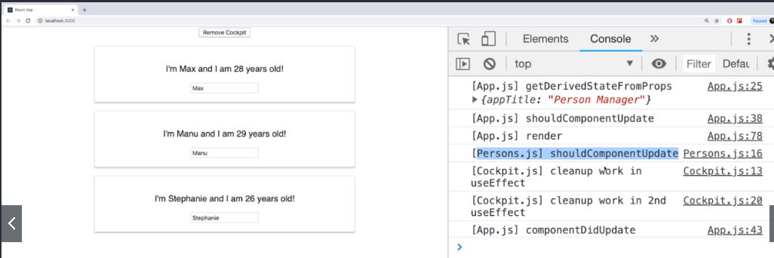

That is super powerful because that can already save us a performance, for that removal of the cockpit,

we did not go through the entire persons component tree to re-render that virtually.

Instead we just skip because we know if the persons prop doesn't change, then there is no need to re-render

because the persons prop is the only thing we're using in here

**Note –**

Now one important note about this check though, persons of course is an array and arrays just like objects

in Javascript are reference types.

reference types, so arrays and objects, are stored in memory and what you

actually store in variables and properties here are only pointers at that place in memory,

so what we do compare here is actually the pointer. If something in that person component changed and

the pointer is still the same,

then this update wouldn't run and the only reason why it does run here is because in app.js when I

do update my persons, like here with name changed handler,

I do actually create a copy of the person I want to change and then I create a copy of that persons

array and hence I create a new person object and a new array object and that occupies a new place in

memory and gets a new pointer and therefore, the pointers now also differ.

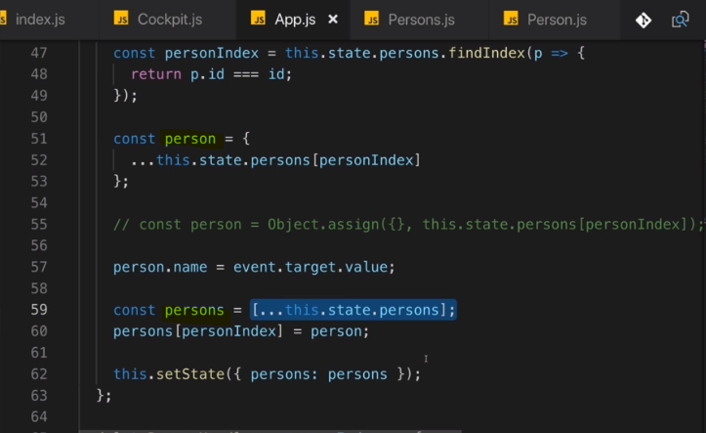

If I wouldn't have updated it like this and instead I would have just manipulated the old array and

therefore the object in memory would be the same

even if some property of it changed but the place in memory would be the same, then our shouldComponentUpdate

check would not work because it doesn't deeply compare this,

it doesn't look at all the properties in persons or in all the objects in persons, it just does a shallow

comparison, which means it compares whether these two values here really are the same and the values

are our pointers here and it works because I updated it correctly by replacing the objects.

in Chrome, you can actually go to more tools and then rendering

and there you can enable paint flashing. That can be useful because it allows you to see what really

gets re-rendered because it's highlighted with a green look.

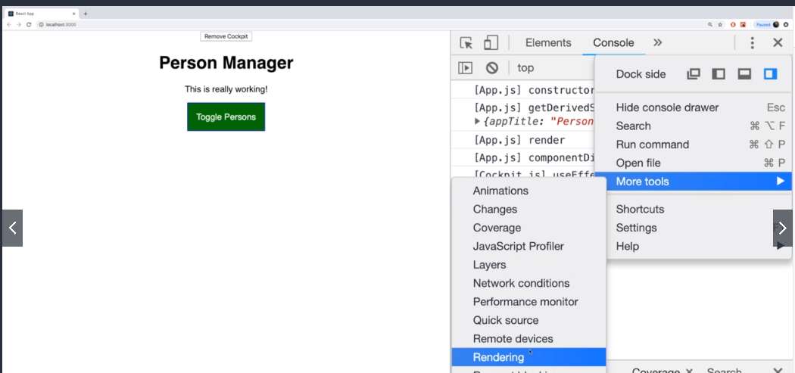

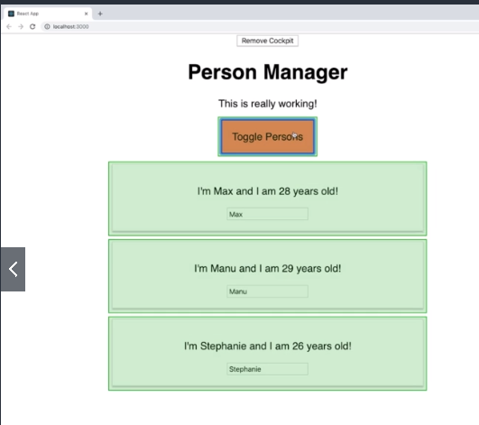

this was really rendered in a real DOM. So this is what gets rendered in the real DOM and not what gets

rendered virtually by React.

So even if we're not doing that performance optimization, we still don't hit the real DOM with every

keystroke which is good but it's even better if we can make this performance optimization

## React.memo() - Optimizing functional Component with React.memo()

let's have a look at how we can optimize performance

with functional components though because shouldComponentUpdate is a great tool but it's only available

in class-based components.

what about the cockpit component?

Because with the paint flashing, we see that and I will disable this now, we see that of course the cockpit is never touched when I type here but still we can tell that it executed its code.

So how can we prevent this if nothing about the cockpit changed?

And for that, we first of all have to look at the cockpit and we see that the only thing that the cockpit uses internally and that therefore should trigger a re-rendering of that cockpit are the persons length here and then also this title. The names of the persons and so on are totally irrelevant.

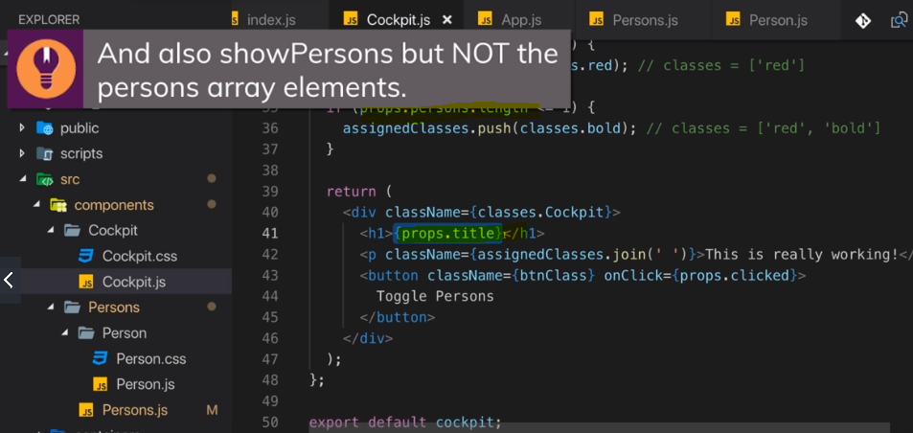

So what can you do now to prevent this unnecessary re-rendering?

**React.memo() -React also has a tool for functional components. You can wrap your export, so your entire component here in the cockpit.js file with React memo. This basically uses memoization which is a technique where React will memoize,**

**so basically store a snapshot of this component and only if its input changes, it will re-render it and otherwise if its inputs do not change and some parent component wants to update this cockpit component, React will give back that stored component.**

Note –

So therefore now initially this of course runs because there

is no stored data and here it actually runs again, now why is that?

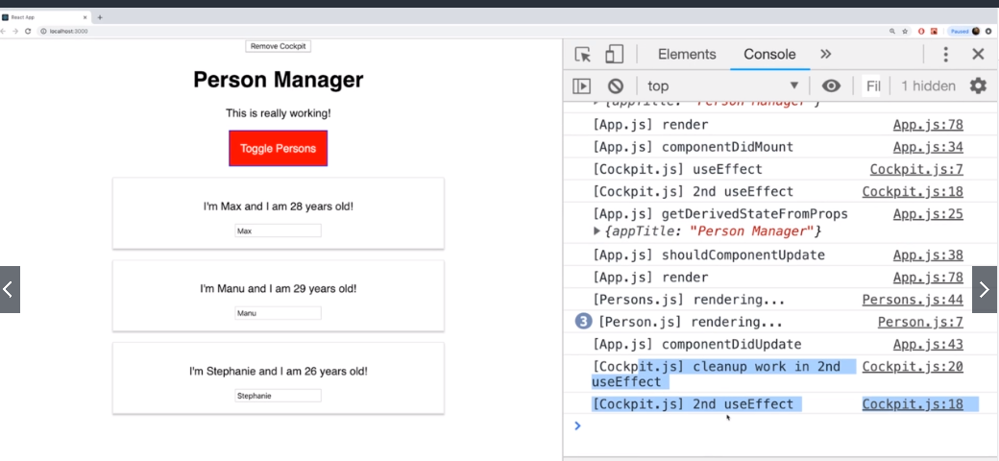

Because in the cockpit component, it only

re-renders when its props change but of course one of the props we depend on is the persons.

We only use the length but that is not something React picks up here. To fix that, we can optimize the

way we pass data into our cockpit though. Here on cockpit instead of passing in the persons, we can pass

in the persons length

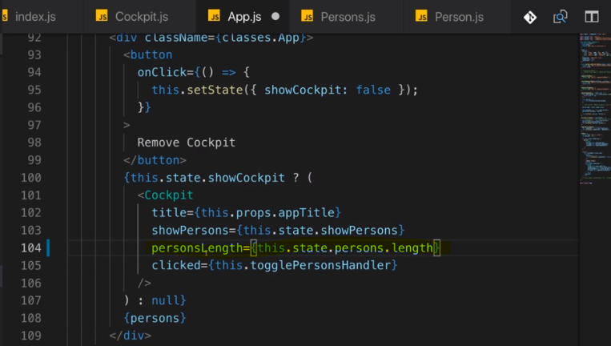

So instead of determining the length inside of the cockpit, we do it outside of the cockpit

now and we only pass in persons length. This of course will now only change if the persons length here

changes.

**React memo is a great way of also getting optimization for your functional components and therefore it is a good idea to wrap functional components that might not need to update with every change in the parent component with it.**

## **When should you optimize**

you should evaluate this carefully,

is this component part of a parent component that could change related to something that does not affect

me at all, as it is the case here where the persons component is certainly not interested in changes

related to the cockpit,

well then you should implement your check here.

Otherwise if you're pretty sure that in all or almost all cases where your parent updates, you will need

to update too,

then you should not add shouldComponentUpdate or React memo because you will just execute some extra

logic that makes no sense and actually just slows down the application a tiny bit.

## **Pure Component** instead of shouldComponentUpdate

Pure component in the end is just a normal component that already implements shouldComponentUpdate with a complete props check,

so that checks for any changes in any prop of that component.

So if that is what you need, you can also just use pure component instead of manually implementing this shouldComponentUpdate check.

The result will be the same, so you can do either of these but of course you can save some code if you use pure component.

Example –

We have commented out shouldComponentUpdate implementation and used PureComponent, still application works the same.

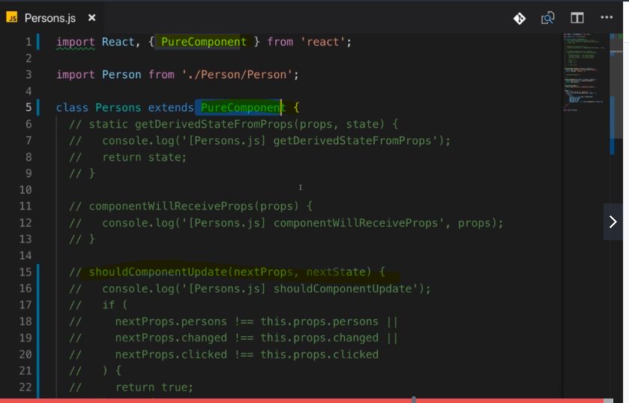

## How reacts Updates the DOM

How does React update the real DOM, the DOM in the browser?

The render method being called does not immediately also render this to the real DOM. Render is more a suggestion of what the HTML should look like in the end but render can very well be called and lead to the same result as is already displayed and that is part of the reason why we use shouldComponentUpdate to prevent unnecessary render calls.

But even if we don't catch an unnecessary render call, maybe a prop did change and still we would render the same result for whatever reason, even then this does not mean that it immediately hits the real DOM and starts re-rendering it, instead it first of all does something else,

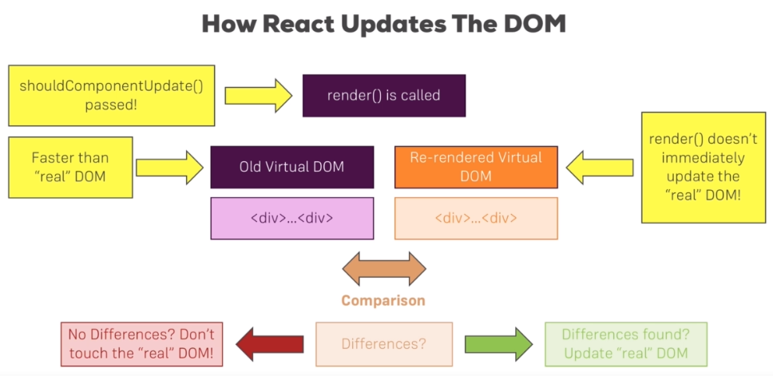



it compares virtual DOMs

It has an old virtual DOM and a re-rendered or a future virtual DOM. React takes this virtual DOM approach because it's faster than the real DOM.

Now a virtual DOM simply is a DOM representation in Javascript.

You can of course represent all HTML and therefore DOM elements and objects in pure Javascript, so without rendering anything to the browser and this is what happens here and

**React basically keeps two copies of the DOM. It has the old virtual DOM and then the re-rendered one, the re-rendered one is the one which gets created when the render method is called.**

**React makes a comparison. It compares the old virtual DOM to the new one and it checks if there are any differences. If it can detect differences, it reaches out to the real DOM and updates it and**

**even then, it doesn't re-render the real DOM entirely, it only changes it in the places where differences were detected,**

**for example if a button text changed, it will only update that text and not re-render the whole button, leave alone the whole DOM.**

If no differences were found, then it doesn't touch the real DOM. Render did execute, the comparison was made and that is why shouldComponentUpdate might make sense to prevent this if it's not needed because this of course already also costs some resources but nonetheless the real DOM is never touched, you can rely on that.

The real DOM will only be touched if there are real differences and this of course is important because as you might know, accessing the DOM is really slow,

this is something you want to do as little as possible and hence, React has this virtual DOM idea, compares the virtual DOM and make sure that the real DOM is only touched if needed. This is what happens behind the scenes.

See for example - 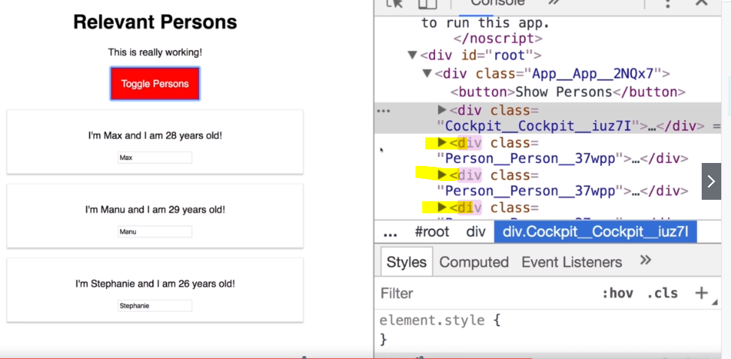

I click toggle persons,

clearly these divs were added,

you saw them flash but if you watch closely the button and the cockpit div, if I click here, this never

flashes because it's not re-rendered.

## Rendering Adjacent JSX elements

I want to dive into that thing that I mentioned that you have to always return

just one JSX element inside of a component.

Now that JSX element can contain other JSX elements, but you must only have one root JSX element, be that another component or a normal HTML element.

So I'm not allowed, for example, to have an adjacent div here. So if I try to return this and of course it does not matter if that's a div or a h1 tag or anything like that, then I get an error, adjacent JSX elements must be wrapped in enclosing tag.

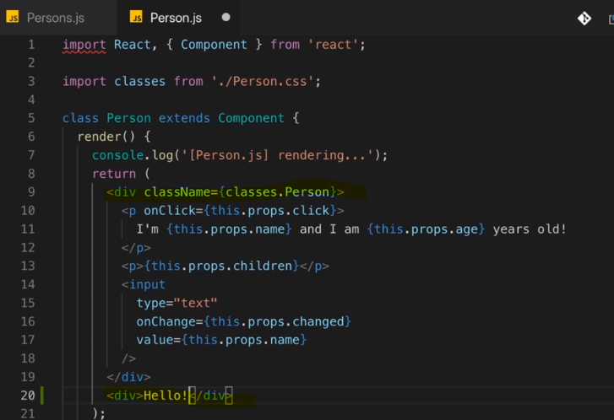

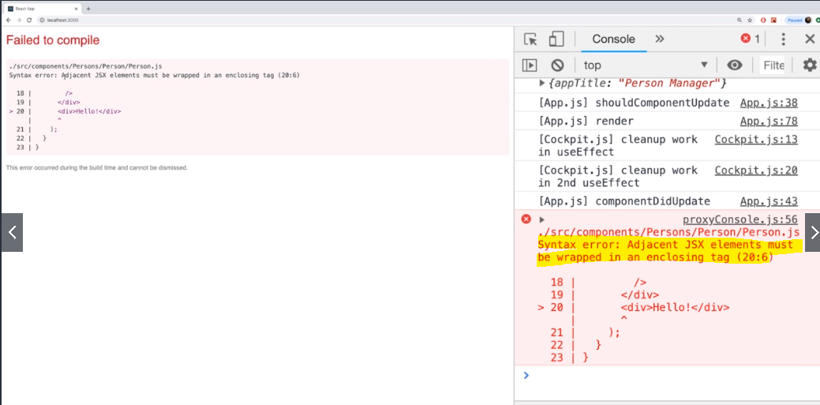

So I'm basically not allowed to return adjacent JSX elements like this on a root level,

so inside of that div, so these elements here, there it's okay that they're adjacent but the root element

I'm returning in this component or in any place where I need to return JSX has to be one single element

with as many children as you want.

Now this is not entirely true though because if you have a look at the persons component. 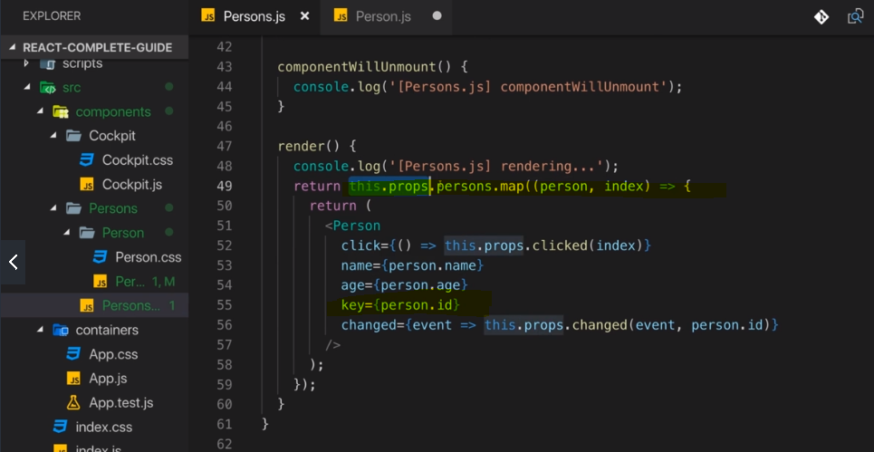

here we actually return an array of persons, right?

**So that's not one single element, it's an array. Now technically, an array of course still is one object but with multiple elements in there and indeed, React does allow us to return an array of adjacent elements as long as all the items in there have a key and that key is required so that React can efficiently update and reorder these elements as it might be required by your app.**

**So how can we make it work for adjacent JSX elements?**

let's wrap them in square brackets.

So here, I will return my JSX elements in an array.

Now this might look strange but remember, JSX is just syntactic sugar for React create element,

so in the end we're just returning a couple of calls to React create element here or the results of

these calls to be precise.

Hence we need to separate these items with commas after each of them

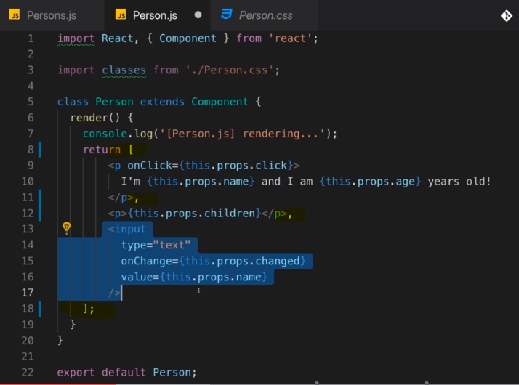

**Output -** 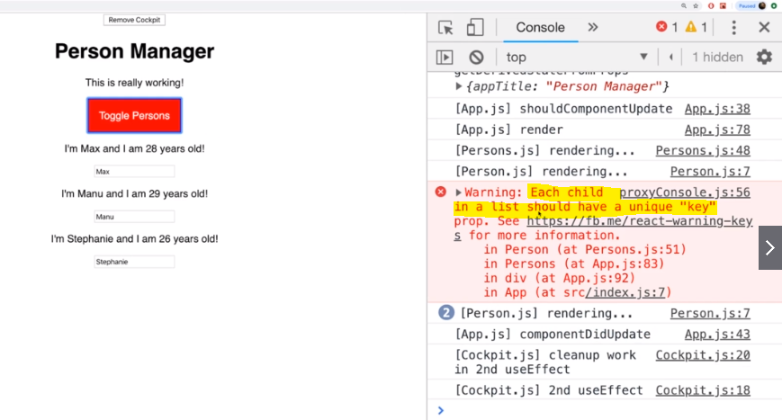

I'm getting a warning regarding that key and that is what I mentioned,

you should add a key here.

Well for that, we can simply add a key on these elements

and here we're not generating the key dynamically, we're not extracting a unique value from anywhere.

You can of course assign your own unique value like i1 for item 1 or whatever you want,

any identifier that you simply don't repeat,

that's the only important thing, each key here should be unique in that array.

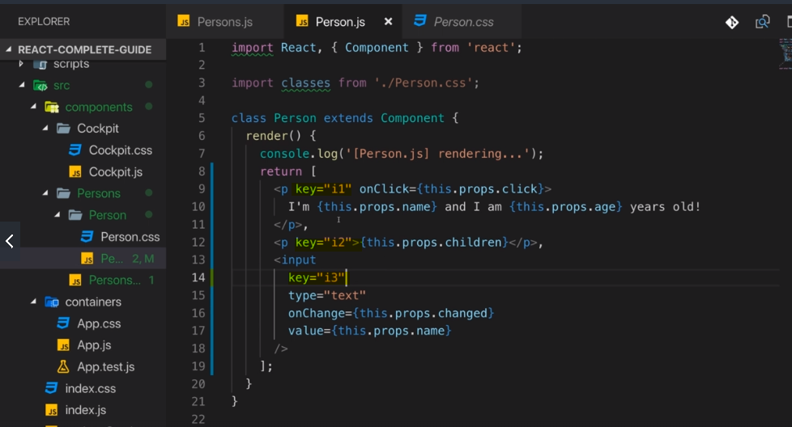

it's important to know that if you don't technically need a wrapping element for a styling or structural reasons, then you can avoid it by using an array.

but this is not even the only way of doing it.

You can of course create such an array but it's a bit inconvenient, you have to wrap this in square brackets, you have to assign the key and so on, so that is not really that great. How else could you do that besides using an array?

**Well this approach might look a bit hacky at first but it's perfectly fine and actually built into React as you will learn. You can create a wrapping component that does not render any actual HTML code but that simply is there to fulfill React's requirement of having a wrapping component.**

**hoc which stands for a higher order component. They are basically components that wrap other components**

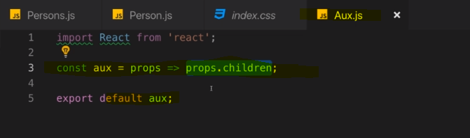



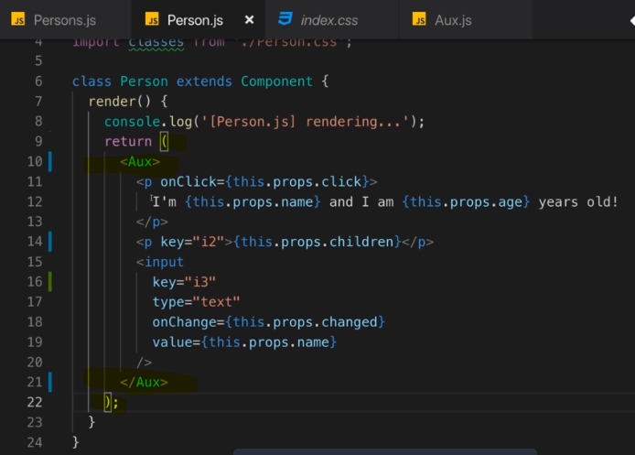

we can use aux like a regular JSX element to wrap all the other JSX code

It's basically an empty wrapper

using that special children property which React reserves for us,

so that really is a reserved property name,

that React reserves for us and children will always refer to the content between the opening and closing

tag of your component.

So in this case, children will refer to all this content and all the aux component

does is it outputs that content.

Now you might argue but isn't is a set of adjacent elements in Aux.js

Well that is the hard thing to wrap your head around, it kind of is

you could say but actually, it isn't because the requirement of having this wrapping top level element

is a pure technical one from a Javascript point of view that you must only return one expression and

that is what we're doing here because you must never forget that these JSX elements are always

calls to React create element and in a return statement, you couldn't return multiple React create element

calls like this next to each other and therefore you can't

do this either for JSX code. But the moment you wrap this with one React create element call so to say, this

works and then here in the aux component, you're just returning an input,

so technically from a Javascript point of view, that is fine,

we're only returning one expression here. So it can be tricky to wrap your head around, it is a pure

Javascript thing here or it's actually the case in most programming languages.

You must only return one expression

### Windows Users Must Read

**On Windows**, the Aux.js  filename is not allowed in ZIP archives. Hence when extracting the attached source code, you might get prompted to rename the Aux.js  file. You might also **face difficulties creating an Aux folder** and Aux.js file.

I really apologize for that inconvenience, Windows is really doing an amazing job here ;-).

Follow these fixes:

**1) Problems when unzipping the attached file:**

Simply **skip this step** (e.g. by pressing **"No"**) and **ignore** the upcoming error message.

In the extracted folder, you'll then find **all source files** EXCEPT for the Aux.js  file. In later course modules (where we work on the course project), the Aux.js  file can be found in an Aux/  subfolder inside hoc/ .

Make sure to take the Aux.js  file **attached to this lecture** and place it inside the hoc/  or hoc/Aux/  folder (which ever of the two you got).

**2)** Problems with the creation of an Aux folder and/ or file:

Simply name both differently. For example, you may create an Auxiliary  folder and name the file inside of it Auxiliary.js . Make sure to then adjust your imports (import Aux from './path/to/Auxiliary/Auxiliary' ) and you should be fine.

### React.Fragment

In last lecture we have created an HOC(Aux) i.e wrapper component to wrap our adjacent JSX elements , without any extra DOM element/HTML element (div) to be rendered to real DOM.

We have seen how this wrapper component works behind the scene.

From react 16.2 we have build in wrapper component provided – **React.Fragment**

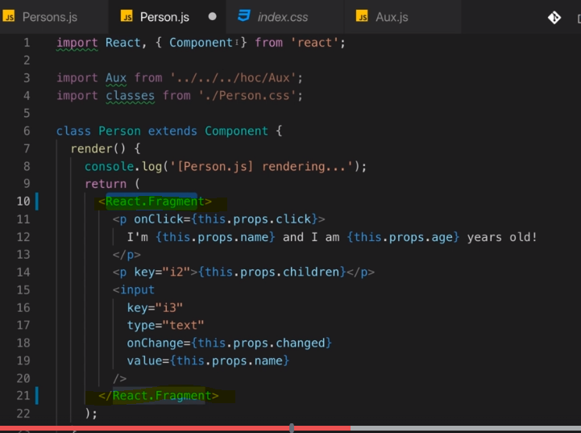

If you don’t like to write React.Fragment then you can simply import Fragment and use it. 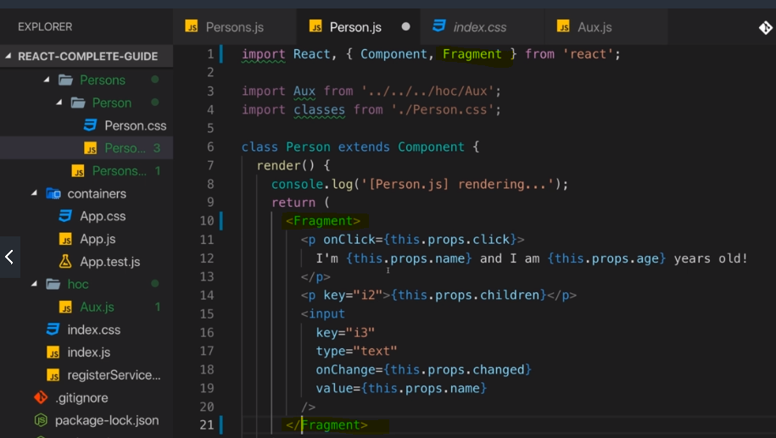

This fragment will do the same thing under the hood that our Aux component(HOC/Wrapper) did in previous lectures.

## Higher Order Components(HOC)

it's named higher order component because all it does essentially is it wraps

another component, it does not contain its own logic, its own styling or add any structure to the JSX code or to the real DOM that will be rendered,

it just wraps another component and then maybe adds some extra logic to it,

Now another example for a higher order component that you could create would be a component that sets up a div that contains a class or sets up a class.

obviously, there is nothing wrong with just using a div with a class name but this serves as a good example for a custom higher order component you could create that does more than the aux component.

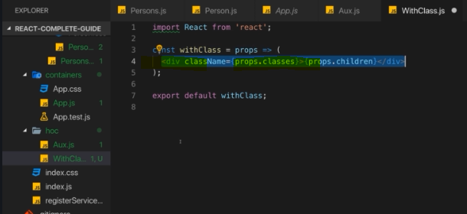

Now



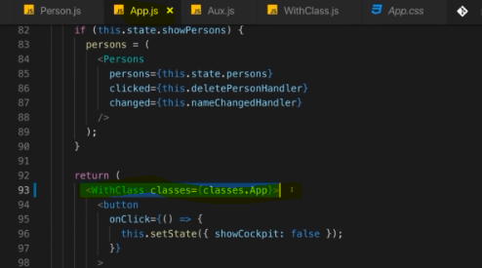

obviously there would be nothing wrong with sticking to a div but we'll introduce other higher order components throughout the course where we for example add error handling that we can wrap around any component that makes an HTTP request and all of a sudden, this becomes more useful.

The general concept is simply that you have a component that wraps other components that adds something to it, that could be styling, that could be additional HTML structure around it or that could also be some logic and we'll add that logic later once we added HTTP requests as I said, to automatically handle HTTP errors.

### Another form of HOC(alternative way of using HOC)

The withClass component here is a higher order component but actually this way of creating it is just one of two ways of creating higher order components,

The other way does not work by returning a functional component here but instead by using a regular Javascript function where the first argument will actually be our wrapped component and you can name this whatever you want but it must start with a capital character because this will actually be a reference to a component

and the second argument then is something that you need in your higher order component and of course that depends on which kind of higher order component you're creating and what your idea behind the higher order component could be.

Here, it will be my class name but you can use whatever you want here as an argument and again, that really is very specific to why you are creating a higher order component.

This higher order component has the purpose of adding a div with a certain CSS class around any element and therefore, getting that class name that should be added makes a lot of sense, of course you can also accept as many arguments as you want based on what your higher order component does.

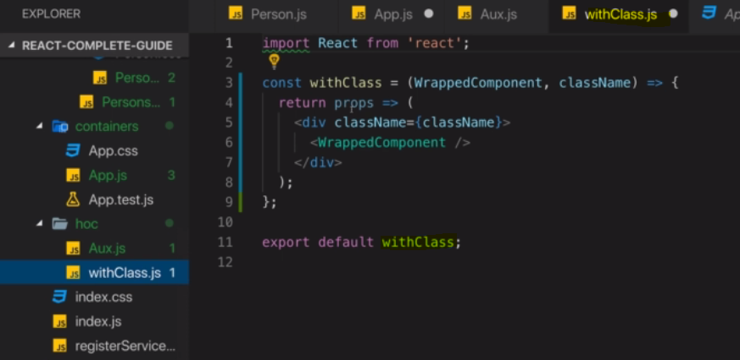

we have a function and that is a normal Javascript function, not a component function because we're not getting props here and we're not returning JSX but instead I'm returning yet another function definition and that is now the function definition of a component function. So here I'm getting props and I'm returning JSX,

Now we need Aux component here because we don't have a root level element but we have adjacent elements, we need that aux component

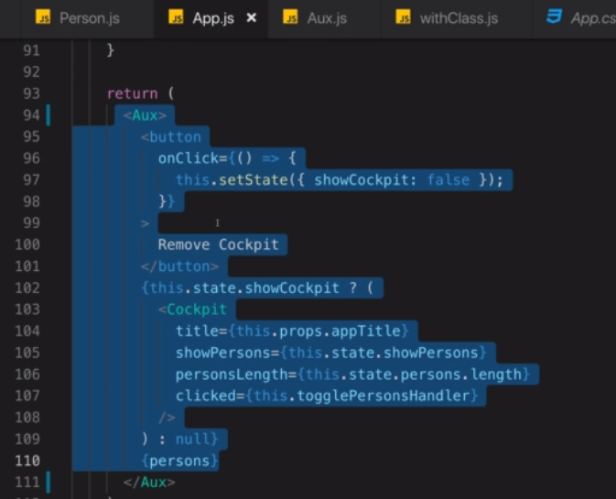

Now we use this way 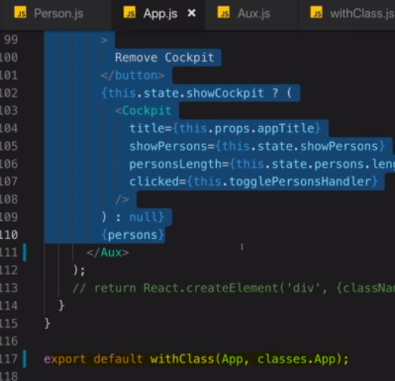

now we're using that alternative way of using a higher order component and that of course leads to the question, which approach should you use and the answer is it depends. There are higher order components, like this one actually would be that mostly change the HTML code or change some styling and I would argue that those best go into your JSX code as a wrapping component

There are other higher order components that add some behind the scenes logic, some Javascript code that handles errors or sends analytics data or anything like that.

Such higher order components maybe should be used or should be written in this style here to really make it clear that they're not so much involved in the JSX code that gets rendered but in the logic that runs but as you see at this example, you can ultimately write any higher order component in any way. This is a semantical thing that ultimately is up to you.

Now throughout this course, we will see multiple higher order components, not all written by us but also some introduced by third-party packages we'll be using and when you see them, remember what they do behind the scenes, they add something extra to the component. That could be styles, that could be HTML code or that could be some extra Javascript logic.

### Missing props of component when using another form of HOC

For example - 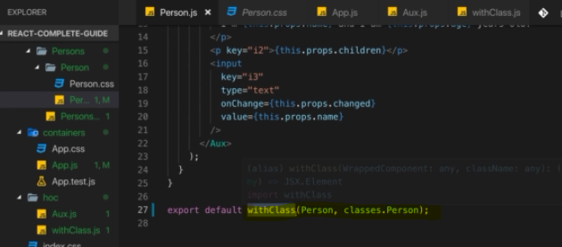

When we use this HOC approach we are missing the props of component. The Person component is not getting any props as we never passed it from withClass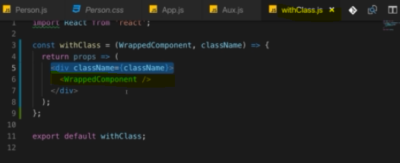

I'm outputting wrapped components like this and I haven't set any props here.

Of course we could set name as a prop here but for one, this is now hardcoded and second, now every component using that higher order component would receive Maximilian as we can see here and that is certainly not what we want



We actually do accept our props here and this will be the props of our wrapped component because we return this functional component in our higher order component

So props will actually be the right props and now we can use a JSX syntax that allows us forward props to the wrapped component.

Now what doesn't work is that we set props equal to props because React automatically takes all the attributes you add to your JSX code and combines them in a props object.

So now props would not replace that props object but be added as a single property in the props passed to the wrapped component.

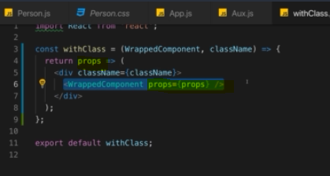

But instead, you can use another syntax where you use curly braces and then a feature called the **spread operator** where you spread the props you're getting. The props you're getting here is a Javascript object and the spread operator pulls out all the properties that are inside of this props object and distributes them as new key-value pairs on this wrapped component.

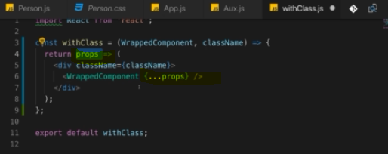

## Setting state correctly

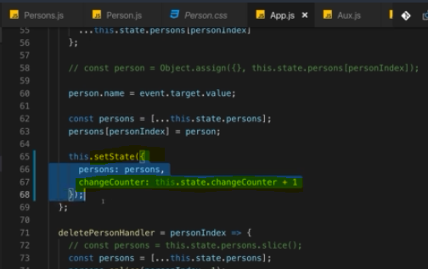

We use setState to update their state.

Now the good news is we're using set state correctly here, bad news is you can use it incorrectly but I will show you how and how to avoid it.

now of course this above code always depends on the old state, right?

Because we want to increment it by one, it seems to work, right and yet it is the wrong way of updating this.

Behind the scenes, set state does not immediately triggeran update of the state of this component in a re-render cycle, instead it's basically scheduled by React and React will then perform the state update and the re-render cycle when it has the available resources to do that.

so when it basically decides that now is a good point of time to do that. Typically, that will of course be instantly especially in simple applications like this one but it's not guaranteed and I want you to memorize this because that is really important.

You call set state synchronously here but it's not guaranteed to execute and finish immediately and therefore, this state when used for a state update is not guaranteed to be the latest state or the previous state on which you depend, it could be an older state.

Let's say you're also calling set state somewhere else in your application which happens almost simultaneously to this set state update and for some reason, this does not execute immediately and the other set state update finishes earlier, something like this. Then the state you depending on here might be an unexpected state, it might not be

previous state you would expect it to be and therefore there is a better way of updating state when you are depending on the old state.

**Set state does not only take a Javascript object, it also works when you pass in a function, so you can use either syntax.**

so without the change counter, this is perfect. With the change counter however, you should use that optional syntax where you actually receive two arguments and I'm using an anonymous arrow function here, where the first argument is your old state and I'll name it prev state for previous state and the second argument are your current props in case you need those. Then you have your function body and in that function body, you should return this new state object, like this. Now of course there, you are now not referring to this state but you can refer to previous state change counter and here, React guarantees you that this will be the actual previous state as you would expect it for this set state update.

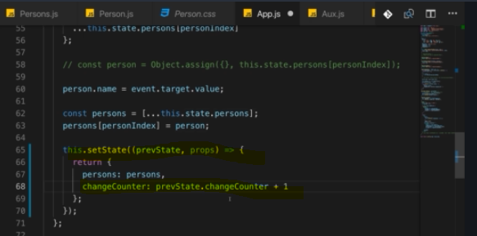

**this is the better way and the recommended way of updating the state when you're depending on old state and therefore, you'll see me use that throughout the course whenever we do depend on old state. Super important to keep that in mind, it's an important pattern, not an optional solution but really the best practice for state updates that depend on the old state.**

## Using Props types

We can actually improve this to be more clear about which props your component uses and to also throw an error or a warning if you try to pass in incorrect props.

Now if you are working on your own application and you're working alone, that is not really that important because you obviously know which props your components take but if you're building a library that you want to distribute to other people, let's say via npm or you're working in a bigger team, then you might have scenarios where people start using your component incorrectly because they don't know that age should be a number, maybe they try to pass in a string.

you can do this by importing or by installing an extra package,



That is provided by the React community or by the official React team actually and it's not built into React core but it is part of React so to say, it's just an extra installation away because it's optional to use.

Now lets use it, first import it in your component



Then use it like this. Detailed explanation below

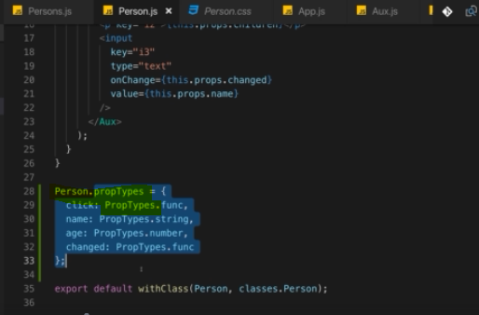

on your component you can add an extra property and now this works in both functional and class-based components.

After your component definition, so either here after your class definition or on a functional component, after setting up the function and storing it in a constant, you access your component, so here person or if that were a functional component, we would probably have written it with a lowercase p, so here uppercase, Person and you add a new property here by adding a dot and then prop types, like this with a lowercase p, that's important here.

**This should now be a Javascript object and prop types is a special property which you add to any Javascript object or any Javascript component object, I should say, that React will watch out for in development mode and give you a warning if you then pass in incorrect props.**

Because in here, in this object, you now define which props this component uses and which type of data each component should be of.

So here, you simply set up key-value pairs where the keys are your prop names, like for example click and you then add click here and now you define as a value which type of value should this be and for that, you use the prop types thing here you import up there.

So now we use prop types with a capital P and now this provides us a couple of data types you can use and after this lecture, you'll find more on the available data types. So here, I'll use func which stands for function, which indicates that for click, I expect to get a pointer at a function, not a string, not a number but a pointer at a function. Now of course we're also working with name and age, so let's add name and name is a string and there is a string prop type. Now let's say age should be a number, well there also is a number prop type and you'll basically find all the types of data you have in Javascript, you can even set up more advanced prop types like hey this should be a function that gets this and that argument and returns something like this, so you can get really advanced here. Now last but not least, we also have the changed prop here and this should also be a function, so again it's prop types

func.

let me switch that age of Max to a string. So it's still 28 but it's now a string not a number anymore

and remember that in the person component, I did set up that age should be a number.

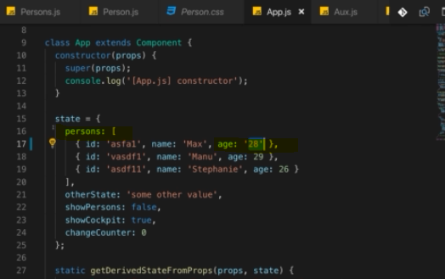

 I actually get a warning that I do pass the invalid prop age of type string where

it expected a number.

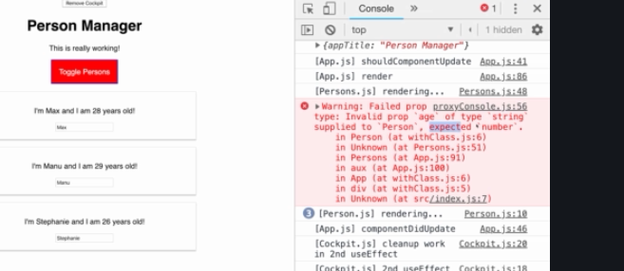

this is especially helpful in scenarios where you distribute your components as a package to other developers or where you're working in a bigger team because if someone uses your component incorrectly, during development, they will get such a warning and then they can fix their error.

 So consider using them whenever you have scenarios where other people are using your components and it might not be super clear which props your components take and which type of data goes into which prop.

## Refs- createRef (using refs in react)

what I'm about to show you works with any HTML element, with any JSX element I

should say here, then you are not limited to setting up two-way binding because that of course is nice for getting the value you entered

but let's say you want to focus that input, let's say when we render all our persons here, the last person should automatically receive focus.

Well then this is kind of hard to do here right, how do we focus this? In regular Javascript,

you could of course write something like in componentDidMount, so right after this rendered let's say, you could use document.querySelector, select your input and on that input, you could then call the **focus** method.

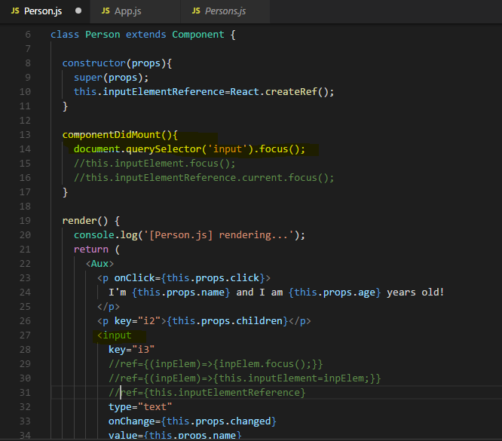

Now if we try that actually and componentDidMount works here of course because it's a class-based component, if I try that, then It indeed focus but I focus the first one simply because document.querySelector selects the first input it finds here and additionally, this is not really that great because it doesn't refer to the input rendered by this component, otherwise it would render the last input because that was the last component rendered,

so this code here actually executed the last time in that last person component and it didn't focus the input of that person component but still, the first input it found on the entire page because document.querySelector is not something that is related to React, it is a general web or browser feature, a general DOM selector and it always works on the entire DOM,

it doesn't care whether we use React or not and therefore, this is not the optimal way of selecting this.

Sure we could set up an ID here to select it by ID but React actually has an easier way for us to select an element, **a concept called refs which stands for references**.

**On any element and that does really mean not just on inputs but on any element including your own components, you can add a special ref keyword. Now ref, just like key, is a special property you can pass into any component, it is detected and understood by React.**

Now ref can be used in a couple of different ways and here is way number one which is supported in older versions of React too.

You pass a function here and this can be an anonymous arrow function as I'm doing

it here and the argument you're getting is a reference to the element you place this on.

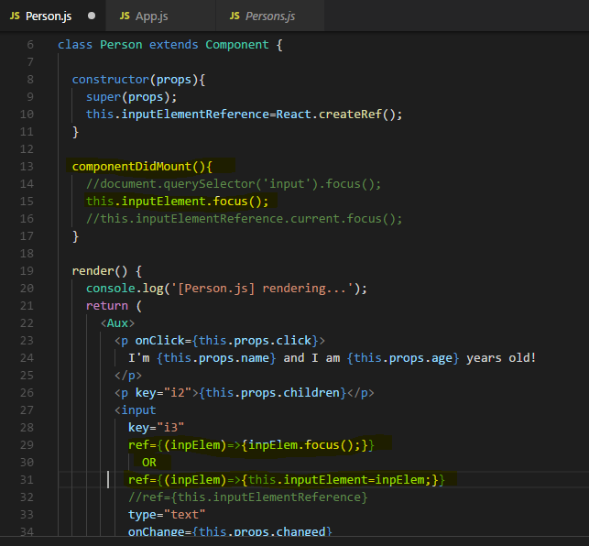

 we could call focus actually in there itself **ref={(inpElem)=>{inpElem.focus();}}** but that's not what I want to do here, instead let's say we want to use that in some other place of the application and therefore what you can also do is, you can add a new property to your class, so not to your state but really just to the class

inpElem having reference to that <input> element.

we're getting as an argument. So we're getting access to the input element here and then we're storing this in a global property, so from that point on we can use it anywhere in our application. And since componentDidMount executes after render, input element will have been set by then,

so in here we can call input element focus. this input element focus of course because input element is a property of this class and therefore this approach only works in class-based components, not in functional components.

now the last persons input is selected because last <Person> Component get rendered last hence its get focus on input element

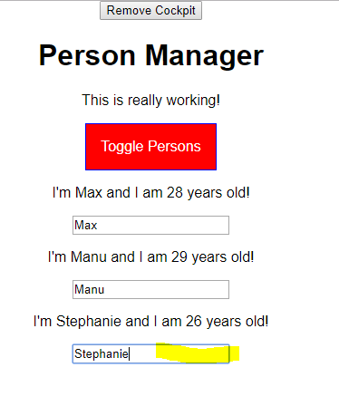

Now this is one approach of using references but as I mentioned, it's not the only one. Since

React 16.3, we also have another way of setting up a reference and that includes the constructor or requires us to use the constructor

and in there, you can now set up your input element, by calling React.createRef(). So create ref is a method offered on the React object we're importing and I'm storing it here in the input element.

Now that means this is not my input, this is any reference object React gives me, whatever that is behind the scenes.

You can now use this reference here instead of passing a function to ref.

so to this property you're initializing here in the constructor. This holds an access to this ref object React gives me and then I'm assigning this to my ref property and behind the scenes, React will make the connection and input element ref will then actually allow me access to the element on which this ref assignment was placed.

**So now in componentDidMount, I can use this input element ref, so this ref property and there, I actually have a current property which you have to access first and this gives you access to your current reference and then focus . so the input element and that does have a focus method.**

Now one thing, if you add a constructor, you have to call super here and of course you should forward the props you're getting here to make sure everything works correctly, always when you add a constructor, add super first.

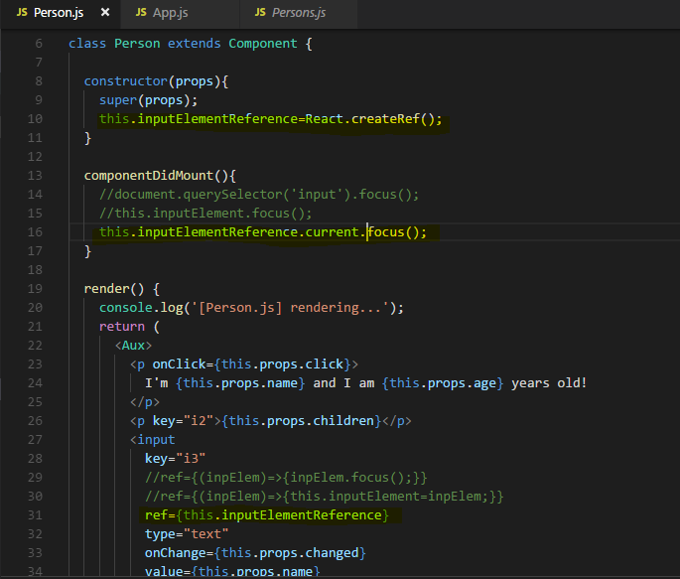

So you can use either approach, either with React create ref which is the more modern approach or by using that function form down there to get direct access to the element,

the older approach and therefore it also works in older versions of React and it's up to you

to use which version you want depending on which version, the version of React you're using, is allowing you to use.

### useRef – react hook (Using Refs in functional based component )

the function-based approach here is not usable in functional components but the other approach kind of is, with the help of React hooks. let's say in here, I automatically want to click this button here whenever this entire page loads.

So first of all, we need to set up a reference and since this is a functional component, we have no constructor, we just have our function body.

So maybe up here, doesn't really matter but should definitely be before you return your JSX code of course, you set up your reference. in a class-based component, we would have used React create ref. In a functional component, this will not work, this is not supported but instead here we have a hook we can use, the useRef hook. So you import useRef from React and then you useRef. Now you could pass an initial value here because you can actually use references not just to get access to DOM elements but you can even store other values in there now we have our reference created with the help of the use ref hook, now we can connect that in our DOM.

Now therefore let's pass null as an initial value here

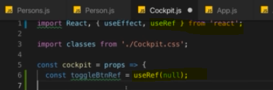

Then –



Now with that set up, we could try clicking that button. So let's use toggle button ref current click

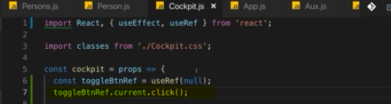

we run this we get an error-

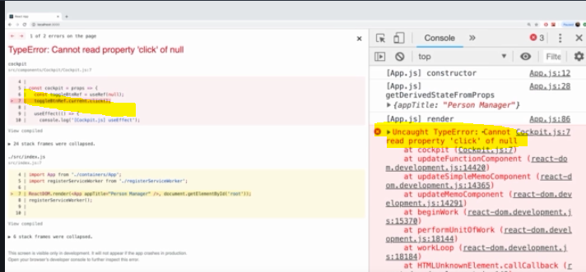

What's going wrong here, do you have an idea?

It's kind of tricky but it's important, if you understand this, you understand how hooks work.

Well I'm getting this because I'm calling click right after I initialize my reference. React didn't have a chance of executing the code down there where I actually do assign this reference to the button and therefore at the point of time I'm calling click here, the button is of course undefined.

We can change this with useEffect.

What we know about useEffect?

It basically runs after every render cycle. So the function you pass to useEffect does not run immediately, it runs after this JSX code here has been rendered for the first time and therefore useEffect here is a great place to actually call click. So therefore here in this useEffect where I pass an empty array as a second argument and which therefore only executes when the component renders the first time and then cleans up when it's unmounted.

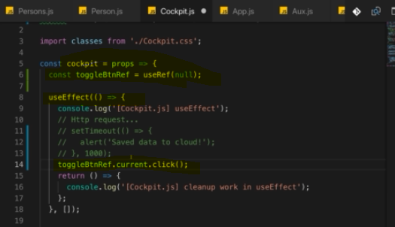

So that is how you can set references with the **useRef hook**, here when using React hooks in functional components

## **Context in react - Understanding Prop chain problems**

**Context was introduced by React and it helps us handle cases like this, where you need certain data, certain state in multiple components and you don't want to pass that state across multiple layers of components just to get it from component A at the top to component D at the very bottom when the components B, C in between don't really care about it.**

For example in below example we're passing down props across multiple levels and for example, the persons component really only forwards the authentication status. It receives is authenticated as a prop but it doesn't really care and this is not so great because it simply leads to extra redundancy and it makes our components a bit less reusable because wherever we're using the persons component, we have to make sure we pass in is authenticated so that we can forward it and there, we have a feature called **context** which helps us solve the issue.

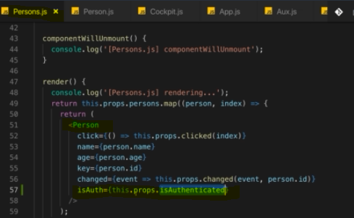

### Using the Context API

add a new folder and name it context and you can name it whatever you want, that of course does not matter and in there, I'll add auth-context.js file. In here, I'll create a so-called context object and React gives us access to that, so we need to import React from React and then I'll create my authContext here by calling React create context and I'll export this authContext as a default for this file.

Now React create context actually allows us to initialize our context with a default value because what the context in the end is is a globally available Javascript object you could say, though globally available is not entirely correct, you decide where it is available. But it is a Javascript object that can be passed between React components without using props



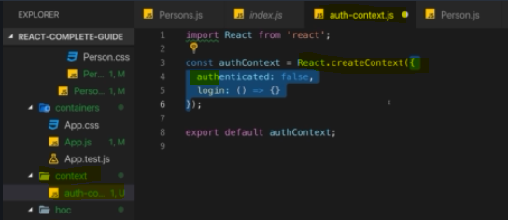

for example here I'll set authenticated to false and I'll also add a login method here.

However this method will not do anything, it's an empty anonymous function and I'm adding this here because

if I initialize my default value with everything I want to be able to access on this context from different components in my application, then I actually get better auto-completion from the IDE

Now import this in App.js file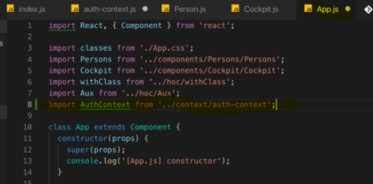

**Now authContext can be used as a component and it should wrap and that's important, it should wrap all the parts of your application that need access to this context.**

use authContext which I imported now as a JSX element but not like this but instead here, you can access with a .provider. So this actually gives you a provider JSX component on this authContext object and you wrap everything where you want to be able to access this context later on.

**So now inside of the cockpit and of persons, we'll be able to interact with our context and also in the app.js file because here I'm setting up this provider component. Now the provider, this component takes a value prop and this is why the default values here don't really matter,the default value will apply when you don't set any other value. However in many use cases like this one, you actually want to have a dynamic value, the authentication status can change afterall and therefore, I'll manage the status here in app.js**

we'll still manage the authentication status in my state of this component because one thing does not change when you use context,

**React will re-render when state or props change. So only changing something in a context object would not cause a re-render cycle and therefore this is not enough. Hence I still manage my authentication status in the state of this component  but I then also store the current state in that authenticated prop of the object I am passing as a value to the authContext and since this effectively is a prop of the authContext provider, this will update whenever this state updates.**

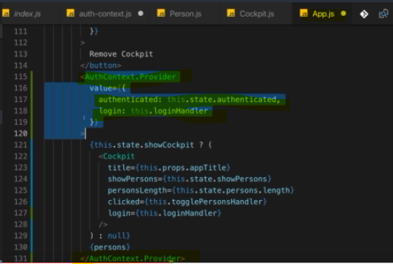

Now this is in my context object that can now be accessed from cockpit and persons because they are inside of the provider wrapper. So let's now access this inside of persons, **how can we get access to our authContext here?**

First of all, we have to import it again. So I'll import AuthContext now here we don't want to provide the context but we want to consume it and you do this by going to the place where you return your JSX code, where you want to use that context and then you simply use **authContext.consumer** as a JSX component

and this now wraps your other JSX code, since this is some Javascript expression, we need to wrap this here with curly braces.

So now here, we have authContext.consumer but this is not yet the entirely correct syntax, authContext.consumer does not take JSX code as a child, so as content between the opening and closing tag but instead this takes a function as a child between the opening and closing tag.

So here, I actually will pass in a function which will eventually return my JSX code and this function which will be executed for us by the authContext.consumer or by the React context API, this function will get our context object,

so this is how we get access to that context object here in the place where we consume it.

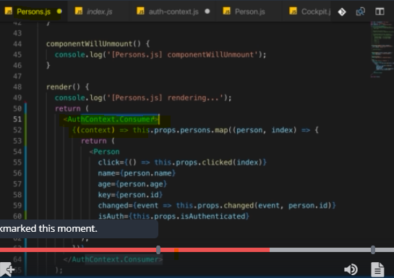

**We provide a function that accepts context as an argument, we'll get that argument by the authContext here, React executes this function for us and then in this JSX code which we return here and which will be rendered in the end, we have access to that context object and therefore now, we could forward this to isAuth.**

But of course, that was not the idea here, right? We wanted to use the authContext in person not in persons, we wanted to skip that extra cycle where we have to forward something which we don't need in this component. So let's actually not consume authContext in here,

We wanted to use authContext in the person component,

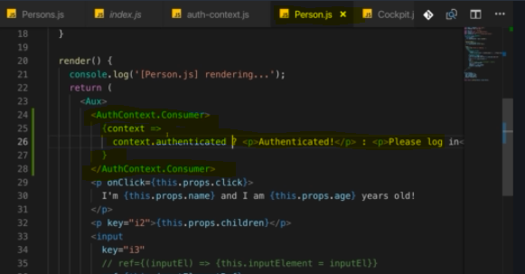

With that, we're consuming our context in the person component to output the right data but we're not using it for making this login button work.

So let's go back to the cockpit component now where we have that login button and let's consume context here as well.

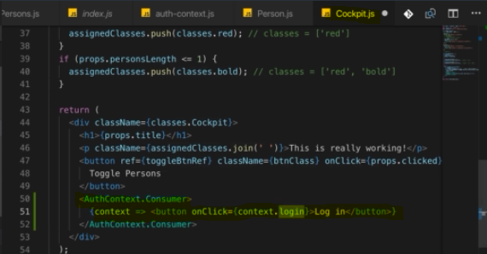

**OR**

**Another way of providing function to AuthContext.Consumer(just syntax change)**

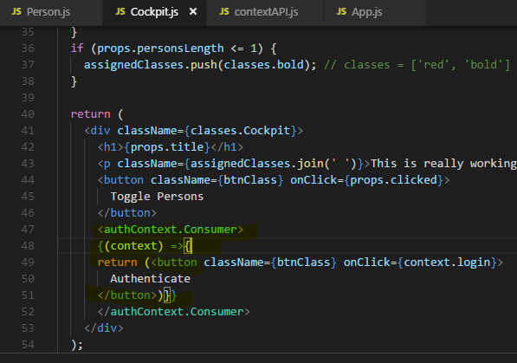

**Output -**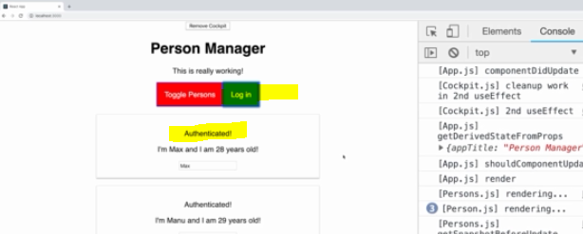

now we're using the context API. And this is especially useful if you have very long chains of data you're passing around and if you don't want to pass data from component to component to component, if you don't need it in these in-between components, then context is a great way of bypassing components and directly passing data from A to D.

### **contextType and useContext() -Better way of Using ContextAPI( for class-based and functional based component)**

**For class-based component**

Previous ContextAPI approach code a bit verbose and can be tricky to wrap your head around when you see it the first time, **it also only gives you access to the context in your JSX code here, where you render authContext consumer.**

Now what if you wanted to have access to it in componentDidMount because here you also need the authentication status because you are maybe sending an HTTP request that needs the user ID? Well then you would have no chance to access the context in componentDidMount when injecting or when using the context like this.

Thankfully, React 16.6 added another way of using context.

You can add a special static property named **contextType**.

Now this has to be named contextType, written exactly like this and it has to be a static property.

Static property means that it can be accessed from outside without the need to instantiate an object based on this class first and React will access contextType for you, so to say.

Now we set a value here and that value should be your authContext, just like this,

not as JSX code, nothing else,just the authContext object.

**Now this allows React to automatically connect this component here, this class-based component to your context behind the scenes and it gives you a new property in this component, the this.context property.**

We can now console log this context here and again, **this.context, it has to be written like this because this is given to you by React automatically**

and there, we can access login for example or authenticated which was our context property holding true or false.

**This allows us to get access to our context even in places like componentDidMount where we previously couldn't.**

**And you can of course also use this context in your render function.**

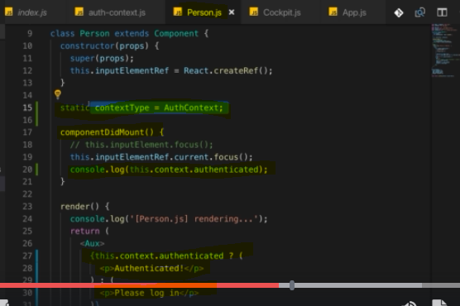

I recommend using it there because it's shorter, it's easier in my opinion and it gives you access to contexts in places where you previously had no access.

**For Functional Component**

Thankfully, React has you covered with hooks.

**You can import the useContext hook and this now allows you to get access to your context anywhere in your functional component function body**

**you simply use context like this and as an argument, you pass your authContext(you can name it whatever you want) object and here again, React will make the connection for you behind the scenes.**

**So now authContext will be a constant that holds information about your authContext data.**

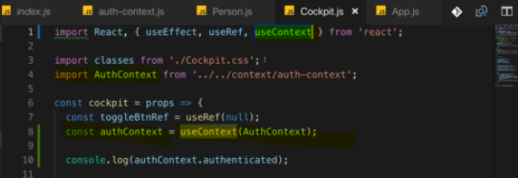

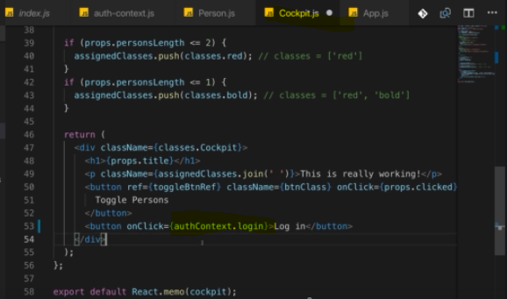

**So use context is to functional components what static context type is to class-based components you could say.**

**It gives you access to the context and the context, the context API is all about managing data across components without the need to pass data around with props.**

**We'll also learn a different concept that helps us with this, Redux later in the course and we'll use Redux later in the course**

**but knowing the context API is important because you can build exciting things with that and it will also make it easier to understand that Redux thing later**

## Useful Resources & Links

Useful Resources:

* More on useEffect(): <https://reactjs.org/docs/hooks-effect.html>
* State & Lifecycle: <https://reactjs.org/docs/state-and-lifecycle.html>
* PropTypes: <https://reactjs.org/docs/typechecking-with-proptypes.html>

# **A Real App: The Burger Builder (Basic Version)**

## Planning an App in react

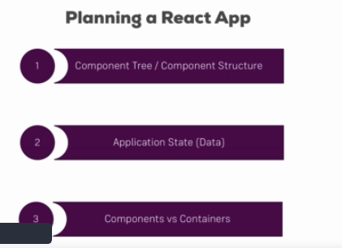

you can of course split this up into more granular steps than these three but here are three very important steps I see and I regularly go through when planning a React application.

The first step is planning the component tree, the component structure.

it's absolutely normal that the result you may have at the end might look different than your initially planned component tree but it's super important to have an idea about what should go into its own component and what not.

The other important part of your application of course is the application state, you can also translate this with the data you plan on using and manipulating in your application.

For example and of course we will do this over the next lectures, in our burger application, we need to keep track about the ingredients a user added because that will determine what we need to render and also what the user needs to pay in the end.

Now once you know the component structure of your application and the state you're going to use in it, you can plan components versus containers. So which components in your application should be stateless, also sometimes called dumb components, so basically components that are functional and don't use hooks or even class-based components that don't use state and which components have to be stateful components, so either functional components using their useState hook or class-based components using the state property.

## Planning our App – Layout and Component Tree

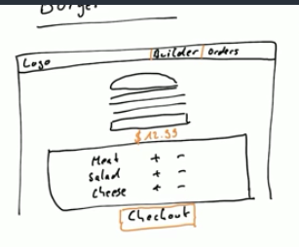

we need to define what our application actually is and what it should be able to do.

Keep in mind, we're building the burger builder application so the goal is that users can use it to add ingredients and therefore build a burger.

Now if we think about the UI and that is something you typically of course get by your designer or you already create it but if we think about the UI, we probably have some header at the top navigation bar where we're then able to go maybe to all our orders and where we have the builder itself, so the tool where we can build the burger and probably some logos, some text or an image to the left.

Now the fine tuning, the colors sensor again, that is something you probably got by or designer, we're not going to take care about this here, we're going to add some colors as you create the application.

Now what goes on the starting page? Let's say we're on the builder part here now, how should that look like?

Well of course it's only up to you but for me it makes sense that we have an area where the actual burger is getting built, so where we see a preview of the burger we built. So that is super ugly here but that of course should be the burger we're building with the different ingredients which get added dynamically as we add them. Now to be able to add ingredients, we need some controls maybe sitting in a box or something like that below the burger. In there, we have stuff like meat, salad, cheese maybe even bacon and so on and we essentially got a button to add or remove each ingredient so that we can well build our burger and then we probably also want to have a check out button, so some button sitting below everything where we can tap on to buy our burger and obviously, we maybe also want to see a price or something like that below our burger as a preview so that we can always see what it would cost.

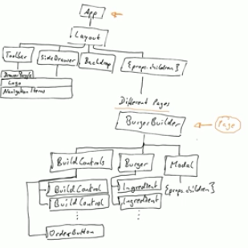

these are probably not all the components were going to add but it is a good overview over our tree. We see that everything starts with one root component here at the top and then we split the tree up,having a layout which could be part of the root component as mentioned and then having all the different branches. Now here, where we have the burger builder, this will be kind of like a page. It is a normal componentno worries, but we probably will add more pages throughout this course when we start adding a page where we can see all past orders and stuff like that.

## Planning the State

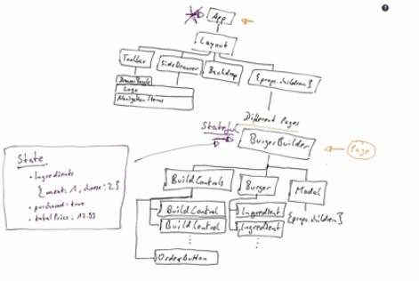

Now where do we manage that state?

You could say we should manage the state in the app component here at the top but I don't agree with that, we won't do it here.

Instead we should do it in the burger builder here,

why?

Because the state I listed here on the right is really just related to building a burger, if we later add a new check out page or something like that, then we will basically have a page where we want to see all orders of the user and we're not interested of the ingredients of the burger the user currently builds.

So managing this state on the app level isn't correct in my opinion because it doesn't affect the whole app, it only affects this burger builder page and for now this is going to be our whole app basically but it's not how our application is going to stay once we added that checkout page and so on.

So the burger builder should be a stateful component, it should be a container basically so stateful, that's what the burger builder should be.

All other components can be components, can be dumb components, stateless components.

Now the app component by default in the new project is a stateful one created with the class keyword, we can of course always leave it to be one but we can also turn it into a dumb component if we wanted to.

Now if we're thinking about pure components or shouldComponentUpdate, we'll both as a rule implement this as we built the application and see if we can identify some places where we need to optimize our update cycle.

## Setting up the project

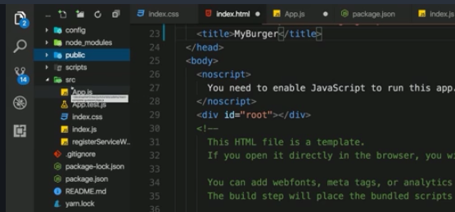

I opened a brand new project created with create react app, nothing has been changed here yet. Now in this project, I first of all want to enable css modules so that I can make sure that the css classes we create in a css file can be scoped to a specific component in our application so that they are not applied globally when we would accidentally reuse the same css class.

For that I need to eject the project

Some Steps for enabling CSS modules

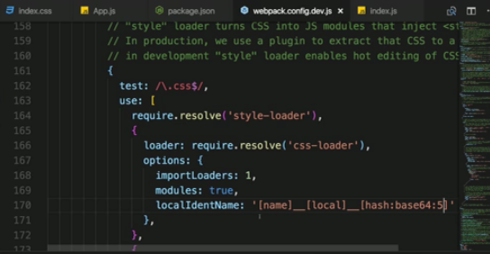

 I want to set the font family to another font. We could of course use that but I picked a different one which I find a bit more beautiful basically. I went to use open sans, and for that you can simply search for Google fonts and on the Google fonts page as I just mentioned is the open sans font here.

Now once you selected this, you can click on at the bottom to customize it and there I don't just want to pick the regular one,let's also pick up the bold one in case we need this,in case we want to have some bold text, for example for headings.

Now with that, let's go to embed and there you find a link to the Google CDN from which you can importthis font and this is perfectly fine, this is exactly the approach I want to use. So now with that link, let's go back to our project folder, to the public folder and to the index.html file and there I'll add it right above the title.

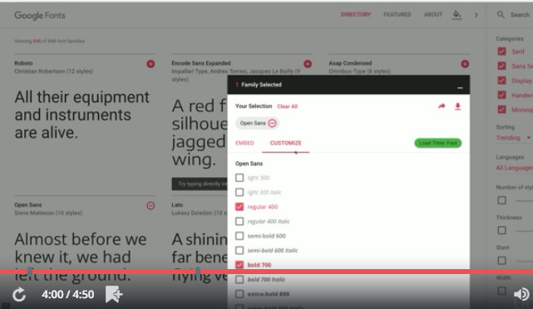

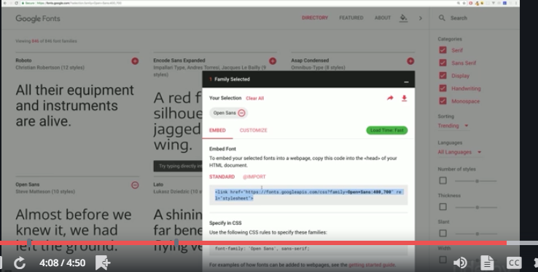

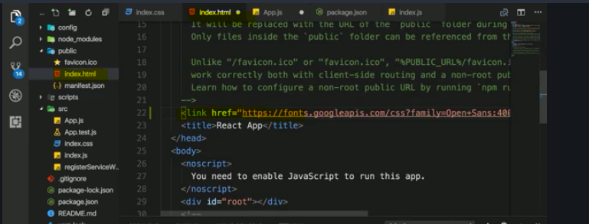

## 157. Connecting state to Build Controls

### **Note : -**

If you don’t use arrow function then you will problem with **this** object

**See below issue-**

**this.state is undefined on addIngredientHandler**

hi i couldn't figure out why i am getting undefined(couldn't able to access) state of BurgerBuilder.js inside "addIngredientHandler" function of BurgerBuilder.js.

when

1. render () {
3. return (
4. <Aux>
5. <Burger ingredients={this.state.ingredients}/>
6. <BuildControls
7. ingredientAdded = {this.addIngredientHandler}
8. />
9. </Aux>
10. );
12. }

but when i bind i am able to access

1. render () {
3. return (
4. <Aux>
5. <Burger ingredients={this.state.ingredients}/>
6. <BuildControls
7. ingredientAdded = {this.addIngredientHandler.bind(this)}
8. />
9. </Aux>
10. );
12. }

why i need to do extra bind in my case only not as per lecture?

please see attached snap for understanding the issue.

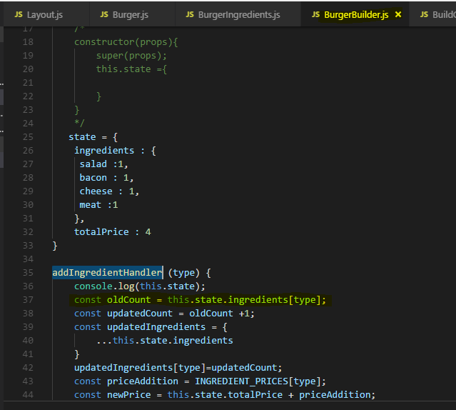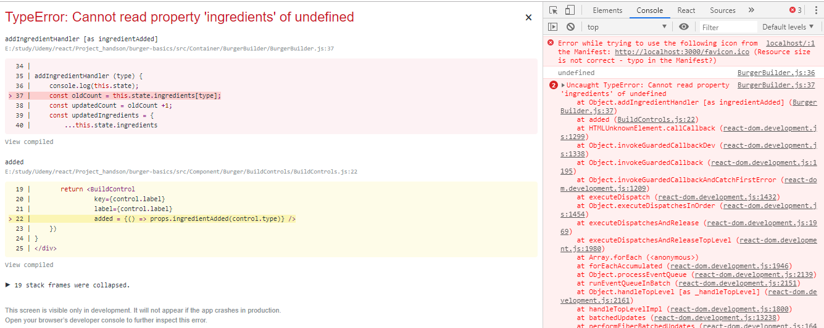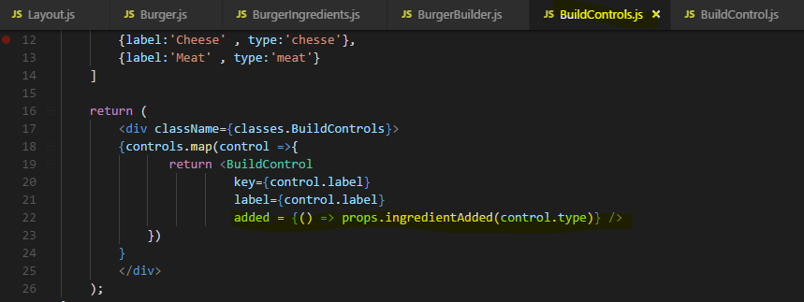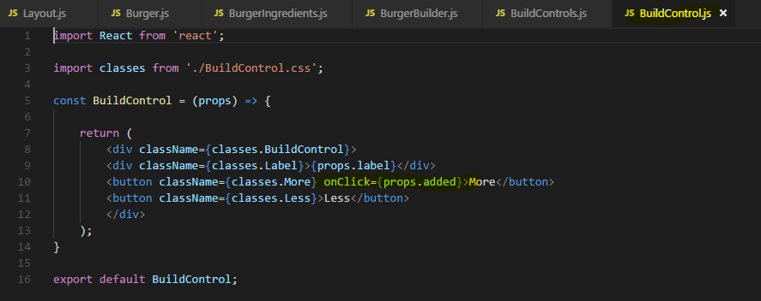

**Following Responses**



[Jost](https://www.udemy.com/user/jost-schmithals/) — Teaching Assistant · 23 minutes ago

**Hi!**

**The difference is that Max uses the arrow syntax when defining the class method. In this way the outer this is used automatically (which is what we want here: this pointing to the BurgerBuilder instance and not to the BuildControls instance) - thus no need to extra bind the function:**

**addIngredientHandler = (type) => {...}**

### **Note : -**

When should we pass a reference of a method that takes arguments using () => this.methodName(args) and when we should be passing only the ref like this.

this.methodName

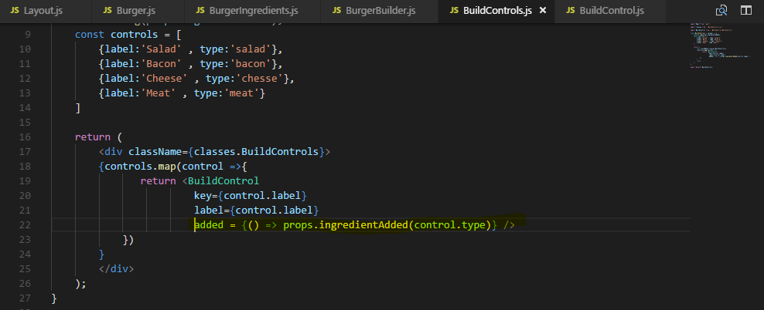

Answer –

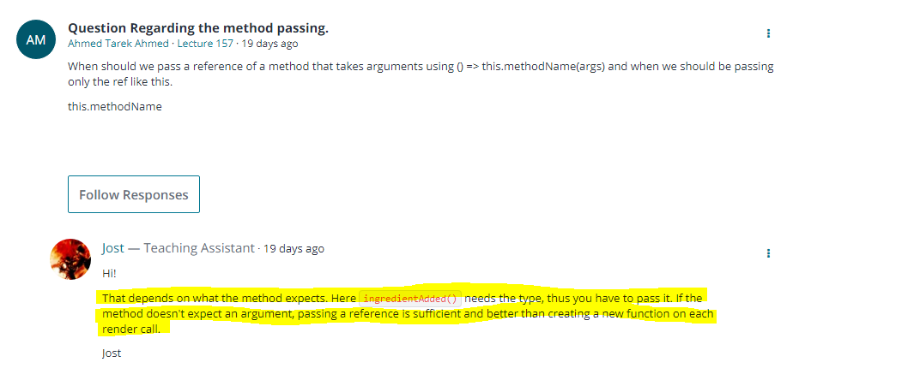

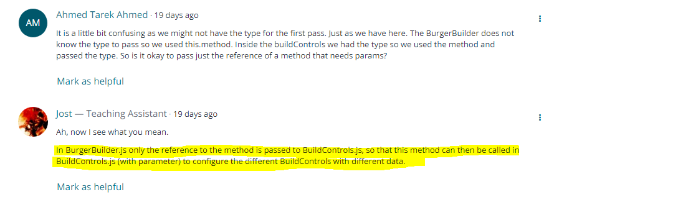

## 158. Removing Ingredient Safely

Now we have a problem if we start deducting elements we don't have though, we get an error then

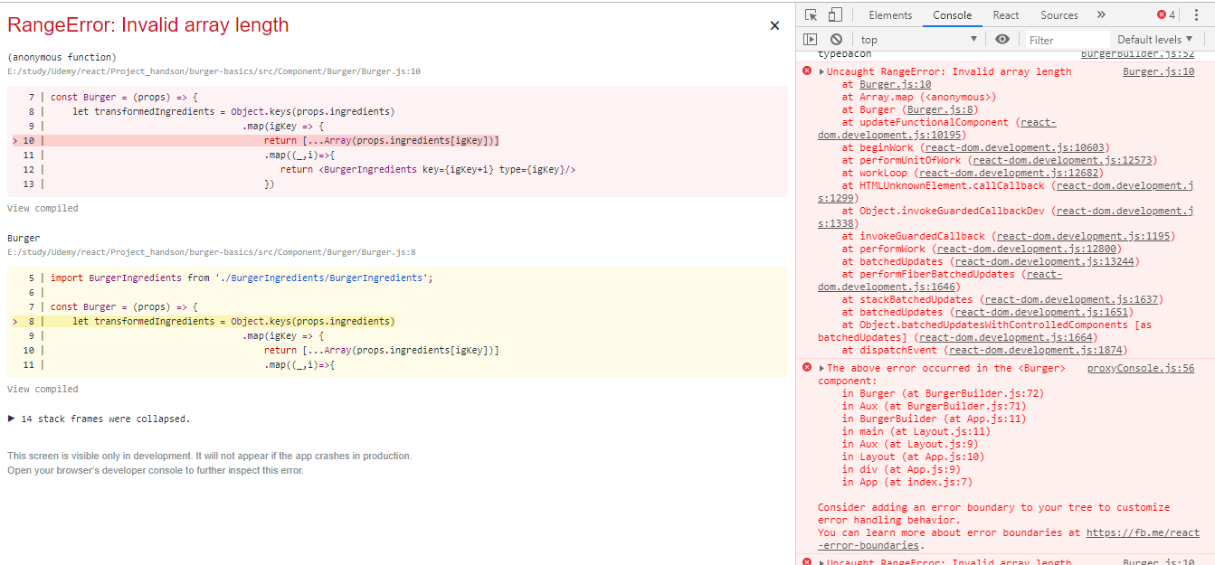 and it makes sense because we tried to remove an ingredient which we don't have.

So our burger builder here, the state becomes negative, we have -1 bacon and that throws an error because we can't create an array to render from a negative value.

So we should fine tune our removeIngredientHandler by also checking if we do have ingredients to begin with.

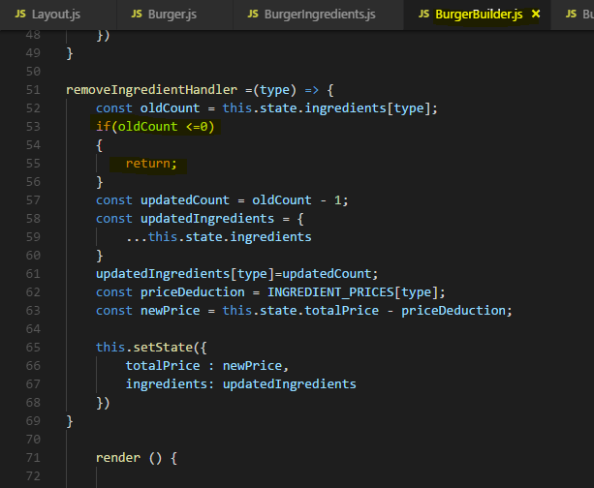

## 159. Displaying and Updating the Burger Price

To fixed the price to 2 decimal do this -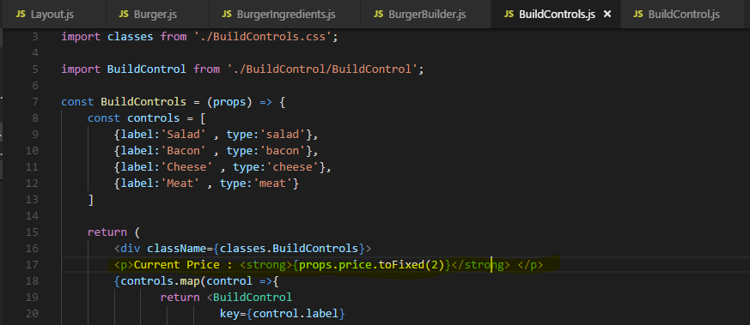

## 161. Adding the Order Button

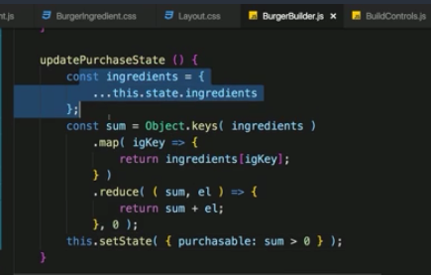

It has something to do with the update purchase state method, the problem is that the ingredients which I'm analyzing is of course my old state here.

Now due to the way set state works, when we execute update purchase state, we might not get the updated ingredients and therefore, once we copy the ingredients and analyze them, we might simply get an outdated version.

Now we can of course simply fix this by passing the updated ingredients we have in add and remove ingredient handler .

We have solved this by -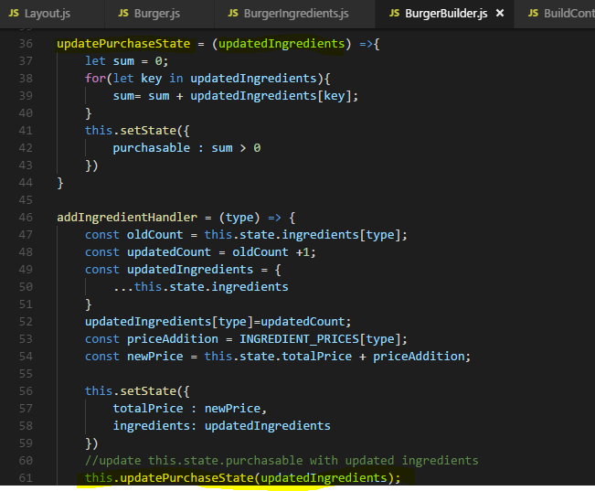

### Note : - Questions Asked

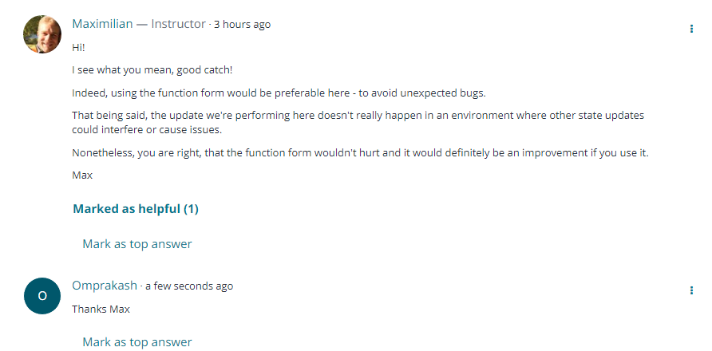

## 162. Creating the Order Summary Model

the idea behind the modal is to have a wrapping element which provides the styling which then simply wraps itself about any content we want to show in that modal

the question of course is where in our application shall we add the modal?

Well I would say we add in a place where we want to show it because that is the logical place where it belongs and where we probably have the state and the methods to control that display. So in our case, that's the burger builder,

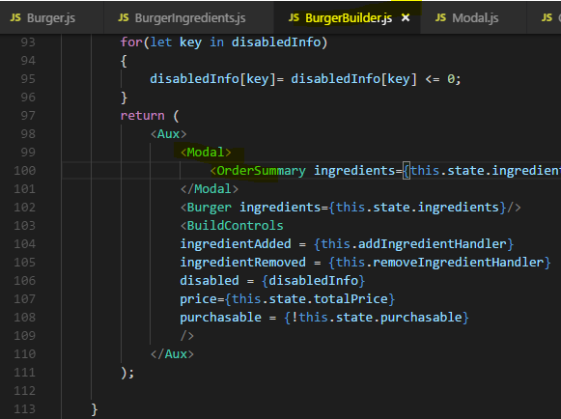

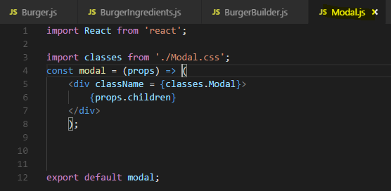

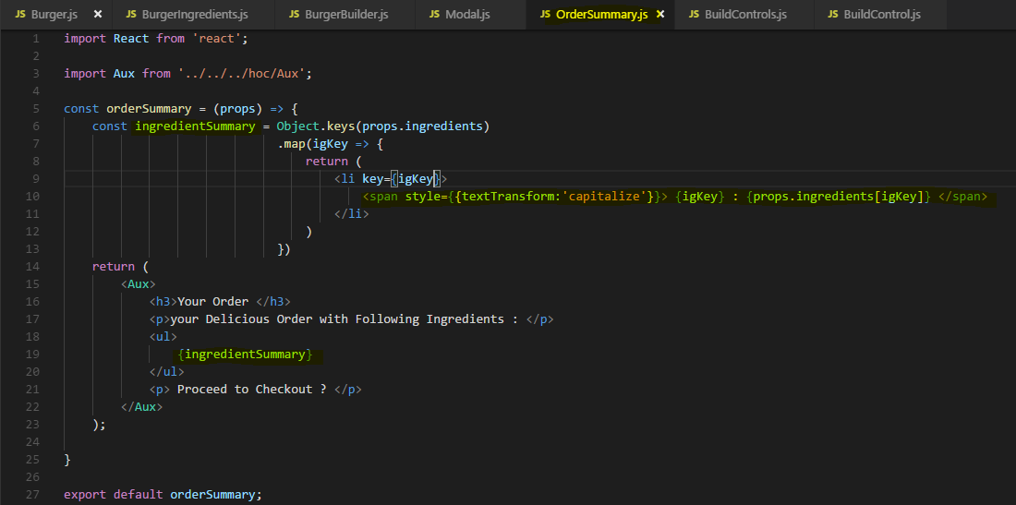

## 163 . Showing and Hiding the Modal

Depending upon Order button is clicked or not we are passing flag in props to Modal and in Modal we changing its CSS style like opacity accordingly-

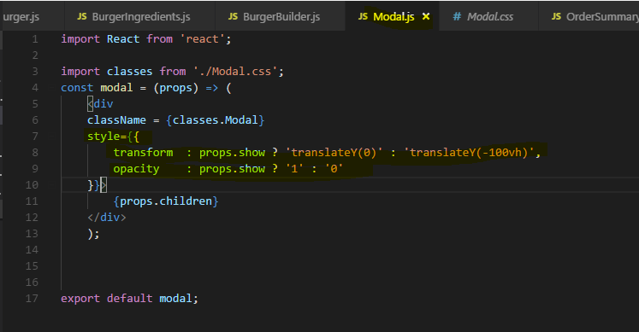

## 164. Implementing the Backdrop component

Modals are built with HTML, CSS, and JavaScript. They're positioned over everything else in the document and remove scroll from the <body> so that **modal**content scrolls instead. Clicking on the **modal** “**backdrop**” will automatically close the **modal**.

the question now is, where do we add this backdrop? And now you can have multiple places where you could add it, where you could argue that it makes sense.

One such place would be in the app component, have it sit next to the layout, outside of the layout even because it's not part of the core page content. Have it sit in the layout component could you argue because it is part of the page but it should not be part of the main content and not be part of the toolbar or anything like that.

You can definitely do that, you can put it into the layout component, you just need to make sure that you then can reach that by passing the show the backdrop state up to that component and so on.

This is a nice challenge for you, try placing and handling the backdrop in different places of your app.

For this, you might also need to switch some of your components from stateless, so functional without hooks to stateful, so functional with hooks or as we do it in this course, to class-based components because maybe all of a sudden, you also need to define some method in a component.

I will go for another approach though, I will add the backdrop to my modal because in my opinion, this backdrop is closely connected to the modal. If the modal is shown, the backdrop should be shown.

So in our application we make a backdrop for Modal which covers the whole screen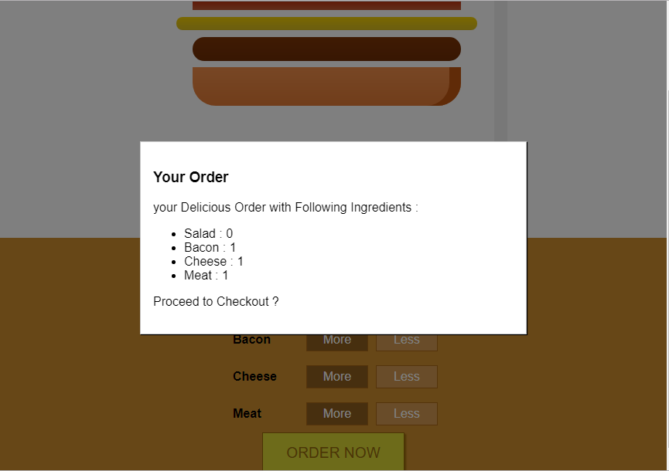

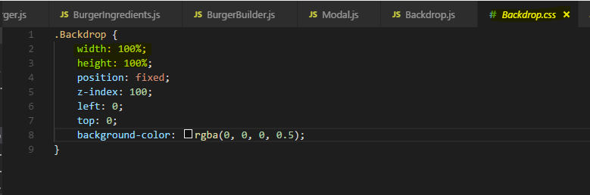

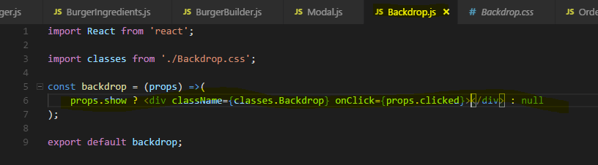

And from BurgerBuilder we are providing a handler which make Modal to disappear but setting flag to false

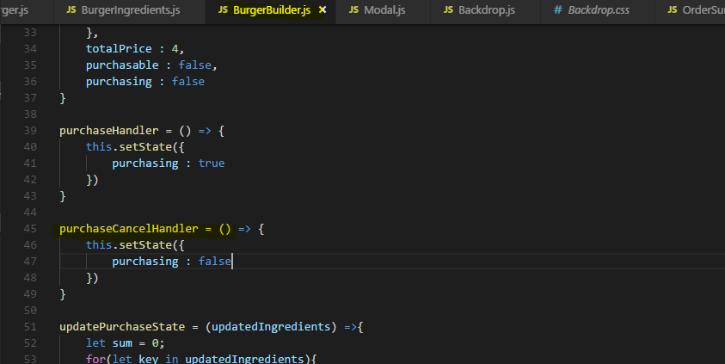

**So if click anywhere on the screen other than Modal the Modal will disappear**

## 165. Adding a custom Button Component

we now need buttons in our order summary so that we have the choice of continuing or canceling.

**actually I might reuse certain button styles throughout the application, having a cancel and a continue button makes a lot of sense**

**so maybe we should outsource the button into its own component,**

**even though there already is a button element in the html, we might still put it into its own component so that we can wrap it with some default styling and don't have to style that button in any component where we use it from scratch again.**

Lets create our Custom Button Component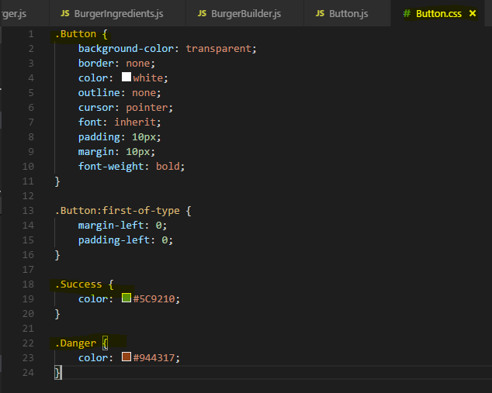

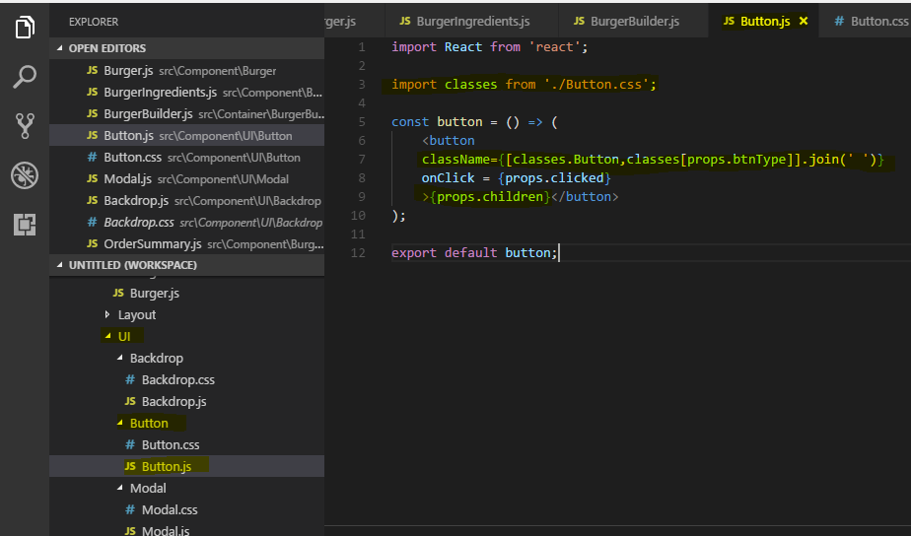

now want to simply wrap a normal button element here but I will need some props to configure it. I of course want to output props.children here so that I can use my own button like a normal button and simply wrap the content which should go inside with my custom button element then and I will need onClick listener for sure where I need to execute props.clicked

I also need different style links for different types of buttons, a cancel button, a continue button or something like that.

Now in the class name here, we have to pass the string in the end, keep that in mind.

So I'll add an array because I always want to assign the button class but then conditionally, I'll add the success or danger class, so I will set classes button as one element of this array, of classes I want to add and then classes

and now I will dynamically pull out a certain type with props button type for example, button type is a prop I have to set through outside and button type will have to be either Danger with a capital D or a Success with a capital S.

And of course you can also use a different approach of assigning the classes, I like this one because it's really flexible and easy to implement and

**keep in mind, what we passed to class has to be a string, right now it's an array of strings though.**

**So let's change this by joining this with a whitespace to have a list of classes which is a string in the end.**

### 166. Implementing the Button Component

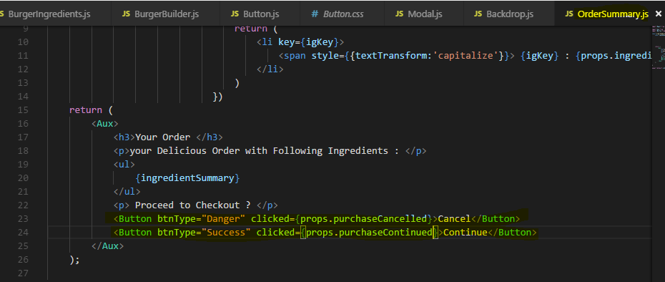

## 167. Adding the Price in OrderSummary

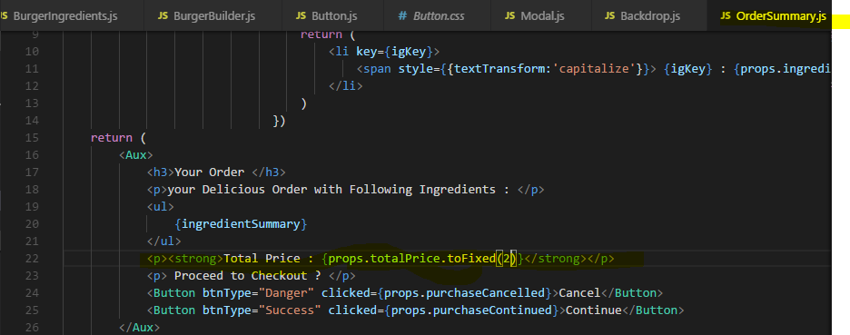

## 168. Adding a Toolbar

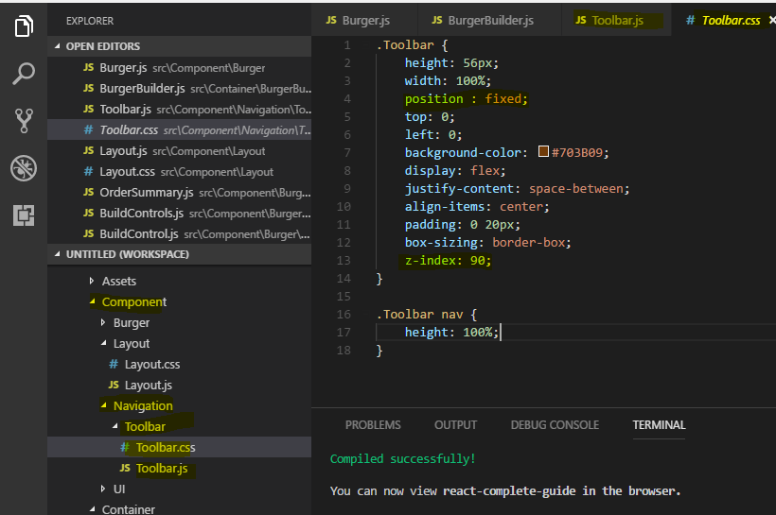

## 169.Using a logo in our Application

Now the image tag will have a source property and this should actually be set dynamically. **Now you could think that you simply say go up to the assets folder and then to the images folder and to burger-logo.png.**

**Now this will not work as you would expect it to work due to the way our build workflow here is set up.**

**keep in mind, the source folder is only the folder we're working in. In the end, webpack will take all these files, bundle them together and create a new output folder.**

**We can’t see that here because we're in development mode where all of that will happen in memory**

**but once we do publish our app, we will get a real different folder where all the optimized, compiled and bundled assets are contained in. Now therefore these assets folder here to the source folder will not be shipped to any real server, the whole source folder won't be shipped there.**

Hence we should also make webpack aware of the fact that we're using this image and we're actually doing that by importing the image into our javascript file. just like how we import the css files,

this does not mean that webpack mixes the image with our javascript code,

**It just means we make webpack aware of the fact that we're using this image and webpack will then handle this image with a special plug-in or a special module that was added to webpack, to its config, will handle the image, will basically copy it over to the destination directory it creates, again only in memory during development and we'll even optimize the image.**

**So here we can simply import burger logo from and now the path to the image,**

**And burger logo here will in the end just receive the path off the image where webpack will copy it to.**

**So this will be dynamically resolved,**

**so here we can simply set source to burger logo and this will again refer to a string in the end to the path where webpack stored the optimized and copied image.**

**This is important to understand**

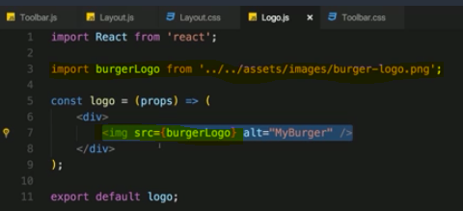

## 170. Adding Reusable Navigation items

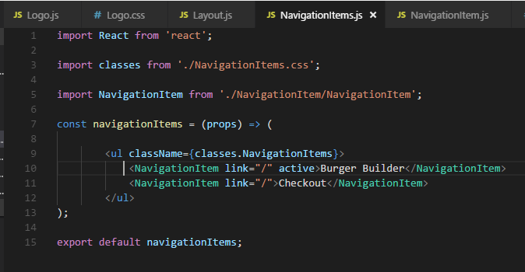

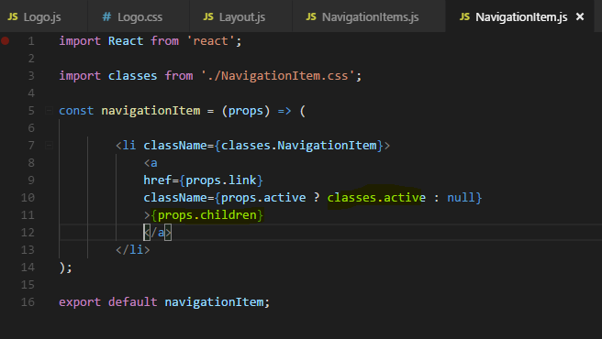

Active class we have added in css file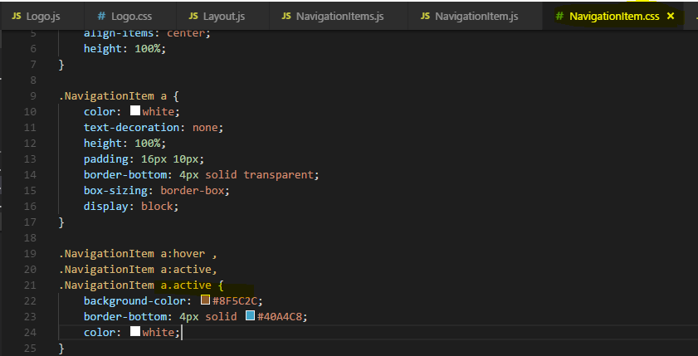

**For using props.children –**

so that we actually wrap the text we want to display with our own component

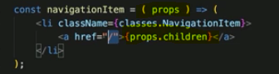

## 171. Creating responsive SideDrawer

sideDrawer will only be visible on small device screens, I will take care that you can only open it there. So let's set the position to fix then because it should always be on the page even if we scroll, it should feel like a static element.

Here’s the CSS -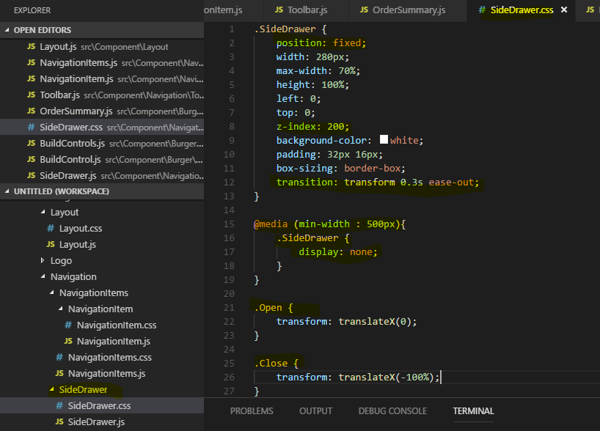

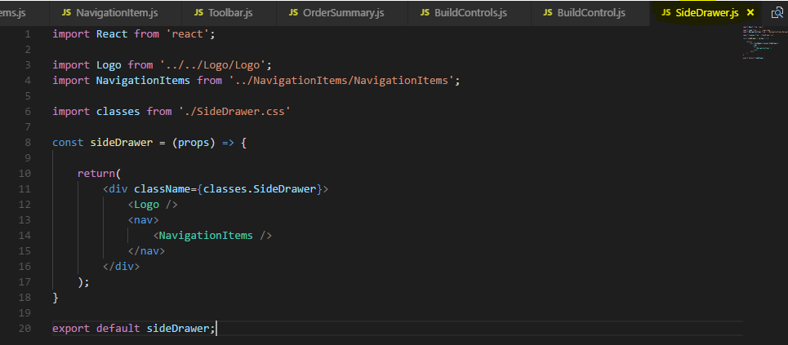

that brings up one important question, where should the sideDrawer component be used at?

In the app.js file? In the toolbar file?

Neither of the two of course, we got our layout and in the layout, we have the toolbar.

It's here where we also should have the sideDrawer because it's part of our core layout in my opinion.

With that, if we go back to the application and we click on this mobile device preview icon here in the chrome dev tools, alternatively you can just shrink your screen size. From a certain point on, you should see the sideDrawer.

### 172. Working on Responsive Adjustement

In the last lecture, we added the sideDrawer and of course this is looking horrible because logo and navigation items need to be adjusted to look good on mobile devices.

Let's start with the logo, it

right now is so big because the logo height is set to 80% and 80% in the sideDrawer means

80% of the full sizeDrawer height here, that of course is a little bit too much.

Now how can we adjust this? We could add some responsive design to the logo.css

file, we could set the default to something like 11% and add a media query to wrap this up

to 80% for bigger screens but that would make our logo harder to reuse.

Instead I'm a fan of controlling the logo height in the place where we embed it instead of in the logo component.

So let's start with the toolbar, as I said, the logo should only be 80% high here,

we can achieve this in two ways. We could add a prop to actually set the height dynamically

so we could add something like height here which we could set to let's say 80% and then in the logo, we can accept this,

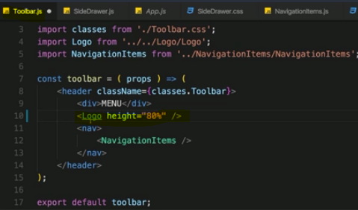

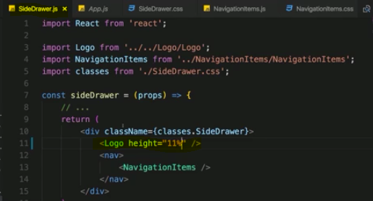

then in the logo, we can accept this,

we do accept props here and we could set inline styles here to overwrite the css class settings, to basically assign a javascript object here where we set height to props.height.

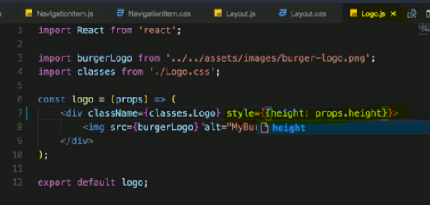

This is one clever way of adjusting this, setting the height as a property where we simply pass the percentage height to the logo component and in the component, assign it dynamically via inline styles.

Nothing wrong with this approach, it should work fine, I want to show you an alternative to that though.

I will instead follow a different approach and wrap logo into a div in the sideDrawer and also in the toolbar And now these divs which wrap the logo, they should control the height, we can do this with inline styles or with a css class like

for example here in the toolbar classes logo and the cool thing is I can now use the logo class here the toolbar component even though I'm already using it in the logo component because due to css modules, it will convert my css class names into different names and to scope names, so that even though I write two identical classes in the development mode here, it actually converts that to two different css classes which get assigned so that they don't interfere.

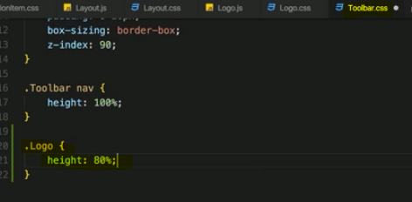

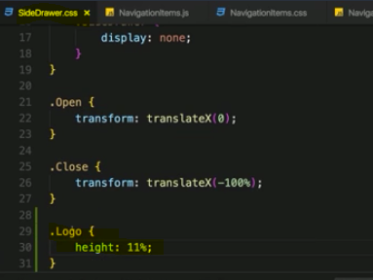

**And now I can use that here in the sideDrawer and assign my class name there too**

**so also set classes.Logo here. And again, I do have that logo class defined in three different files but due to css modules, this is actually converted to three different css classes so that they don't interfere.**

With all these changes saved

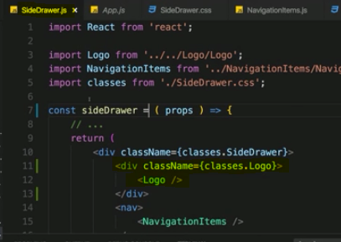

So you saw different approaches of adjusting this dynamically and making sure that it looks good on all the devices we need to support.

Output –

1. In Fullscreen (Toolbar will show) 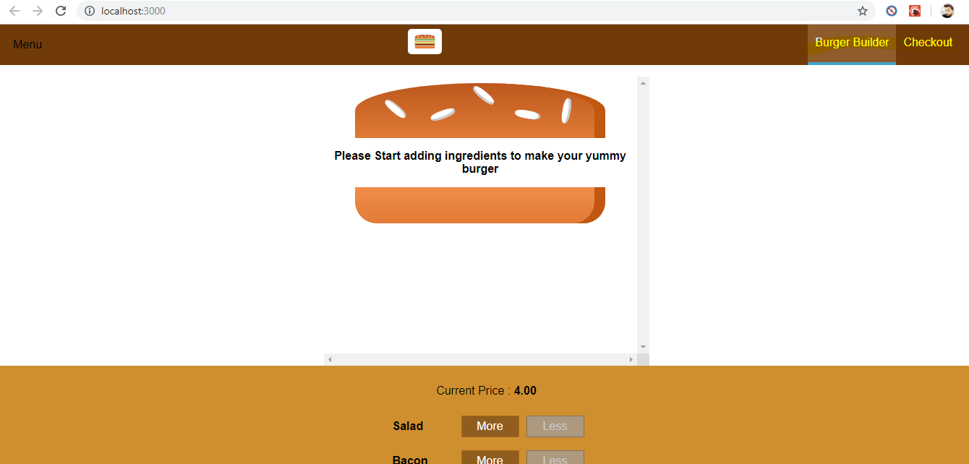
2. In smaller screen SideDrawer will show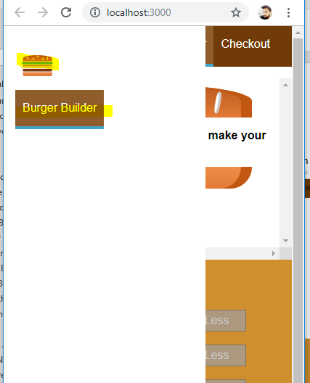

### 173. More About responsive adjustement

The toolbar navigation coming out as well in smaller devices. 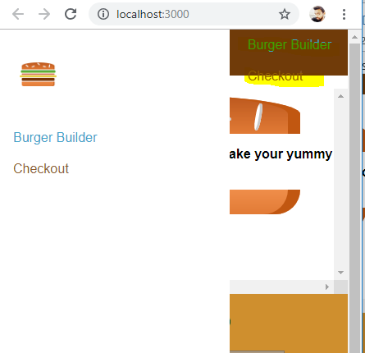

To fix this - 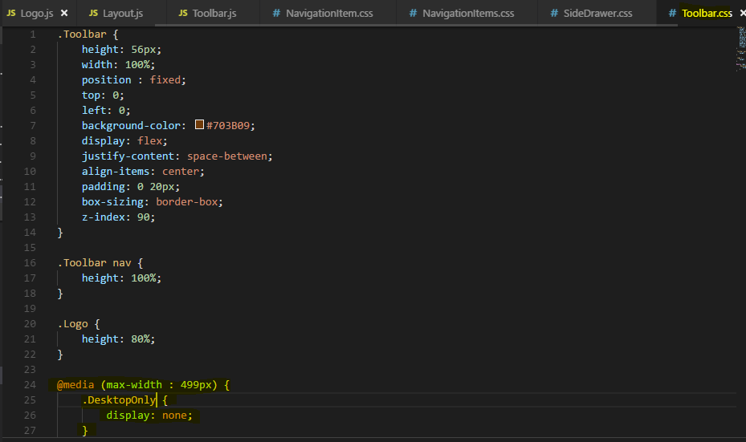

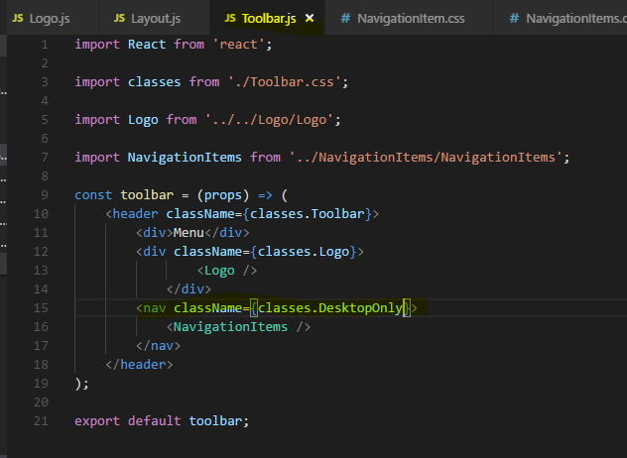

Now its hiding for smaller devices - 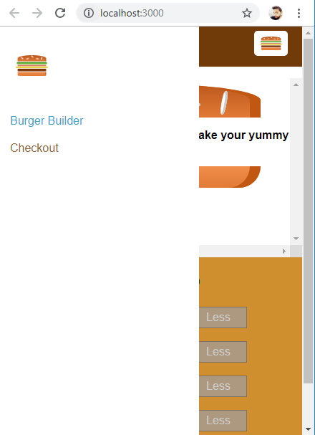

## 174. Reusing the Backdrop in SideDrawer

Let's make sure we all have a backdrop behind the sidebar and I also of course want to ensure that we can open and close it dynamically.the backdrop should be behind to sideDrawer and we already have a backdrop component in the UI folder

but how do we best add it to the sideDrawer?

Well just as I added it to the modal, I included it in the modal component, I want to include it in the sideDrawer component too because it belongs to the sideDrawer also.

the Backdrop should sit outside of it otherwise it would be contained inside the sideDrawer and that's of course exactly not what I want.

the sideDrawer should only be shown sometimes once you click the menu button essentially and it should also be closed once you click the backdrop.

We have that click listener, clicked, which can fire any method we want to fire, so the goal is to now be able to handle this method in the sideDrawer.

Now in the modal we simply propagate it, this click up so up to our holding container. Here in the sideDrawer,I also want to do this. We could also have turned the sideDrawer into a stateful component and handle the click in here with a method and with a state which we switch from show so from true to false and so on and there would be nothing wrong with that but we will also trigger the sideDrawer from the toolbar at the end because there we'll have this menu button.

So in the end we also need to create a connection from toolbar to sideDrawer and we have that connection already, it's the layout component, this is where we use both.

So in my opinion, it makes more sense to turn the layout component into a class component

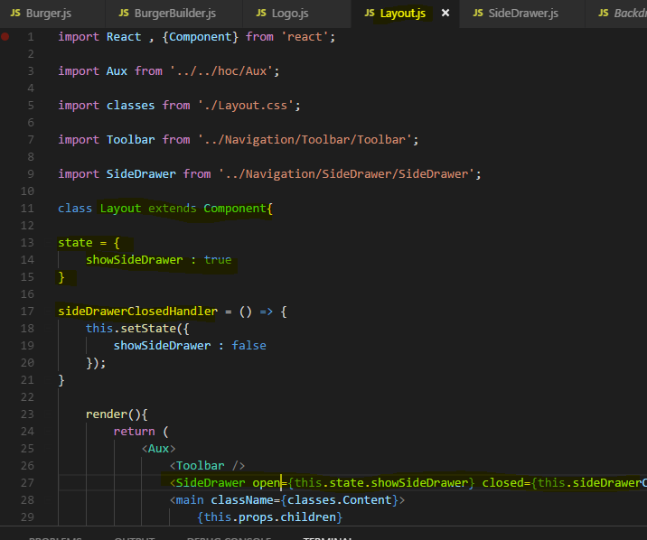

where we can implement the method so that we can listen to both the sideDrawer closing itself by clicking on the backdrop as well as toolbar opening the sideDrawer by clicking on that toggle button.

Click on Backdrop to close the SideDrawer

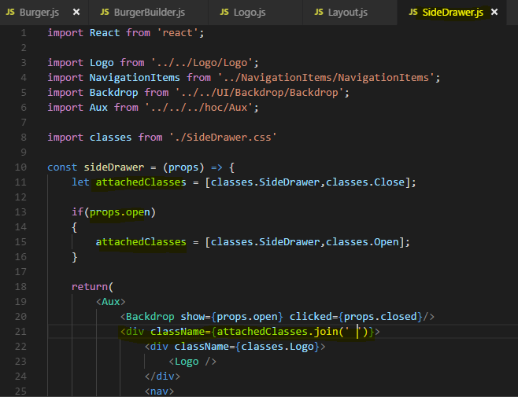

## 175.and 176. (Adding a SideDrawer Toggle Button and adding a Hamburger icon)

**Set State correctly if you are accessing previous state in there.**

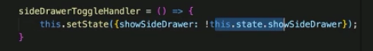

if you plan on using the state, insert state, you shouldn't do it like this because due to the asynchronous nature of set state, this may lead to unexpected outcomes.

So instead use the function form, expect the previous state as input and in there, simply return the object you want to set as a new state or you want to merge into the state

I should say. And of course therefore in there, you don't access this.state but you use the previous state you get passed into this function automatically.

Here we want to show **Hamburger Icon** only when the SideDrawer are enabled (in my case for smaller devices, width less than 500px).

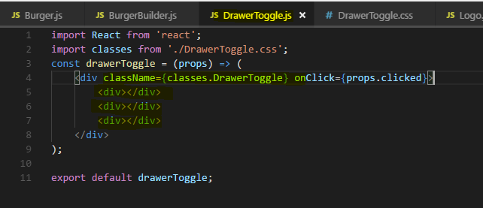

**Three empty <div> is there just to make a Hamburger icon , see CSS applied on them in DrawerToggle.css file**

Hence write media query css and use that class name.

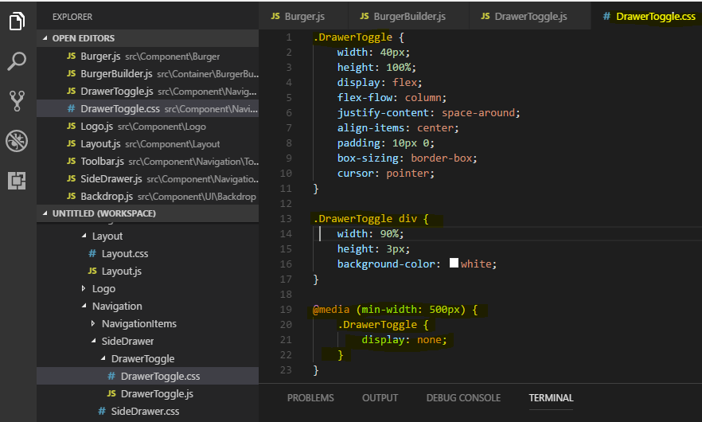

**For smaller devices** - 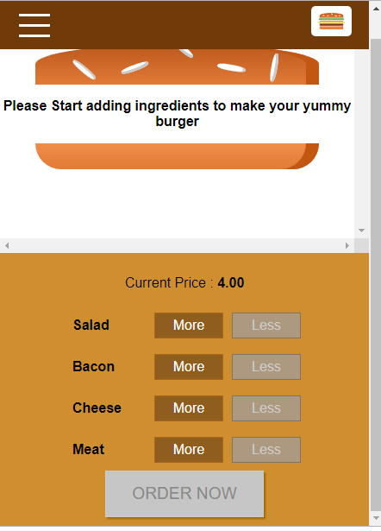

For bigger devices - 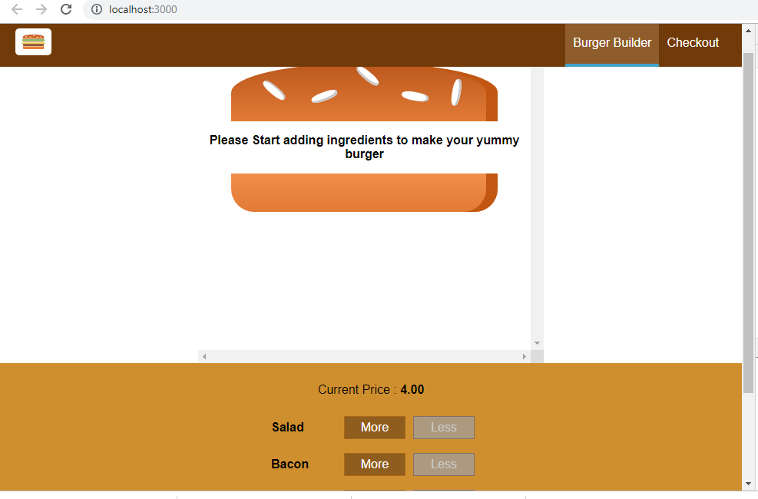

## 177. Improving the APP

### 178. Prop Type validation

Right now we're doing prop type validation in the burger ingredient component.

There we make sure that the type is set, so it's required and that it is a string.

I'm not doing any validation in any other component and the reason for this is that here I'm not working on a project which is going to get used by other people,

I'm not working on the third-party library, I am not even working in a developer team,

so a lot of the reasons why properties might be used incorrectly aren't relevant here.

Additionally, we'll get logical errors in our application if we forget or assign a wrong key property anyways and that is why I don't use prop type validation that much in this application.

Feel free as a practice to add prop types validation to more components. You can convert them to class based components for that or keep them as functional components, doesn't really matter,

I typically convert it in class-based components also to highlight the difference and to make it really clear that I'm adding prop type validation but you don't need to do that and I will not add them to all my components but you can definitely do this as a practice.

## **179. Improving Performance**

what about pure components and shouldComponentUpdate? We're not using that in the application,

now let's analyze the application.

Do we have any state or prop changes which trigger a re-rendering even though this might not be required?

If we have a look at the running application, most clicks and things we do really change the UI and therefore should trigger updates, should trigger a re-rendering of these components.

So we shouldn't really lose performance there and using a lot of pure components for unnecessary shouldComponentUpdate checks might even hit the performance more than doing an occasional unnecessary re-rendering.

Crucial points we should check are of course our burger builder container, there we change the state but whenever we do change the state, it really affects our application and we do need to re-render stuff.

I can identify one element here though where we might be able to save some performance by not re-rendering it unnecessarily and that is the modal component. It wraps the order summary and that of course means that whenever ingredients or the price changes, since these are props of order summary, order summary will be re-rendered.

However if the modal is not visible, we don't need to do that. So actually only if the modal is shown, re-rendering of that wrapped element here makes sense.

so let's first of all find out when order summary is re-rendered by simply adding a lifecycle hook to it. So I'll go to order summary and currently this is of course a functional component, let's turn it into a class component so that we can add lifecycle hooks, so that we can see when this is updated.

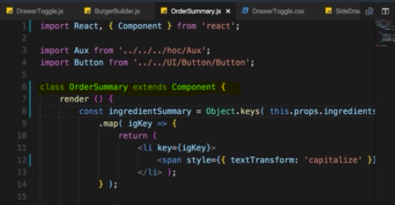

let's now implement method to see when this actually updates, I'll add componentWillUpdate here. Now if that fails for you because your React version maybe doesn't support it anymore, well you can also simply use componentDidUpdate, in the end

I just want to highlight here that we're in the updating process

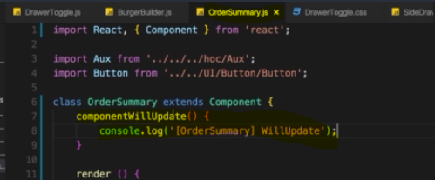

Now let's see when this updates. If we reload the application and I add an ingredient, you'll see order summary will update

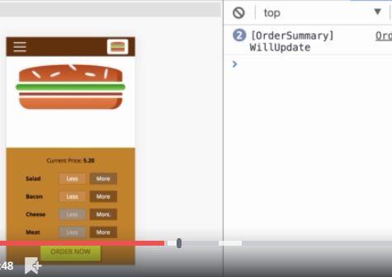

even though we're not showing it, so it doesn't necessarily make a lot of sense to re-render that.

Now let's see if that changes, if we make sure that modal doesn't update unnecessarily and for that, let's head over to the modal.js file and let's also turn modal into a class so that we can implement shouldComponentUpdate.

Alternatively of course, you could keep this as a functional component and wrap the exported component, so the modal constant you're exporting with React.memo.

This would be an alternative to using shouldComponentUpdate, both works and both will effectively have the same impact and effect here. let's now see if we can control the updating of order summary which is wrapped by the modal by changing the way the modal itself updates.

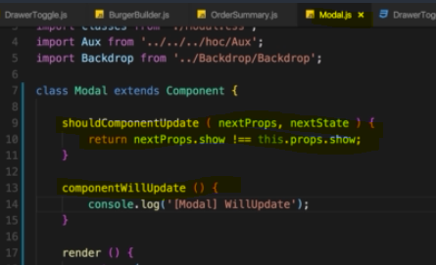

Now let's see, if I now reload the page and I start adding elements, we see order summary is not calling will update anymore,

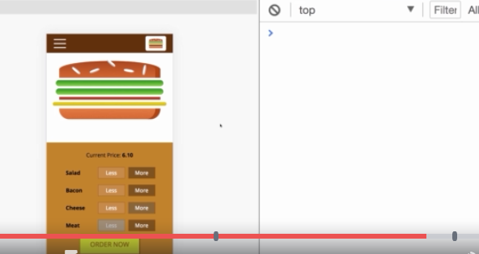

if I click order now, now modal will update is called and order summary will update is called.

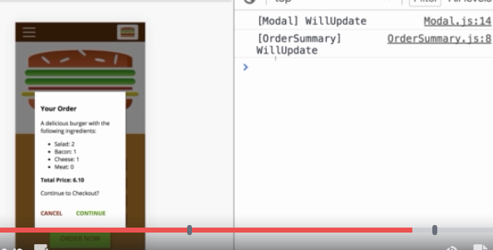

So here, we definitely improved our application because we make sure that we don't unnecessarily update order summary, that we don't unnecessarily re-render that and you also see that the wrapping element controls the updating of the wrapped element. So order summary theoretically, the component, is included in the burger builder but it is not updated because the wrapping element modal has a shouldComponentUpdate method where we control this

## 180. Using Component Lifecycle methods in Application

Now what about other lifecycle methods like componentDidMount orcomponentDidUpdate and all these things?

Why don't we use any of them? When would we use them?

Well actually you will see some of them being used once we add HTTP. As you saw in the slides in the last course module, the componentDidMount and componentDidUpdate lifecycle hooks are extremely important for causingside effects, that sounds strange but in the end just means things like reaching out to a web service and fetching data from there.

Now we're not doing that yet in the application, there is much initialization we have to do in our components.

That is why we don't need the lifecycle hooks, other hooks like WillUpdate and so on which we don't use except for login here, well you typically don't use these that often.

There might be some cases where you need to adjust your components state based on some props you received from outside and that certainly can occur in bigger react applications but it's also not that uncommon to have react applications where you don't use that many lifecycle hooks except for componentDidUpdate maybe.

So that is the reason why you don't see too many of these being used, there will be more once we add HTTP access

## 181. Changing the Folder Structure (Optional)

 Let's have a look at our layout component, in the layout folder under components. If we have a look at it, it's clearly a class based component and it has a state, a state to handle their display of the sideDrawer.

Now I don't really consider it to be a container, though you could argue for it to be one because obviously it contains some other components and it passes states down to them, so it wouldn't necessarily be wrong to place that layout component here in their containers folder like this

so now I'll move it over there. You could also argue for something different with the given folder structure which of course is only just one possible way where I have this hoc folder for higher order components,

you could kind of argue that a layout is really just a higher order component, because what you're doing with it is you're wrapping your other components with the layout.

So the burger builder component in our application but once we add routing, that of course are going to be more components.

And in the app.js folder, we're really just wrapping the burger builder with our layout component and this essentially makes it a higher order component.

These are maybe just semantics, it doesn't really change the way your application work, how you call your components.

Still you could move layout into containers or you could move it into hoc or maybe in your application, you don't really have a hoc folder, maybe there, you just have containers and components.

There is more than one correct way, now I like this set up though where layout is now in the hoc folder because I consider it a higher order component,

it's only there to wrap other components and therefore here we're using it in app.js to wrap whichever route we're rendering hence I move it into the hoc folder. Now I will also create a new subfolder in hoc therefore, the aux folder and move my aux.js file in there.

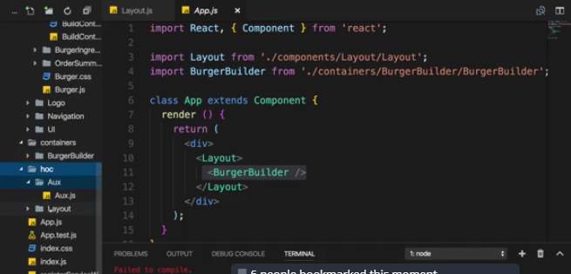

but now with our new folder structure, which is optional but which makes more sense in my opinion since or due to the way our components do work.

# **Reaching Out to the web (http /Ajax)**

## Understanding HTTP request in React

So how does sending HTTP requests work in react applications typically and I'm saying typically because if you're creating a multi-page react application, there actually isn't

anything special to it. You probably have your application, your page where you submit a form and that sends a request to your backend and you get back a new html page with potentially new react code in there.

You don't have a single page application, you don't have a strong decoupling going on.

If you have such a single page application, you have a strong differentiation between your frontend, your react app and your backend though. The react app and the servers still need to communicate from time to time but they don't communicate by exchanging html pages.

So if a react app sends a request to a server, you don't get back a new html page instead you can back some json data typically or you send some json data to the server.

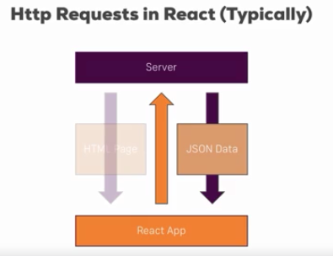

## Axios and Understanding the project

 I will use JSONPlaceholder which you can find at **jsonplaceholder.typeicode.com**

which simply is a back-end, a RESTful API back-end which you typically use as I explained in the last lecture where you can send requests to to fetch some dummy data or to simulate

storing some dummy data there, though you won't actually store something on that server of course, it's just faking some data

but exactly what we need for learning how to send HTTP requests.

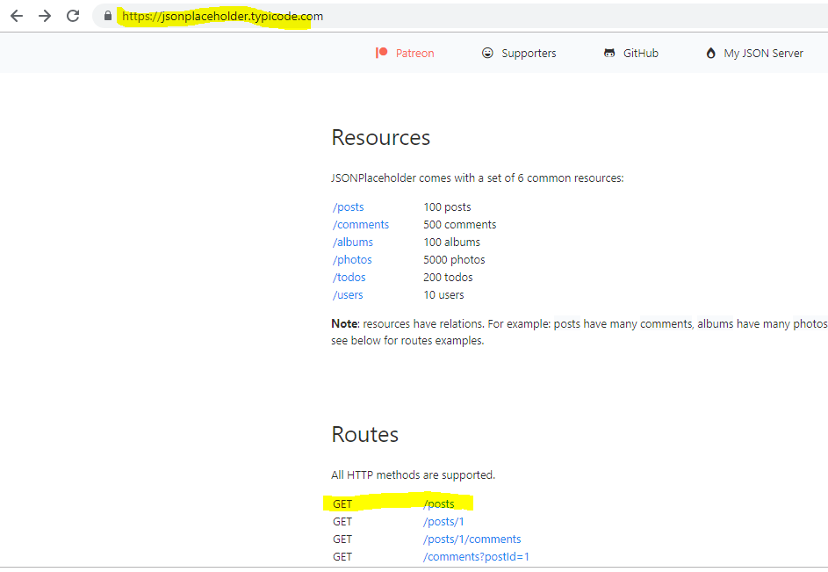

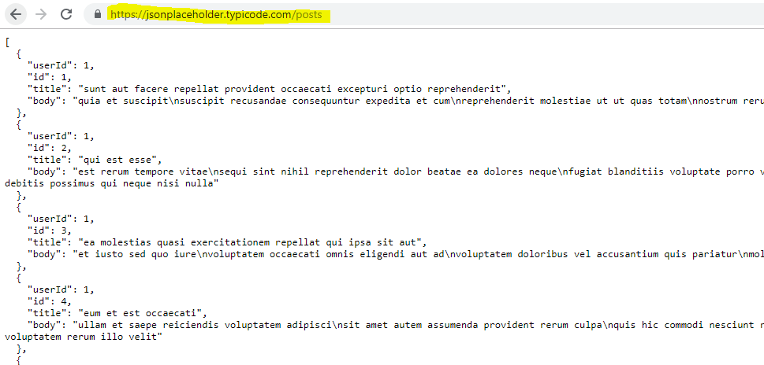

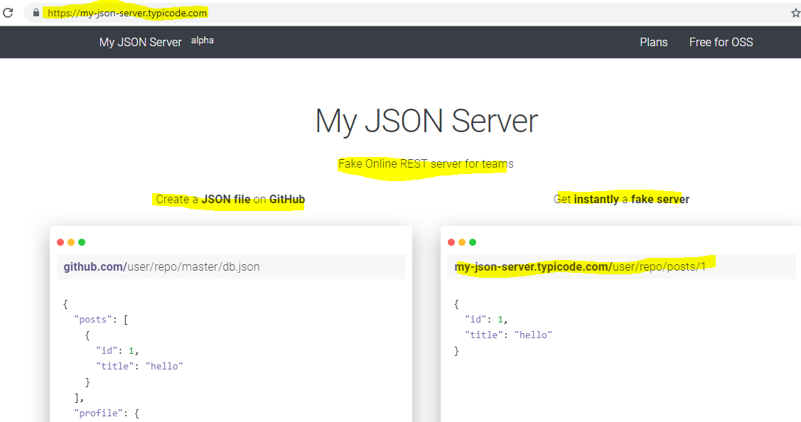

we of course need some way of sending these Ajax requests.

Here you have basically two options, Javascript of course has the **XMLHTTPRequest** object. With that you can construct your own Ajax requests and send them to a specific URL and handle the response.

Nothing wrong with that since React is just about writing Javascript everywhere, you can of course use all the Javascript features including **XMLHTTPRequest**.

But writing and configuring requests with that object manually is quite cumbersome,

so the second option is to use a package, a third-party library which makes that easier

and for that I recommend using axios.

### **axios –**

is a third-party Javascript library which you can add to any Javascript project, it's not connected to React at all but of course it fits nicely into Raect because it's Javascript and the axios page here on Github is a good starting point to learn more about this package.

**Axios is a lightweight HTTP client based similar to a Fetch API. Axios is promise-based async/await library for the readable asynchronous code. We can easily integrate with React.js, and it is effortless to use in any frontend framework.**

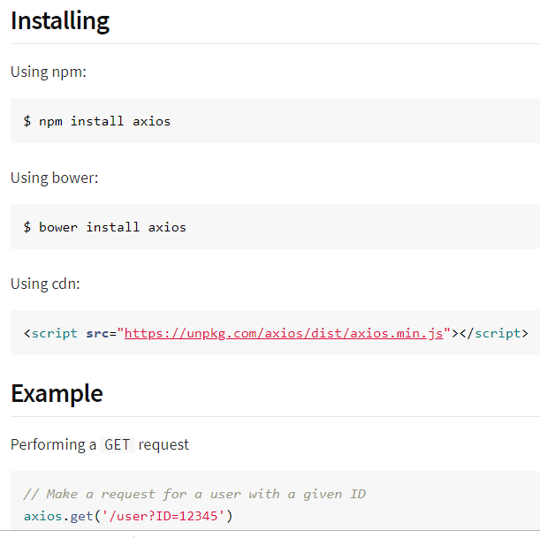

## Creating a HTTP request to GET data

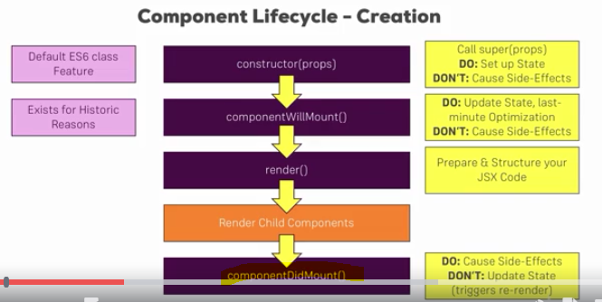

If we have a look at the lifecycle hooks we encountered during component creation, there is one life cycle hook we should use for side effects, **componentDidMount**

**and the HTTP request is a side effect, it doesn't affect your react logic or something like that but it has the side effect of fetching new data and if your react application is dynamically outputting some data which it probably is, the data changing of course is a side effect affecting your application.**

So componentDidMount is a great place for causing side effects but not for updating state since it triggers a re-render.

We will still update the state here once the HTTP request has gone and got us new data because we actually want to re-update the page, so here this is actually a wanted behavior.

Now I will you axios to do a GET request

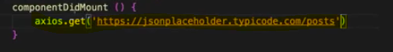

**The thing of course is this should return some posts but trying to store them in a post constant won't work because of course that get request happens asynchronously,**

**it doesn't finish immediately, it needs some time to go to the server and get the data.**

**Javascript though executes your code in a synchronous manner,**

so after this line, the next line is executed immediately, it won't pause until this is finished, so it won't store the posts and the posts constant here. This is the wanted behavior because we don't want to block the execution of our application just because we're waiting for this request to finish.

Axios therefore uses promises, a default javascript object introduced with ES6 and thanks to our workflow we're using with create react app also available in older browsers since the code gets compiled to code which also works in older browsers.

**So axios uses promises and GET returns a promise, so we can chain then on it, then is simply a method which takes a function as the input and this function will get executed once the promise resolves.**

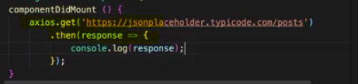

Http response - 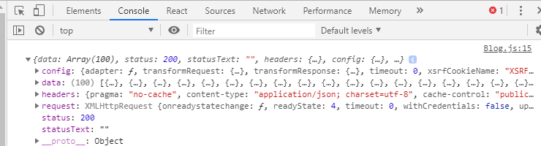

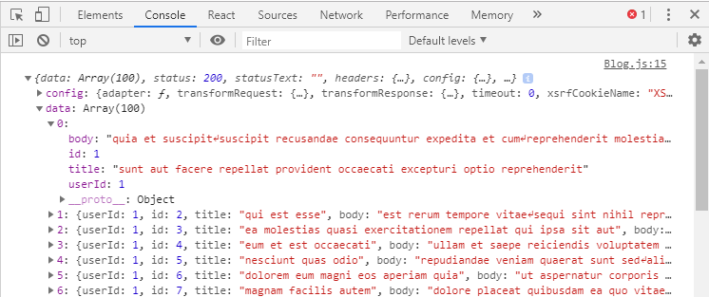

**Just for information i try to do GET http request from XMLHTTPRequest**

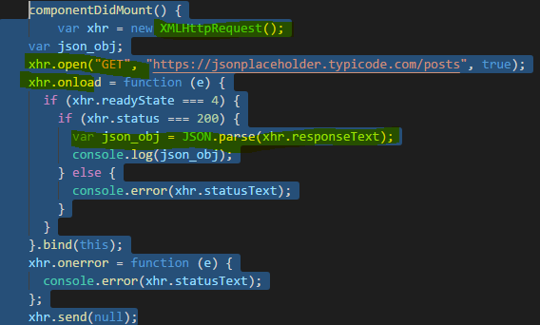

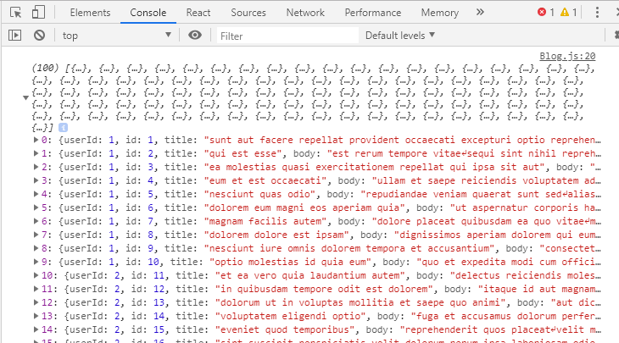

## Rendering Fetched Data to the screen

we added the code to get some data,

of course that is a huge first step but it would be even more useful if we could write that data to

the screen, if it could render it to the screen and replace this array of dummy posts here with a dynamically

generated array based on the posts we fetched. For this, we need to manage some state of course and we

should have some posts in that state,

initially this can be an empty array.

Now I want to update this state once we fetch data from the server and therefore the place to call this

set state is inside the then method.

If we would call it outside of this, so after this axios get method, we wouldn't have the post yet because The code javascript doesn't wait for this to finish so if you're immediately calling this set state after the get method, the data won't have been fetched yet. 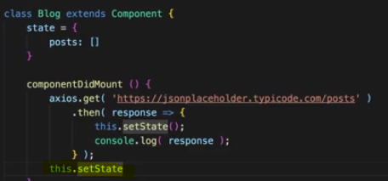

So inside the then blog is the right place and there we can set posts to response data,

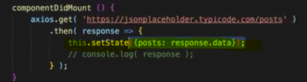

let's output posts dynamically in the render method, for that I'll create a new constant here, posts, and that should be an array of jsx elements. call the map method to map it

into an array of jsx elements

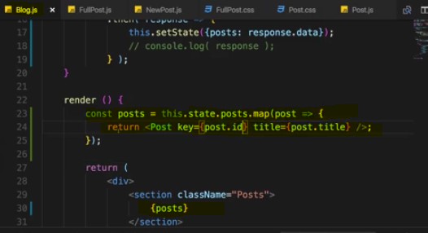

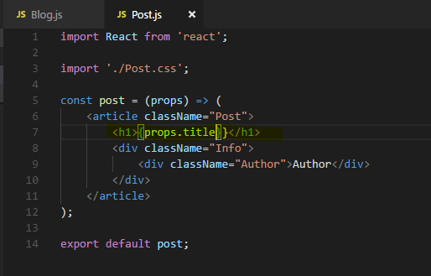

Output - 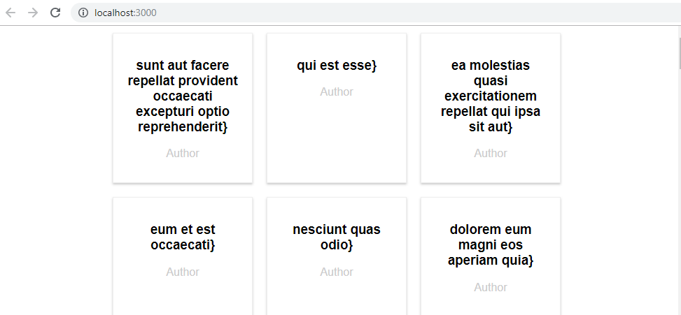

## Transforming the Data

In the last lecture we fetched some post but of course, we're fetching too many posts here. Now for a real application, you probably can send some query parameter to your backend to restrict the amount of data you want to fetch, some pagination basically.

**But of course we can also transform the data once we got it in our react application (Frontend)**

all the **slice** method on that array and only get the elements 1 to 4, to only fetch the first

four posts.

Actually I fetched them all but I only store 4 of them in that post constant

I'll then create a second constant updatedPosts even, because I want to add an author field to my posts.

Now typically you would of course get this from your backend but our fake backend doesn't have that, so I simply add here to also show you that of course, you can edit the data you fetch from the server,

we're just working with javascript in the end so we can add any javascript code we want.

So here I will take my posts, call the map method on them and for each post, I want to return a new javascript object where I distribute the property of the post, so the properties we got from the server basically and then also add a new author property which I'll hard code to Max. With that, I got the updated posts

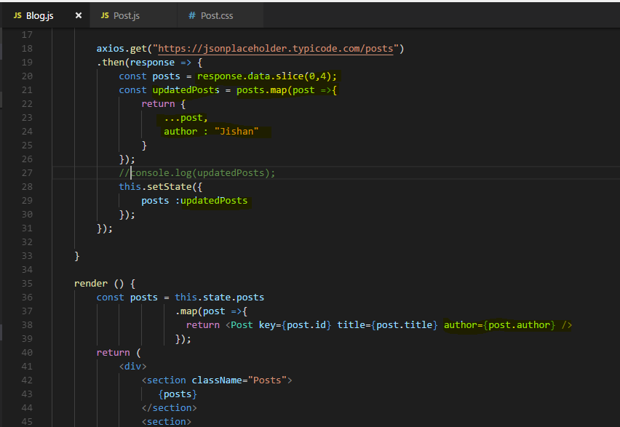

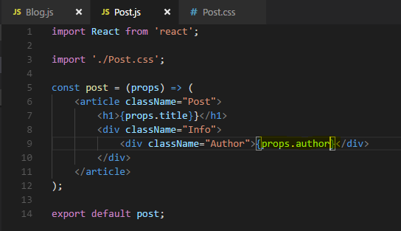

**of course this is just one example transformation to showcase that you can of course work with the data you will get back before setting it to the state.**

## Making Post Selectable

let's now also see how we can make sure that we can click on one of these posts and then load the post data there

now there are two ways

**1 just save the id of the selected post in state and again do an ajax/http request to get data for that id and show it in <FullPost>**

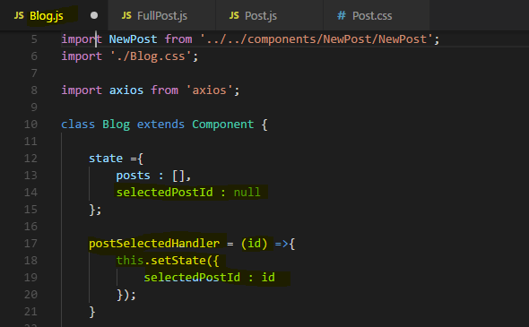

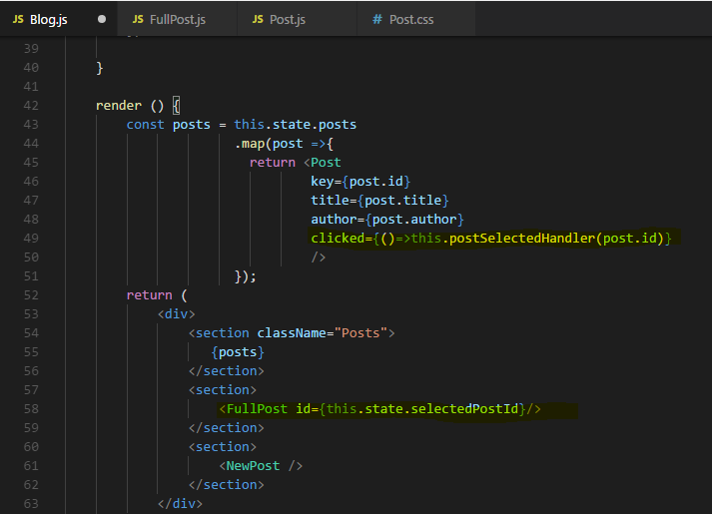

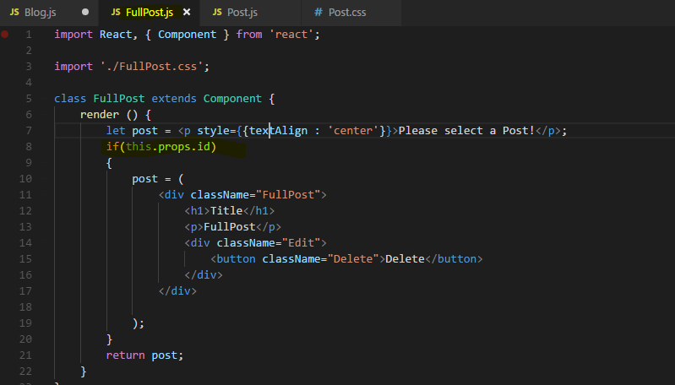

**Now to make an Ajax/http call we will do in next lecture**

**2 Save the selected post data in state and show it in <FullPost>**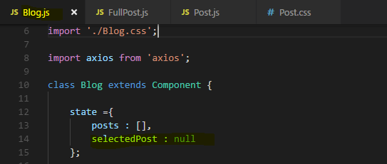

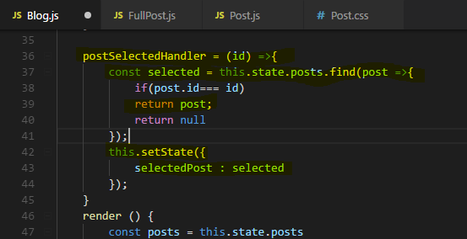

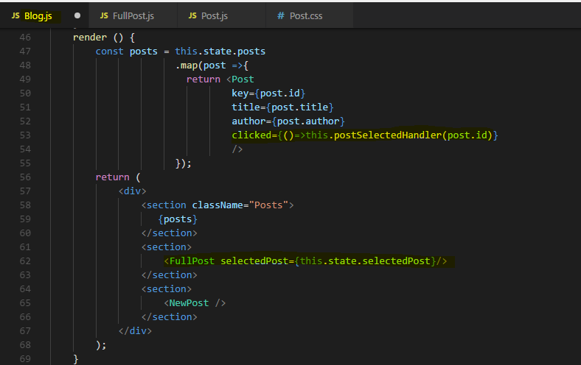

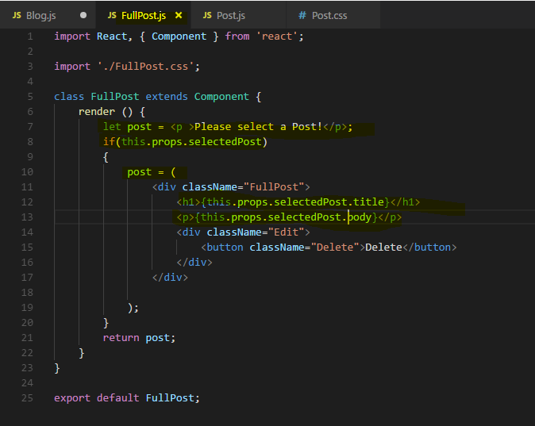

## **Important - Fetching Data on update(without creating infinite loops)**

let's actually send HTTP request once we got a valid ID.

Now which lifecycle hook should we use here?

**Let's have a look. If we have a look at the lifecycle hook for updating components and we are of course speaking about the update lifecycle hook because the component is there right from the start but data should be fetched once we receive a new prop ID,**

**so that is what we're looking for.**

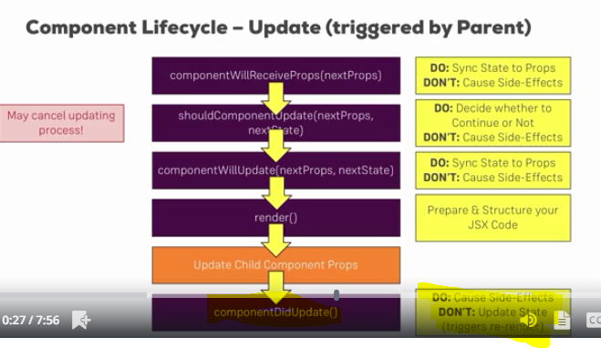

**Then componentDidUpdate is a good place for causing side effects, it also has one issue though.**

**If we update the state in there, we update the component again and we therefore enter an infinite loop, that is something we'll have to watch out for**

**Now first do the ajax/http request**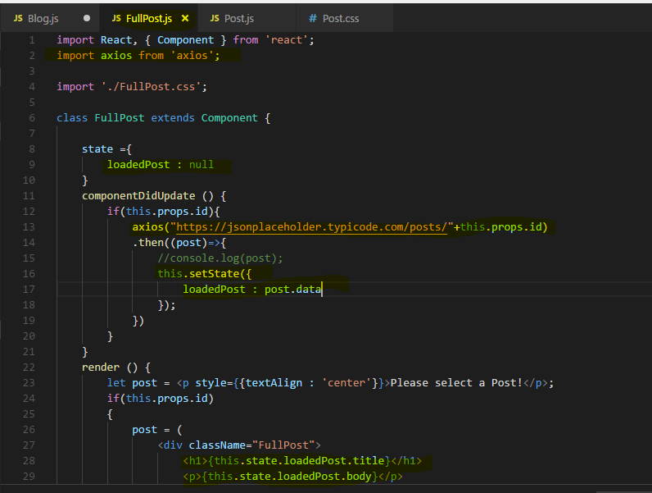

**Now lets see output -**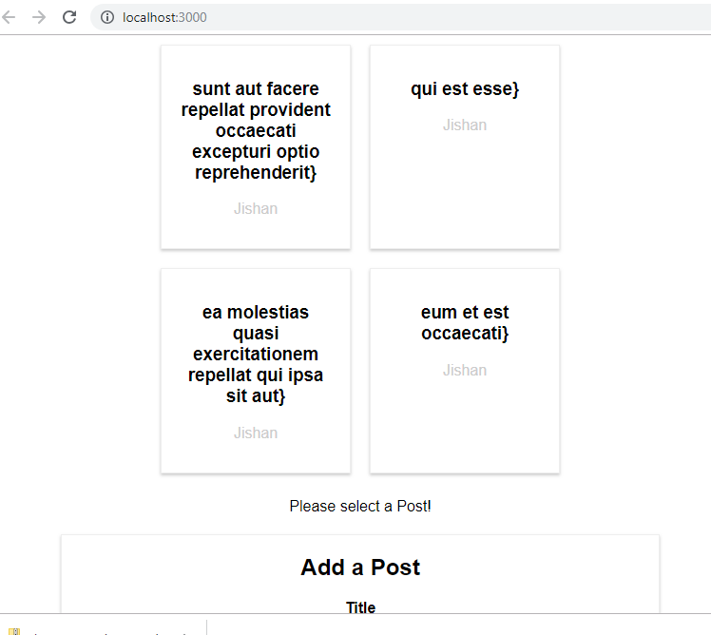

**When we click on any post I see error -** 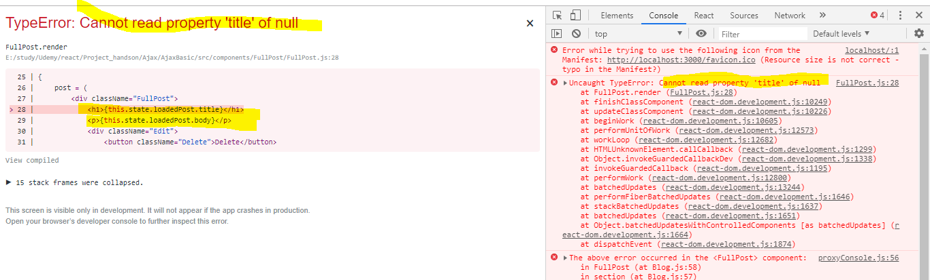

**This makes a lot of sense because here in our jsx code for full post, we immediately access this.state.loadedPost.title and we do this as soon as we get a valid property.**

**Now we get a valid property before we have a valid loaded post because as you learned, fetching data is asynchronous. So first we get the ID and then a little bit later, we get the loaded post but we reran it in the dom immediately after we got the id.**

We can simply fix this by adding a check for the validity of the ID with this.props.id as we already have it and say that in this case, post should actually be a paragraph still but maybe a paragraph where we simply say loading because we selected a post but the data isn't there yet.

And then in the bottom if statement, we check if state.loadedPost has been set because initially it's null so it would be treated as false but as soon as we got one, this will return to true or resolve to true and hence, we will render this jsx code.

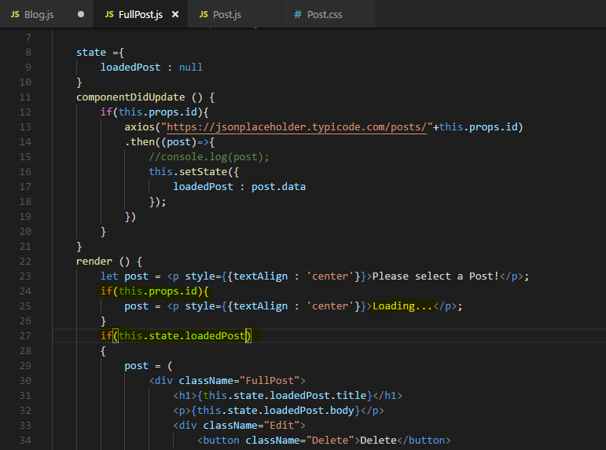

now if I save this and I click on a post we see loading for a fraction of a second and then we

see the post.

**We also got an issue here though, if we open the network tab, you'll see that we're resending after request after request after request,**

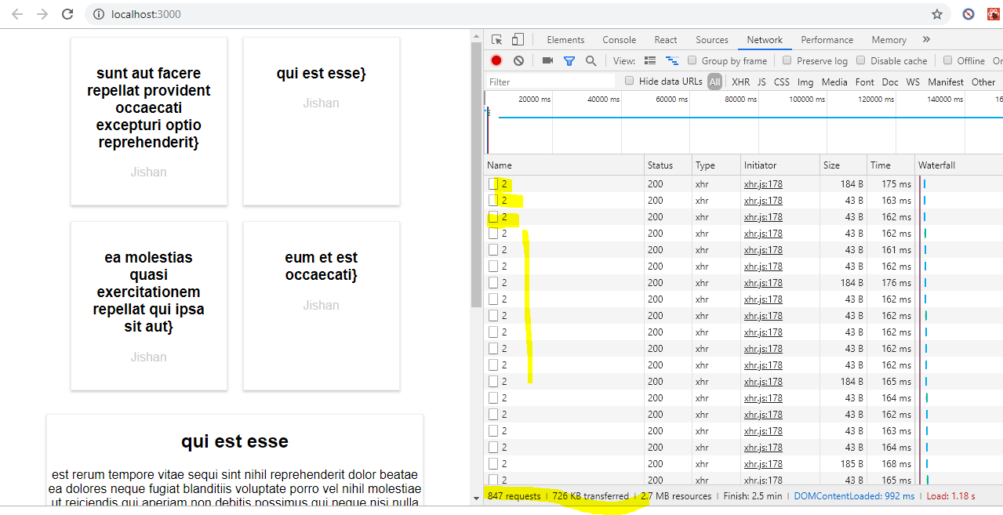

but why are we seeing this?

**We are seeing these infinite requests because we're updating the state from within componentDidUpdate and this creates an infinite loop because when we call setState, the component will be updated and componentDidUpdate will execute again.**

**So we have to make sure that we only send this HTTP request and hence update the state if we actually loaded a new post.**

So how do we do that?

We can enter if check inside the outer if check here and there we can show if we already have loaded post, if that is true. So that is a first indicator that we did already load a post.

Then of course we also want to make sure that for this loaded post, the ID is not the same ID as we just got via props because that would mean the ID for which we want to fetch new data is the ID we already have loaded, so we don't need to make HTTP request in this case.

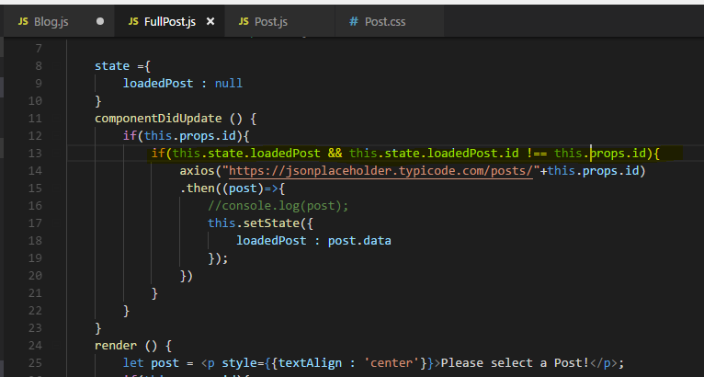

**Lets see output now –**

**But now we never see our Full post when we click on any post, we just see Loading…**

**It means never reach there there something wrong in our if condition**

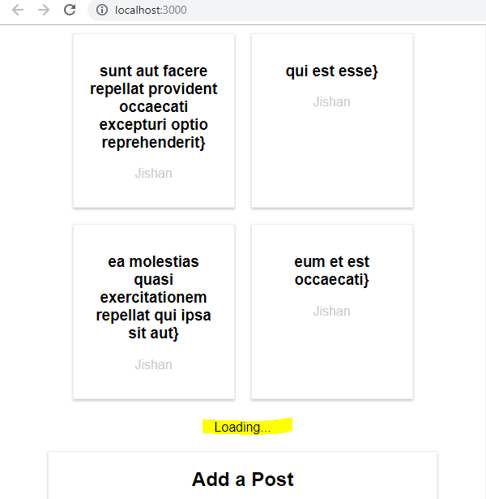

**Well we have to change it a little bit because initially it will of course fail because loaded post is null initially so this would only succeed if we had at least one post loaded.**

**So I will instead check if we don't have this.state.loadedPost or if we do have it but if it then also has a different ID than the ID we plan on loading. So we go ahead and make the request even if we have no loaded post or if we do have one but the IDs are different.**

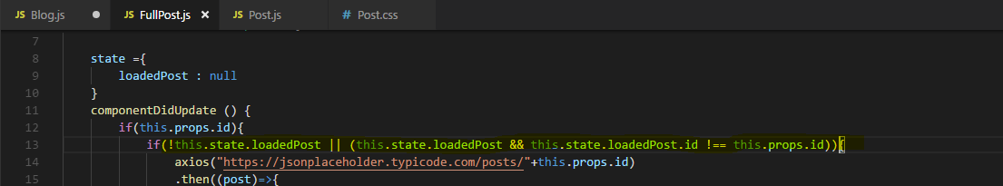

**Output -**

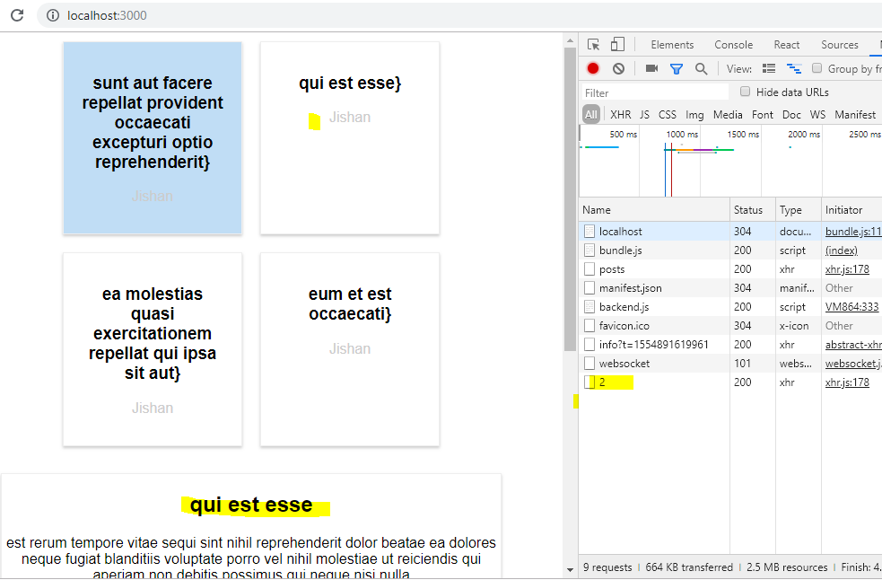

So now if we go back to the application, on the network tab if I click a post it loads and

it doesn't start sending infinity requests. **See above image**

**So now we got a way of safely fetching data in componentDidUpdate and still componentDidUpdate is the right place because we want to fetch data whenever we receive new props.**

## POSTING Data to a Server

it's managed by the new post component which is a class based component which manages its own state and hence is in a Component because we're not passing or distributing the state to any other components.

The post mehtod still takes a URL as an input and for our dummy backend, we can simply use the same URL we used for the get request, it also accepts post requests.

Now a post request needs more than the URL though, it needs a second argument which is the data we want to send

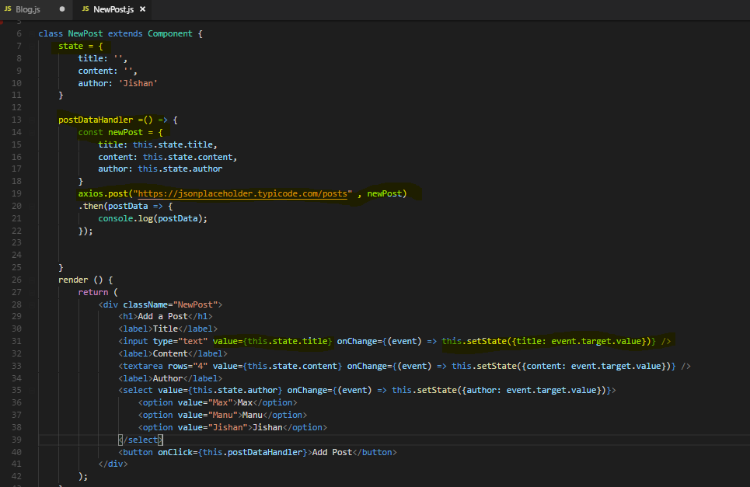

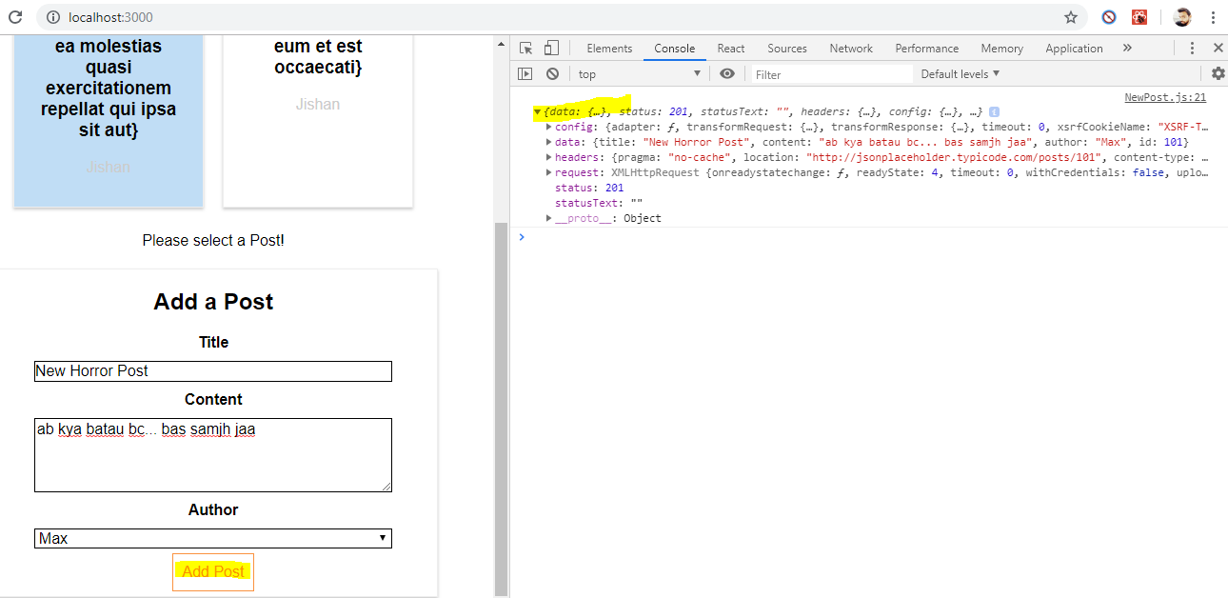

## Sending a DELETE request

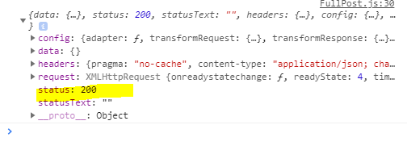

## Handling Error Locally (Front end)

Handling errors is super simple with axios,

let's say we've fetched the posts incorrectly

Since axios uses promises, we don't only have the then method we can chain but we can also add a second method, simply chain it after then, the catch method, as the names suggests, this catches any errors you get.

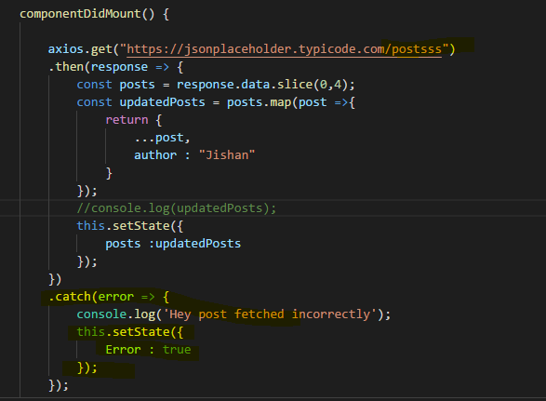

**We can also do something in .catch method like setting Error flag to state so that we can render the html element conditionally**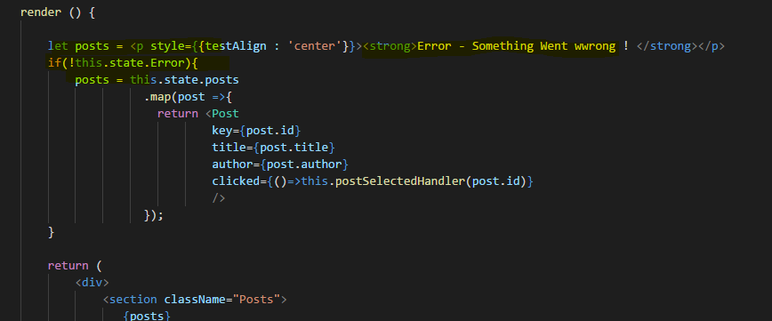

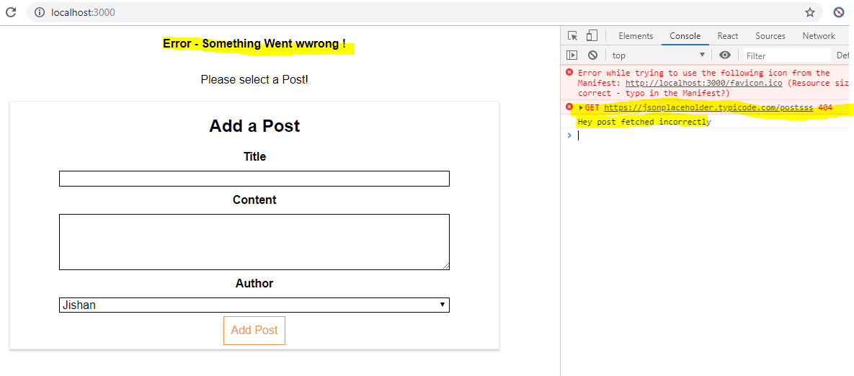

## Adding Interceptors to Execute code globally

Handling errors locally in components makes sense a lot because you probably want to do different things with errors depending on in which component you're at.

Maybe here you want to show something went wrong and in another component, you want to show something different

**but sometimes in some places, you maybe want to execute some code globally. So no matter which HTTP request you send, from within which component, you want to do something when that request gets sent and or when the response returns.**

**You can do it with axios with the help of so-called interceptors,**

**these are functions you can define globally which will be executed for every request leaving your app and every response returning into it.**

**This is especially useful for example for setting some common headers like authorization header maybe or for responses**

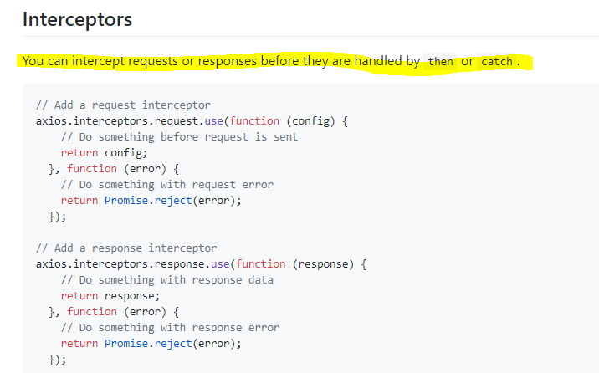

I will show you how to add interceptors

Let's go to the index.js file because this is the most global file we have in our react app, it's the file where we actually start our react app by mounting it to the dom.

So here, I now also want to import axios from the axios package and all these axios imports actually all share the same configuration.

So that is why we cannot also use axios here but axios’s special interceptor's object, and again, this will be then shared not only in this file but across all files in your project so it will affect all requests sent from anywhere in your app.

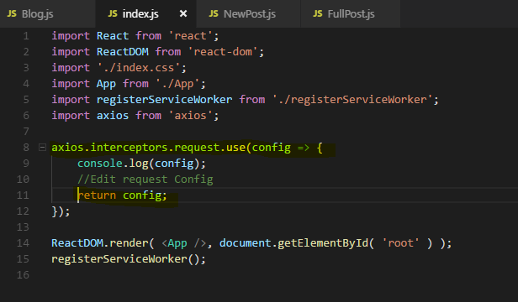

**In your interceptor function here, you need to always return the request or the request config otherwise you're blocking the request**

Now of course you can also edit the request config before you return it, that's the idea behind the interceptor, you can add headers, do stuff like that.

So now if we save this, we get the posts and if I click on one, you will see another log because another request was sent and for that, the interceptor also ran even though it was fired from a different component, as I said all components, all areas of your app are covered with that.

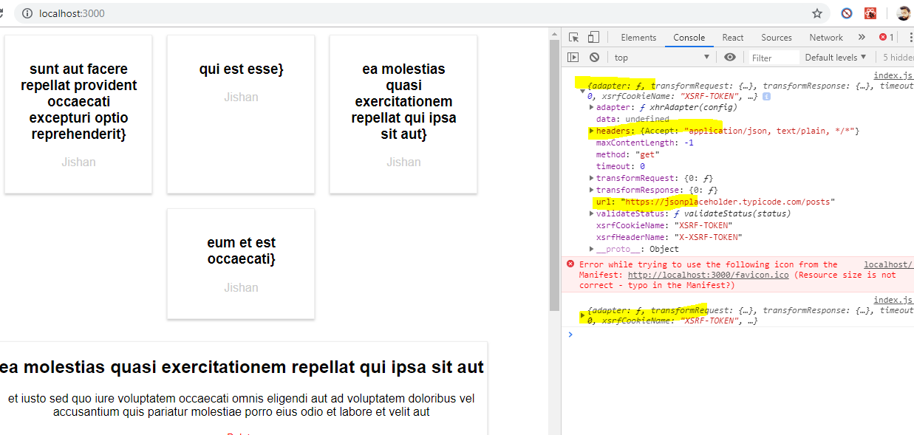

we can also pass a second function besides that request configuration changing function,

we can add a function which handles any errors. So here we can log an error like this,

**we should also return promise reject error here though so that we still forward it to our request as we wrote it in a component where we can handle it again with the catch method, this make sense if you have some local task you want to do like show something on the UI but also globally, you want to log it in the log file which you send to a server or something like that.**

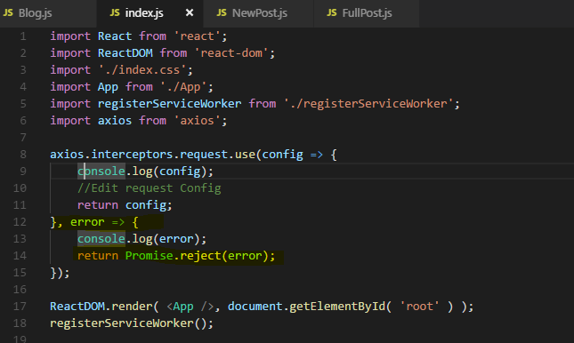

if I now save that file and now turn my posts, my get posts URL invalid again.

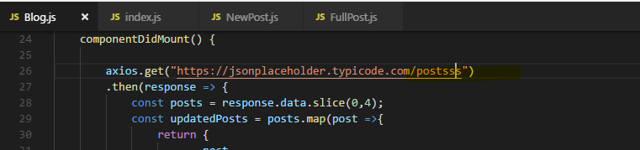

Now you see something went wrong here but you don't actually see the console log from the error handler, from the interceptor.

The reason for this is that this error here is related to sending the request, for example if you had no internet connectivity or something like that, it should pop up so if the request sending fails.

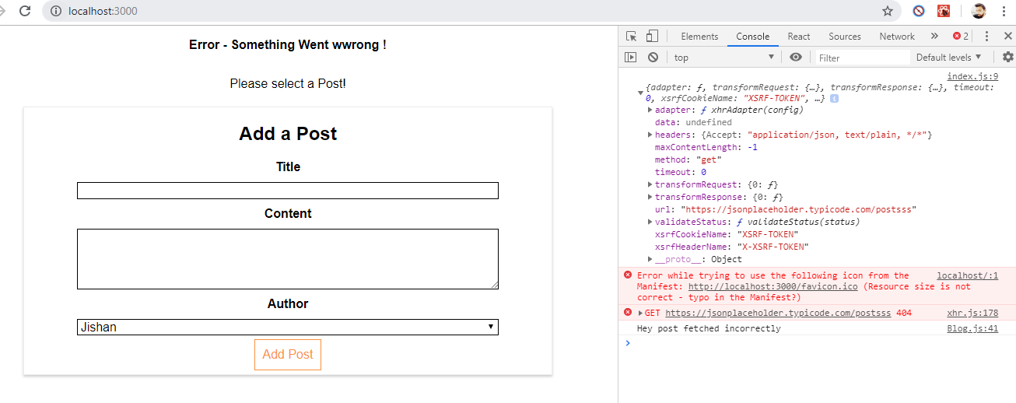

**We can also add an interceptor to handle responses though, we do in the same way as you do it for the request but we use the response object on the interceptors object.**

**Then we also use two functions here , one function which will receive the success response, we can also log it here and we should return it so that we can also still use it in the component in the then block.**

**So that is one way we should return it and we also fetch errors and we should also reject them here so that we can still handle them in the catch block locally in a component.**

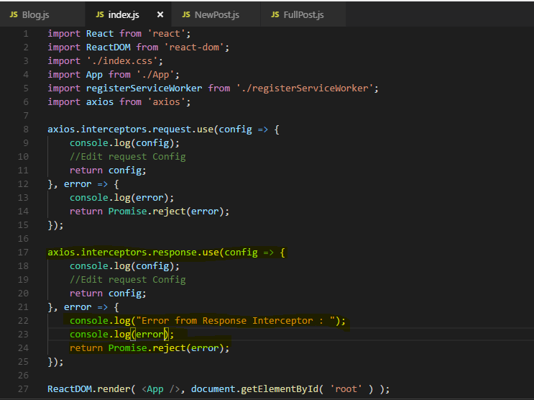

Now with that added, with that response interceptor added and the error function being present, now if we go back, we actually see the log here and we still handle it locally,

so both works.

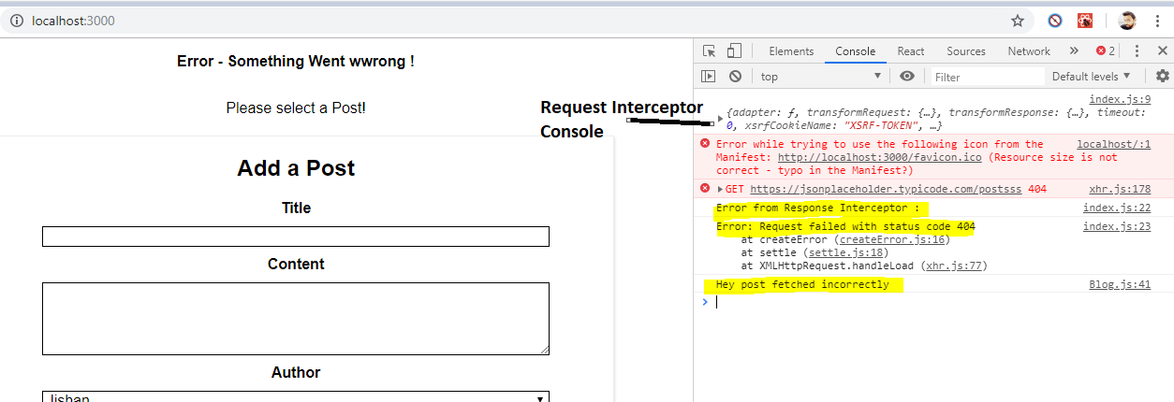

If I now go to the block container and turn my URL into a valid URL again, we see just the log for the response.

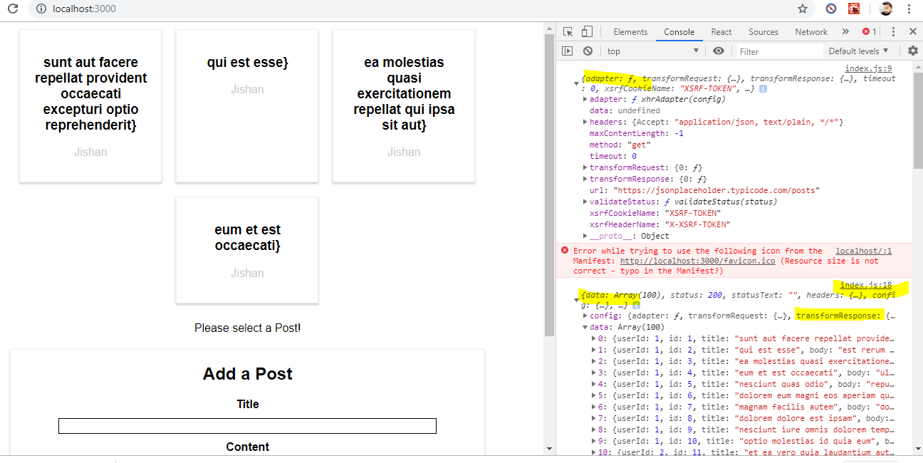

**So this is coming from the interceptor as you can tell by the file name and line number**

and this is another way of course of potentially manipulating that response here or logging it or doing whatever you want.

So being able to define these interceptors can be quite powerful, again a very common use case is for the request interceptor to add some common headers

for example, an authorization header. Though we also have a different way of accessing global axios configuration,

I'll show you how this works in the next lecture.

### Removing Interceptor

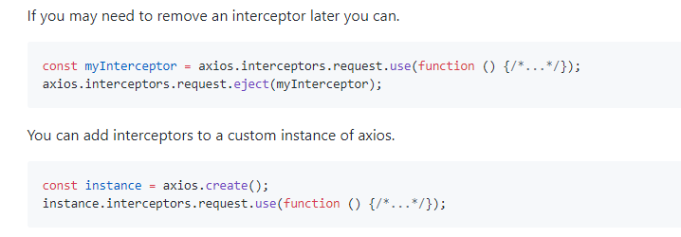

## **Setting a Default Global configuration for axios**

Now sometimes, you don't want to intercept the request but you want to set up some global configuration.

Let's say the URL you are sending the requests to in your application is always the same,

so it's always <https://jsonplaceholder.typicode.com> in our case here and then slash something. So that starting part is always the same **so it would be nice if we could cut it out here and just send the request to get posts and automatically append this to some common starting URL**

Turns out we can do that in the index.js file which is a good place because it runs first, it starts to react app,

everything still works fine here because we didn't really change the way we sent requests but we made it a bit easier for us because of that global configuration.

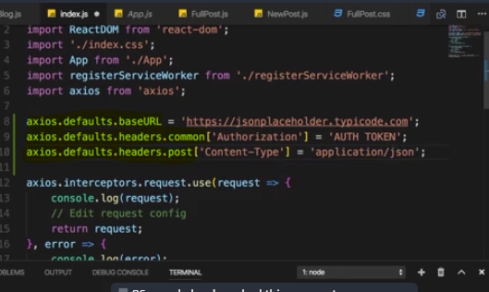

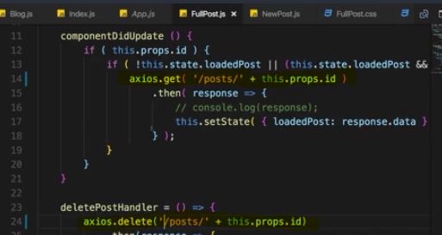

you're also not limited to just setting the baseURL here, you can also access defaults headers and there set a common header, so on that common object of authorization,

common headers are simply the general headers which are set for all types of requests, and there you could set this to your auth token if you had one or whatever that is.

You can also set headers just for specific request types, like for post requests only where you maybe want to set the content type you're sending to application.json,

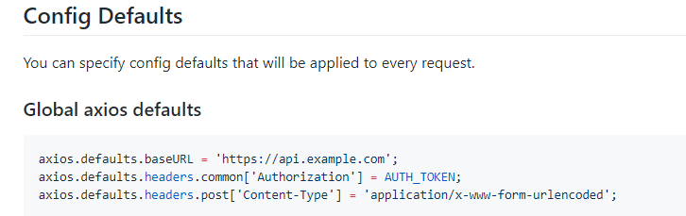

## Creating and using axios instance

what if you actually don't want to use the same baseURL for your entire application but only for parts of it and for other parts, you have a different URL and the same of course for the headers and so on.

In such a case, you can do a half measure by creating a cool feature provided by axios which is called instances.

**Let me create a new file, axios.js in the source folders on the same level as the index.js file.**

**axios .create ,this creates a instance of axios, like a copy of the axios object you could say and you can create multiple such copies.**

Now here, I'll pass the Javascript object to configure this and set the baseURL.

**We can create own axios instance and you could of course create multiple instances in different files for different parts of your application,**

**By default, the instance here will also assume the default set up here but overwrite anything which it sets up in the instance itself.**

For example, I could leave the authorization header being set up for default(in index.js file) but I also want to set it up for my own instance.

Now important, we have to export this instance as the file default so that we can use it in other files.

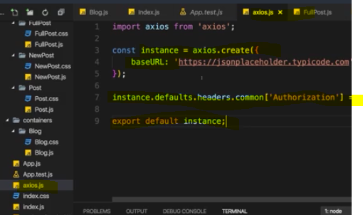

Let say the blog container where we use axios to get all the blog posts, let's say we no longer import axios from the axios package but we set this axios variable here or constant to our axios instance by pointing to that file where we export that instance as the default.

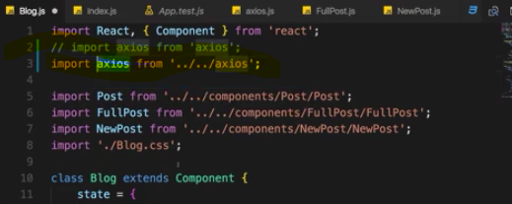

**Now you will notice one thing though, you no longer see the interceptor printing the log for the request which was sent and the response which was fetched, because the interceptor was set up for the global axios object which we're not using anymore here in the blog container.**

**we are able to use the axios package with its default but also use our own instance in places where we want to use it in our application to overwrite some of the settings for the places where we use that instance instead of the default object.**

And now we get the best of both worlds,

And of course we could also add interceptors to our own instance, you can simply use instance.interceptors.request, just like you did it for the default instance, the default axios object.

**being able to use instances can give you the flexibility you need in your application,**

**it allows you to control in detail in which part of your app you want to use which default settings.**

# BurgerBuilder Project : Accesing a Server

## Firebase : Creating a firebase project

just as kind of a dummy backend because it's easy to get started with it

and for our needs here, it's free

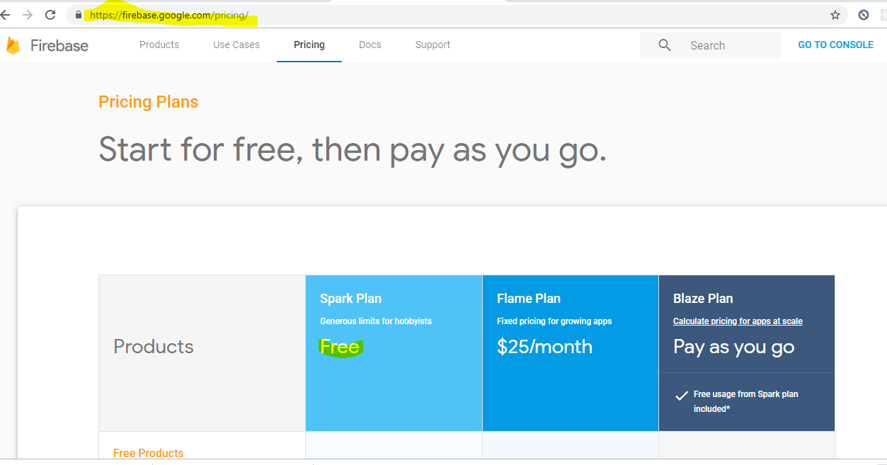

Now click on Go to Console tab right corner top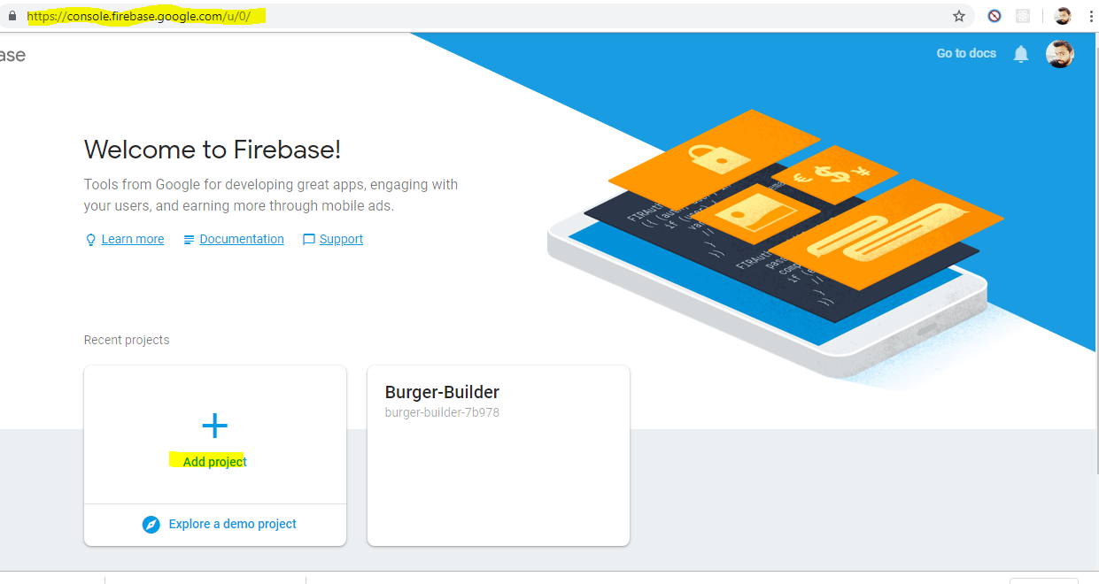

Here in database tab choose Realtime database

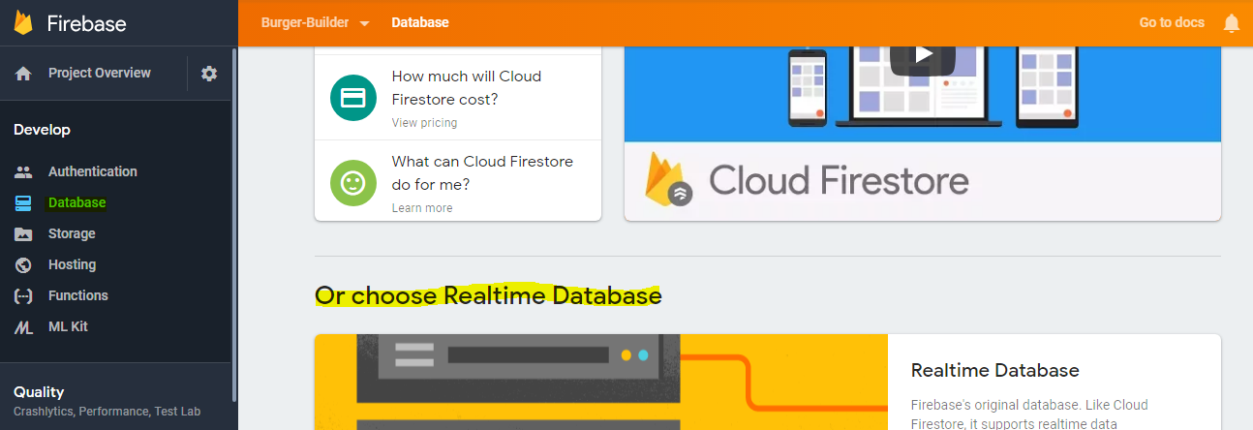

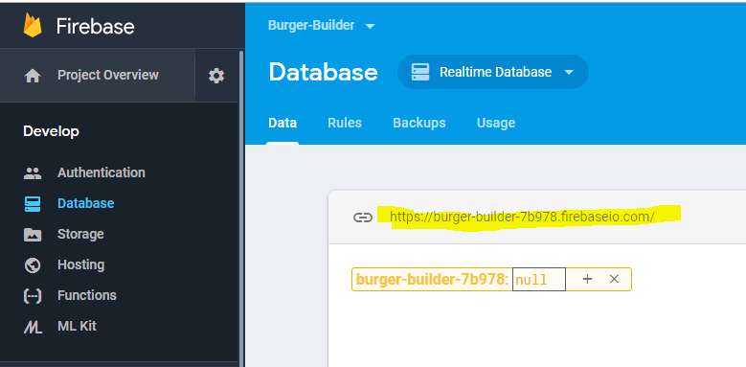

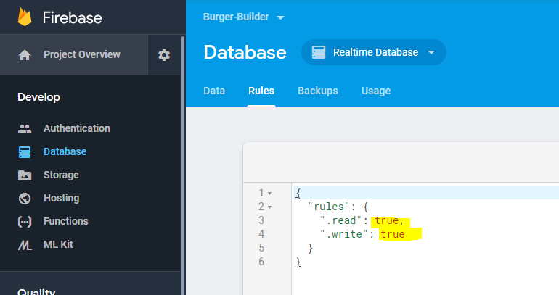

## Creating the axios instance

we created this firebase project and we had changed the rules, now let's start sending HTTP requests to this endpoint and to send HTTP requests, we of course should install a new package in our course project.

We do this with npm install --save axios

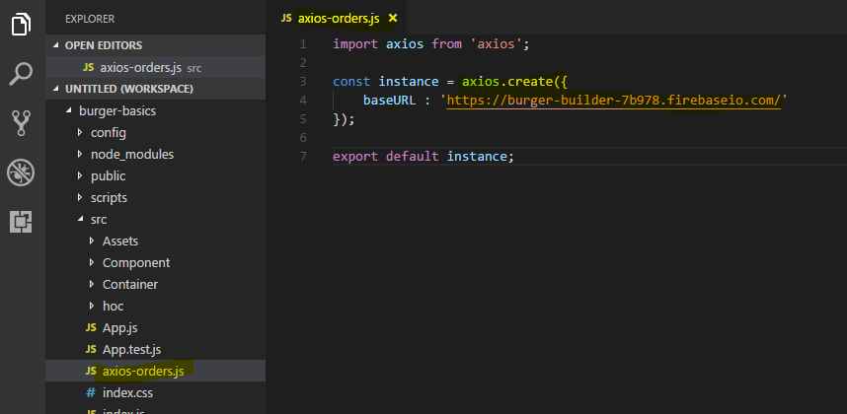

Now I have my own axios instance configured for this base URL, this is also the reason why I use this instance approach because later in the course when we add authentication, we'll all use a different URL with axios, so I don't want to set to base URL as a global default

## Sending a Post request

Lets try to simply take the order as it is and store it like this with some dummy data appended to it in the database.

**I want to send my data to my backend, I want to make this HTTP request. So in the burger builder file, we should import our own axios instance**

**I'm going to import axios the axios-orders.js file, this is going to use our configured axios instance.**

import axios from '../../axios-orders'; 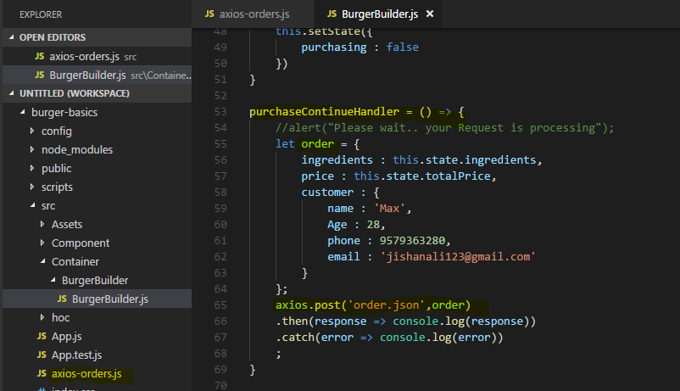

Now the URL is of course now our base URL plus whatever we're adding here, and that's the cool thing about firebase I said that it uses as MongoDB like structure, we don't actually have tables

**here we just have json like nested structure and if you send a request to something like this URL slash orders, it's going to create our orders node and store our orders beneath that node and this is exactly what I want to do. I'll add slash orders here and now for firebase only, there is a special thing, you need to add .json here.**

**This is the end point you just need to target for firebase to function correctly.**

Of course in your next project you probably have your own backend or you use some other service and you need to choose the appropriate endpoint there.

For firebase it's any node name of your choice .json.

just a little side note of course for your production ready application, you should definitely calculate that final price on the server because you probably have your product stored on the server there to make sure that the user isn't manipulating the code before sending it and manipulates the price which you're using.

Output -

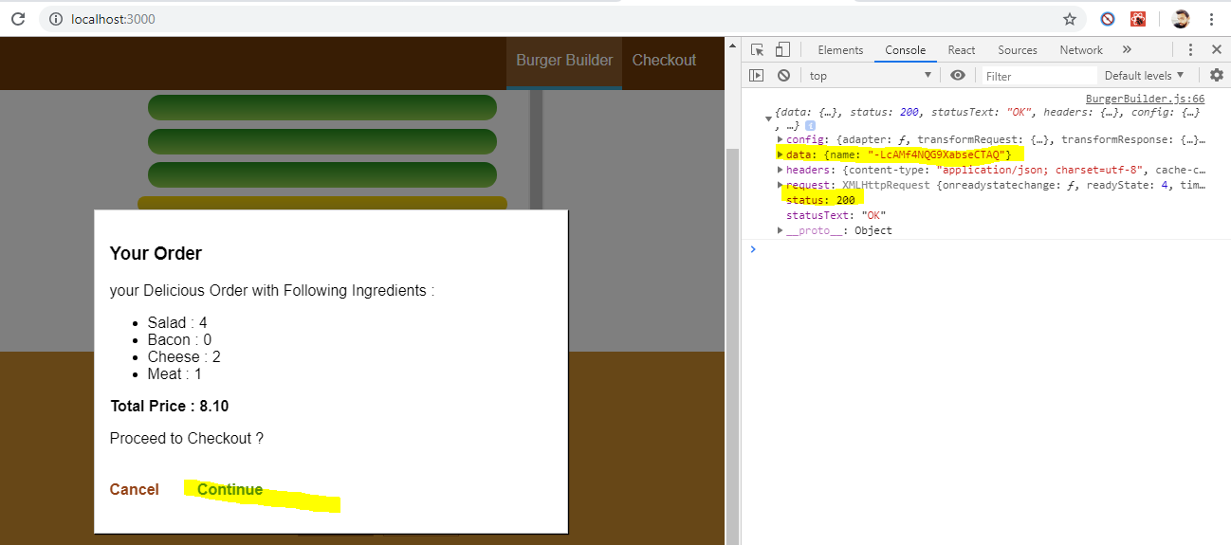

**so let's check out firebase.**

**It should update this page automatically and you should see the orders node in which you now see this cryptic name here.**

**Now to use the post method, firebase is automatically creating and managing a list here**

**and each list item simply get a unique ID assigned and created by firebase automatically.**

**If we expand this object we see the order data**

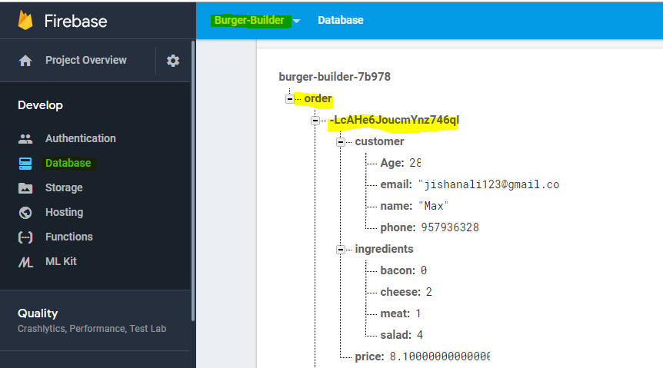

**we got our orders saved here but the cool thing is of course that this data is staying here.**

**If we reload the app, we reload this html file and therefore of course lose the application state because the javascript state is gone but of course our state on the server is still there.**

**So now we could fetch the orders and output them to the user**

## Displaying a Spinner while sending a request

 I want to show a spinner so that the user can see that something is happening here and once you are done the modal should get closed and the spinner therefore of course will also disappear.

**First of all we need a spinner component, that is clearly a UI element**

**Now to create a css spinner, we can simply take advantage of some resources we can find on the internet.**

**If you search for css spinners, you're going to find that awesome project here the very first search**

**which is a page with loads of css spinners and the code for it, which you can simply use.**

**You can also adjust them here by picking a background color and front color**

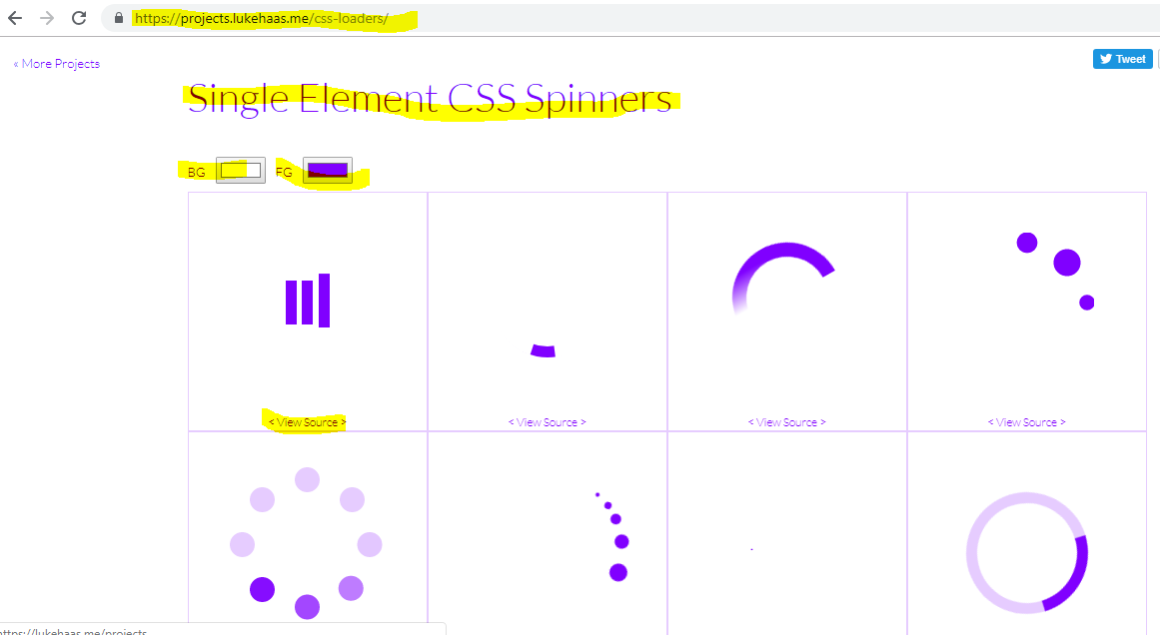

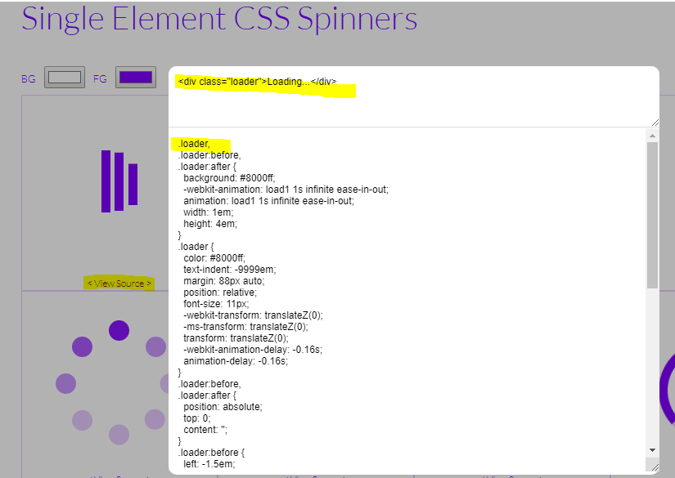

I'm going to grab all that code,

you also see the HTML code which is really simple, I'm going to grab all that code and then head back to the react application.

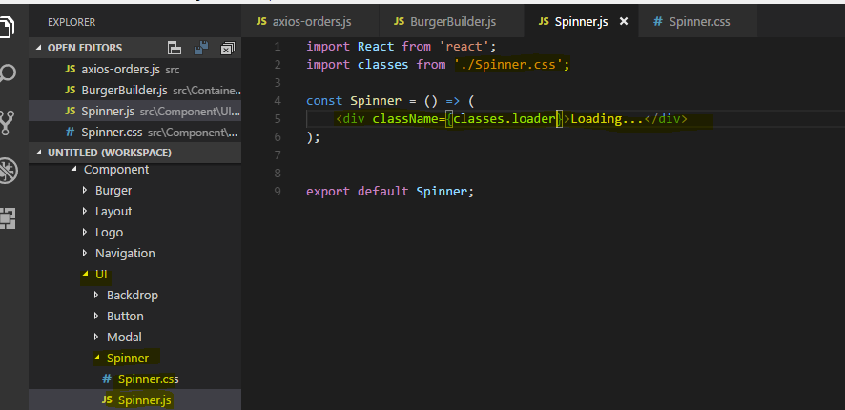

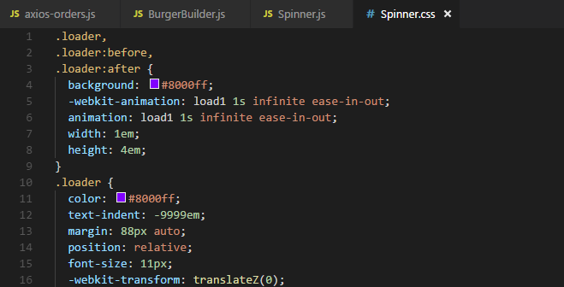

That actually is all the code I need for a spinner

now I only need some logic to show it inside the modal whilst we are loading.

So essentially I conditionally want to render order summary or my spinner. for that, I need a new state in my burger builder here, I'll then add a state which I'll name loading and which is false initially. When it is true, I want to show the spinner, when it is false, I want to show the order summary in this component.

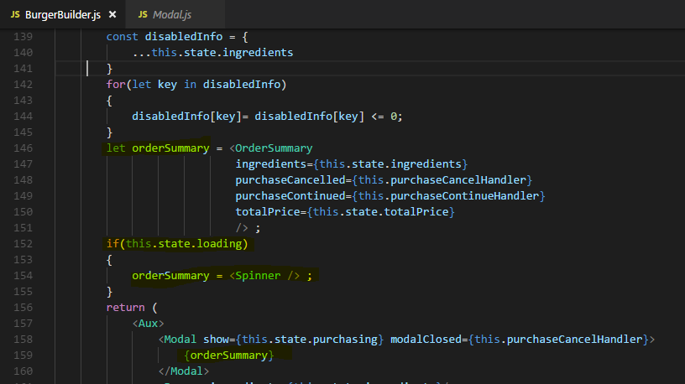

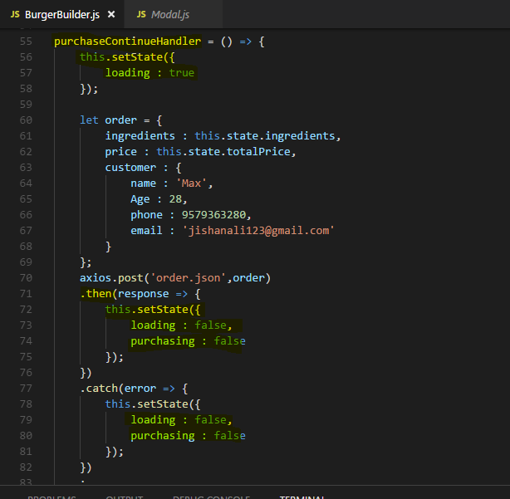

Once the response is there though ,I want to stop loading and close the Modal (well that can be done easily because the modal is only shown if the state purchasing property here is

set to true.) component also and I want to stop loading and close Modal component no matter what the response is because the request is done even if it failed.

If you have implemented update lifecycle hooks in Modal component like this then it will show

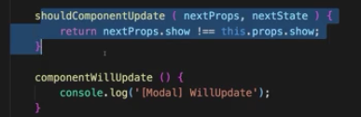

**In our modal code we use shouldComponentUpdate here and we basically only update the component if the show state changed. Here however, the children of the component simply change to props.children.changed,**

**we're passing a new child, we're passing the spinner instead of the order summary, that doesn't trigger an update here. So we simply have to finetune our shouldComponentUpdate method**

**in the modal component We have to add another condition also**

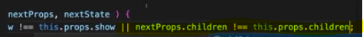

**we have to check if nextProps.children is actually different to thisProps.children so that it does update if it gets new children.**

## Handling Errors

It's also an improvement to the user experience if we show error messages in case something fails and here again, there are different places to where you could show such an error message,

I simply want to set up some global error handler which shows a modal with the error message . I don't want to be stuck to this container, to the burger builder container.

I want to have a flexible way of showing an error, no matter which component, in which container it occurs, so therefore my modal is going to get added to a higher level in the application and I want to have a higher level of the application, so some higher component

than this burger builder container where I catch errors and where I then make sure that my error modal is displayed.

I simply want to create a higher order component with which I can wrap the burger builder or which I'll actually use in that second way I showed you for using higher order components so that we can simply wrap any component which should have this error modal with it and can conveniently add the error handling functionality to it.

**I am using this syntax withErrorHandler because I want to use this second way of creating a higher order component which will be used here on the export and not used as JSX code.**

this should be a function which takes the wrapped component as an input and which then returns a function which receives props and of course simply returns some JSX including the wrapped component,

I of course want to return the wrapped component and distribute any props this component might receive on it because I don't know these props but I definitely don't want to lose

them,

I then want to export this withErrorHandler function as the default but now I also want to use my or add my error modal.

don't use a self-closing tag here because in the modal of course I want to output something.

For now I'll just say something didn't work, just like that.

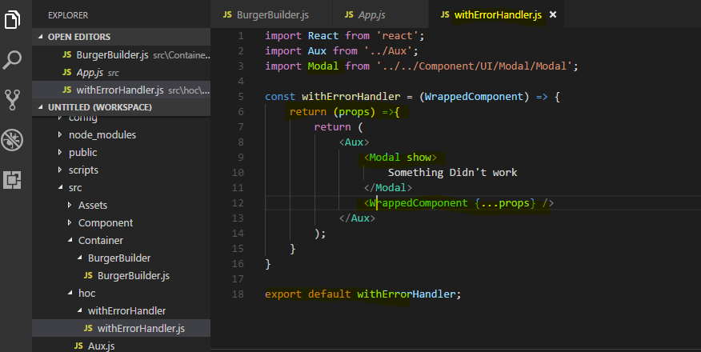

Now import withErrorHandler in BurgerBuilder 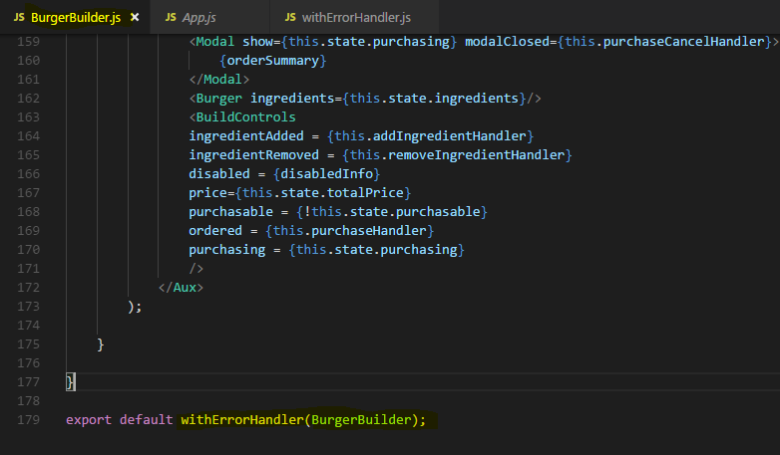

**Output -**

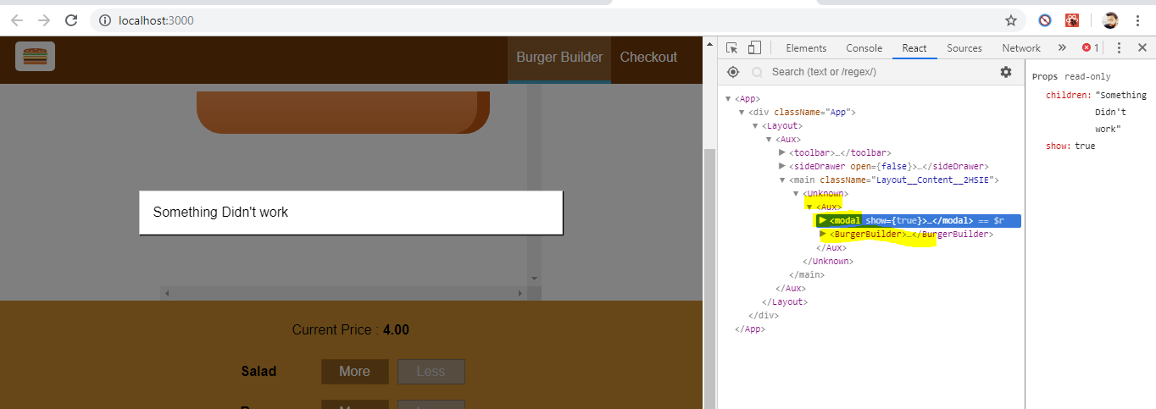

we see always see something didn't work.

Now obviously we only want to show this if we got an error, so we need to set show to something else and that something else needs to come from the wrapped component, we need that information

if it did fail. To get that information, we should add a second argument to our higher order function here, the axios instance which was used so that we can set up an error handler, a global error handler on it.

**Now to use that instance here, I will change this functional component into a class-based one because I want to add the componentDidMount lifecycle hook to set up the axios interceptors.**

Now theoretically of course, you could keep this as a functional component and use the useEffect hook here to do the same,that would be OK as well and of course we'll see it in action in that module where I convert the entire project to use hooks.

So for now, I'll go with the lifecycle method approach and convert this to a class Based Component.

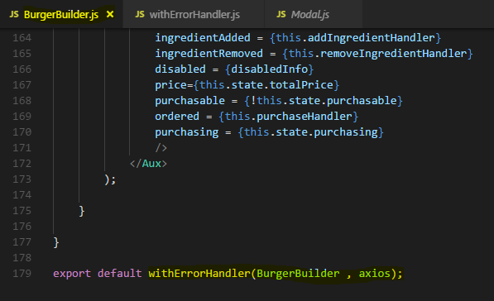

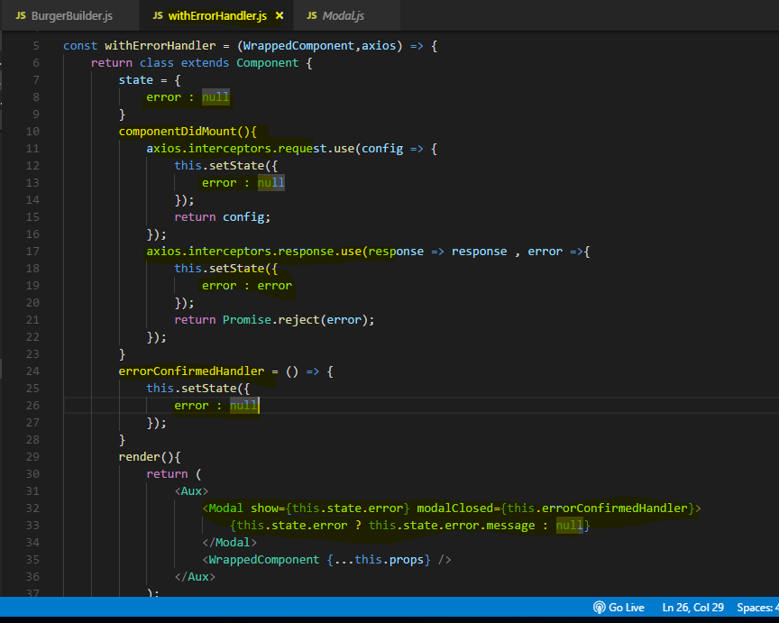

**As you can see it's an anonymous class, I don't set up a name here because I never use that class, I return it here, it's a class factory essentially, withErrorHandler creates these classes.**

now with this, **we can add componentDidMount here and in componentDidMount, we can now set up our axios listener, so on the axios instance here, we can now set up our global interceptor which also allows us to handle errors.**

this function here will get the response and then do something with it but I'm not really interested in that first argument, so I'll pass null here.

**The second argument is the one I'm interested in, that's the error case where I get an error.**

**I will then set or call this set state and set error to the error I'm getting here back from Firebase and this happens to be an object which also contains an error message, on the message property**

I'll add a new interceptor for a request, I'm not really interested in the request but there's one thing I want to do in there, I want to call this set state and clear any errors, so that whenever I send a request, I don't have my error set up anymore

**So now on the modal, I will only show it if this state error is not null essentially and then in there, I can output this state error and then again, there will be a message property on the error object returned by Firebase.**

the modal component we created also exposes the clicked property which occurs when we click the backdrop and in this case of course I also want to clear the error because then we click the modal, I don't want to show it anymore,

**Now if our response fail then error will be coming in interceptor and our modal will show**

**Lets fail manually and see the error coming from Firabase(Backend)** 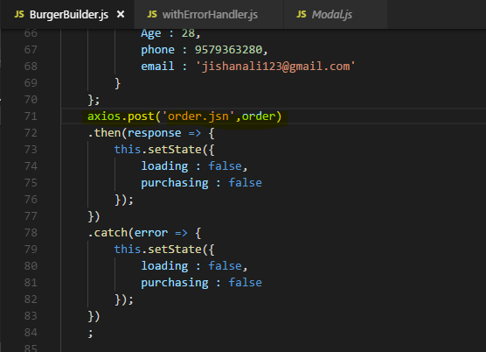

Output - 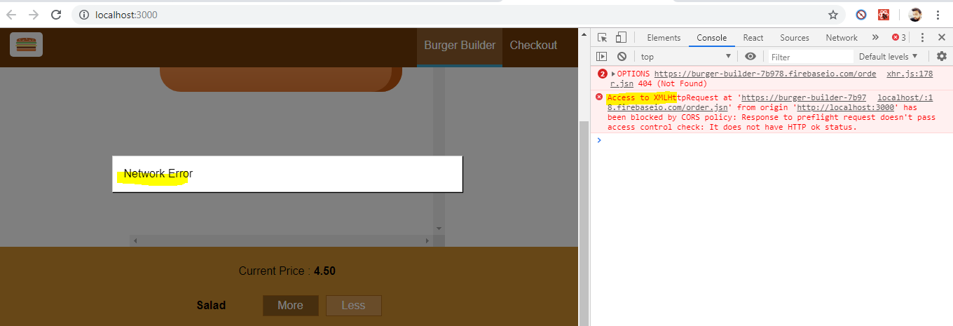

So now we're handling both the success case and the error case, we're showing a loader

as long as needed and with that, we get a robust application with a reusable higher order component which we can wrap around any component which uses axios to handle its errors.

## Retreiving Data from Backend

So the ingredients which we setup like this, why don't we get the ingredients dynamically from the back-end?

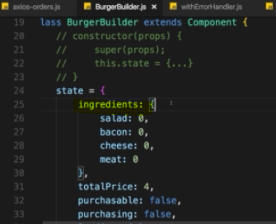

let's go to Firebase  create our data there. 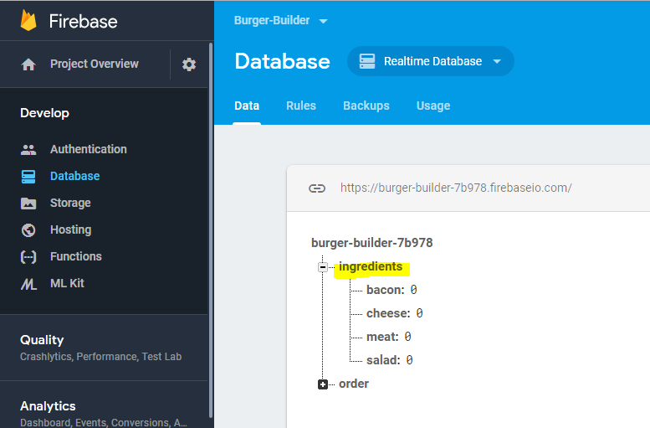

here is the URL to it, you need to append .json to really access it though and now the goal is to initialize our ingredients here with the ingredients we just stored on Firebase.

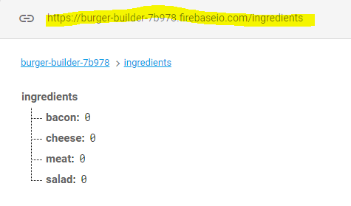

in the burger builder component, I want to set up the state dynamically and you learned that a good place for fetching data is componentDidMount,

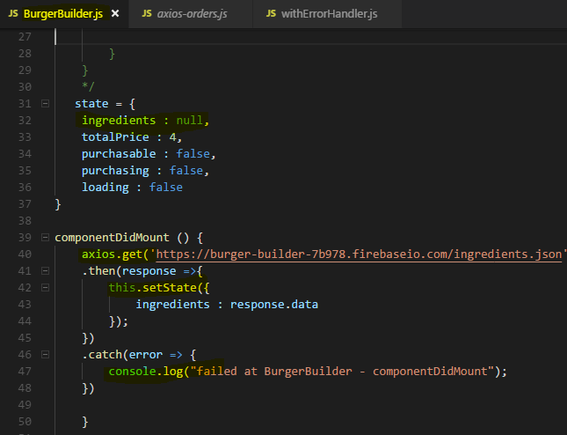

Now if we save that and we go back to our application here, you see we get an error

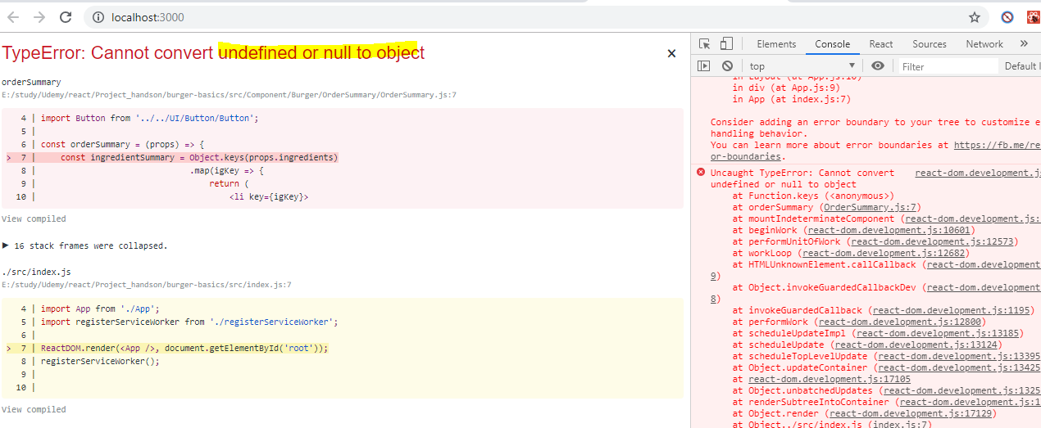

**Because now when we try to loop through our ingredients at the start of the app(componentDidMount() run after render() method), that of course fails because initially ingredients is now null,**

**we're only fetching it at the start and that's a typical use case in applications,**

**you fetch data when it loads, so parts of the UI which depend on the data will therefore fail.**

Now this of course can easily be prevented by checking if we have ingredients before rendering anything which depends on ingredients.

I want to show a spinner instead of the burger and instead of the build controls whilst I am waiting

for the ingredients to load.

So to do that, I'll add another variable here which I'll name burger and this will be the burger and

the build control

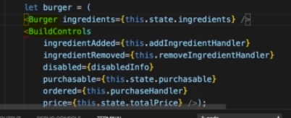

now of course, this will fail due to us having adjacent elements here in JSX which is not liked

by default

as you learned

but you can either return an array or use our aux helper component here essentially.

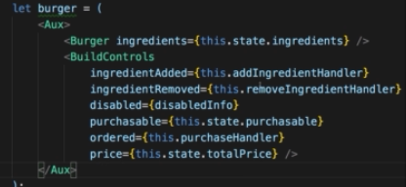

Now with that setup in every places where we use ingredients

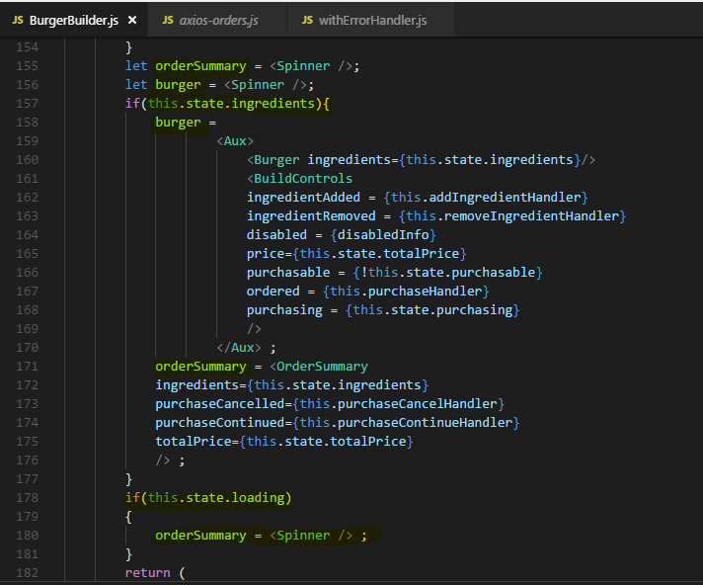

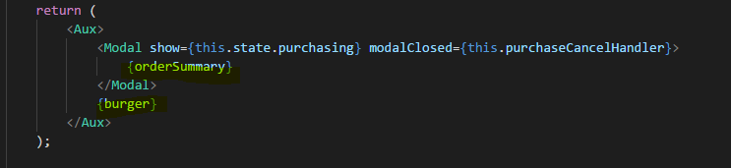

So now when we save this and go back to the application, you saw that spinner for the fraction of a second and thereafter you can get going and you can create that burger which you can see is still handled correctly,

The cool thing now is if we go to Firebase and we update our ingredients, so that for example we always start with meat, we can simply set meat to one here and confirm with enter and then go back to our burger and if we now reload it, you'll see we already start with one meat, so that's pretty cool.

So now we're also fetching this from the back-end and now we really improved our application and we have both a post and a get request. Now the cool thing is we're showing the spinner

**but if we now are removing the .json (means making ajax/http fail)**

we don't get the error modal.

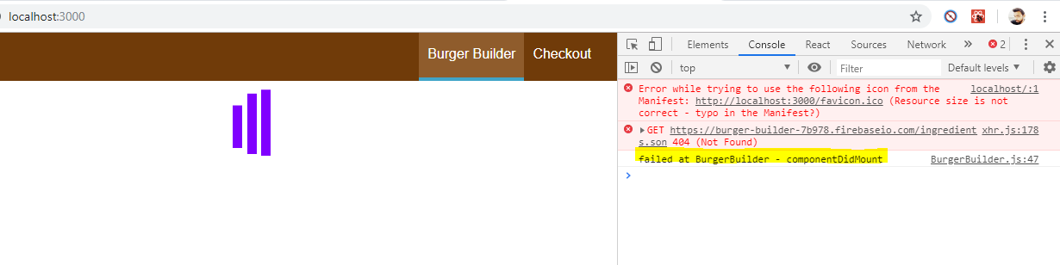

Now that's not cool,

why are we not getting that? That can be hard to spot.

**The reason actually can be found in our withErrorHandler function. We're setting up our interceptors in the componentDidMount hook and it worked great for the post request**

**but think about that lifecycle diagram** 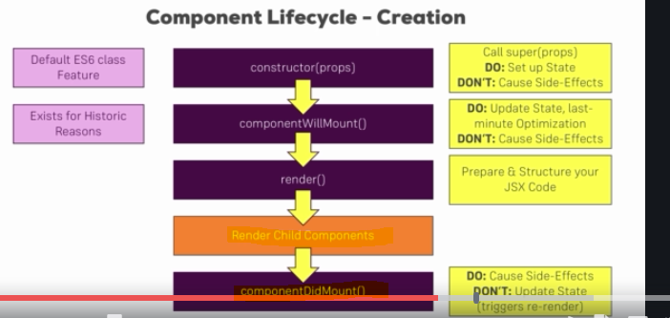

**there you see componentDidMount is actually called after all child components have been rendered, which means after componentDidMount was completed in the child components.**

**Now think about our withErrorHandler, here we're wrapping this wrapped component which is our burger builder container for example because there we are using withErrorHandler on the export,**

**so we're essentially wrapping the burger builder and that of course has one implication, componentDidMount in the withErrorHandler will only be called once componentDidMount was called here and since we reach out to the web in componentDidMount of the wrapped component, we never set up our interceptors.**

The fix is simple, here

I'll use **componentWillMount**. However in the future, this React lifecycle hook or lifecycle method will not be supported anymore and therefore you can also just use the constructor because the general idea here is that we execute this code when this component here gets created and with that, I mean that component object and of course the constructor also runs when this gets created, so therefore using the constructor instead of componentWillMount will work in exactly the same way.

**This will be called before the child components are rendered and we're not causing side effects here, we're just registering the interceptors and we want to do that before the child components are rendered.**

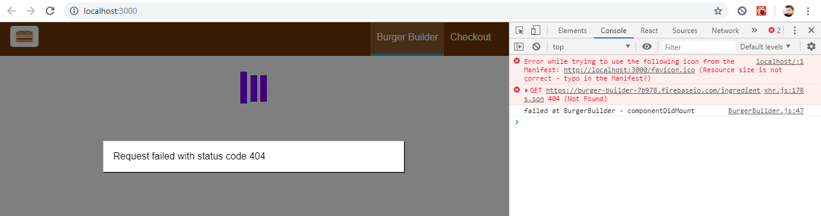

## Removing old interceptors

There is one improvement or fix we should apply to it it really improves our application,

Let's have a look at this withErrorHandler higher order component.

There we obviously added Our interceptors in componentWillMount and of course it makes sense to add them there because we wanted to make sure that we can intercept errors and hence show this error modal we set up in this higher order component.

**we have one issue though. This withErrorHandler method can be wrapped around multiple components, that's the whole idea of having this higher order component otherwise we could have put that code directly into the burger builder if that were the only component**

**where we want to use that.**

Right now, it is the only component, we're using it but again our higher order component is of course not limited to the burger builder.

**The problem we have is if we add this higher order component, withErrorHandler to other components, we'll call componentWillMount again and again of course because the class component we return it is higher order component is created every time this is wrapped around an existing component,**

**so every time we call withErrorHandler on the element we're exporting as we do in the burger builder.**

**So we're actually attaching multiple interceptors in our application and we're attaching them to the same axios instance.**

The problem of course is and we don't have that right now and we will face later in the course, the mentioned routing will lead to the problem, once we have more pages where we might use withErrorHandler, we of course create this instance here multiple times, this component here and therefore all the old interceptors, so all the interceptors we set up when we wrapped this around another component which might not be needed anymore still exist.

So we have a lot of that interceptor sitting in memory which actually are not that but which still react to our requests and in the worst case, they lead to errors or do somehow change the state of our application but even in the best case, they leak memory because that's code that still runs that is not required anymore.

So we should actually remove the interceptors when this component gets unmounted,

so when this specific instance of our withErrorHandler wrapper is not needed anymore and there actually is a lifecycle hook for this too, it's componentWillUnmount.

Now as the name suggests, this is a lifecycle method which is executed at the point of time a component isn't required anymore.

Alternatively if you're using a functional component here and you're not returning this class-based component, so if you're effectively using the useEffect hook thus far, then you would write this code in the return function of useEffect since this function runs whenever the cleanup is done for this component.

Now to be able to remove an interceptor here, we need to store a reference to the interceptors we create in properties of this class.

Now we have the state property already, we can simply add new properties to Class.

So for that, I will simply create a new property on the fly by using this, the this keyword to refer to the class and then any name of your choice,

I'll name this the request interceptor, maybe like this, request interceptor and we'll store the result of our interceptor setup which is just a reference to the interceptor passed back by axios automatically and I'll do the same for the response interceptor here.

So now I have two new properties in my class and I can now use these properties in will unmount to remove the interceptors.

There we can now simply use axios interceptors, just like we created them **but now we can also access request and response there and call eject and eject now requires the reference to the interceptor.**

So here, this request interceptor and I'll simply duplicate this to also do the same for the response, so for the response object, I'll call eject and then call response interceptor.

And now with that, **we got this set up in componentWillUnmount and we should remove our interceptors with that preventing memory leaks**.

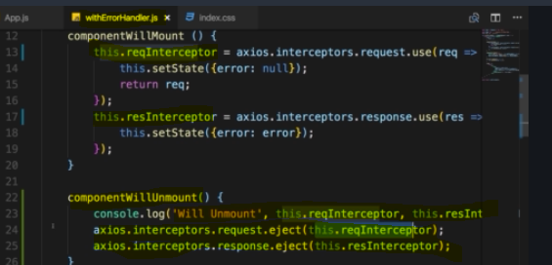

**Now to test this , we go to App.js file where we inject our Layout Component and try to unmount it by some way** 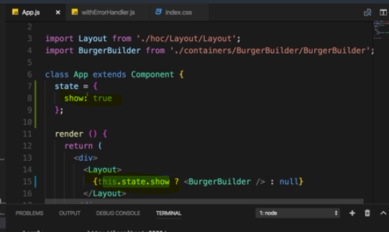

So now I just need a way to unset show after a while

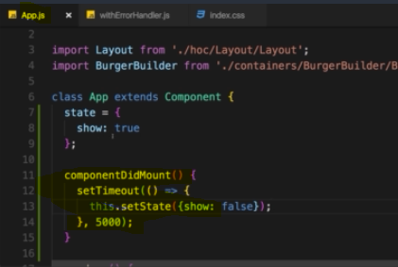

**now let's reload the application, we see the burger and let's wait five seconds and we should then see will unmount and we see zero zero and that's actually correct because these are simply the IDs.**

**There are IDs being kept the memory by axios for both the request and response interceptors, so two different lists of interceptors and they start with index zero.**

**We added one to each list, one request and one response interceptor, so that is why we see two zeros here.**

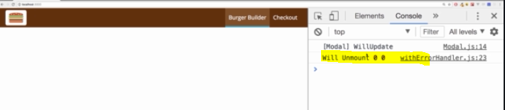

this will just ensure that whenever we don't need the burger builder component anymore that we clean up the interceptors which we attached due to using withErrorHandler on the burger builder so that if we reuse withErrorHandler in our application, we don't create more and more interceptors with the old ones living on.

# Routing : Multi-page feeling in Single-page application



**one important thing, routing, what this module is about is not built into the core of react. We'll use another package which is not created by Facebook** but the de-facto standard for this task in this module,

so that's important. React at its core is just a component creation library, now we're turning it to much more like a framework by adding a major feature, routing.

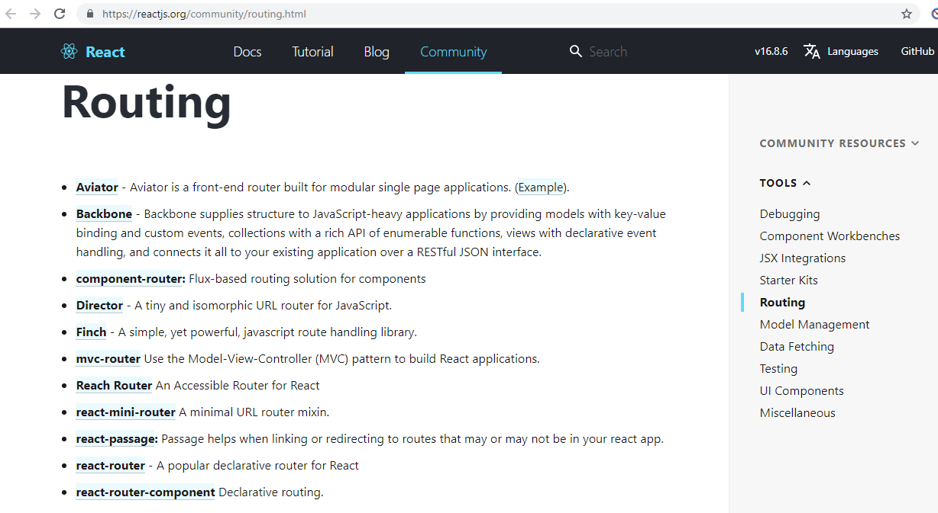

## Routing and SPA (Single page application)

Routing is about being able to show different pages to the user.

Now of course you may wonder multiple pages in a single page application, how does that work together?

**Well keep in mind the idea behind a single page application is to have, A single page, a single html file. We still want to provide the user with a normal web using experience though, we want to show the user different pages for different URLs.**

**The trick just is that we don't actually have multiple html files, but then we instead use javascript to render different pages for different paths.**

**So we don't really have different files but simply we re-render parts off that single page or maybe the entire single page depending on which path the user navigated to in our application.**

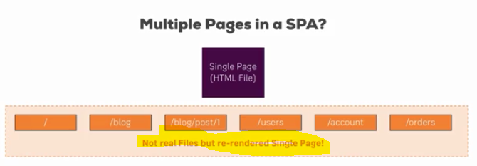

**This is what routing is about, parsing this path, so the path after our domain and showing the appropriate jsx or component code in our app.**

for that as I said, we're going to use a router package to add such a functionality so that we don't have to parse that path on our own which is non-trivial.

**That router package has a couple of tasks,**

**1 : it has to parse the URL path to understand where the user wanted to go to.**

**2 : Then we as a developer have to configure different paths in our application which we support and the router package can then read our configuration basically, so that it knows which paths are supported and what should happen when the user visits one of these paths.**

**3 : it will then render or load the appropriate jsx or component code depending on which path the user visited.**

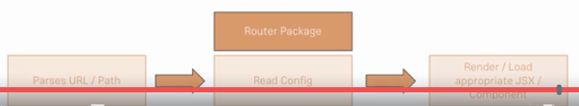

This is the idea behind routing, load different code, conditional jsx or component code for different paths and we use a router package so that we don't have to determine which path the user is on on our own.

## Setting up some links

want to show some links at the top to allow the user to switch between pages and

well load different pages.

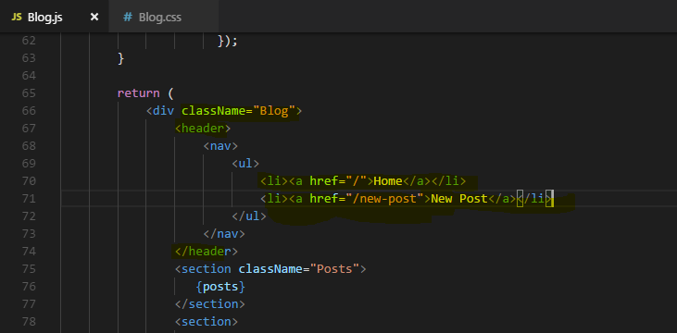

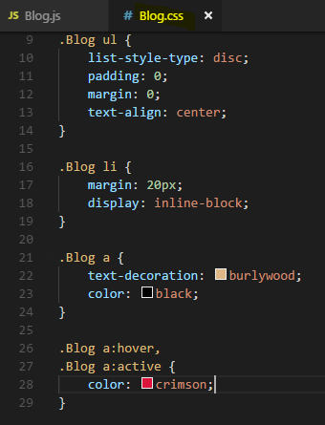

**That's of course nice but clicking these doesn't really do much, It loads different**

**URLs as you can see in the URL bar, but it doesn't affect our application.**

**Actually it always returns to same page.**

**This is related to the way our development server is set up and your production server should also be set up.**

**It always returns the index.html file for every route because for the server, there are no different routes, there is only one single file it has return all the time.**

## Setting up the Router Packages

**react-router** contains the logic you could say but to be able to render something to the dom, so to tell react to render something, we need **react-router-dom** too,



**we first of all need to enable routing in our react app.**

**we do this in the index.js or the app.js file.**

**There you now need to wrap the part of your app which should be able to render routes and to read routes, you need to wrap it with a component you import from the react-router-dom package.**

Now as I said, you can do it in both index.js and app.js,

I'm doing it in the app.js file and there**, I'll import something from react-router-dom**

**There we use curly braces to import something which has a name, so a named export from the package and here it should be the browser router,**

**this browser router object. Now you should wrap everything in your app which should be able to use routing with that.**

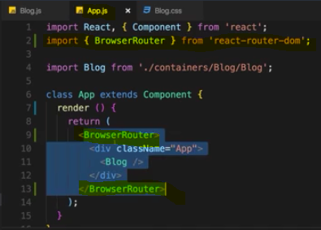

This is now the router of this application and now we can use routing features from that routing package anywhere inside this

wrapping components, so in any subcomponent which we embed here, this of course includes the blog.

Now inside the blog component I now want to use routing in here,

section posts,

this should now actually be a custom component which we load when we visit /nothing on the URL.

So for that, I'll create a new component and actually you could turn all these components into containers

now because they will be distinct pages which typically have subcomponents distributing their state

to them.

So what I would need to do is I'll move full post into the blog folder of containers,

new post and I'll create a new folder in the blog containers which is posts. Now the single

post, I'll leave in components because it's just presentational but the other components were moved there.

## **react-router vs react-router-dom**

We installed both react-router  and react-router-dom . **Technically, only react-router-dom  is required for web development. It wraps react-router  and therefore uses it as a dependency.**

**We don't need to install react-router  on our own for it to work. You can omit this installation step**, I left it in there for historic reasons and because I like to emphasize that the main package is named react-router. If you ever search for assistance, you probably want to search for "react router" - that's the name of the package.

## Preparing the project for Routing

In the last lecture we broke our app by moving the components into the containers folder because now we're going to load them as pages through routing and that really turns them into containers because they're no longer included by some other component.

So with that, let's work on the post component which is the one component we're now missing.

**post.css** file which we now import in the post component. So there I'll import simply

import ‘./posts.css’;

keep in mind here we're not using css modules hence the different syntax.

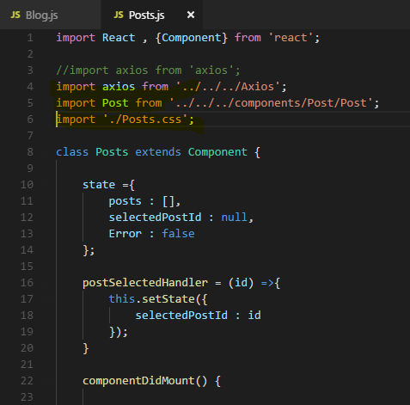

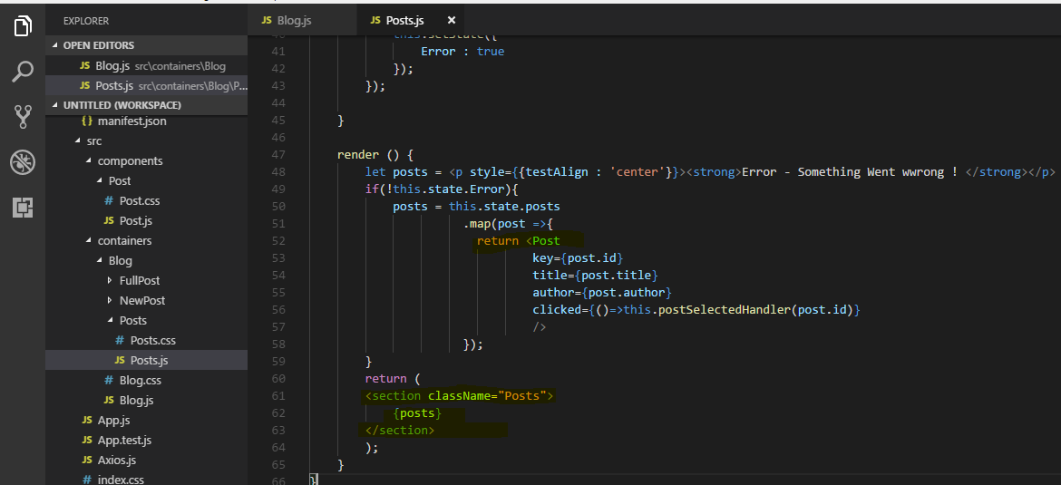

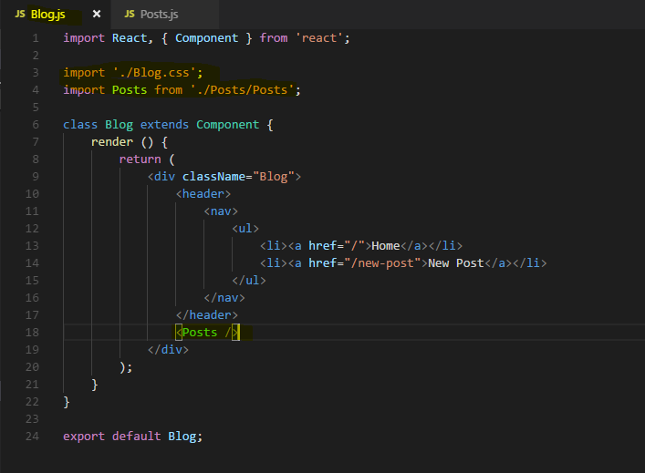

**And with that, we now got the post component created, fetching its own posts and rendering them to the screen**

**Now we get different components, containers which we can use as pages in our app because we want to load either all posts or a single post or the new post page. Now we need routing to load only one of them.**

## Rendring Routes

now I no longer want to render posts all the time, I want to load this dynamically depending on the path we have in the URL and for /nothing. So for essentially localhost:3000/ in our case here or whatever our domain then in the end is, I want to load the Posts component

Now we already turned on routing in the app.js by wrapping everything with the browserRouter.

 I need to import something else from the router package. So from react-router-dom

again because it is related to rendering, from there I want to load the route object, the route component to be precise.



**Now we use it like any other component in our jsx code and it's a self-closing component.**

**Route needs some configuration though, route needs a path property  and all these props here I'm setting up are of course reserved words kind of, they are expected to be named like this by this component so you can't change the name and path simply is a string.**

**Here you define the path for which this route should become active then you need to define what should happen when this is the active path, So when react router finds out that this is the active path.**

**Now in its simplest form, you can now add a render prop which actually holds a reference to a function and you can pass an anonymous function an arrow function here.**

**So here this function then has to return jsx which should be rendered, so you could simply render something like h1 tag where you say home and of course you can also render structured jsx here by wrapping it in parentheses and writing multi-line just like you write**

**Jsx anywhere else.**

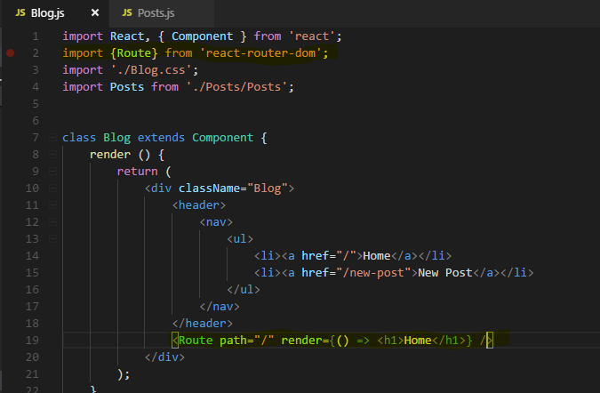

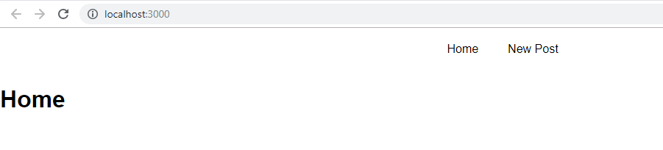

**You also see that though if you visit new post.** 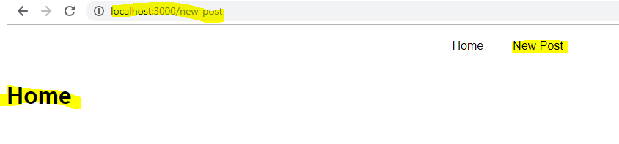

**the reason for this is that react router to determine which path you're on sees if your current path starts with this path. So if this is a prefix, you can override this behavior by adding one more prop which is exact. That's a boolean prop so just adding it like this sets it as true, the**

**default when it's not added is false.**



Now with exact for new post new you no longer is see home, you'll only see for the home page where indeed the full path is slash

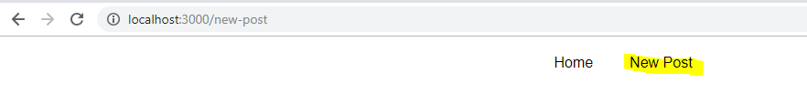

**You use the path here to tell react router does my path start with this? Except for the case that you define exact, then the question would be is my complete path like this?**

**And then here render determines what the react router should render to the screen in this component's place here, so route simply replaces itself with the Content you define in render.**

**you can of course use multiple routes, even for the same path.**

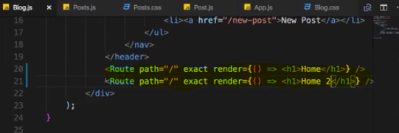



we render both home and home 2 beneath each other.

**So you can use route anywhere where you want, beneath each other, you could also nest the second route into a div, you can use as many routes on the same page as you want,**

**react router will for each of them check if this criteria here is met.**

**So if this criteria here is met,** **so if path is the current path or if you don't specify exact, if it is the prefix of the current path and then render this content.**

**This is the core functionality of the router** .

## **Rendering Components for Routes**

**We can render components for routes in two ways**

**1 : we can use render props incase we need to pass some props too**

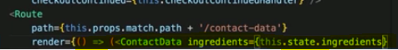

**But in this case we don’t get Route props like history , match and so on…**

**due to the way we are loading Component by basically rendering it manually down here with the render method, we don't have the history object available in there.**

**So to get these props in render component we need to manually pass these props we get in render method into rendered component**

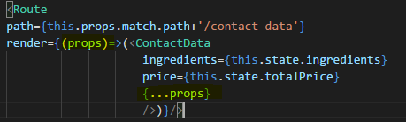

**Alternative way is -**

we can wrap the ContactData component with this withRouter helper method.

**Export default withRouter(Posts); - here Posts is parent component**

**2 : by component property(as a props )**

<Route path="/" exact component={Posts} />

this allows us to pass a component which should be rendered in this route's place.

Now component is not a string so we don't write “Posts” or {<Posts />} here, that wouldn't work, component needs to be a reference to the function or class we want to use.

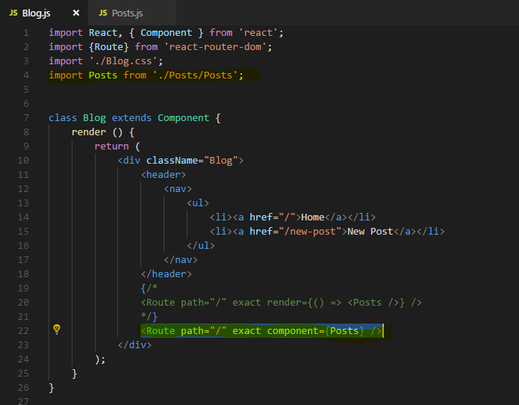

**So this now shows us how we can load components just like with render but with the component property.**

**Obviously this is the use case you're probably going to use a bit more, render is most important for short info messages.**

**You shouldn't really render a whole component's code here even though you could technically do that but that will mess up your code, will make it very hard to maintain but loading components like this here that is the default case which will use a lot.**

## Switching between pages

 let's add more routes here to load different components like new post component.

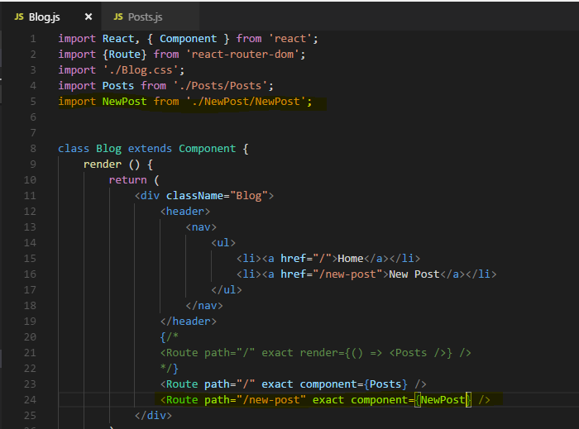

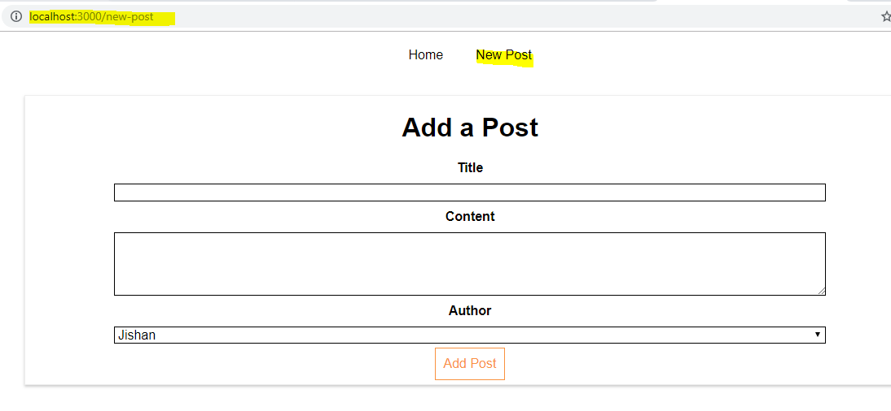

**Right now our application has an issue though,**

we can click these links they are normal anchor tags but each time our application actually reloads, as can see if you watch the reload icon next to the URL bar.

**Now this is not a problem here but theoretically a reloading application means that your javascript code is starting anew and therefore**

**all previous application state is lost.**

**This is rarely what you want in your react application, as long as the user is navigating around in it, you want to not reload the page, you want to just re-render the page in the parts where it needs to be re-rendered to look like the new page.**

**So we need to change to behaviour so that we don't have a normal link here which reloads the page but that instead we prevent the rebuilding of the page and let react router only re-render parts of the dom or tell react what to re-render to be precise that needs to be re-rendered.**

## **Using Links to switch pages**

In the last lecture we made sure that we can actually switch between pages but our application is constantly reloading and we don't want that.

Now we want to make sure that we stay inside the application when clicking on links inside of it.

when coming from outside of it and directly entering /new-post, obviously it will reload the app if we hit enter, that's just how the internet works, We send a new request to get a new page.

But inside of our application when we click links, we don't need that behavior because we're inside of it.

We can basically prevent the default and make sure no requests get sent and handle that click internally to re-render the page with javascript.

**For that we need to change our links, right now we use normal anchor tags and this is not what we really use when using react router, there are we have a special component we can use, the Link component. As the name suggests, link allows create a link.**



**We use this instead of the anchor tag,**

**Link alone of course doesn't do much because we need to tell react router where**

**this link should lead to.**

We do it as with the **to** property, the **to** property **in its simplest form is a string, like to='/'.**



Now this is essentially kind of the same as a href="/"

but react router will create the anchor tag and then prevent default which would be to send a new request and instead handle that click on itself that is why we need to use **Link**

**Now I said in its simplest form, to is a slash(any string), to can also be a more complex element, it can be a javascript object and hence needs to be wrapped in single curly braces to output dynamic content and then the dynamic content is a javascript object, so one more pair of curly braces.**

**And there, we can now configure where we want to go to,**

**we can set up a pathname property here which then again is the string where we want to go to like /new-post but we can also now add a potential hash tag after that like submit which I don't have but this would allow us to then jump to any ID submit we have in that elements, so using that feature of appending a fragment of the URL, you might be aware of that,**

**you can simply add hash something after the URL to jump to that point.**

**We can also set up search and search allows us to add queryParams like quick submit equals True**

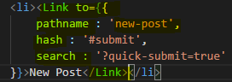

if we save the application and go back, you will see I'm on /new-post now, if I click on home

I go back to home but you will see that this reload icon actually never spins the same for new posts, and here you also see that queryParams and the hash tag added to the end.

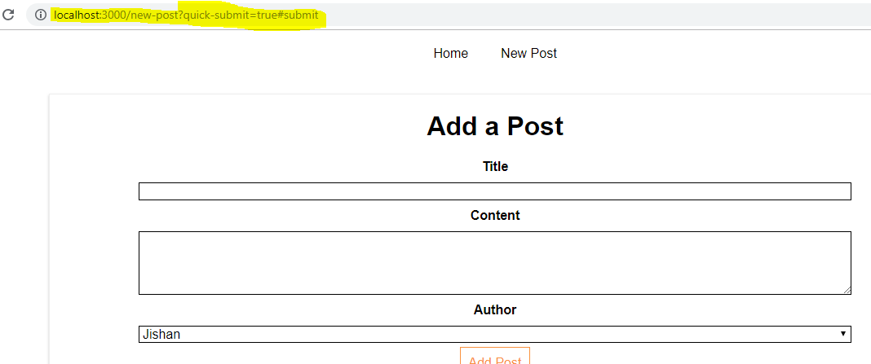

So now we're not actually reloading the page, it looks exactly like before but now simply react is re-rendering parts of the page which need tobe re-rendered,

we're not loading a new page, we're not loading that same page again.

Of course when loading the same page again it's still react rendering the javascript to the DOM but as I said we'll actually reload the page whilst doing that and therefore lose our state.

**Now our state is contained, we don't reload the application and this is the way we should actually navigate around therefore, using the Link component.**

## Routing-related Props

let's have a look at the information we actually get in the components we're loading because **react router gives us some extra information about the loaded route through props.**

We used Route to reach to Posts Component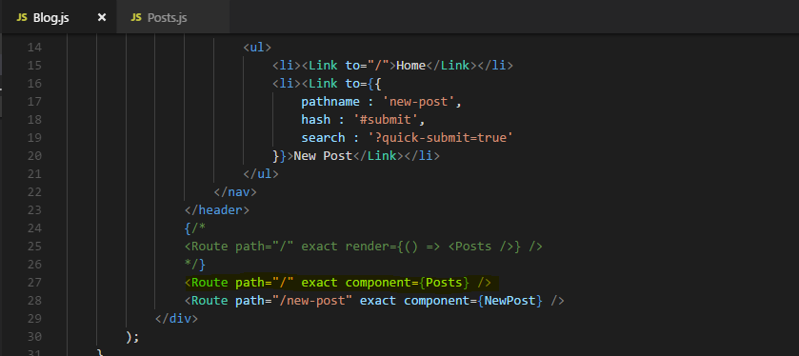

Lets print props in Posts Component in componentDidMount to see what it contains

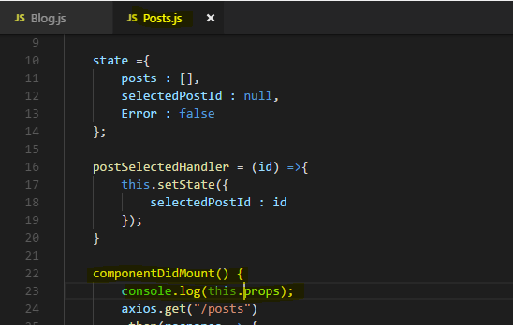

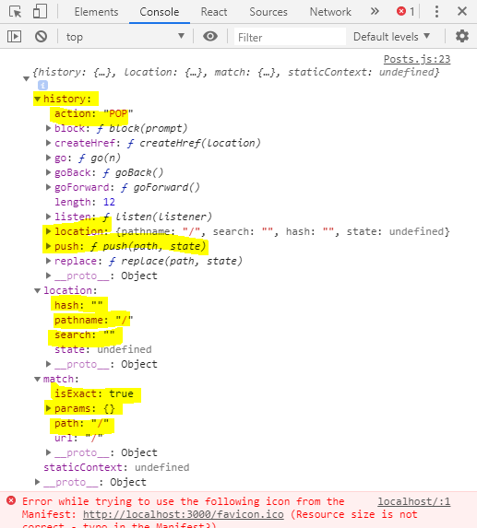

**this is the props object and history, location and match, this is not something we set up, this is passed by react router.**

Now match gives us some information about the matched route, you saw that we defined it to be exact the path and URL are found therefore **and potential params, I'll come back to what params are later.**

You get more information about the location and there you see for example the search

params we set up or something like that at the hash fragment and the history. **The history object also has some methods we can use like push to interact with that and push a new page programmatically without needing a link component, this is also something I will show you later.**

So this is some additional information we get, this is part of the props and you can use that to for example extract your query params, move to a hash fragment or do whatever else you need to do. We will later see how we used this history object to use a method that provides us.

## **“withRouter” HOC and Route Props**

**what if we actually want to get this information not in one of our containers, so not in a component which was loaded through a route but in a component which is rendered as part of such a container.The Posts container is loaded with this route here in the blog container and the Posts container simply renders the Post component then.**

Lets try -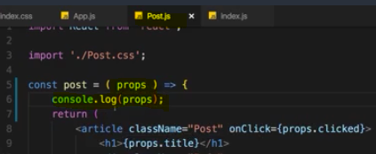

Output in console - 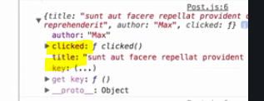

the props are not passed down the component tree, we can't access them in components which we simply embed as part of the jsx code of a container.

Now if you wanted to use the props there, there are **two ways to get access**,

**1 : one of course is we can pass them on with the spread operator and this props, this passes any props this post container has onto the post component.**



we could also explicitly target certain props like for example if you want to pass on the matched property, We could also do this.props.match. Now this is one way of passing it on

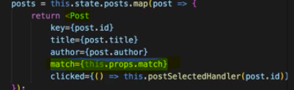

**2 : there also is a higher order component we can use on the post component, there we can import something which is called withRouter from react-router-dom.**

**Now withRouter is a higher order component which we use by wrapping our export with it**



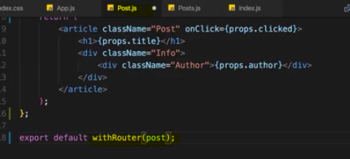

Output - 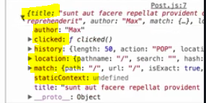

**So withRouter adds these props to other components, to any component we wrap with it.**

**So withRouter is a nice way of making that component route aware and it will use or it will get the props containing information for the nearest loaded route.**

**So in this case since post is included in posts, we get the same props as we receive in posts.**

**this is one way for you to get access to routing related props which you might need for calling push on the history prop or for getting information about the loaded route.**

## Absolute vs Relative paths with Route

One more information about the links you set up here, to='/', to='/new-post', **the way you write your links here doesn't affect whether it's an absolute or relative path.**

**Absolute path** - An absolute path is always appended to your domain

so if you're serving this app from **example.com** then you want to go to **/new-post**,

if you navigate to **/new-post** with Route, that simply means always **attach /new-post right after the domain**. Even if you previously were at **example.com/posts**, you wouldn't add **new-post** at the end of that, turning it to **posts/new-post** but turning it into **example.com/new-post** and omitting posts, this is what an absolute path does.

**when setting up to, you can't control whether it's an absolute or relative path, it's always treated as an absolute path.  it's an absolute path and will always be appended to your root domain.**

Now what if you wanted to turn this into a relative path though?

So if you wanted to make sure that if you are on your domain/posts, you actually go to your domain/posts/new-posts so you append this to the end of the current path.

Then you actually need to build this path dynamically by taking into advantage that you know at which path you are currently on.

Remember that you have access to this.props.match, The match object has the URL object which is the currently loaded path in the end. Now you can chain /new-post to this, you can build a dynamic path like this.

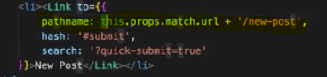

So if you ever want to build a link which simply appends the path to the end of the current path, use this approach otherwise, this always generates an absolute path.

Absolute vs Relative Paths (Article)

You learned about <Link> , you learned about the to  property it uses.

The path you can use in to can be either **absolute** or **relative**.

#### **Absolute Paths**

By default, if you just enter to="/some-path"  or to="some-path" , that's an **absolute path**.

**Absolute path** means that it's**always appended right after your domain**. Therefore, both syntaxes (with and without leading slash) lead to example.com/some-path .

#### **Relative Paths**

Sometimes, you might want to create a relative path instead. This is especially useful, if your component is already loaded given a specific path (e.g. posts ) and you then want to append something to that existing path (so that you, for example, get /posts/new ).

If you're on a component loaded via /posts , to="new"  would lead to example.com/new , **NOT** example.com/posts/new .

To change this behavior, you have to find out which path you're on and add the new fragment to that existing path. You can do that with the url  property of props.match :

<Link to={props.match.url + '/new'}>  will lead to example.com/posts/new  when placing this link in a component loaded on /posts . If you'd use the same <Link>  in a component loaded via /all-posts , the link would point to /all-posts/new .

**There's no better or worse way of creating Link paths** - choose the one you need. Sometimes, you want to ensure that you always load the same path, no matter on which path you already are => Use absolute paths in this scenario.

Use relative paths if you want to navigate relative to your existing path.

## Styling the active Route

It also be nice to see which route is active here by styling it appropriately.

We kind of want to add a special css class to the link which is active so that we can use that class to change the styling.

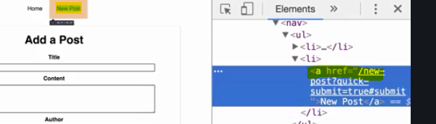

if we inspect that here, you'll see it is an anchor tag which was created behind the scenes

but again, an anchor tag managed by the react router preventing the default which would be to really send that request.

But you also see that there is no class being added to it even though that technically right now is still active page.

So what we have to do is we manually have to tell react router to do so and we do this by not using a link but a different type of link, the **NavLink** component.

**It's pretty similar to link but it has some extra props which allow us to define some styling for the active link.**



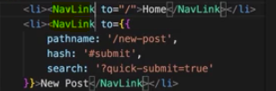

Now if you go back to the application, you see the inspect element , there is an active class added now, this css class wasn't present before. This of course now allows us to apply some styling.

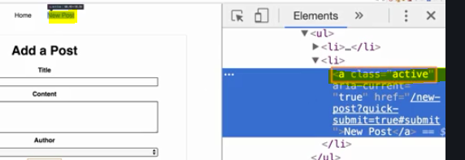

If we save this, now actually both are green, If I click on home though, only home is green. **Why is that?**

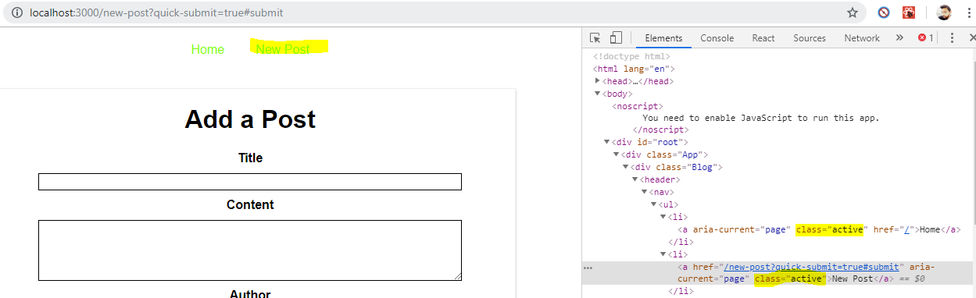

The reason for this is something we learned about earlier, by default react router treats these paths here as prefixes, and the same is true for links. When checking whether a link is active or not, it treats this as a prefix,

So we have to add **exact** here just as on the route, to tell react router no, the full path should be this for this to be the active link.

So this doesn't change the link we're pointing to, It will always be the path we defined but for the active class, it would take this as a prefix.

We override that with exact,

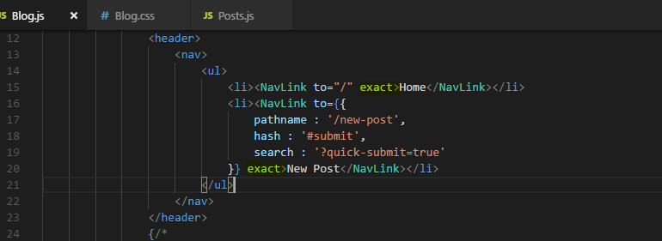

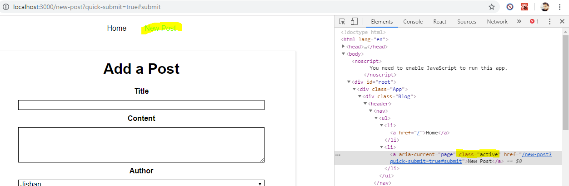

Now sometimes you don't want to use that default of active as an active class name.

Maybe you want to use my-active or highlight or whatever you want, that's why you can override the class which should be appended.

You can add additional props , you can add active class name and set this to a string and this could now be my active.

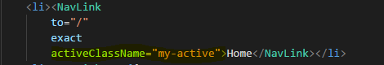

**home** link , now doesn't receive the active styling because as you can see if we inspect it on the right, it has a css class of my-active because that is what we set up here.

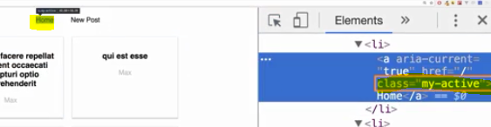

You also don't have to work with css classes if you don't want to you can also set the active style instead.

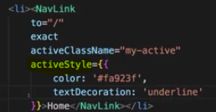

It's a javascript object and it actually works just like you use inline styling. Here you can set up any css styles

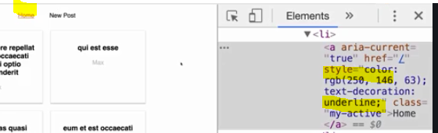

**The key takeaway is you have to use to nav link object, not the regular link object and you might need to use exact to make sure you only style the links for the routes you want to style and you don't use the to part here as a prefix when it comes to determining whether a route is active or not.**

## Route Parameters : Passing route Parameter

when clicking on a Post I actually now want to load the full post. For this

we of course also need to determine where this full post should be shown.

We could render it in the blog component instead of our post here, we could load the full post in Blog, this is one option. Here however, or **no matter where we use actually, we need to be able to get dynamic routing parameter because if we have a look at our posts output, each post has ID .And this ID of course is important because when we click on a post, we need to know which post that was, which post we want to load and that doesn't change when we use different routes.**

so now we need to pass that ID as part of the URL so when we load it, we can get this parameter and load the appropriate post.

**For this, when defining the route, we need to inform react router about the fact that we now have a dynamic element in this URL.**

instead of hardcoding the different IDs, we define a flexible, a variable route parameter with colon and then any name of your choice like ID or postID, I'll just use ID because it's shorter.

This will be replaced dynamically or essentially it tells the react router hey whenever you have slash something, this route here is meant, so just call an ID.



**we also want to make sure that we pass that parameter when clicking on a route now. For that we need to handle a click on a single post in the post component and there would be two ways of doing that.**

**The first is to simply wrap that post component we output here with a Link and that would be perfectly fine, it may be the default way you do it.**

So now we're essentially returning a link and there we now have to set to to something dynamic and that dynamic should be our ID.

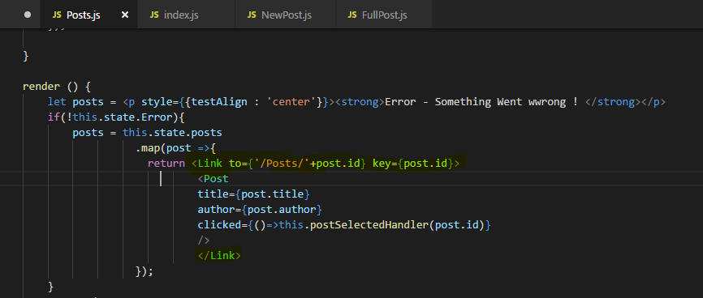

Now when clicking on any post below

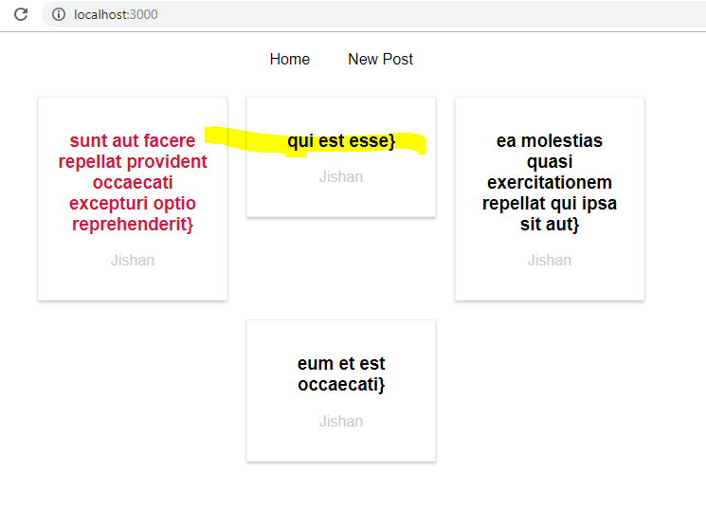

We got our Full post and New Route working

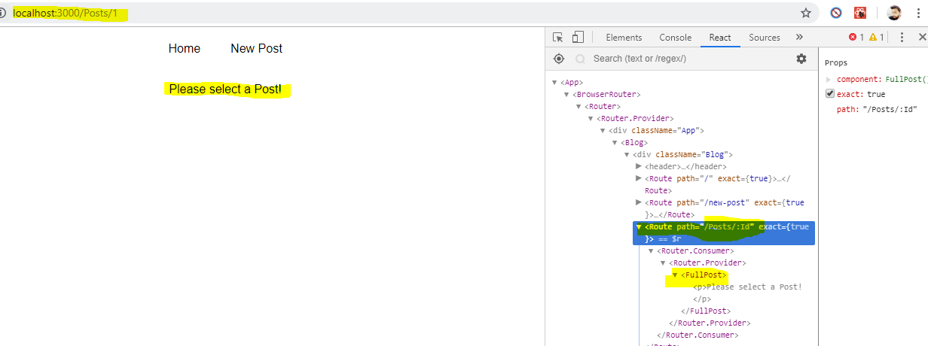

you can actually see that there is the ID in the URL and you see please select a post.

**It makes sense in one way though, we don't load the posts successfully because this.props.id in the full post component is not set anymore, it's not how we retrieved the parameter we're passing through the URL.**

what is working though we can confirm this in our application is that we can click on posts and load different IDs. we're also loading the component. Now we just need to work on extracting that parameter though.

### **Extracting Route Prameters**

Lets print props we received from Route in FullPost.

**For that lets print this in componentDidMount**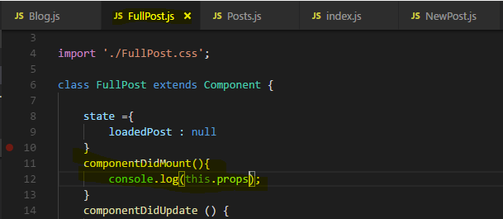

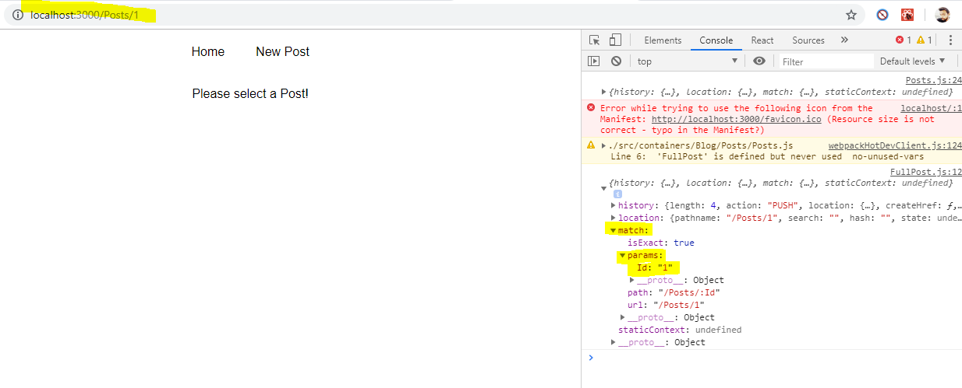

under **match**, we see that in params, we have the **param** and it's called **Id** because that is the name we set up as the name for this flexible element in this route definition in the blog component.

Now of course that allows us to extract this thenso here we can not only log it we can also access this.props.match.params.id and we know it will be there because this component is only loaded through this route which defines this id param.

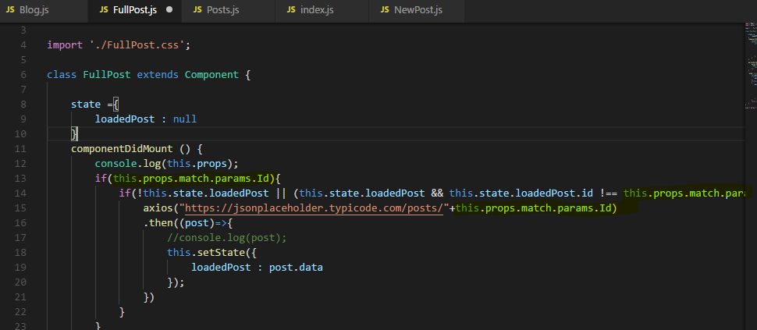

Now if we click on a Post we get Output - 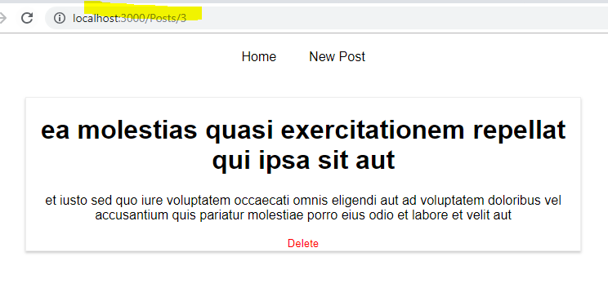

So now we really have an application where we have a dynamic element because we are successfully passing route parameters and extracting them.

### **Parsing Query Parameters & the Fragment**

You learned how to extract route parameters (=> :id  etc).

But how do you extract **search** (also referred to as "**query**") **parameters**(=> ?something=somevalue  at the end of the URL)? How do you extract the **fragment** (=> #something  at the end of the URL)?

#### **Query Params:**

You can pass them easily like this:

<Link to="/my-path?start=5">Go to Start</Link>

or

1. <Link
2. to={‌{
3. pathname: '/my-path',
4. search: '?start=5'
5. }}
6. >Go to Start</Link>

React router makes it easy to get access to the search string: props.location.search .

But that will only give you something like ?start=5

You probably want to get the key-value pair, without the ?  and the = . Here's a snippet which allows you to easily extract that information:

1. componentDidMount() {
2. const query = new URLSearchParams(this.props.location.search);
3. for (let param of query.entries()) {
4. console.log(param); // yields ['start', '5']
5. }
6. }

URLSearchParams  is a built-in object, shipping with vanilla JavaScript. It returns an object, which exposes the entries()  method. entries()  returns an Iterator - basically a construct which can be used in a for...of...  loop (as shown above).

When looping through query.entries() , you get **arrays** where the first element is the **key name** (e.g. start ) and the second element is the assigned **value** (e.g. 5 ).

#### **Fragment:**

You can pass it easily like this:

<Link to="/my-path#start-position">Go to Start</Link>

or

1. <Link
2. to={‌{
3. pathname: '/my-path',
4. hash: 'start-position'
5. }}
6. >Go to Start</Link>

React router makes it easy to extract the fragment. You can simply access props.location.hash .

## **Pass props to React Router's Link component**

Often when building an app with React Router you’ll need to pass props through a Link component to the new route.

There are two different ways to pass data from a Link component through to the new route that’s being rendered. The first is through URL Parameters and the second is through state.

First, let’s take a look at URL parameters. If you’ve read our [URL Parameters](https://tylermcginnis.com/react-router-url-parameters/) post, you’ll be familiar with this example. Say we were in charge of building out the Route that renders Twitter’s [profile](https://twitter.com/tylermcginnis) page. If created with React Router, that route may look like this.

<Route path='/:handle' component={Profile} />

Notice that handle is going to be dynamic. It could be anything from tylermcginnis or dan_abramov to realDonaldTrump.

So in our app, we may have a Link component that looks like this.

<Link to='/tylermcginnis'>Tyler McGinnis</Link>

If clicked, the user would be taken to /tylermcginnis and the Profile component would be able to access the dynamic handle (tylermcginnis) from props.match.params.handle.

class Profile extends React.Component {

state = {

user: null

}

componentDidMount () {

const { handle } = this.props.match.params

fetch(`https://api.twitter.com/user/${handle}`)

.then((user) => {

this.setState(() => ({ user }))

})

}

render() {

...

}

}

URL parameters are great, but they’re not really meant to serve as a way to get data from one route to another as they’re limited to just strings. What if instead of just a string, we wanted to pass something a little more complex, like an object or an array? There would be no way to do that with URL parameters. This brings us to the second way to pass data from one route to another and that’s with state.

Going back to our example from earlier, what if we wanted to pass along if the user is coming from a certain route through to the Profile component when the user clicks on the Link? React Router gives us a way to do that and the API looks like this.

<Link to={{

pathname: '/tylermcginnis',

state: {

fromNotifications: true

}

}}>Tyler McGinnis</Link>

Now, the component that’s being rendered for that route (in this case, Profile) would be able to access fromNotifications by accessing props.location.state.

class Profile extends React.Component {

state = {

user: null

}

componentDidMount () {

const { handle } = this.props.match.params

const { fromNotifications } = this.props.location.state

fetch(`https://api.twitter.com/user/${handle}`)

.then((user) => {

this.setState(() => ({ user }))

})

}

render() {

...

}

}

To recap, there are two ways to pass data from a Link through to the new route: URL parameters and state. URL parameters work great for strings, but break down after that. By making the Links to prop an object, you can pass along any sort of data you need under the state property and that data can be accessed in the new route under props.location.state.

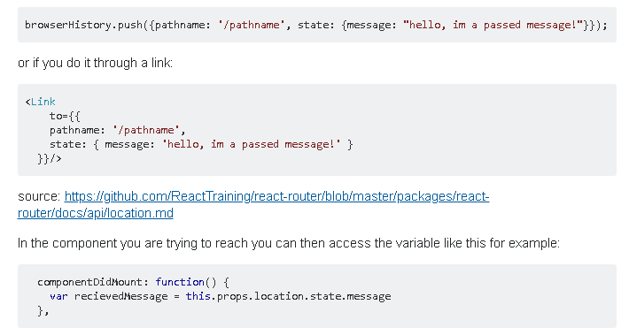

## **Pass props to a component rendered by React Router**

React Router uses a declarative, component-based approach to routing. What that means is when you want to create a new route, you render a Route component. If you’re familiar with React Router you know that to do that, you pass Route a path and a component to render when the app’s location matches that path.

<Route path='/dashboard' component={Dashboard} />

Now, what if we also wanted to pass Dashboard a prop? There are a few different ways to solve this problem but only one right way. The first idea you might have is to just pass it as a prop on Route.

<Route

path='/dashboard'

component={Dashboard}

isAuthed={true}

/>

Unfortunately, this won’t work. React Router won’t forward that prop onto the component. Instead, it will just ignore it.

The next idea you might have, and a pattern I’ve seen a few places is to pass component an inline function that creates the element.

<Route

path='/dashboard'

component={() => <Dashboard isAuthed={true} />}

/>

Though technically this will work, it’s not the best solution. The reason for this is because of performance. According to the official docs…

*“When you use the component props, the router uses React.createElement to create a new React element from the given component. That means if you provide an inline function to the component attribute, you would create a new component every render. This results in the existing component unmounting and the new component mounting instead of just updating the existing component.”*

So if you’re not supposed to pass a function to component, what’s the solution? Turns out the React Router team predicted this problem and gave us a handy solution. Instead of using component, use the renderprop. render accepts a functional component and that function won’t get unnecessarily remounted like with component. That function will also receive all the same props that component would receive. So you can take those and pass those along to the rendered component.

<Route

path='/dashboard'

render={(props) => <Dashboard {...props} isAuthed={true} />}

/>

So to recap, if you need to pass a prop to a component being rendered by React Router, instead of using Routes component prop, use its render prop passing it an inline function then pass along the arguments to the element you’re creating.

## Using Switch to load single Route

If you have a route like this

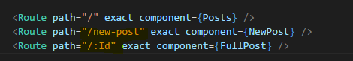

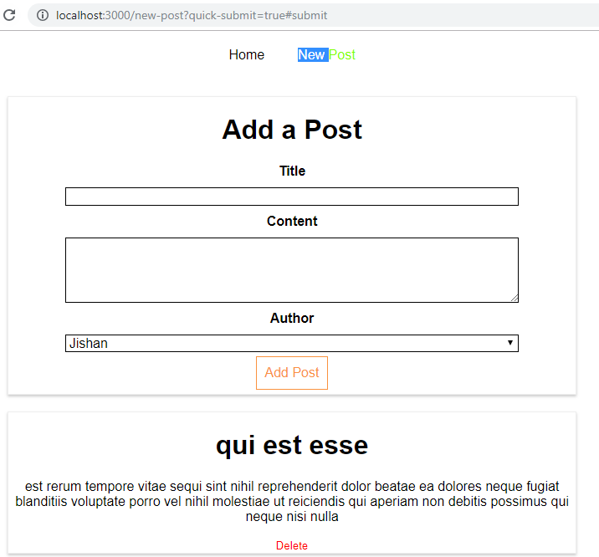

**Then we have a issue that if we click on NewPost then also we get our FullPost Route appear**

**The reason for this is because both route matches the path /new-post.**

**Remember that all routes here are rendered if they match the path.**

We can still tell react router to load only one of all these routes at a time, by wrapping our route config here with another component provided by the react-router-dom package, this **Switch** component.

**Switch tells the react router, hey please only load one of the routes. The first one actually you find that matches from a given set of routes.**

So now we can wrap our three routes with switch and the first route that matches a given path will be loaded and thereafter, it will just stop analyzing the routes, it won't render any other route.



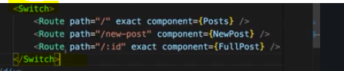

We also now see that if I change the order and put ID first, that we can never reach new post in this scenario and of course we get an error because new post is now treated as the ID and obviously an invalid ID for our backend.

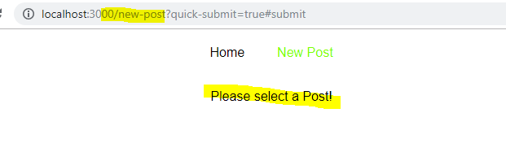

So now we see that it does stop after finding the first fitting route which is of course this one with a flexible parameter and therefore new post never gets rendered.

**So the order is important especially when using switch of course, switch however is important if you want to ensure that only one route gets loaded, and of course you can also mix it,**

**you can put one route outside of switch. So this will always get analyzed at least and potentially also rendered if it fits and then one of the following**

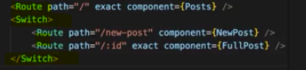

and then maybe add one more thereafter so you can really mix and match this as you want.

That's the cool thing about the router, it's really flexible. So this is one potential set up where we

can use URLs you want to use and still ensure that we only load one route at a time.

## Navigating between Routes Programmatically

Right now we're using a link to load a single post and navigate to its page and there's nothing wrong with that

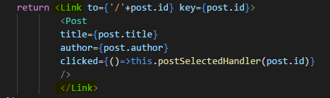

however I now want to show you an alternative and for this, I'll comment out the link path here now I'm not using link any more

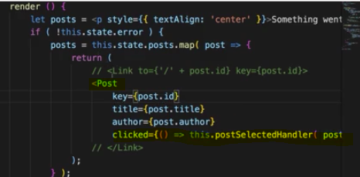

**I have to find some other way of going to that post and remember that we have this clicked listener where we execute this postSelectedHandler where we also pass the ID.**

**We can use that method**

I was showing this here as a demo. Of course using the link would be fine for this use case **but you also sometimes have use cases where you want to navigate after something finished, after a HTTP request was sent**

**Now to do this, we can take advantage of that history object we received on the props,**

remember here in the props we got history and there we actually have some functions we can execute, functions for navigating around like go back or go forward, which do exactly what they sound like, they basically do the same you have with the forward and backward buttons.

**There also is this push method which allows you to push a new page onto the stack of pages because navigation basically just is about a stack of pages.**

That is why the back and forward buttons work in the browser because you can go back to the last page on the stack or forward again to that page on the stack you had on the top of it before you went back.

**So therefore we can use this.props.history.push and then a string or also an object, so essentially the same we use in router link on the to property to navigate to a page.**

**So there we could navigate to a javascript object where I set pathname to slash and then plus the ID, and this is just the same I had down there with link to, just using the object notation**

**but again the alternative which I'll comment out would be to just go to slash plus ID,**

**so just passing a string. So both will work.**

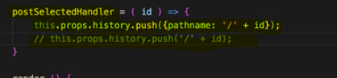

## Nested Routes

Thus far in our application we loaded the single post route as part of our blog page so that when we click on a post, we exchanged the posts page for the single post page.

however sometimes you also have a set up where you want to create a nested route. So **where you want to load a certain component or where you want to render certain content inside of another component which is also loaded via routing.**

right now we have only one level where we do routing, here in the blog container we load different components for different routes

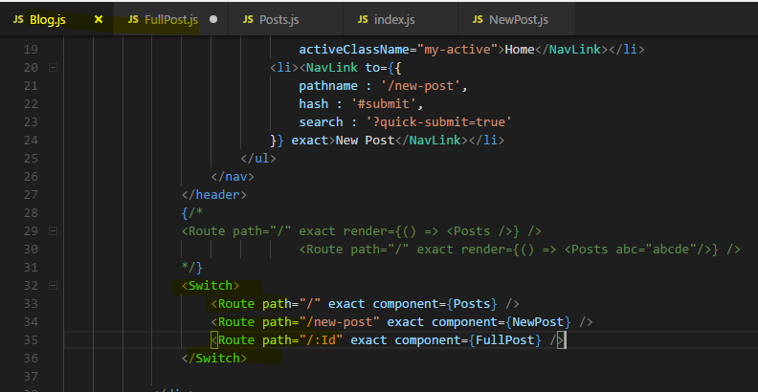

Now let's say we want to load a specific Post not inside the blog component but inside the Posts component right beneath our Posts here.

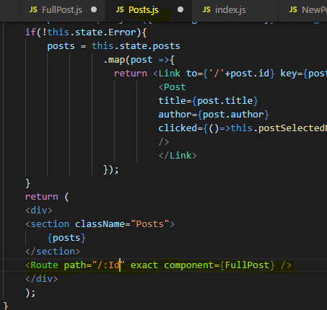

**You can use the route component where ever you want in your application as long as the page the component where you are using it is wrapped by that BrowserRouter and that**

**of course is the case because we're wrapping the blog component with it. and since the post component is just a child component of the blog component loaded through a route,**

**it will work.**

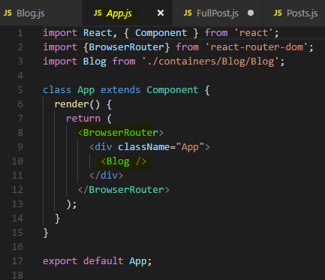

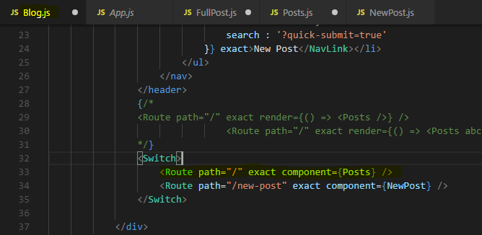

Now if you save all the files and you click on a single post, you will see that URL updates but the post isn't rendered and the posts are gone too.

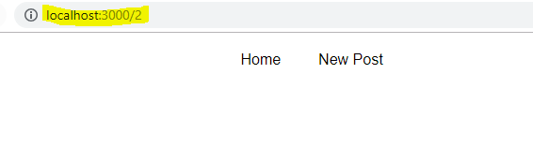

**The reason for this is that we now create a nested route FullPost in Posts Route**

**and this is the top most level where we react to any route changes, and the Posts component which we load through a router. Keep that in mind we load it, we implement it through the router in this component here.**

**When we click on single post , it now looking for a Route for /someID**

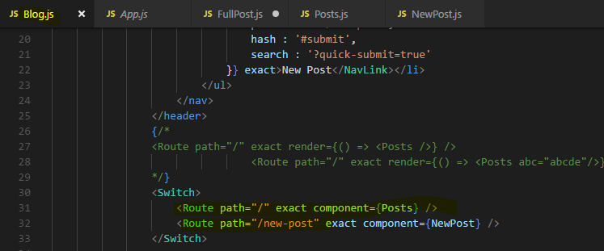

And No Route matches here for that path.

**We're not going to reach that route because we have the exact matching for / . So /:Id doesn't match that route, so the Posts component never gets rendered and our FullPost component Route is inside Posts component that we want to render for a given ID.**

**So for /:Id our Posts Component Route never match or never load because we have exact in <Route> for Posts**

**So we would never reach to or load our FullPost because our Posts never loads for that Route.**

**Hence for /:Id we also need to render Posts so that we can reach to FullPost Route**

**To fix this we can of course remove exact then this will match slash and /1, /2 and so on.**

**We should then change the order though so that / doesn't also consume the /new-posts first.**

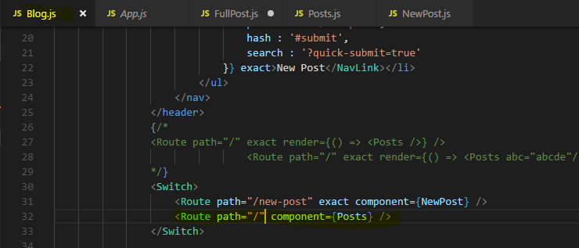

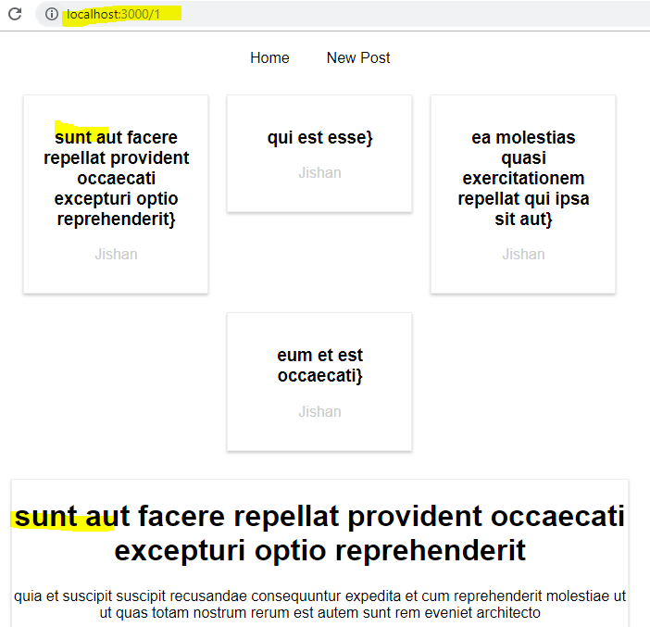

We face an issue though, let's say we have /posts here and not /

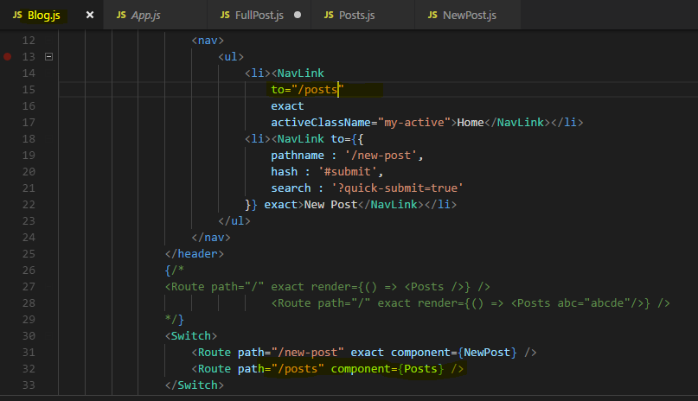

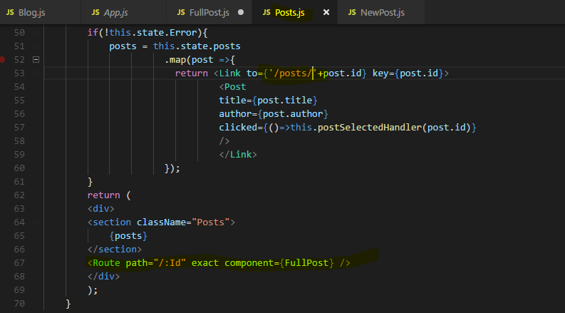

we load the Posts and If I click on a single Post then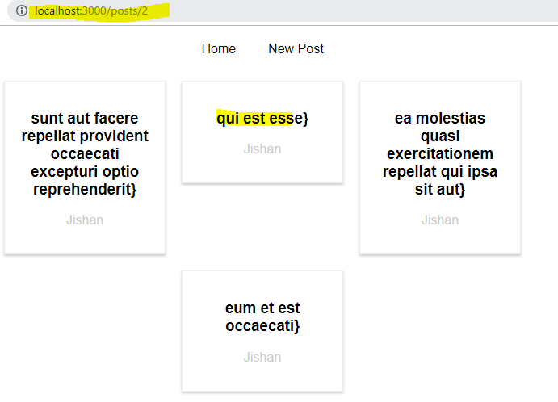

the Route path we are changing /posts/:Id but for FullPost we are looking for Routes /:Id

**ofcourse we can change the Route for FullPost like this**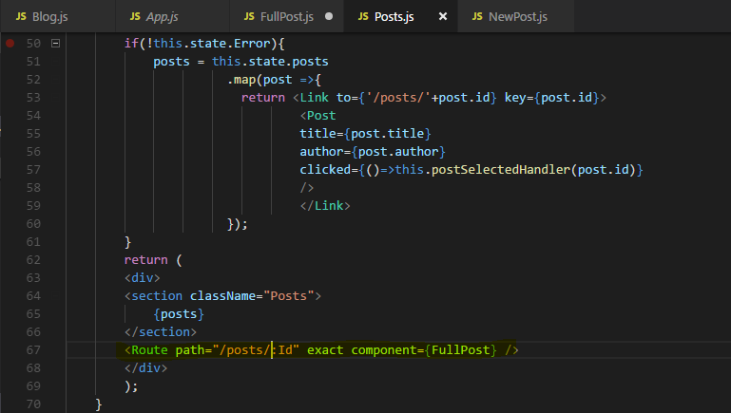

It is of course very cumbersome to do so.

**So instead of using post like this, a better way is to get the current path dynamically so that this really is a dynamic, a flexible nested route and for that path should be set to something dynamic here not a hardcoded string.**

**And in there, we probably should use** **this.props.match this match object and in there there is a url property which is basically the url we loaded thus far.**

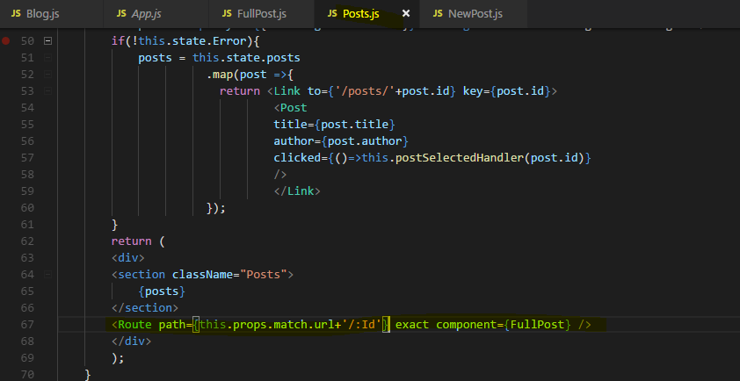

Now this will match.posts.id and if we ever were to load this component differently, let's say on /allposts, then this would automatically resolve to all posts here because it is dynamic.

this is how you create truly nested routes in your react application with react router.

## **Important : Dynamic Nested Routes**

In the last lecture we learn how to use nested routes.

Now you might have noticed one thing maybe even earlier, when we are on a given post and we click on a different post, we don't actually load another Post **you can see in the URL that the ID changes. So it is registering the click but it isn't loading the new component.**

**Now the reason for this is that react router behind the scenes doesn't replace the component all the time.**

**Important –**

**If you're loading a component on which you're already on, like we are here, it won't re-render thewhole component and therefore for the FullPost componentDidMount isn't executed again, because why would it do that?**

**The component itself didn't change it would be very inefficient to unmount it and remount it. So since componentsDidMount isn't executed again though, we're not reaching out to the web again.**

**So to fix this what we should do is we should also implement componentDidUpdate to handle this case because did update will be executed again.**

 I will add a new method, loadData where I reach out to the web and load my data because now I want to call this both in componentDidMount and componentDidUpdate. So this loadData will be called in both lifecycle hooks so that I'm prepared both for the first time this single post gets loaded and the second time and so on.. when Posts get clicked

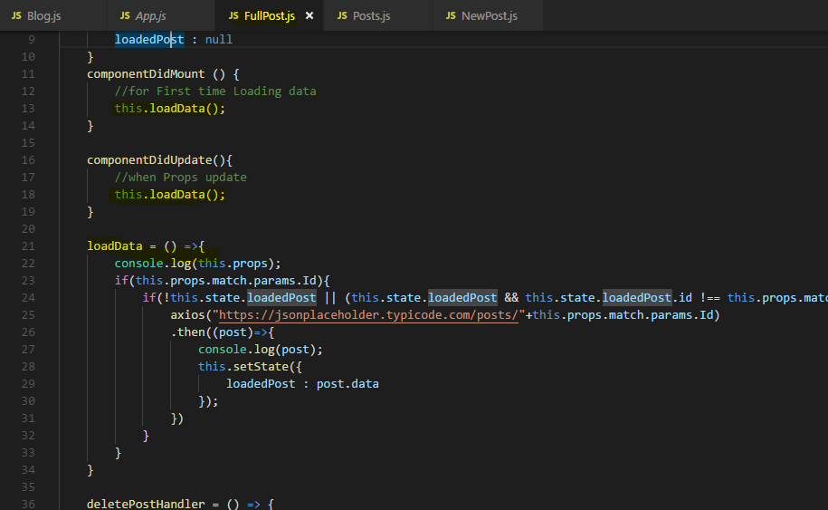

Now however you see by the console log already, we have an infinite loop

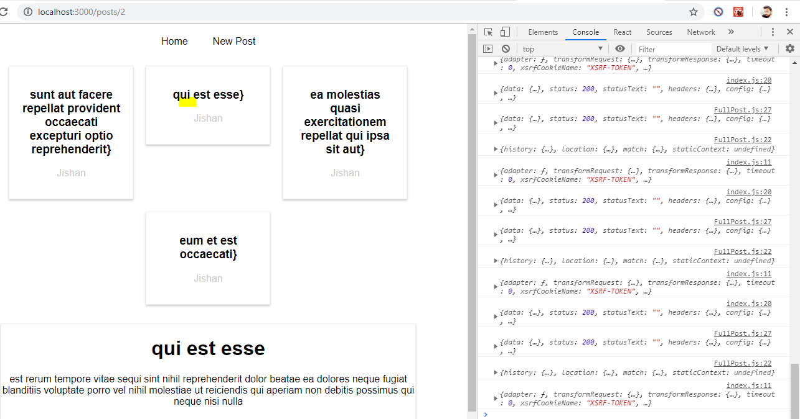

so this is not the perfect solution, I click on a link here and it keeps on loading again.

Now with all these changes in place, it would still not work

**because the Id we're retrieving from the route params is actually going to be a string.**

Now here we're checking for type equality too and the id stored in the loaded post actually is a number.

So we either have to convert these string IDs to a number or simply turn this into a check where we just check for the value.



Now if we just check just for the value and we click a post, now you see it's not loading all the time, instead it only loads once but it correctly updates it when we switch to post.



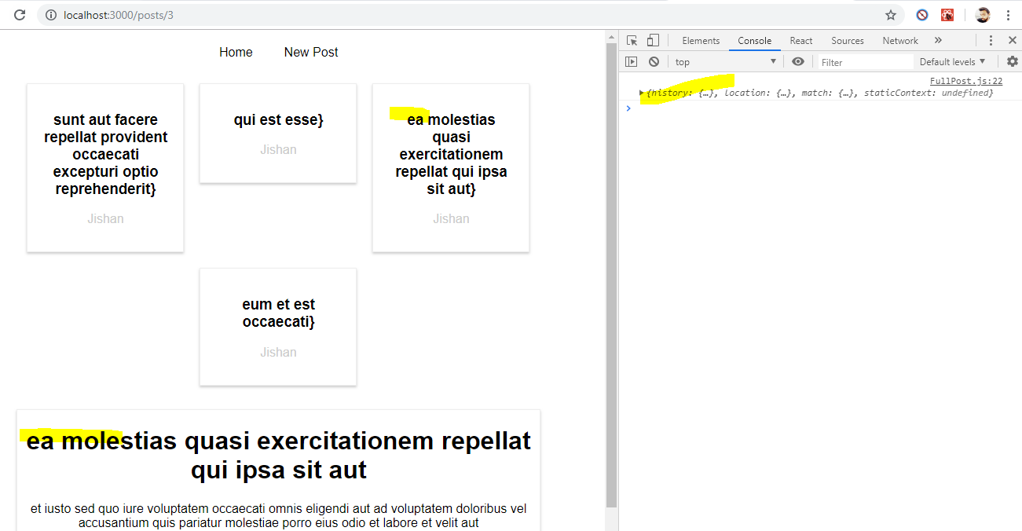

Again the alternative would be to leave the type quality check but to convert this into a number by adding a plus in front of it, for example.



Now again if I click on a post, we load it, we load it only once, we don't enter the infinite loop.

This is an important fix to the full post component in general that we use match.params.id all over in the component.

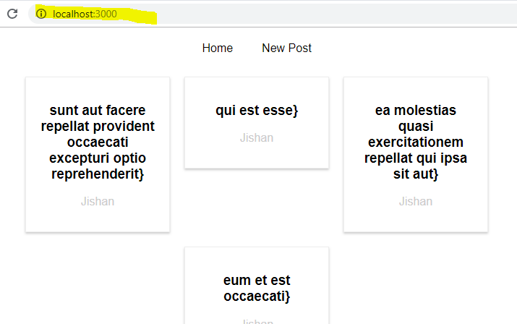**It's also important to understand that you need to handle changes in componentDidUpdate if the Post component or if component in general is already loaded through routing because the router will not unmount the old one and mount the same one again with different data, it will reuse the old one and just adjust the route parameter,**

**it's your job to react to this new parameter and you can react to that in componentDidUpdate which will be called because the props changed. You receive a new props with a new match object with a new params object with the new ID**

this is important to understand when working with nested routes.

## Redirecting Request (to different Route)

let's talk about redirecting the user. Sometimes you want to redirect the user,

for example, let's say that you also want to lead the user to /posts, if he visits just /.

**Of course you can duplicate that route and also handle the / case here, in this case, you could render component posts.**

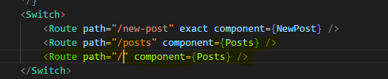

Now if you save this and you reload the page, you'll see that you load the posts component

even if you go onto just slash without /posts



This of course works and there's nothing wrong with it,

**you can definitely have multiple routes with different paths which render the same content,**

**that's absolutely fine.**

I want to show you a different solution.

You can also use a special component provided by react-router-dom, the **Redirect component.**

The **Redirect** component as it is a component is simply used in your jsx code, there you can add it to your switch statement and then you specify a **from** property, so from which route you want to navigate to which. For example, from / **to** /posts and then it's a self-closing component.

import {Route ,NavLink , Switch , Redirect} from 'react-router-dom';

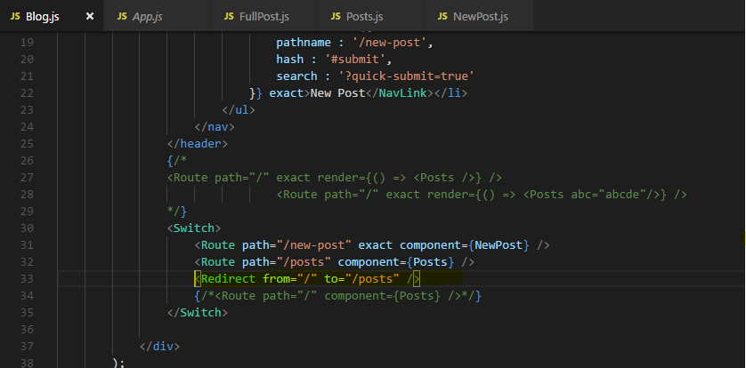

**If you use it outside of the switch statement, from can't be specified, then you can just always redirect to switch /posts and not respect the path you were navigating to.**

If you save all of that and we now load the root URL again, you'll see that URL changes to

/posts because we are redirected. This is how we can redirect to ensure that the user is removed or is navigated to the route we want to have him on.

I'll come back to conditional redirects outside of switch in the next lecture though.

**So now we have that redirect statement in the switch statement and it's just like another route, the only difference is it doesn't render content, it simply just changes the URL so that we then reach another route for which we render content.**

### **Conditional Redirect**

**in the NewPost component. we want to redirect once we clicked the submit button means once we made our HTTP request. We often then want to change the page and not remain on that page.**

**if we place redirect in jsx outside of a switch statement, we always have to redirect with the to property though, we can't use from.**

So here we could redirect to /posts,

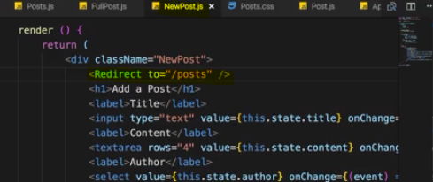

**The issue with that is if we click onto new post we are immediately redirected back to posts because the redirect component is rendered and when whenever this is rendered, it redirects us, so we have no chance of entering content.**

**Therefore we need to render this conditionally and since it's a normal component as all of js react router is, we just have to render it conditionally as we render any other content conditionally.**

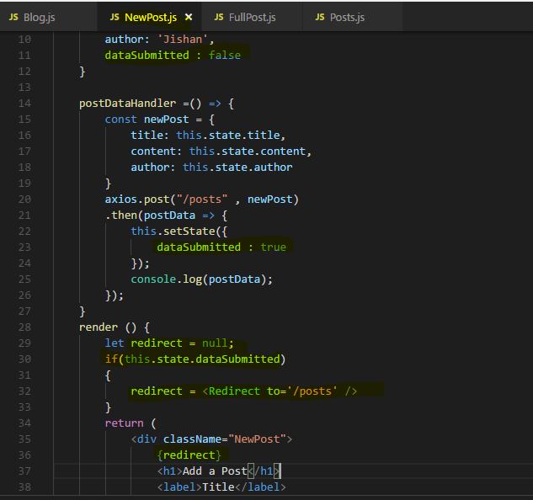

**this is our way of using Redirect outside of a switch statement, not with from, but instead the conditioned just is did something happen so that I want to render this component? And then we only render it when we want to redirect.**

### **Using the History props for Redirecting ( Replace method)**

after submitting a post successfully, you just want to switch to page and for that you can of course also use that history prop **which you get on every component which is loaded inside a browser router wrapped component and new post is in the end loaded through blog**

**so therefore it is wrap by browser router. In there, we have access to that match, location and history prop.**

**history** prop has a couple of convenience methods we can use for replacing the current route or pushing a new route.

**So we can also change the page here without changing the state and therefore by never rendering that Redirect component but instead by accessing this.props.history and there the push or replace method which allows us to push a new page or replace it.**

**This.props.history.replace(‘/posts’);**

Or

**This.props.history.replace({pathname:’/posts’});**

**Technically push pushes this page onto the stack, so if we click the back button, we go back to the new post page. Whereas redirect replaces current page so if we then click the back**

**after redirecting and not by pushing, you can go back but you won't go back to the last page because redirect replaces the current page on a stack, it doesn't push a new one.**

So replace basically does the same as redirecting and therefore you can use it as an alternative. I wanted to show you both methods though because maybe you have a use case where you want to render that redirect component conditionally and then this is an easy way of doing it.

If you don't want to use the approach of rendering that component, replace or push also is a way of changing the page after some operation finished.

## Working with guards

A guard is something you might know from other frameworks and their routers. Typically guards is for example used when you don't know whether the user is authenticated or not

and there are some paths in your application, some routes you only want to allow the user to visit if he is authenticated.

With the react router, you might need to have to think about these guards in a new way.

For example in the blog components where we set up the routing for a new post and so on.

**Since in the end, all we're doing here is just rendering some components, the Route components, the Switch component, if we want to make sure that new posts can't be reached, we can simply render this conditionally.**

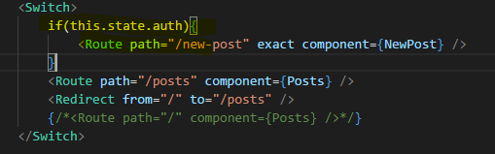

Now there is no way the user can access new post if he's not authenticated, so if the auth state is false because this route is basically unknown then because it's not rendered.

this is a guard. It's totally different that we use guards in Angular or any any other framework but in the end, this is how you can conveniently control whether the user is allowed to access this page or not.

Of course an alternative to this would be to go to the guarded page and inside componentDidMount here, you could also check if the user is authenticated and it of course depends on the application from where you are getting that information but then you could also check that here and simply use this.props.history.replace posts.

**if user is authenticated for example like that. So this also is an alternative, using componentDidMount to essentially redirect the user if it's not true.**

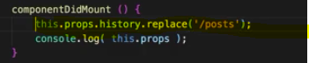

This is how you work with the react router, this is how I want you to think about it. You control a lot of it by the way you render its components.

And **if that route isn't rendered, you can't reach that route, the definition isn't rendered so the component connected to it can't be loaded.**

This is how you have to think about it and how you have to structure your application.

Wrap your head around this this is really crucial to get right and crucial to understand

## **Handling 404 case (Unknown Routes )**

**now I want you to consider a case where we're accessing a route which is unknown.**

**We actually saw one way of handling it with Redirect (or this.props.history.replace) where if we try to access new posts when unauthenticated, this route is unknown because it's not rendered and as you could see if we still click on new post, we are essentially redirected back to post.**

**This is one way of handling for 404 requests, you can simply redirect to another route.**

**However you can also handle them in a different way,**

**You can specify the Route component here and if you leave out the path so you don't add path, you can simply define a component or the render method you learned about to render something for any unknown route.**

**So here I'm going to output Page not Found , of course you could again just set it, use component and render 404 error page component you created , but this route will catch any routes which are not handled prior to it.**

**So any unknown routes in our case and it will output this.**

**Now it won't work together with redirecting from the root (‘/’) route because this also catches all and what ever order you use, one or the other wins so the other one doesn't do anything. For any other use cases where you don't redirect from the route route though, you can use them together.**

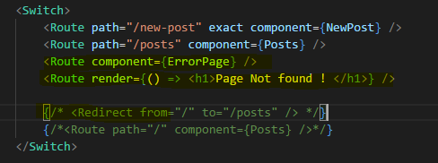

**Now as I said, it won't work together with redirect if you redirect from slash, if you redirect from any error page than slash, it'll work though.**

**The reason they don't work together is that here, from is treated as a prefix and therefore this catches all routes as does this and therefore no matter how you order them, it won't work together.**

I still wanted to show you both because you rarely have the case that two routes collide here and then you have a powerful way of handling 404 error cases with a route without a path.

## **Important : Loading Routes Lazily (Loading Component Asynchronously)**

there's one more **advanced concept** though not difficult to implement but one advanced

concept I want to cover.

Let's go back to our application and to really show what I mean, let's go to the network tab in the developer tools. There if we have a look at all the requests once we load the page,

so if I go into posts you see that we're loading this bundle.js file

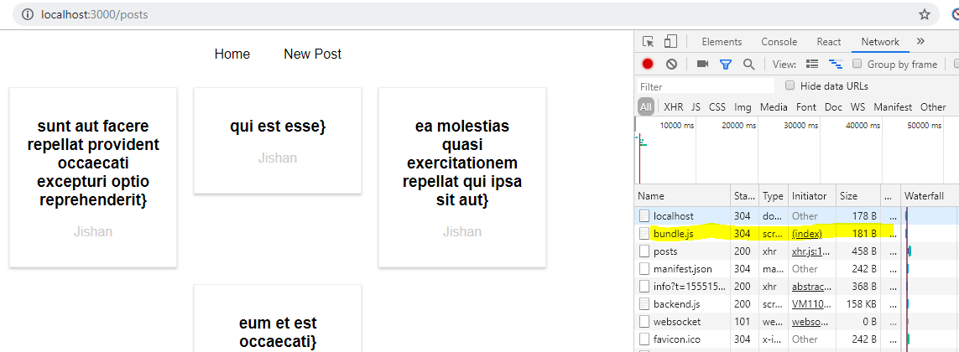

this contains all our source code, it's relatively big because we're in development mode, it will be much smaller once you are shipping this for production.

**Still loading the entire bundle with all the code of our application up front can be bad if we have a big application with distinct features and distinct areas in the app where a user might never visit a certain area. Like in our app, we have the NewPost.**

**if the user never visits new post, loading the code responsible for that component doesn't make a lot of sense.  It should only be loaded if the user actually navigates to /newposts ,**

**otherwise new posts and all potential children are never needed.**

**So why should we download the code up front? Would it be better to not download it and hence have a smaller upfront chunk to download and instead download the code responsible for this component and its children when needed.**

Now for a tiny application as ours here, this is not super useful because making that extra request for one kilobyte or something, what this component is worth when it comes to its size, that's not super useful but it is useful to know this technique for real for bigger applications you are building where this might matter where you are downloading quite a bit.

**The technique of downloading only what you need is known as code splitting or lazy loading and there you would essentially want to make sure that in your component, you're only loading the component once you need it.**

How does this work?

**To implement code splitting or lazy loading, we have create react app and react route for and that's important. This technique will work for react router for and for create react app**

**because code splitting depends heavily on the webpack configuration you are using, it is an advanced concept after all.**

So the way I'm showing you is the way it works with the config from create react app which is a pretty modern and good configuration though, so chances are it also works in any decently set up webpack project

As I said at the beginning of this course, I strongly recommend using create react app anyway.

So **for this to work in this setup, we need a higher order component**.

So let's create a new folder hoc and then there, I'll add a new component which I'll name AsyncComponent

AsyncComponent.js , that's the javascript file name, because this component or this code here should help me load a component asynchronously i.e. only when it's needed.

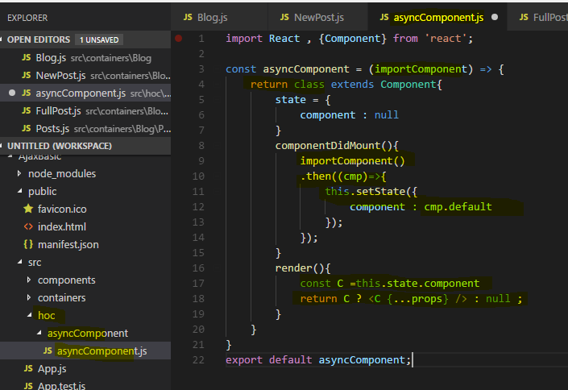

**There I expect to get my import component argument which will in the end be a function**

So there, I now need to return something and I will return a class here which extends component, so a normal react component

I'll set up state and there I want to have a state which with a component property which is null. This state here, this component property will be set to the dynamically loaded component and the code for this will get implemented in componentDidMount.

So once this component was mounted here, this wrapping higher order component.

Now as **I said import component should be a function reference in the end, so what I want to do is I want to execute import component here and this actually will be a function**

**which will return as a promise , .then block will get an argument, cmp , the name is up to you which will have one property default which will be the component we loaded dynamically.**

**So in this .then block, I can call this.setState and set my component state to cmp.default. This is the case due to be set up we're using here with create react app.**

It is all of course heavily reliant on the type of function import component will refer to.

So now at some point of time, we will have loaded the actual component we want to use and it will be stored in our state. Hence in the render method, we want to render it, I'll create a constant and name it C and this should be this.state.component. Then I want to return jsx in this render method and I'll check if C is set in a ternary expression. If it is set, then I'll render C as a normal react component, I'll use this this.props spread trick here to pass any props we might need to this component and I'll set it to null if C is not set yet,

so if the component hasn't been resolved yet. Of course I now also need to export this asyncComponent function here.

Now we can go back to the blog component where we do import new posts,

**I want to load this dynamically now Now the thing is whenever you are importing something like this here, with import something from somewhere**

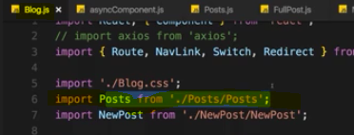

you basically inform webpack, the build tool which gets used behind the scenes about this dependency and it will include it in the global bundle, this is its job.

**Now for a lazy loading, this is exactly the opposite of what we want to do, we don't want to include it in the bundle, we want to load it when needed.**

**Still webpack needs to be able to dynamically prepare some extra bundle for this potentially loaded code.**

So what we have to do is we have to comment out this old way of importing

and I'll then use AsyncComponent here and execute it.

**Now asyncComponent this function, requires an argument and I told you that this argument, in that function we named it importComponent, that this argument should be a function which is why we executed like one here in componentDidMount**

**So we have to pass some function to asyncComponent and this should be an anonymous function, there I'll use the import keyword as a function.**

**This is a special syntax, the dynamic import syntax which means whatever comes between the parentheses here is only imported when that function here is executed and that function here will only be executed once we render AsyncNewPost to the screen**.

now I'm only importing this when this constant gets used somewhere.

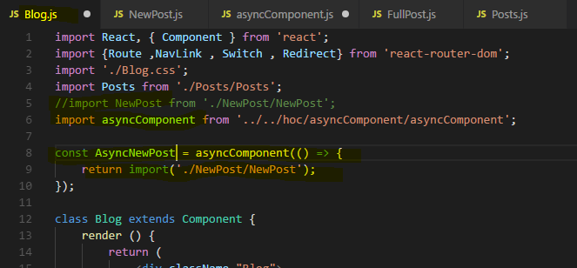

I want to use it down at the bottom of my blog container at the new post route, instead of using new post as a component, I want to use AsyncNewPost as a component.

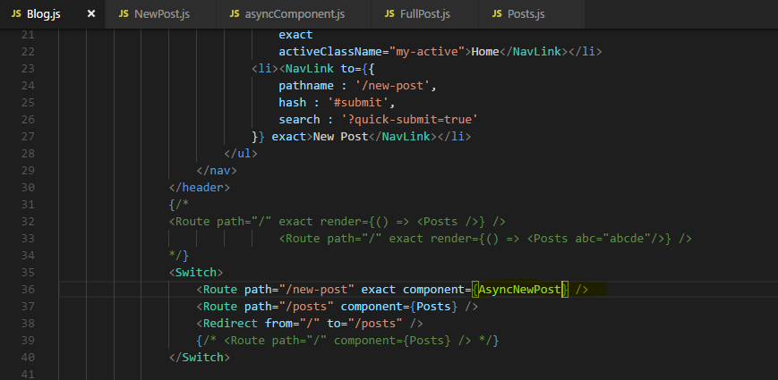

**Eventually this will be a component because keep in mind AsyncComponent returns a component, we have a higher order component. It returns a class with a render method so this is a valid component.**

**This component will eventually render some dynamically loaded component and we decide which component it should be with the function we passed to AsyncComponent.**

**Now if we save this and we go back to our application, watch that path on the bottom right ,when I click on new post. Once I click there you'll see that this 1chunk.js file was loaded which is very small.**

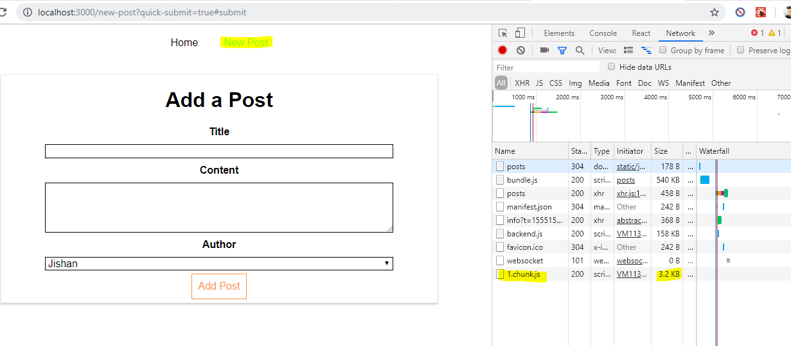

This is an extra bundle webpack created because whilst bundling our code, it detected this dynamic syntax here which it knows due to our set up we're using too, this build workflow setup and therefore it created the extra bundle with the new post component and all potential child components that were exclusive to that component if any.

**But it didn't add it to the main bundle, instead it's prepared to load it when needed when we actually include AsyncNewPost which we only do when navigating to /newpost. This is how you load components asynchronously,**

and as I mentioned this is extremely useful in bigger apps where there are bigger chunks of code, a whole feature area in your application for example which might not even be visited by the user so you can save that code up front to only load it when needed.

### **Important : Lazy Loading with React Suspense(16.6 or above)**

**if you are using the latest react version or react 16 or higher then you have a new way of lazy loading your routes because react 16.6 adds a new method on the react object.**

**The lazy method which you can use to load your data your components asynchronously. Which means only when they are needed.**

So react lazy is a method that was added with react 16.6.

That allows us to load components asynchronously which means they are only loading, the code behind them is only loaded when they are really required when they are being rendered.

**And this is for example useful when having routing in your application because only when a user visits a certain route that component will be required and react lazy allows you to defer the rendering and the loading of the code of that component until it is required. And that of course means that you don't load redundant code in advance.**

It's not just useful for routing.

**Whenever you have a use case whereas some component is loaded at a later point of time for example because you have a check and some condition needs to be met to render a certain component in all such cases you could use react lazy.**

Lets see in Action-

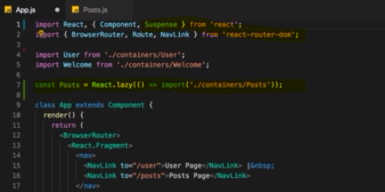

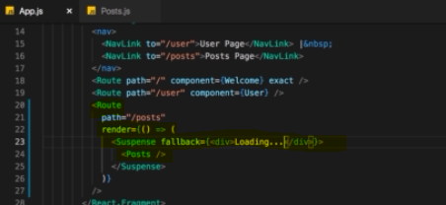

**We should use default exports named exports are not supported in React.lazy() method.**

**there we now need to make a little change. Instead of using that component let's use the render method here.**

**I now need to import a new component from react Suspense component with an import.**

**That is what I want to render here.**

**And in-between all render posts.**

**So my constant as a component here and now let's add one more thing to that Suspense component. And that's the fallback props which should be JSX code and they all add div where I say loading and this will actually be displayed. In cases where re-act basically postpones the rendering of this wrap component and shows as well fallback in the meantime.**

**And of course that doesn't have to be a div with loading that could be a spinner or anything like that.**

now click on the post page and you will see that there it loaded a new file and that is the file holding the code for this component and that is async rendering at async loading in action because this component and its code is only fetched and rendered when we really need it.

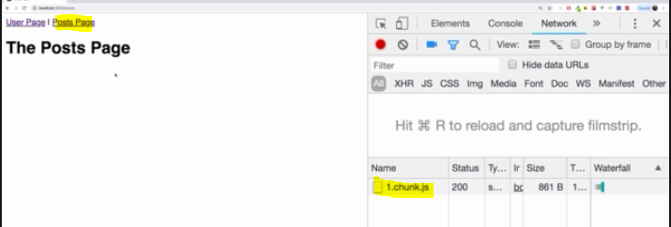

So this is a neat alternative to the other way of lazy loading pages which we had before.

A great advantage of this approach is that we of course can not just used is in a routing scenario.

We could of course also have a scenario where we don't use that browser router instead let's say I have a simple button here where I say toggle mode . And now I just want to render either the user or to post page.

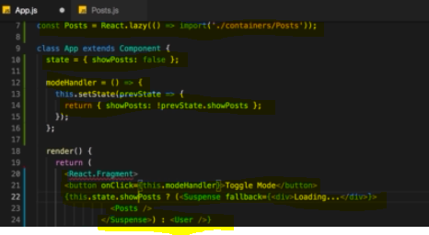

if I go back and I click on toggle mode we see that chunk was loaded and we see the post page. 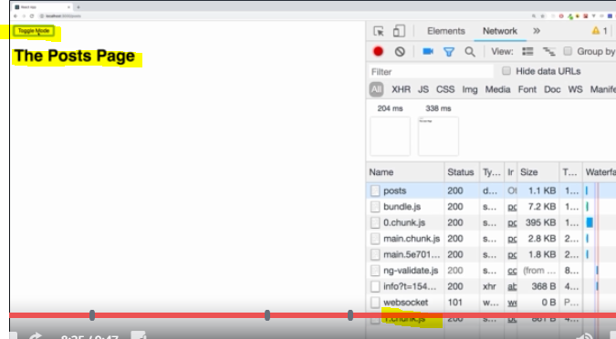

So here we all take advantage of this. Async rendering and that is really something useful and a great addition with react 16.6

Please be aware that this will not work if you're trying server-side rendering.

Then this is not supported.

But if you have a client side rendered application as we have it here and of course then this is a great addition and definitely something you want to check out for cases where you conditionally render some component needed in the if statement or be dead in a routing scenario.

Now of course one thing to keep in mind the benefit you will get out of this will be greater if you have larger chunks of data behind your components.

If you have very simple components using suspends might actually be overkill and could even slow down your application or be suboptimal.

## **Routing and Server deployment**

one important thing you have to know regarding routing when using the react router, when it comes to deploying your app to a real server because you won't notice it here on the development server because it's already configured correctly( by creat-react-app).

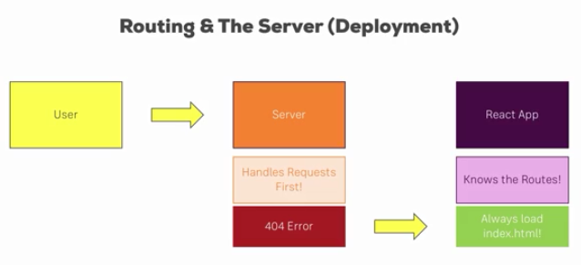

You have to remember how handling requests actually works in the web.

We have the user who sends a request to the server and we have our react app which is then loaded the index.html page.

The thing is before we load to index.html page the server needs to find out which page the user actually wanted to visit. That of course is the case because the server always handles requests first, this is how the Internet works.

**The problem is it's the react app which knows the routes. So if we visit /posts, there is no /posts route on our server, that is defined in the javascript code which is loaded on the index.html page which we never get because we get a 404 error on the server because we tried to visit a route which is unknown to the server.**

And clearly this is not what you saw during development because as I said the development server is already configured correctly.

We have to configure the server in a way that it always forwards requests no matter if it understands them or not, so also 404 error requests to the client, so that it always returns the index.html page, also for unknown requests because this then allows react to take over and parse the request against the routes it knows.

So we should always load index.html and if then there is a request we dont know, well you learned how to handle 404 errors with the react router.

Now as I said, the development server we used here already is configured to always load the index.html file. It is something you will also have to do when hosting the app on your own server though, **always return index.html even and especially in 404 error cases.**

There is another thing you have to be aware of when hosting your app on your server, if you are hosting it on let's say example.com/ so if that's the page with which we're landing on the root page of your react app, you don't need to set up anything special.

**But if you're serving your app from let's say example.com/myapp, so anything beneath that folder should be your react app,**

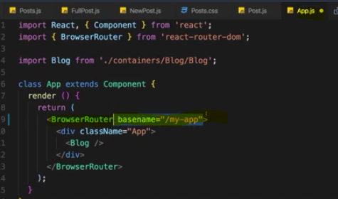

**you need to tell react about this, the react router to be precise.**

You need to set the base path for the react router and I want to quickly show you how to do that.

In your application, in the place where you use browser router, so in our case in the app.js file here browser router, you can also configure that and you really need to do that.

**there is a basename prop you can set and by default, that's set to /.**

So this is the default which you don't need to set. If your serving your app from myapp, you should set this to /myapp, then all your requests are routed against myapp/ and then the link you were pointing to.

Otherwise, if you had a link like here, if you push the page change up on clicking a post, here we navigate to /posts and it would always add this to your root domain.

**Now if your react app is served from /myapp, it will only work correctly and add it to the end of your domain /myapp If basename is set up. So whenever you are serving your app from a sub directory, make sure to set basename.**

# Adding Routing to our Burger Project

## Navigation Back and NextPage

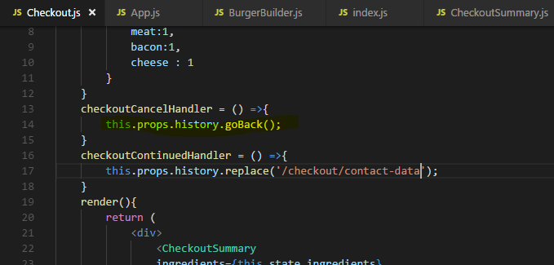

**history prop also has a go back method.This simply goes back to the last page,**

## Pass data to Route via queryParam

from the burger builder I build some burger and if I now click order now and continue,

I need to pass data about ingredients onto the checkout page. I want to pass this by query param. 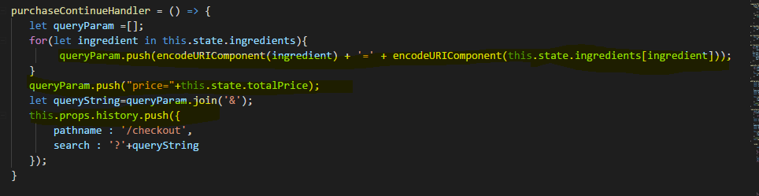

## Parsing queryParam

Now of course I need to parse this in the checkout component and then I'll do this in

componentDidMount. I won't use componentDidUpdate or anything like that because whenever I load this component, it will mount itself, there is no way I can route to it without it being mounted again because it's not nested in some other page or anything like that.

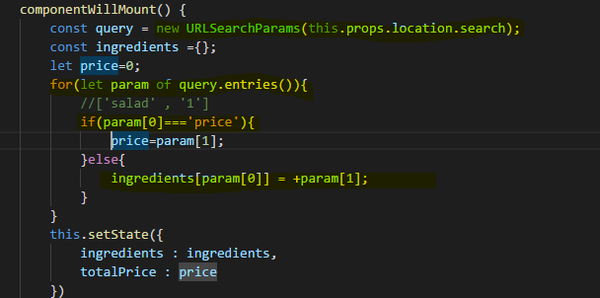

## If you want to pass some props in Route to component then –

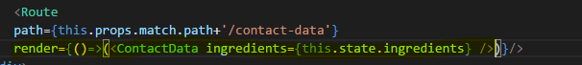

But in this case we don’t get Route props like history , match and so on…

due to the way we are loading Component by basically rendering it manually down here with the render method, we don't have the history object available in there.

So to get these props in render component we need to manually pass these props we get in render method into rendered component



**Alternative way is -**

**we can wrap the ContactData component with this withRouter helper method.**

**Export default withRouter(ContatcData);**

## To Stop <form> to reload the page on button click-

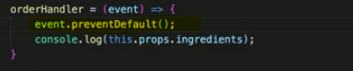

**On button/Submit clicked it reload the page because we're inside a form, that is something**

**which is the default behavior actually but here, I should handle the event object in orderHandler(button click handler) and add event.PreventDefault() to prevent the default which is to send a request which I don't want. I don't want to send a request because while this reloads my form,**

**preventDefault is important on the orderHandler on the event you're getting automatically to prevent the default which would be to send the request and reload the page.**

## Implementing Navigation links

**Now button has the active class but our css styling not working** 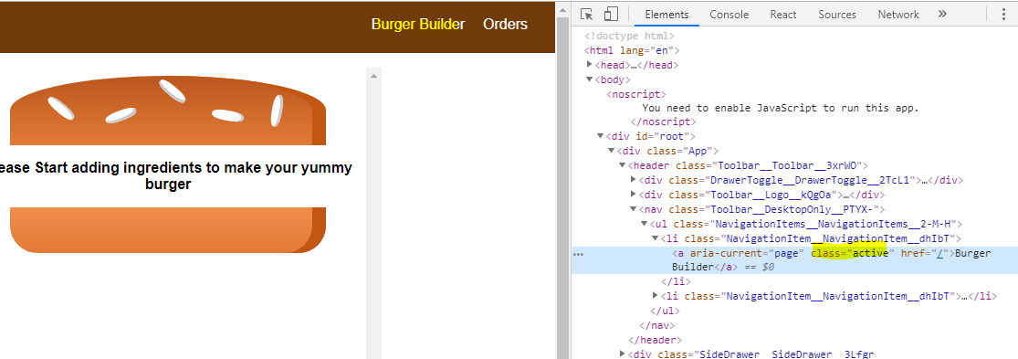

It is related to css modules,

keep in mind the nav link automatically appends or attaches a class named active.

And of course, we set up the active class here,

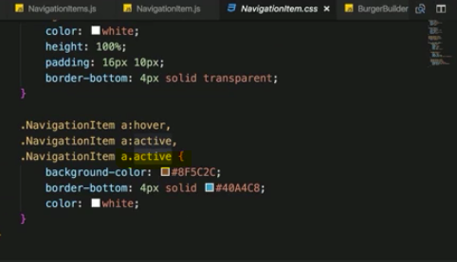

 keep in mind that **css modules will actually take our class names here and convert them into unique class names.**

**Therefore when we set up active here in css, it won't come out as active, it will have some hash attached to it, it will be unique.**

Therefore active class attached at runtime by nav link will not match our active class.

We can easily fix that though, that nav link element has one extra property we can set up,

we can set our own active class name. You can add active class name here, and here I then want to use classes.active again referring to my classes object which comes from my css file, this will now be the active class name as our css modules transformation spits it out.

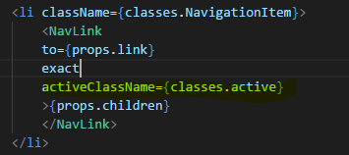

Now with that, if we save this you already see its working

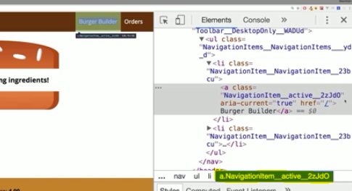

Now we have used exact to only make the NavLink active when the path is exact to the path assigned to them

Now this will attach **exact** to all nav links,

**If you only knew that somewhere this should happen, you could simply pass the exact property, a new property i just defined to navigation item and in navigation item, you can now bind the exact prop of nav link to props exact, so to the one you're passing in from outside.**

Now this will actually only be used on the first link with just slash and not on the second with orders.

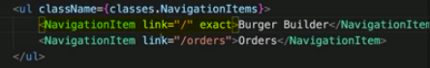

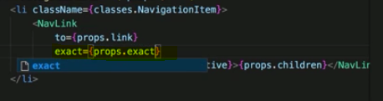

## Fetching and Outputting the orders

### Dynamically insert number of component as per array length

### Convert an object into array so that we can insert dynamic number of element in jsx

# Forms and Forms Validation

## Creating a Custom dynamic input Component

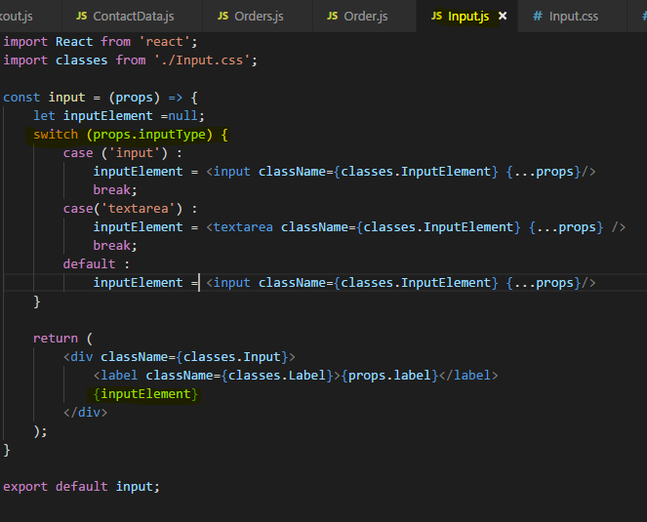

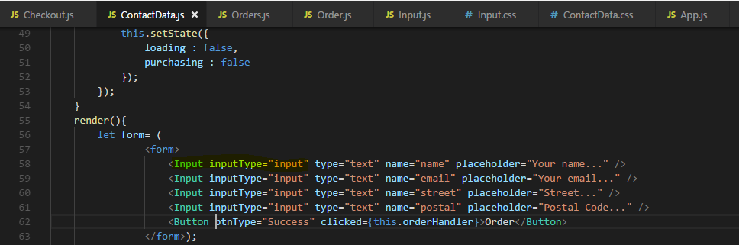

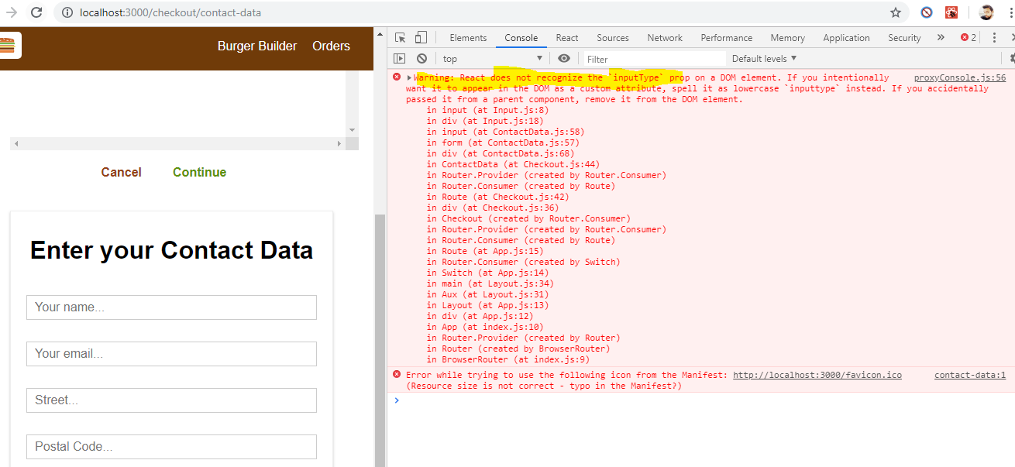

**Now what about this error.**

**this error message is stemming from a change in react 16, it does pass on all props here and input type due to its casing is not reusable as a default html prop because html in the dom is case insensitive,therefore it throws this error.**

**In the past prior to react 16, it wouldn't have passed on this type prop which it doesn't know. Now it does and it warns us that this is then invalid because of the casing,**

so one way to fix this is to simply change this to inputtype,

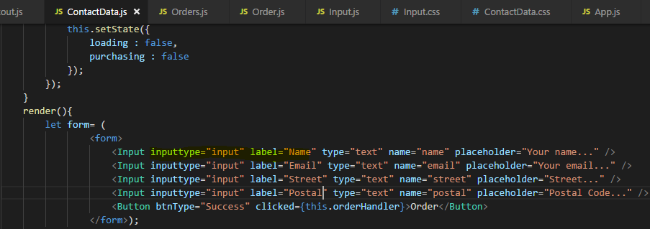

## **Setting up JS Config for form and Dynamically create inputs based on JS config**

**let's find a way to create our form dynamically and to clearly define how each element should look like.**

**Lets define in the state of component.**

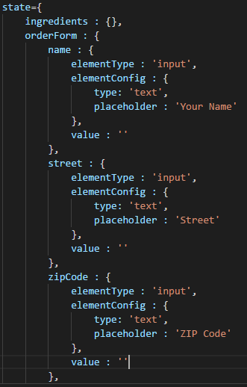

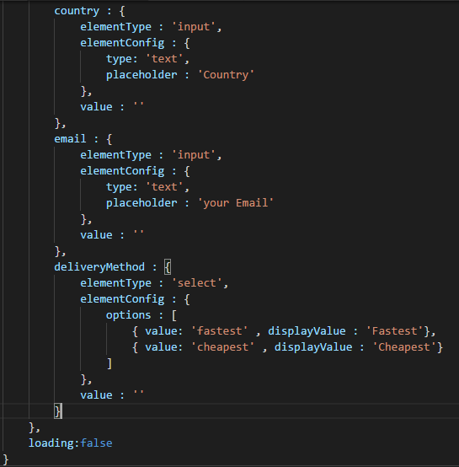

**I now want to use our javascript form data we configured as a state to create the real input elements with it.**

**I want to create all these inputs dynamically. I now need to first of all turn my order form object here into some kind of array I can loop through**

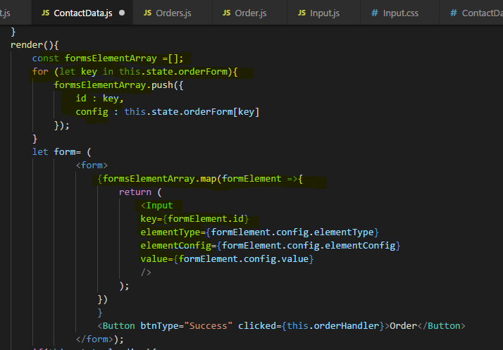

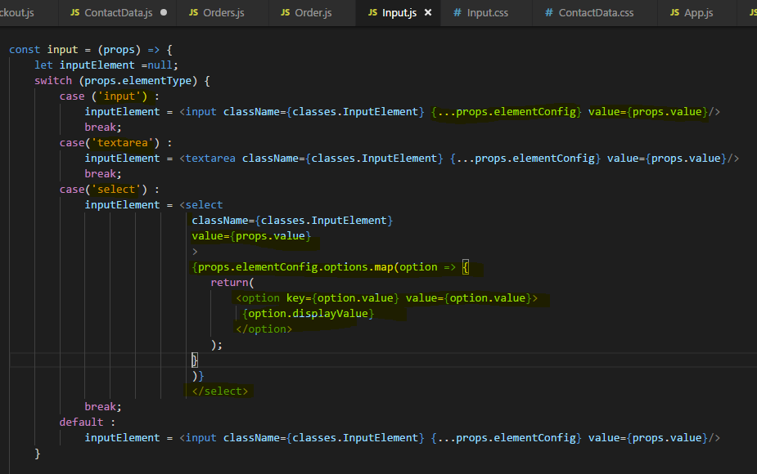

## Two way Binding : Handling User Input

we have this basic form set up with our own input component,

let's adjust this to also be able to react to user input and to get the user input.

So for that my input component, each element of course should receive onChange listener,

**We have value in state which determines the value which is shown on the screen for a element. So we need to update the value for a given input upon user changes, for that of course we need more information than just the event which gives us access to the event target value, we also receive or need a second argument which is the input identifier so that we can reach out to our state, get the right element here, the right object and adjust its value and of course, we have that value key for each input element which we bind to it.**

We get this event object which is created by react automatically and I want to pass this on but I also now want to pass my identifier, which is form element ID, that is this ID which is just a key from our object and that's exactly what I need.

These input key in our state object(like name , street,email….and so on ) , these are the identifiers of the inputs and exactly the objects I need to adjust it. 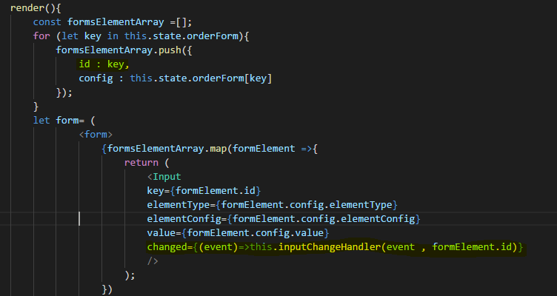

### Deep Cloning

the problem just is I of course can't access this.state.orderForm identifier and update the value, this is not how we mutate the state. Instead we have to mutate it, well immutably and we do this with set state

and for that what I'll do is I'll first of all create my copy my form data, so from the state here, my order form, I'll create, copy it. So I'll name this updatedOrderForm and for that here, I will now create a javascript object where I copy this.state.orderForm.

**However this does not create a deep clone, so I copy that object and I distribute all the properties, I get a new object but since these objects, I have more nested objects, these would not be cloned deeply**

**but there, I will again just copy the pointer to them and hence if I change something there, I will still mutate the original state unfortunately because the object in my copied object and the object in the state would still be equal.**

**So we need to clone this deeply, how do we do that?**

Well in the end I only care about the value here ,so I only need to make sure that this object here is also cloned and I don't point to the same object anymore.

I can achieve this in my inputChangedHandler by not just distributing the properties of order form which would be name, email and so on but that I also copy the properties inside my selected order form element deeply.

For this, I'll take the updatedOrderForm which is a clone of the original one and not referring to the original one anymore and there I'll now access my input identifier so this is a value like email, like delivery method.

Now I get access to this object which we haven't cloned already so now I need to clone that object and I'll store the new constant updatedFormElement, maybe. In here again, I'll create a new object and used to spread operator here to create a clone. Now I can safely change the value of the updatedFormElement because it is again a clone.

**Only if I were to change the element config, that would still be an object which I haven't cloned which points to the original one but I'm not doing that here if you are doing that, you need to also clone that deeply with the spread operator.**

So I will reach out to updatedFormElement value and set this equal to event target value

and now, I can take my updatedOrderForm, so this which is my clone original form and there, I can now again access the input identifier and set it equal to the updatedFormElement. Now with this, I can call this.setState and set order form to updated order form.

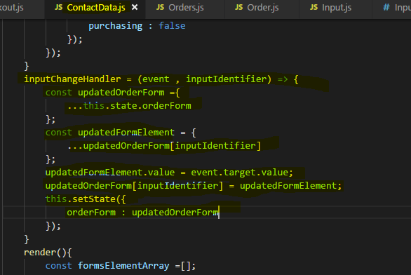

**this is all updated now when you type or select in input ,so two way binding is now working. Now we successfully set this up in a very generic way which is great.**

## **Handling Form Submission**

let's make sure we can also submit this form.

For that, we have the button with the clicked handler and I don't want to use to clicked handler, there actually is an onSubmit event handler we can use on the form itself.

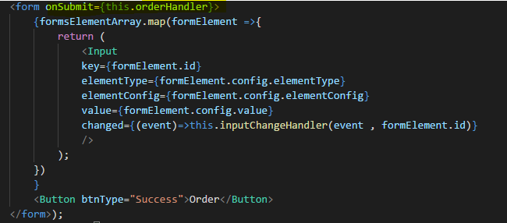

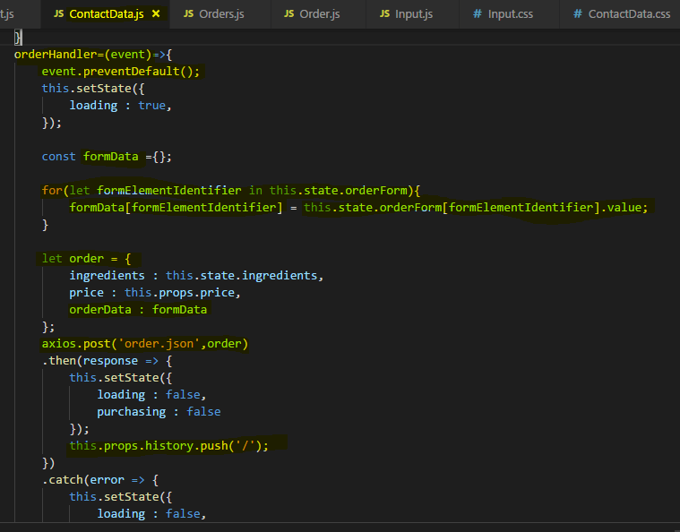

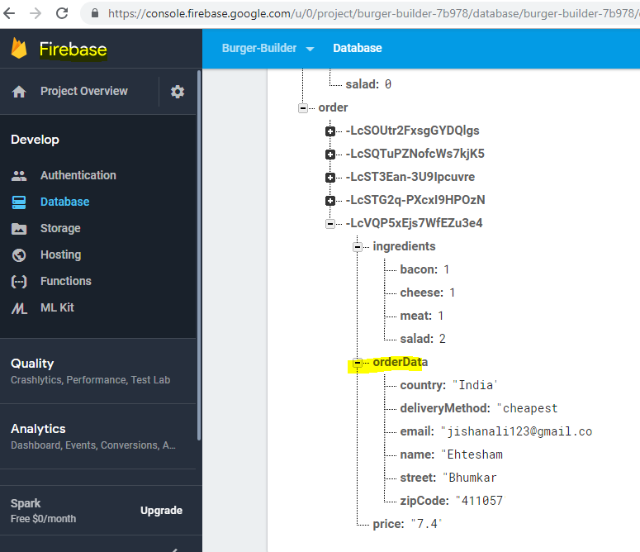

So submitting the form works just fine and in a very dynamic way,

look how easy it is to add a new input. You simply add a new property to your order form in the state, set up the element type, configure it here and assign a value and you quickly added a new input. And of course since this is in the state, you can even manipulate this order form immutably at runtime, so you can dynamically add new properties, enhance new inputs or remove them or change the configuration. That is why such a dynamic way of creating a form is so awesome.

## **Adding Custom Form validation**

there's one important thing missing, validation.

We can always submit the form, we don't get any validation errors, we don't see if the form is valid or not.

Now whilst a framework like Angular has a built-in validation package basically, react hasn't,

you have to do validation on your own. There are some third party packages you might want to check out but in general, you can also build validation on your own

the goal is that when ever we change the values, so here in the inputChangedHandler, we also check if it's valid or not and of course, the validity of element should be defined by some rules which we set up in the order form. So here for a given input where we also define the type and the config, so basically the html attributes and the value,

we also might have some validation key where we set up rules we want to have respected.

This could be a rule like required should be set to true so that this is a field which is absolutely required, that it must not be empty,

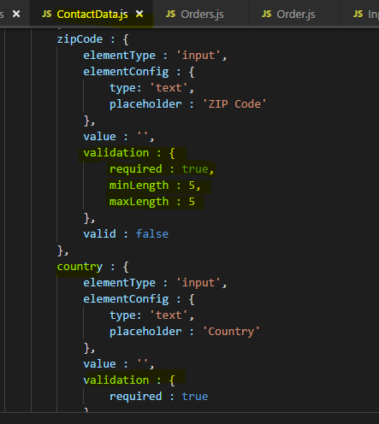

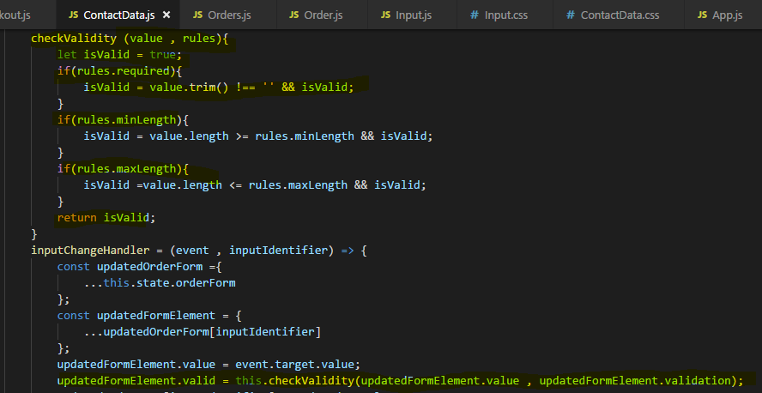

### Adding Validation feedback

To output feedback upon our validation result, I have to go to my input component and therefore each input element, I in the end want to add a special class to that element

if it is invalid. So my classes here have to become more dynamic.

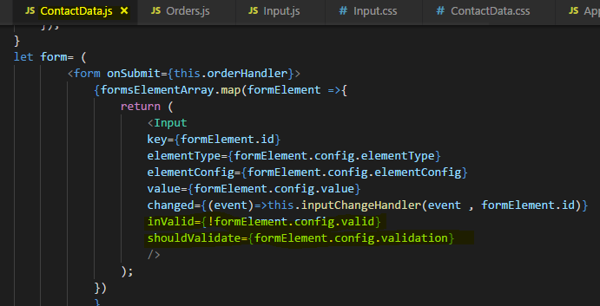

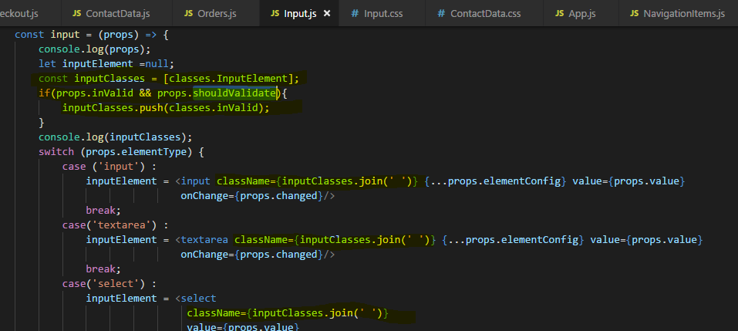

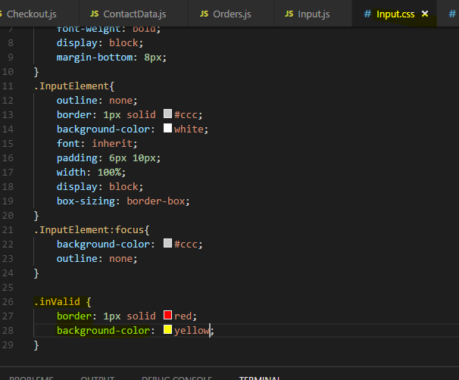

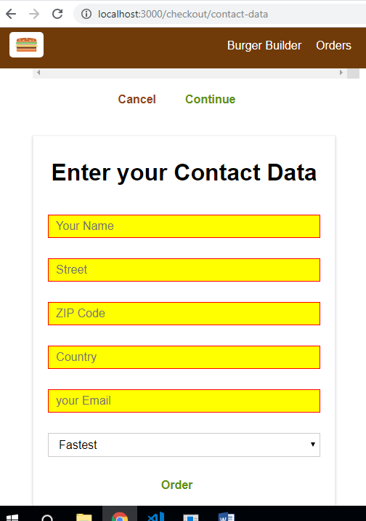

### **Improving Visual Feedback**

We don’t want to start with an all red form fields, we have to track whatever a user already touched an input or not.

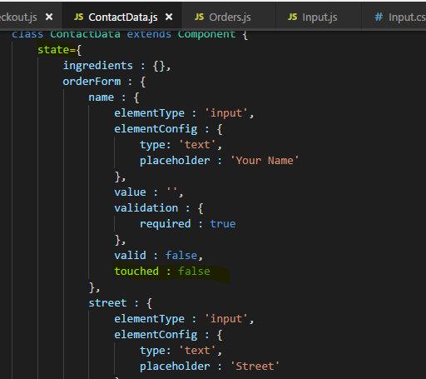

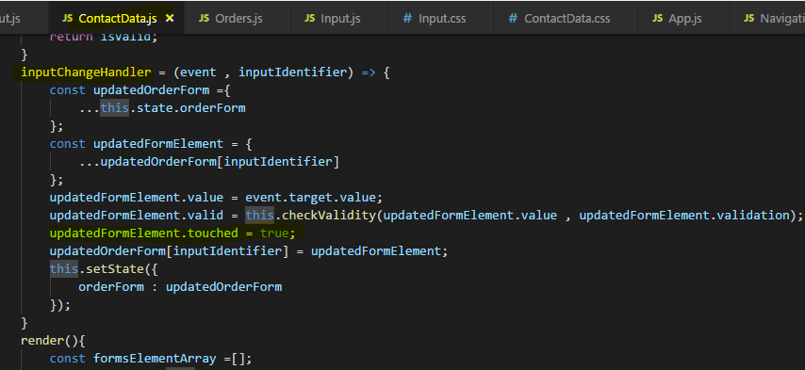

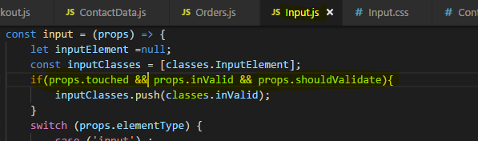

### **Showing Error Messages**

We're not showing any error messages in our form, but you can of course easily add some.

The form inputs (<Input />  component) already receives the information whether it's invalid or not. You could of course easily add some conditionally rendered element inside of that component.

For example (inside <Input />  component function):

1. // all the other code from the videos
3. let validationError = null;
4. if (props.invalid && props.touched) {
5. validationError = <p>Please enter a valid value!</p>;
6. }
8. return (
9. <div className={classes.Input}>
10. <label className={classes.Label}>{props.label}</label>
11. {inputElement}
12. {validationError}
13. </div>
14. );

This could of course be finetuned. You could also pass the value type (e.g. "email address" ) as a prop:

validationError = <p>Please enter a valid {props.valueType}</p>;

You could also receive the complete error message as a prop:

validationError = <p>{props.errorMessage}</p>;

And of course, also don't forget to style the messages if you want to do that:

validationError = <p className={classes.ValidationError}>{props.errorMessage}</p>;

In your CSS file, you could have:

1. .ValidationError {
2. color: red;
3. margin: 5px 0;
4. }

### **Handling overall Form Validity**

To turn off the order button if the form is invalid, I need to find out if my overall form is invalid

We can add a property to our state for Form validity

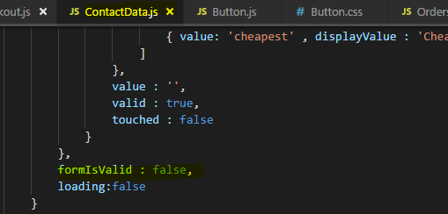

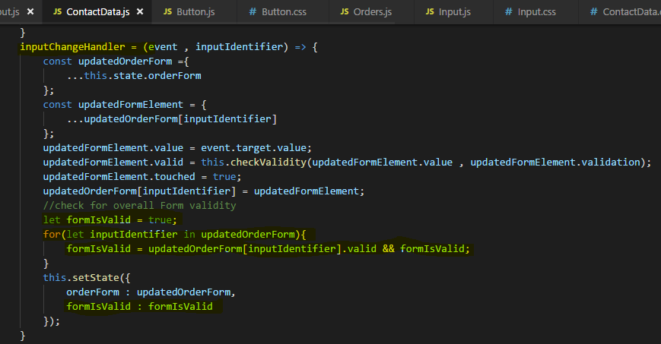

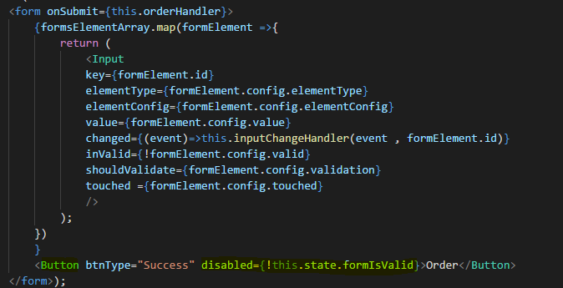

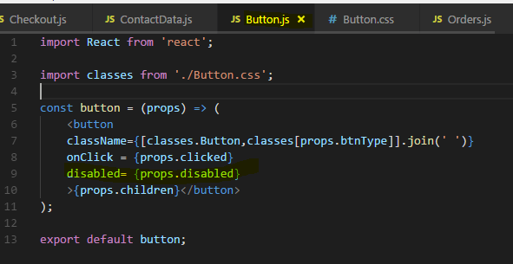

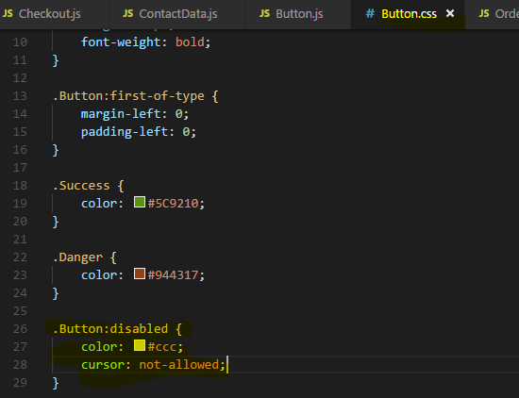

Output - 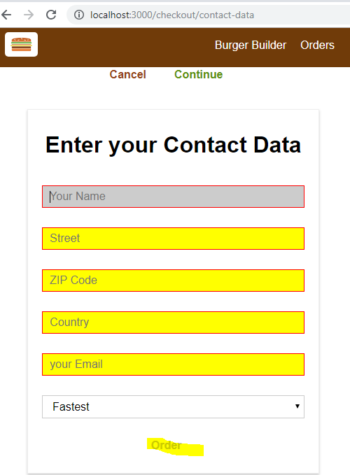

## **Useful Resources & Links**

* Validate.js (you may import its functionality into your React projects): <https://validatejs.org/>
* Get more ideas about potential validation approaches: <https://react.rocks/tag/Validation>

Alternatives to the manual approach taken in this course:

* react-validation package: <https://www.npmjs.com/package/react-validation>
* formsy-react package: <https://github.com/christianalfoni/formsy-react>

# **Redux**



it's a standalone third party library. It is a library often used in react projects though to make state management, the management of application state easier because that can be hard in more complex react projects.

## Understanding State

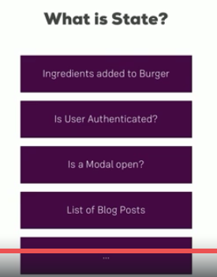

take for **example are the ingredients we added to our burger, that's part of our application state, the application state of our burger builder application.**

**The information, which ingredients we added is crucial because it determines what we need to render to the screen, how should our burger preview look like there?**

**It's also important behind the scenes when we store that burger on a server and we need to submit all these ingredients in the HTTP request.**

Another example would be the question, whether the user is authenticated or not, that can be super important as it might determine the options we're showing in the menu or the access we're granting to certain components.

**Also interesting is UI state like is a given modal open, is a backdrop open, should it be open? That's super important too,**

**it's less about data like ingredients and user authentication is, it's more about our pure UI only state.**

It might only be relevant to one single component, still this is also an example for a state, more of a local than an application wide state but still,

**state determining what should get rendered to the screen and that is in its core what you can boil it down to, state influences what you see on the screen.**

So therefore our last example would be a list of blog posts which we render, which we might filter, where we might need to know which of these posts were created by the user, also important state we might need in our application. And of course the list goes on and on

## **Complexity of Managing the Sate**

State management can be very complex.

**react is great at reacting to state changes and updating the UI accordingly but managing that state can get very difficult as our application grows.**

Of course react gives us the built-in state property which we use thus far but we could already see in our burger builder project that passing the ingredients from component A to component B can be very difficult and we had to use routing query parameters for that, certainly a workaround but not a very elegant one.

So state management should be easier, the example from the burger builder is a classical example, nothing special. Consider this application which is not the one we built,

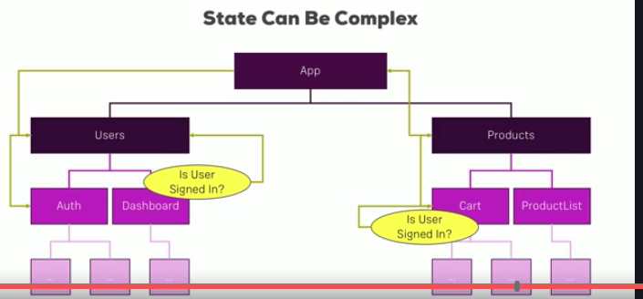

It's an app with the root app component and then a user is in a products container and some subcomponents.

Now let's say we have authentication added to this application, so users can sign up and sign in, to access the dashboard in the users area, we need to check if the user is signed in and only grant access if that resolves to a true.

**Now checking that isn't too difficult because we're probably managing the authentication status in the auth component over there.**

**The problem now is what if we all need that information in a totally different area of our app like in the burger builder where we need ingredients in a totally different area of the app in a checkout. If we need information there, we somehow have to create a connection between the auth component and our card component here.**

**Well that is super complex and a very long chain of props or query params or however we manage to pass data around.**

It's a pity that it is this difficult because in the end, we're writing javascript right and we're having a bundled javascript file as output or a couple of bundles if we're using lazy loading.

So in the end, why can't we just set some global variable which is a javascript object which stores our entire application state and which we can access from anywhere, why do we have to take the complicated route with query parameters if all we do is just use javascript in the end?

**The reason is that react's reactivity system doesn't react to changes in some global variable you defined and it's good that it doesn't, that makes it so efficient.**

**However, having this global store still sounds very interesting and that's exactly what redux is all about**

## Important:Understanding the Redux flow

remember that idea of having some central place where you manage the entire state,

**I said that we can't use a global variable for that and we can't but redux gives us a certain flow of data, a certain way of managing data that we can then nicely integrate with another package into the react app, so that react does react to changes of data.**

let me describe how redux works. How does it manage data and how does it update it? In the end, it's all about a central store we have in each redux application.

And I want to highlight that redux is a third party library which works totally independent of react, it's most often seen in conjunction with react but theoretically, it's independent.

So it's all about a central store, this store stores the entire application state, it's that simple, you can think about it as a giant javascript object.

In a react application We've got components and a component probably wants to manipulate or get the current application state, now it doesn't do that by directly **manipulating that central javascript object, that would not be picked up by react's reactivity system and even worse, it would make our store pretty unpredictable. If we added it from anywhere in our application, that we can never see where we made a certain change that broke our app**, for example.

**So we need to have a clear, predictable process of updating the state on which we can rely on and which is the only process that can change our state.**

**That is actually what redux is all about, having a clearly defined process of how your state may change.**

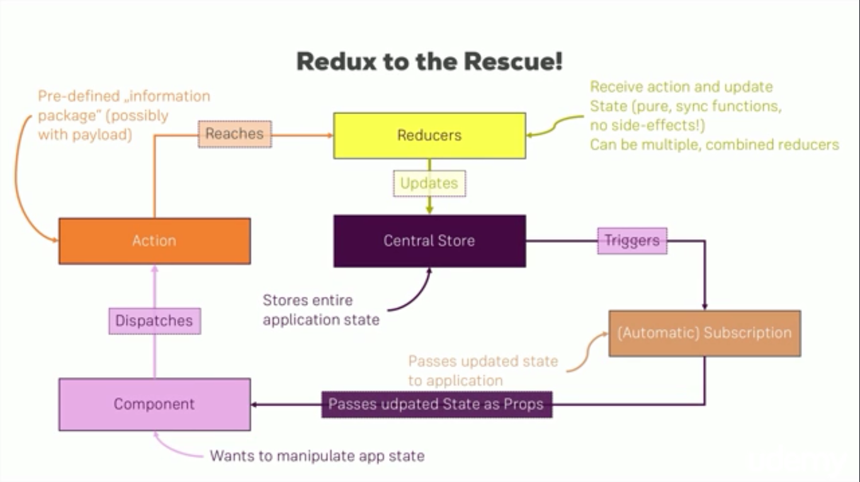

**The first building block besides the central store are actions which are dispatched from your javascript code, in a react app, they are dispatched from within your components. And action is just information package in the end with a type, something like addIngredient or removeIngredient,so a description you could say.**

**Possibly, it also holds a payload, for example if the action is addIngredient, we need to also pass the information which ingredient and that would also be a part of the action.**

**So it's a information package we're sending out to the world or to redux to be precise, that action doesn't directly reach the store, that action doesn't hold any logic, it doesn't know how to update the store, it's just a messenger.**

**The thing changing the store is a reducer. Now here I've written reducers because we actually can combine multiple reducers into one but in the end, you'll end up with one root reducer which is directly connected to your store in the end.**

**So the action reaches the reducer and since the action contains a type, the reducer can check the type of the action, for example if it's addIngredient and we then define the code for that type of action in the reducer.**

**The reducer in the end is just a pure function which receives the action and the old state as input and which then spits out an updated state.**

**The important thing is that the reducer has to execute synchronous code only, no asynchronous code, no side effects, no HTTP requests, nothing of that, you'll learn later how you can still implement asynchronous code but in reducers, it's just input in, output out, nothing in between, no delay.**

**So this is the reducer and the reducer spits up the updated state which then is stored in the store again and replaces the old state and that has to be done in an immutable way, so we always return a new state which can be based on the old one but which is technically a new javascript object, because objects are reference types in Javascript and we want to make sure that we don't accidentally change the old one.**

**So that is how the reducer handles the action,**

**now the store is up to date.**

How do we get the updated state back into our component then? For that, we use a subscription model.

**The store triggers all subscriptions whenever the state changes, whenever the state is updated in the store. And of course our component can subscribe to store updates and it then receives that update automatically, this is how simple it is.**

**It works through a subscription model and we simply say hey I want to get notified whenever the state changes, just as we say hey I want to change the state, here is an action describing my plans.**

This is the redux flow, this is how redux works,

## **Install redux , Setting up Reducer and Store**

First lets install redux

npm install redux –save

**redux library works standalone and we'll actually use it standalone for now but we'll soon add it to our react application to see how it works together with it.**

So with redux installed, I'll create a new file in the root folder next to the package.json file,

I'll name it ReduxBasics.js.

Now this file here will not be holding any react code, we won't include it into our react project**, I'll execute it with nodeJS instead, just to show the different concepts of redux in one file and to show that it's independent of react.**

**So in this ReduxBasics file, I want to create everything that we need to use redux, that of course is the store, that will be my reducer, that will then be an action probably or some code dispatching an action and we also certainly want to see a subscription action.**

So let's start with the store

and for that, I need to import something from redux. Now we'll still use the import something from something syntax later when we go back to react but since I plan on executing this file with node, I need to use the node import syntax, which is I'll create a constant, name it redux maybe and this constant will now require redux, like this. Again, this required syntax is nodeJS syntax and are only required because I want to show these with nodeJS

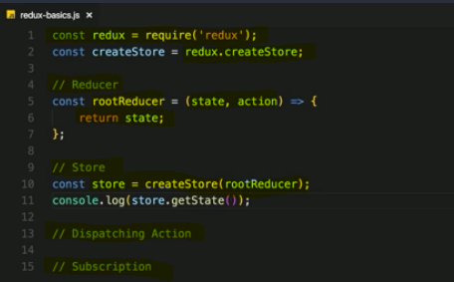

**So here I can then create a constant name, createStore which refers to redux.createStore, createStore is a function but don't execute it yet. createStore as the name suggests allows us to create a new redux store, I'll store it in a constant named store but you can of course give this constant any name you want, and here I'll simply execute createStore, like this.**

createStore like this won't do much though,

**a store needs to be initialized with a reducer because the reducer and remember we only have one reducer, even if we combine multiple ones, they will be merged into one.**

**The reducer is strongly connected to the store, it's the only thing that may update the state in the end.**

**That's why we need to pass the reducer to this creation function here because it's so closely connected to the state.**

**Therefore I actually need to create my reducer first before I create the store, so here, I'll create my root reducer, the name of course is always up to you and that is just a function, you can of course create it with the function keyword or you can also use an arrow function, whatever you like.**

**Now this function here receives two arguments, the first one is the current state because as I said, the reducer gets two arguments, state and the action and the state is the old state which it then may update. So the state is the first argument, the second argument is the action and then the function has to return one thing and that is the updated state. The simplest reducer you can write simply returns the old state, so this is a valid reducer though of course it does nothing, it just returns the state you already had.**

**But we can already use that reducer and pass it as an argument to createStore rootReducer,**

**with that, our reducer our store is created with that reducer in mind and now we have a created store, however this store will hold an undefined state. We can verify this by console logging store and there, getState, that's a function we should execute and it will pull out the state from the store.**

**Lets run this js file by nodeJS -** 

the state is undefined because our root reducer only returns the old state and we never initialize it. To initialize the state, I'll set up a new constant which I'll name initialState, as for all constants this name is up to you.

**It's a javascript object though theoretically, it could also just be a number or anything like that so it doesn't have to be object but most often it is because you have more than one field in your global state most of the time but if your global state is just a number, you could set up just a number.**

**Now in the root reducer, I'll use a feature provided by ES6, I can initialize this argument to the function with a default value, whenever this function is now called with this argument being undefined, it will take the default value instead. A default value is simply assigned by adding an equal sign and then the value you want to use as a default, so now it will take initial state whenever state is undefined, which will be the case when it's creating that store where it will execute the reducer for the first time.**

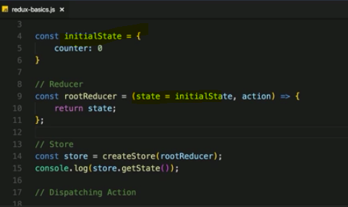



So this is how we create a store with a reducer and how we initialize the state

## **Important : Dispatching Actions**

Now I want to use that store and not just output it with this console log statement but also dispatch an action.

An action is dispatched by simply accessing the store, so this store constant which holds the created store and on that store concept, we can call dispatch.

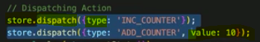

**Dispatch is a function** and now important, **this dispatch function here takes an argument and that argument is an action, that should be a javascript object which needs to have a type property.**

So don't mistype or anything like that, it's just type, make sure to spell this correctly. This will later be **important building block in getting the information which type of action was dispatched and what we should do in the reducer,**

**type** then is just some unique identifier of your choice.

The **convention is to use all uppercase string, for example INC_COUNTER**, for increment counter, now you can use whatever you want here but this is the convention, all uppercase and be descriptive whilst also being short about what you're doing when this is dispatched.

Now I said you can also pass some optional payload, we'll do this with the next action. Besides INC_COUNTER, let's also emit ADD_COUNTER. Now inc should increase it by 1

so we don't need to pass any extra information but ADD_COUNTER should actually add a specific number to the counter and that value needs to be passed along with the type. Now the **type is the one property you have to use like this, you can add any other properties you want to this object now, you can add value, name, ID whatever you want or you add one additional property which you might name payload or any other name you like which then could in turn be a javascript object grouping all the data you want to pass with the action.**

This is totally up to you, I'll not pass a payload object because I only want to pass one other field of information, I'll name it value but again, the property name is totally up to you and I'll set value to 10 because I want to increase to counter by 10 and of course, you can pick any number.

So now we're dispatching two actions.

**Right now we haven't added any logic to react to these different action types ,we don't listen for the action type anywhere.**

**This is what we'll now do in reducer. we get the action as a second argument so of course, we can react to different types of actions.**

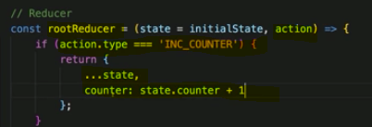

We can add an if statement and see if action.type and we noted a type property will be there because I said that it is mandatory on every action we dispatch,

so we can check if action.type is for example INC_COUNTER. If it is inside of the if statement, I want to return something else.

**one important thing, you don't set state.counter++ which would increment it and return state because this is not immutable, you're mutating the original state here.**

**So what you instead do is you return a new javascript object where you may first copy the old state with the spread operator, state and then overwrite the one property you want to adjust, so the counter and if that also would be a javascript object, you would have to copy it first too so that you never mutate any data, never, always do this immutably.**

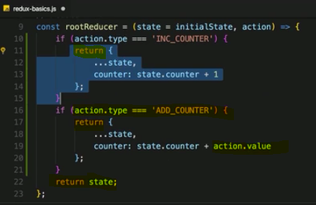

### **Note :**

**the new object we return from Action in Reducer, it updates the state of Reducer behind the scene**

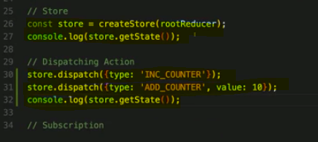

Output –



We get counter 0 for the first log which is executed right after initializing the store but after dispatching the two actions here, we actually get a different output for the second log where the second counter is 11 because we incremented it and we added 10 to it.

**This is now actions and dispatching of actions.**

## **Adding Subscription**

**Subscriptions make sure that it inform me whenever something changes in state**

It inform me whenever I need to get a new state because something changed, because if I manually do it like here in a console log, I always have to guess if something changed.

**I access my store and there, I have a subscribe method I can execute.**

**Now subscribe takes an argument, a function which will be executed when ever the state is updated, so whenever an action reached the reducer.**

The function we passed to subscribe doesn't get any arguments. in the function body, we can execute any code we want on state updates.

I can also reach out to the store and get my state there. The getState method is the same as

before, the difference is that I now know that I should get the state here because I know hey something changed and that subscription actually, of course typically is set up right after the store was created so that we get informed about any future dispatches.

**the function in the subscribe method will be executed whenever action is dispatched and mutates the store.**

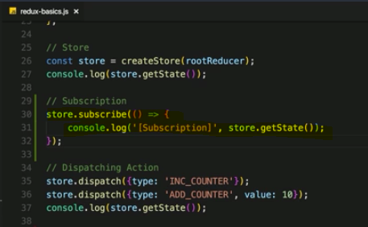

Output - 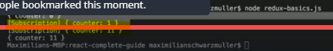

Now I get the two subscription outputs not because subscription comes before last getState console, but because it's triggered when ever an action is dispatched, which of course happens before I do this last console log statement.

This is how a **subscription works, it's getting triggered whenever the state is updated.**

## **Connecting react to redux**

we already installed redux and with that, we can create a store.

This store should be created right before our application or when our application starts, so the index.js file is a great place, this is where we mount our app component to the dom,

**Store takes a reducer as the input. For that, I of course need to create the reducer too and I won't do this in this file, I will have more complex reducers in react applications with a lot of code for different types of actions and therefore, we typically store that logic into their own files.**

Now there are different set ups you can use but you'll often see that there is a store folder in your project next to the containers and the components folder and in there, you can have a reducer.js file

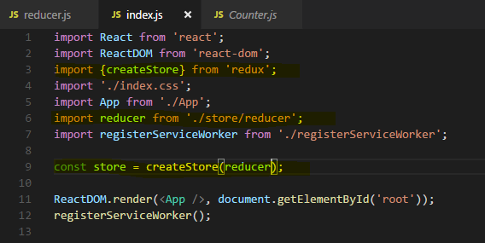

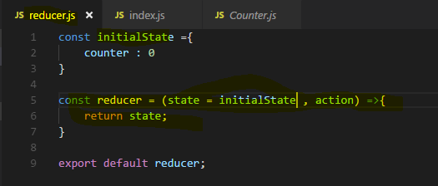

Now of course the reducer alone doesn't do that much, we also want to connect this store which you just create and store in a constant here to our react application and we want to be able to get slices off the state in our react containers, so that we can display the state or render something depending on which state the application has. And of course we also want to be able to dispatch actions, so connecting redux to react,

that is what we'll do next.

## **Subscribe : Connecting Store to react**

Let's connect our store here to react, we already got a store, now to connect it,

**I need a special package because redux alone is standalone, it is not connected to react.**

**I'll install it with npm install --save react-redux**

**it allows us to hook up our redux store to our react application.**

Now with that installed, so import something from react-redux.

Now here that something actually is a Provider component,

**we wrap our app component with Provider. Provider is a helper component which allows us to kind of inject our store into the react components.**

**For hooking up the provider component with our store here, I need to set up a property, a special property expected by the Provider component. It's named store**

**So I'm passing that store constant as a value to this prop. Now with that, the store is connected to our react application, at least a bit**

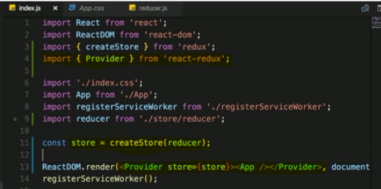

how do we actually get the data from the store, like the counter value in our counter container? where I manage this all internally. Well **for that, we need to connect this individual container with the store or to be precise, in the end what we want to do is we want to set up our subscription here,** we do this a bit differently than we did in the nodeJS file though, we won't do it manually by calling subscribe,

**we will use a feature provided by that react-redux package instead**,

let's **import something from react-redux, its call connect**



**it's a function, a higher order component actually, a higher order component we use on the export.**

**Actually connect returns a function which takes then a component as input, so connect is not really a higher order component, it's a function which returns a higher order component.**

The whole idea behind this complex set up simply is that connect now also can be called as a function and since it returns a function, we then execute the result of connect of this function execution. we can pass some configuration for this given container.

Precisely, **we passed two pieces of information to connect.**

**(1) Which part of the whole application state is interesting to us because here we only have counter but in bigger apps, you may have loads and loads of different states and pieces of states you manage and you don't need all of that and all your containers. So you can define which slice of the state do I want to get in this container.**

**(2) which actions do I want to dispatch because again, in bigger applications you may have thousands of actions dispatched from all over the application but a given individual container may only dispatch a couple of these.**

**So the actions we want to dispatch and the state we want to get,**

let's start with the state you want to get. For that, I'll create a new constant mapStateToProps and please notice that I do this after the class here, after my component

class, before the export.

**You store instructions about how the state managed by redux should be mapped to props you can use in this container** because that's important.

**the state managed redux is not received as state here because state is the thing you change internally from within a component.**

**Those times are over,**

**redux is now the place where we manage and change the state, so we don't want to get anything which we can change internally and props are changed internally, that is why we map the redux state to props. This is where the name comes from, mapStateToProps,**

**it actually stores a function which expects the state stored in redux as the input and returns a javascript object which is a map of prop names and slices of the state stored**

**in redux.**

**Now this function will eventually be executed by the react-redux package because we will pass it to connect. it's our way of configuring which kind of information we need.**

**now in this object which we return to here, we should define prop names which are of course totally up to you, like ctr for counter and then you access state and this state here again, will be given to you by react-redux which of course will reach out to your redux state which of course in turn is the state you set up here in Reducer .**

**so there will be a counter property available. So we can access this counter property on our state and with that, we're saying hey please give me the value of the counter in our global state managed by redux and give it to me in the form of a property name ctr which I then can use in here.**

**Now with that, we passed this to connect(mapStateToProps),**

**so pass this constant which holds this function and now connect which also then receives the counter component on the function returned by that first function. Connect**

**then gives us this container with access to this ctr, our property. This now allows us to output the ctr property.**

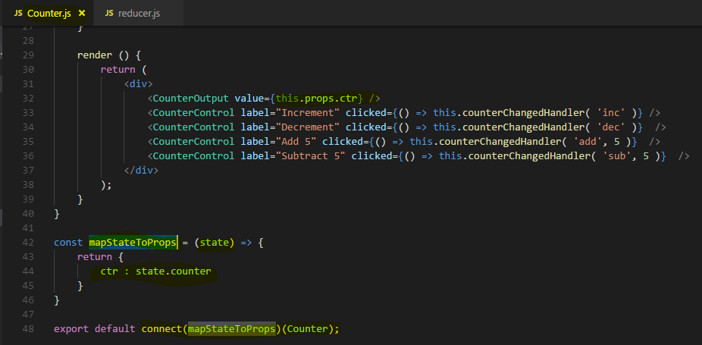

Now we can use ctr as props received from redux global state

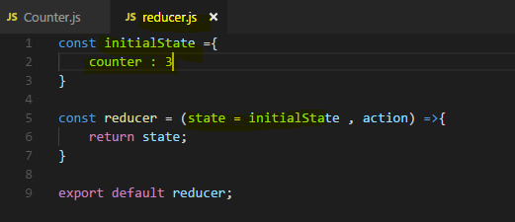

Output - 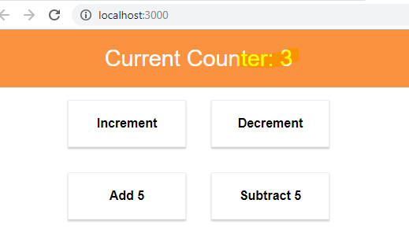

Important Note :

**this pattern doesn't change, it's still our container components that managed the state, now**

**they don't manage it on their own anymore but they are now the places which receive it from redux. We still use container components which then may distribute it down to their components which they embed but we never change our pattern of having a few selected components getting the state and passing it on**

### Error : You might get this error after npm install react-redux --save

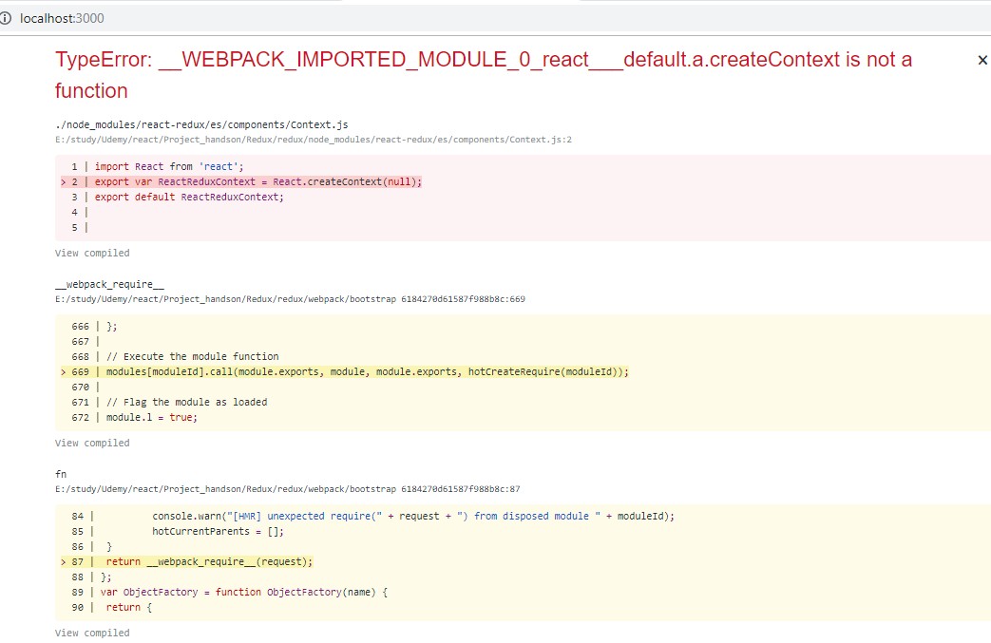

Solution –

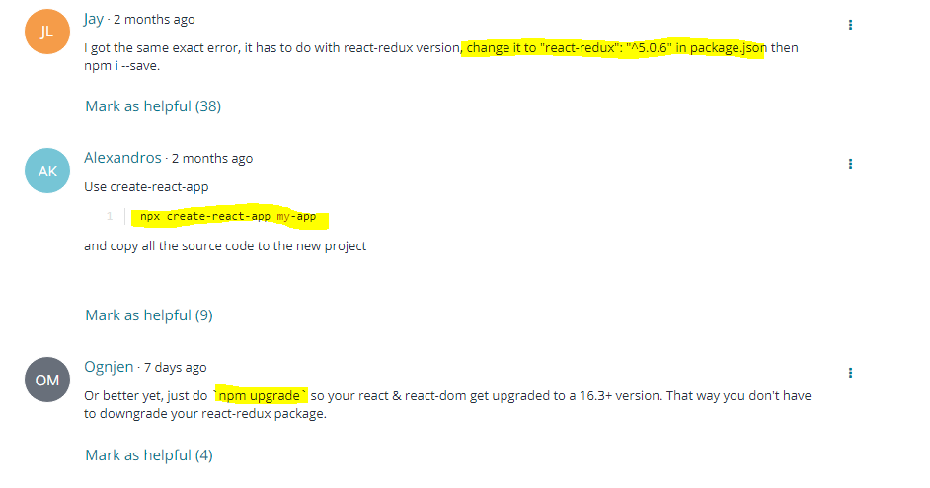

## **Dispatching Action within the component**

now I also want to be able to dispatch actions

**when we just use redux in standalone, we simply called dispatch on the store. Now we don't have access to the store in our container at least not directly,**

**we got access through connect though and just as we were able to pass some information about which kind of state or which slice of the state you want to get, we can also pass a second configuration, I'll name it mapDispatchToProps because here I'll say which kind of actions do I want to dispatch in this container.**

This also stores a function which will receive the **dispatch function which we can execute as an argument**, just as we have dispatch available on the store here, if we directly access the store, **the react-redux package gives us well basically this helper function which will call dispatch on the store behind the scenes.**

We then here also **return a javascript object where we can define some prop names which will hold a reference to a function which should eventually get executed to dispatch an action.** Now you can choose any property name you want here, I'll name it onIncrementCounter, but again, the name is up to you.

**I want to return a call to dispatch and this is the call, what I want to do here, this function here will in the end be available through this property and therefore, whenever this property**

**is executed as a function,**

**for example, if we assign it to an onClick handler, then this dispatch method here is going to get executed.**

And to this method, I can now pass a javascript object where we need to set up a type

as you learned and I'll set the type to increment here. With that, we got a property we can also use in our container, well at least we can do so when we pass it as a second argument to connect.

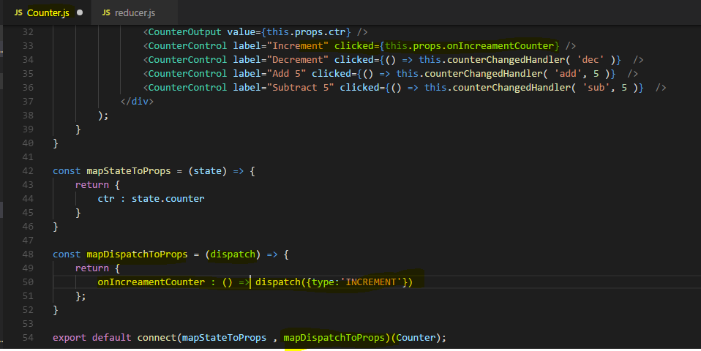

**onIcreamentCounter passed via props to this component**

Now in Reducer we need to handle this Action

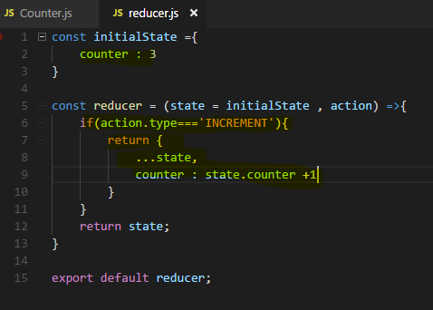

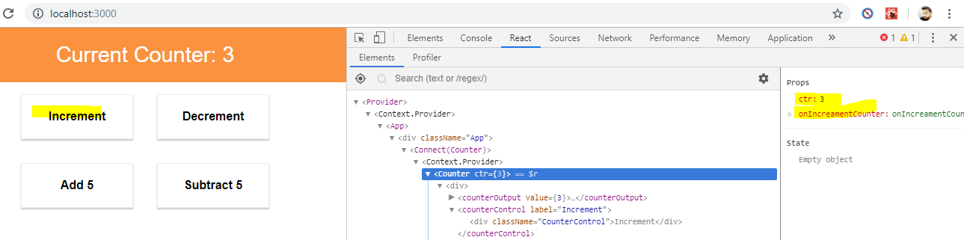

**So whenever you click on increament button this action will be dispatched to Store via connect and we get updated state as props because of subscription of this Action and that eventually re render the react application**

**Now lets add actions to every button**

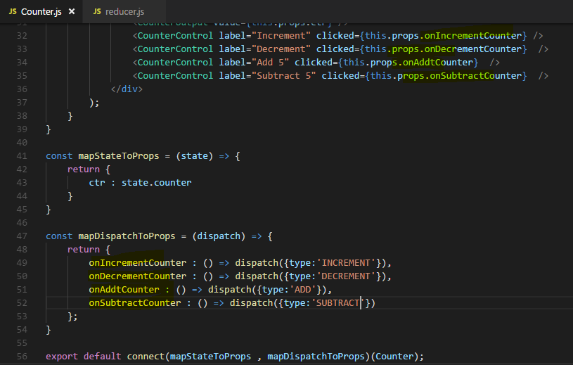

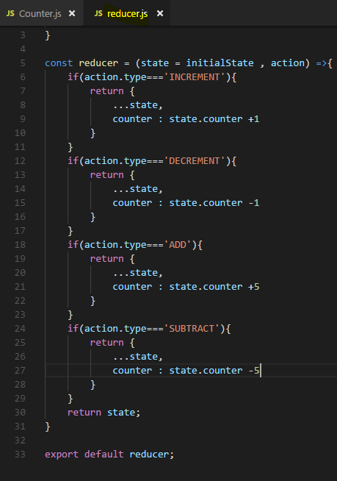

**Note :**

by the way, if you ever have a case where you don't have any actions in your container, you just leave it out



if you have a container which only needs to dispatch actions but doesn't need a slice of the state, you'll simply pass null as the first argument to connect



## **Passing and Retrieving data with Action**

**it would make sense to also receive a payload, some additional data passed along with the action type**

because right now, we have hard coded +5 and -5 into the reducer but of course, in a lot of applications for example when creating a new blog post, you would get that information from your component, the input the user entered for example, the ID of the post the user clicked on, you can't hard code that into your reducer for that reason.

So let's also say we don't want to hard code the value by which you want to add or subtract to the counter or from the counter into the reducer, instead we want to get this information along with the action

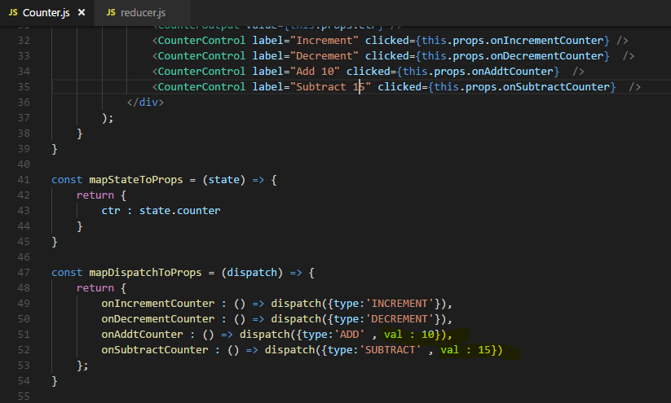

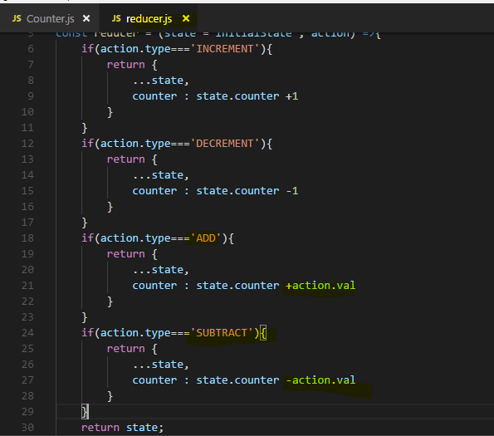

So now we are passing a payload with the action, passing some additional data and not just passing the type.

## **Switch case in Reducer**

We could switch the action type and then define multiple cases

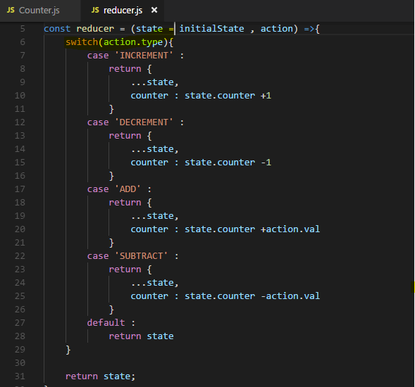

I don't need to add a break statement because return automatically exits out of this function

now our reducer is a bit leaner and a bit easier to read because it's very clear that we're looking at the action type and then we're just handling different cases.

**And if we don't make it into any of these cases, we always have the default return statement here at the end which returns our either initial state or if this was already set, the current state. This is especially important since we have to keep in mind that if we were to dispatch an action which has a type which is not covered here, we would still run through that reducer because when ever you dispatch something, it goes through that single reducer you have in your application.** **Therefore if that reducer doesn't handle that action type you dispatched, you have to return the current state to not break your application.**

## **Updating State immutably**

We don't get an error when we dispatch actions which you actually don't handle in the reducer, because we have default case there where we simply return the old state if no cases match in reducer

**Important note :**

**I want to return an updated version of my state and we should this immutable, right now in all the cases, we'll always return a new javascript object where we only update the counter for the single reason that we only have the counter property there, the whole state previously was made up only by the counter property.**

**Now we also have a results property which is an array and therefore right now, if we increment, decrement add or subtract, we basically remove that from our state because we return the updated version of the state and it just is a javascript object with the updated counter but without a results property.And unlike set state did in react, this is not merged with the old state or anything like that, this is the new state instead. So here, the new state doesn't have results anymore**

**so actually this is not how we should update the state,**

**instead we should copy the old state properties and then only update the ones which need updating and this should happen immutably. So what we don't do is we don't set const newState equal to state and then set newState.Counter equals state.counter plus 1 and then we return newState here, this is not how we do it.**

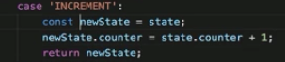

Right way to do this –

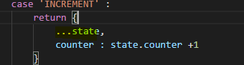

**This simply tells javascript return a javascript object, take all the properties and values of the state argument which is our old state, distribute these properties with their values in this new object and then since we define an additional property, add this property to the object or if it already was present due to us distributing the old state as it would be for the counter, this is part of the old state, overwrite this but only this, leave results untouched.**

**This is what's happening here, we're distributing the old state, we're overwriting counter, we're not touching results. So this is how we should update the state in all cases, do it immutably, don't touch the old state, don't just return a new object without covering all the properties of the old state .**

**Now this will basically clone the old object in an immutable way giving us a new javascript object which has all the properties of the old object but is a technically different object and that of course is important due to the way objects and array work in javascript with the reference types or these primitive types**

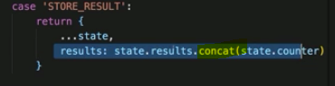

**this results property we want to update,**

**we can set an equal to state results and then we can call concat which simply is like push but where push manipulates the original value,concat returns a new array which is the older array plus the argument you add to concat. So it's an immutable way of updating an array by adding an item, it returns a new array, that's the key thing here because arrays also are reference types, if you would call push, you are touching the original results property in the original state, even though you used the spread operator here, that doesn't prevent you from doing thatand this is not a good practice, not how you should do it, your state management becomes unpredictable if you do it.**

**Now lets implement action for Storing result of counter and displaying them** 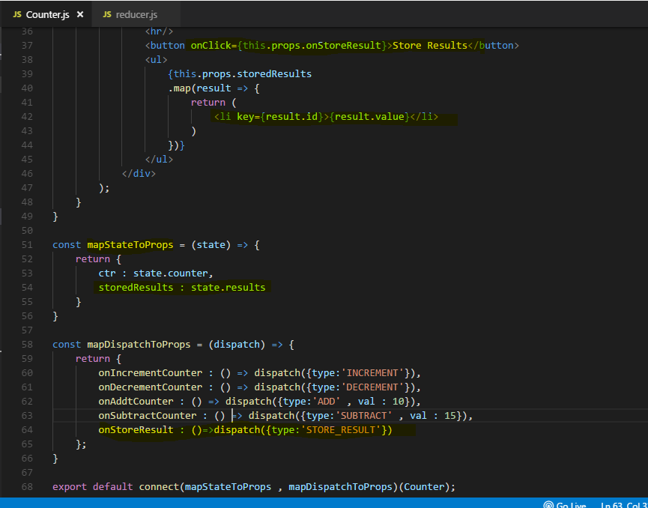

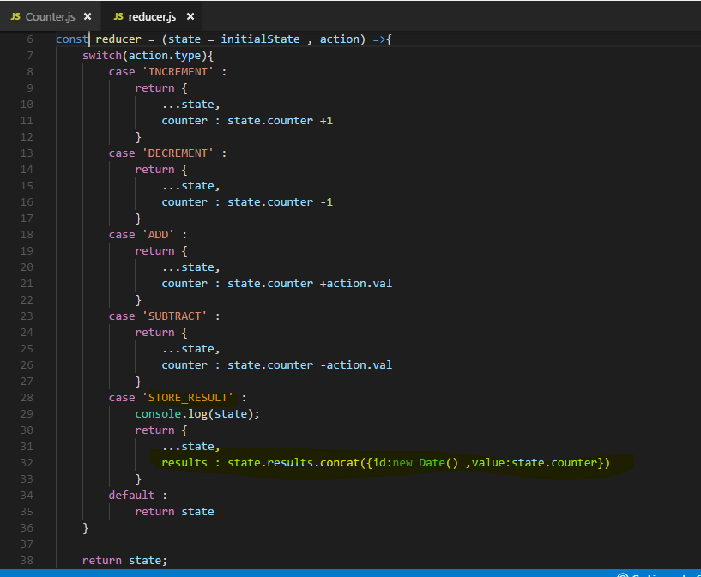

### **Important Note :**

**Whenever we click on Store result button , STORE_RESULT action triggered and it returns a Updated state to the Component in subscription mapStateToProps as storedResult available as a props to this component.**

**Then we use this data to display our <li> element**

### **Important Note :**

**The new object which we return from an Action in Reducer , updates the state of Reducer behind the scene. So Reducer state gets updated by the action**

## **Updating Array immutably**

Now I want to handle the case that I delete a result on clicking on <li> element

For that we need to delete element from results , which is an array available on reducer state.

so how do we do this in an immutable way then? There are a couple of ways,

I'll show you two.

**(1)**

The first is that you create a copy of your array, so new array could be a new array you create and then use the spread operator to distribute all the elements in state results into that new array. With that, you created a copy of the new array, important if the elements in state results were objects as they actually are, the objects themselves are still pointing to the same objects they did before. So if you change a property in one of the elements themselves, just creating a new array like this isn't enough, if you just plan on removing an object though, that is okay because you won't touch the object, you just remove it from the array, that's a difference. So we create a copy of the new array here and then we could simply use that new array here in our splice operation and then return state where we set results equal to the new array, which is a copy of the old array but updated and since we copied it, we never touch the old array. So this is one way of doing it.

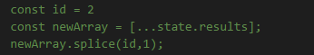

**(2)**

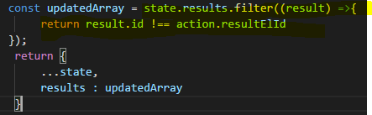

If filter returns a new array, doesn't touch the old one, returns a new one. Filter takes a function as an input, the function is executed on each element in the array, it determines whether this element fulfils a certain condition to make it into the new array which is returned by filter or not. then we have to return true or false. For true case, element will be added to new array.

Now Lets delete an <li> element on clicking

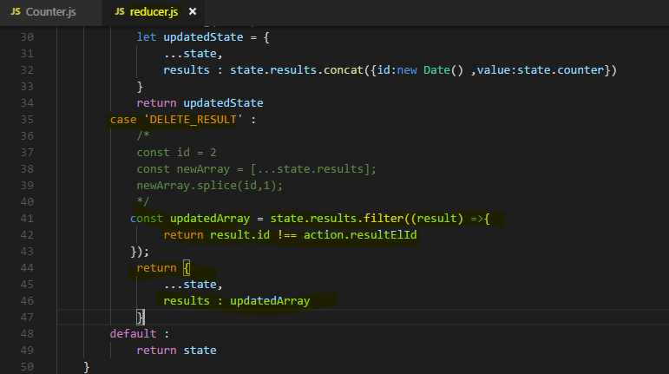

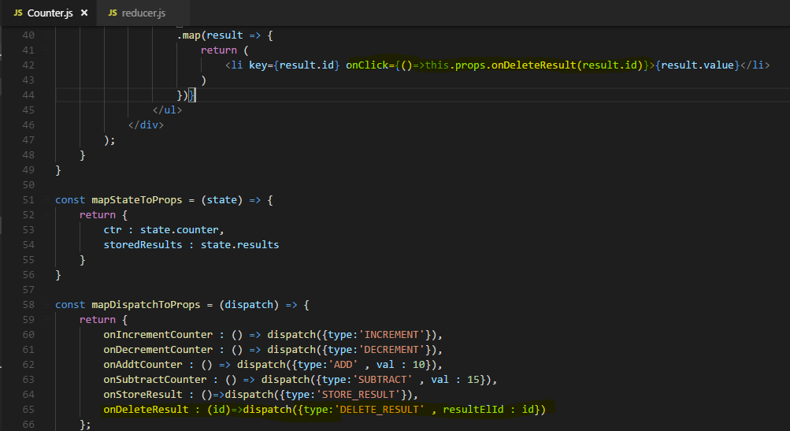

**To pass an argument we need to execute an anonymous function on onClick which execute this anonymous function in actions . this anonymous function in actions expected to receive an argument that we passed from onClick. Then we call dispatch method in this anonymous function and pass the id we get as an argument to dispatch method.**

you learned a lot of important things here, you learned how to delete elements immutably with filter and you learned how to pass actions from within your UI to an action by expecting to the argument you get from the UI in mapDispatchToProps and then passing it along with the action, and of course by then passing that argument you are expecting here from within your UI by wrapping this prop you execute in an anonymous function which allows you to pass data along with the function call.

## **Important : Immutable state patterns**

Immutable Update Patterns

Immutable Update Patterns on reduxjs.org: <http://redux.js.org/docs/recipes/reducers/ImmutableUpdatePatterns.html>

#### **Updating Nested Objects**

The key to updating nested data is **that every level of nesting must be copied and updated appropriately**. This is often a difficult concept for those learning Redux, and there are some specific problems that frequently occur when trying to update nested objects. These lead to accidental direct mutation, and should be avoided.

##### **Common Mistake #1: New variables that point to the same objects**

Defining a new variable does not create a new actual object - it only creates another reference to the same object. An example of this error would be:

1. function updateNestedState(state, action) {
2. let nestedState = state.nestedState;
3. // ERROR: this directly modifies the existing object reference - don't do this!
4. nestedState.nestedField = action.data;
6. return {
7. ...state,
8. nestedState
9. };
10. }

This function does correctly return a shallow copy of the top-level state object, but because the nestedState variable was still pointing at the existing object, the state was directly mutated.

##### **Common Mistake #2: Only making a shallow copy of one level**

Another common version of this error looks like this:

1. function updateNestedState(state, action) {
2. // Problem: this only does a shallow copy!
3. let newState = {...state};
5. // ERROR: nestedState is still the same object!
6. newState.nestedState.nestedField = action.data;
8. return newState;
9. }

Doing a shallow copy of the top level is not sufficient - the nestedState object should be copied as well.

##### **Correct Approach: Copying All Levels of Nested Data**

Unfortunately, the process of correctly applying immutable updates to deeply nested state can easily become verbose and hard to read. Here's what an example of updating state.first.second[someId].fourth might look like:

1. function updateVeryNestedField(state, action) {
2. return {
3. ...state,
4. first : {
5. ...state.first,
6. second : {
7. ...state.first.second,
8. [action.someId] : {
9. ...state.first.second[action.someId],
10. fourth : action.someValue
11. }
12. }
13. }
14. }
15. }

Obviously, each layer of nesting makes this harder to read, and gives more chances to make mistakes. This is one of several reasons why you are encouraged to keep your state flattened, and compose reducers as much as possible.

#### **Inserting and Removing Items in Arrays**

Normally, a Javascript array's contents are modified using mutative functions like push, unshift, and splice. Since we don't want to mutate state directly in reducers, those should normally be avoided. Because of that, you might see "insert" or "remove" behavior written like this:

1. function insertItem(array, action) {
2. return [
3. ...array.slice(0, action.index),
4. action.item,
5. ...array.slice(action.index)
6. ]
7. }
9. function removeItem(array, action) {
10. return [
11. ...array.slice(0, action.index),
12. ...array.slice(action.index + 1)
13. ];
14. }

However, remember that the key is that the original in-memory reference is not modified. **As long as we make a copy first, we can safely mutate the copy**. Note that this is true for both arrays and objects, but nested values still must be updated using the same rules.

This means that we could also write the insert and remove functions like this:

1. function insertItem(array, action) {
2. let newArray = array.slice();
3. newArray.splice(action.index, 0, action.item);
4. return newArray;
5. }
7. function removeItem(array, action) {
8. let newArray = array.slice();
9. newArray.splice(action.index, 1);
10. return newArray;
11. }

The remove function could also be implemented as:

1. function removeItem(array, action) {
2. return array.filter( (item, index) => index !== action.index);
3. }

#### **Updating an Item in an Array**

Updating one item in an array can be accomplished by using Array.map, returning a new value for the item we want to update, and returning the existing values for all other items:

1. function updateObjectInArray(array, action) {
2. return array.map( (item, index) => {
3. if(index !== action.index) {
4. // This isn't the item we care about - keep it as-is
5. return item;
6. }
8. // Otherwise, this is the one we want - return an updated value
9. return {
10. ...item,
11. ...action.item
12. };
13. });
14. }

#### **Immutable Update Utility Libraries**

Because writing immutable update code can become tedious, there are a number of utility libraries that try to abstract out the process. These libraries vary in APIs and usage, but all try to provide a shorter and more succinct way of writing these updates. Some, like [dot-prop-immutable](https://github.com/debitoor/dot-prop-immutable), take string paths for commands:

1. state = dotProp.set(state, `todos.${index}.complete`, true)

Others, like [immutability-helper](https://github.com/kolodny/immutability-helper) (a fork of the now-deprecated React Immutability Helpers addon), use nested values and helper functions:

1. var collection = [1, 2, {a: [12, 17, 15]}];
2. var newCollection = update(collection, {2: {a: {$splice: [[1, 1, 13, 14]]}}});

They can provide a useful alternative to writing manual immutable update logic.

[Immutable Data#Immutable Update Utilities](https://github.com/markerikson/redux-ecosystem-links/blob/master/immutable-data.md#immutable-update-utilities) section of the [Redux Addons Catalog](https://github.com/markerikson/redux-ecosystem-links).

## Outsourcing Action types

I emphasize that the identifiers we're looking for here in the reducer are the identifiers

we should use in our container components, in our application where we want to dispatch these actions.

We do so of course but there always is the danger of us simply adding a tiny typo and searching for it for hours because we don't find it. Therefore it is a good practice to outsource your action types into constants you can use in your application so that you always just import a constant and eliminate the danger of mistyping, this is especially useful as your application grows.

If you only have two types of actions you dispatch, you might not need that but for bigger applications, definitely add it. For this, I'll add a new file to my store folder and I'll name it actions.js

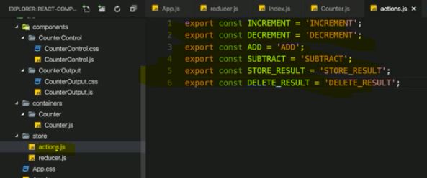

we can now simply import everything from a given file and store it in some javascript object

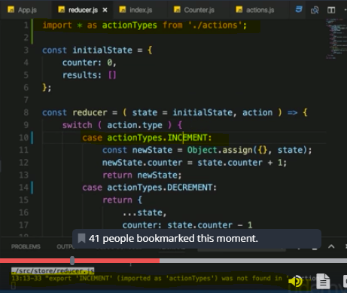

The huge advantage of this approach simply is we're now importing our constants here and if we mistype one constant name, we'll actually get an error by our IDE or by that build process then I do the same where I dispatch them in component, it of course doesn't make any sense to still have hardcoded values here because I could still mistype,

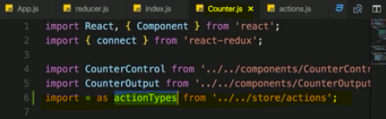

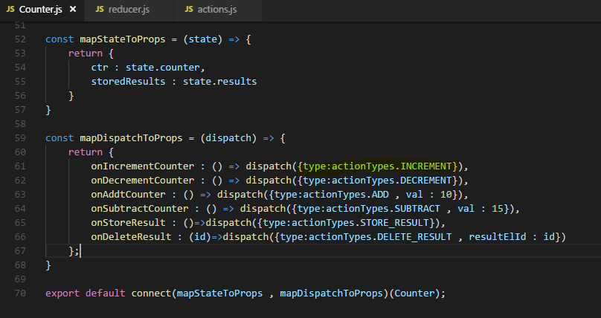

**we're now always referring to that property, to the constants we are exporting in the actions file and hence we can't mess up by mistyping or having different identifiers because now we have only one place where we set up and store our identifiers**

## Combining Multiple reducers

there is something else we do a lot as our application grows and that is use multiple reducers.

Now I did say that **we only have one reducer with redux and this is the case, all actions in the end get funneled through one reducer but redux, the package gives us a utility method combineReducers we can use to combine multiple reducers into one, so that we still follow the pattern of having only one reducer behind the scenes**

In our tiny demo application, it might make sense to have a reducer which handles the counter and one which handles the results, even though they're somehow related, they technically are different or they manage different parts of the app so splitting it up might make sense.

**Now create two reducer which their local state for counter and results. At the end it all combine to one root reducer hence one global state.**

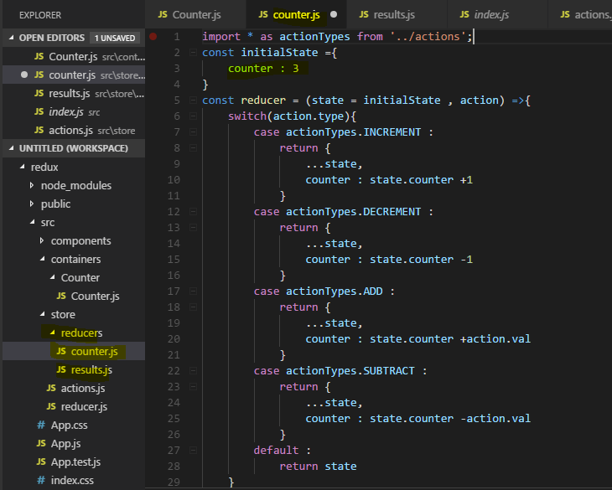

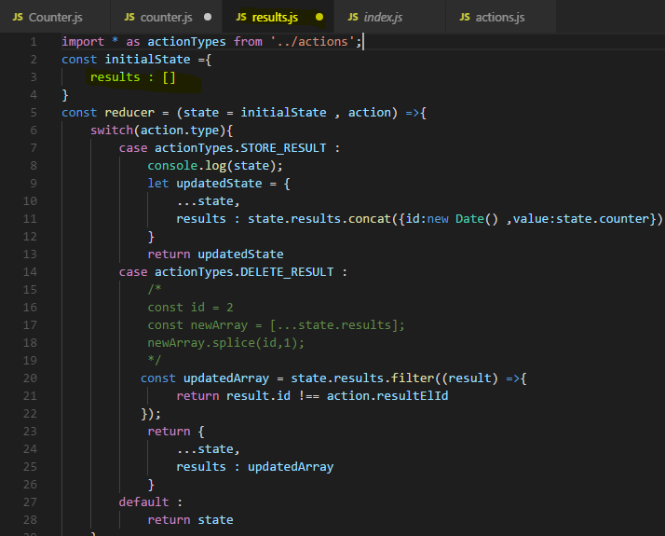

**Notice that I still access state.Counter in result.js because in the end, the two reducers are going to get merged together into one global state so there still is going to be a counter state in there, we still might need to update this later but we'll see.**

**Now to combine them, I need to import a helper function from the redux package, it's called combineReducers, as the name suggests, this is a function which takes a javascript object mapping our reducers to different slices of our state as input and merges everything into one state and one reducer for us.**

Now as I just said, combineReducers function takes a javascript object as an input and there, we now simply can create sections of our app so to say, any name you want like the counter or just ctr, whatever you want, I'll name it ctr here here and map the counter reducer to it and then I'll add my res area with the resultReducer.

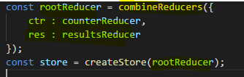

So now we're telling redux in the end, hey I got two different feature areas in my application, ctr and res, please use these reducers for each of them and merge everything together into one store, into one state, into one reducer.

**If I save this and run the application , we get an error**

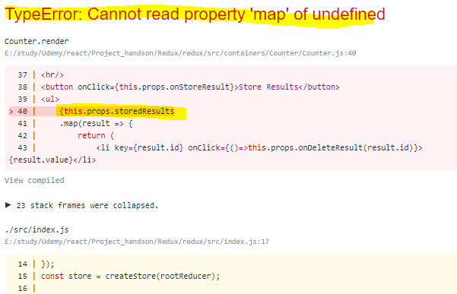

the problem is that stored results where we map through all the stored results, that this won't work because this props stored results now refers to undefined and not to an array of results anymore.

**This happens due to us combining reducers, now we will have one state in the end but to avoid naming conflicts, redux adds one level of nesting where it has one state object but basically with these keys here,**

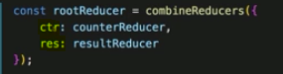

**in combined reducers as properties which give us access to these sub states for these feature areas, you could say.**

**So in the counter.js file, if we want to access the counter we have to access the global state.ctr.counter. since this is the name we gave this slice of our global state and for the result, it would be state.res.results**

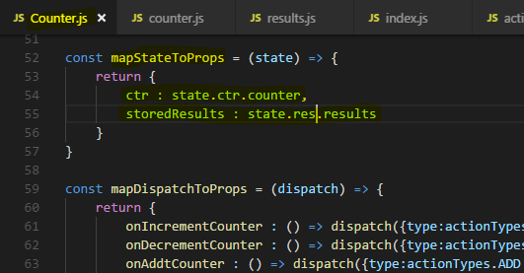

With these changes the error is gone.

But Store result button not working

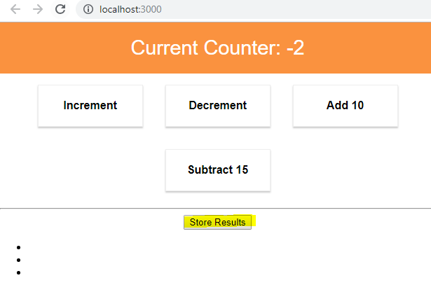

**The reason for this is that the stored result actually is undefined because in the resultReducer, we do store a snapshot here for state.Counter and this doesn't work because this now, state.Counter, is not known because this local initial state in this reducer doesn't have a counter property.**

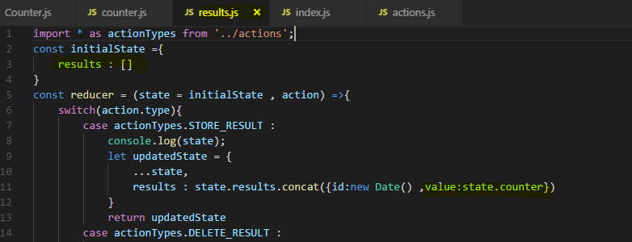

Now you could think that you simply add state.ctr.counter, if you do this and save everything, click

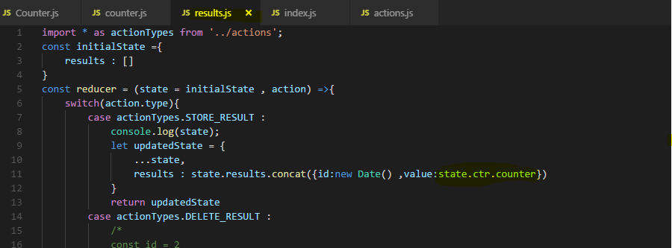

add 10 and click store result, you get an error though that you can't read property counter of undefined.

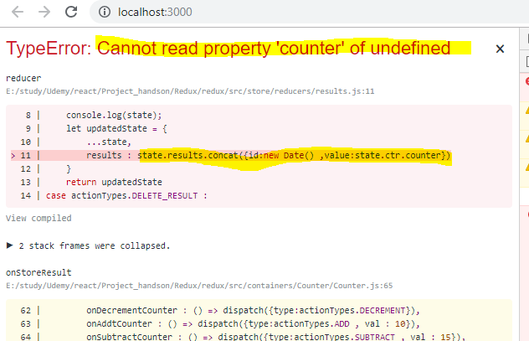

**The reason for this is that** **inside this reducer function, it basically has no access to the global state only to that state of that reducer function.**

**That's different than the counter component where we connect our react component to the global state, there we can access the different pieces of the state through our slices we set up in index.js**

**This does not work inside of the reducers.**

**So if we are in a reducer where we need to get a value from the global state, we should simply get it as an action payload and this is generally how your reducers work anyways**

**most of the time, it's old state plus action plus optionally action data and you return a new state.**

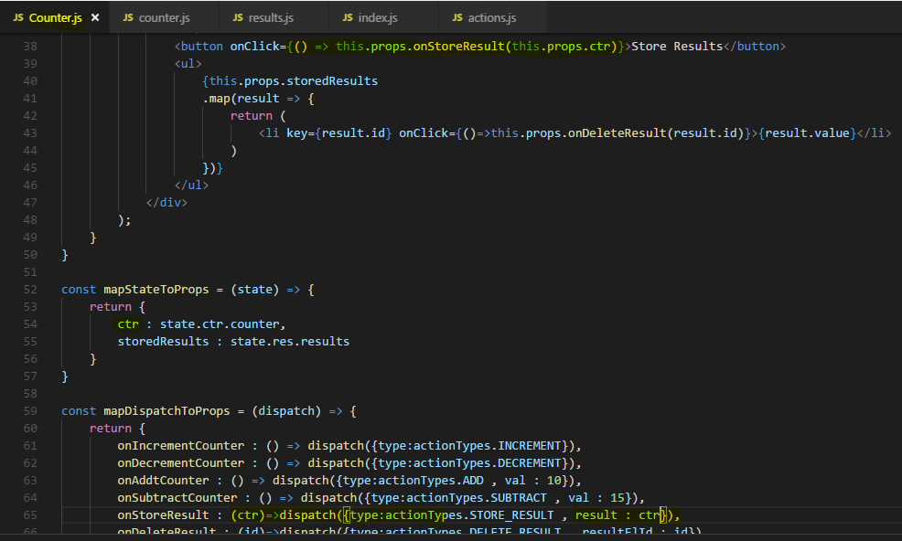

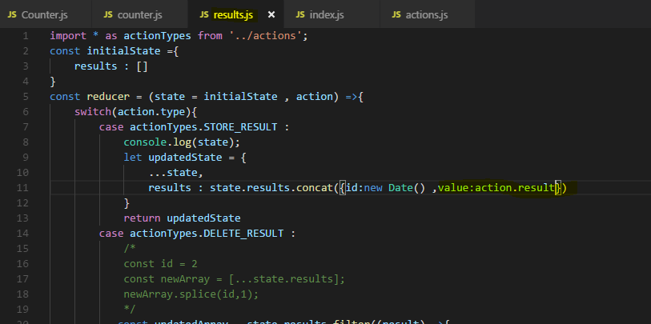

Output – 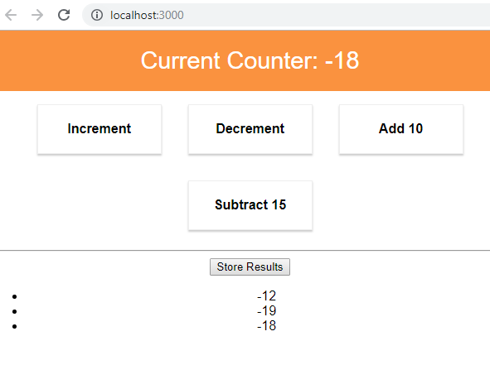

## Understanding State types

Is this always the approach you should follow, do you always have to use redux to begin with?

Well the question whether you use redux or not depends on the size of your application and the complexity of your state. You have a simple, a small application, setting up redux might take you longer than the benefits you get out of it are worth it.

**For any decent medium size or big application, using redux and managing the state there is probably a good idea but then still, we have to ask which state should be used for redux because you shouldn't necessarily manage all the state in it.**

Let's have a look at the various types of state, some examples and whether you should use redux for them or not.

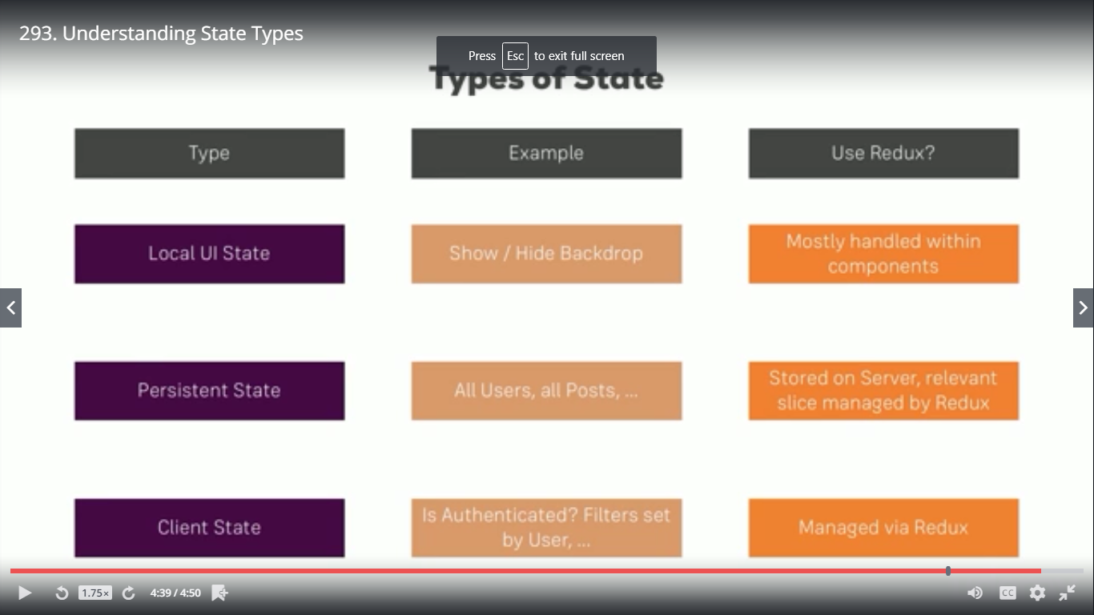

Let's consider local UI state such as showing or hiding a backdrop, opening a modal,

all these things which of course change the state to update the UI of your react application and hence to show something different, should you use redux for that?

The answer is often times, you might not use redux here, you mostly handle this within your components, that being said, you can use redux for that. You can have show modal property in your global state, dispatch an action to set it to true and dispatch an action to set it to false then connect your component and listen to that property to conditionally render a modal or not but that might be overkill. Often times, you can't handle that within your components just as we did it before.

Another important type of state is persistent state,

this means the state you typically also store in server side databases like the users of your application or posts of a blog, all burger orders, stuff like that. Now here, you typically do use redux but of course not for all the data you have in your server side database because **redux of course is just for managing the state in your application as long as your application is alive. And always keep in mind, when the user refreshes your page, your state is gone. so redux is not a replacement for a database,**

instead you store such data on a server but the relevant slices are managed by redux.

So the post you're currently displaying, the users you currently need to display, the post the user currently may edit, these things are loaded and stored in redux so that you have them available so that you can render them to the screen but that might not include all the data you have in your database.

And then we have typical client state, things like is the user authenticated or filters set by the user, so if you have a dropdown allowing the user to filter your posts, that's not data you store in the database, you can't store if the user is authenticated because if he enters the wrong login information, you don't need to store it on the server unnecessarily. Also the filter set by the user, you might not store that on a server because it's not that important

to store it in the database, you definitely need to be aware of the current filter settings on your client in your javascript code in the react application though. This is state you definitely use redux for, you managed that via redux because it might affect multiple components or areas of your application,

for example if the user is authenticated, it might be important for a lot of components in your app and there, redux really shines because the central storage then offers a huge advantage.

## **Combining Local UI state and Redux**

 it would be a typical use case to have input fields for the user to use to specify these values,

how would that work?

It's a typical case of local UI state.

You did of course learn over the last modules in this course that for user input, we also handle this with set state and in the state in general and for that, we don't need to use Redux just to store the value the user input.

We need it then if we want to create a person with that input but just to handle each keystroke and use two-way binding, we don't necessarily use Redux.

**This is a typical use case of local UI state Whatever the user entered into these inputs here probably isn't relevant to the entire application, there is no need to store this in the global Redux store, you can absolutely store it in the state of that component because it only matters to that component, it does matter to the other components as soon as this button is clicked.**

So we will pass some data when button is clicked

**So here, we will pass an anonymous function so that we can pass some data along to the props, I want to pass this.state.name and this.state.age along with it, so that in the container where we handle the person added prop, where we connect a method to it, where we previously add it on added person or execute this, that there we now actually take advantage of the arguments we receive.**

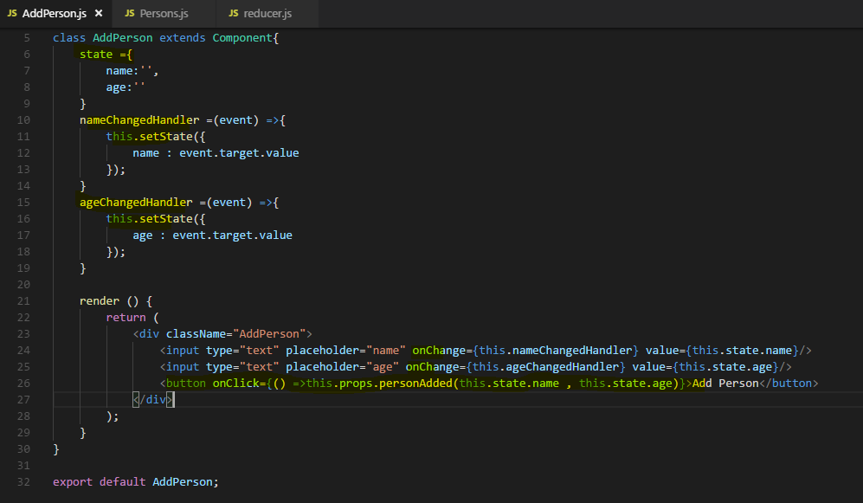

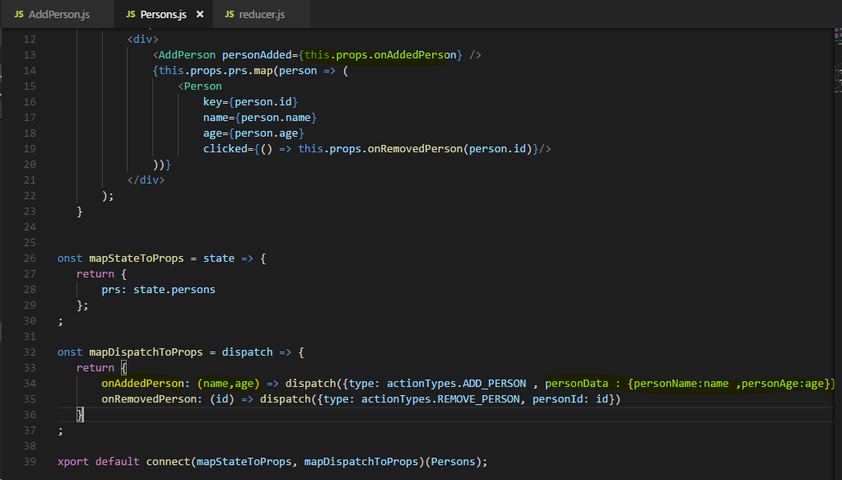

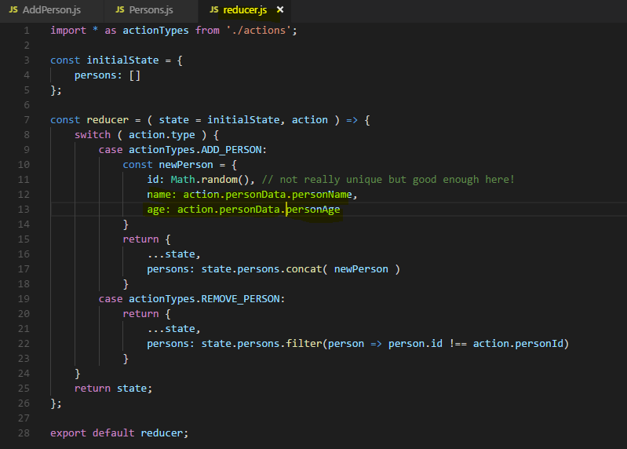

**now we're combining both, local UI state to handle the input and then still Redux to handle the created person which affects broader parts of our application.**

**And I wanted to show you this, how to handle user input, how to handle that in a Redux world and how to differentiate between local UI state as we use it here for information that really is only relevant to this component and the global state managed through Redux for information which is important for our entire application.**

# **Adding Redux to our BurgerBuilder project**

## Basic Setup for Burger Builder project

**We have <BrowserRouter> wrapping our App ,now for redux we have to wrap our App by <Provider> the question is who should we wrap to all?**

**The answer is the Provider should wrap everything**,

there is something special about using react-redux with the react router and I'll come back to that and how we fix this.It basically has to do with making sure that the connect functionality and the routing functionalities work together fine because both implicitly set up some props on the wrapping component and we have to make sure that everything works there.

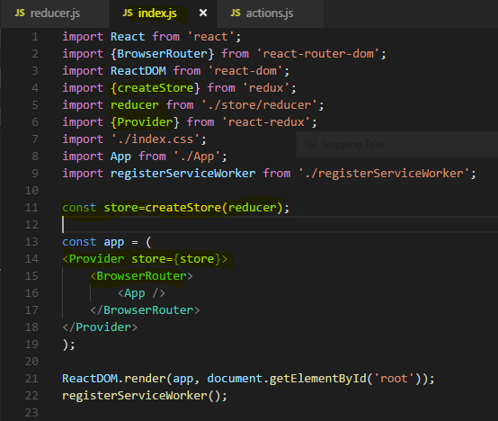

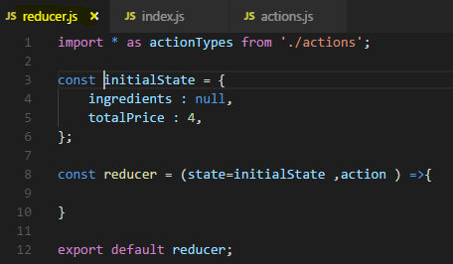

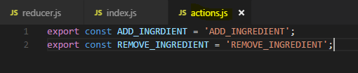

## **Finishing Reducer for Ingredients actions**

keep in mind that the burger builder, we start with null because in componentDidMount, we actually load our ingredients, our starting ingredients from the internet. This is something I will really re-add but for now, since we haven't learned how to handle asynchronous code here, I will ignore this here, will basically comment out the code in componentDidMount and instead start with my own ingredients set up here in the state. So here, ingredients will not be null in my reducer but instead be an object where we have salad 0, bacon 0, cheese 0 and meat 0,

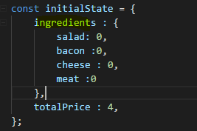

**we'll copy the entire old state with the spread operator, so that when we set new ingredients we also keep any other properties around by distributing them over this new javascript object first. But that then is the second thing we want to do set the ingredients to something new, ingredients should now also be a new javascript object, immutability, don't reuse the old one, create a new one, where I first of all distribute all properties of state ingredients. Again doing this to really create a new object, just distributing state here won't do that because it doesn't create deep clones of objects, it doesn't go into objects and create new objects for these too, it simply just copies the surrounding object but ingredients which is object on its own would still point to that old object while we fix this by spreading out the properties of that old object into a new object here. Now with that in this new ingredients object, we want to overwrite the given ingredient which we need to get as a payload of this action.**

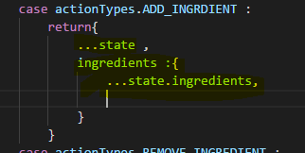

Now in ES6, there is this special syntax you can use to dynamically overwrite a property in a given javascript object, you can use square brackets, now this does not create an array here.

Instead here, you can now pass a variable over a something which contains the name you actually want to use as a property name and I expect to get that property name on my action, maybe on a ingredient name property. Now ingredient name is something we get as a payload to the action and then here, we simply distribute all ingredients into our new object, So this object then holds salad, meat bacon and cheese and one of these, which ever that is which we receive as a payload of the action will receive a new value. We target it with this syntax and then with colon and the new value, well we set this new value, the new value now simply is state.ingredients then again select the given ingredient name, so this now factors the old value for that ingredient, so like 0 or 1 or whatever it was and then we add plus one. So now here, we get the number of the old ingredients, add one and assign this to this ingredient where we overwrite the copy we created here.

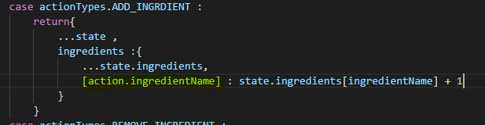

Now we're returning a new version of the state with the updated ingredients

Lets also complete action for remove ingredient and complete reducer for now-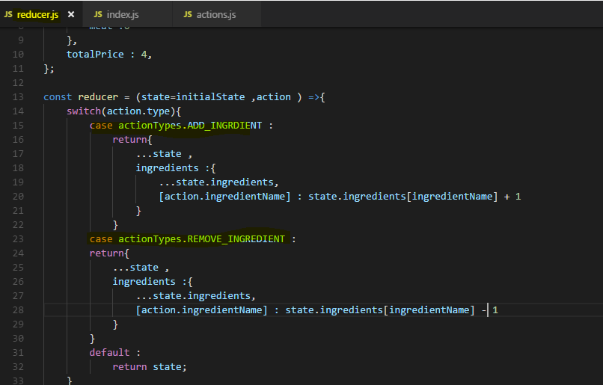

## **Connecting BurgerBuilder Container to our store**

here we face an issue, we already have a higher order component wrapping our export, the withErrorHandler high order component we set up here.

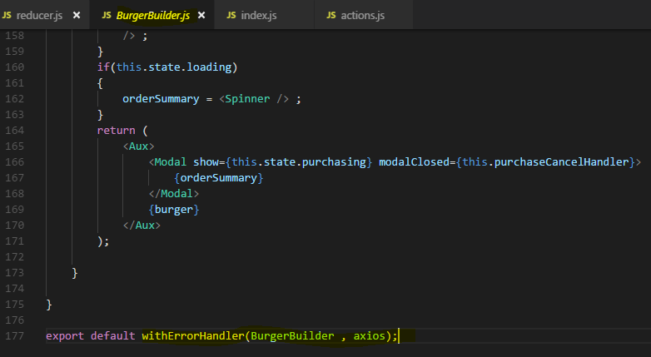

Well this actually isn't a problem, you can have as many higher order components in there as you want. In the end what connect will do is it will just set some props on the component it's wrapping, so as long as you pass this props on in your own higher order components, this should work fine

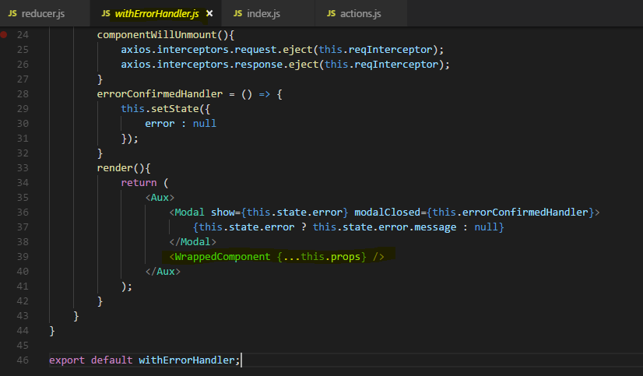

Because any props set by other higher order components which might wrap this one will still be passed on just fine.

Lets see the updated code for redux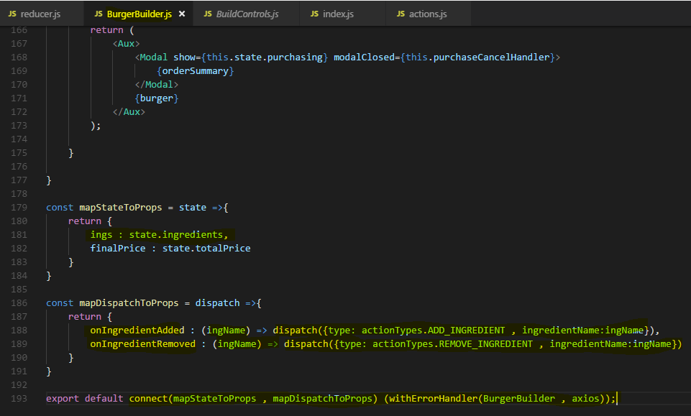

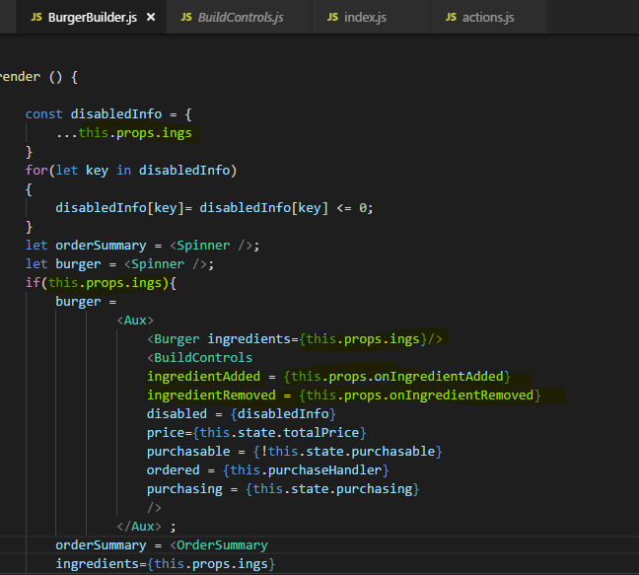

Now how did we passed the parameter for ingredient name? lets see

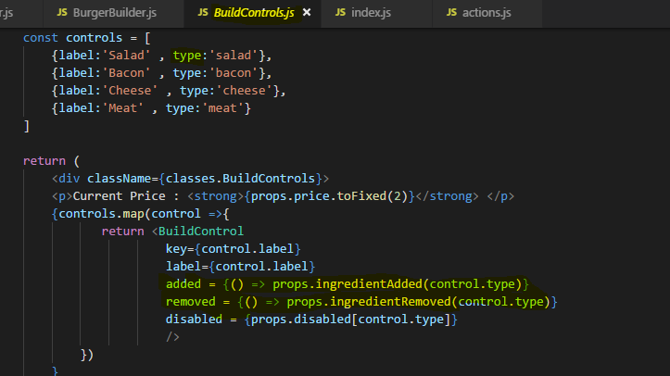

## **Working on total price calculation**

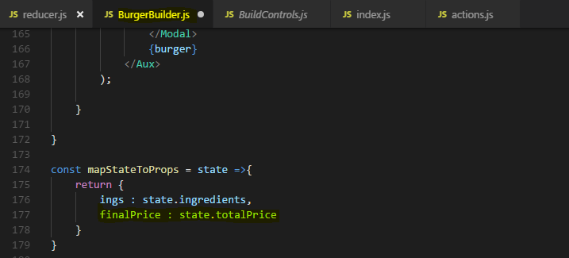

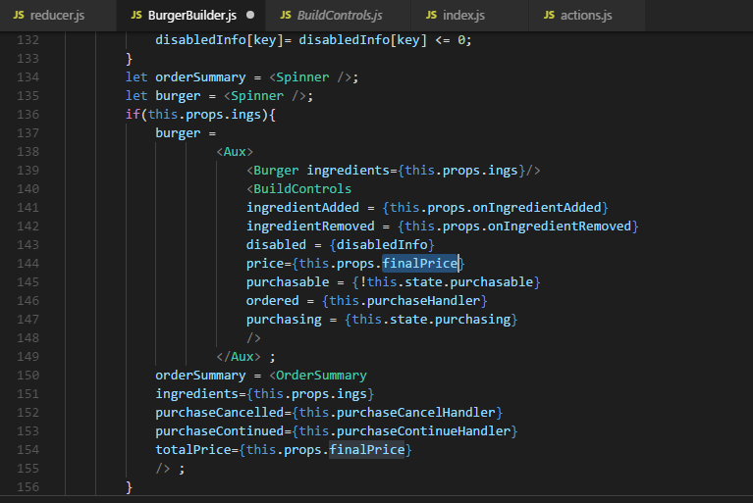

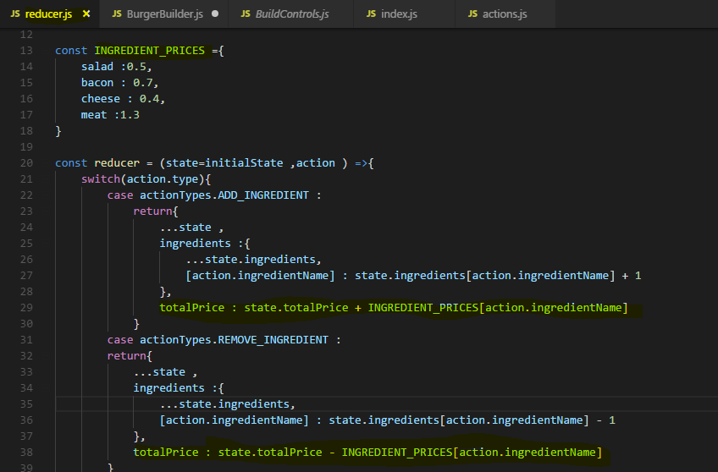

## Redux and UI State

**We now have two options,**

(1) we could leave the method and simply adjust it a tiny bit to return the result of our boolean check

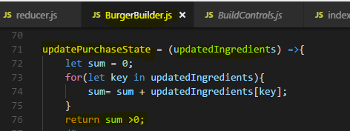

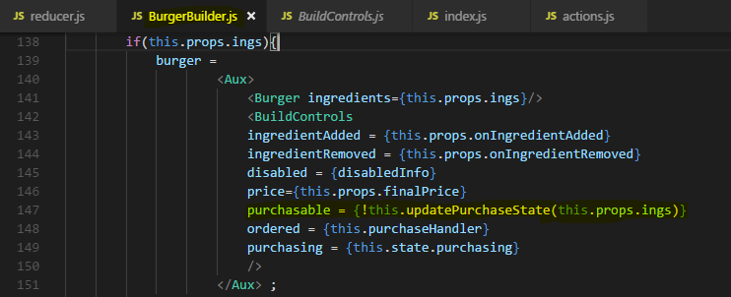

2) you could of course also manage the purchasable state in your, well through your reducer by adding something like purchasable and then also update this whenever the ingredients change

With that you see our state shrank a lot, we now only have purchasing, loading and error in there

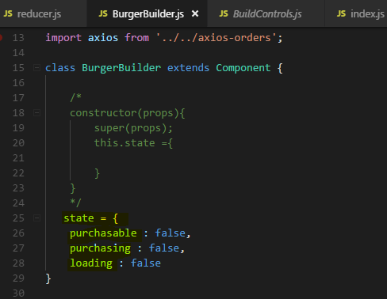

**and as mentioned at the beginning of this module, these are all states or state properties relevant for our UI state only, should we display a modal, should we display an error message, nothing we necessarily need to manage through our global redux store, so that is why I will leave them here.**

**They can co-exist together with redux, you can put everything into redux but you don't have to.**

## Adjusting Checkout and Contact data

Now that we're handling everything related to ingredients through redux,

**we of course should also adjust the other components where we use that ingredient data, namely Checkout and ContactData, especially checkout and contact data are super great now that we use redux because thus far, we used query params to pass our ingredients to the checkout component, this is something we finally can get rid of.**

**So in the burger builder component where we do pass our ingredients through query params here, purchaseContinueHandler, we no longer need to do that,**

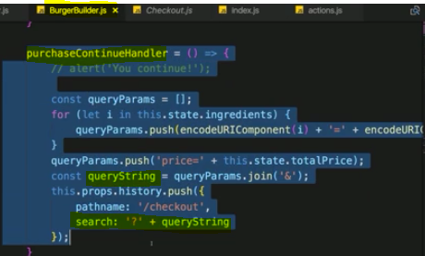

**Instead we need to handle this through redux now, we probably still want to navigate on but I don't want to pass query params anymore.**

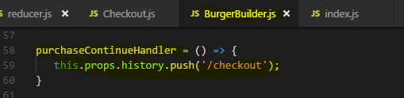

**we can then simply get the ingredients from the redux store by connecting Checkout Container to redux store.**

So our purchaseContinueHandler lives on in the burger builder but it's much leaner

**Now in Checkout container**

**we no longer need to get our ingredients in componentWillMount like this.**

**Instead we can get rid of componentWillMount here altogether,** 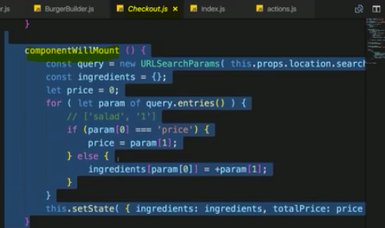

we can get rid of our state which only handles ingredients and price,

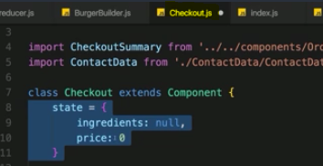

**we got all these data directly from redux store by connecting Checkout container to redux store.**

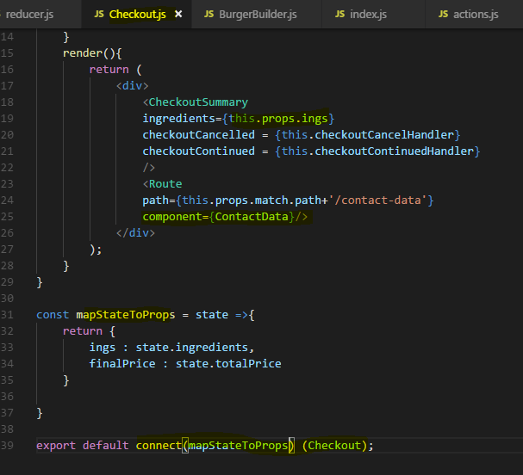

we don't need mapDispatchToProps here because we're not actually dispatching anything in this container, we just navigate a little bit but we don't do this through redux store, we do this through the react router so there is nothing getting dispatched here, so for now we only need mapStateToProps, I then wrap this with connect.

**Now here we have used some trick to pass ingredients and price information to ContactData container using below trick as a props**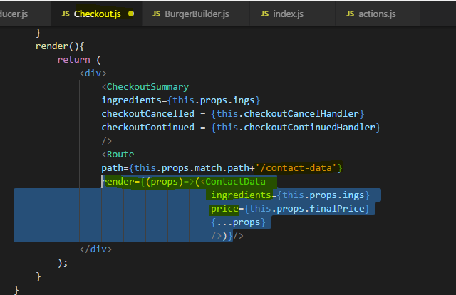

**Now thanks to our redux store, we no longer need to use the tricks so we don't actually even need the price here because we don't use it anywhere else in this component.**

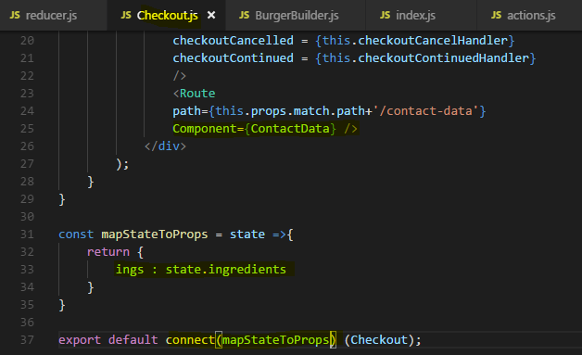

**With that we also need to adjust our contact data of course because in there as you know, we also use the ingredients which we get on props and the price. Prior to redux, we got it with this little trick we just removed, now we can simply connect this container here to redux as well.**

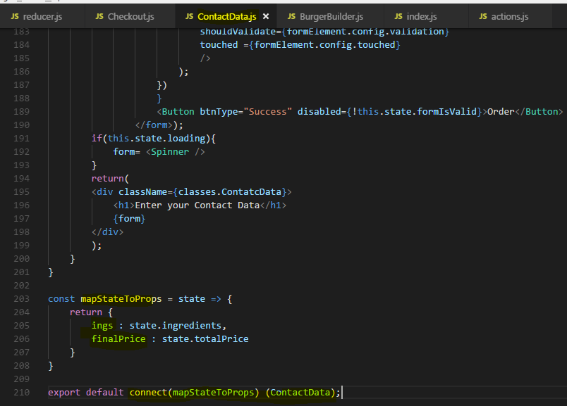

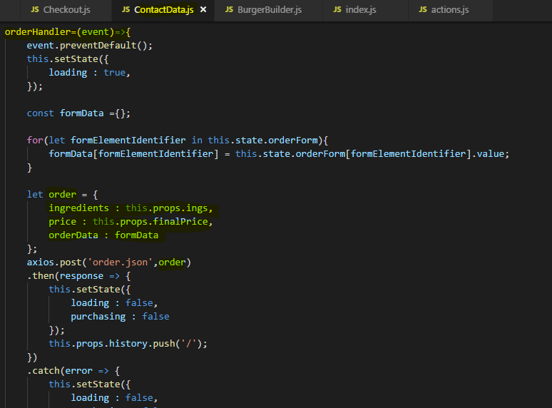

**Now without any fancy tricks, really taking advantage of redux and this also hopefully shows where redux shines. This is not a super huge application but it is a bit more advanced than just having a To-Do list and here, we really make it much easier to ourselves if we use redux. We have a predictable data flow and we make passing data around in our application super super simple.**

## **Wrap up**

**what we are doing is managing the core ingredients through redux. What I also already mentioned is that for example in the contact data, we still have a lot of state in our state property, the whole form is inside there ,the validity of our controls and I want to really highlight, you can manage all of that through redux, you can do that. You can dispatch an action on every keystroke the user does and put all that logic you have in that container**

**here into redux so that you check the validity of controls in redux, that you update the form control values through redux, that you have redux for everything, you can absolutely do that, and if you want to do this, really depends on the style you want to have in your application. Do you want to have very lean components and containers?**

**This one here obviously isn't, then you have to put everything into redux. Do you want to have the state management placed where it belongs?**

**So say this really is UI state, it's only relevant in this component and shouldn't be affecting any other components, then you might keep it in this container here.**

**So this is really something you have to decide, both is correct,**

# **Redux Advanced**

## Adding Middleware

let me dive into a super important advanced concept we have when working with redux and with that, I always mean redux the package on its own, be that connected to your react app or not.

**You may add middleware to it right between your action being dispatched and it reaching the reducer, this is where you can add middleware.**

Now you might not know what middleware is, if you're a server side developer having worked with Express.js for example, you might have an idea though.

Middleware basically is a term used for functions or the code general you hook into a process which then gets executed as part of that process without stopping it.

**So we can add middleware and the action will still reach the reducer thereafter but we can do something with that action before it reaches the reducer, that can be simply logging something**

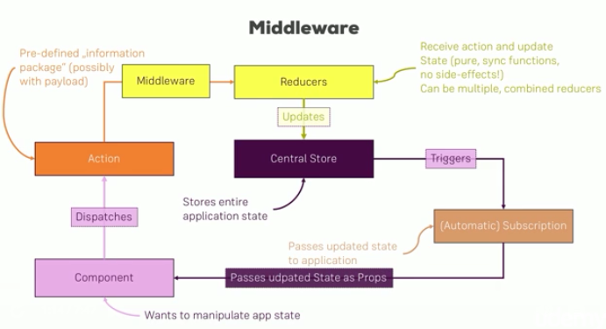

let's see middleware in action by adding it to our project. To show you how middleware works, let me go into the index.js file, the file where we actually create the store.

**It's at this point of time that we can also add middleware to the project**

Now I'll create my own middleware here, later we'll add middleware provided by other providers. I'll create a new constant and I'll name it logger, this will be the name of my middleware so to say, of course the name of the content is totally up to you as always. This then takes a function and I will use the ES6 arrow syntax. It will get the store as an input, **this is the case because we will soon use a specific method provided by redux to connect our own middleware to the store and this method provided by redux will eventually execute our middleware function and give us the store.**

Now the function body of this middleware function then looks like that, we return another function, so that can be confusing but this function simply returns another function. I'll also write this other function in the ES6 arrow function syntax, this other function will receive the next argument, you can name this argument whatever you want but next makes sense because this will be a function which you can execute to let the action continue its journey onto the reducer,

you might know this next function if you are an experienced express developer.

So this function which is returned here will also be executed by redux in the end, this function then and now it really becomes a bit confusing but this function now also returns a function, the last one though, which will receive the action you dispatched as an input, again this function will also be executed for you. **So this nested function part here is simply a middleware,**

**now inside that inner function which receives the action, we can also access a store and this next function and of course the action itself. And here we can now execute the code we want to run in between the action and the reducer.**

**Thereafter, I will execute next(action) and here, important, this will now let the action continue to the reducer, though for that to succeed, we need to pass the action as an argument, now that's important because you could theoretically also change that action here in the middleware, we have access to it, we get it as an argument, we could change the type. Of course we should do that with caution because we can break our application or worse than that, we can implement unexpected behaviors.**

**So here I will call next and pass the unmodified action, the cool thing is I can now store the result of this call which I will need to return in this inner function**, so I will return results here.

Now in between these two steps, I can log something else, so console log, log a middleware related log statement here and there, I will have my next state so I can simply called store.getState because I do have access to my store,we get it in the outer function,

So this function tree is in the end what gets executed, all of that is done by redux, we don't have to call any of these functions, **all we have to do is apply this middleware to our store.**

So how do we do that?

First of all, we need to import something from redux, **applyMiddleware** this function as the names suggests allows us to add our own middleware to the store.

**So here in create store where we initialize the store, we can add more argumentsand the second argument here can be a so-called enhancer. Now this enhancer is nothing else than a middleware**

now we can pass our logger constant which holds this function tree which happens to be a valid middleware executable by redux to apply middleware and therefore connect that to the store.

**you can pass a list of middlewares here to applyMiddleware, they will be executed in order then.**

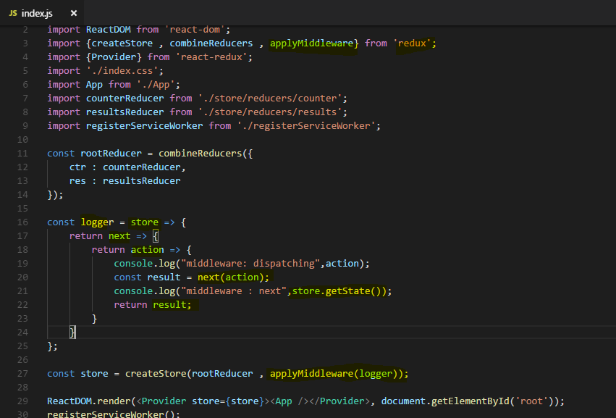

Lets run our application -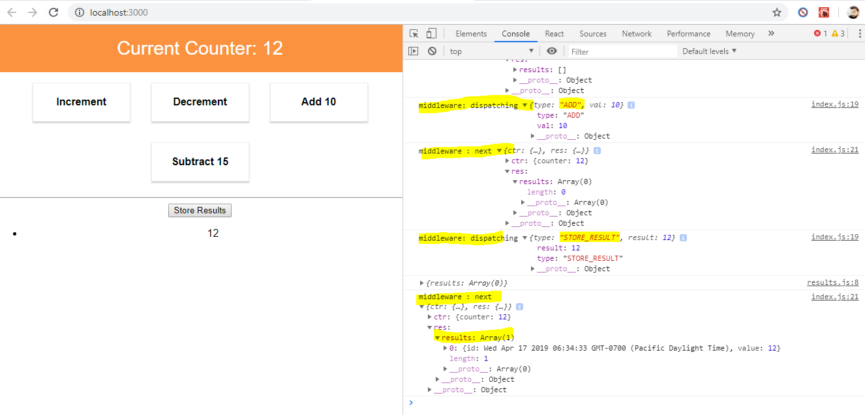

So this is our middleware in action, now of course the middleware can already be nice to do exactly that, log your state and see very well what's going on. Now a more useful use case for a middleware is to be seen later when we actually handle asynchronous code. But first I want to stick to this idea of getting some insights into this state, it would be nice for debugging if we could always look into the store. So if we had some logging but more than that, that even if we just didn't dispatch anything, we could still look into the current store.

## **Redux DevTools**

As of now we don't really see what's inside the store.

It would be nicer to be able to look at the full store and even see the actions which were dispatched, maybe even rewind. Well for that there are special developer tools we can install, if you google for **redux devtools**,

you'll find two results, the second one, the redux dev tools extension or to be precise, the third one the redux dev tools in the chrome web store,

You should install this extension to Chrome, it will give you a nice plugin you can use to look into your store. you can read more instructions on that second result, the redux dev tools extension github repository, here you'll find more instructions about how to install and set it up

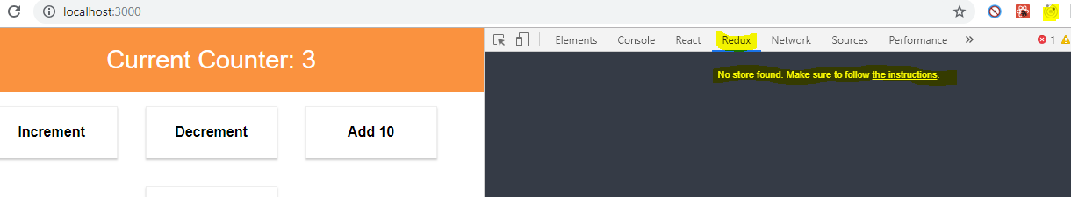

it's saying no store found because we haven't followed the second step where we have to basically inform this extension that there is a store in our web app and for that, we simply need to set up a special variable here or pass a special enhancer we should say to our create store method. Since we're using a middleware we have to use the advance store set up but it's still pretty simple.

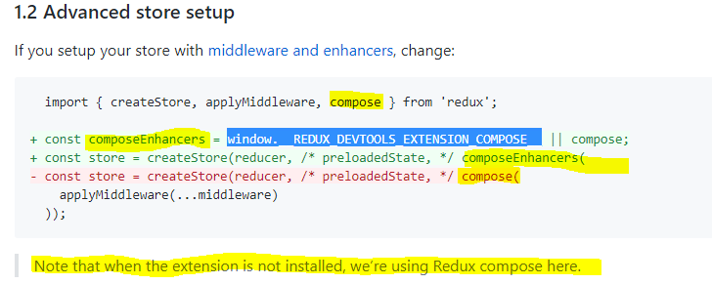

**window.__REDUX_DEVTOOLS_EXTENSION_COMPOSE__**

**this essentially is a variable which is injected by the Chrome extension into our javascript at runtime so it will be available.**

I will first of all as instructed here create a custom constant before we do anything on the store, I'll name it composeEnhancers. This will then be our special variable or in case that can't be found, we'll fall back to a default compose function provided by redux, you can import it from the redux package.

Now compose is a little bit similar to combineReducers, combineReducers allows us to combine well reducers, compose allows us to combine enhancers, applyMiddleware is only for middlewares if we have other enhancers like the store dev tools, we need to use compose to compose a set of enhancers with both the dev tools features and our middleware.

So we also add compose here, separate it with this or sign to take this dynamically injected variable if available but if not, to still have to fall back to the native redux solution which of course doesn't give us dev tools support then. So now composeEnhancers essentially just holds a function,

if we go back to the documentation, we see that now we should create our store and use this new composeEnhancers function which uses either the dev tools function or the natively built-in one to then pass applyMiddleware to it.

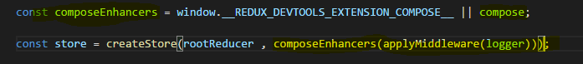

you don't need to pass anything about the dev tools because it will be passed in automatically, if that is chosen, so if that is available.

So we got a set up where we should be able to connect our browser extension to the store running in our Javascript code

Lets look into our application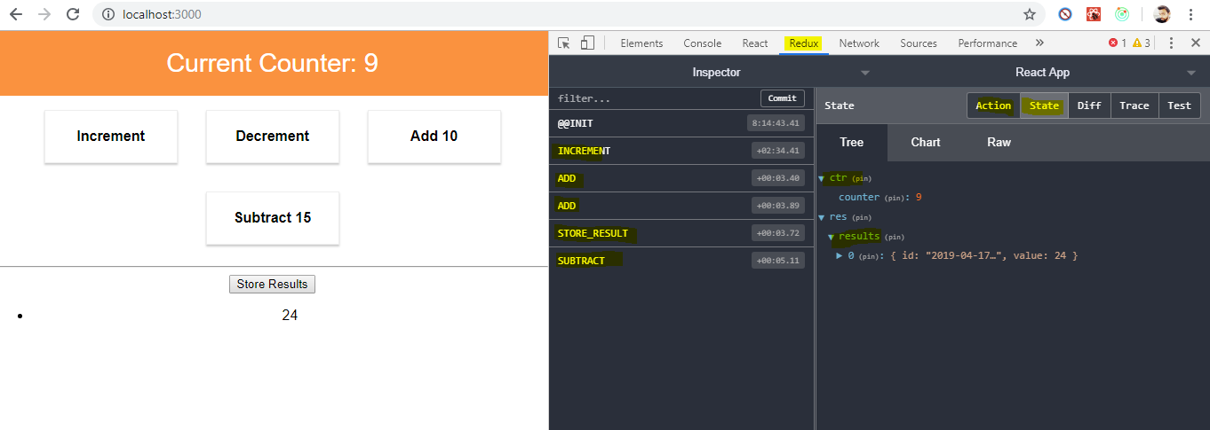

**Here we can see , we get details of actions we are performing on application and the state changes dynamically so we are getting updated state .**

**we can always see how we adjusted our state and what our current state**

**is and what our state was in the past**. So redux dev tools are extremely useful and definitely dive into the documentation I pointed you to to learn more about them.

Now one important feature I want to show you is the time traveling, with the redux dev tools, you can travel through time.

So for example, of course the application we see here reflects the state after all these actions but if we wanted to rewind and say yes let's go back to that subtracting here, you can click on subtract and then on jump and now you see you are back to that point of time where you just subtracted 15.

**Now the old states are not lost,**

you can always go back to there by clicking jump on that again but you can also go back and for example skip this to update your state as if you haven't ever dispatched this action

and of course, this can also be reverted.

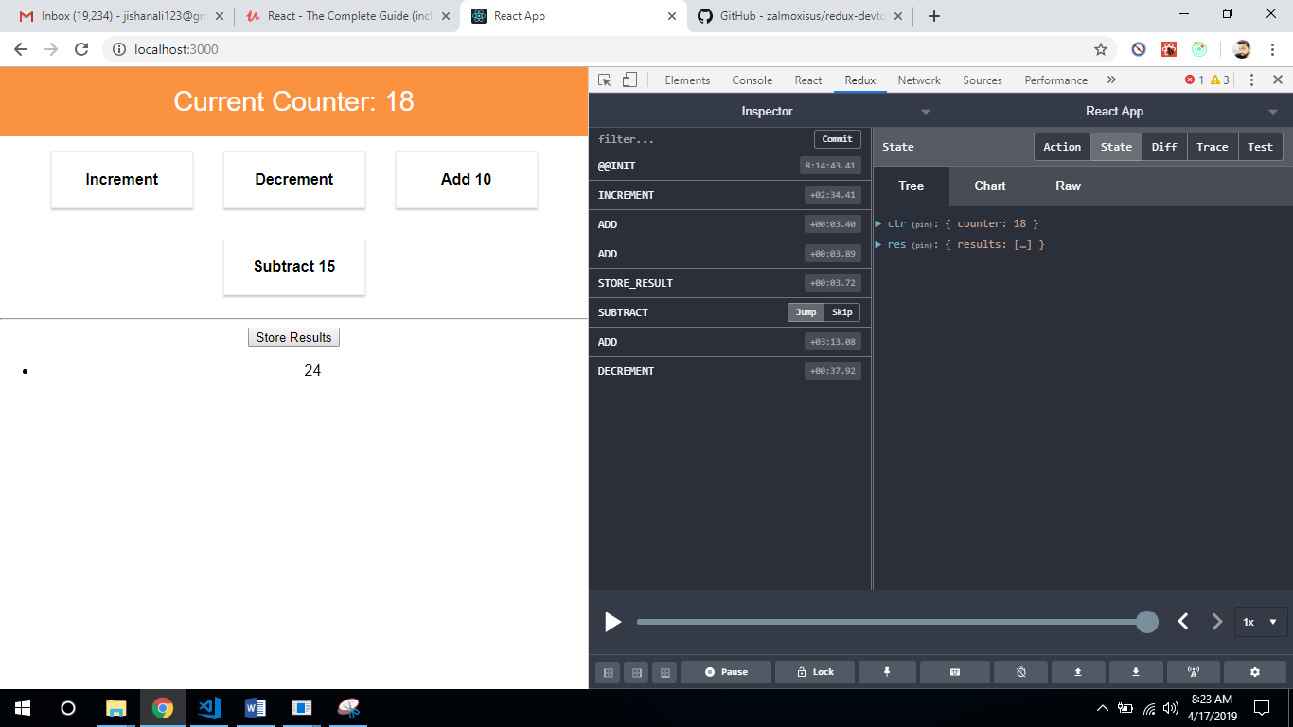

So this is a extremely nice feature which gives you a lot of debugging possibilities and especially more complex apps, this is great to make sure that only actions are dispatched you expected to be dispatched and to find out why the state is currently in well the state it is in.

## **Action creators : Executing Asynchronous Code**

**We can execute asynchronous code with the help of so-called action creators,**

**An action creator is just a function which returns an action or which creates an action**

We right now create our actions hardcoded in our code or simply when we need them I should say, in the counter component.

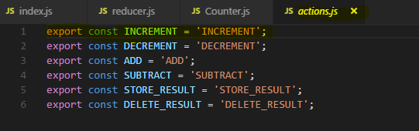

Here on mapDispatchToProps, the actions, these are just these javascript objects, right?

An action creator would return such an object and you can see the benefit when we talk about asynchronous code.

the convention is to use the same name as your identifier but in camel case, so lowercase character first.

**it will return something eventually and it will receive something, it can receive something I should say, it receives any payloads you want to pass with that action.**

Here for increment, I don't want to pass any, so instead I just **return something and that something is the actions or javascript object. Now as any action, it has to have a type** and the type should be INCREMENT, referring to our identifier.

**For other action creators which receive any payload we should pass them and receive inside the action creator function and return this also.**

**File : actions.js**

//export const INCREMENT = 'INCREMENT';

export const increment = () => {

return {

type : 'INCREMENT'

}

}

//export const DECREMENT = 'DECREMENT';

export const decrement = () => {

return {

type : 'DECREMENT'

}

}

//export const ADD = 'ADD';

export const add = (payloadData) => {

return {

type : 'ADD',

...payloadData

}

}

//export const SUBTRACT = 'SUBTRACT';

export const subtract = (payloadData) => {

return {

type : 'SUBTRACT',

...payloadData

}

}

//export const STORE_RESULT = 'STORE_RESULT';

export const storeResult = (payloadData) => {

return {

type : 'STORE_RESULT',

...payloadData

}

}

//export const DELETE_RESULT = 'DELETE_RESULT';

export const deleteResult = (payloadData) => {

return {

type : 'DELETE_RESULT',

...payloadData

}

}

**Now we can use these function for different actions in the counter.js file at the bottom where we map our props to dispatch functions.**

import * as actionTypes from '../../store/actions/actions';

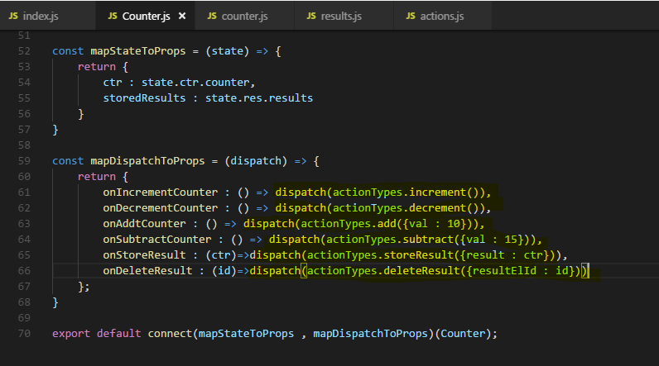

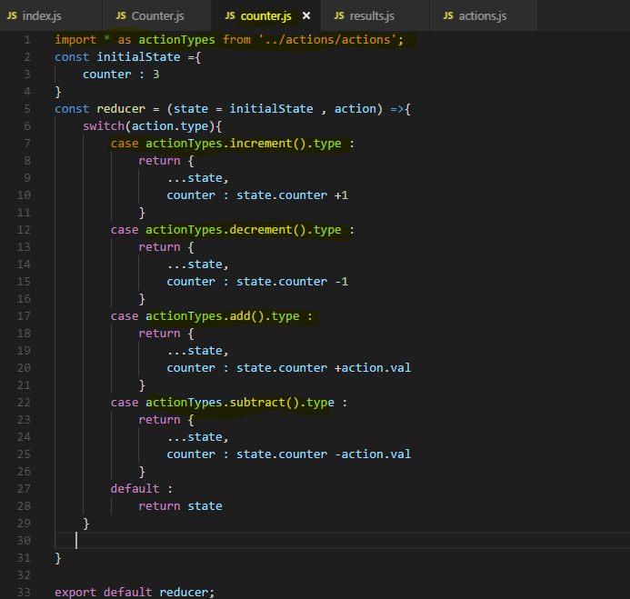

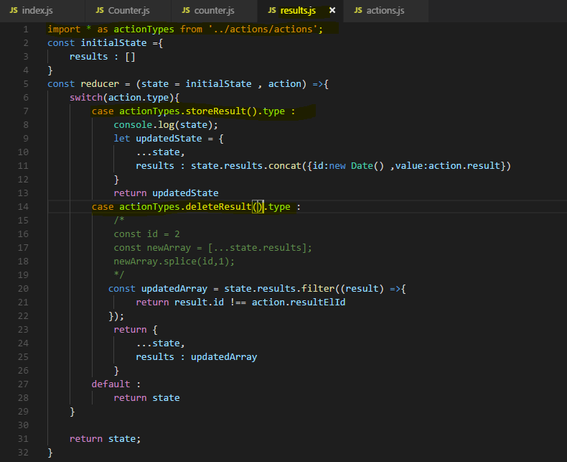

So now I click these buttons and we see indeed that we are successfully manipulating our store again, this time through our action creators though.

**Thus far, only synchronous code runs in them, as I said action creators are useful for handling asynchronous code**

so let's dive into asynchronous code next.

But let me also quickly elaborate on the question whether we should use them for synchronous code or not, the answer is it's up to you, it's a clean way of creating your actions, you have everything about actions in one file, you don't have to create the action objects anywhere else.

This is a tiny cleanup which can be considered good so nothing speaks against using action creators for synchronous code too but as I said, it will be extremely useful for asynchronous code.

## **Handling Asynchronous Code**

I want to take advantage of action creator to handle asynchronous code and to handle asynchronous code, we need to add a special middleware to our redux project, a third party library we can add called **redux-thunk**.

### **Redux-thunk**

<https://www.npmjs.com/package/redux-thunk>

**Redux Thunk**[**middleware**](https://github.com/reactjs/redux/blob/master/docs/advanced/Middleware.md)**allows you to write action creators that return a function instead of an action. The thunk can be used to delay the dispatch of an action, or to dispatch only if a certain condition is met. The inner function receives the store methods dispatch and getState as parameters.**

An action creator that returns a function to perform asynchronous dispatch:

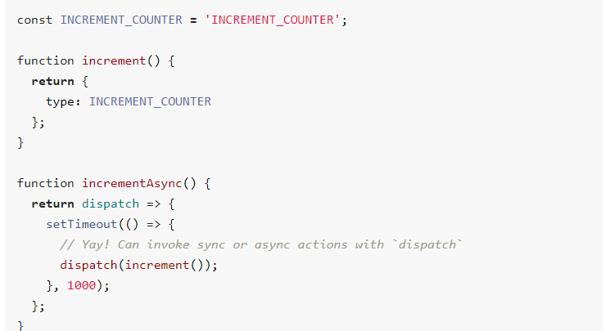

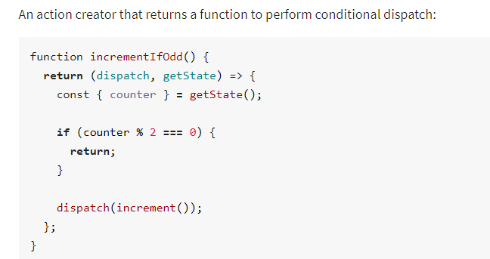

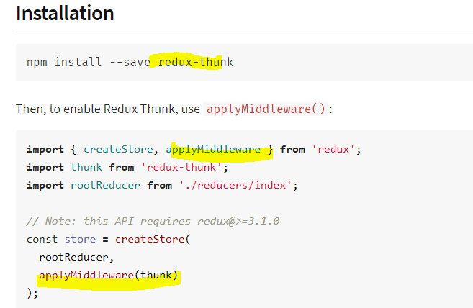

**React-thunk is a library which as I just said adds a middleware to your project which allows your actions to not or your action creators to be precise to not return the action itself but return a function which will eventually dispatch an action. With this little trick, not returning the action itself but a function which will then dispatch one, we can run asynchronous code because the eventually dispatched one part is the part which may run asynchronously,**

Lets Add react-thunk middleware to our project

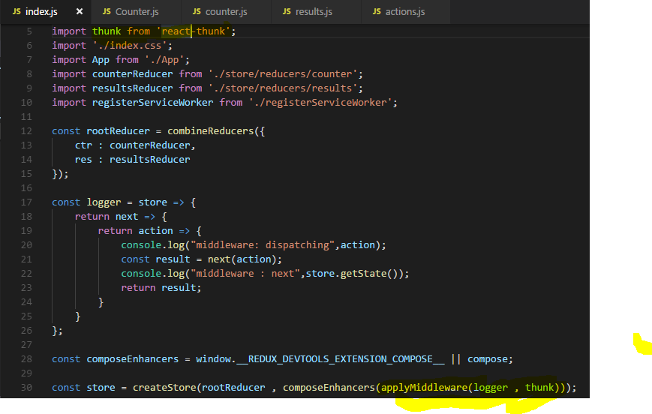

let's say in storeResult, we actually want to execute set timeout and only after 2 seconds

we want to store the result. So here in this function which gets executed, somehow in there, we want to return this action after two seconds to simulate that we previously or prior to this action reached out to a server to store it there and only update our state once this one's successful

**the function receives dispatch as an argument, the dispatch action, now we get dispatch in here due to redux-thunk. I said that middleware runs between the dispatching of an action and the point of time the action reaches the reducer, now the thing we do here is we still dispatch an action but then redux-thunk, the middleware comes in, steps in, has access to the action there, basically blocks the old action we could say and dispatches it again in the future.**

**Now the new action will reach the reducer but in-between, redux-thunk is able to wait because it can dispatchan action whenever it wants.**

**This is the asynchronous part and that is exactly allowing us to execute some asynchronous code inside of this function.**

**inside of this function passed to set timeout, we can execute dispatch to now dispatch whichever action we want to dispatch.**

**So what do we typically do is we create asynchronous action creators, which in the end dispatch actions created**

**by synchronous ones.**

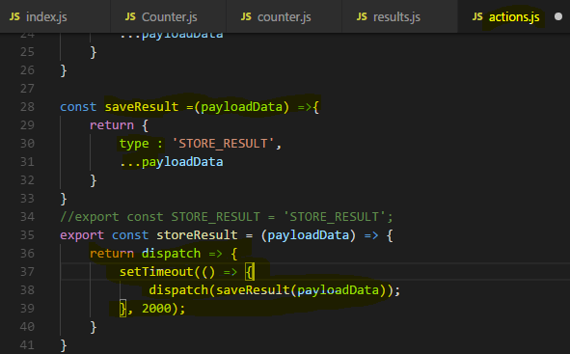

Now save the files and run our app. if I click storeResult here, you see that it took two seconds to actually print storeResult.

**So only the action dispatch in there after two seconds leaves a footprint because it's our synchronous action and only synchronous actions may edit the store. The other action creators like storeResult which runs some asynchronous code are only possible due to redux-thunk and are caught in between, they never make it to the reducer**,

**we only use them as a utility step in-between to run our asynchronous code which happens to be required to run on a lot of actions and then dispatch the synchronous action to change the state in the store.**

**with redux-thunk, that middleware, we could basically find a place to execute our asynchronous code when dispatching an action and block that original dispatching to then just dispatch another action, all that handled by that redux-thunk middleware once our asynchronous task is done.**

So this is how we can work with action creators to handle asynchronous code in our redux store.

## **Restructuring Actions**

**Note : I'll just export something from a file. I can do that so I don't even import it in this file, I just have one file, the index.js file which groups all exports from separate files, so that in the end I can always point to that file to import something from any of the file**

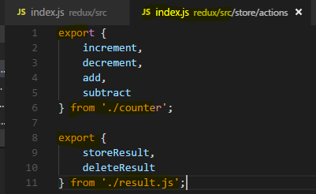

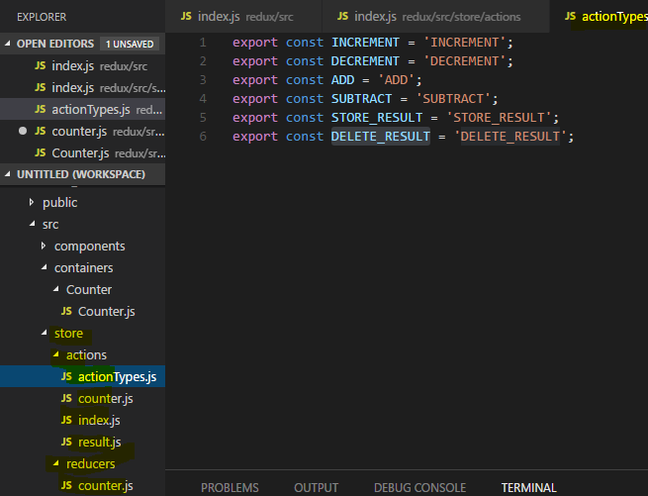

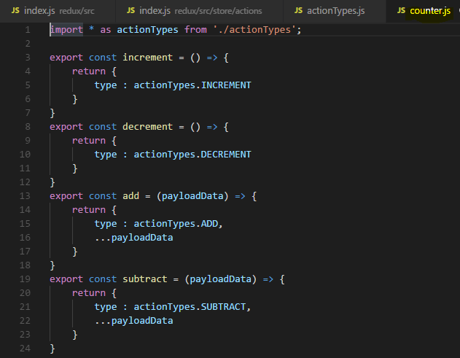

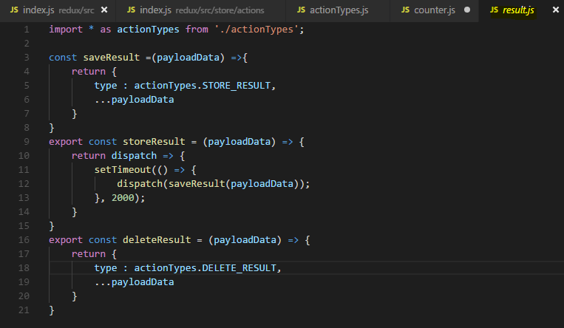

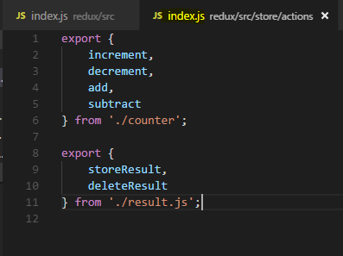

Now however with a bit more split up action creators over multiple files, as I said for this demo project overkill but definitely something you should keep in mind for bigger projects because what it allows you is that you have files with only a few action creators in each file which makes it easier to find that action creator you want it to change or check. So this is why I chose that setup and it is something I wanted to show you for your bigger projects.

## **Where to Put Data Transforming logic**

the only place where we can execute asynchronous code is in our action creator, it's what redux-thunk is made for and it's the common and best practice pattern if you need to reach out to a server to fetch data from it and thereafter store it in your store, definitely do that with the action creator.

**Sometimes we need to transform our data before update the state in Store**

where should you then change it?

**In the reducer ,you can of course also run some code before returning here, change data or in the action creator**

**Both works, what's better?** Let's take a closer look.

In the end, the question comes down to where to put the logic, we have action creators and reducers as options

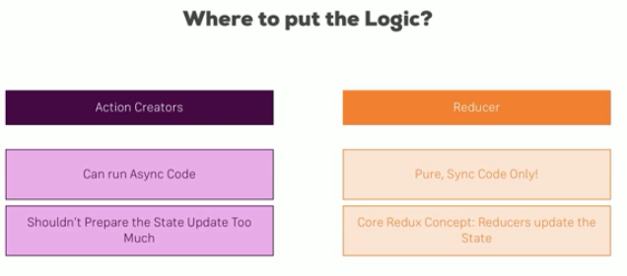

**action creators as you learned are great for running async code when you dispatch an action, reducers on the other hand only are able to run synchronous code and are pure, input in updated state out.**

**Reducers however keep that in mind, are meant to be the place where you update the state,**

**this is one core redux concept. Action creators are not core redux concept, a core concept are actions,these javascript objects with a type and a payload. So the reducer is the core concept and the whole idea behind redux is that the reducer is the only thing which updates the state, action creators shouldn't prepare the state too much for that reason because it should be the reducer which does the update but there of course is also a difference**

**between updating the state which essentially just means returning a new object which makes up our state and changing the data which goes into the state.**

**Still you can find arguments for both directions, I lean towards putting the logic into the reducer and not too much logic into the action creator. Asynchronous code has to go there but once you got back the data from the server you might need to reach out, you can of course transform it in the action creator and you should do that to a certain extent but once you've got data that is relatively clean, you should hand it off to the reducer. And if you then still need to manipulate it, for example by taking 8 times 2 or anything like that, in my opinion that should go into the reducer.**

## **Redux-thunk – action creator and getState**

redux-thunk can pass as an additional argument, getState,apart from dispatch argument

that is a method we can execute to get the current state.

Sometimes in your asynchronous code, you need to be able to reach out to the state prior to your to-be-

dispatched action,

let's say you want to save some data for a given user and you have the id of the user stored in your

redux state, you can then get it with getState,

for example here, we can get the old counter by executing getState here and simply accessing the counter

property, getState will give us the complete state which of course has a counter property

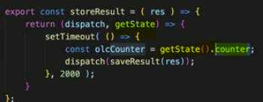

or to be precise

since our reducers make up the state and we have two of them,

we can get the counter just as in the counter container in mapStateToProps, we have to access ctr.counter.

So we can do that

here, .ctr.counter in the action creator, thanks to the second argument passed into it by redux

thunk.

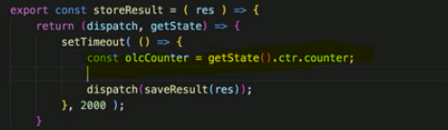

That's the old counter I get right before dispatching this event which then actually leads to the code

executed in the reducer.

if you need it, it's a nice utility function,

don't overuse it though.

I try to write my action creators and reducers in a way that I don't have to use getState, instead

you can pass all the data you need in your async action creator like the user id into it by accepting

it as an argument.

That of course means that you need to have access to the data you need in your action creator in the

container where you actually dispatch the action leading to the action creator.

So here storeResult which leads to the async action creator,

here we would then have to pass this user ID or whatever it is and for that,

we of course need to have access to that user id in our container.

But that is something we might be able to expect and we should build our app accordingly.

If you just can't do that or don't want to, you have getState as a fallback and you can use it,

just don't over use it.

Don't put too much logic in there, at least is the route I take in my bigger react applications.

## **Using Utility Function**

cleaning up that reducer file a bit more can be an idea and I say can be, it's not a must, it's optional it's a good practice I'd say but you don't have to do it.

So the first thing we can do is related to immutability,

we constantly update an object here in the end whenever we return a new state, what we do is we just return an updated object, we return an object which copies the properties of the old state and then replaces one of the properties. Now obviously, we can absolutely do it like this but **we could create utility functions for that , this would then allow us to call this utility function and save some code here,**

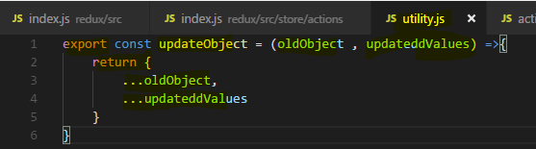

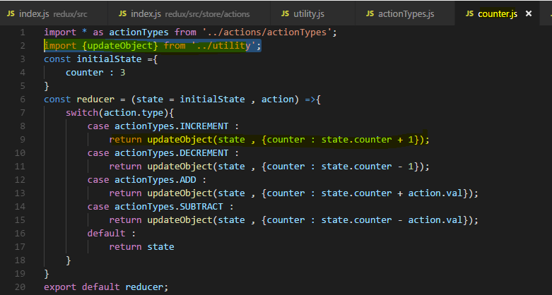

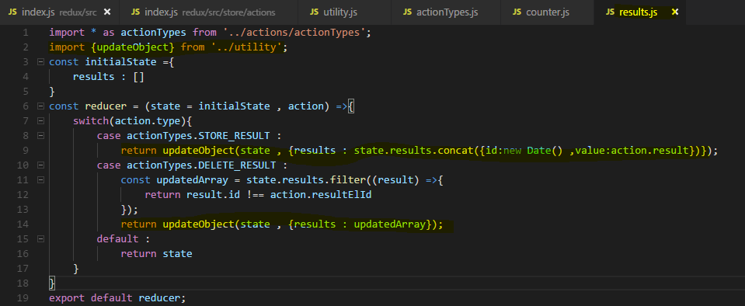

**We can even make our switch case More Leaner** 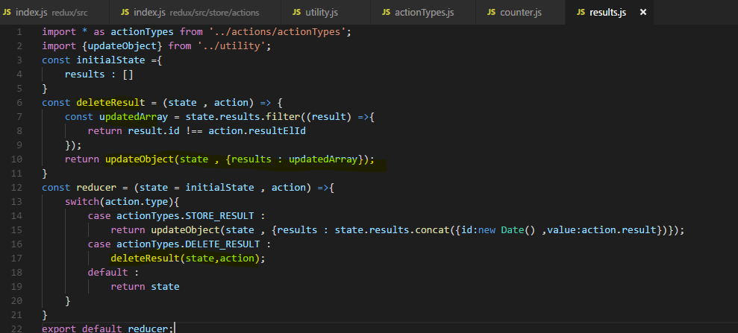

## **Alternative Folder Structure**

**As your store grows, you might add more and more action and reducer files and you'll notice that some of your reducer files refer to some container and other reducer files to another container.**

**For that reason, in an alternative project structure, you could create a store subfolder in every container and then only add the reducer and the actions for that given container to that store. And if you had more containers, each container folder had a store folder, you wouldn't have that global store folder and you would have a lot of actions and reducers for each container which you then still combine together in your index.js file though.**

So this is an alternative,

you can also mix that with a global store for some global or shared operations you might need everywhere, that really is something you can fine tune and where you can read a lot of articles with a lot of opinions. for many projects, the approach shown here with a central store folder should be fine but be aware that you're free to deviate from that when needed.

## **Useful Resources & Links**

* Middleware: <http://redux.js.org/docs/advanced/Middleware.html>
* redux-thunk package: <https://github.com/gaearon/redux-thunk>
* Async Actions: <https://redux.js.org/advanced/asyncactions>

[https://redux.js.org/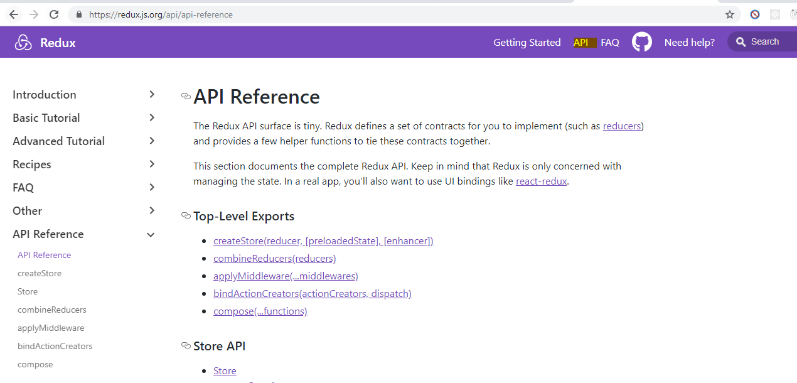](https://redux.js.org/)

you can learn more about possible alternative practices and best practices here.

**Now most of the content covered on this page has been covered in the basics and this advanced module though, so no need to dive right into it right now and go through all of that, just see it as a fallback page you can go ahead and look at if something is unclear or there is some use case where you are not sure how to handle it.**

**One especially useful resource I want to point you to though is the immutable update patterns article here under recipes, on the redux page.** If you click on it, you'll read more about how you update nested objects and arrays immutably, this can be tricky since you have to go down to all nested levels. If you have an object with an object with an object inside of it and you want to change something in the deeply nested object, you have to clone all three first as shown here before you can actually update something immutably and you can see some patterns and examples in this article that might be a great help to make sure you're updating everything in the way you want to update it.

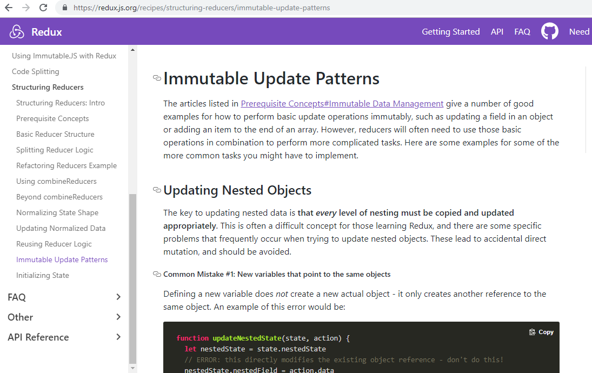

# **Redux Advanced : Burger Project**

## **Installing Redux Devtools**

I want to add to our code are the redux dev tools. We installed that extension for the browser in the last module now we want to set up the store here in our burger builder application such that we can use the dev tools there too because I want to be able to analyze my store.

For that, I'm back on the redux dev tools extension github page with the installation instructions and there's one difference to the set up we used in the last module, though we'll go back to that set up from there.

Right now we don't use any middleware, so we don't need the advance store set up where we need it to create this composeEnhancers constant and use the native compose function or those special variable passed by the dev tools, since I got no other enhancers

right now, we're not using any middleware yet, we can go with the basic set up for now

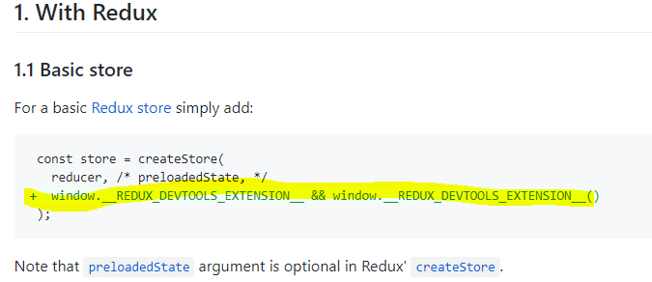

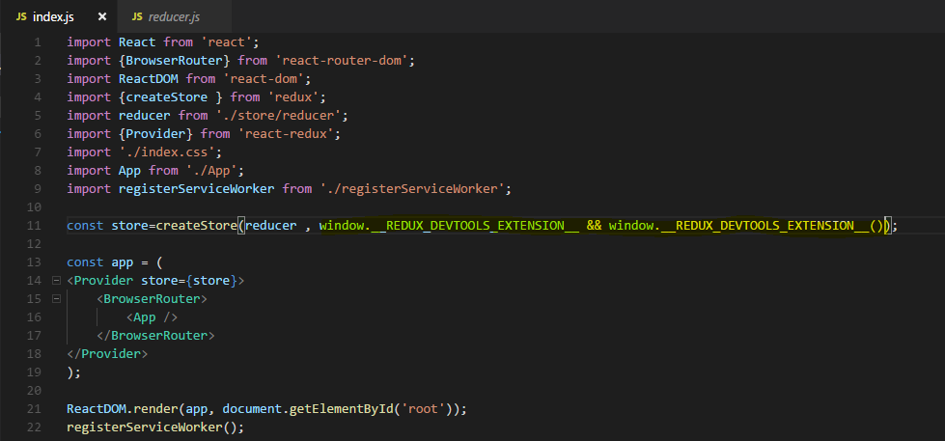

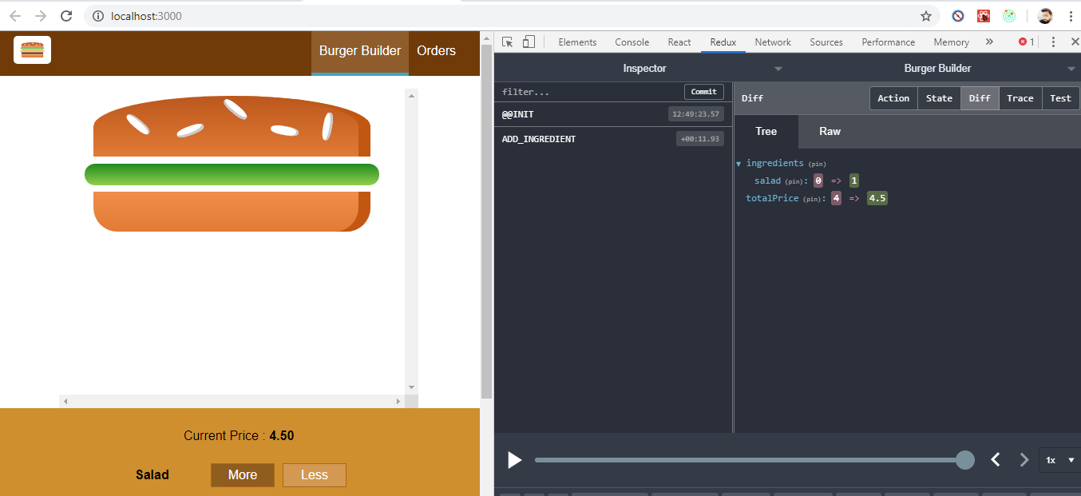

## **Creating Action Creators**

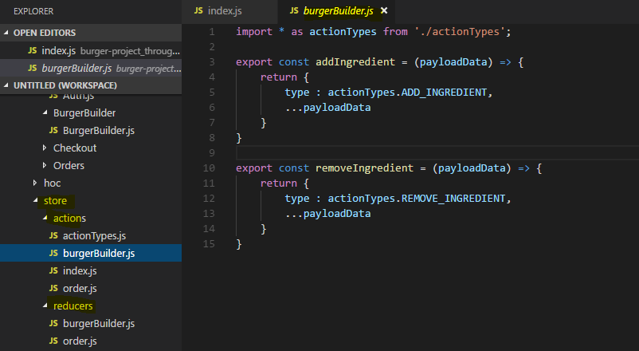

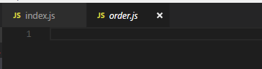

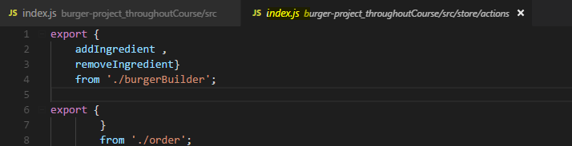

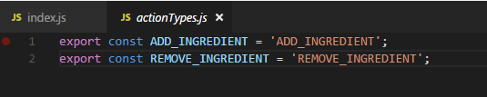

import * as allActions from '../../store/actions/index';

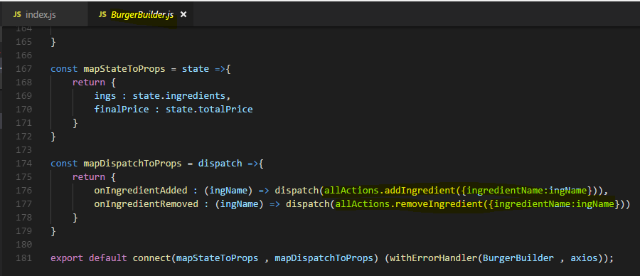

## **Setup : Executing Asynchronous code**

Right now, we're handling only synchronous code though but I mentioned that the idea of course is to use asynchronous code in there too, at least when it comes to handling orders. Before we do that, we get one piece of asynchronous code we can execute right away though, in the burger builder container, we used to fetch our ingredients in

componentDidMount .

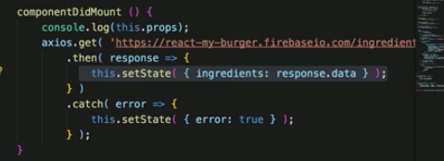

Now is the time to again fetch this and there are two routes you can take -

**1) in componentDidMount where we reach out to our firebase backend, where we fetch the data and instead of calling this.setState here, you could dispatch some actions from BurgerBuilder Container passing ingredient data(payload) to action which eventually trigger that action in reducer , which updates our ingredients in the redux store.**

**Then you would run the async code in your component and you wouldn't need action creators at all because you just dispatch normal actions at the end once the response is there.**

**2) Using action creator -**  the idea behind action creators is that you can still put your async code into the redux world and as I mentioned earlier, this is the route I want to take here.

For that, I first of all need to install

**redux-thunk**

**That's this middleware which allows us to use asynchronous code in action creators due to the middleware wrapping itself around the dispatch action and blocking the request until the async code is done.**

**Now we have middleware so we need to do advance setup of redux devtools**

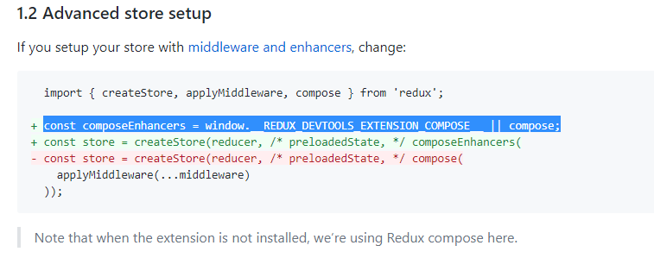

compose allows us to compose our own set of enhancers and middleware is just one kind of

enhancer, the dev tools would be another example.

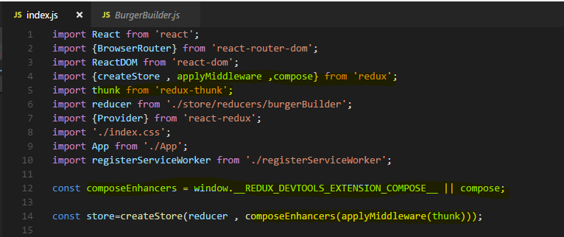

## **Important : Fetching Ingredients Asynchronously**

We will firstly define our actions in Action creator

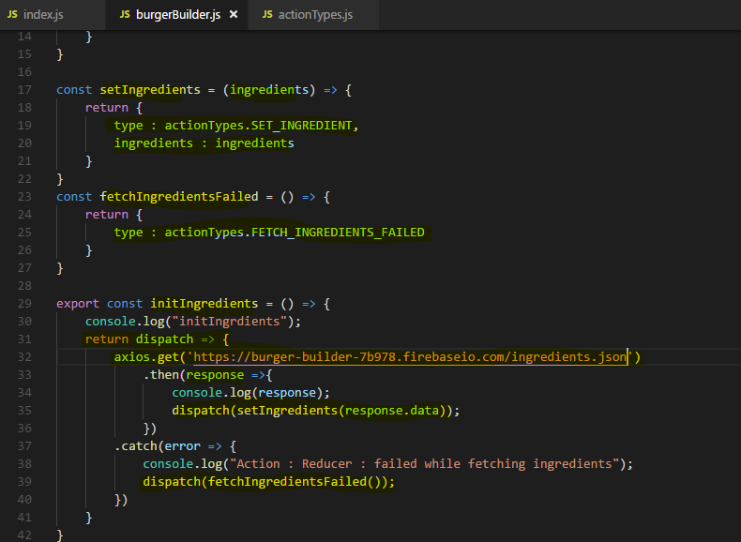

**Here we define an action creator initIngredients , there we do asynchronous call to get ingredients from server. We can do this because of middleware redux-thunk , which blocks the dispatch until asynchronous call doesn’t complete and then dispatches an action which finally reach to Reducer.**

**If ajax call succed then we dispatch an action setIngredients with type :“SET_INGREDIENT” and it will finally reach to Reducer and update the state.**

**If ajax call fails then we dispatch another action fetchIngrediensFailed with type:”FETCH_INGREDIENTS_FAILED” and it will reach to reducer to update the state.**

**Lets see the updated Reducer**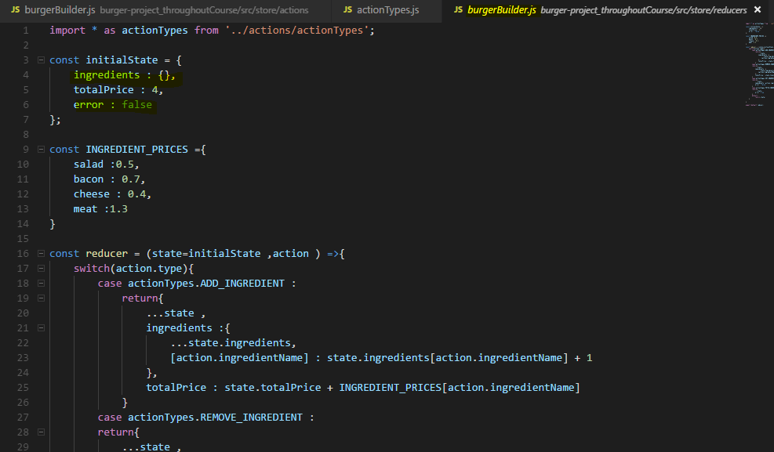

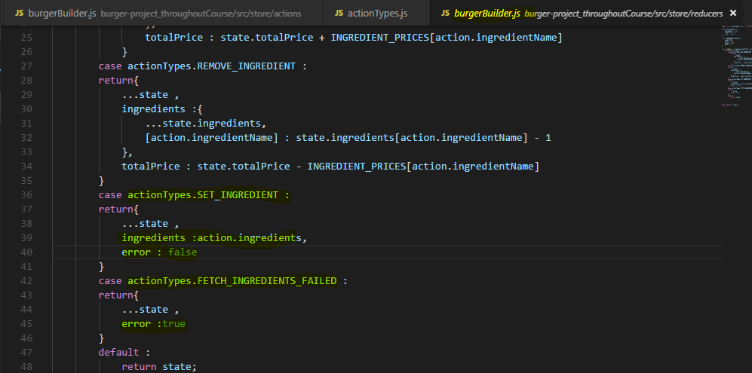

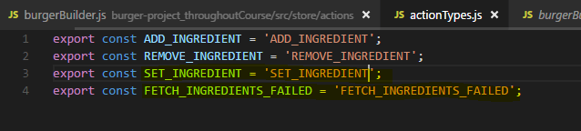

**now one other thing we have is we never dispatch our initIngredients action, this one which actually reaches out to the web, we never dispatch this so this will never get initialized.**

**So I also want to be able to dispatch that from the burger builder**

**So I'll add a new property here to mapDispatchToProps to Dispatch initIngredients Action.**

**So that it will be available as a props to this component and we can call or trigger it.**

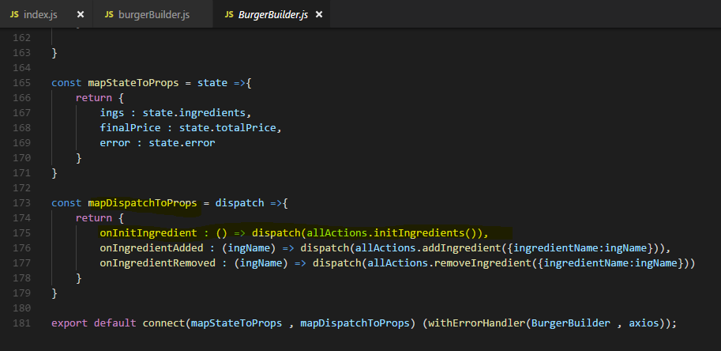

**Now the last step is to call onInitIngredient in our componentDidMount method here,**

**Previously we call an action on button click but you know we call this anywhere.**

so there I will now execute this.props.onInitIngredient, like this and this should execute this, dispatch this action and hopefully successfully fetch our ingredients.

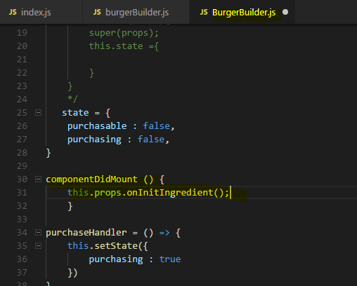

**Now we can see we indeed get the initial ingredient from server and we trigger that action on componentDidMount()**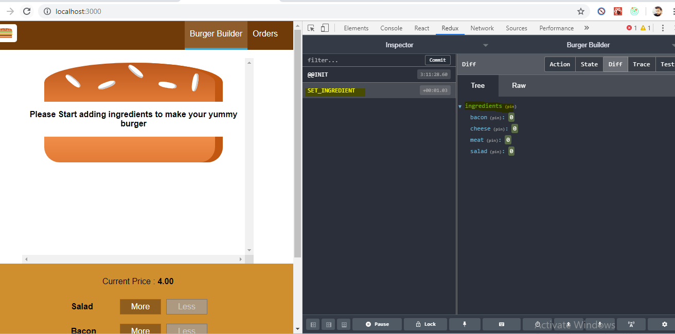

## **Changing the order of ingredients manually**

If you want to change the order in which ingredient shows, not as it is present on server you can change it manually like this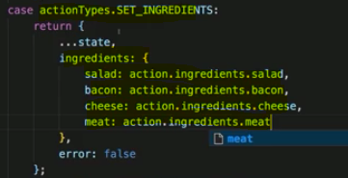

## **Important : Working with Order Container and Redux**

Lets define actions for placing orders -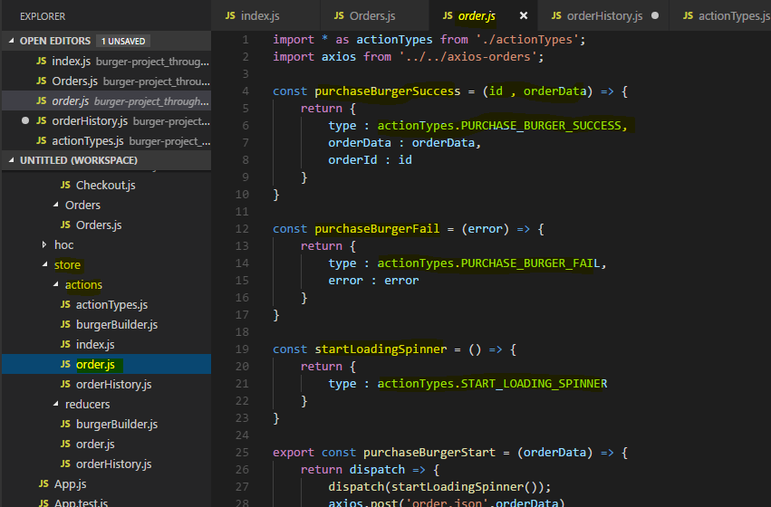

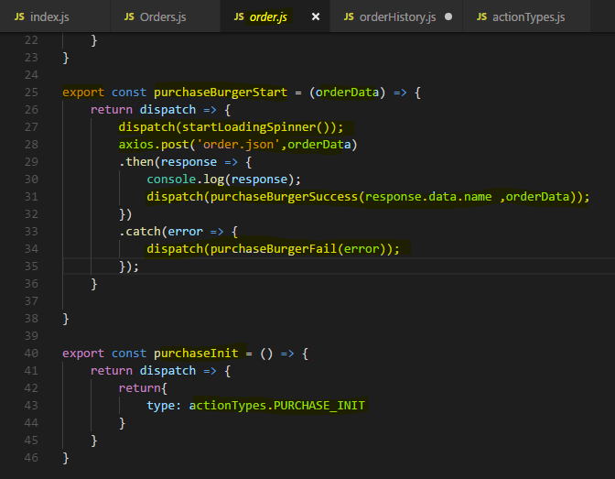

**Lets handle different actions and state for ContactData Container in order Reducer**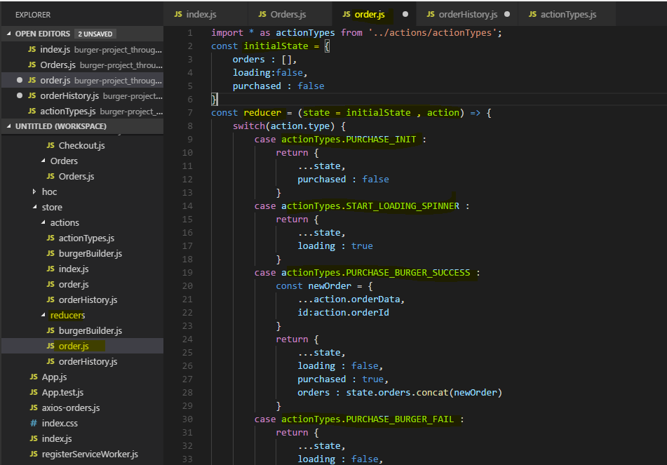

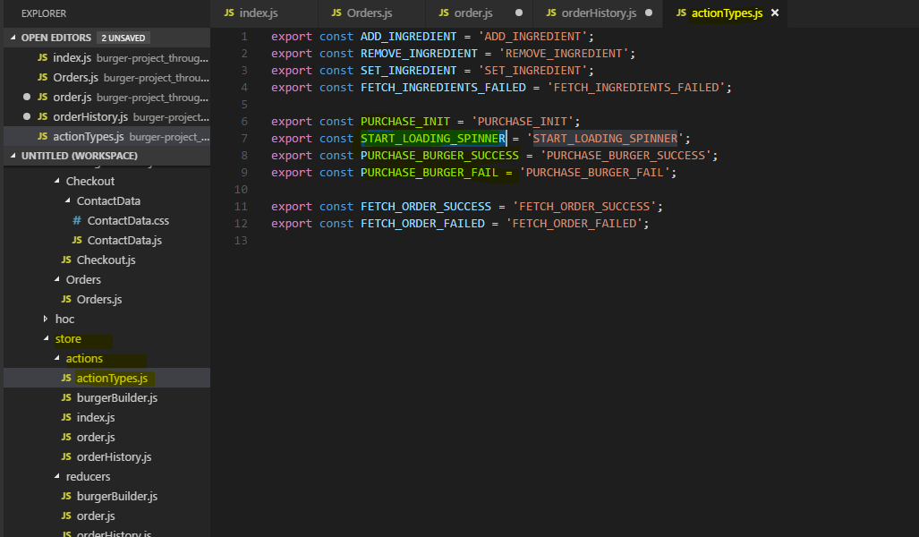

**Now we need to combine Reducers because now we have multiple reducer handling different slices of State . So Combine these into one Root Reducer**

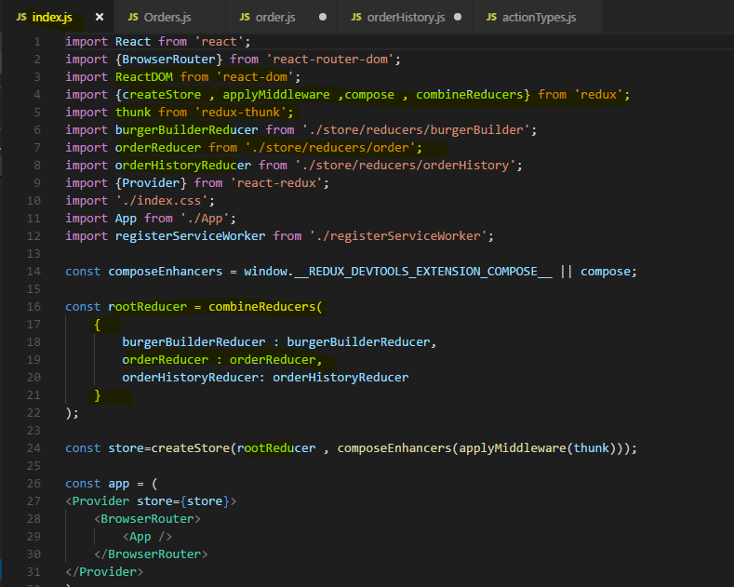

**Lets connect our Store to ContactData Container and get and update the Store State**

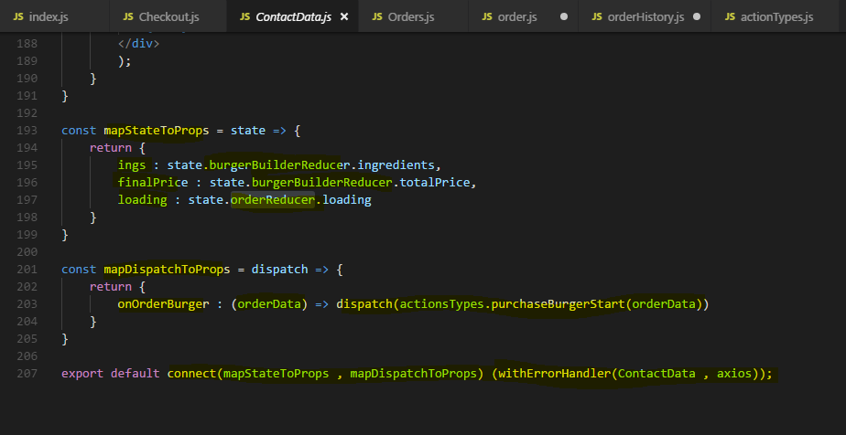

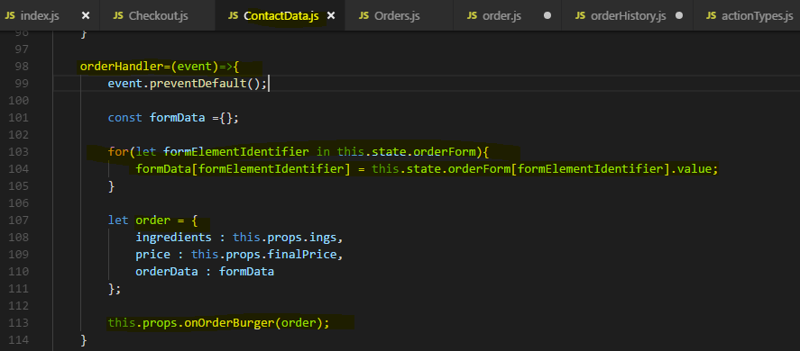

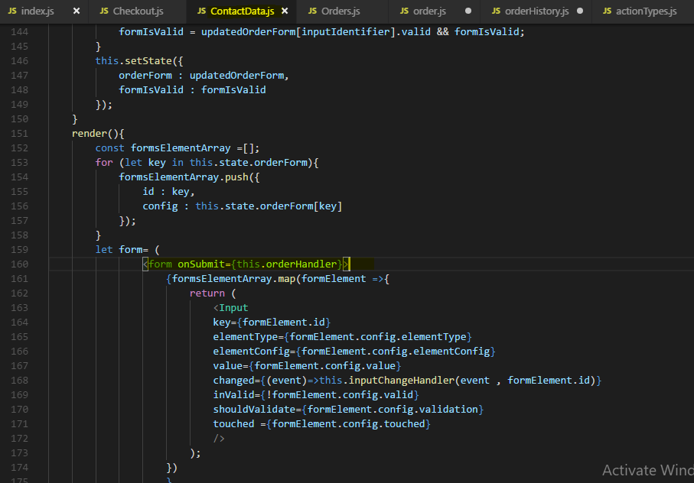

redirected once we placed an order. Now there are various ways of implementing redirection, one thing is you could pass a reference to that router history prop onto your order action creator and when you dispatch burger success or fail, or at least for the success case, you could then use that if you receive it as an argument in this function to call the push method on it.

I don't like this approach too much though but you can definitely do that. Now the approach I'll use is a redux only approach

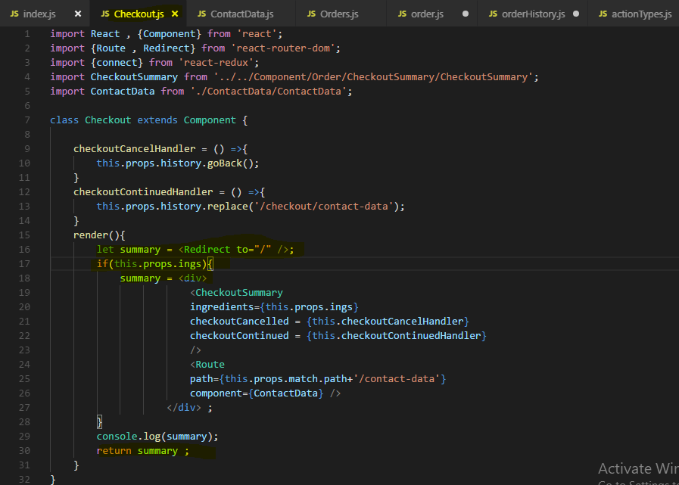

### **Resetting Price after purchase**

**We can see that once we purchase an order and we directed or go back to our root page the price were not reset to initial price. The price shown still pointing to the price of last order calculated.**

we can easily fix this.

In the burger builder reducer when we call setIngredients and update the ingredients,

we simply also have to update the total price and we could get this value from a server too or we simply hardcode it to form which is our initial price up here too.

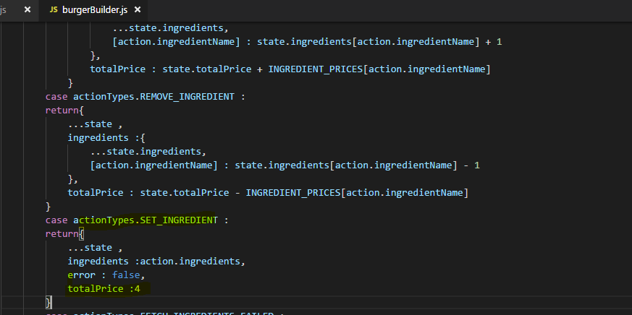

## **Fetching Orders history via Redux**

Lets define actions and handle this in Orderhistory reducer.

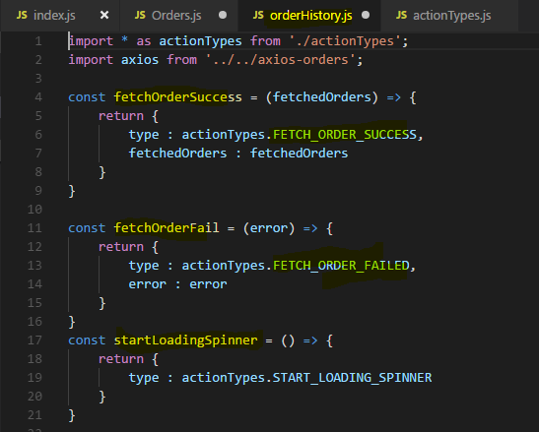

**Here We used redux-thunk middleware to do Ajax call**

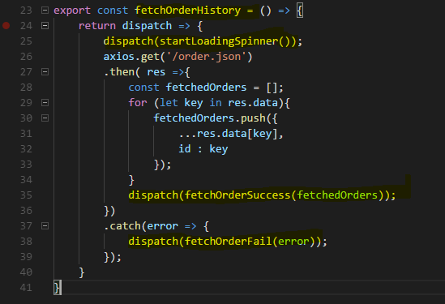

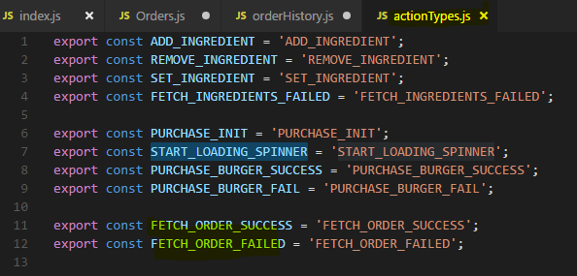

Reducer - 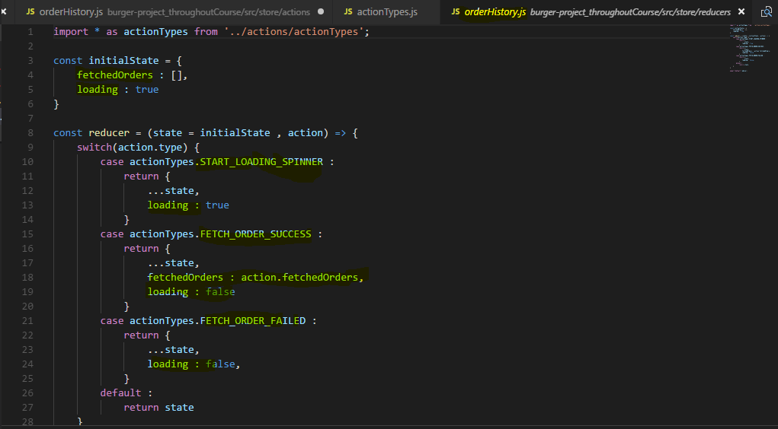

**Now Combine this reducer too in root reducer in index.js file**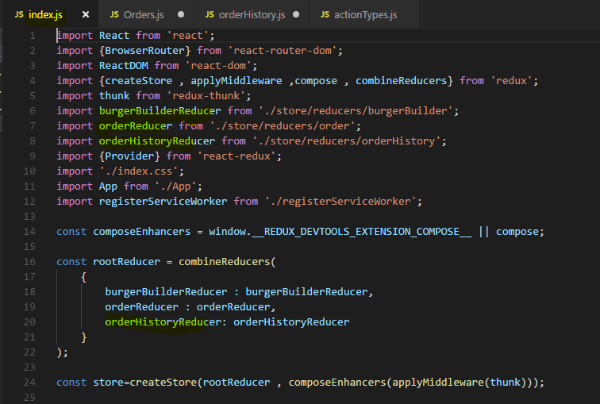

**Now lets get the Store state and dispatch actions from Order container**

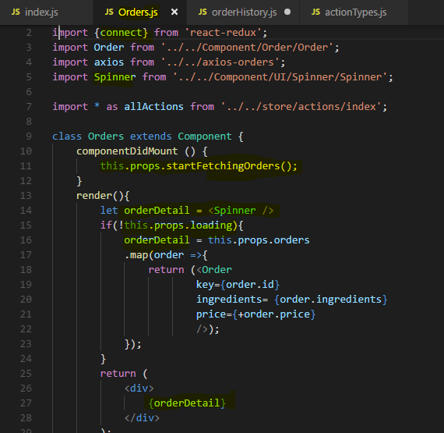

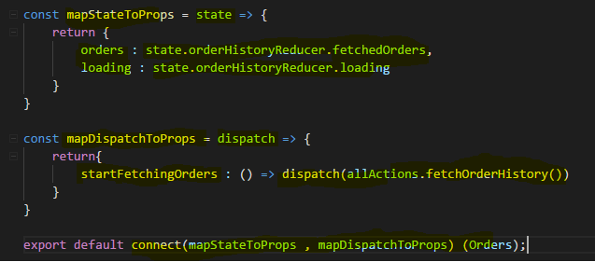

## **Refactoring Reducers**

to clean up this reducer

and make the switch case statement a little bit leaner

Lets make a utility functions for that

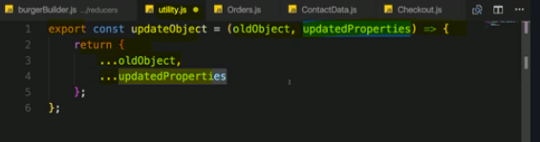

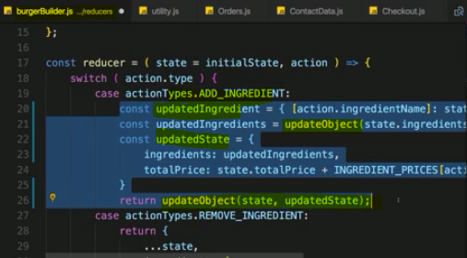

Making reducer more leaner –

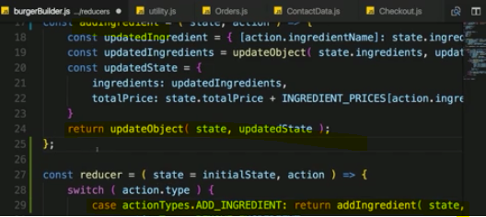

# **Adding Authentication to Burger Project**

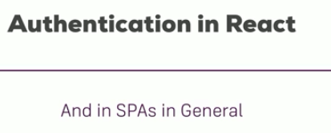

**I want to show you how this would work in a react single page application, because if you have a multi-page application where you render different pages for different requests from your server, you handle authentication in the traditional way of having a session on the server and returning different pages after checking the validity of the user or the authentication status on the server.**

**Now the special thing about authentication in react is that you have only one file and thereafter, you get no new file, so you can check the authentication status of the user on the server but not on every request, at least not in the traditional model.**

## **Authentication in Single page application (SPA)**

We have a server and we have our single page application running in the browser.

**Now the single page application sends the authentication data to the server because we probably have a sign up or a sign in page in our SPA and therefore we get data like the e-mail address and the password and we send this to the server to validate it there because such logic obviously always has to happen on the server and this is also where we store our persistent data, in the database on the server and the server doesn't have to be firebase as in our project of course. This can be any server, any restful API to be precise, this is what we typically communicate with when using single page applications.**

**That server then send something back and you could think that's a session but since the server in a SPA world typically is a stateless restful API, we're not getting back a session because the server doesn't care about the different clients connecting to him.**

**Instead we get back a token, you can think of that token as a javascript object and code it as json, json web tokens are the typical form of tokens you get.**

**So it's a javascript object in the end you can say and this javascript object now has to be stored on the client, for example in local storage. We could also store it in our redux store but there, it will be lost when ever the user refreshes the page.**

**So we typically use local storage since that persists page refreshes and allows us to fetch that token even if the user did leave and revisit our page, so that we can leave the user are logged in if we want. And what do we need this token for then?**

**Well, imagine we're making requests to some protected resource on the server, like for example we tried to change our password or we want to create a new blog post, such requests of course are only allowed to authenticated users and since we don't constantly check the authentication status on the server, we have no session there.**

**We pass the token along with requests to such protected resources, that token and that's important is created by the server and in a way that the server can verify if it's a valid token created by the server or not.**

**So that we can't fake such a token on the client, we can't create it there and send to the server, that would not work. Only the tokens sent by the server is accepted on the server.**

**So this is how we then authenticate ourselves on subsequent requests after receiving that token and that's the pattern we're going to implement in this module.**

**Now as I said, we'll use firebase here since we used it as a backend because it's so easy to set up but that pattern is going to be the same no matter which backend you use, as long as it's a restful API.**

## Required App Adjustment

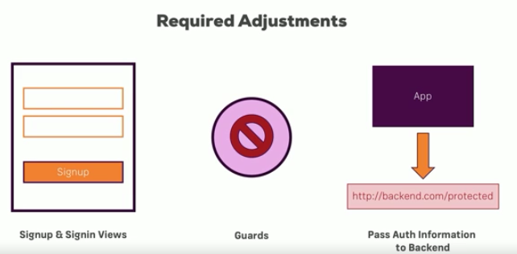

## **Adding an Auth Form**

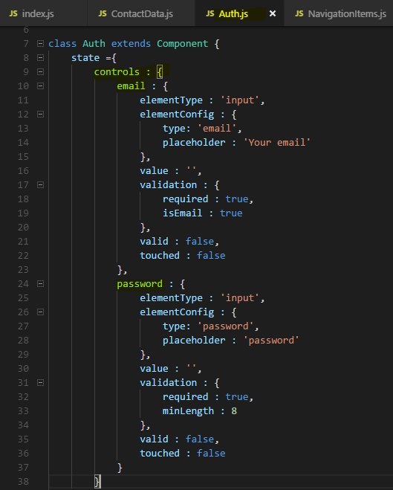

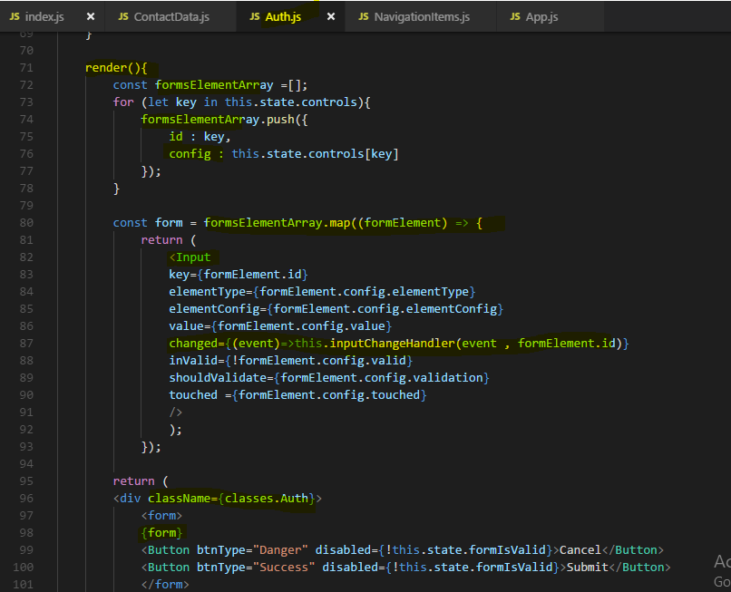

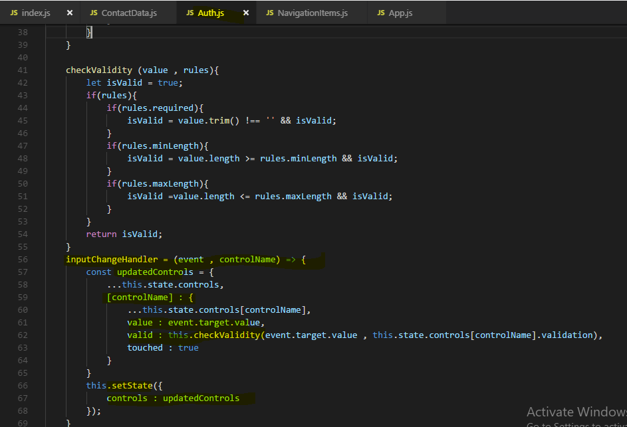

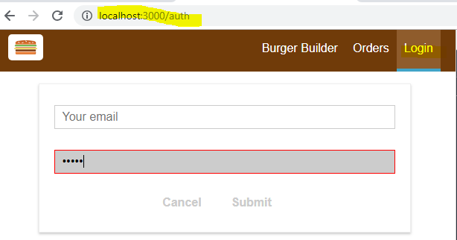

## **Adding Actions**

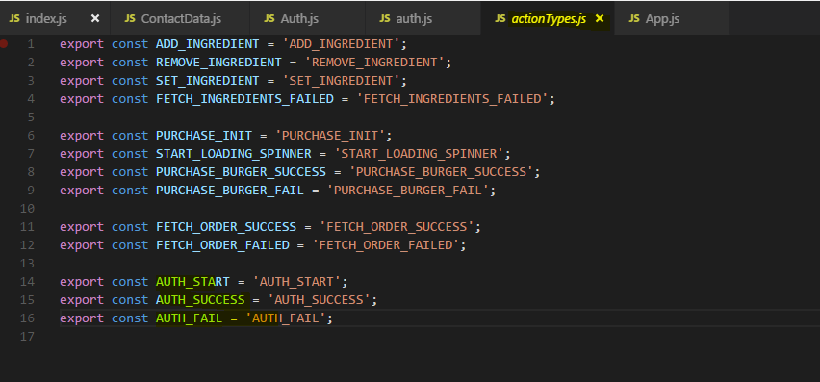

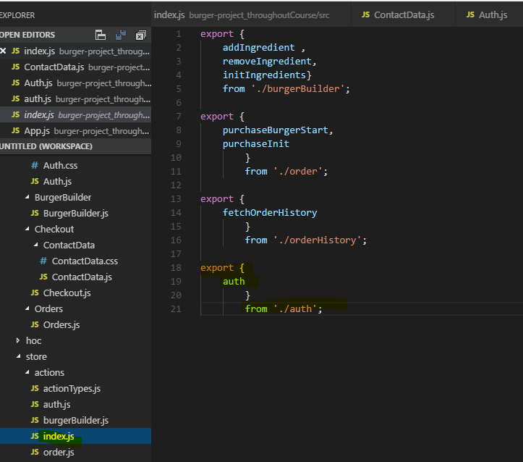

**Now in Auth Container**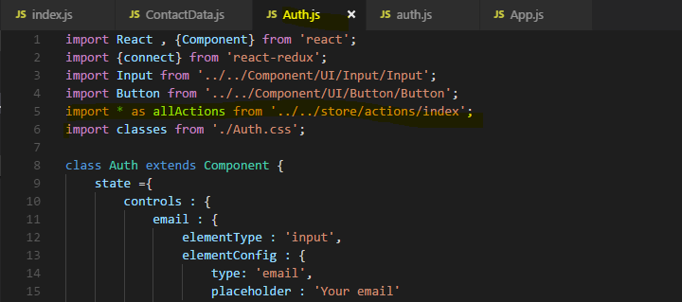

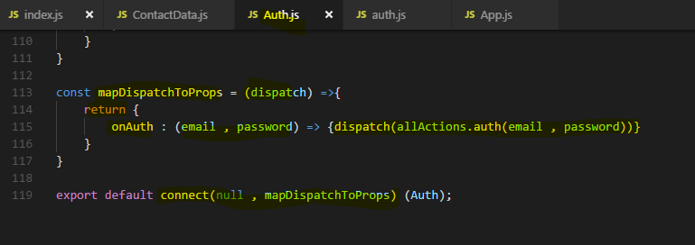

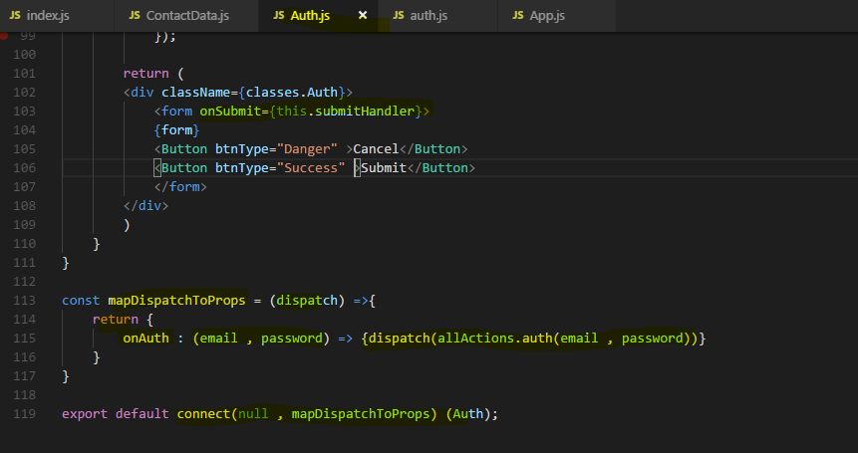

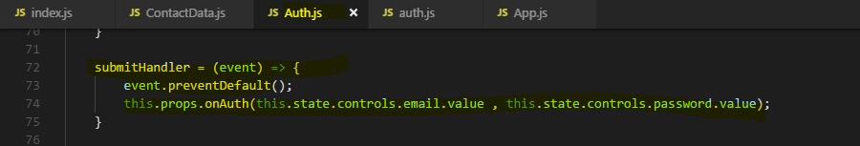

## **Getting token from Backend**

So the goal is to now get a token from the backend and we're using firebase but the approach of course works with any backend given that the backend has appropriate API endpoints to connect to.

firebase, the easy to use backend we are using gives us authentication out of the box.

If we click on authentication there, we have to set up a sign in method and there, I can choose e-mail and password, this will store the user data in our own firebase project. I click on enable there and save this and now we can reach certain rest API endpoints to sign up users and get a token.

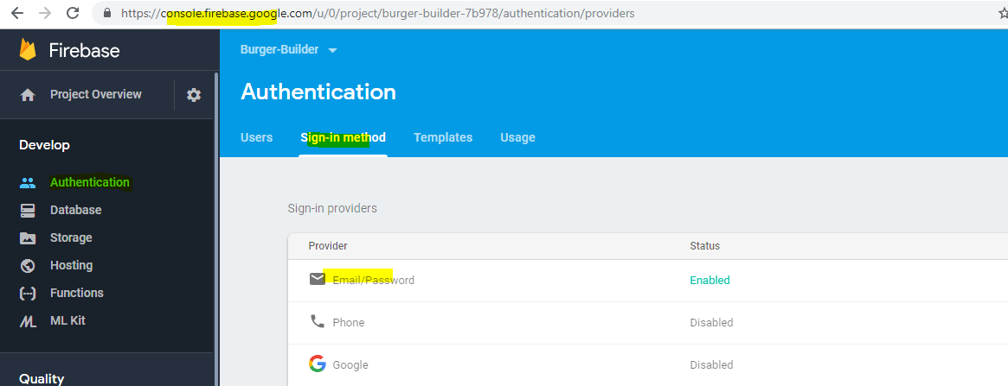

To find out to which address we need to send that, it's not our database address we used thus far, we simply can google for firebase rest auth. and here it's a second result, the firebase auth rest API.

Here you find to which API endpoints you can send your authentication data to sign a user up or in,

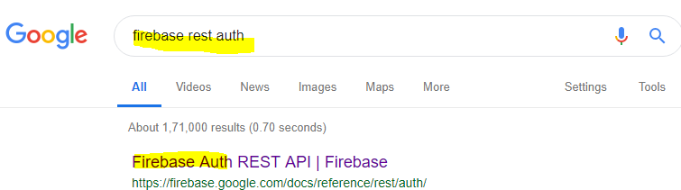

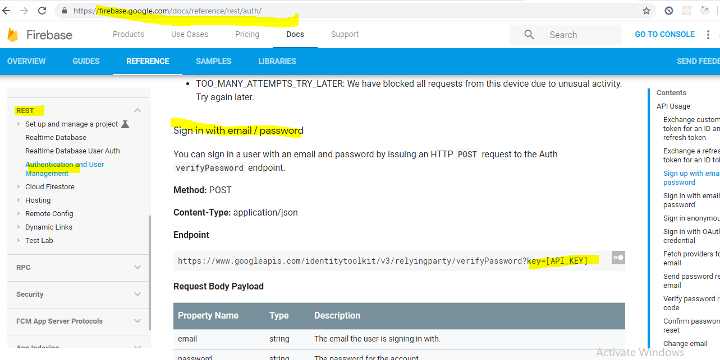

**Now to get the key -** 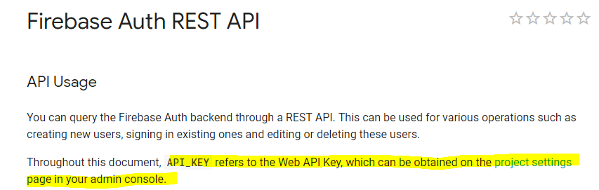

**So for our project on Firebase -** 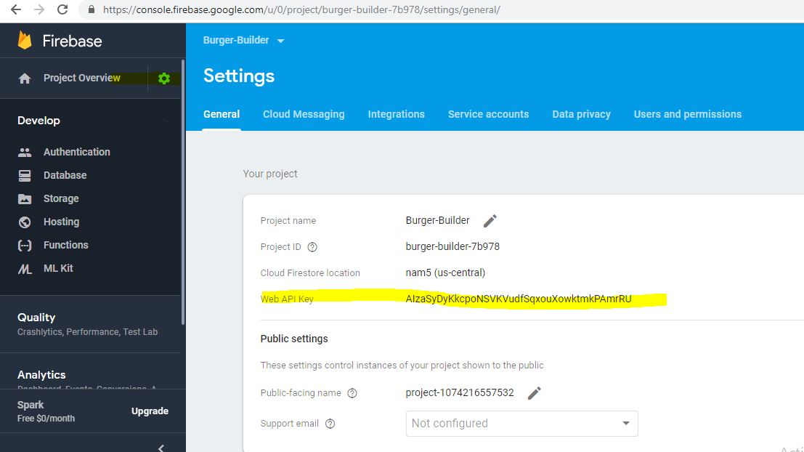

### **SignUp/SignIn**

Now passing POST data , what do we need to pass -

**Signin api – It will verify the password for this email and send the response**

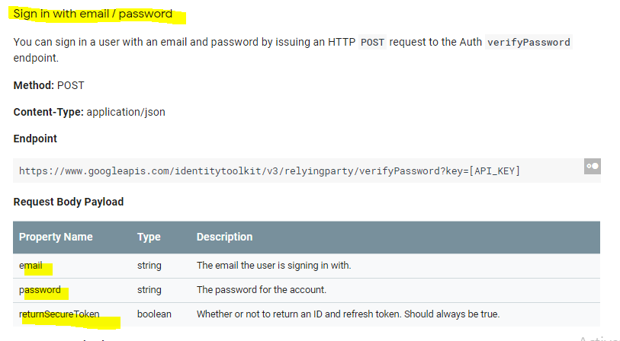

**Signup Api – It will add new email and password on server**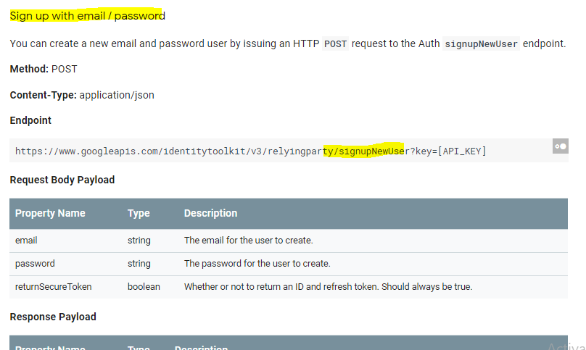

**Also add a new button to toggle the Mode to Signup to signIn and vise versa.**

**Now to handle this toggle lets add Boolean flag to state. which url (signIn or SignUp ) will be used will depend on this flag .**

Lets implement this - 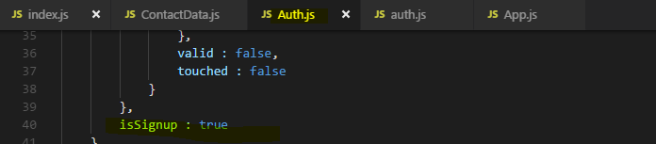

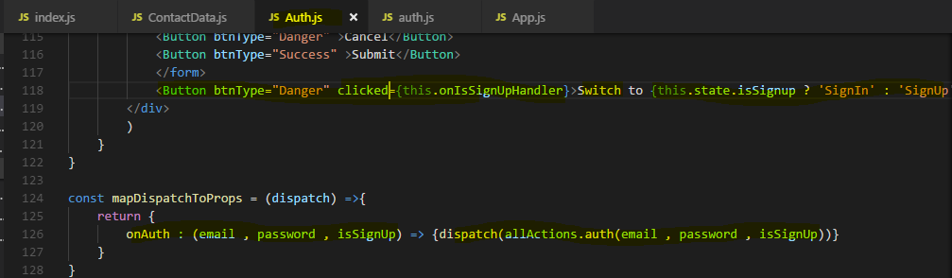

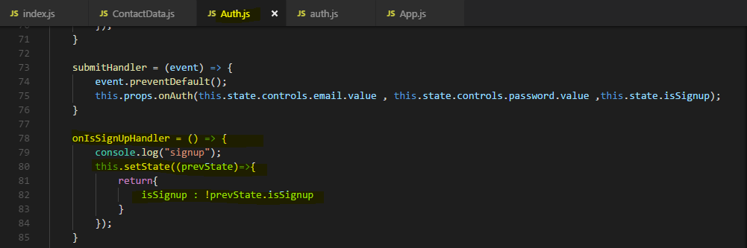

Now lets see Action file - 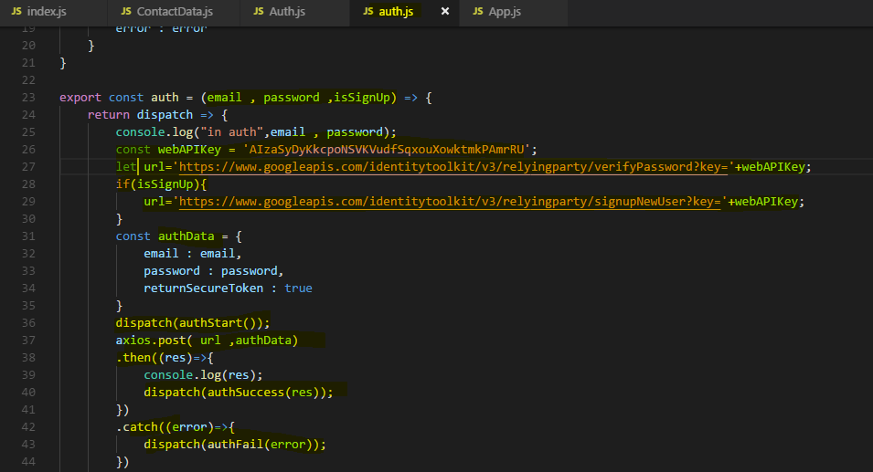

**Response on successful SignIn**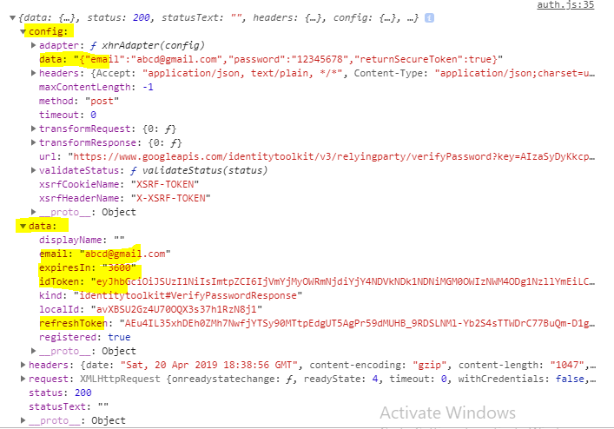

## **Storing the Token**

We got the token and all that information when signing up and signing in, obviously we want to store this to be able in the future to also access resources on our server which are protected.

**Now for storing the Token which we got from Server lets define auth Reducer and the state for the reducer.** 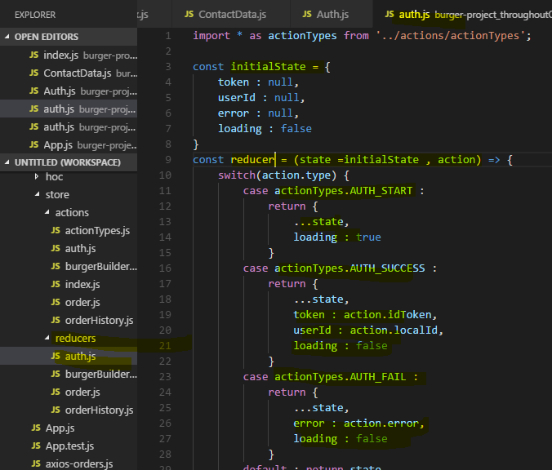

**Now we need to dispatch this information from actions**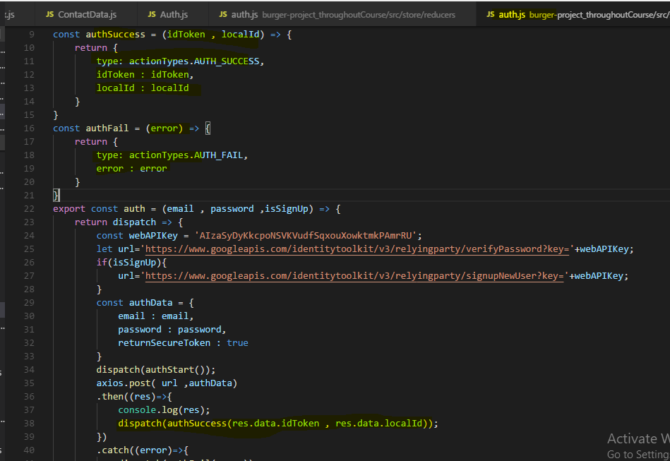

**Now add our auth reducer to store by combining multiple reducers**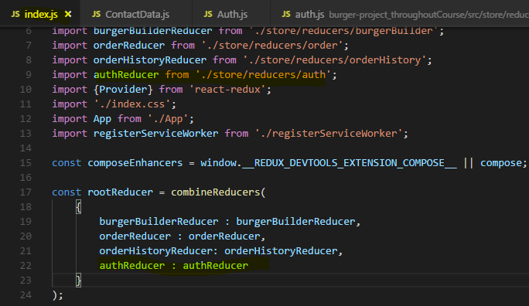

Output - 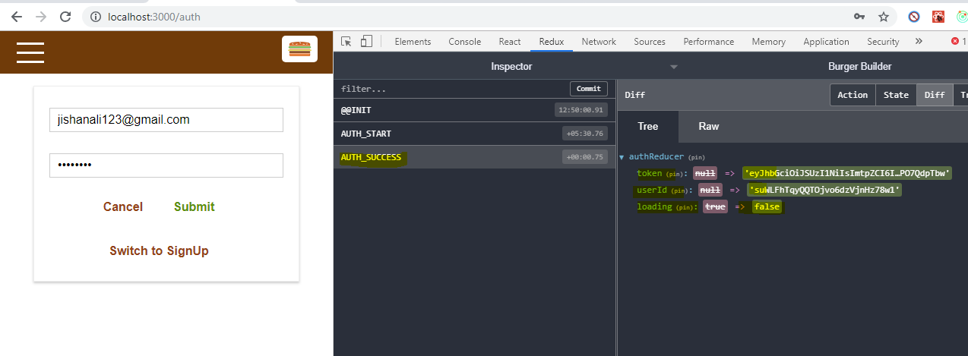

## **Adding a Spinner while SignIn/SignUp and Adding Error message for Wrong credentials**

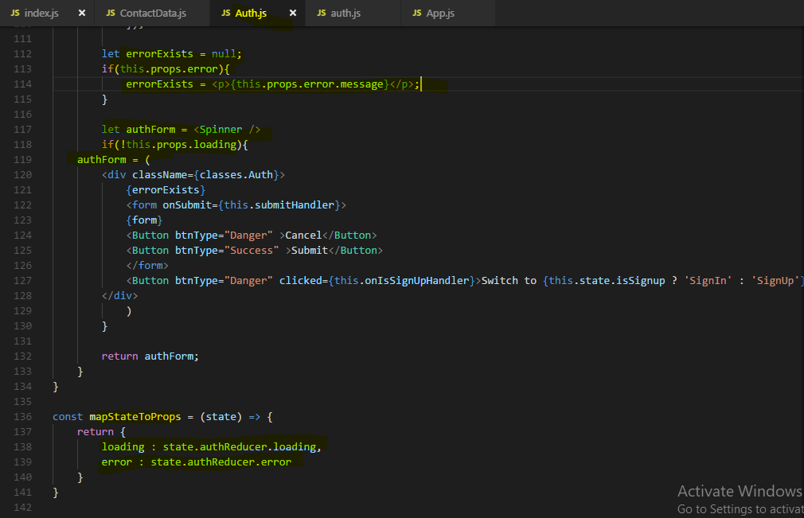

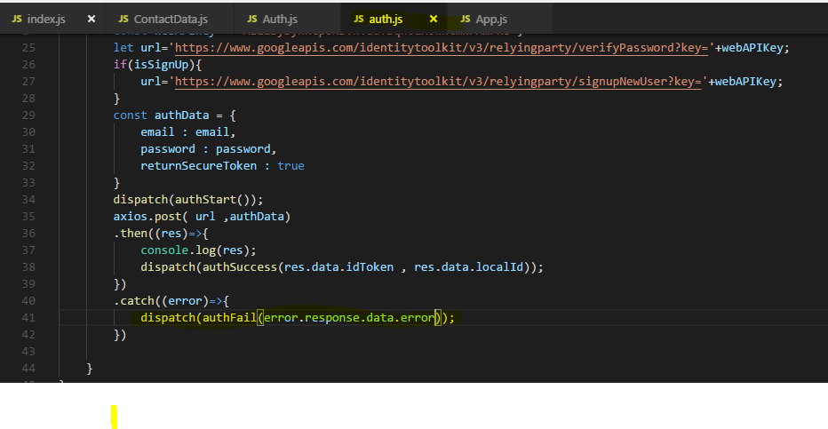With this, if we save everything and we submit an empty form, we get invalid e-mail, if I now use that e-mail which we already have in use and I'm not signing in but signing up, we get email exists.

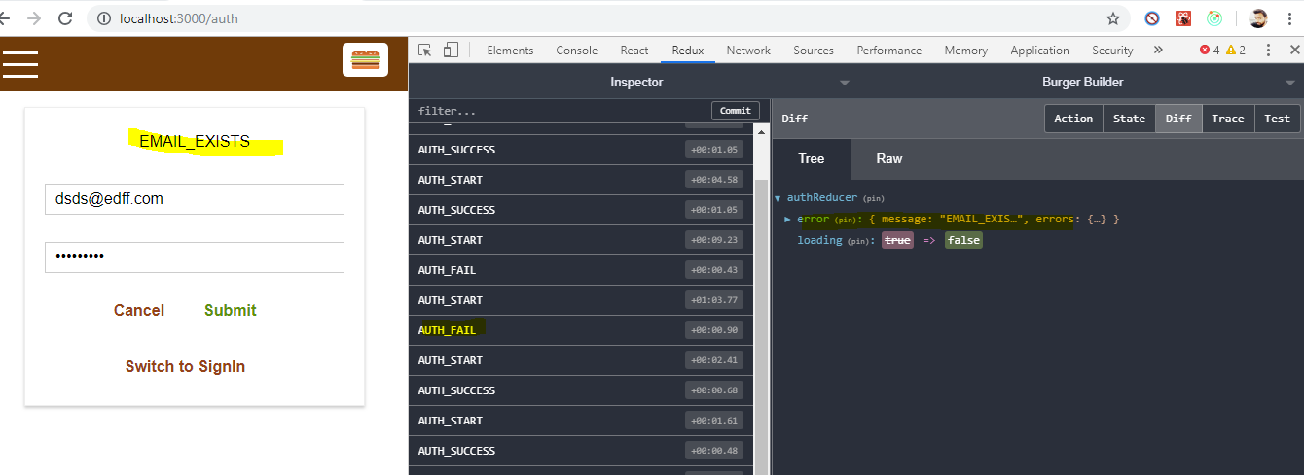

Now this clearly is not a nice error message, it would be nicer to get nice text we can easily read, I guess it does say what's wrong though. You can of course map these codes to your own error messages, it is something I won't do here for now but definitely something you can keep in mind as an improvement, map this to your personal favorite e-mail address.

You can always find out which potential errors you can get by having a look at the firebase auth rest API documentation here and there, you see common error codes like e-mail not found, invalid password or for signing up which we currently tried, that would be e-mail exists, too many attempts or invalid e-mail as you just saw.

## **Accessing protected resources with Token**

let's turn our heads towards using that token to make requests to protected resources.

That's of course a typical use case, you have a backend with certain API endpoints which should only be usable by authenticated users, right now in our demo backend with firebase, that's not the case though. If we have a look at database which gives us our endpoints in the end, all the endpoints so all requests being sent to that URL and then any nodes nested beyond that are basically available to everyone.

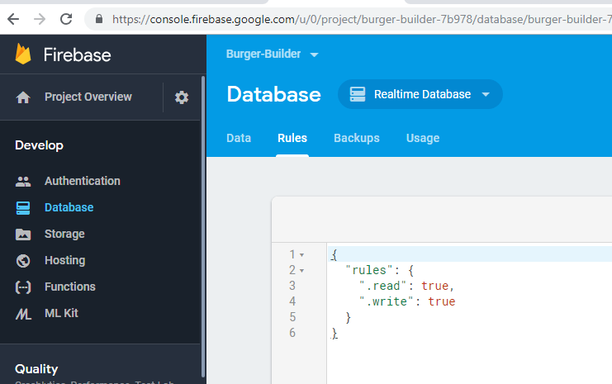

**for your own backend where you write your own API code, you probably have some if check where you check if some valid token is attached to the request and you simply return a 403 answer if that's not the case.**

**now actually I want to give access to ingredients for everyone and just make access to orders only available to authenticated users.**

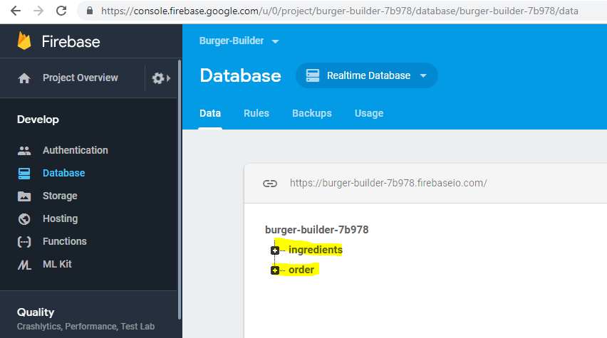

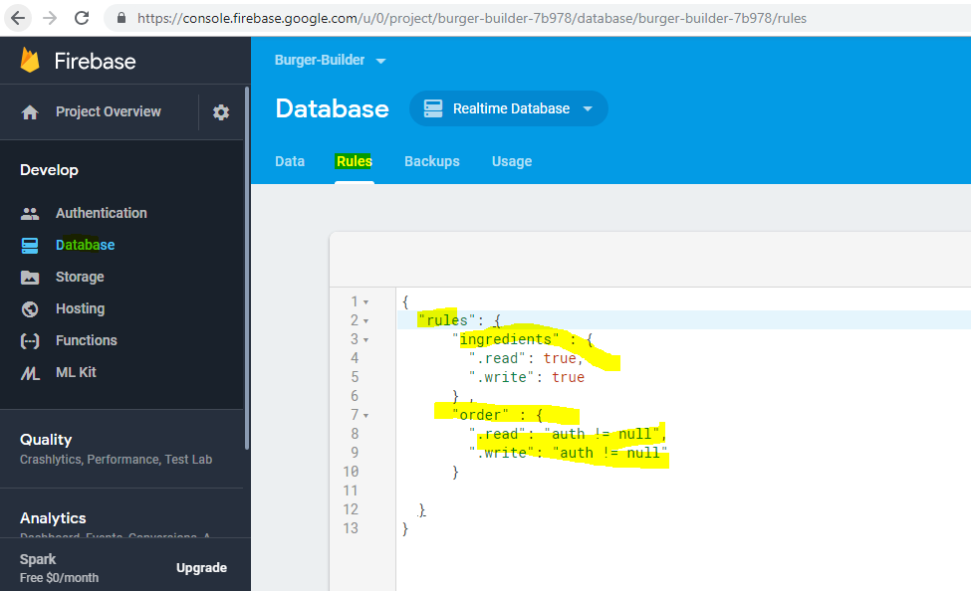

and with that, we can now make sure that we can still reach orders if we are authenticated and have a token.

The authentication is very simple then, we just have to add a query param questionmark auth equals to the URL we're making the request to which requires a token and then we have to pass the token.  our token we got back from firebase when authenticating.

**Now the token of course here is the special thing, the token is stored in our redux store,**

Now in our action creator Of course we could receive getState, you learned about this, you can not only get your dispatch action, you can also get the getState function here which you can execute to get access to the state.

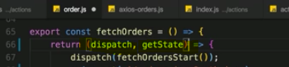

**I also taught you that I'm not recommending using that a lot and I don't want to use it here, though I see that this could be a case where it makes sense to get this information which doesn't really matter to your view right in the action creator. Still, I want to get it in the place where we dispatch the fetchOrders action and then simply pass it as an argument to this action creator.**

Lets first do for Fetching order History -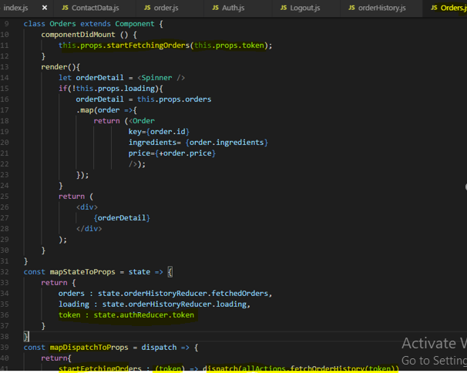

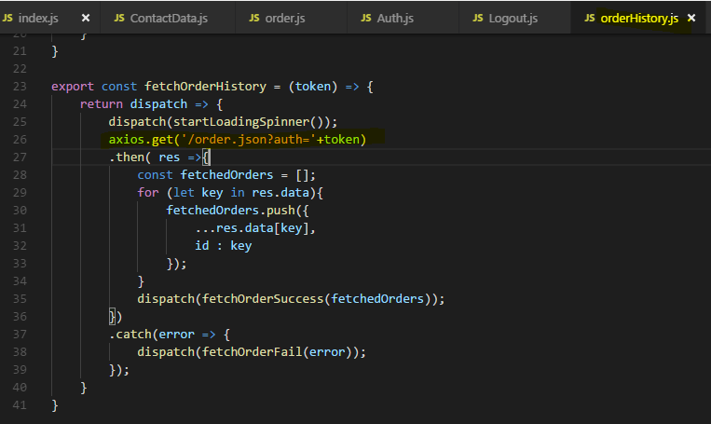

Now lets authenticate Submit order - 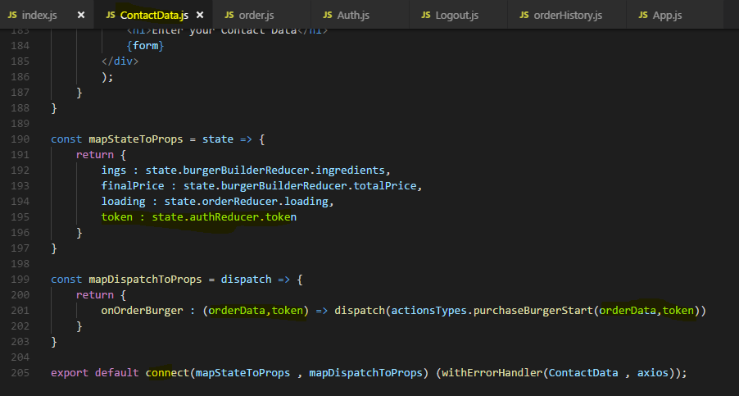

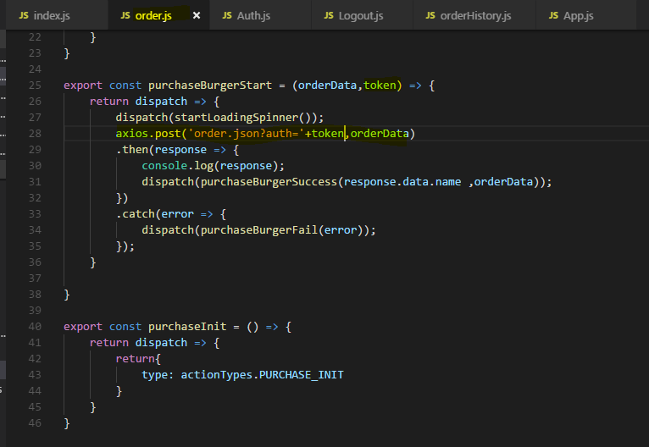

Now if we try to access the order tab without logging first we can access it - 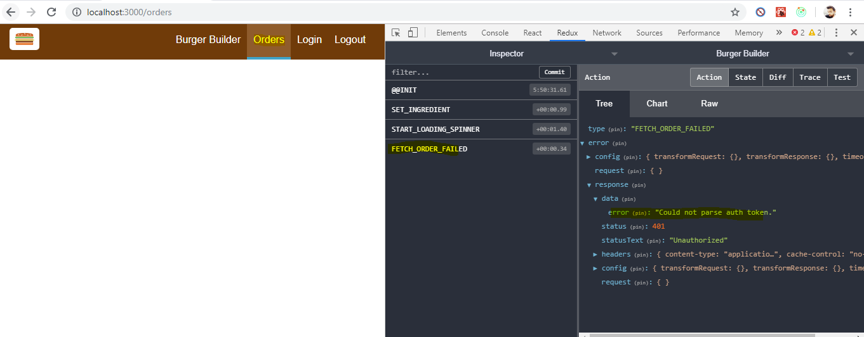

**Same with Submit order.**

**So once you logging and Token is set in redux store , we can authenticate our request at server**

**So this is now working, now we are using that token to reach protected resources and as you can see when you reload the app and visit orders for example, it's not working if you don't have a token.**

**Of course it's not the greatest user experience to well just visit a page and then fail. It would be better if we can't visit pages where we need to be authenticated in the first place, of course it would also be better if the UI would show us if we are authenticated and it would be best if we could also log the user in if there theoretically still is a valid token so that we don't lose our authentication state whenever we reload the application.**

**These are all things we're going to tackle over the next lectures.**

## **Updating UI depending on Authentication state**

Now I want to make sure that we can see in our UI, in the app whether we are authenticated or not.

Right now we always see authenticate here which leads us to the authentication form but even **if we do login successfully here, we still see authenticate here, would be better to see logout here if we did authenticate.**

Now the idea is to only show navigation item with authenticate on it if you are unauthenticated, so if you do need to sign-up or sign-in and show a logout link instead if you are logged in.

**So for that, we need to check our state, our login state in navigation items. Navigation items of course is a presentational component so we can't connect this to Redux.**

**Well we could, we could turn this into a class-based component and use connect on this component or use to use that hook, you can do that but I wouldn't recommend doing that.**

**This breaks the idea of having a few container components which are connected to the store and having a lot of dumb components which don't know about the store, so I wouldn't recommend using that approach.**

**A better approach would be to pick a fitting container which actually loads navigation items and here it's not in the container folder but in the layout folder simply because we use it to wrap other components, the layout.js file is a class-based component and there we implement the toolbar and the side drawer which are of course the components which use navigation items in the end.**

**So it would make sense to connect the layout here to our store so that we can pass the auth information down to toolbar and side drawer which then in turn could pass it to navigation items.**

This is exactly what I want to do,

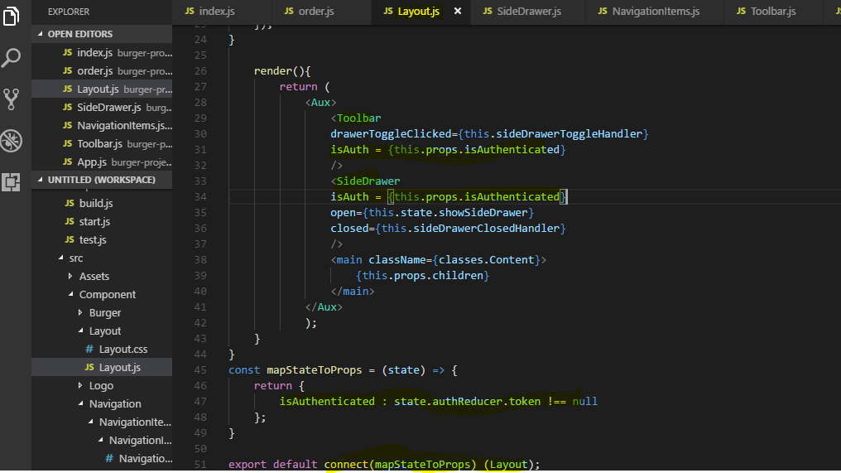

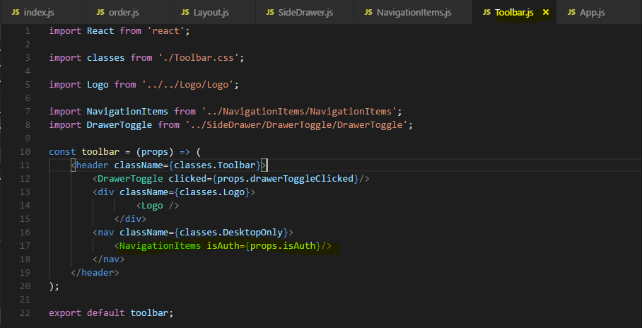

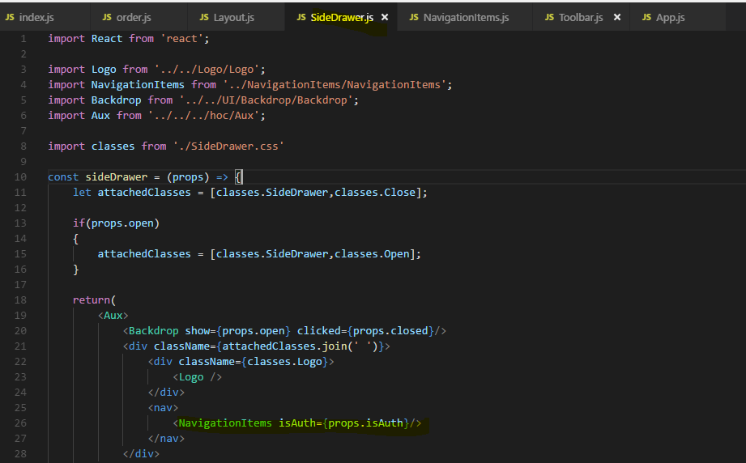

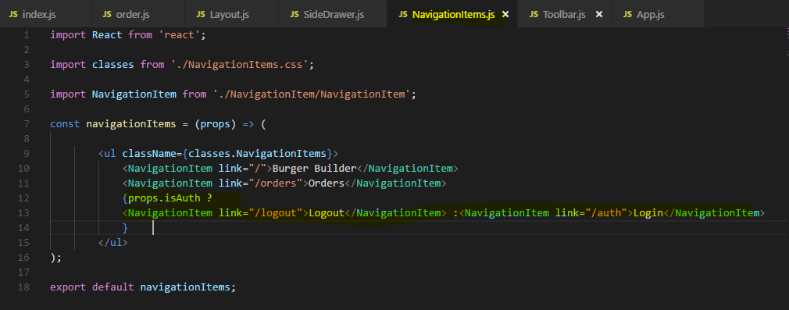

Now Lets see in action -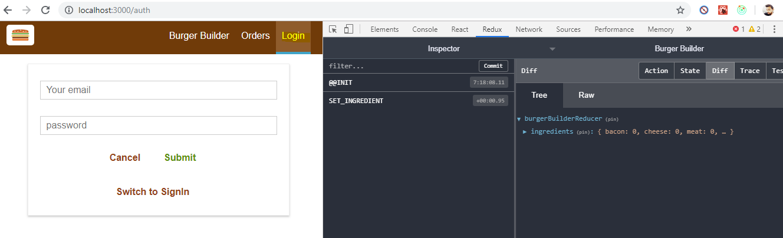

**Now once logged in -** 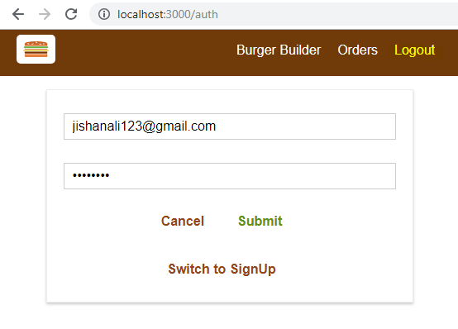

**With SideDrawer also** - 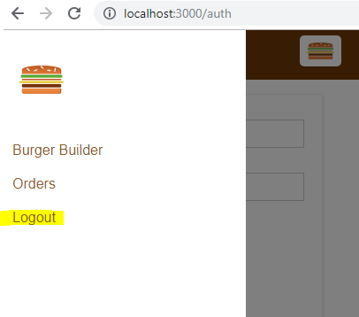

## **Logging User out**

I want to make sure that the logout link works Now logout leads to /logout obviously and I want to do something upon a logout, I want to clear my token and we do have an action for that, if we check the store actions folder auth, there we do have that logout action creator so I want to dispatch that and I then of course also want to redirect, for example if we click logout, I always want to redirect back to the starting page so that if we were on orders, we're not staying there because we're not authenticated anymore, so that's the idea, redirect and dispatch this logout action.

Now there are different ways you can achieve this,

one possibility would be to go to your navigation items here and make sure that you create a separate kind of navigation item which isn't a link but actually a button and then you could register some action prop which in the end is a link to a method you want to call to dispatch, that would be a way to handle this situation.

**I want to show you this way with linking to a page which then just redirects and logs you out,**

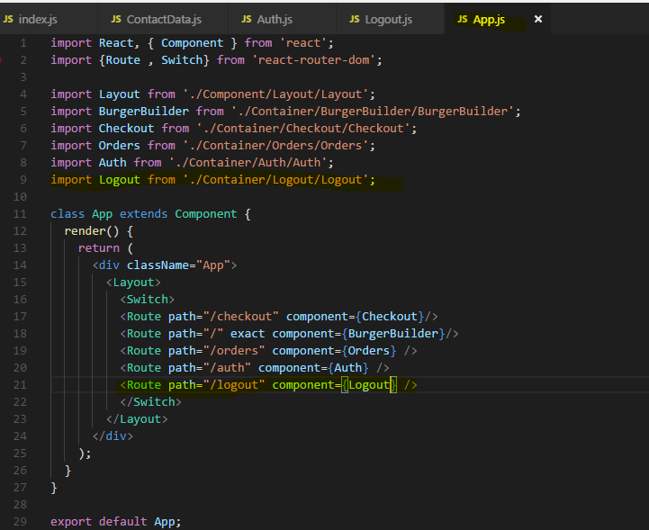

**Now lets define an Action which will clear the server token**

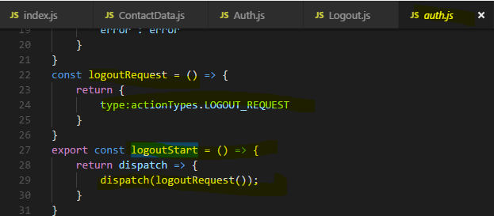

**Reducer -** 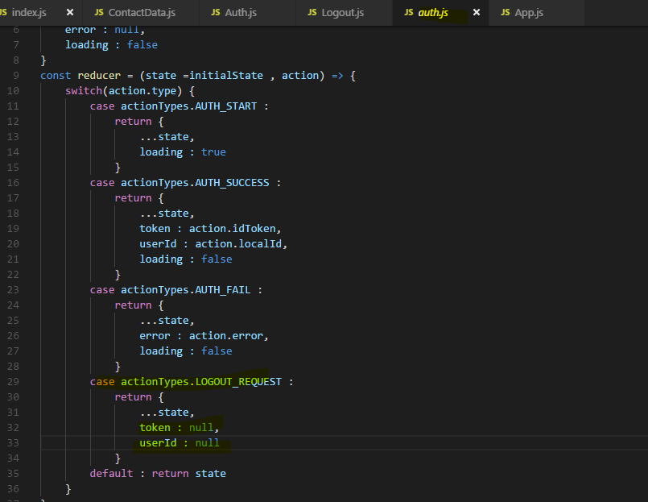

I said, I also want to redirect and now we have two different ways of doing that,

one would be to forward the props of this component which will be loaded via the router, so therefore we could forward this props history and on that history object of the router, we would have the push method.

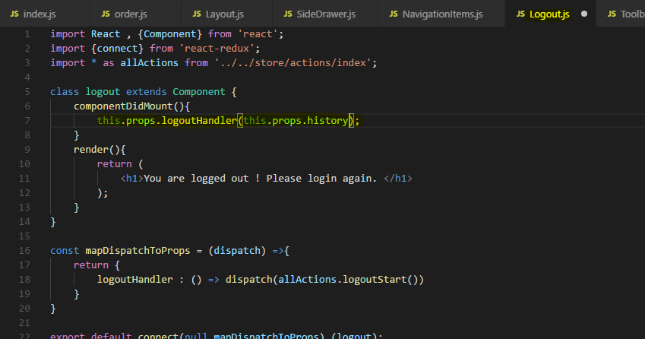

**Now what I want to do instead is I want to redirect declaratively, And then the only thing I return as part of this Logout component is that redirect component here which means whenever this container is loaded, it just redirects me to Root path ‘/’**

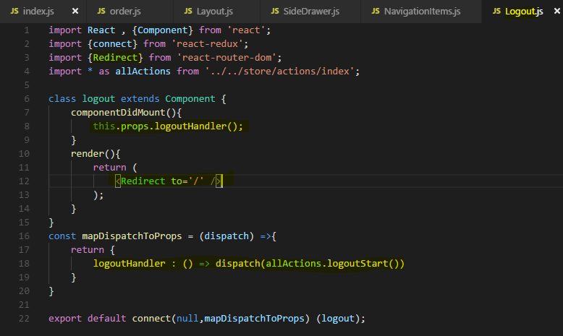

Now with that implemented, I want to work more on the UI, I want to make sure we don't even see the orders button if we're not authenticated and I want to make sure that when we build a burger, that this is available when we're not authenticated but that the order now button actually is a sign up to order or or something like this button when we are not authenticated.

## **Forwarding Unauthenticated User and Redirecting after successful authentication**

I want to make sure that orders is only visible if we are authenticated.

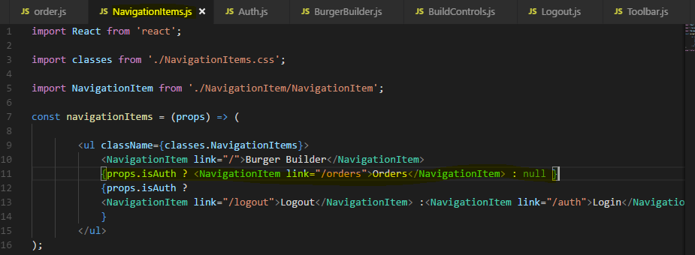

Now another thing I want to do is when we did login successfully, I want to redirect away from the authentication form here because it doesn't make sense to show this anymore.

**This can be done in two ways**

**1)with Redirect**

**2)with this.props.history.push(“/”)**

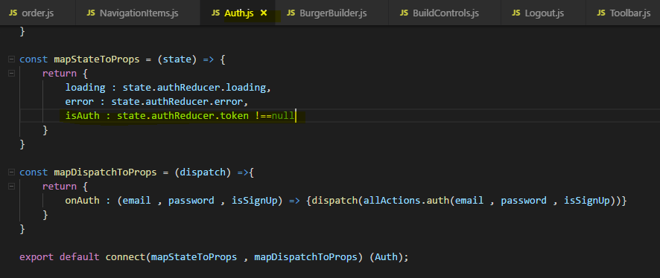

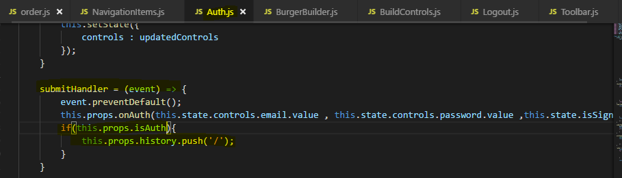

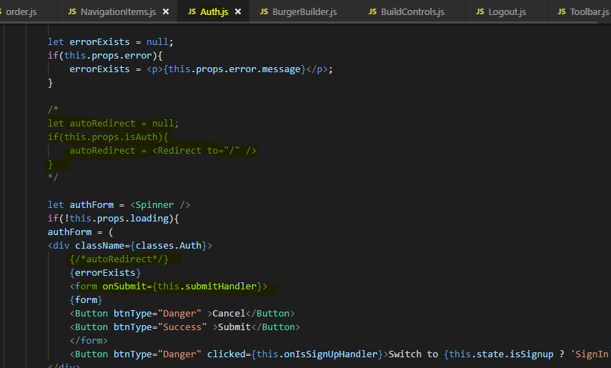

**let's now ensure that when the burger builder is used, that we can use it even if we are not authenticated, so just as here but that once I started building one and I click order now, I don't reach a page where I can't do anything anyways but instead that it says sign up to continue, so that you have to sign up to continue checking out the burger.**

**I will go to my burger builder container of course here, this is where I include the build controls, this is what's holding this order now button and the build controls need to know whether I'm authenticated or not.**

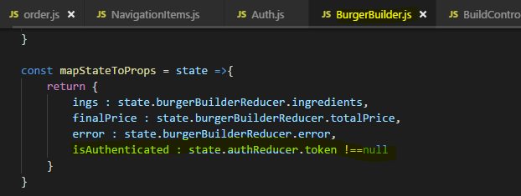

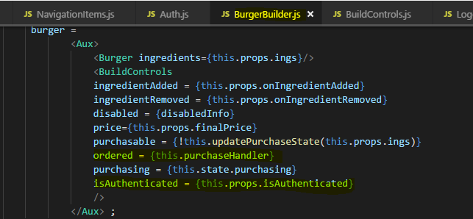

in the build controls presentational component, isAuth that's the prop we just pass down, if that's true then I'll output a string order now otherwise I'll output sign up to order, something like that.

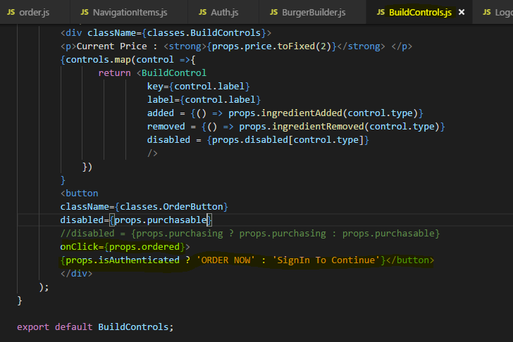

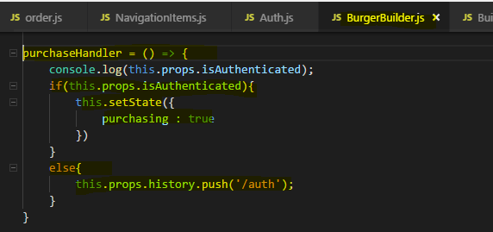

**Now with that if we save our application and we go back, now we can add something to the burger and click sign up to order and clicking this button redirects us here to the sign up page.**

**Of course the issue that we have is that if we now sign in, we'll simply be redirected back to the burger builder and our currently built burger will be lost.**

**It would be better to be redirected directly to the checkout page and there, still have our burger, the latter would be the case because the burger ingredients are stored in the redux store and if we don't go back to burger builder, this won't be reset but of course, that redirection is the issue because we only want to redirect in this scenario. If the user just got into the app and clicked on authenticate, we don't want to redirect on checkout because no burger was built yet, there won't be any ingredients to checkout.**

Let's take a look at how we solve this problem in the next lecture.

## **Redirecting User to checkout page after SignIn**

So we want to make sure that when we build a burger and are redirected to the sign up page because we weren't authenticated, that we are then redirected to the checkout page from the authenticate page so thatwe can continue with the burger checkout.

**Lets add a new property to burgerBuilder reducer state to record if the user did started with building with burger means if he touched the + or – sign to add ingredients and come to Login page OR User directly come to Login page.**

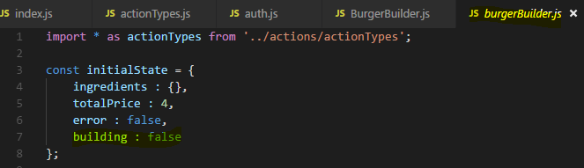

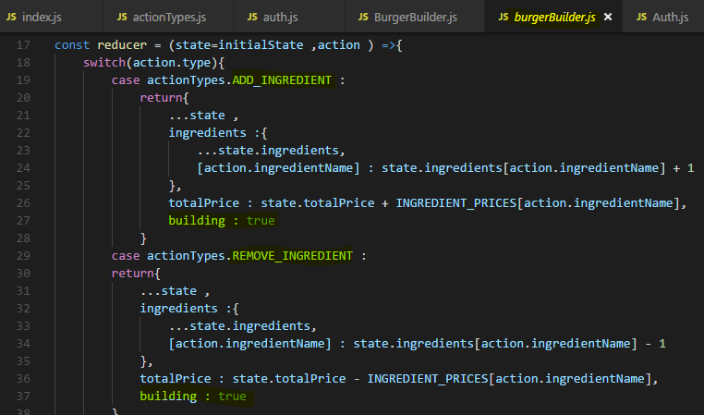

**With this new building prop added to the burger builder slice of the state, we can go to our auth page and there where we redirect the user after signing in, we should have two different redirects, one to just slash( /) and one to the /checkout page depending on where we need to go.**

**Now a more dynamic approach if you need to support different URLs would be to store the URL in your redux store.**

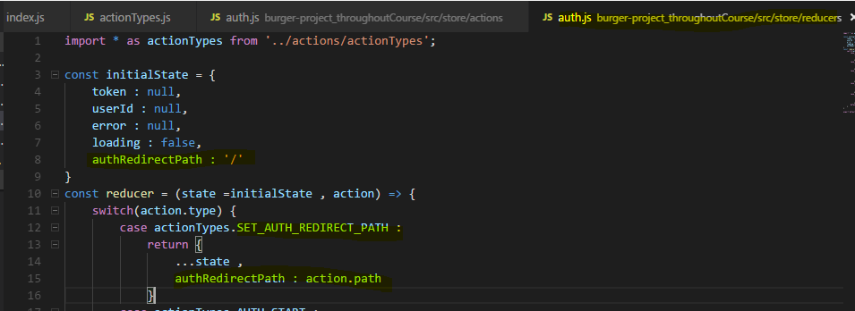

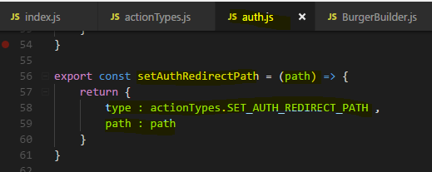

**Now we need to set this ‘path’ slice of state of auth Recucer from BurgerBuilder Container whenever we redirecting to Login page from BurgerBuilder Container because that means user has build some burger before signIn that means he touched + or – build control (because ORDER button is disabled when you don’t select anything)**

**So set the path to checkout –**

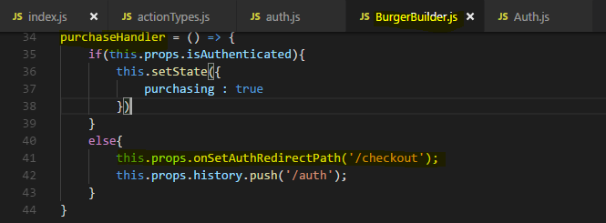

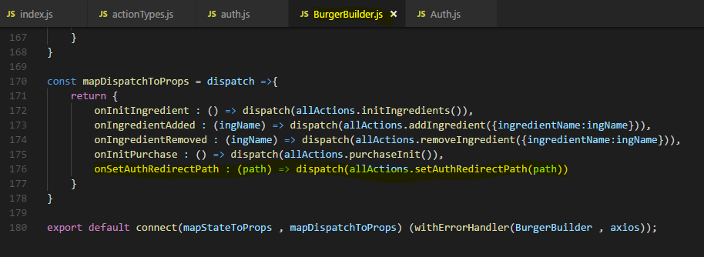

**Now in Auth Container we need to Redirect to /checkout or / depending upon if user did build some burger or did they directly come to signIn page**

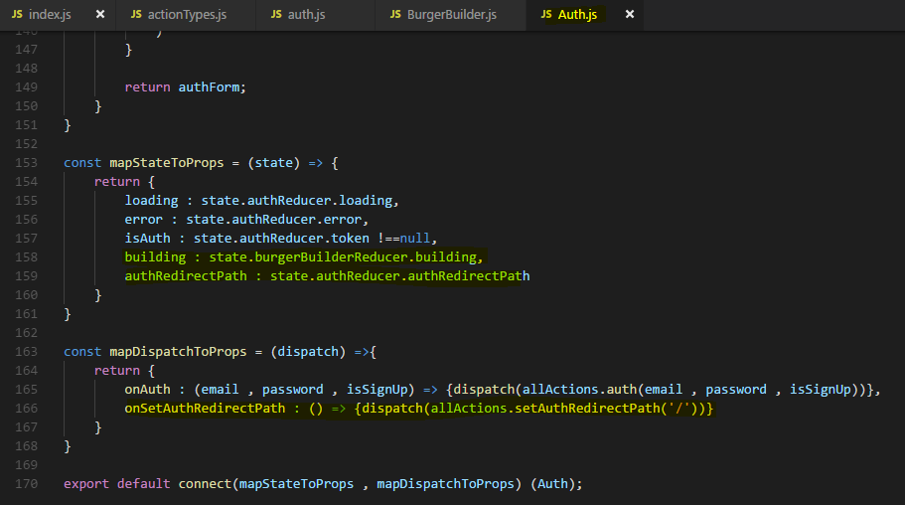

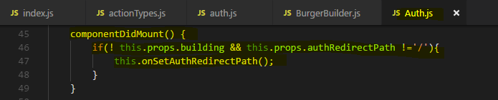

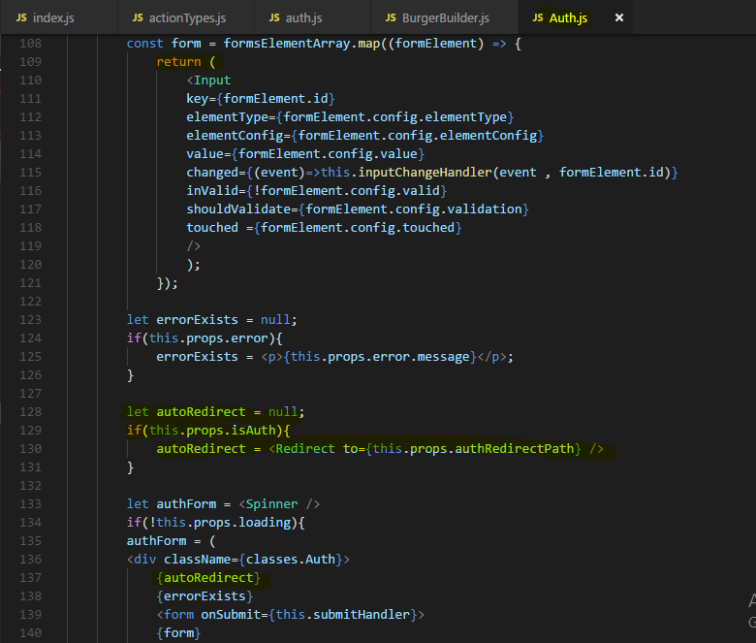

**Now reason for using Redirect compare to this.props.history.push(this.props.authRedirectPath)**

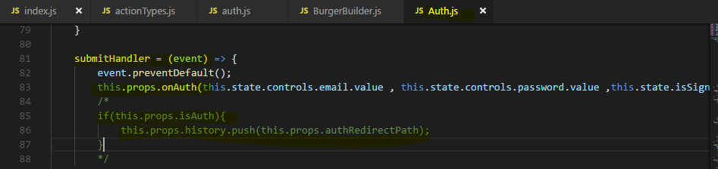

**Reason is we are doing Ajax call for authentication on form submit in “submitHandler” and it does update the state “isAuth” of auth Reducer . It is asynchronous call hence the next statement will execute without waiting for Ajax call to complete.**

**Hence this condition will execute before setting the isAuth state to true or false and we will always get the false result wheather we are authenticated or not**

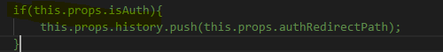

**And we all know when Redux store gets updated the render() methods called and react re-render the component hence <Redirect> condition will still work because its inside render() method.**

**But submitHandler() never gets re-called when state changes hence we have used first way of Redirecting.**

**let's see if that works.**

**Back in our burger builder, let's first of all reload the app so we're not authenticated and let's go to the authenticate page and log in. We should be redirected to the root page.**

**That worked.**

**now, switch to sign in, submit, this works. Now let's try again, let's log out,**

**build a burger. Let's click signIn to order, we go to authenticate, let's now sign in, we should now reach checkout and we do, we can check the burger out here.**

let's next work on the issue in quotation marks that if we are logged in and we reload the page, we are logged out,

let's see what we can do about that in the next lecture.

## **Important : Local Storage : Persistent Auth State(Store Authentication State(information) in Local Storage)**

**we still have the behavior that if we are logged in and we reload the page, the login state is lost.**

**The reason for this is that when we refresh the page, we download the single page application again, we download the javascript again, it gets executed again, it's a totally new application when we look at it like this.**

**Therefore our state stored in redux which is in the end just stored in javascript is of course lost.**

**So we need it to persist our login state across our sessions and this requires a browser API we can use, localStorage.**

**auth action creator, here where we do successfully login and dispatch authSuccess, there we also pass on the token and it would make sense to also store that token in our browser local storage then. The local storage API is baked into the browser so we can easily use it.**

**token alone won't be that useful if we fetch it in the future, we also need to know when it expires. So I'll store something else, setItem and I could store expiresIn but that's just the amount of seconds until it's invalid, that won't tell us much the next time we fetch this from local storage because the number of course won't update.**

**So instead we should store the expiration date, so expiration date and the value should be the expiration date, now I'm going to calculate this and store it in a separate constant, expirationDate can be calculated as new date which gives us the current date plus the expiration time, so response data expires in times 1000 because javascript time works in milliseconds and the time we got was in seconds but just like that it won't work, instead on the new date we generated, we have to extract getTime, it's a function, it gives us the current time of the date and now this gives us the expiration time but to turn this into a date object again, we have to wrap all of that with new date.**

**So new date without arguments like here gives us the current date, new date with arguments gives us a date with the date we passed as an argument,**

so here this will be the current date , plus expiry time in seconds. So this is how that works,

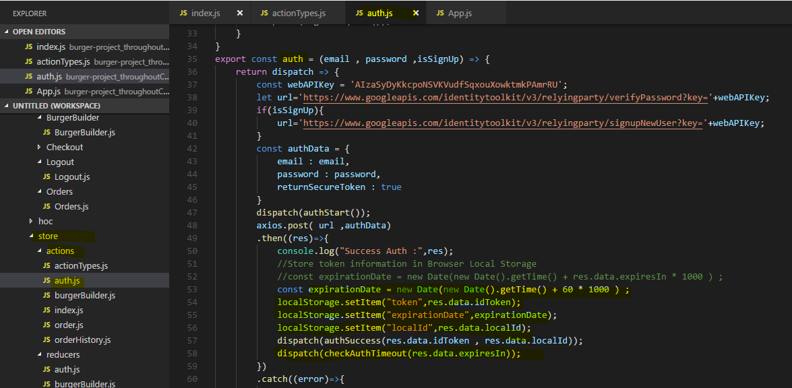

**let's see if that works. Let's go back to our browser, click on authenticate, switch to sign in and let's authenticate here, submit and we can inspect our local storage in the Chrome browser dev tools by going to the application tab there.**

**On the application tab, you will find some storage information and you can click on local storage and expand it and click on your domain.**

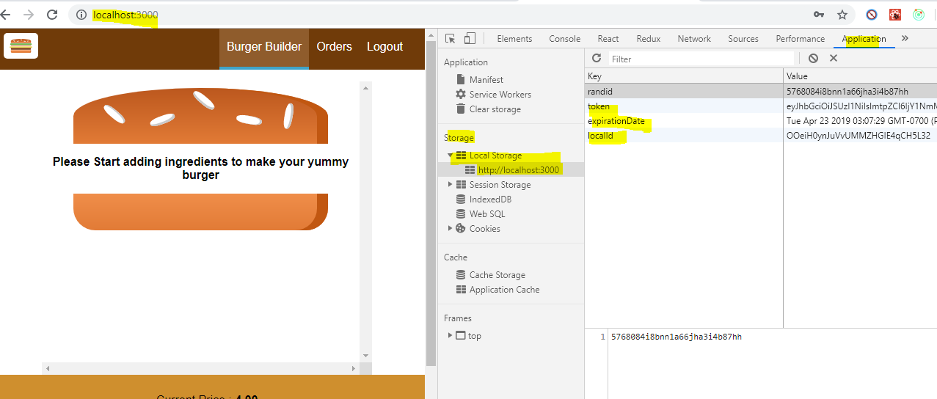

**we can now take advantage of these three fields to check them whenever our application loads, to log the user in automatically if we got a token and if it's still valid, so if we haven't passed the expiration date yet.**

Otherwise we want to clean this up, we want to clean this up with the logoutStart dispatch action.

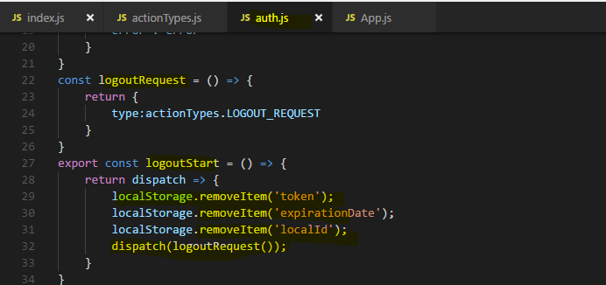

So now let's fetch the token when we login,

where can we check this?

Well we should check it when the application loads, so for example in app.js this is the root component of our app and it's always loaded, no matter which route we visit so therefore this makes for a great app to check our authentication status. For checking this, we will need a new action

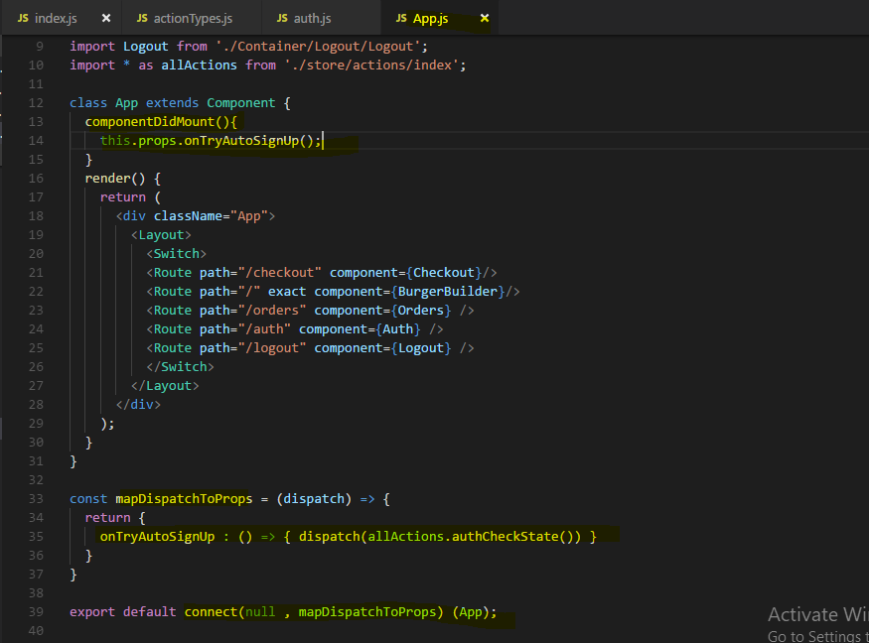

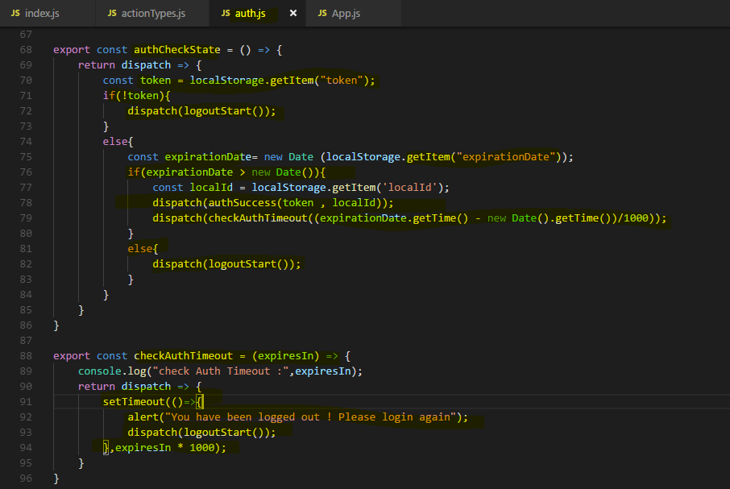

**Now reason for using checkAuthTimeout() . Actually in there we have used setTimeout function provided time after which first parameter(function) of setTimeout will run. Which logout the user automatically. Means user didn’t refreshes the page or being idol then after some predefined time this function will run which automatically logout the user.**

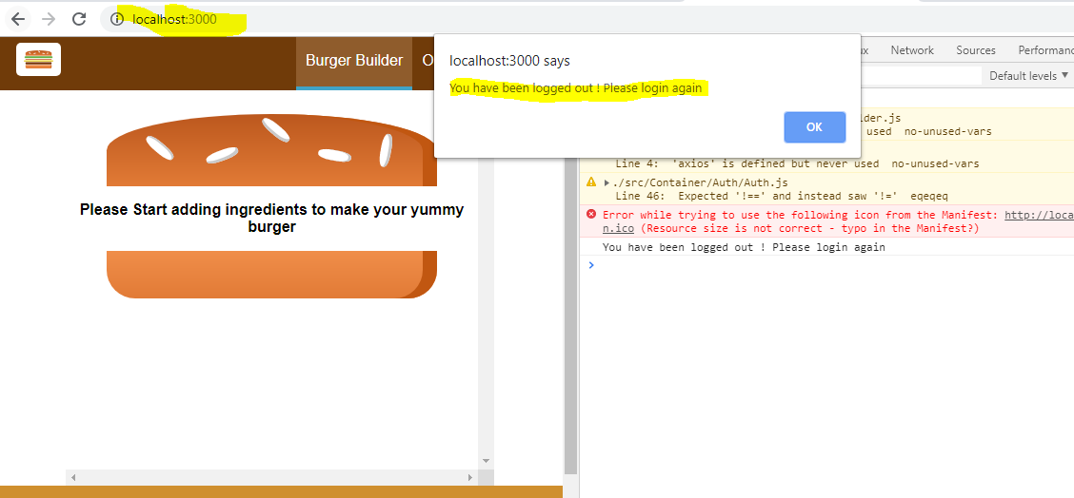

**So whenever user login to to Application, after successfully login some of the information we store in Browser localStorage which also has expiration time means after what time the token will expires and user will be logged out automatically and have to login again and we also clear the localStorage on logout.**

**If user refreshes the browser which clear the state and redux store but Browser localStorage data still there hence if token is not expired then we automatically log In the authenticated user.**

### **Fixing connect + routing error**

The error we're facing here has to do with the fact that we're wrapping our app container with connect and that simply breaks our react router. We can easily fix that though we need to import the withRouter higher order component from react-router-dom.

if you get an error like this which is always related to connect wrapping your component which you also want to load with routing and therefore this component doesn't receive your route props, you can simply wrap connect here with withRouter



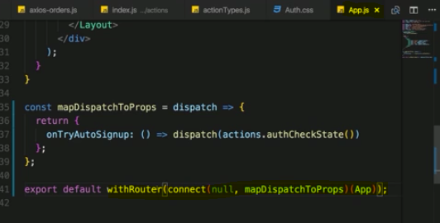

## **Important : Debugging The application for resolving error –**

We can use browser for debugging in source tab and placing breakpoint in that file.

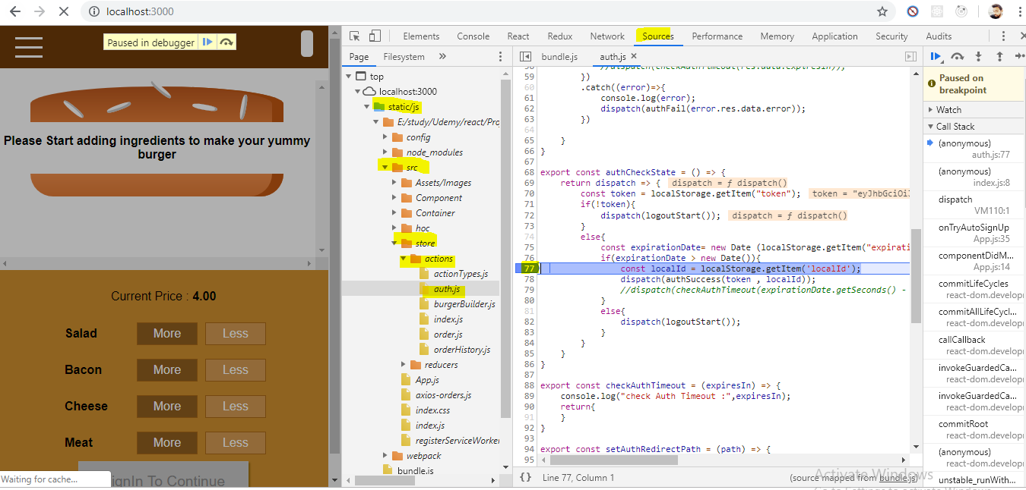

**We can also debug by Visual Studio Code** 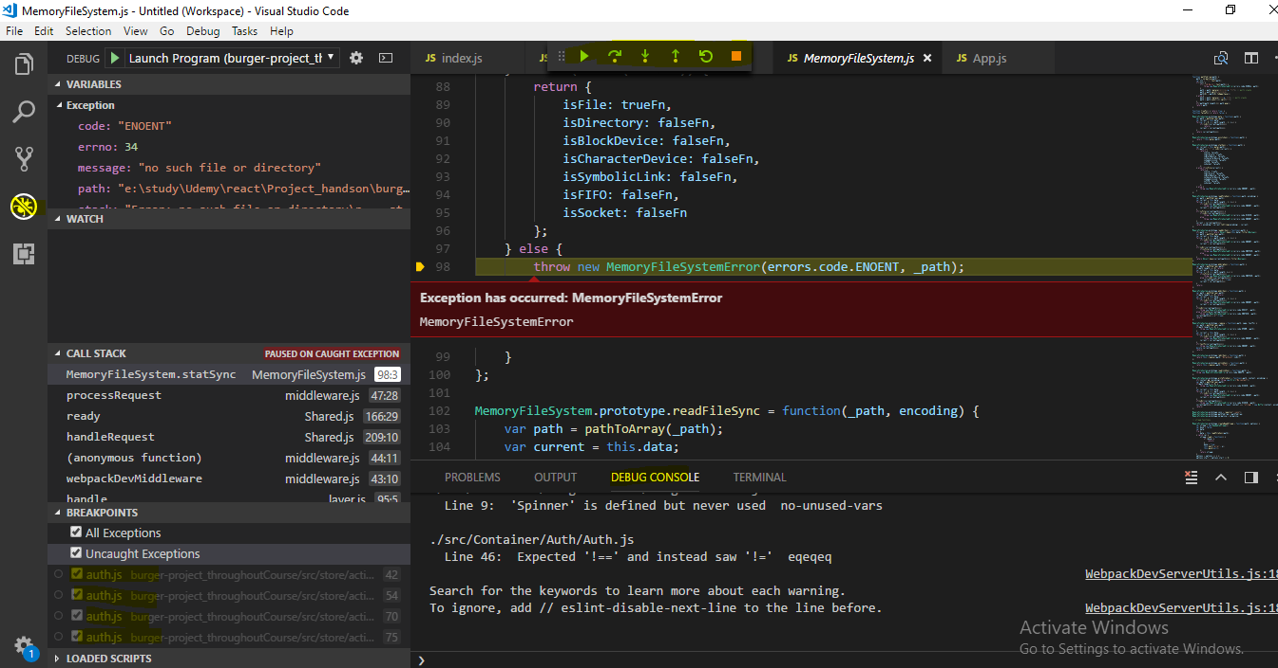

## **Ensuring App Security**

As you learned,

we manage our auth state here with the token and we automatically log the user in if we have a valid token. That token is only valid for 60 minutes though, that is for security reasons because if the token gets stolen, anyone can access your data of course,

now that sounds very bad.

**Keep in mind though it's stored in your application in local storage, local storage can be accessed with cross-site scripting attacks and cross-site scripting attacks are prevented by Angular, you can't output insecure code by default. So you got a lot of protection from that side, so your data and local storage should be safe, an additional safety net then is again that the token expires after one hour.**

**Now firebase would theoretically also give you that refreshed token if we inspect the response we get back, here that refresh token. The refresh token doesn't expire, you could store that too in local storage and then there is a specific end point on the firebase auth rest**

**API where you can exchange a refreshed token for an ID token, you just send your refreshed token to this API endpoint and you get back a new ID token.**

Theoretically that's a cool pattern,

you can always do that with every HTTP request you send, with every request you send you send an additional one where you exchange your refresh token for a new ID token even if the ID token hasn't expired yet so that you always get new ID tokens and you could also get a new one when the user is automatically signed in with the functionality we added over the last lectures, I opted to not use that here.

It's also safe because we can store the refresh token in local storage and as I mentioned, this is only accessible with cross-site scripting attacks.

Still, having a token which never expires and which you can exchange for a token which gives you access to everything could lead to security issues or at least you should be very careful about protecting it if you are using the refresh token.

That's just something I wanted to add, you can enhance the user experience by using the refresh token, you can essentially make sure the user is never logged out because as the refreshed token never expires, you can refresh the main token even after a week

just check for the token being valid, it isn't, take the refresh token and get a new one but due to that security thing, I opted to not use it and I wanted to bring this to your attention.

## **Guarding Routes**

I also want to make sure that you can only visit the orders page and the checkout page even though we do redirect there if you are not building a burger but that you can visit both only if you are logged in.

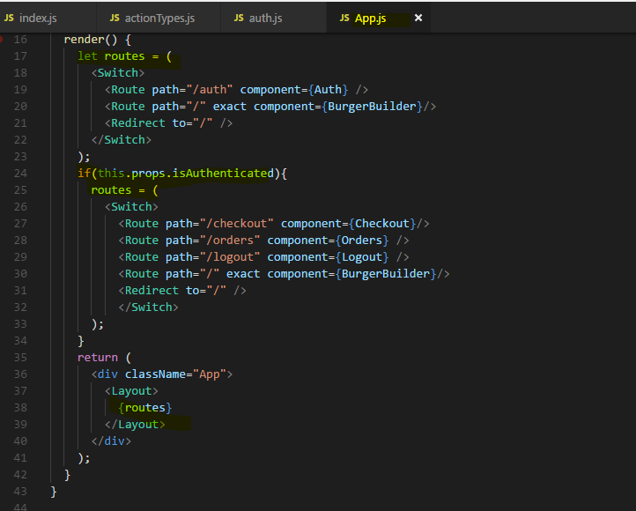

And with that we got guards in place, we make sure we can't visit pages we shouldn't be able to.

Now one important note, since this of course is all javascript, people can of course always theoretically dig into your source code and still kind of manipulate it to still go to the protected route, and this is why we have protection on the server, to not return any data for unauthenticated users. This is how you protect your data, the front end is only about providing a user experience that makes sense and to prevent the user from accidentally visiting a page he shouldn't be able to visit to because he won't be able to do anything on it. So this is route protection on the frontend with guards

## **Displaying User specific orders**

let's make sure we only see orders of our user and for that of course, we first of all need to make sure that when we place an order, we attach the user id.

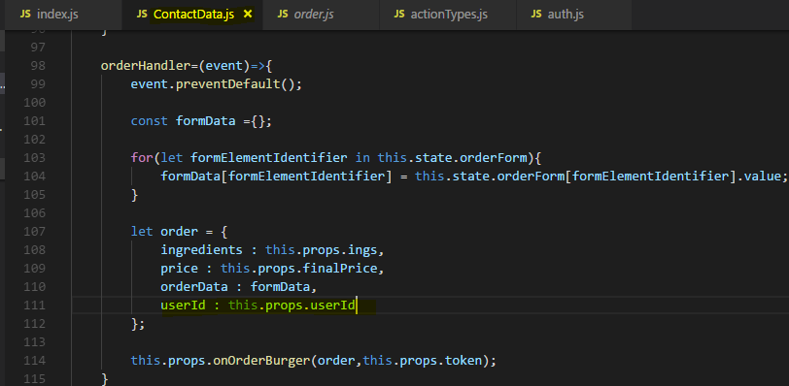

we also want to make sure that when we visit orders, we only see orders of that user.

Now there are two ways of checking this, **one is on the frontend because the data we get back from the backend will hold this information**, we can see this if we expect our state here for fetch orders success, order, this orders array, the last order which is the most recent one has this user id property so **we could check if that user ID matches the ID of the logged in user. But we would still fetch all orders and that's a potential security issue because if anyone inspects our javascript code, he could see orders which aren't meant for him.**

**So a better way is to just fetch the orders we need from the backend in the first place and we can do that easily with firebase, of course for your own API you need some way of passing that user ID to the backend or use that token you pass along anyways to only fetch data for a given user. When using firebase, you can easily filter data by going back to your async order action creator file and there where we have fetch orders, we already passed the token, we can pass more query params here**

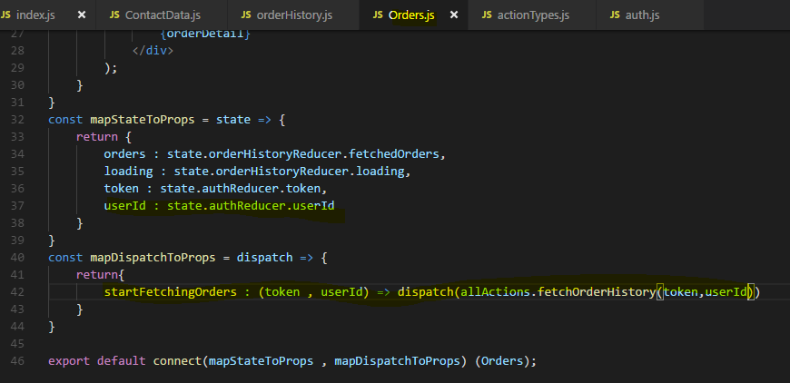

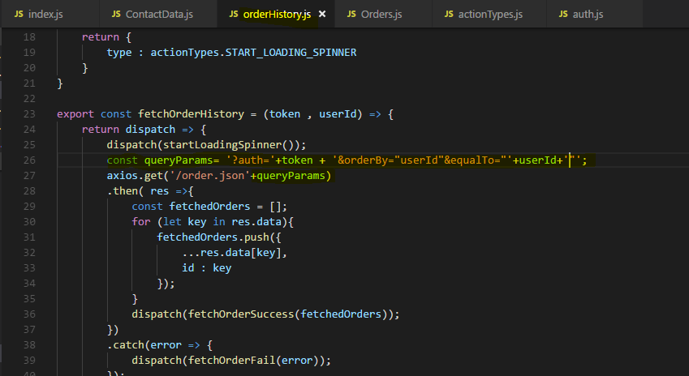

**For this to work we need to do some changes at our server Firebase, lets do that too -** 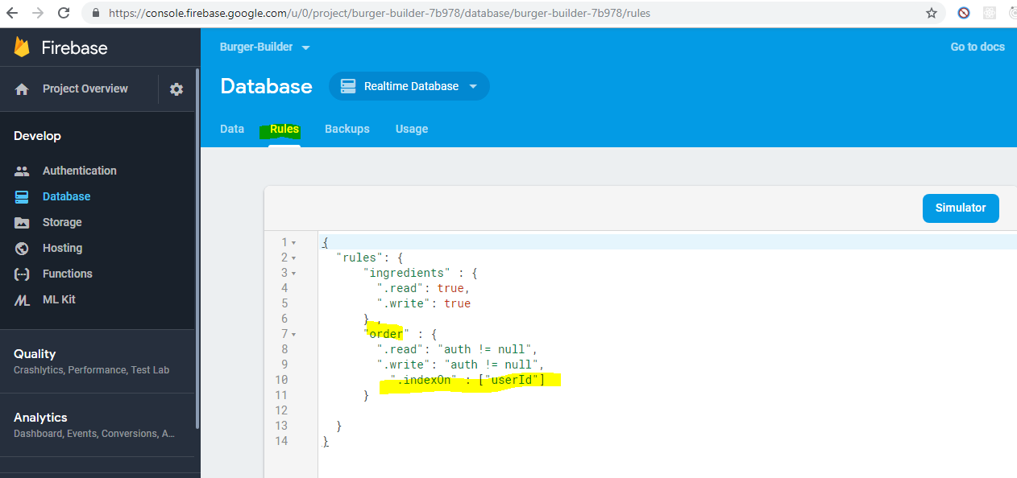

**Now with that we can see the user specific orders for that user -** 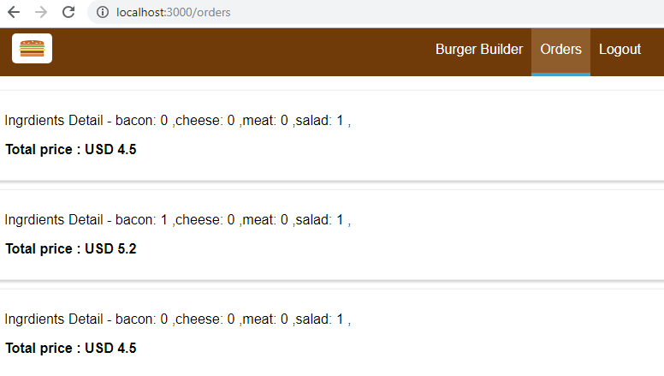

**So now we only get the data and we have no chance of accessing data that doesn't belong to our user.**

**Now this example is of course only showing us with firebase but on your own backend, you probably have your own filtering logic, either returning only user related data from the server anyways by checking the token you pass along or by also giving you some query functionality as we used it here.**

## **Useful Resources & Links**

* SPA Authentication in general: <https://stormpath.com/blog/token-auth-spa>
* Firebase authentication REST API: <https://firebase.google.com/docs/reference/rest/auth/>

# **InComplete : Improving BurgerBuilder Project**

This section is partially completed – will complete later

## **Using Environment Variables**

now there's one other thing I want to bring to your attention.

If this project gets deployed, everyone will be able to look into your store with the redux dev tools.

That's not strictly or necessarily a problem, in the end people can always look into your javascript code if they really want to, you can't encrypt it but you maybe want to make it a bit harder and not as obvious to access your state.

**To do that, you can go into your index.js file which is where we unlocked the redux dev tools and we can adjust this code a tiny bit to only unlock it if we are in development mode and not do it if we are in production mode.**

**To do that, we can take advantage of a feature called environment variables in our create react app project and this is a feature which is project set up specific, we can use environment variables, we can define them in the config folder, there in the env.js file, you can basically add your own environment variables, you can add them down here where you see NODE_ENV and public URL.**

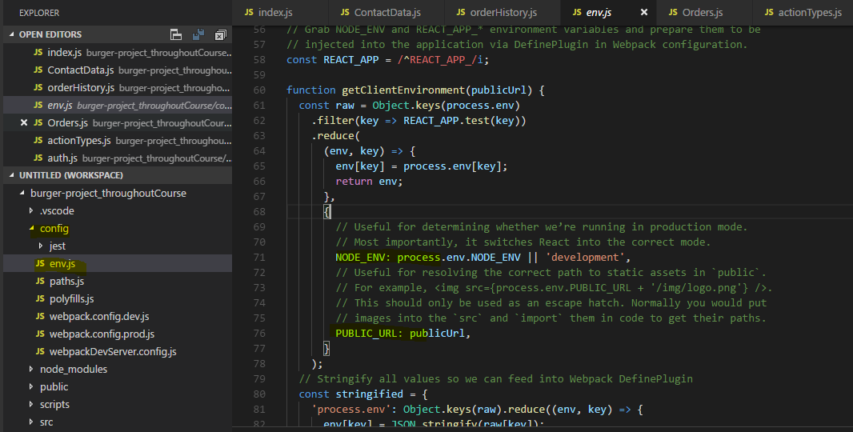 **Now the NODE_ENV thing here is interesting, it's automatically set for you and it is development if you're in development mode.**

**So with that, we can go to our index.js file and just need to access this variable to only set this extension if we are in development mode. We access our environment variables and again, this works to this specific project set up by calling process which is a global variable which is available here, we don't have to import it, env for environment and there we can access NODE_ENV,**

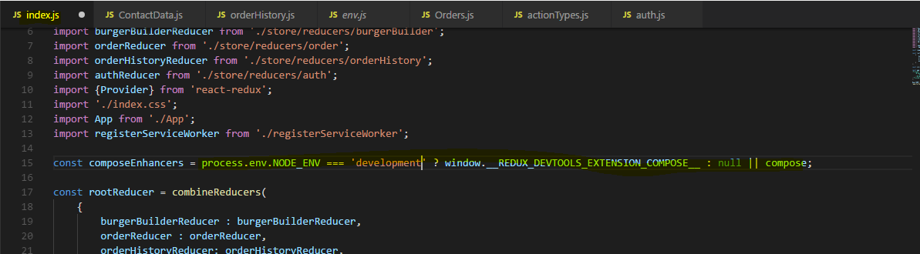

So now redux dev tools will only be available in the development environment.

# Testing

Welcome to another important module in this course,

Testing react apps. Now with testing here, I don't mean us manually clicking around in our application, we already do that constantly while developing it. With testing here, I mean writing automated tests.

now here is something important which I want to mention right at the start of this module, testing is a complex topic and is actually a huge enough topic to make up an entire course just on its own. This is not a testing in general introduction and it's also not a complete react testing guide like module.

**Instead I will introduce you into writing unit tests for react applications built with create react app and that can then be something you build up on or which helps you apply your general javascript testing knowledge you already have or gathering other resources.**

## **What is Testing**

What is testing? As I said, testing does not mean that we test our application manually, we obviously do that and we should do that.

With testing here, I mean that we write automated tests. So what we typically do is we build an application, then of course we test it manually in the browser and then we ship it to a server, now there's one extra step we can add in any development workflow and that is that we don't just ship the app after testing it manually but that we also have automated tests.

**Now these are tests which run automatically, we write them and then each test tests a tiny fraction of our application, that's a so-called unit test, it tests a unit of our app.**

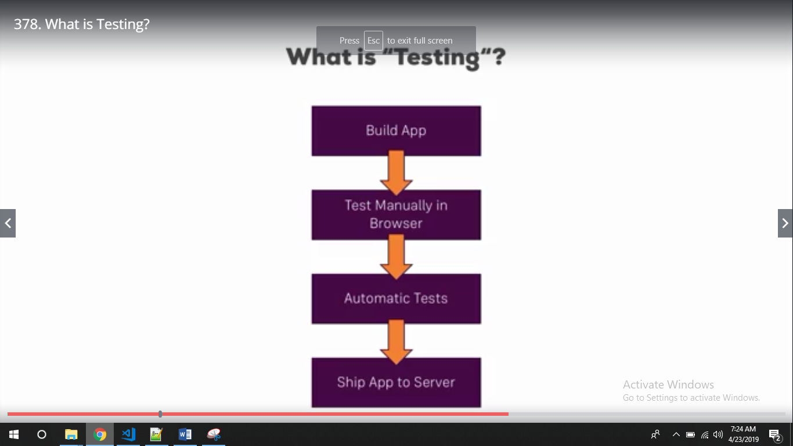

**The idea behind such tests is that since we define these tests, if we change anything in our application and that breaks our app or breaks a component in our app then the respective test will fail and hence we might get a warning about a potential error we introduced before we even have to find it by manually testing the browser.**

In more complex applications, this is especially important since there, it's way easier to break something without quickly noticing it.

 There also is a different way of thinking about testing, instead of adding it in the end of the build workflow, there also is this idea of test driven development which you might have heard about,

**test driven development imports the tests first, there you write the tests before you write any application code and therefore all the tests will of course fail initially but then you add the application code and the test should pass step by step.**

I want to show you how to write these unit tests and you can of course then build up on this knowledge to use it in whichever way you want to use it.

### **Why Testing**

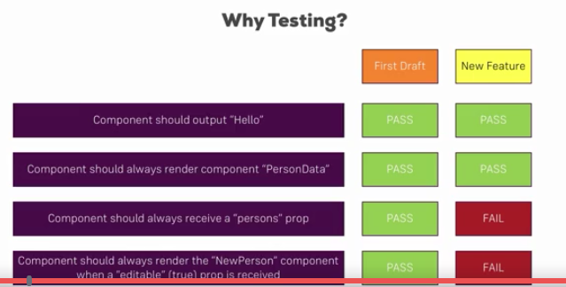

we might have an application and there, we might have a component which does a couple of things as suggested here on the left and in the first draft we created for the component, it may pay us all the tests we defined for this given component so we wrote test for a given component and they pass.

**Now when we change something in this application or we add a new feature and that affects this component and we change something in that component for that reason then we still might have some passing tests but maybe some of our tests then fail and that's exactly showing us then where we need to look into our code and potentially fix or adjust it or fix or adjust our test to the changed requirements, either of the two,** but at least we have to take a look at that so that's the idea behind testing.

## Required Testing Tools

So we learned that testing might make sense, how do we test then?

**We need two tools to write good tests and be able to test our react application.**

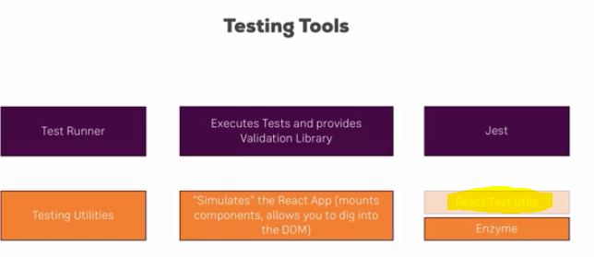**Test runner**

this is basically a tool which is responsible for executing our tests so for running the code, test code and providing a validation library which in the end is a library which allows us to do comparations and potentially throw some errors.

**The idea behind unit tests is that they don't run in the browser but instead with nodeJS though often emulated to be in a browser environment with the help of specific javascript packages.**

**The test runner then is the core tool which simply executes our code using that environment and the good thing is create react app already comes with a pre-configured testing environment we can build up on.**

So that's the test runner and we will use **jest (a Test Runner)** in this course, jest is already installed in the app created with create react app and is a popular javascript testing tool which is not limited to react but often used in react apps.

**Now running the test is one thing, when working with reacting components, we also need a way of emulating these components, so basically mounting them to some non-existent dom you could say and then traversing our components and we want to do this in an efficient quick way without having to actually create that whole component tree which might also introduce some side effects.**

**For this, we need testing utilities which help us with testing and there, we specifically need the just described help to simulate the react app, mount components and dig into that dom which is created with react.**

In this course we could you as react test utils, that's the official utility tool but there's another tool which became more and more important and interesting and is also suggested by the react team and that's **enzyme(Testing Utilities).**

Enzyme is a tool developed by AirBnB, they use react in a lot of their projects and they share this tool which makes it easy to mount components and then navigate through them.

## **What to Test**



So in general, here are some things you would not want to test,

**you don't want to test the library, you don't want to test react or axios or redux itself, these are third party libraries which already were tested by the developers. You don't need to test if they work correctly, you don't need to test if the store, the redux store is working correctly,**

you want to test the code ,you add to your application and there you want to test the code which does not use that library.

So for example, if you're sending an axios post request, you don't need to test if that is sent successfully, if it fails you probably have no internet connection, it's not the axios library. You typically want to fake data you get back from my server in such a use case and just test what you are doing with such returned data so that's the idea behind testing.

**Additionally you don't want to test too complex connections especially in react, there is the danger of testing that you click a button in one component and you change something in a totally different component. Now you don't have to test if react is able to use the concept of props to emit an event and pass that on, you would be interested in testing if the button click in your react triggers a specific prop in the first place or if the change in data you receive via props in one component leads to a different result being rendered, that is what you want to test.**

There are some testing guides which goes so far to say for react components, you only need to test if a react component itself is rendered correctly.

Now I will show you how to test different thing with react components but definitely keep in mind, don't test too complex connections.

So these are the things you don't want to test,

what are you going to test then?

Typical examples are isolated units.

**you want to test that reducer function you created, you want to test that component function you created, you also want to test conditional output if your component has a property which leads to something being rendered if that property is true, then you want to test if this really happens. What happens if some property changes in your component? Does that affect the output correctly?**

These are things you want to test in your unit tests.

## **Writing First Test**

we need to install some additional packages after all we're not just using jest but also enzyme.

Now if we have a look at our package.json file we see that jest is indeed installed, you might have a different version but it should be installed but enzyme isn't.

So let's first of all install that with npm install --save enzyme, now that alone won't do the trick though, we need to install two additional packages to make it work correctly with jest and react.

**1) react-test-renderer package, that is a dependency of enzyme which we need to install separately**

**2) enzyme-adapter-react-16 , we need to install an adapter of the enzyme package to our current react version. So here this is the version for react 16.**

**npm install --save enzyme react-test-renderer enzyme-adapter-react-16**



now let's write our first test and I want to start with writing a test for a component.

Now let me start with a functional component here because that's of course a super easy way of testing and then we'll also move to containers and thereafter, to redux.

now keep in mind most of your react components are just functions and therefore they only depend on the props they receive, that's something you have to keep in mind for testing.

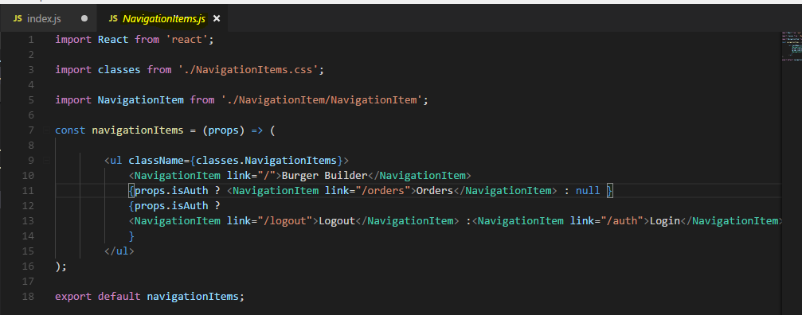

Now let's create a testing file for this component, therefore next to it in the same folder, I'll add a new file which I'll name NavigationItems.test.js

**the .test.js is important because that is automatically picked up by create react app ( means by jest ) once we run a special command( npm test) and will then be included in the testing and therefore will be tested.**

**Jest discovers test files within your project via their filenames, of which can be located at any depth of your project.**

**There are 3 naming conventions we can adopt in order for Jest to pick up our tests:**

* **Any file with a .test.js suffix or a .spec.js suffix. This may be preferable when a component (e.g. App.js) can be accompanied by an App.test.js file in the same directory, where they will reside next to each other. This optimises discoverability and keeps import statements to a minimum.**
* **Any .js file within __tests__ folders throughout your project. If you have multiple test files to test a particular component or component directory, a __tests__ folder allows a more coherent structure whereby your tests and components are not mixed. This may be preferable in larger projects.**

some key methods of Jest –

**1)describe()**

**2)it()**

**3)expect()**

Lets understand this syntax:

* **describe()**: An optional method to wrap a group of tests with. describe() allows us to write some text that explains the nature of the group of tests conducted within it. As you can see in the Terminal, the describe() text acts as a header before the test results are shown.
* **it()**: Similar in nature to describe(), it() allows us to write some text describing what a test should successfully achieve. You may see that the test() method is used instead of it() throughout the [Jest documentation](https://jestjs.io/docs/en/getting-started), and vice-versa in the [Create React App](https://facebook.github.io/create-react-app/docs/running-tests#writing-tests) documentation. Both are valid methods.
* **expect() and .toEqual()**: Here we carry out the test itself. The expect() method carries a result of a function, and toEqual(), in this case, carries a value that expect() should match.

**expect() makes assertions: what is an assertion?**

expect() is a global Jest function for making **assertions**. An assertion takes a boolean valued function and always expects that return value to be true — hence the name expect. In the event that false is returned, the test fails and execution stops within the corresponding it() or test() block.

**toEqual() is a matcher: what is a matcher?**

toEqual() is called a **matcher**. A matcher is a function whose resulting value must be true relative to what it is testing from expect(). Jest have documented the full list of matchers [here](https://jestjs.io/docs/en/expect.html#content), ranging from toContain, toBeFalsy, toMatch(regexpOrString) and toThrow(error). It’s worthwhile familiarising yourself with what is available to optimise your test syntax.

The first important method is the describe method, you don't need to import it in that file, it will automatically be made available in our create react app project once we run the test command.

Describe is a function that takes two arguments, the first is just a description of the test bundle this file holds. so here I'll simply name this NavigationItems and I'm writing it like a jsx element but that's not required. This is only what you'll see later in the console output

The more interesting part comes in a second argument, that is your testing function.

It's a normal javascript function ,here you're going to write your actual tests. Now to do that,

you write a test by writing **it**, that's another function which will just be available. It describes or allows you to write one individual test,

it also takes two arguments. The first one is again just a string, a description which will appear in the console ,it doesn't matter what you write here, this is not parsed or anything like that, it should just be something meaningful you recognize in a console because if the test fails, you want to know which test failed.

**then you describe what it should do. now let's look into our NavigationItems component, so it should render two navigation items if we are not authenticated. So that is what we want to test**

Now what we want to do is we want to create an instance of this component as it would be rendered to the dom, to the real dom through react and then have a look into the rendered component and see what was rendered for the case that the isAuthenticated prop is false.

Now you might think that for this, we obviously need to render the entire react application because navigation items is just one tiny piece in the entire react application,

**that is where an enzyme comes in, this testing package. Enzyme allows us to just render this navigation items component standalone independent of the entire other react application, that's the whole idea behind the enzyme package, that we can really write unit tests, isolated tests, tests where we don't need to render the complete react app.**

**So let's import enzyme then, I need to import {configure} from enzyme I'll also need to configure enzyme and connect it to my react version. For that, I need to import the adapter and it's a default export so you you may name this whatever you want. The adapter from enzyme adapter react 16,**

With these two imports added

**here above the described function, we can now execute configure and pass a javascript object to configure. There we should set up an adapter property and assign new adapter as a constructor function, so this adapter is instantiated with new adapter and that's all, with that enzyme is connected.**

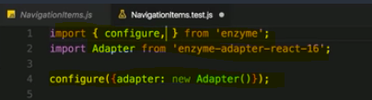

Now we want to render a navigation items component and then look into it, for this enzyme gives us a specific helper method we can use, we import that too, it's the shallow function.

**Shallow is the most popular or the best way of rendering react components in many circumstances,**

**enzyme offers two alternatives( mount() and render()) which I'll also point you to later but shallow is the one you should use as often as possible because one thing shallow does is it renders the component with all its content but the content isn't deeply rendered.**

**So the navigation items component here has navigation item components but these are only rendered as placeholders, the content of them isn't rendered and that of course again is important for creating isolated tests where we don't then render a whole sub tree of components, we just want to render this component and know what's inside of it without rendering everything which is nested inside its included components.**

**So shallow is the method to use here. we pass jsx to the shallow method.**

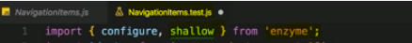

Here we have used the shallow() assertion method. shallow() will test the component we are providing, and ignores any child components that may be present in the component tree thereafter; if we had a <Header /> and <Footer /> component within <App /> for example, they would be ignored in this test.

shallow() is a type of unit test for React. A unit test is a test specifically designed to only test one function. When we are testing functions that rely on other functions, we refer to such tests as integration tests. Likewise, if we are testing an entire React component tree instead, this would be an integration test.

In Enzyme we can do such a test with mount(); a full rendering test that takes the entire component tree and lifecycle methods into consideration.

**we of course need to import react then because no matter if it's a test or not, the jsx code needs to be converted to its react create element alternative.**

**So now we're shallowly rendering this and we're storing the result in this wrapper constant, now we can have a look into the wrapper in this test. And that's the last part of testing, we now our expectation, for that we use another method which is made globally available by jest, the expect method.**

**Inside expect, we define the thing we want to check so here I want to check if the wrapper contains a certain element. Now on the wrapper, we can again use a utility function (.find) provided by enzyme defined method, this allows us to look into the wrapper and see if it contains a certain content and here I want to find a navigation item.**

**So we need to import this too, I'll import NavigationItem and therefore here in the find method, I now want to find NavigationItem.**

**Important, this now is not a jsx element, it's this normal exported function from the NavigationItem file.**

**Now with that imported we want to check if we find that, but what is our expectation then?**

**these are some utility methods made available by jest. there are a couple of helper methods.**

**So we can expect to find the NavigationItem two times if we're not authenticated.**

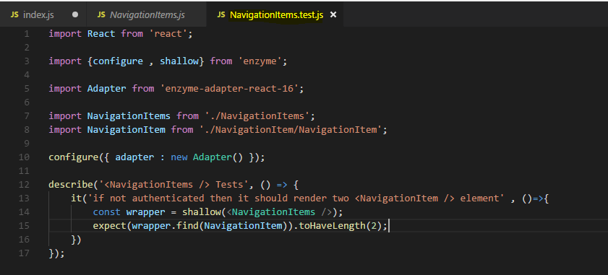

**Now it will have isAuthenticated set to false because we're not passing this prop, remember? We're just shallowly rendering navigation items, we're not sending any props here. Now if we render it like this, isAuthenticated is not passed and therefore will be treated as false.**

**So with that, this test should actually succeed.**

Now let's find out how we can test it then. For this let's have a look at the package.json

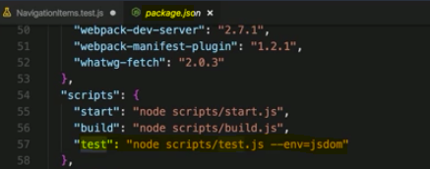

we can run this with npm run test or just npm test actually, like start it's a special script where we don't need to run command.

This will now execute all the tests and it will automatically scan for all tests files by looking at the ending, test.js. save this file, so I should do so now, this will then automatically rerun our tests, it's watching the test files.

The warning regarding the polyfill can be ignored,

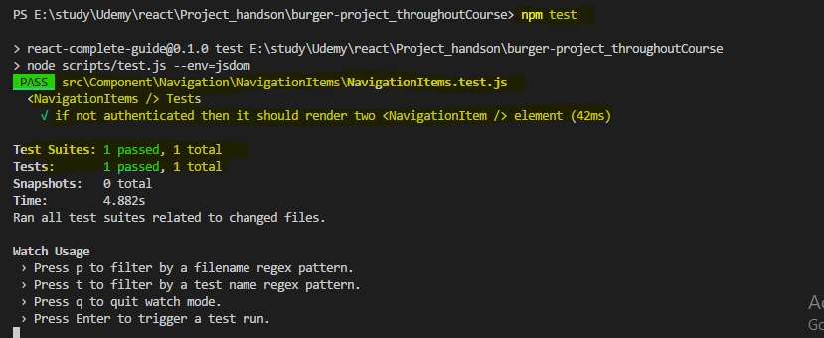

So our test is passed as we have expected and this is how we write a test for a component.

### **Testing terminology:**

* **Smoke test:** Verifies that a component renders without throwing. Utilising Enzyme’s shallow() is indeed a smoke test, as is mount().
* **Shallow rendering:** rendering a component with no children. Enzyme’s shallow() is a form of shallow rendering, whereas mount() is not.
* **Full rendering:** Rendering a component and all of its children. mount()is a full rendering method whereas shallow() is not.
* **Static rendering:** Rendering components to static HTML files and then analysing the results. Enzyme’s render() method is used for static rendering.

### **Let’s Write another Test**

let's now write another test for the same component now we want to have three navigation items if we are authenticated, so for this we simply need to pass the isAuth prop and adjust our test.

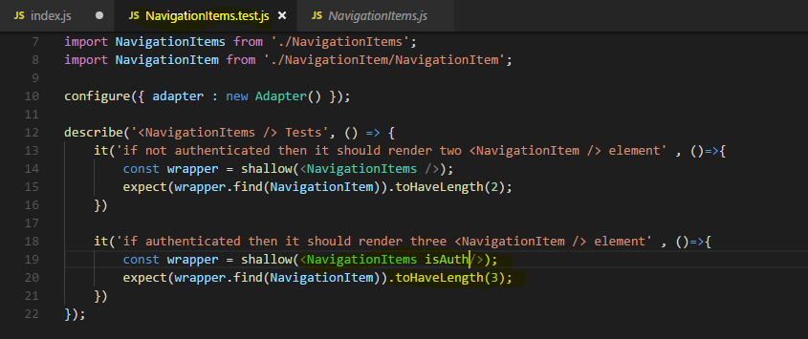

if some line of code is common for all test then , **there is a helper method we can use inside the described function here.**

**It's the beforeEach function, this is a function which will automatically be executed before each of your tests, you also have an afterEach function for cleanup after all your tests if you need do. So we can do some general set up in beforeEach.**

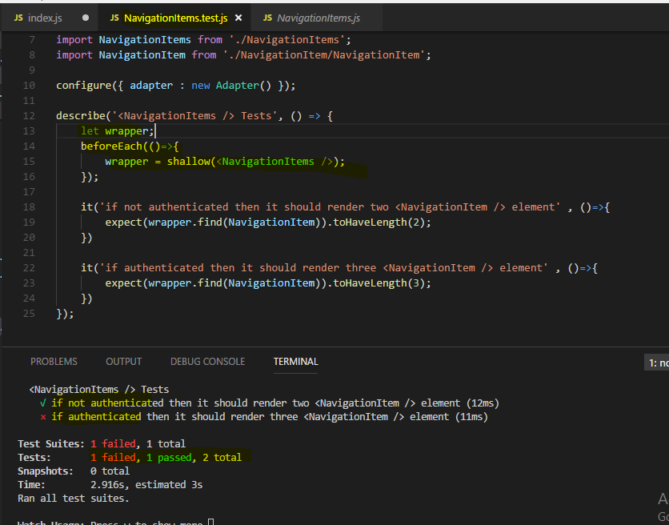

we of course have a failed test.

We can now look at it, the test which should render three navigation item elements if authenticated fails and it makes sense that it does because we never are authenticated, we only render the wrapper once here and we don't pass isAuth to it so we are unauthenticated, this test of course uses the same wrapper and hence fails.

Now what we can do here is two things,

**the first is that we can of course use the wrapper and set it equal to shallow with navigation items here and pass isAuth as we did before, if we save this, both tests succeed.**

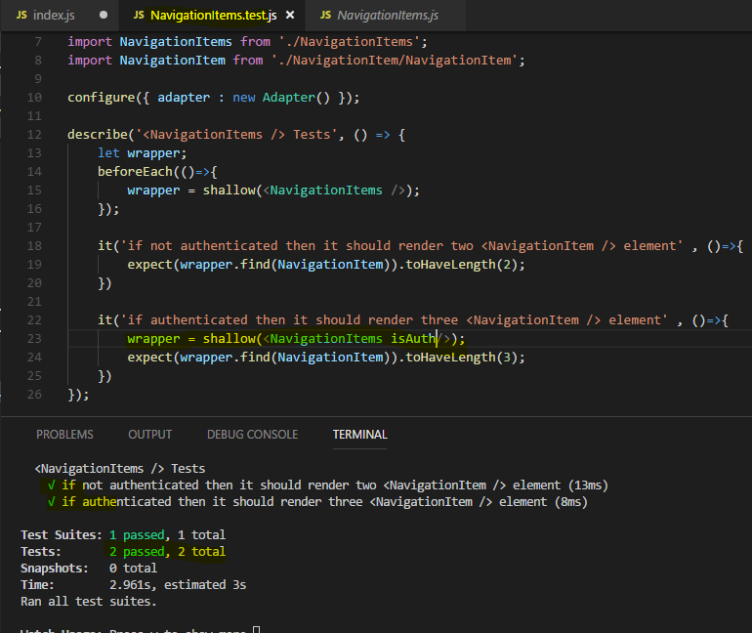

**we can also use another helper method of the enzyme package, we can access the wrapper and then there is a setProps method we can execute on that wrapper, so on anything which stores a shallowy or other rendered react element.**

And to set props, we simply pass a javascript object with key value pairs where the keys are the prop names and the values, well the values of the props

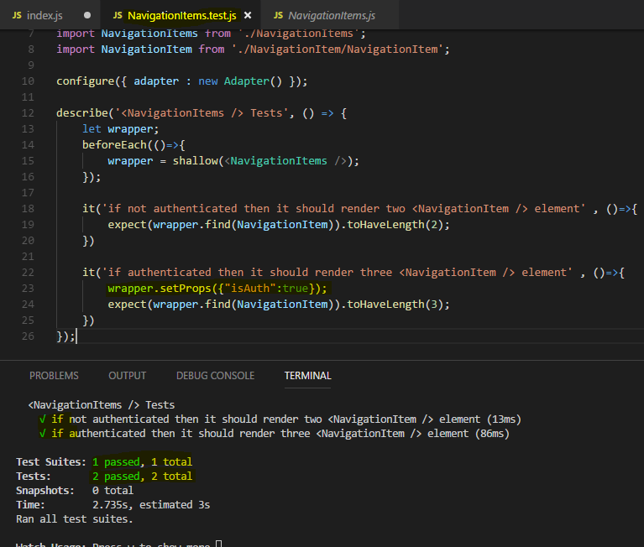

# **Webpack**

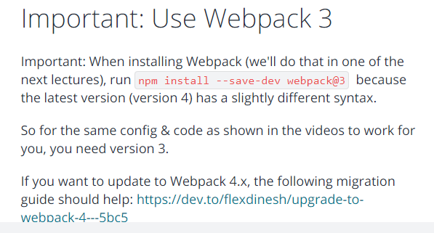

## **Introducing Webpack**

**Webpack is a bundler but it actually is more than that, a bundler alone would just concatenate files, webpack does that but it also allows you to optimize your files and you hook in various plugins and so-called loaders to also transform your files and for example transpile next generation javascript to current generation javascript.**

in its core,

**the idea behind webapck is to have multiple javascript, css, image, whatever files and bundle them together. It analyzes connections between these files like imports and then bundles everything together, allows you to optimize it.**

webpack is the de-facto standard for setting up projects these days. That's why we'll also **use it in this module for setting up our own react workflow and project.**

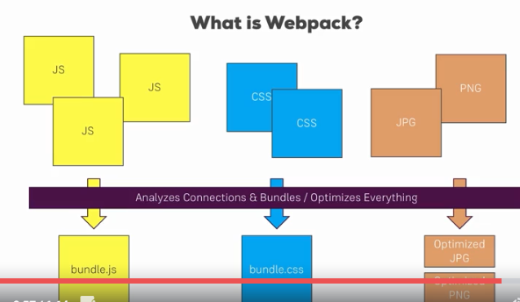

## **How Webpack works**

let's understand how it works behind the scenes since it is such a crucial tool handling our whole build workflow.

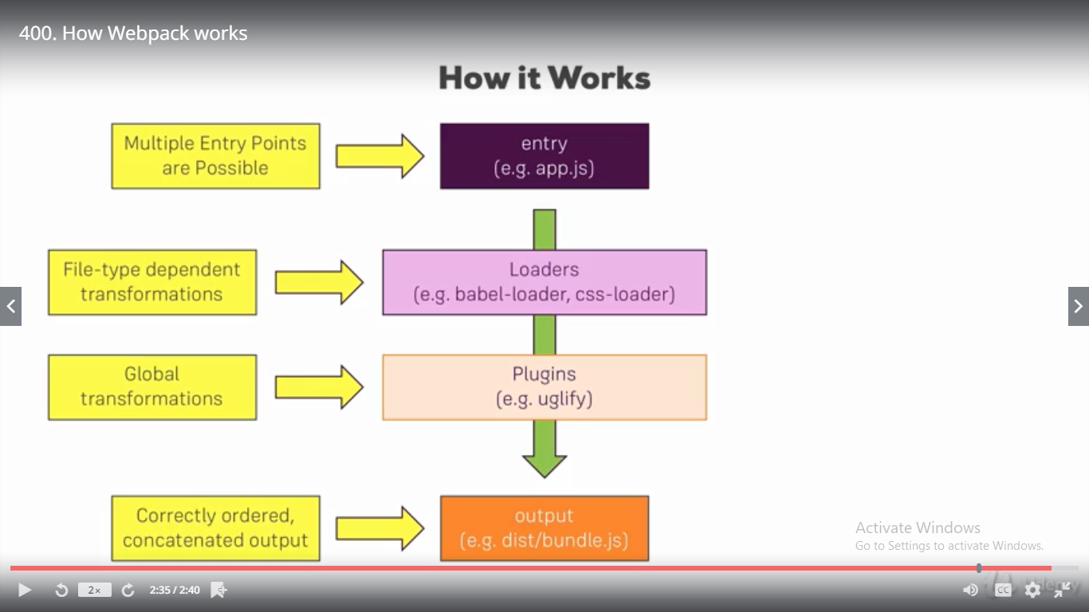

Behind the scenes, webpack has **four important things**, four important features.

### **entry**

**it always needs at least one entry point, you can have multiple ones.**

**This could be our app.js file, our root javascript file which mounts our react application to the dom, which calls react dom render for example, it needs this file since it then analyzes the dependencies of this file and the root entry file will have a dependency to another file which then in turn has more dependencies, so webpack can build up a dependency graph starting with that root entry file so it can understand which files make up our application**

### **output**

**if we give it our entry file. It then analyzes all the dependencies and bundles them together into an output we specify it like a bundle.js file in a dist folder, we specify the file name and where it should go. And there it will put all these dependencies into that file, correctly ordered and in one concatenated output file.**

This is the core functionality but as I said it's more than that,

**in-between, there are two other important features we can utilize.**

### **Loaders**

**loaders are applied on a per file level so we can for example say all javascript files should get handled by loaderX, all css files should get handled by loaderY, babel-loader and css-loader are two popular examples which get used in a lot of projects, so loaders are file dependent or apply file dependent transformations.**

### **Plugins**

**We also then have plugins where loaders are applied on a per file basis, plug instead take the concatenated files, so the bundle but before it's written to the output. Here we can apply some general transformations or optimizations like uglify, so this is on a global level and happens after the loaders did their job.**

This is how webpack works, what it does behind the scenes and **this is all set up in a webpack configuration file.**

## **Basic Workflow requirement**

let's first analyze what the requirements of our workflow are.

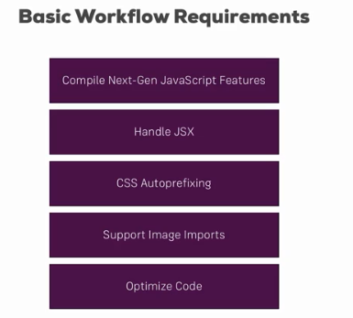

We certainly want to support next generation javascript features so we need to be able to compile that next generation javascript code to current gen javascript code which runs in all major browsers these days. Additionally we want to be able to handle jsx so that we can use jsx in our script files, in our react project. We also want to add css auto-prefixing so that we can write simple css rules and get automatic prefixing so that it supports the best syntax in all browsers our applications supports. And we also want to support images of course, we should be able to import images as we did it in our create react app and then use it to our template. Finally we want to optimize the code, before we built that bundler or we spit it out, it should be optimized to shrink our javascript code to as small of a size as possible.

**These are the requirements, that's basically what creates react gives us though that also gives us more like linting and so on**

**these are the core requirements I also want to build in this custom workflow.**

## **Project and NPM setup**

Now the first thing is that we want to use npm to manage our dependencies, so to manage all the files and the tools we need to set up a working workflow. For that we need to put this project under control of npm which we do by running npm init

you'll see that the package.json file was added, this is the file which we'll use to set up our build scripts and to also the manage the dependencies of our project.

let's install import dependency, with npm install --save-dev,

**we install new dependencies and we mark them as development only dependencies ,it makes it clear which dependencies we use only for setting up the build workflow and which dependencies really have an impact on the running application,**

**you will see that they will be grouped differently the package.json file later. Both --save and --save-dev add an entry to package.json so that we can easily share our project without having to share the big node modules folder too.**



**Webpack-dev-server is this development server we want to use so that we can test our application locally on the machine and webpack is well basically the build tool itself, webpack-dev-server wraps this build tool, they're both from the same team.**

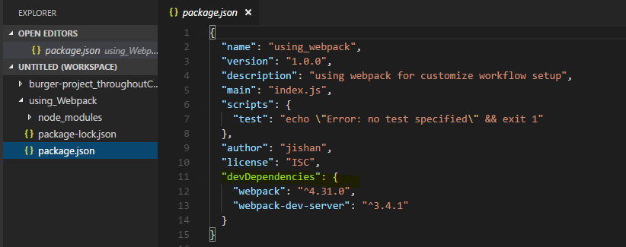

you see that we have the new dev dependencies node in the package.json file.

**we can now share this project without node modules which has all the source code (dependency) downloads in this course and everyone taking this project can just run npm install so that all the dependencies listed in dev dependencies or dependencies, the normal dependencies get installed and the node modules folder gets recreated.**

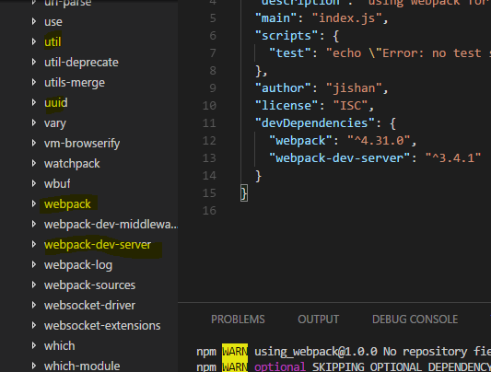

**In the node modules folder, we see a bunch of dependencies not just webpack and webpack-dev-server, that simply is because web pack and webpack-dev-server have their own dependencies which they also installed but here you can see webpack and webpack-dev-server. So with that, we can use these dependencies.**

## **Creating a basic folder and file structure**

we now want to set up our project and first of all I'll set up the project structure I want to work with.

Now I won't recreate the exact structure of create react app but a fairly similar one.

**I'll create a source folder in our root folder and in that source folder, I'll add my index.html file so this single page which gets served in the end. if you got any imports from CDNs of fonts or styles you can add that in the head section, the scripts and any other imports generated by the workflow will be injected into this file automatically though, we'll add a configuration which does this to our set up.**

**With that I'll now add a div to this body which should get a specific ID root, this will be the div where we'll later mount our react application to.**

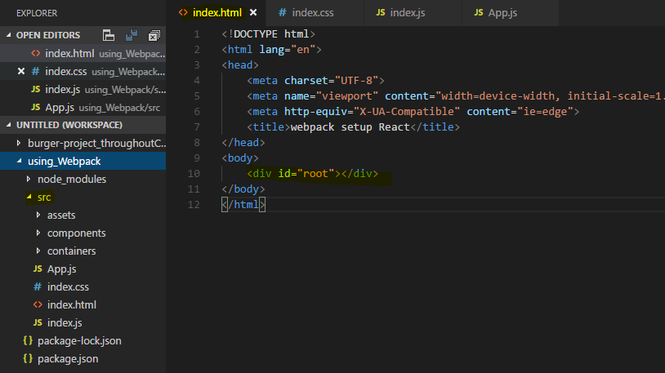

now let's set up the other parts of this project. In the source folder, I want to have the assets folder where we could store images or anything like that we use, I also want to set up a components folder and a container folder so basically the same setup I used in my other project in the project in this course.

Now **I also want to create a react application, for that I'll create an index.js file in the source folder and the index.css file which I want to use for some global styling**, so this will be imported in the index.js file, there I'll import that index.css file

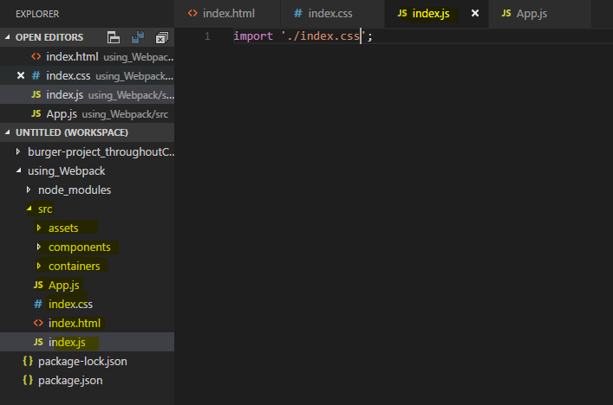

**now I also want to add an app.js file which should be my root component** and then so that we can really see that all of that works,

I want to set up a basic react project which isn't super amazing but which uses routing and lazy loading so that we can see if that works and which just simulates a lot of features we might use in a typical react application, for example it should also incorporate an image. Now I'll set up this demo react project in the next lecture

## **Imp - Creating a basic React Application**

**Let's set up a basic react application we can work with**

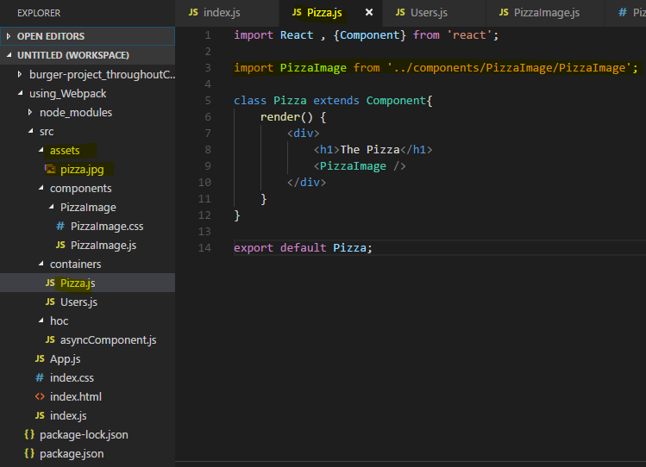

So inside my pizzaImage div, I then want to have an image, self-closing where I want to import that image and output it here as a source.

**Note : my build workflow should essentially copy that file to a new destination when you build the application then and give me a link to that file in this constant PizzaImage automatically.**

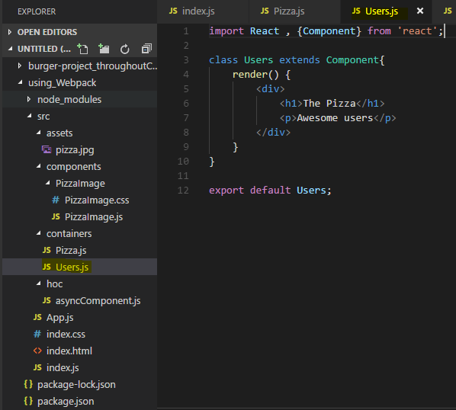

Now I've got two containers,

**now I also want to load them via routing. So in my app.js file, my root component**

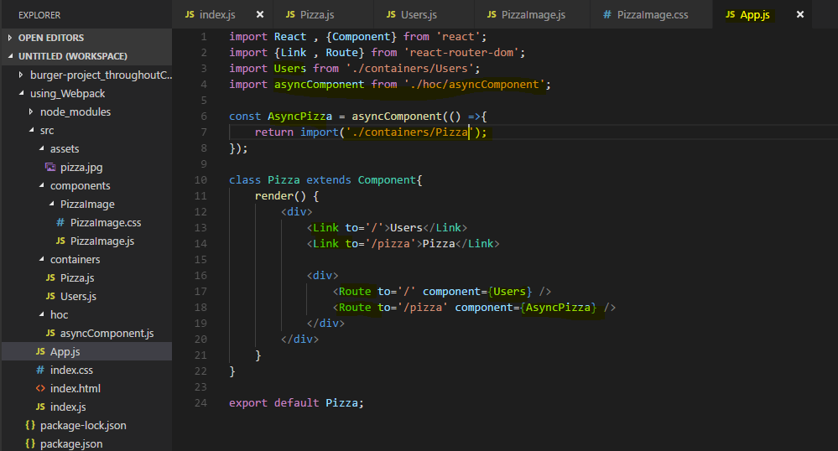

**Here in App.js file , I want to Lazy load my Pizza component hence I have created a hoc component which import the Pizza Component asynchronously whenever needed(we can also Lazy load by React.Lazy – react 16+ version)**

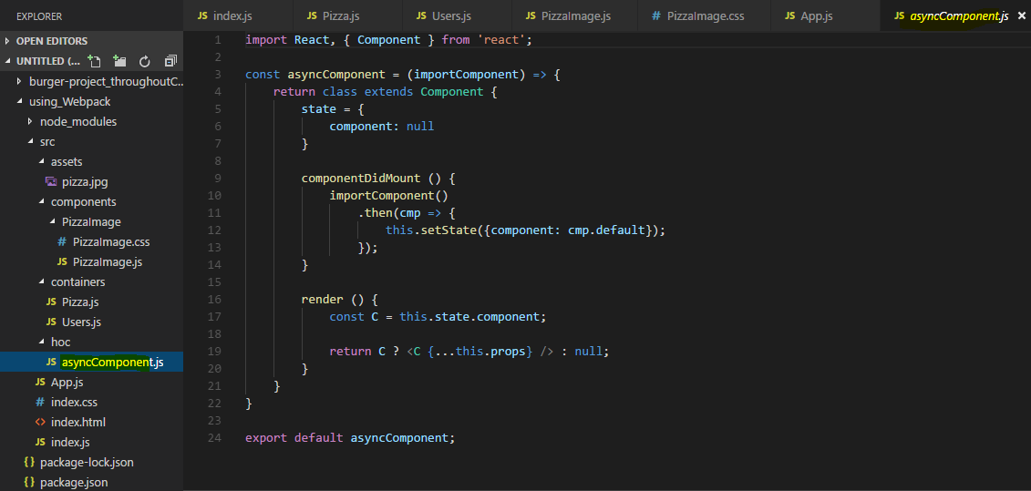

This is my app set up thus far

**now of course we need to mount this app to the dom, for that I need to go to the index.js file so I'll add react-dom render here at the bottom to then render app in the place of this root element, so this div with the ID root in the index.html file.**

So for that, I'll now reach out to it with document_getElementById and then pick the root element here.

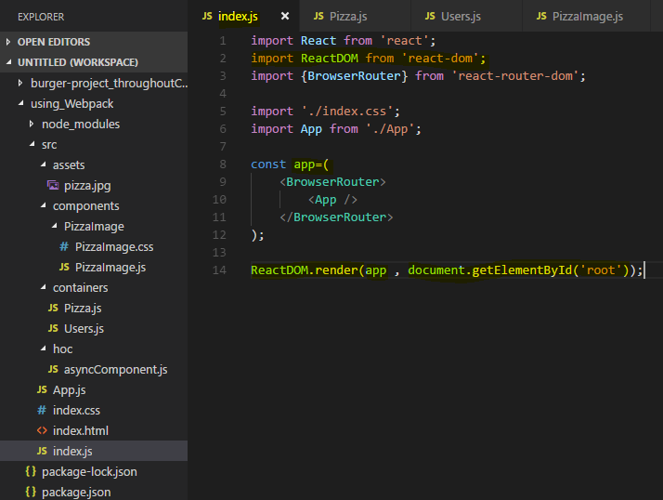

Now with all of that, our react application is mounted

## **Installing Production Dependencies**

now it's time to install some dependencies,

for example the react application obviously uses react or react-dom and the react router

so we should install all these production dependencies,

we do this with npm installed **--save,** **not --save-dev because we want to indicate that these are production dependencies**

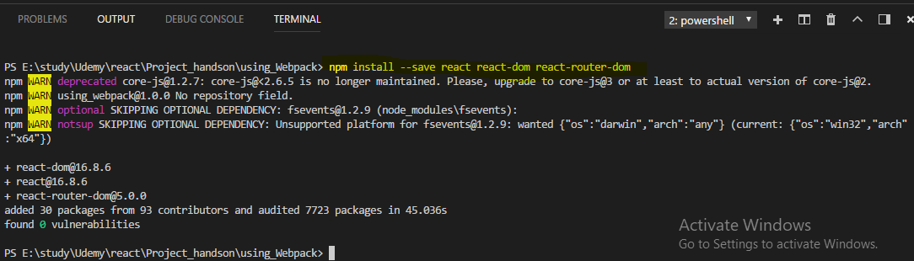

 installed and therefore placed into the node module folder, appropriate entries with the latest versions are also added to the package.json file

we did install webpack a while ago already,

we now need to install a couple of other dependencies to build a workflow and I will add them step by step whenever we need them. So what I want to do is I now want to start with setting up the webpack configuration such that it is able to handle next generation javascript, css, images and all that fun stuff.

## **Setting up the basic webpack config**

We already installed the webpack tool, the dependency in the package.json file and I said that I will manage the workflow through the scripts we have in package.json file

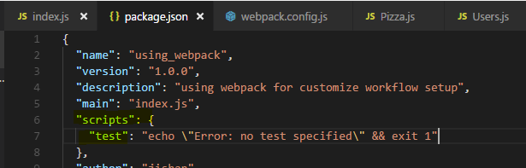

which we then **can run with npm run and then the script name** or in the case of the special script, **npm start we can just type npm start, and the start script should be the one launching the development server.**

So I want to add a new script to the scripts section which is called start and on the right side of the colon, in the double quotation marks which you need to use since this file uses the json format, here I want to simply execute webpack-dev-server

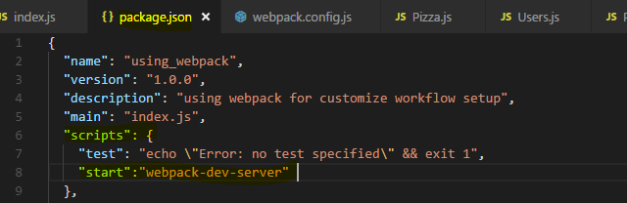

**make sure to not mistype, this has to be the name of this package which simply exposes a function you execute with this call. So this will spin up the dev server,**

however the dev server out of the box won't work, we need to configure it and to configure it, I'll add a new file next to the package.json file, I'll name it webpack.config.js **this is a special file name, make sure to name it exactly like this webpack.config.js. Webpack will automatically look for this file when executing either webpack or webpack-dev-server as we do here, so it will automatically take this file into account, therefore you have to get the naming right.**

in this file, I'll set up my development workflow. We'll later create a separate file for the production workflow because there, we will differ in some aspects, we will apply some extra optimizations and so on.

n the webpack.config.js file, I'll now set up my webpack workflow and for that, we need to export something here which webpack will then use, we do this with the node export format by writing **module.exports and we then set this equal to a javascript object.**

**So this is the syntax webpack understands to read in the config we now specify in this javascript object** and I did mention the four important aspects of that configuration

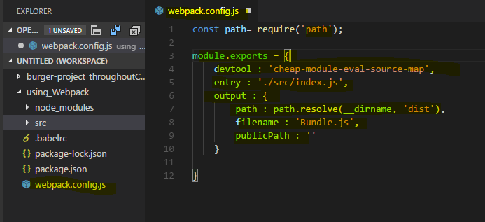

**let's start with the entry point. Here we define where the journey starts for webpack and we want to point to our index.js file here, this tells webpack that it should look at this file first and then analyze the dependencies of that file which are all the imports and then it is able to do something with these imports.**

**However to be able to handle css or any other non javascript file, we need to give webpack some extra set up, we need to do this for javascript files too though since we use jsx which is not native javascript and since we use next generation javascript features too,**

**we also import images and stuff like that so that's all the stuff we have to handle with loaders later.**

**Before we do that, I'll add one additional configuration, it's called devtool and here we can define which kind of source maps, if any webpack should generate and I'll use cheap-module-eval-source-map here. Now that's super confusing long term, in the end it is the best kind of source maps you can generate for the development, very detailed, good performance, so this is what you should use here to get source maps which allow you to easily debug your original code in the browser.**

So with that we get the entry

let's now also define the output

**so the output key and here I want to create a new folder with a file, output is not just a string, it's an object and in that object we configured the path, so where this should be stored, the file name, so where our or how our file should be named and the public path, that's important for webpack to know where our files are put to and if that then is the root folder of the server in the end or if it's a nested folder.**

**So here it should be the root folder so public path is just an empty string which means you store the files in a specific folder and you don't need to adjust any imports or adjust for anything, the file structure, the folder structure will be the folder structure as we deployed in the end. More important is the file name, here that's a string too, we define what the file should be named and I want to name it bundle.js, it's a convention to use bundle.js just because it is a bundled javascript in the end.**

**Now you might wonder what happens to css images, this will be handled differently by certain loaders we add and the loaders will define where the css or image code is put,**

so this only affects javascript therefore it's bundle.js.

**Now the path is also important, where should the assets be stored? And there I will actually import a node module which is called path which I do with the node import style where I require the path module. Now we didn't install this with npm install but it is a default node module, so since we have node installed we can also pull this in. The path object here has a resolve method which allows us to generate an absolute path in the end, here we can pass a special variable which we have available in node systems and webpack will use node behind the scenes, so it will have access to that variable, it's __dirname and it refers to the directory**

this is running and then the second argument to resolve is the folder where we want to create it and resolve will then create an absolute path taking the full path to the current folder on our operating system and appending dist,

**so it will in the end output a file in the dist folder which doesn't exist yet which it will create instead which is named bundle.js, this is the output of this operation.**

**Now that is the base set up here, this doesn't transform any files or anything like that though** so these are all things I'll take care about in the next lectures.

## **Adding File Rules**

One important thing we have to add upfront is to make sure that webpack automatically appends .js at the end of these imports here so that it is able to import that correctly.

Now to get it to behave like this, we have to configure it in a certain way, in our webpack config on the same level as entry output and so on, **we add the resolve configuration**.

**That takes a javascript object and there we can resolve some extensions, so we can basically tell webpack that it should be aware of certain extensions and if it encounters an import without an extension, it should try these extensions and see if it finds a file of one of these. So that's an array of possible extensions and I want to support .js , .jsx and .json here so that it will see if it finds a file with that extension if no extension is defined.**

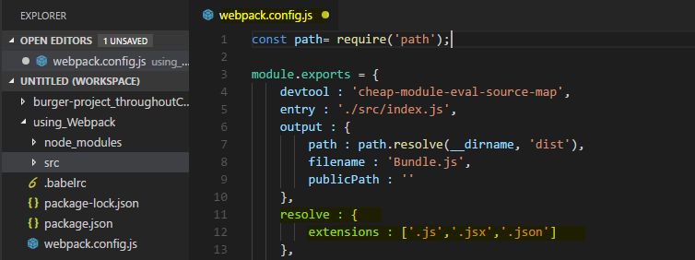

**Now the next and most important thing are our loaders though where I want to make sure that we do correctly handle different file types, this is done with a special configuration on the same level as output and resolve which is named module because I import a dependency is referred to as a module, so you could kind of translate module with file.**

**So here we set up what webpack should do with the individual files and we control this with a rules array.**

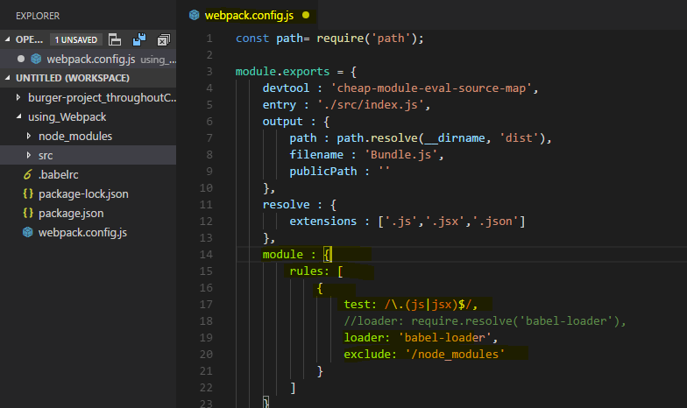

**Now each rule is a javascript object and each rule now needs to first of all test, which means test if a given file, a file webpack identified fulfills a certain criteria, this criteria is the file name and is checked with a regular expression, the regular expression commonly checks the file extension.**

**So we could say anything ending with .js or .jsx and I have to escape the dot here since we're in a regular expression and otherwise it would refer to any character.**

**If we're in a .js or .jsx file, so if it ends with .js or .jsx, then I'll want to apply a certain loader, now a loader is like a third party plugin which does something to the file.**

**Now for js or jsx files, I also want to add an additional configuration which is exclude which allows me to exclude certain patterns. Also a regular expression, I only want to check for node modules in the file path, so it shouldn't try to transform anything in node modules since these are third party libraries we already do import, we don't want to transform them again, they are already optimized, it should only touch our own files.**

Now what about this loader though?

**Well for javascript, we will use the babel loader, babel is the defacto standard for transpiling next generation javascript to current gen javascript, so let's install and configure babel in the next lecture.**

## **Introducing Babel**

for javascript I mentioned that I want to use babel, the defacto standard for transpiling my javascript.

**We will install it with npm install --save-dev again because it's a development only dependency**

**we need to install the babel-loader package, that however does just provide the hook for webpack. Babel itself is a library which kind of has the knowledge about how to transpile your javascript, so we also need to install babel-core which holds that knowledge.**

**We now also need some configurations to basically tell babel which kind of next generation javascript or which special javascript syntax we want to support and here, these are so-called presets, the packages we need are babel-preset-react to support jsx and babel-preset-env for an environment adjusting preset which basically has a look at the features we use and automatically transpiles everything correctly.**

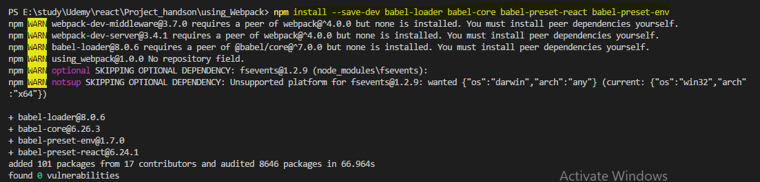

**now we need to configure babel because just because we installed the presets doesn't make babel use them, it doesn't analyze all other packages we installed and then see if there is a preset inside of them.**

**So instead we add a new file, dot and the dot at the beginning is important, .babelrc**

**that's a configuration file babel will automatically read if it's in our root folder, so in the same folder where we will later run our webpack build workflow.**

**The babelrc file takes adjacent configuration and there we should add a presets node, now we can make babel aware of all the presets we want to apply**

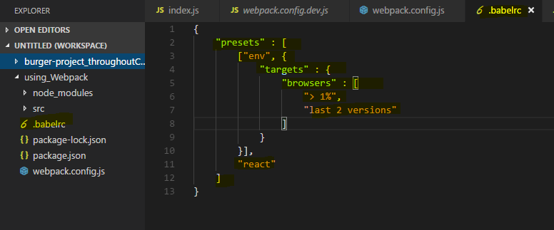

and here**,** I want to apply two of thepresets,the first one is env and the second is react.

So these are the two presets we installed without the babel-preset- thing at the beginning, just the path at the end so react and env, these are the two presets.

**Now the env preset will receive some special configuration from my side, I do this by enclosing it into an array with square brackets and then the second argument after the name of the preset is a javascript object where I can configure it and here I want to set up the targets of that preset which means which browser versions do I want to support,**

**that's of course important. It automatically identifies which next generation features I use but to know what next generation actually means, it needs to know what my current gen is,**

**so which browsers do I target with my app?**

**So targets is another javascript object where we can then set up browsers and browsers then is an array where we can use the browser list type of configuration, you can google for browser list to find this repository here to learn more about the syntax you can use for configuring browsers. However the syntax I'll show you here is a pretty common set up.**

**So what we want to do here is we want to target greater 1% of market share or last two versions so this is will be combined with or in between.**

**So now this is the target environment we want to support and this is what babel will then take into account when compiling our next generation javascript to current gen, it will compile it to javascript which runs in browsers which fulfill this criteria.**

So with that, we get the babel configuration finished, now we can add the babel loader in our webpack config

**I'll therefore add a loader in single quotation marks, the babel-loader. So here I take the full name of the package we installed, babel-loader.**

**So now it will be applied to javascript files compiling the jsx and next generation javascript features,**

**it would still fail though because we also import css which webpack wouldn't understand, it only understands javascript natively and in the pizzaImage component, it would import css and even an image, so we need to support that too.**

### **Note :**

**If you have latest webpack installation , then babel installation and file also changes**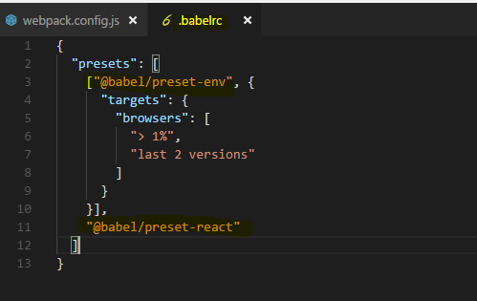

**npm install --save-dev @babel/preset-react**

**npm install --save-dev @babel/preset-env**

**npm install --save-dev @babel/core**

Let's add support for these types of files in the next lecture.

## **Adding CSS file support (css-loader/style-loader)**

let's now also support css files and images. For that, I'll add a new rule and I want to start with css,

so we test for files ending with .css, that's our simple test.

I also want to exclude anything in node modules here just to be safe

and then we can define which type of loader we want to use here.

**Now for css, I actually need a more complex setup, for js we also have a quite complex set up but that's all handled through babel and our babel config,**

for css we'll configure it here in the webpack config file.

**So instead of loader I can use use here, that's the long form, loader is the very short form if we just want to set up a loader without any config, if we want to set up multiple loaders or a loader with config, we should use use here.**

It takes an array of the loaders we want to apply and here, I now want to install two loaders

I'll do that with npm install --save-dev css-loader style-loader

**Css-loader basically tells webpack what to do with these .css imports and the style loader. That's a loader which will then extract the css code from the css files and inject it at the top of our html file hence reducing the amount of file downloads we have to make.**

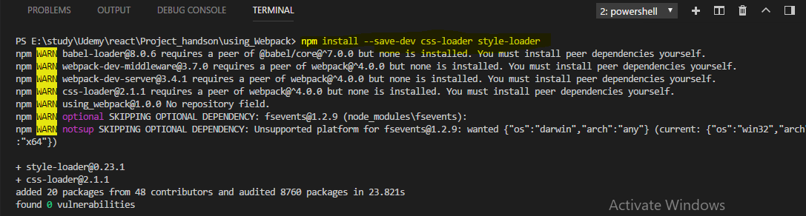

**in my use array, I'll add a javascript object which has a loader property again where I define the style loader, it's followed and the order does matter here by another object with a loader, the css loader.**

Now important and this is easy to mess up,

**webpack parses loaders in this use array and applies them from right to left, so from bottom to top if we write it like this. So it first takes the css loader which it should because that makes it understand the css imports and don't throw an error and then it applies the style loader on the extracted css code and that's exactly the order we need here.**

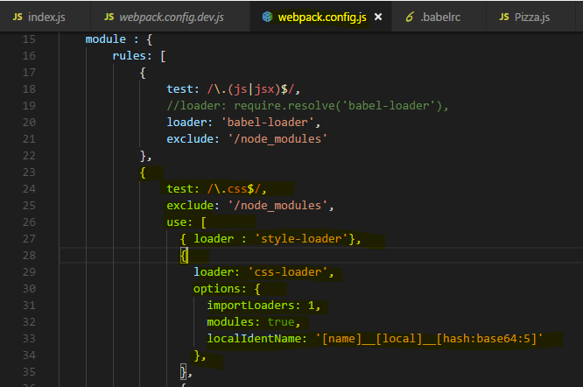

**Now we can also give the css loader which is responsible for parsing and handling the css another property which is called options. Now options is a javascript object where we can configure this loader.**

**now here I want to set modules to true to enable css modules and I'll set up the localIdentname to define how the generated css classes due to css modules should look like. And here I'll take the name of the class we defined, two underscores then the module name, so the component name and then a hash to really have unique names, this is the same set up we added in the styling module to do the configuration create react app gave us.**

We're not done with css though,

**I also want to add auto-prefixing and for this I'll install another package with npm install --save-dev postcss-loader** 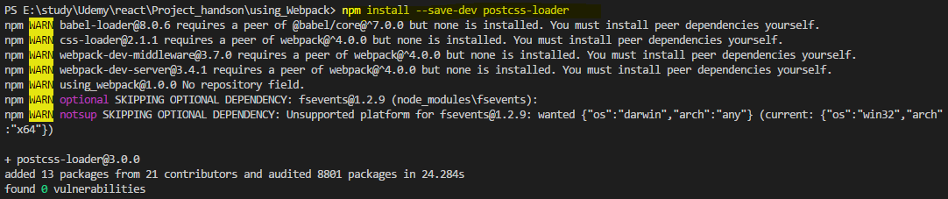

**now postcss sounds like it does something to css after we parse that, here it'll actually run before the css loader, dive into the css file and adjust our code before css loader pulls it out and adjusts the class names and so on. The post css loader simply is a loader which allows us to transform the css,**

**for example we could also use postcss loader to handle sass and stuff like this, here**

**however I will simply add it as another loader and therefore in third position because it should run before that css loader**.

Here I will set up my loader which is postcss loader and I need to set up my options on that loader with the options key where I now want to set the ident option, that's important internally here

**but more important are the plugins, that actually takes a function which returns an array and these are now steps we should apply or we want to apply to transform everything.**

And here I want to run **autoprefixer**, now autoprefixer needs to be installed.

It's a separate tool. So I'll run npm install --save-dev autoprefixer,



**that's a third party library which is able to auto prefix our css properties, we need to import it into the config file** so I'll create a new const, autoPrefixer which uses the required syntax to import autoPrefixer.

Now with that import added, we can add this to the plugins array here, so here I'll add autoPrefixer and this is actually a function we need to execute and we pass a javascript object to it to configure it and there again we pass a list of browsers

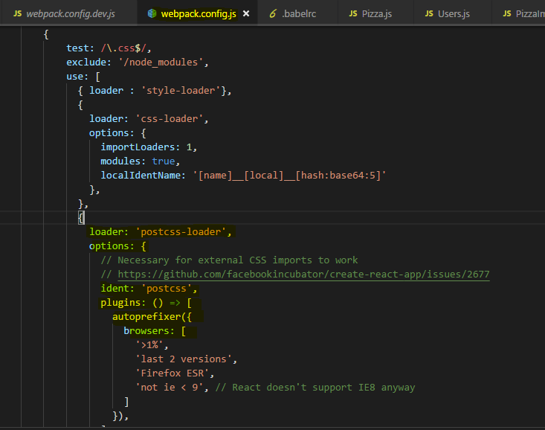

That's the bare minimum set up I want to use.

**Now since we run one additional loader before css loader, we actually need to inform css loader about that, that's just a special set up css loader needs.**

**So there I'll add importLoaders : 1 because we run one loader before css loader is applied.** And that's our css handling setup

let's continue and let's make sure that we now also can handle images since we also import these.

## **Creating rules for Images**

I'll add another rule and that rule should test for images. I want to use a loader we have to install with npm install

**npm install –save-dev url-loader**

**URL loader is a loader which will take our images and if they are below a certain limit we define, it will actually convert them into data 64 URLs which it can inline into our documents, so we don't have to download extra file. But for bigger files, it would be inefficient so files above that limit we specify will simply be copied to our output folder and it will then generate a link to these files and put that into our import we use in our components.**

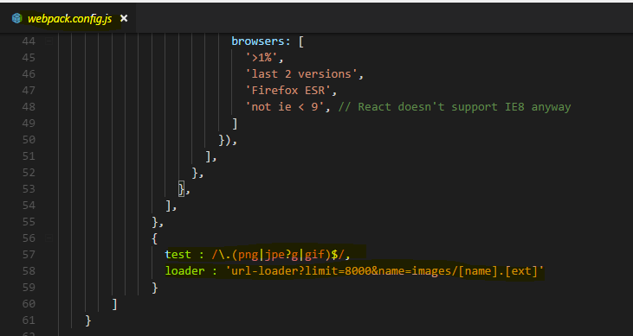

What we do here is we use the URL loader here but now we configure it with query params and we do it with query params so that the configuration here, it gets automatically passed onto a fallback we will use if the limit is exceeded.

Now that fallback is another loader we also need to install though

**run npm install --save-dev file-loader**

**file-loader is a loader which in the end simply copies the file you could say, because it copies it into a new direction and gives us a link to it and that is the fallback we'll use automatically here if we exceed the limit**

we now define here. As a query param, limit could be let's say 8000kb, so anything above that will not be inlined but will be copied. And we need to pass some configuration to the file loader, the name and that's also the path of where we want to store that file, I'll use **images/[name].[ext], these are placeholders taking the original name and extension. So the image is going to get copied into that folder, in our dist folder because that output set up is taken into account even though we're not creating a bundle.js file but the path still is taken into account, so that is where our images will end up at if they're exceeding this limit.**

So this is our loader for images and with that, the image files we import in our javascript files shouldn't pose a problem anymore.

**Now you can add more rules for different file types, for fonts for example, but I'll keep it to it for now**

let's now turn our heads towards plugins we might want to use and then most importantly, have a look at how this actually works and if it does work.

## **Lazy Loading support in webpack**

now I want to have a look at plugins and then see if the setup actually works.

Now regarding plugins, it's actually super simple for us here, we don't need any for development workflow, we will add one later when we set this up for production, there I want to add some plugin but for now that is all, I won't add a plugin here.

Let see if this works

if we run our start script which runs the dev server which I said would automatically take this config file.

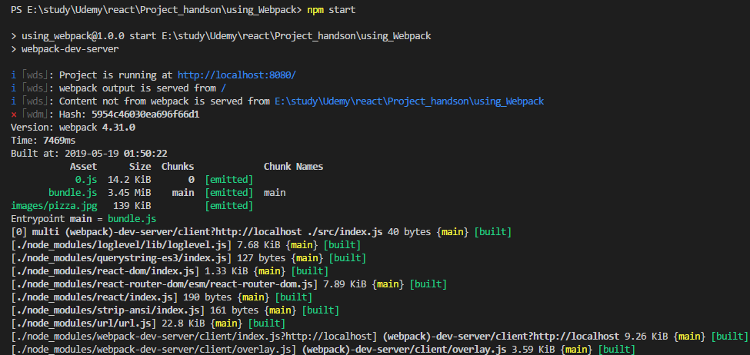

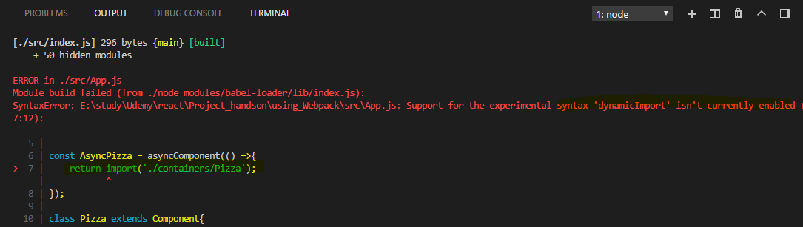

**So now at least it doesn't crash when starting the server, it does give us an error though that it doesn't understand this import syntax here, the dynamic import syntax, it doesn't understand this.**

So how do we make it to understand this dynamic import?

**We need to adjust our setup here to be able to create dynamically generated extra chunks of code, lazy loading means that it's an extra bundle and not part of the main bundle which is downloaded initially, to support code splitting in webpack and code splitting is just a different name for lazy loading,**

I have to add **chunkFilename** here to my output config.

**This simply determines what these other files, the separate files which are generated for the lazy loaded code which is of course not included in the bundle**, that would defeat the purpose of code splitting, what these file name should be named.

They have to have a variable part in their name because they are generated by webpack dynamically, I'll use “[id].js”

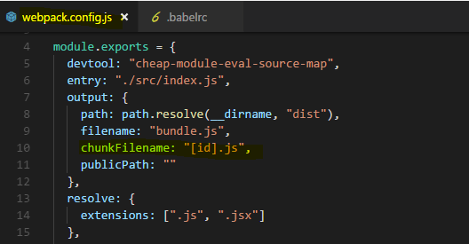

here, IDs are dynamically generated ID 0, 1, 2 and so on, generated by webpack **so that feature is outsourced into separate bundles received their own javascript files.**

Additionally we need to make babel aware of this dynamic import syntax which it otherwise doesn't understand I'll install a plugin

it's called babel-plugin-syntax-dynamic-import and this will make sure that babel understands this dynamic import syntax.

npm install --save-dev babel-plugin-syntax-dynamic-import



So once this was installed, we can go to the babelrc file and we already get presets, now I'll also add a plugins node here which also is an array and here I'll add my syntax dynamic import plugin, so that's the name of the plugin.

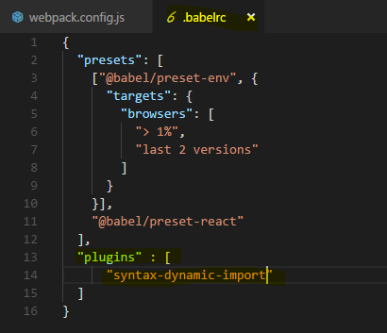

With that added, let's save all these files and let's retry npm start and see if this now works,

now this compiles but we get a different error,

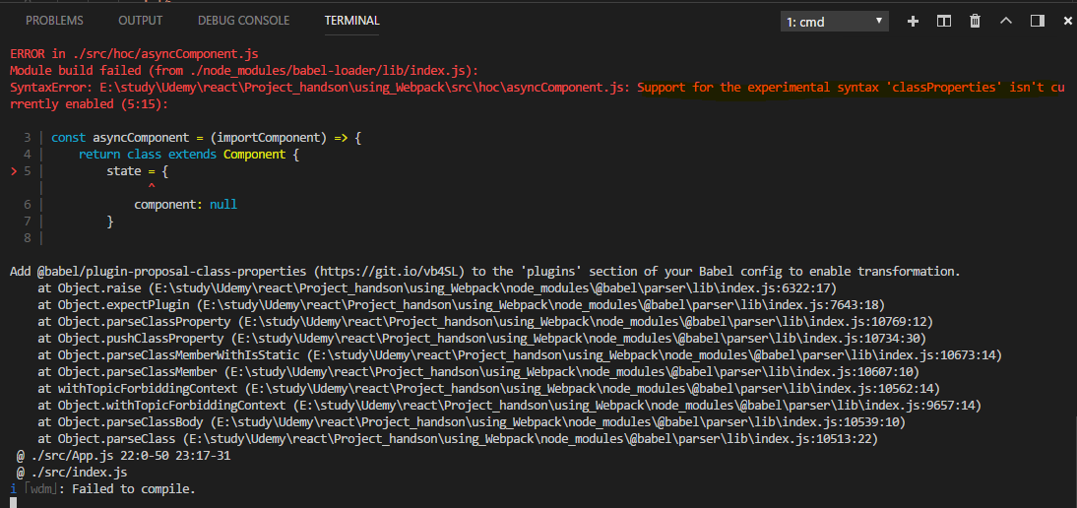

we get an error that this syntax here where we assign our properties like this isn't supported.

**The reason for this is that the env preset which we're using, this one here only supports latest browser features that are part of the specification. this special property syntax is only in draft state though and it's not included in the env preset**

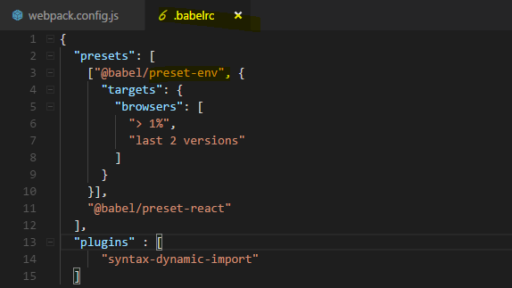

It isn't a problem though we just have to add another preset.

we now install another preset which is named babel-preset-stage-2,

**stage 2 presets simply are draft features which may eventually get supported but which we already want to use.**

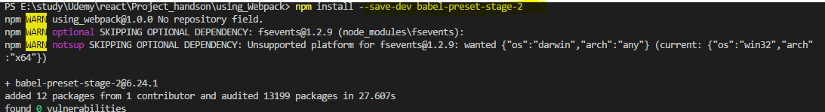

Now we have to add this to our babel setup 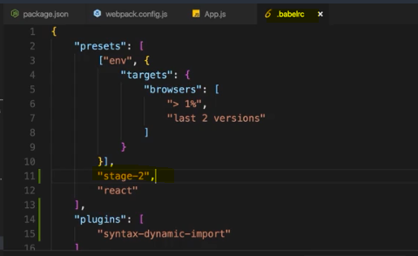

### **Note : Error**

If you get this Error - 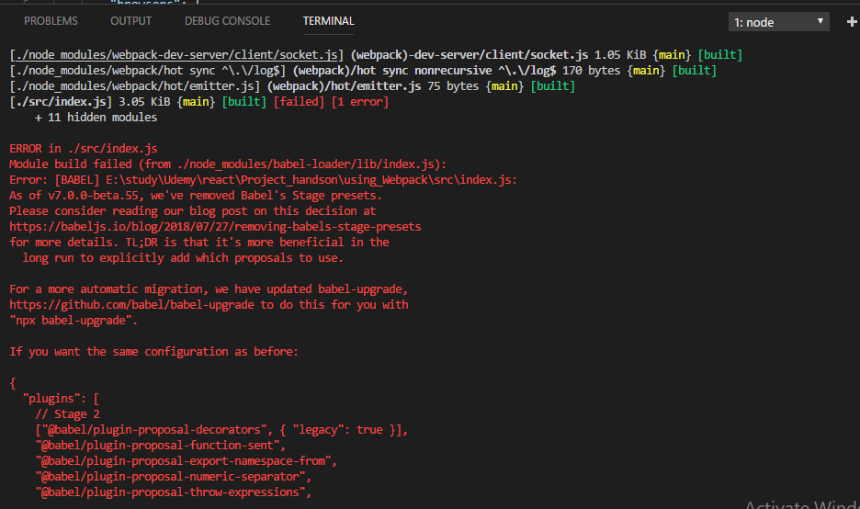

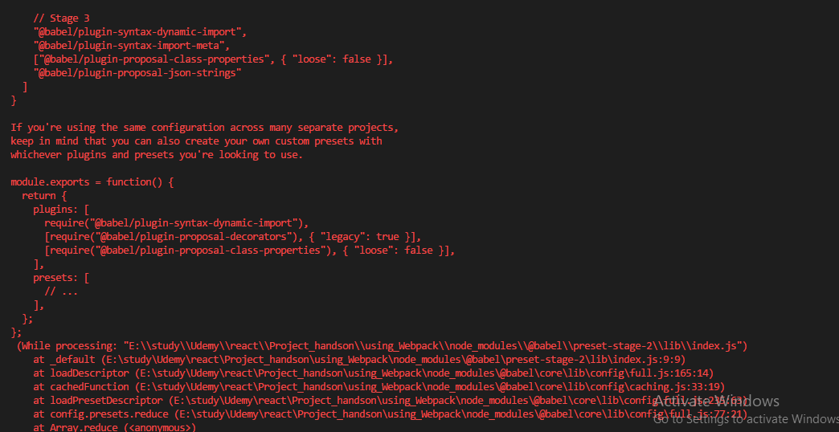

**Try this -** 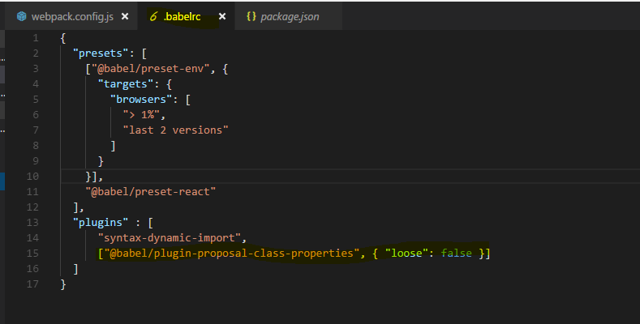

Let's now try this again with npm start and now this looks better, at least we don't get an error,

we'll face one problem though. The application is now served and by default, it's doing that on localhost8080,

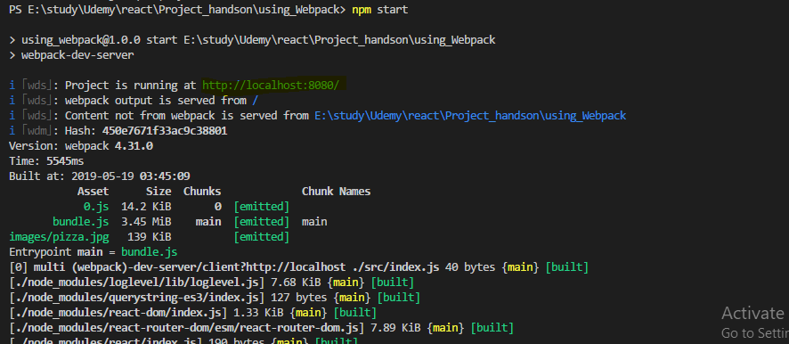

so let's open that, there however we won't see app,

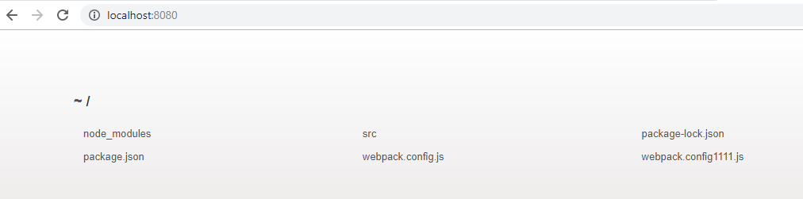

**the reason is that we didn't connect our build output which by the way is not stored in the dist folder when we use webpack dev-server but in memory, that we didn't connect that output with the index.html file, we have no imports in that file,**

how would we add the script to it?

That is something we have to do on our own and we will do that in the next lecture.

## **Plugins – Injecting the script into index.html file**

**To make our project work and servable by the dev server or later in production, we need to connect our index.html file to the output files which are generated, when using the dev server they are only stored in memory but they're still generated.**

We need to install a webpack plugin for that,

**npm install --save-dev html-webpack-plugin**

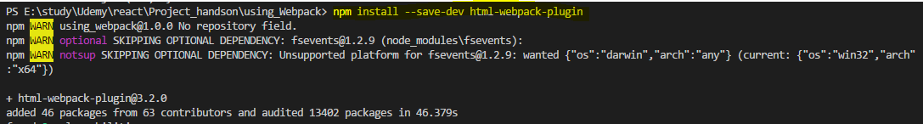

**this is a special plugin which allows to connect our html file with our output and webpack will do that automatically and inject our bundled script and so on into that html file.**

In the webpack config, we now add plugins, it's a new node on the root config level, plugins and it takes an array as an argument or as a value, I should say.

And now first of all we need to install or import I should say the html webpack plugin, so I'll create a constant which I'll name htmlWebpackPlugin but the name is up to you and here I will require html-webpack-plugin, the package we just installed.



Now in the plugins array,

**I create a new instance of it, new HtmlWebpackPlugin and we pass an object to the constructor where we configure this plugin. I'll setup a template, so the html file I want to use as a basis  /source/index.html, constructing a path to it. So now we're pointing to the file we want to use as a template, I want to inject my stuff into the body that's extra configuration we can pass to the plugin here and the output file, filename should also be index.html, that's the file it will eventually generate, again for the server only in memory,**

**later when we use a different workflow for building this, for production, it will give us the real files we could upload to a server.**

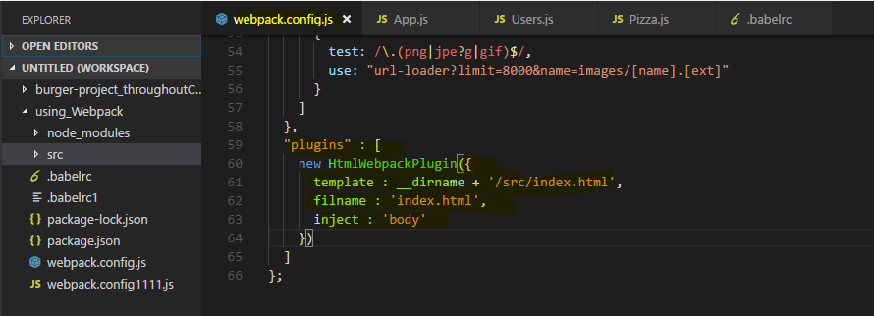

**Lets now try it -** 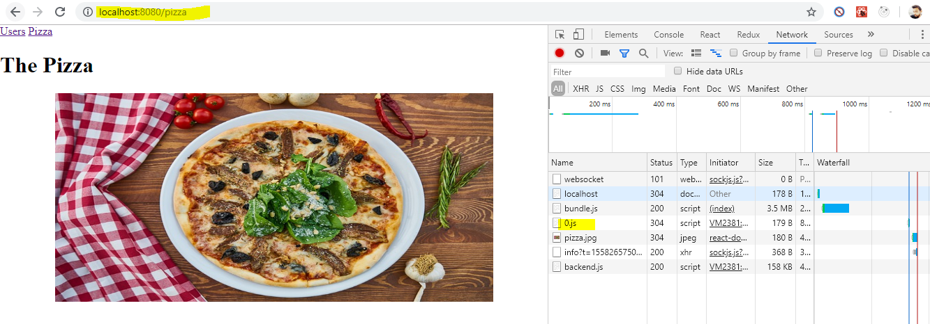

**if we inspect the network tab and I go back to users and reload the app, watch the network requests, you see that 0.js file? That's our lazy loaded javascript file we downloaded, so lazy loading is working here and our react application is working**

**he styling also seems to kick in, if we inspect the pizza image we see we're using css modules here and we get the styles we setup in our css files.**

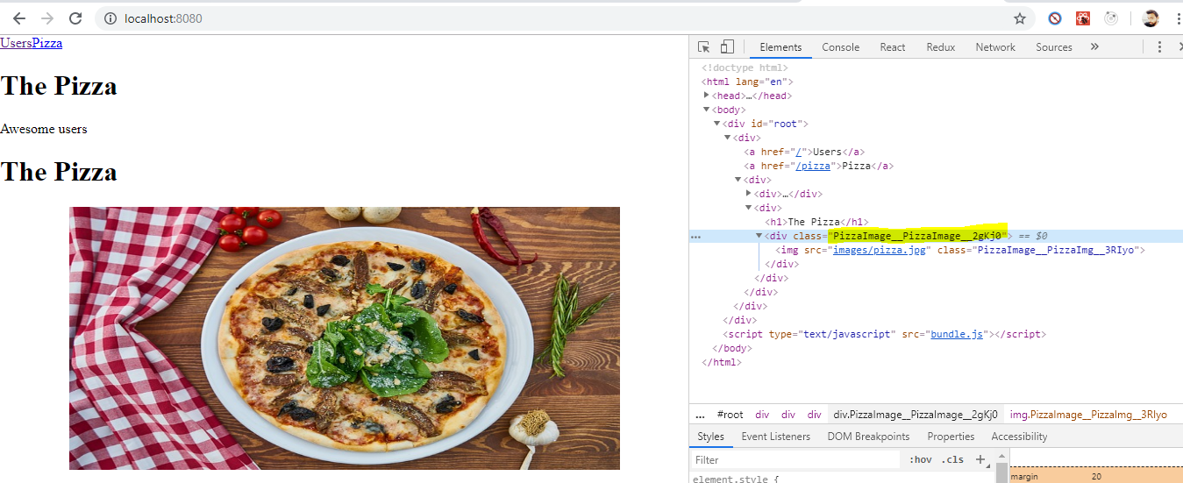

Now we have a working workflow, a working project setup where we can create a react app with the features you learned about in this course.

**Now that's only the development workflow, the development server,**

**if we now want to ship this app to a real server, we'll have to do some adjustments to the setup to have it prepared and to have it be optimized for production.**

## **Imp : Creating a Production Workflow**

Lets work on the production workflow.

**Add a new script in package.json file to create a production build for the application**

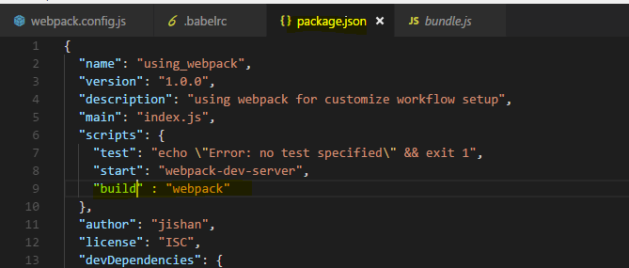

**I want to have a second script, let's name it build**

**here I don't want to run the webpack-dev-server but the webpack. Now if I would run it like this, it would use the setup of the development workflow. We can actually do this to see the output because the development server did everything in memory, now we can create the actual files by running npm run build.**

**So npm run build will now run webpack itself and take the same config file we worked with before but now it gives us this dist folder where you now see the image file it copied and you see the javascript files here. You see the index file it copied where it also injected our import and that is all the code we have**

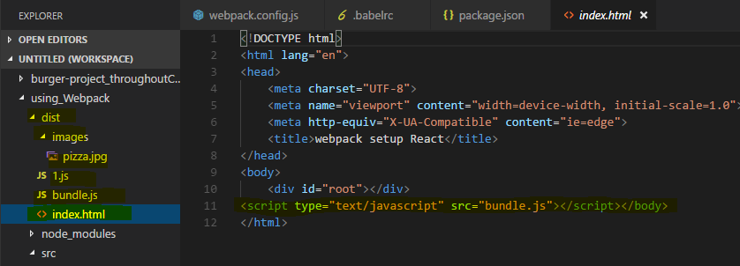

**Also we can see the bundle.js file automatically injected into index.html file**

now what you can see this file already is it's not really optimized at all, this certainly isn't the code we want to ship

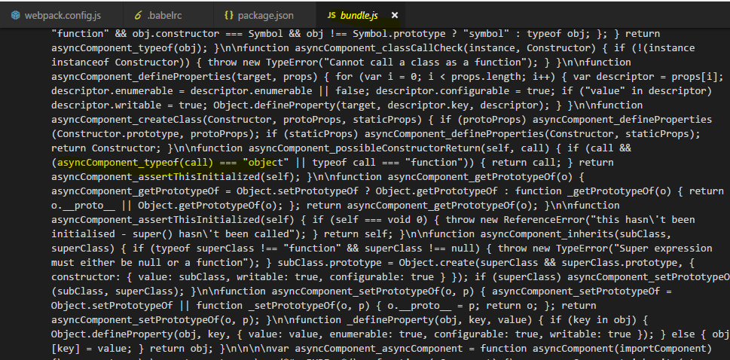

for now. The goal instead is to have a dedicated workflow for production which does some optimizations.

**I'll add a second config file, webpack.prod.config.js. Now it won't automatically take this file into account, we will have to point at it but that's actually super simple.**

Now I'll copy the setup from the other file, from the development workflow so that we can adjust it in the production workflow

Let's see what we need to adjust.

Let's start at the top,

**the dev tool, here I'll remove the eval to create more optimal source maps which are less resource intensive, you can then always decide whether you want to deploy them or not but it's nice to have source maps here too to quickly find some bugs in the production workflow, if there are any.**

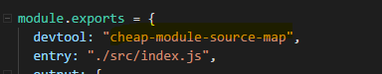

Now the entry file still should be index.js and the output also still makes sense as it is, now

the loaders, what about the loaders? Well we want to apply the same transformations as in development so we don't need to touch the loaders.

we'll do our work in the plugin section,

**now there we have a plugin for connecting the html file and I want to keep that, what I want to do now is I also want to uglify my output, I want to optimize it and that actually is a plugin that's built into webpack,**

we don't need to install it. What I'll do is I'll simply import webpack itself into that file,



so webpack via require webpack and then we can use one of the build in plugins. So down in the plugins section here, I'll add this plugin, here I'll add new webpack, optimize and there we have the uglify js plugin.

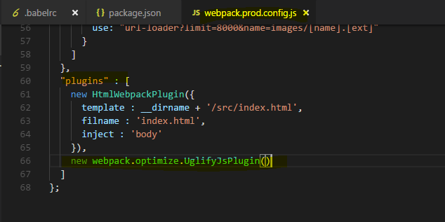

This plugin now also can be configured and you can always check out the official github pages of all these plugins and loaders to do so, I'll take the default setup though

**and with that I got my production workflow where I also optimize the files, where I minify them to ship as little code as possible.**

**Now to use this configuration, I need to adjust my package.json, the build scripts here where I point at webpack, I don't want to use the default config instead I want to use a special one, so I'll use --config, that's a flag we can pass to the webpack script and there I'll point to webpack.prod.config.js file since this is in the same folder as the package.json file,**

**I don't need to specify any path, I can just specify the filename. With that I'll also add some additional options, progress, profile and colors to adjust the console output of the webpack build workflow**

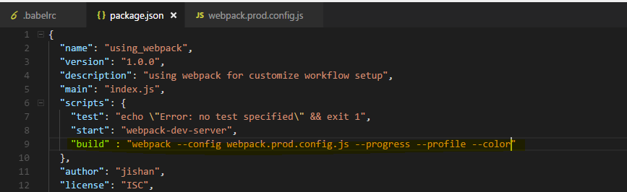

I will install one additional package with npm install --save-dev,

**it's called rimraf and it allows us to delete a folder or files and I want to delete the dist folder at the start of every build process so that we create a brand new one**

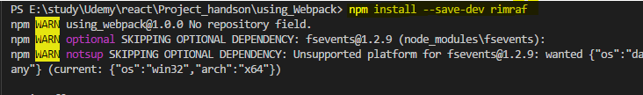

So I'll execute rimraf dist first and then two && signs to then run this project or this command here after the deletion is done. With that, let's run build again, npm run build and let's see if this gives us a nice output,

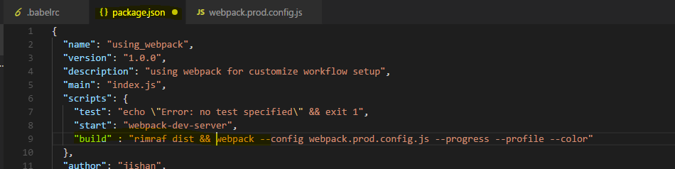

**Now with that, it's building the project we can see it here, it should succeed and it does, it gives us the dist folder still but if we have a look at the bundle file now, you see this is minified code. It's a lot of code because it includes the complete react library but this is all minified and therefore optimized and the same of course in our 0.js file.**

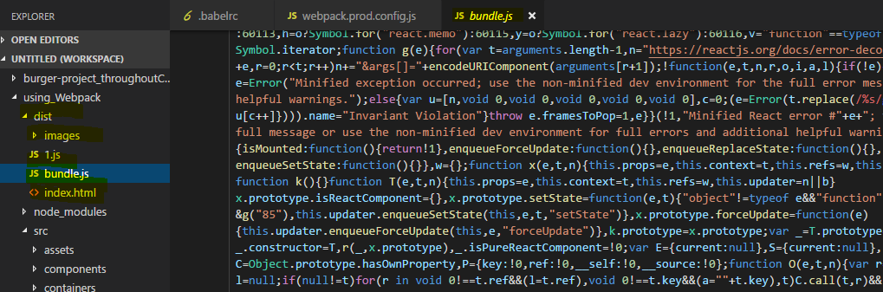

**So now we got our dist folder and this would be what we upload to a server, the content of the dist folder.**

### **Note : Error**

Because of latest versions

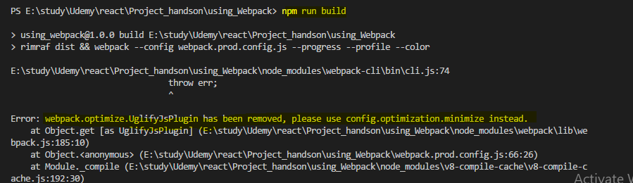

**Then try this , it will be resolved** 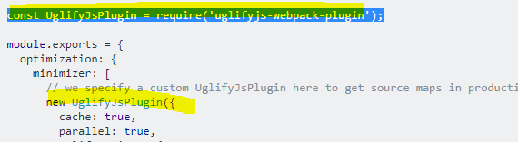

So lets do this - 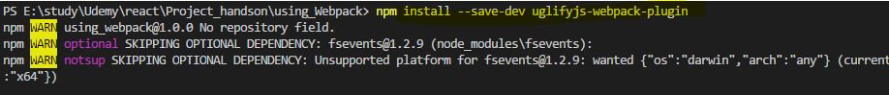



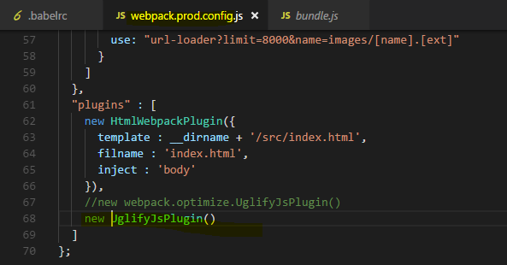

**This is now our own production and dev workflow and I hope it became a bit clearer how webpack works and how you can set up such a custom workflow.**

## **Wrap Up**

So over the course of this module, we built our own basic project setup with webpack as a build tool.

Now you can go into way more detail, there's a lot you can configure,

you can add more loaders, more plugins and fine tune everything to your needs.

Definitely dive into the e-check, that configuration we have for create react app, there you can have a look at the webpack config they used when setting up the create react app config though it's a very elaborate and therefore complex config.

This is a simpler one because I want you to understand how webpack works and what it does and I hope this became a bit clearer over this module. Feel feel free to adjust and fine tune this Configuration and take it as a starting point for your next projects, always dive into the github pages where you can find the documentations of the various loaders and plugins to really configure everything as you need it.

Create react app , webpack config for reference - 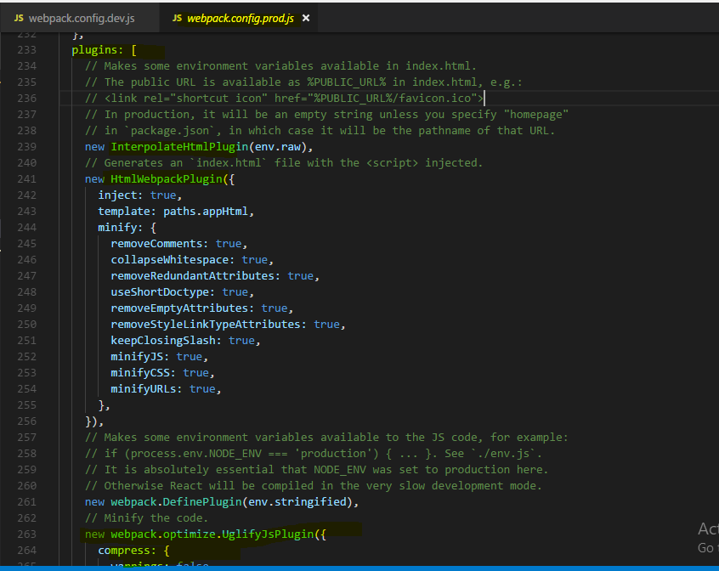

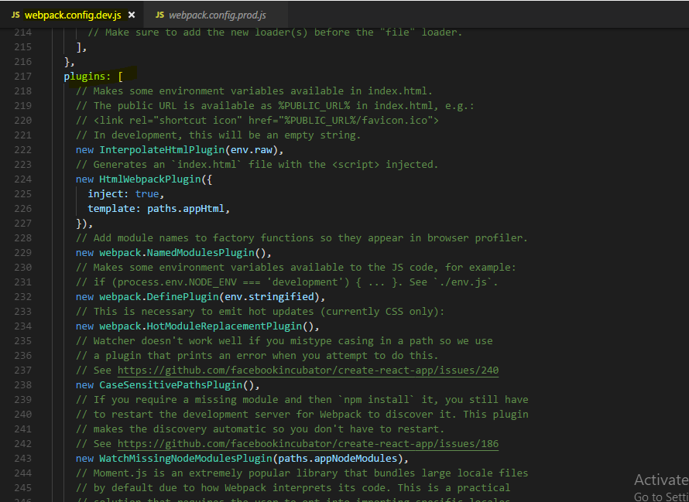

## **Adding babel-polyfill**

Adding babel-polyfill

The current setup won't support all browsers theoretically supported by React. Features like Promises and Object.assign()  are missing in older browsers - especially in IE of course.

If you need to support these browsers, you need to add a polyfill (a package which provides these features for older browsers). babel-polyfill  is a great and easy-to-use choice.

Add it like this:

npm install --save babel-polyfill

Add the following import to the top of your index.js file:

1. import 'babel-polyfill';

Change the config of your env  babel preset in the .babelrc  file:

1. "presets": [
2. ["env", {
3. "targets": {
4. "browsers": [
5. "> 1%",
6. "last 2 versions"
7. ]
8. },
9. "useBuiltIns": "entry"
10. }],
11. "stage-2",
12. "react"
13. ],

useBuiltIns  was added and by setting it to 'entry' , the import in the index.js  file (import 'babel-polyfill' ) is actually changed to import whatever features need to be supported for your chosen browsers and environment. More information can be found here: <https://github.com/babel/babel-preset-env#usebuiltins-entry>

## **Useful Resources & Links**

* Webpack Docs: <https://webpack.js.org/concepts/>
* More about Babel: <https://babeljs.io/>

# **React Hooks**

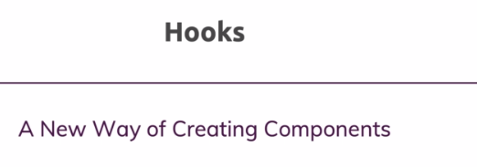



React hooks are a very new feature added to React with version 16.8 and this feature allows you to use functional components only. You can still use class-based components.

React hooks as you will learn in this module give you a new way of writing your React components, you can use functional components only and with the help of React hooks, you can manage state and so on in these components.

## **What are Hooks**

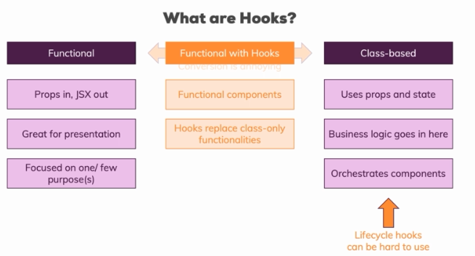

**hooks are a new way or offer us a new way of writing our components. Hooks give us a new way of creating functional components.we don't have a new way of creating a component,we will use the functional approach instead,but hooks are extra features, extra functions we can call in our functional component which give us access to certain capabilities we could only use in class-based components before.**

class-based components are the components which actually hold the majority of our business logic, so with business logic, I mean things like we make an HTTP request and we need to handle the response and to change the internal state of the app or maybe even without HTTP. A user fills out the form and we want to show this somewhere on the screen, we need state for this, we need class-based components for this and therefore we also typically use class based components to orchestrate our other components and pass our state down as props to functional components for example.

one problem we have with this separation, with all the benefits it adds but one problem we have is that converting from one component form to the other is annoying. It's not really difficult but it is annoying. If you ever found yourself in a situation where you needed to convert a functional component into a class based one, it's a lot of typing and a lot of typing of always the same things, so it's annoying.

**A bigger problem in quotation marks is that lifecycle hooks can be hard to use right**

**I should say. Obviously it's not hard to add componentDidMount and execute some code in there but knowing which lifecycle hook to use, when and how to use it correctly, that can be challenging especially in more complex applications and anyways, wouldn't it be nice if we had one way of creating components and that super component could then handle both state and side effects like HTTP requests and also render the user interface?**

**Well this is exactly what hooks are all about.**

**Hooks don’t work inside classes. But you can use them instead of writing classes.**

**What is a Hook? A Hook is a special function that lets you “hook into” React features. For example, useState is a Hook that lets you add React state to function components**

**When would I use a Hook? If you write a function component and realize you need to add some state to it, previously you had to convert it to a class. Now you can use a Hook inside the existing function component.**

## **Enabling react hooks**

**to use React hooks, you need to use the right version. any version, 16.8 or 9, doesn't matter but any version higher than 16.8 or at least 16.8 will do because the hooks feature was included in that version.**

**So make sure to update your project to React 16.8.0 then delete node modules and in the terminal, navigate into your project, run npm install and this will now install React in that version, into your project and make sure that you can use hooks and all the syntax I'm about to teach you in this module.**

## **useState() hook**

**we import it from the React package and it's called useState.**

**This function takes an initial state. We can pass anything here by the way, an empty string, 0, null, an empty array, an empty object, whichever kind of state you want to manage.**

Now this alone doesn't do much because there is no magic connection between calling this function and this input here but **useState returns something**. **It returns us an array, input state here is an array and this array will have exactly two elements.**

**Now which two elements are that? The first element is the current state. The second element in this input state object here or array to be precise is then a function which we can use to manipulate that state and this function is also given to us by React.**

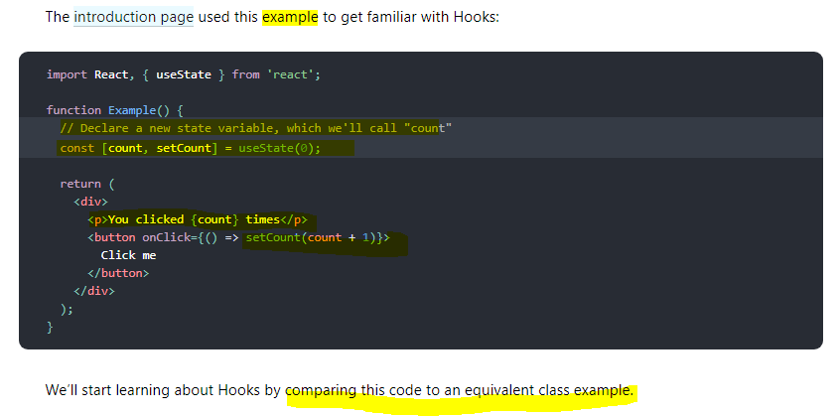

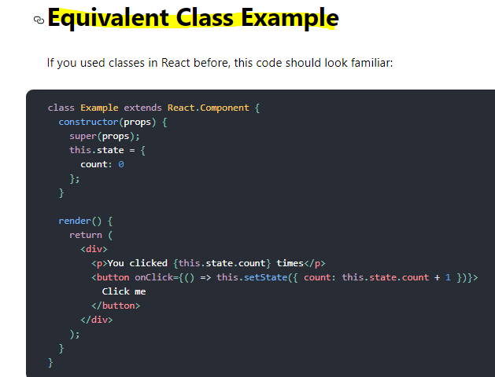

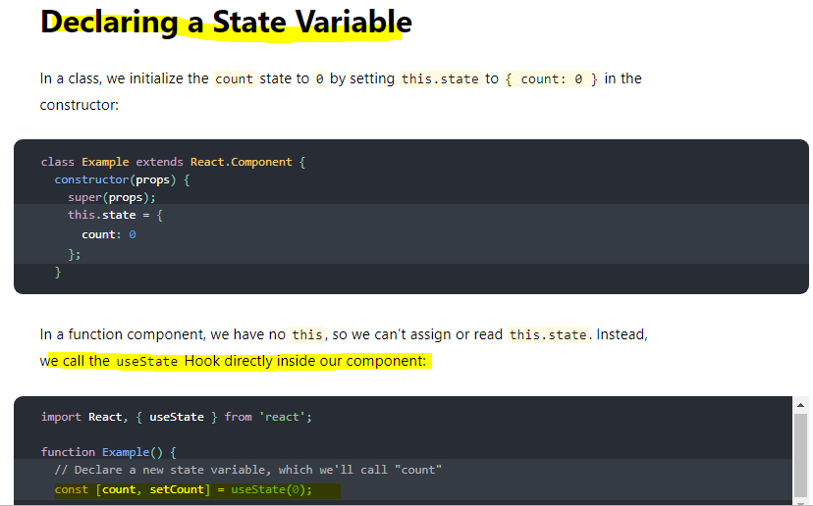

**Very Important** 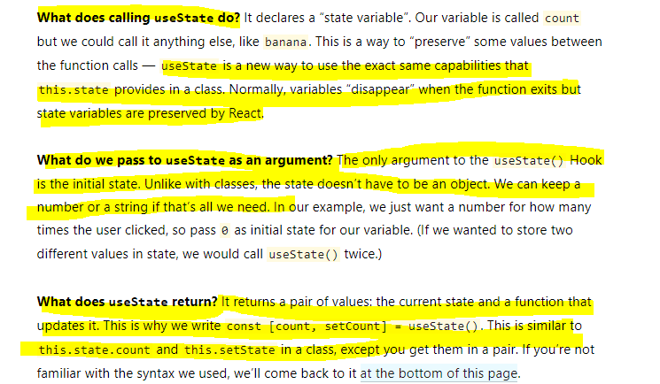

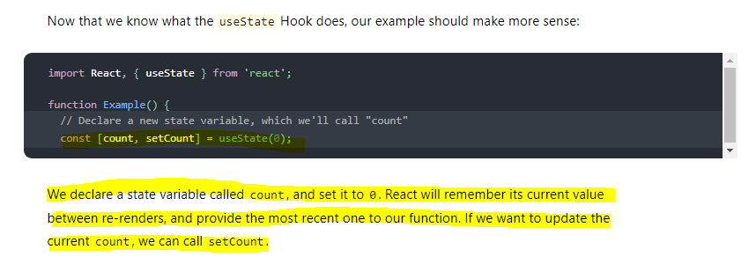

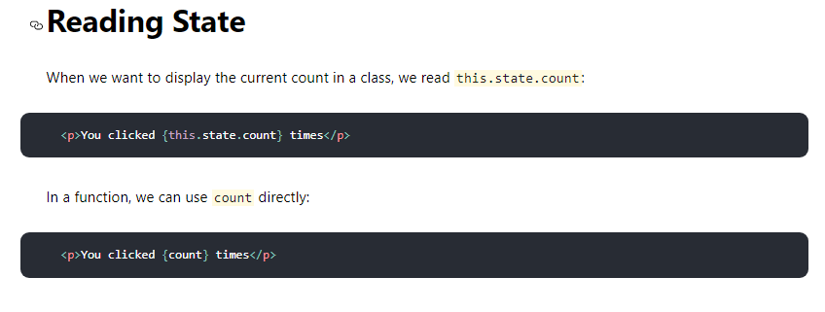

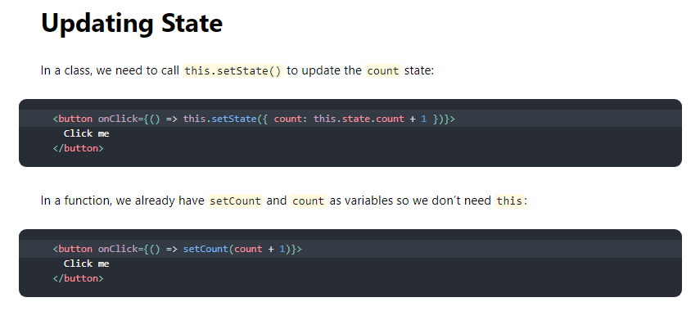

### **Array Destructuring**

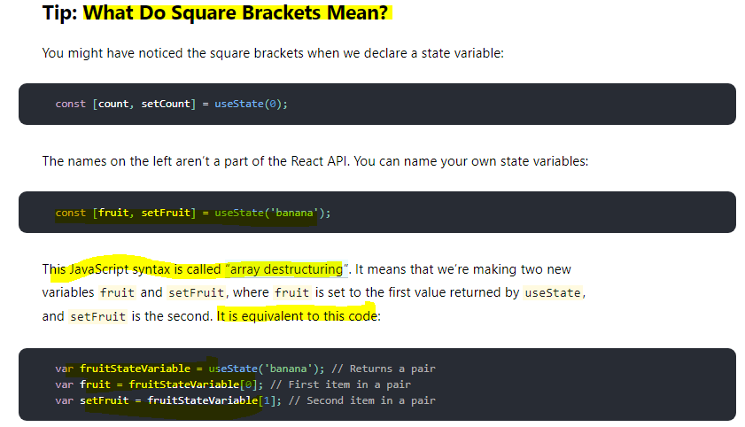

### **Using multiple state Variables**

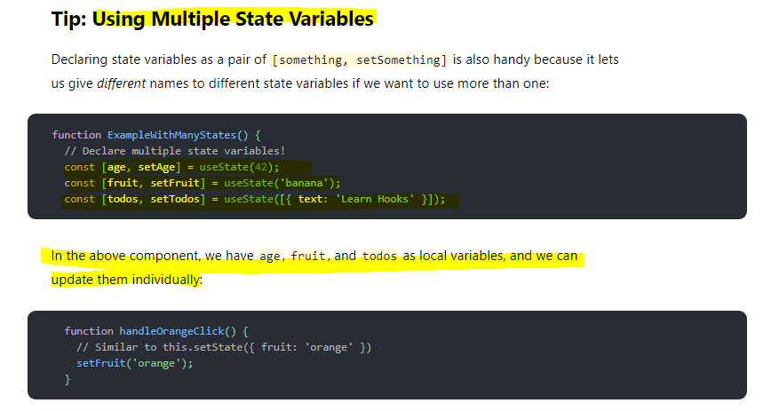

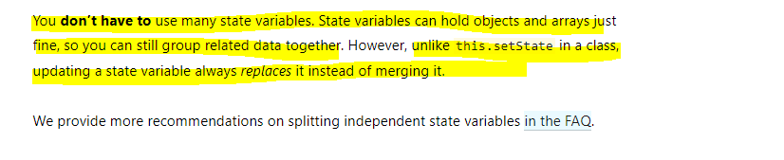

**Example -** 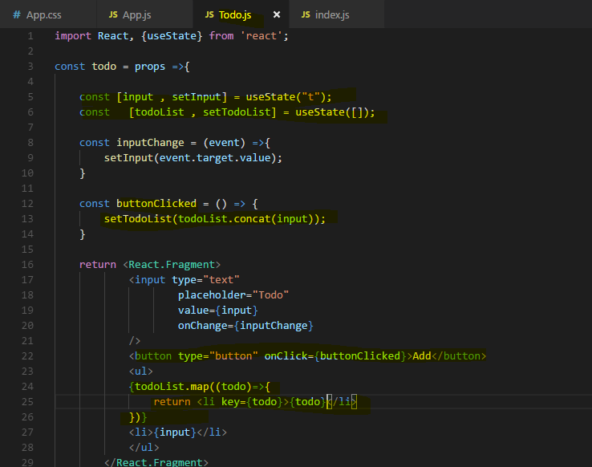

important, since we set a new value, we overwrite the old one.

So if I want to change my value depending on the previous value, then of course I have to take my previous value into account here and I can safely do this. With set state, you might remember that we had two ways of calling this, right?

You could call set state like this with an object, with something like count and then count number or we could use the functional version where you got the previous state as an argument, then you returned this mergible state object and there you could then safely access the previous state if you needed that for your state update.

**Now this was required for class-based components, for functional components with hooks, we don't need to do that, instead here when I depend on my old state, my old todoList, I can use it right away.**

**Using One State Instead**

We now use two instances of the useState function, we call it two times and that is perfectly fine and actually the way I would recommend working with that, that you separate your states across multiple hooks where each hook manages one individual state. Like here, we got the user input and then we get the todoList and of course we use the user input for the todoList but when one of the states changes, it does so independently of the other, when the user enters something in todoInput, we don't need to change the list right away and when we add something to the list, we don't need to change the user input.

**why having separate states might be beneficial. Because one important takeaway is that unlike set state which took an object and merged it with the existing state, the hook created update function here will not merge whatever you pass in with the old state, it will simply replace the old state with the new one and that is super important to understand. And therefore any merging has to be done manually by you,** **exactly what we do here and that is again a reason why you might want to split it up because manually merging it all the time just leads to more code being written and is of course more error prone.**

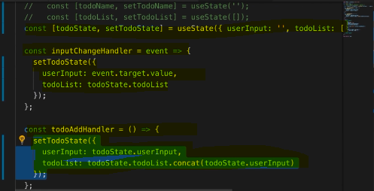

**Very Important**

**unlike this.setState in a class, updating a state variable always replaces it instead of merging it.**

**Real code example**

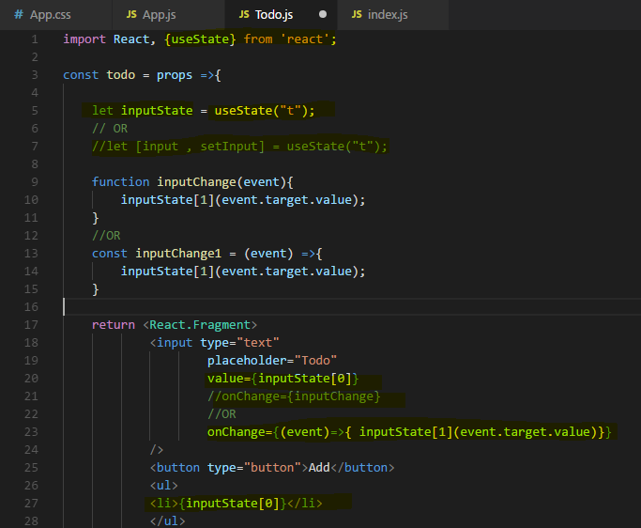

**we're using this useState function which is coming from React to which we pass our initial state and which then seems to return an element or data which is actually an array with two values and exactly two values and the first value is always our latest state and the second value in input state is a function which we can execute to update this state here with a new value.**

## **Rules of Hooks**

Hooks are JavaScript functions, but you need to follow two rules when using them. We provide a [linter plugin](https://www.npmjs.com/package/eslint-plugin-react-hooks) to enforce these rules automatically:

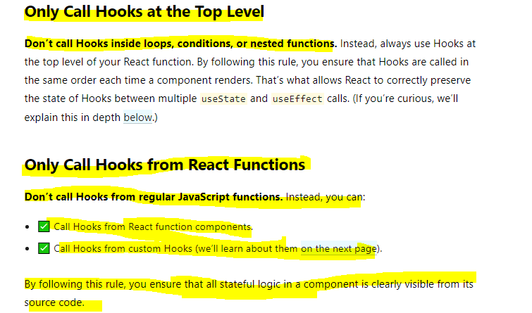

**You must only use useState and all the other hooks at the top level of your component function and that already contains a lot of important things. Important is that it has to be a component function, so such a function which takes props and returns JSX, a function which React can use to render a component. It has to be such a function, you can't use another function and call a hook in there. Well you can call it of course, it's a function in a Javascript function but it will not work correctly, for example state changes will not be picked up by React.**

**The next important takeaway is that the top level here has to be guaranteed, you must only call useState directly in your top level of the function body. You must not call useState in here for example, in a function of the function, so in this nested function here, you can't or you must not call it. You must also not call it in an if statement. So if you had a if condition, in there also not ok. The same goes for for loops or any other form of nesting, only call useState at the root level of this function here.**

Now with these **rules in mind of which the important ones are that you have to have a React component function and that you have to use hooks at the top level.**

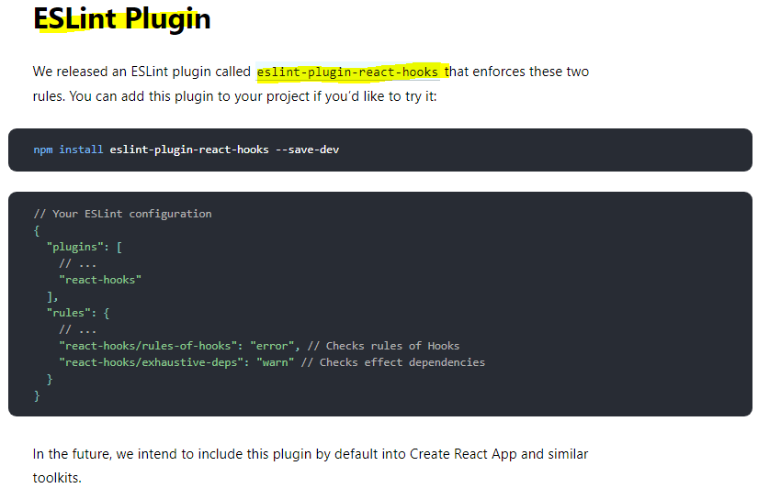

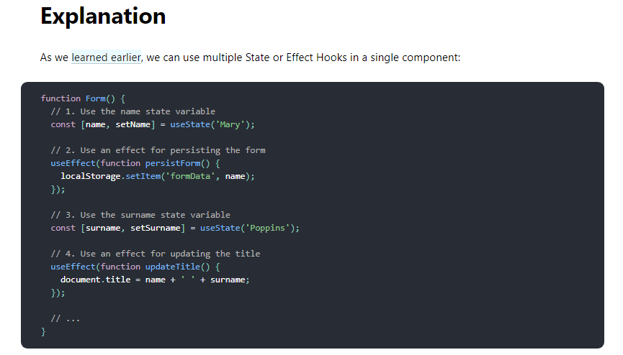

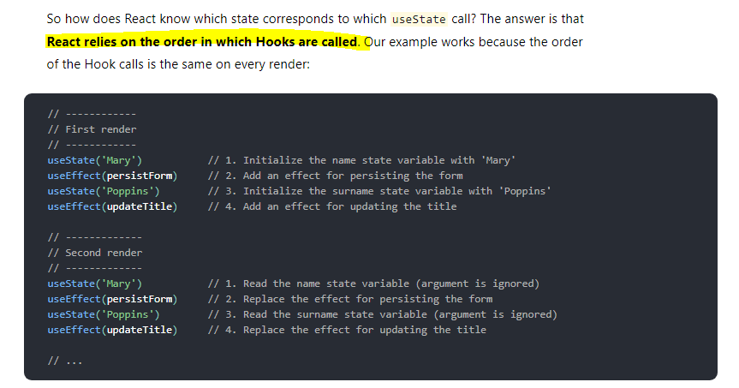

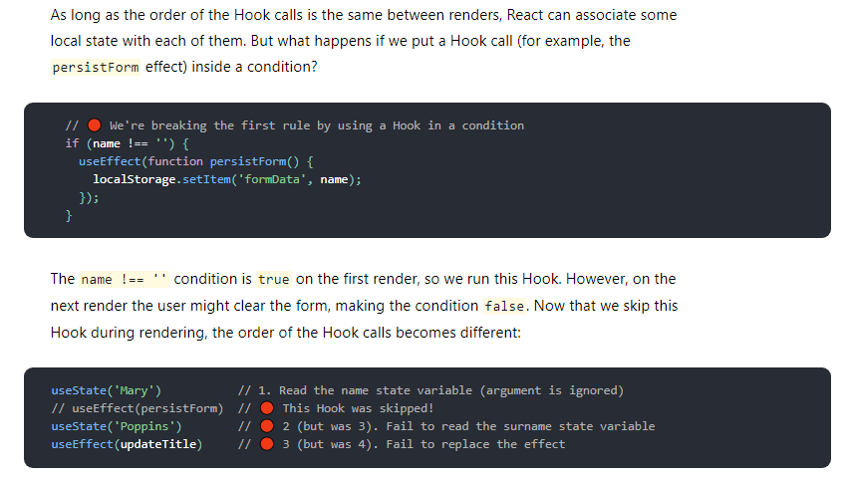

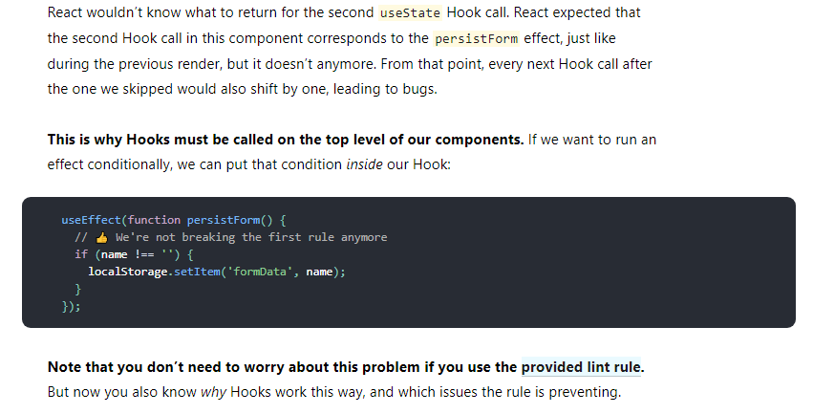

## **useEffect() hook**

**The Effect Hook lets you perform side effects in function components.**

**Data fetching, setting up a subscription, and manually changing the DOM in React components are all examples of side effects. Whether or not you’re used to calling these operations “side effects” (or just “effects”), you’ve likely performed them in your components before.**

**If you’re familiar with React class lifecycle methods, you can think of useEffect Hook as componentDidMount, componentDidUpdate, and componentWillUnmount combined.**

**useEffect is also a function which you call and to this useEffect function here, you pass a function that should be executed.**

**So this function here will execute after this component renders** and now correctly you might say if I want to execute code when this function renders, I could add it right here, right here, I could add my code there.

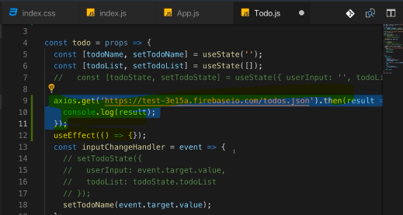

We could do that and this code would work but it is a very bad idea to do that.

**The problem with calling it here would be that we call it inside of the render cycle and that is bad for performance reasons. React does a lot of behind the scenes magic stuff when it renders our component and updates the DOM and when we do operations like this one which then may change the state once they have a response, when we do them inside of that render cycle, we can end up with a bad performance and unexpected results in the UI because maybe we get this response, the result of this request, we get this when React completed its render cycle and therefore changes might end up not being reflected or we just hit the performance and perform too many updates.**

**As a general takeaway, you should not cause any side effects, so things like make HTTP requests or manipulate the DOM on your own or send analytics data to some server, don't do these things here in the render function, do them in a callback function passed to useEffect instead.**

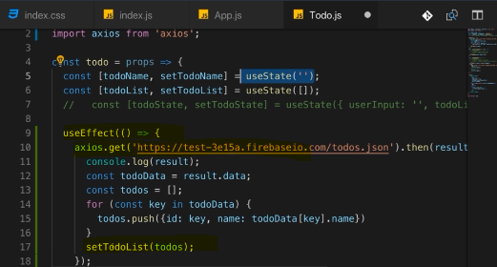

So this is OK because this again, **this useEffect hook here hooks into React's internals and makes sure that this code executes at the right time which is after this render cycle finished, so that this can run in a high performant way and that the UI is always updated correctly and you don't end up with some strange state changes behind the scenes outside of what React expected or anything like that.**

**And just to make this really clear, calling setTodoList in here is absolutely fine, it would not be OK to call useState in here or to call useEffect in here because of the rules of hooks I mentioned earlier, you must only call hooks at the top level of your function, not in a nested function as this one is and this applies to all hooks, useState, useEffect and any other hook. So setTodoList is OK because this is just a function returned by the hook, it's not the hook itself, not the hook function itself. So we can safely call setTodoList in here, then I pass my todos to that list or I replace the oldest with my new todoList to be precise.**

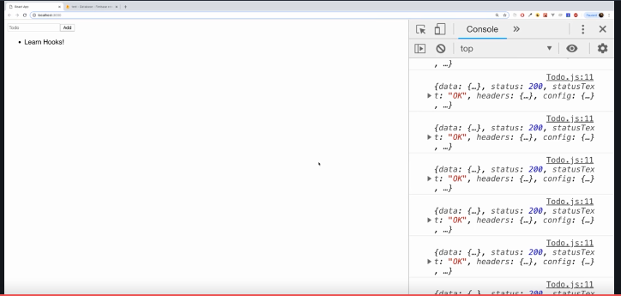

And now if we save that, this page reloads and it actually loads the data from the back-end but what you'll also notice is that we enter an **infinite loop here**,

we get more and more responses coming in. So that is a problem which we certainly have to take care about.

So I added the useEffect hook to cause side effects, it worked but well we caused quite a big side effect because we entered an infinite loop.

**The reason for that is that useEffect does not only run once, like for example componentDidMount did but it runs ofter every render cycle. So we make more and more requests here because I update my state in there, hence we re-render the UI, hence we make a new request, that is of course bad.**

Now how can we avoid doing that?

**Well useEffect takes actually two arguments.It does not just take this first argument which is the function it executes, it takes a second argument instead which is an array of values we want to have a look at before it executes this and only if the values we have a look at changed, only in this case this effect should run again.**

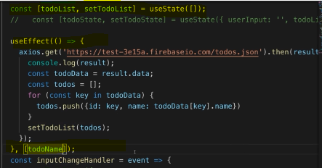

**The second element, the second argument you pass to useEffect is an array where you list all the values, all the variables you want to look for and only if a value passed here in this second argument array, only if one of the values you pass in here changed, this function here, this first argument to useEffect will run again.**

**So if you have multiple elements here, multiple things you're watching for, then any change in any item will be enough to run this again.**

**if you only want to run an effect after only mounting (that is on ComponentDidMount only) well then you pass an empty array here because what you're saying here is this should only run when the items in here, when one of the items in here changed and if you pass no items, well then React hasn't anything to watch and therefore it will not detect any changes and therefore this first argument function will never run again.**

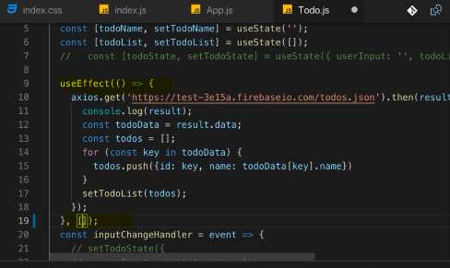

**So if you want to replicate componentDidMount, then pass an empty array, if you want to replicate componentDidMount in combination with componentDidUpdate with an if check included in it, then you should add state variable or other variable because this is now just like your own componentDidUpdate implementation where you also check for whether variable changed.**

**useEffect can be tricky to understand but it's actually straightforward,**

**anything you would have run in componentDidMount or componentDidUpdate before should go in there and with the second argument, you can control when this function should run. If you have no second argument, it'll run for every render cycle. If you have an empty array, it will run for mounting of the component and if you have an array with a value to watch, it will run whenever this value changes.**

### **React website documentation**

There are two common kinds of side effects in React components: those that don’t require cleanup, and those that do.

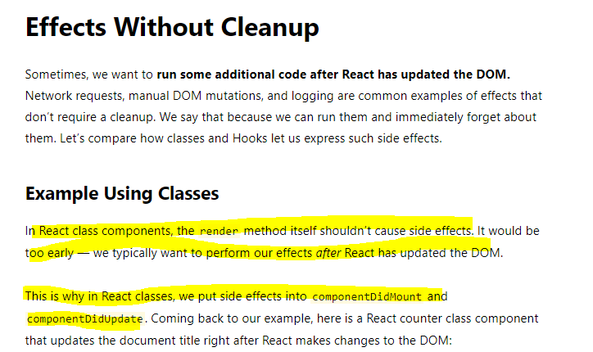

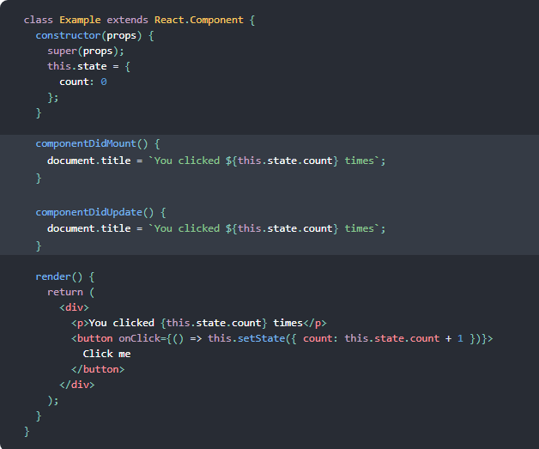

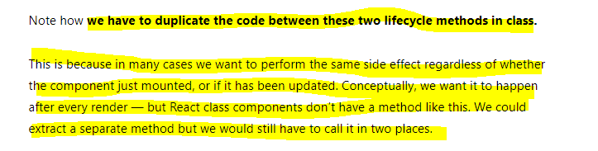

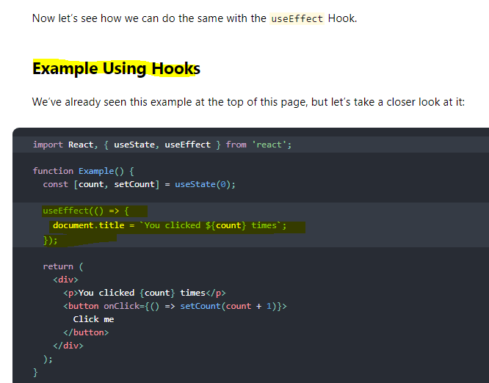

**Very Important** 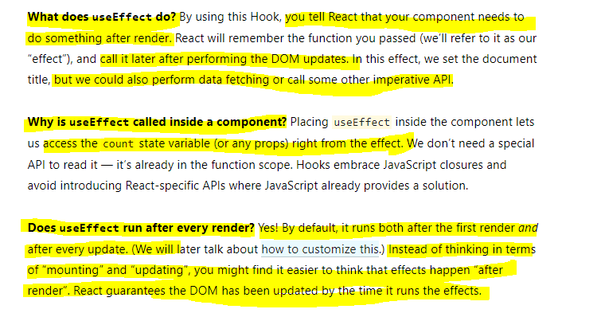

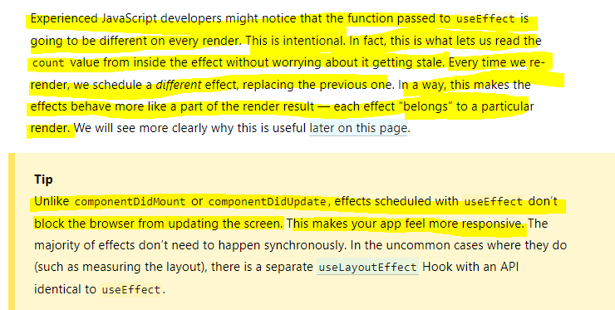

### **Effect Cleanup**

Now what about componentDidUnmount, what if you want to run something whenever a component gets removed or in general, what if you have side effects that require cleanup

work? Maybe not just on component removal but whenever this component re-renders? Well you can do cleanups too.

**You can return something in this function you pass as a first argument. If you add return statement here, then this return statement should also be a function, an anonymous function like this and you don't have to use arrow functions by the way, you can use the function keyword as well and this function will be executed by React on every render cycle too and React will actually execute this as a cleanup before it applies the effect of your main code again. So you can clean up after your last useEffect call basically.**

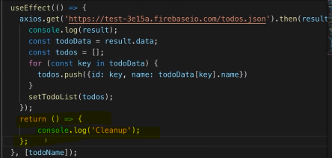

Now obviously for a normal HTTP request which we fire like this and where we don't need todo any clean up even if we re-render early, this doesn't make too much sense

but consider an event listener and let me show you an example for that actually.

Consider we have another effect, just as we can have multiple useState calls,

**we can have multiple effects and in this effect here, let's say we have an event listener we want to add to our document. We want to listen to mousemove events so when the user moves the mouse because maybe we're collecting that data and we send it to our analytics server so that we can track where the user moved the mouse on our page.**

**you'll see tons of stuff being printed on the right, these are the coordinates of my mouse.**

**Now I might want to clean this up and not apply a new effect whenever this page reloads because if I type, you see, watch the numbers next to my coordinates, more and more calls, more and more console log statements and that simply happens because I add more and more event listeners which is awful for performance and absolutely has to be avoided.**

**So we certainly want to clean up our old listener before we attach a new one.**

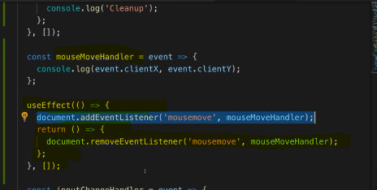

**this will be executed by React because React automatically executes the function we return in useEffect and it executes it as a cleanup function or as a cleanup work to do before our other code here takes effect or has an effect again.**

**maybe you only want to clean up when the component gets destroyed and you can do that by adding this empty array as a second argument which basically again means this should be executed on componentDidMount and then as an extra feature, the cleanup work will only be done on componentDidUnmount basically, so React will now only act when the component gets loaded and when it gets removed**

#### **React Website Document**

